Supplementary Materials

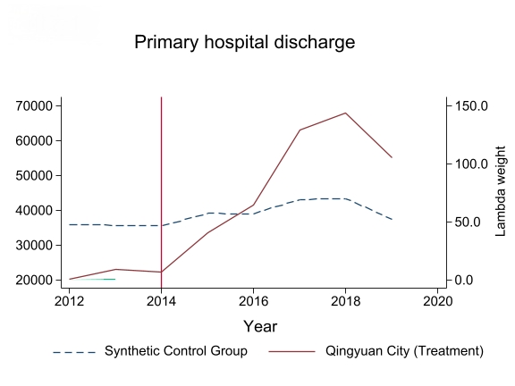
Supplementary Figure 1 Trends in hospital discharges from primary hospitals

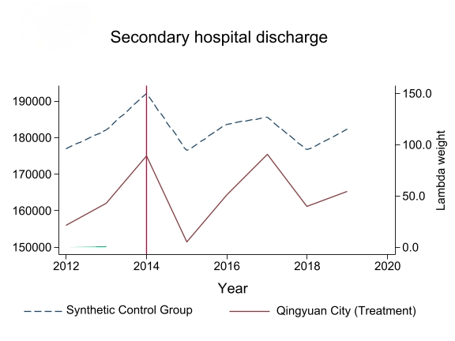
Supplementary Figure 2 Trends in hospital discharges from secondary hospitals

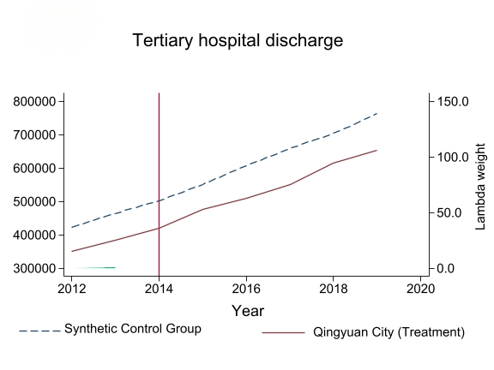
Supplementary Figure 3 Trends in hospital discharges from tertiary hospitals

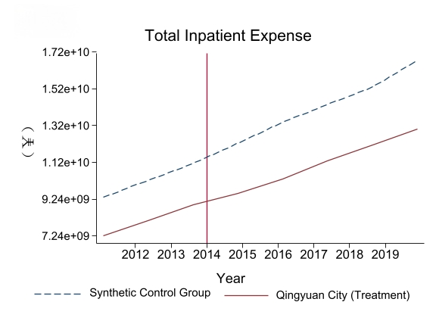
Supplementary Figure 4 DIP policy effects on total inpatient expense

