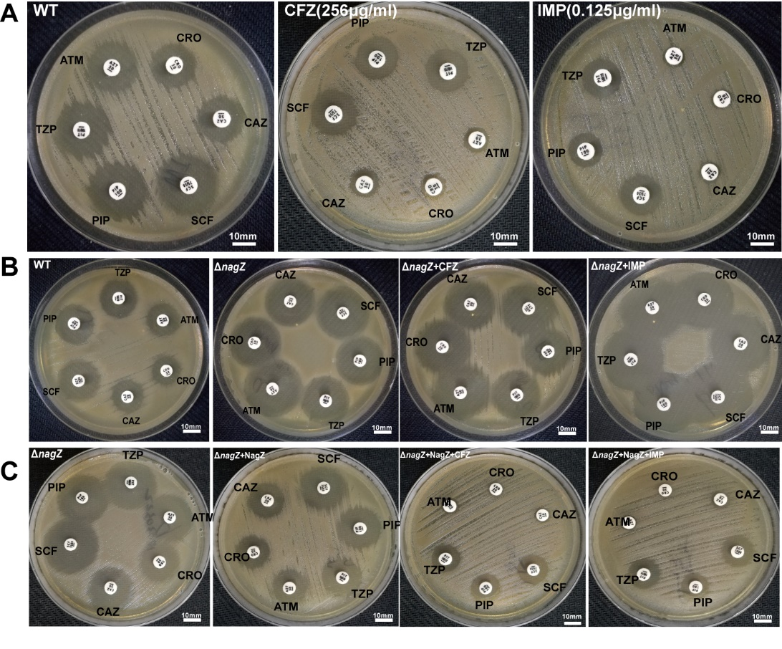
Fig. S2 Kirby-Bauer figures. (A) Antibiotic susceptibility test (Kirby-Bauer method) was employed for determining the roles of subinhibitory concentration CFZ (256μg/ml) and IMP (0.125μg/ml) in resistance in Enterobacter cloacae (EC) clinical isolate. (B) Kirby-Bauer method was employed for determining the roles of NagZ in resistance in WT, ΔnagZ, ΔnagZ+CFZ, and ΔnagZ+IMP strains. (C) Inhibition zone of PIP, TZP, ATM, CRO, CAZ, and SCF was detected by Kirby-Bauer in strains of ΔnagZ, ΔnagZ+NagZ, ΔnagZ+NagZ+CFZ, and ΔnagZ+NagZ+IMP. CFZ: cefazolin IMP: imipenem, PIP: piperacillin, TZP: piperacillin-tazobactam, ATM: aztreonam, CRO: ceftriaxone, CAZ: ceftazidime, SCF: cefoperazone-sulbactam. WT: EC clinical isolate, ΔnagZ: nagZ-knockout EC clinical isolate, ΔnagZ+CFZ: ΔnagZ treated with CFZ, ΔnagZ+IMP: ΔnagZ treated with IMP, ΔnagZ+NagZ: ΔnagZ complemented with NagZ, ΔnagZ+NagZ+CFZ: ΔnagZ+NagZ treated with CFZ, and ΔnagZ+NagZ+IMP: ΔnagZ+NagZ treated with IMP. Scale bar, 10 mm.

