SUPPLEMENTARY INFORMATION

Thermodynamic Constraints on Glycerol-Based Proto-Nucleotides: Phosphate versus Arsenate in Early Backbone Evolution

Lázaro A. M. Castanedo,^{(1,2)} Chérif F. Matta^{(1-4)*}

⁽¹⁾ Department of Chemistry, Saint Mary's University, Halifax, Nova Scotia, Canada B3H 3C3. ⁽²⁾ Department of Chemistry and Physics, Mount Saint Vincent University, Halifax, Nova Scotia, Canada B3M 2J6. ⁽³⁾ Department of Chemistry, Dalhousie University, Halifax, Nova Scotia, Canada B3H 4J3. ⁽⁴⁾ Dép. de chimie, Université Laval, Québec, Québec, Canada G1V 0A6.

* Corresponding Author: cherif.matta@msvu.ca

See https://github.com/mattas-research-group/scripts_PhD_thesis_Lazaro/ for a list of all the scripts written in bash and python to generate the nucleosides, post-process and analyze all the results and generate diagrams and tables.

Table S1. Final unique PM7 optimized conformations (n), number of conformers (n') that contributed at least 50% to the partition function and their contribution in % (Z) for the non-canonical TC glycerol, canonical (A, G, C, T), non-canonical RUs (TAP, BA, MM).

 |  | n |  |  | n' |  |  | Z
Component |  | vac.⁽¹⁾ | solv.⁽²⁾ |  | vac. | solv. |  | vac. | solv.
glycerol |  | 45 | 97 |  | 5 | 9 |  | 54.02 | 53.94
A⁽³⁾ |  | 1 | 2 |  | 1 | 1 |  | 100 | 51.48
G⁽⁴⁾ |  | 1 | 3 |  | 1 | 2 |  | 100 | 69.52
C⁽⁵⁾ |  | 2 | 5 |  | 1 | 3 |  | 51.41 | 64.10
T⁽⁶⁾ |  | 3 | 4 |  | 2 | 2 |  | 68.75 | 53.35
TAP⁽⁸⁾ |  | 1 | 3 |  | 1 | 2 |  | 100 | 68.84
BA⁽⁹⁾ |  | 3 | 3 |  | 1 | 2 |  | 58.94 | 78.43
MM⁽¹⁰⁾ |  | 2 | 4 |  | 1 | 2 |  | 57.74 | 53.40

⁽¹⁾Values of n, n' and Z in vacuum at the PM7 level. ⁽²⁾ Values of n, n' and Z in implicit solvent using the COSMO model at the PM7 level. ⁽³⁾A = adenine. ⁽⁴⁾G = guanine. ⁽⁵⁾C = cytosine. ⁽⁶⁾T = thymine. ⁽⁷⁾U = uracil. ⁽⁸⁾ TAP = 2, 4, 6 triaminopyrimidine. ⁽⁹⁾BA = barbituric acid. ⁽¹⁰⁾MM = melamine. ⁽¹¹⁾CA = cyanuric acid. ⁽¹²⁾Ac = acetyl group (-CH₂-COOH).

Table S2. Gibbs ($∆G^{°}$) energies at standard pressure and temperature in kJ/mol for a hypothetical classic (a+b) and alternative (c+d) pathways leading to the 5 canonical and 6 non-canonical GNA nucleotides containing HPO₃⁻ and HAsO₃⁻ in vacuum and aqueous environment (from DFT calculations at the B3LYP/6-311++G (d, p) level of theory, with aqueous solvation modeled with the IEFPCM model).

RU⁽¹⁾ |  | $$∆G_{a}^{°}$$ | $ΔG_{\text{Rx}(b)}^{°}$$∆G_{b}^{°}$ | $ΔG_{\text{Rx}(\text{a+b})}^{°}$$∆G_{a+b}^{°}$ |  | $$∆G_{c}^{°}$$ | $∆G_{d}^{°}$$ΔG_{\text{Rx}(b)}^{°}$ | $∆G_{c+d}^{°}$$ΔG_{\text{Rx}(\text{a+b})}^{°}$
 |  | vac.⁽²⁾
 |  | HPO₃⁻ |  |  |  | HPO₃⁻
A |  | -27.12 | -53.16 | -80.28 |  | -35.15 | -44.93 | -80.08
G |  | -25.71 | -51.42 | -77.13 |  | -35.15 | -51.06 | -86.21
C |  | -16.31 | -46.35 | -62.66 |  | -35.15 | -37.39 | -72.54
T |  | -16.82 | -68.71 | -85.53 |  | -35.15 | -49.58 | -84.73
U |  | -16.44 | -72.38 | -88.82 |  | -35.15 | -52.00 | -87.15
TAP-C⁵ |  | -19.14 | -61.54 | -80.68 |  | -35.15 | -44.55 | -79.70
TAP-N |  | -9.93 | -36.38 | -46.31 |  | -35.15 | -24.45 | -59.60
BA-C⁵ |  | -55.62 | -121.63 | -177.25 |  | -35.15 | -129.76 | -164.91
BA-N |  | -13.86 | -47.13 | -60.99 |  | -35.15 | -0.76 | -35.91
CA |  | -12.68 | -47.64 | -60.32 |  | -35.15 | -24.78 | -59.93
MM |  | -9.60 | -31.21 | -40.81 |  | -35.15 | -4.77 | -39.92
 |  | HAsO₃⁻ |  |  |  | HAsO₃⁻
A |  | -27.12 | -43.06 | -70.18 |  | -25.67 | -47.67 | -73.34
G |  | -25.71 | -36.04 | -61.75 |  | -25.67 | -53.60 | -79.27
C |  | -16.31 | -50.63 | -66.94 |  | -25.67 | -41.57 | -67.24
T |  | -16.82 | -59.53 | -76.35 |  | -25.67 | -48.57 | -74.24
U |  | -16.44 | -62.67 | -79.11 |  | -25.67 | -51.15 | -76.82
TAP-C⁵ |  | -19.14 | -48.91 | -68.05 |  | -25.67 | -45.77 | -71.44
TAP-N |  | -9.93 | -31.51 | -41.44 |  | -25.67 | -27.46 | -53.13
BA-C⁵ |  | -55.62 | -108.21 | -163.83 |  | -25.67 | -140.16 | -165.83
BA-N |  | -13.86 | -39.35 | -53.21 |  | -25.67 | -0.84 | -26.51
CA |  | -12.68 | -41.30 | -53.98 |  | -25.67 | -28.32 | -53.99
MM |  | -9.60 | -16.51 | -26.11 |  | -25.67 | -8.19 | -33.86
 |  | solv.⁽³⁾
 |  | HPO₃⁻ |  |  |  | HPO₃⁻
A |  | -28.61 | 3.18 | -25.43 |  | 6.75 | -32.17 | -25.42
G |  | -24.84 | 1.33 | -23.51 |  | 6.75 | -21.37 | -14.62
C |  | -17.84 | 1.67 | -16.17 |  | 6.75 | -22.91 | -16.16
T |  | -12.94 | -0.57 | -13.51 |  | 6.75 | -16.79 | -10.04
U |  | -11.56 | 1.41 | -10.15 |  | 6.75 | -17.20 | -10.45
TAP-C⁵ |  | -32.50 | 1.52 | -30.98 |  | 6.75 | -41.92 | -35.17
TAP-N |  | -9.31 | -3.75 | -13.06 |  | 6.75 | -16.72 | -9.97
BA-C⁵ |  | -42.75 | 1.99 | -40.76 |  | 6.75 | -78.99 | -72.24
BA-N |  | -13.33 | 2.00 | -11.33 |  | 6.75 | -18.05 | -11.30
CA |  | -8.85 | 1.36 | -7.49 |  | 6.75 | -15.07 | -8.32
MM |  | -19.72 | 1.82 | -17.90 |  | 6.75 | -9.78 | -3.03
 |  | HAsO₃⁻ |  |  |  | HAsO₃⁻
A |  | -28.61 | 5.17 | -23.44 |  | 8.38 | -25.48 | -17.10
G |  | -24.84 | 9.70 | -15.14 |  | 8.38 | -23.52 | -15.14
C |  | -17.84 | 2.43 | -15.41 |  | 8.38 | -16.53 | -8.15
T |  | -12.94 | 5.57 | -7.37 |  | 8.38 | -16.88 | -8.50
U |  | -11.56 | 10.80 | -0.76 |  | 8.38 | -17.18 | -8.80
TAP-C⁵ |  | -32.50 | -5.05 | -37.55 |  | 8.38 | -30.86 | -22.48
TAP-N |  | -9.31 | -0.96 | -10.27 |  | 8.38 | -17.00 | -8.62
BA-C⁵ |  | -42.75 | 0.78 | -41.97 |  | 8.38 | -50.32 | -41.94
BA-N |  | -13.33 | 3.64 | -9.69 |  | 8.38 | -18.10 | -9.72
CA |  | -8.85 | 8.55 | -0.30 |  | 8.38 | -8.68 | -0.30
MM |  | -19.72 | 2.05 | -17.67 |  | 8.38 | -10.74 | -2.36

⁽¹⁾RU = unspecified recognition unit. ⁽²⁾ Differences in ∆G° in vacuum at the DFT level. ⁽³⁾ Differences in ∆G° in implicit solvation.

Table S3. P-OC3, As-OC3 distances and RMSD measured in Å for the 5 canonical and 6 non-canonical GNA nucleotides containing HPO₃⁻ and HAsO₃⁻ from a hypothetical classic (a+b) and alternative (c+d) pathways in vacuum and aqueous environment (from DFT calculations at the B3LYP/6-311++G (d, p) level of theory, with aqueous solvation modeled with the IEFPCM model).

RU⁽¹⁾ |  | P-OC3_{(a+b)} | $ΔG_{\text{Rx}(b)}^{°}$As-OC3_{(a+b)} | $ΔG_{\text{Rx}(\text{a+b})}^{°}$RMSD_{(a+b)} |  | P-OC3_{(c+d)} | As-OC3_{(c+d)} $ΔG_{\text{Rx}(b)}^{°}$ | RMSD_{(c+d)}$ΔG_{\text{Rx}(\text{a+b})}^{°}$
 |  | vac.⁽²⁾
A |  | 1.68 | 1.83 | 0.55 |  | 1.66 | 1.82 | 0.10
G |  | 1.68 | 1.83 | 1.58 |  | 1.66 | 1.81 | 0.08
C |  | 1.67 | 1.82 | 1.21 |  | 1.66 | 1.83 | 0.56
T |  | 1.68 | 1.82 | 0.38 |  | 1.67 | 1.82 | 0.08
U |  | 1.68 | 1.82 | 0.39 |  | 1.67 | 1.82 | 0.09
TAP-C⁵ |  | 1.66 | 1.81 | 0.09 |  | 1.66 | 1.81 | 0.96
TAP-N |  | 1.68 | 1.83 | 1.16 |  | 1.67 | 1.82 | 0.09
BA-C⁵ |  | 1.61 | 1.76 | 0.60 |  | 1.63 | 1.79 | 0.41
BA-N |  | 1.63 | 1.78 | 0.86 |  | 1.66 | 1.82 | 0.12
CA |  | 1.68 | 1.82 | 1.16 |  | 1.67 | 1.82 | 0.10
MM |  | 1.66 | 1.83 | 2.69 |  | 1.66 | 1.82 | 0.12
 |  | solv.⁽³⁾
A |  | 1.66 | 1.82 | 0.07 |  | 1.66 | 1.81 | 2.17
G |  | 1.66 | 1.82 | 0.77 |  | 1.66 | 1.82 | 0.07
C |  | 1.66 | 1.82 | 0.07 |  | 1.66 | 1.81 | 1.77
T |  | 1.66 | 1.82 | 0.07 |  | 1.66 | 1.81 | 0.08
U |  | 1.66 | 1.82 | 0.65 |  | 1.66 | 1.81 | 0.08
TAP-C⁵ |  | 1.64 | 1.81 | 0.71 |  | 1.65 | 1.81 | 2.68
TAP-N |  | 1.65 | 1.81 | 0.10 |  | 1.66 | 1.81 | 0.07
BA-C⁵ |  | 1.66 | 1.82 | 0.07 |  | 1.62 | 1.82 | 2.10
BA-N |  | 1.66 | 1.82 | 0.08 |  | 1.66 | 1.82 | 0.08
CA |  | 1.66 | 1.81 | 0.57 |  | 1.66 | 1.81 | 1.46
MM |  | 1.66 | 1.82 | 0.07 |  | 1.66 | 1.82 | 0.08

⁽¹⁾RU = unspecified recognition unit. ⁽²⁾ Distances and RMSD measured in vacuum at the DFT level. ⁽³⁾ Distances and RMSD measured in implicit solvation.

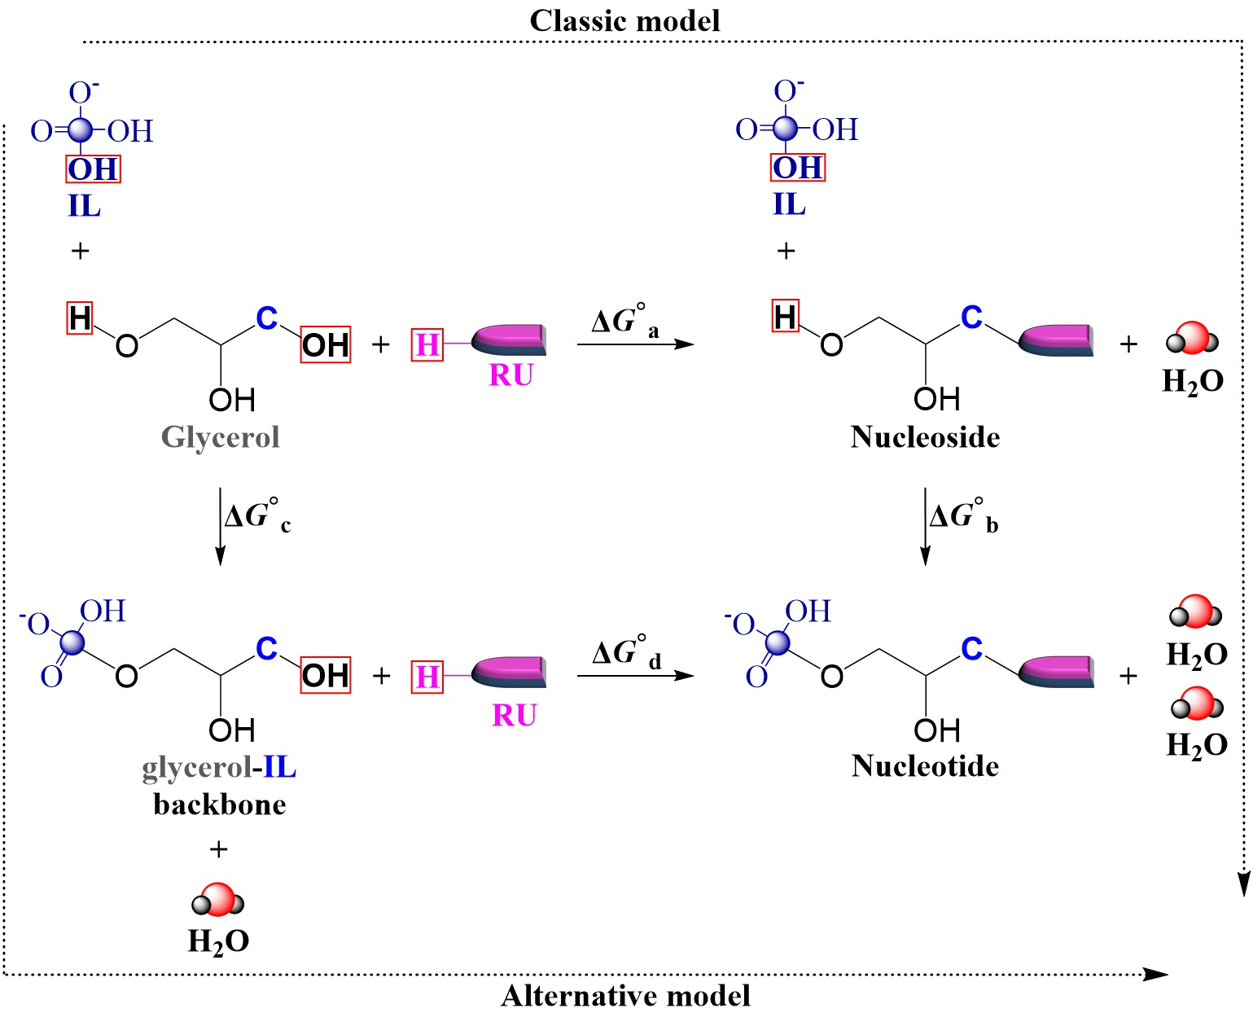
Fig. S1 Reaction schemes for the formation of glycerol nucleosides and nucleotides. The classic pathway (a+b) involves condensation of glycerol with the recognition unit followed by phosphorylation (or arsenation), whereas the alternative pathway (c+d) proceeds via initial formation of a glycerol–linker backbone prior to condensation with the recognition unit. Reaction labels correspond to those used in the main text.

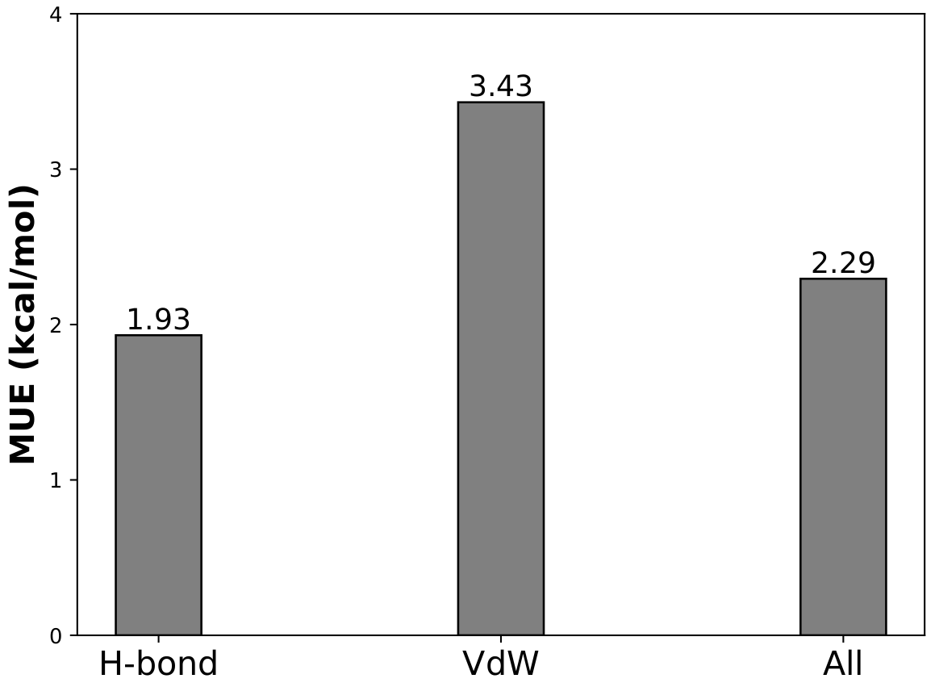

Fig. S2 Benchmarking of the B3LYP/6-31++G(d,p) level of theory against the S66 dataset of noncovalent interactions. Mean unsigned errors (kcal/mol) are shown for hydrogen-bonded and dispersion-dominated complexes, illustrating the reliability of the method for describing intermolecular interactions relevant to nucleoside and nucleotide formation.

Fig. S3 Representative optimized geometries of glycerol nucleotides obtained for both classic (a+b) and alternative (c+d) pathways in vacuum and implicit aqueous solution. Structures correspond to the most thermodynamically favorable systems identified in each class. Phosphate-containing systems (GNA) and arsenate analogues (GNA(As)) are shown, with superposed structures highlighting their close structural similarity.

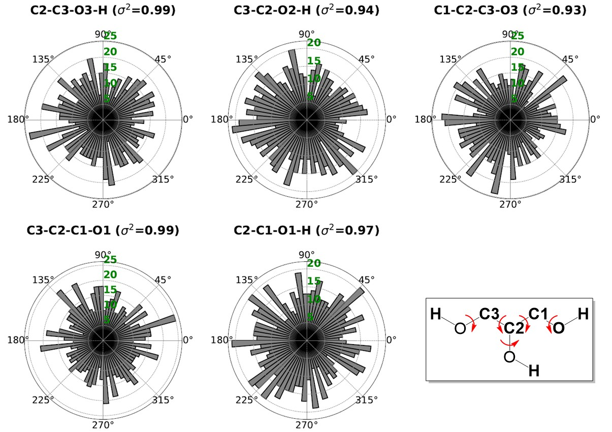
Fig. S4 Distribution of torsional angles sampled during conformational exploration of glycerol using the GRANADAROT algorithm. The circular histogram (rose diagram) demonstrates broad coverage of conformational space, with high circular variance for all sampled dihedrals, ensuring adequate representation of accessible geometries prior to quantum chemical refinement.

