Supplementary Figures

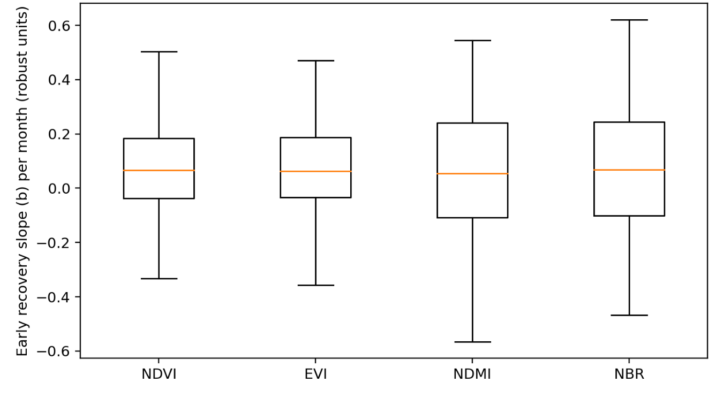
Fig. S1 Early recovery sensitivity across indices. Distribution of recovery slopes b (robust units month⁻¹) for NDVI, EVI, NDMI, and NBR, computed from a linear trend over the 12 months after the disturbance minimum in the standardized patch–buffer contrast series (patch − 100 m outside buffer). Boxplots show median, IQR, and whiskers (outliers omitted); n = 75 complete-case patches

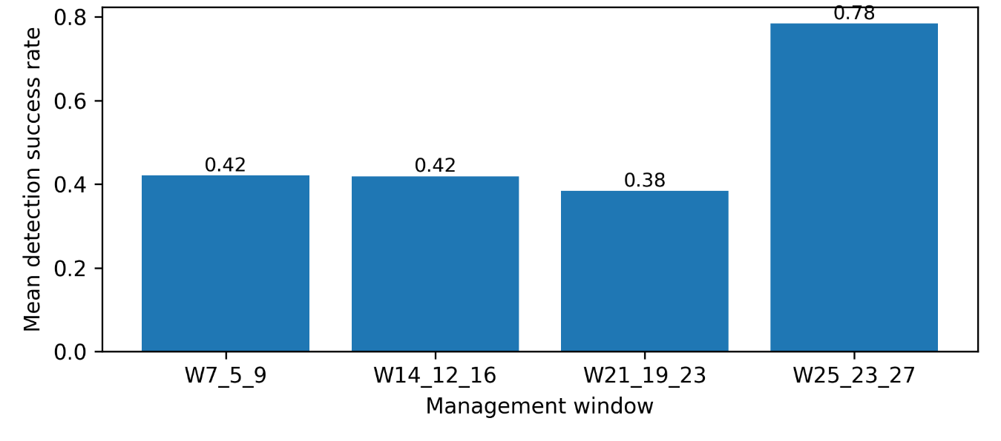
Fig. S2 Mean BFASTmonitor breakpoint-detection success across indices by management window (observable windows only). Bar chart of the mean “ok” detection rate across NDVI, EVI, NDMI, and NBR for each management window that overlaps the 2017–2026 Sentinel-2 period. The 23–27-year window shows the highest mean success rate

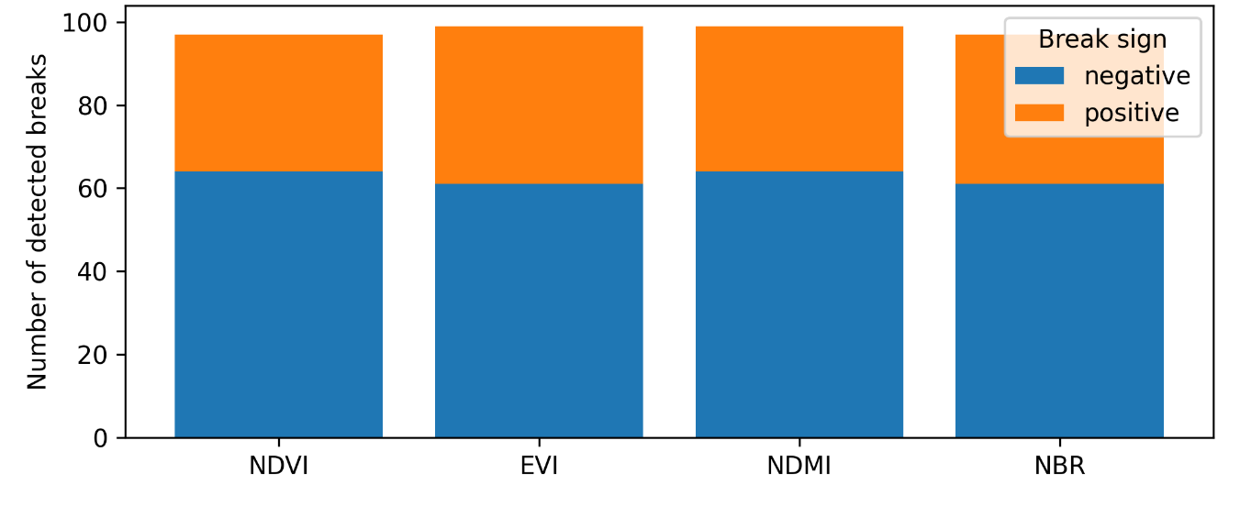
Fig. S3 Sign of detected breakpoints in the 23–27-year window (observable patches).
Counts of negative and positive breakpoint magnitudes among successful detections (“ok”) for NDVI, EVI, NDMI, and NBR within the 23–27-year window, based on the patch–buffer contrast series (patch minus outside buffer). Negative magnitudes indicate a decrease in patch signal relative to its local surroundings, while positive magnitudes indicate an increase
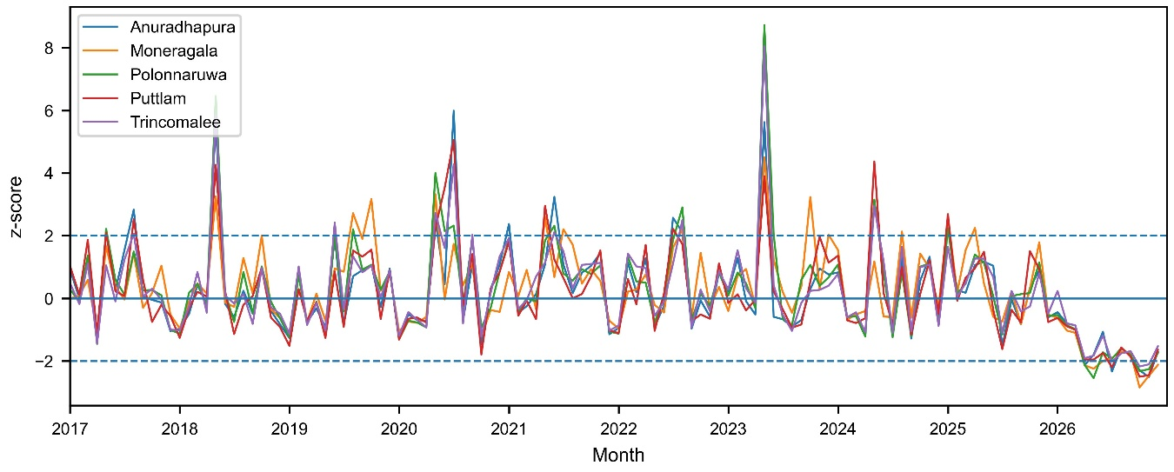
Fig. S4 Rainfall anomaly intensity during 2017–2026 (CHIRPS). Distribution of absolute standardized monthly precipitation anomalies (|z|) computed relative to the 1981–2010 month-of-year climatology, for patch-centroid locations across all study patches during 2017–2026; bins summarize the frequency of near-normal versus anomalously wet or dry months.

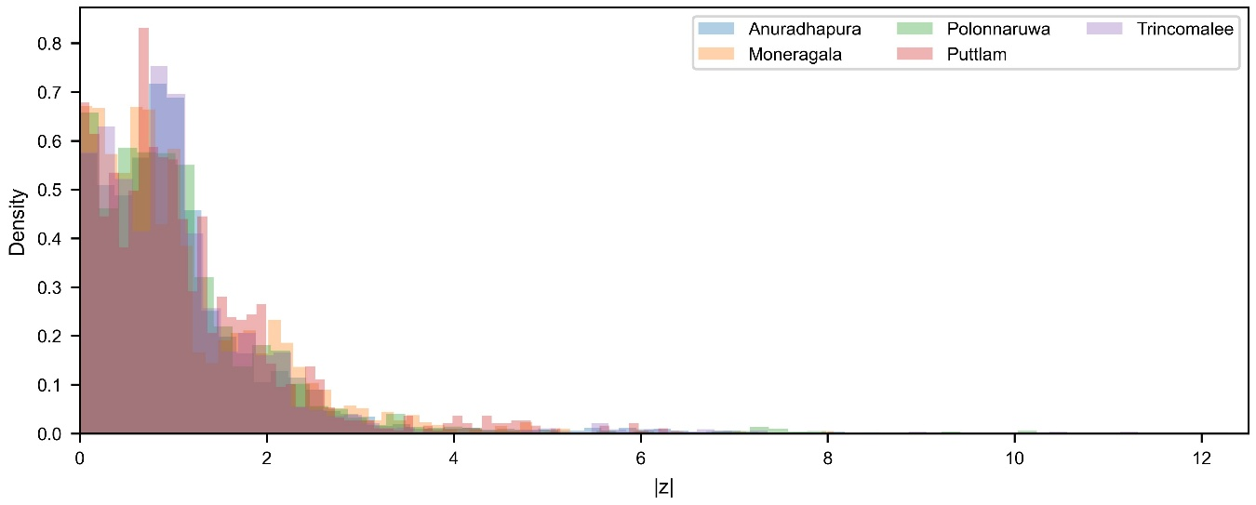
Fig. S5 District-scale rainfall anomaly time series (2017–2026). Monthly mean CHIRPS precipitation z-scores, standardized relative to the 1981–2010 month-of-year climatology, aggregated by district using patch-centroid sampling and illustrating the temporal evolution of wet and dry departures across the five study districts

