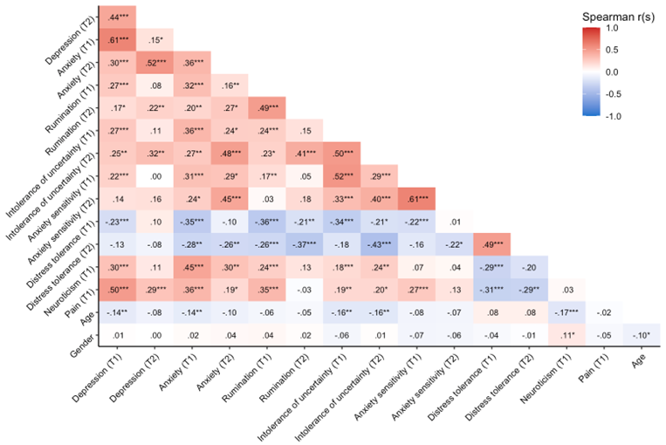
Figure S2. Heatmap reflecting two-tailed partial bivariate Spearman rank-order correlations between model variables in the EMS group, adjusted for age, gender, and pain severity.

Note: *=p < .05,**= p < .001, ***=p<.0001. Gender coded as a binary variable (0= men, 1= women).

