Figures S3-6. Interactions plot illustrating moderation effects of gait-disability level (SRDSS) on the cross-sectional relationships between cognitive factors and anxiety symptoms in the MS group.
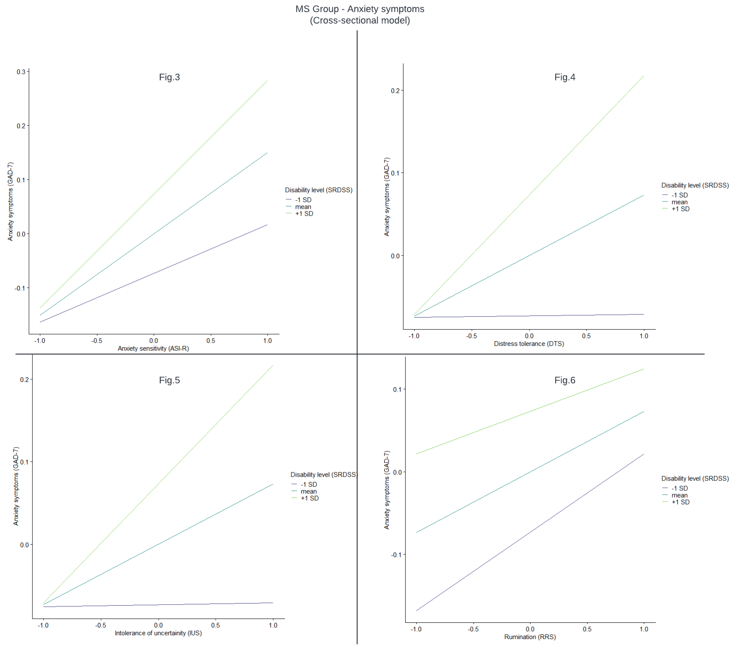

Figures S7-10. Interactions plot illustrating the moderation effects of gait-disability level (SRDSS) on the cross-sectional relationships between cognitive factors and depressive symptoms in the MS group.
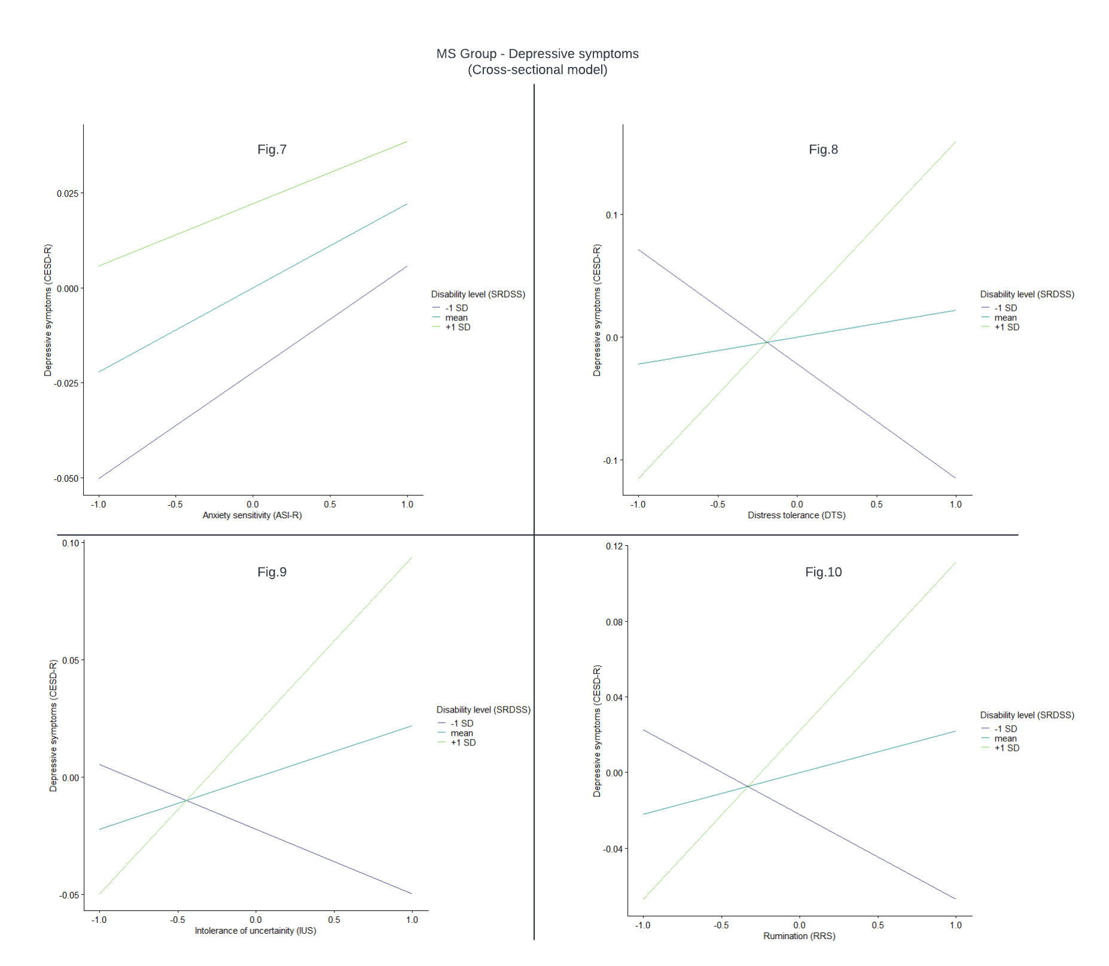

Figures S11-14. Interactions plot illustrating the moderation effects of pain severity (POQ-SF) on the cross-sectional relationships between cognitive factors and anxiety symptoms in the EMS group.
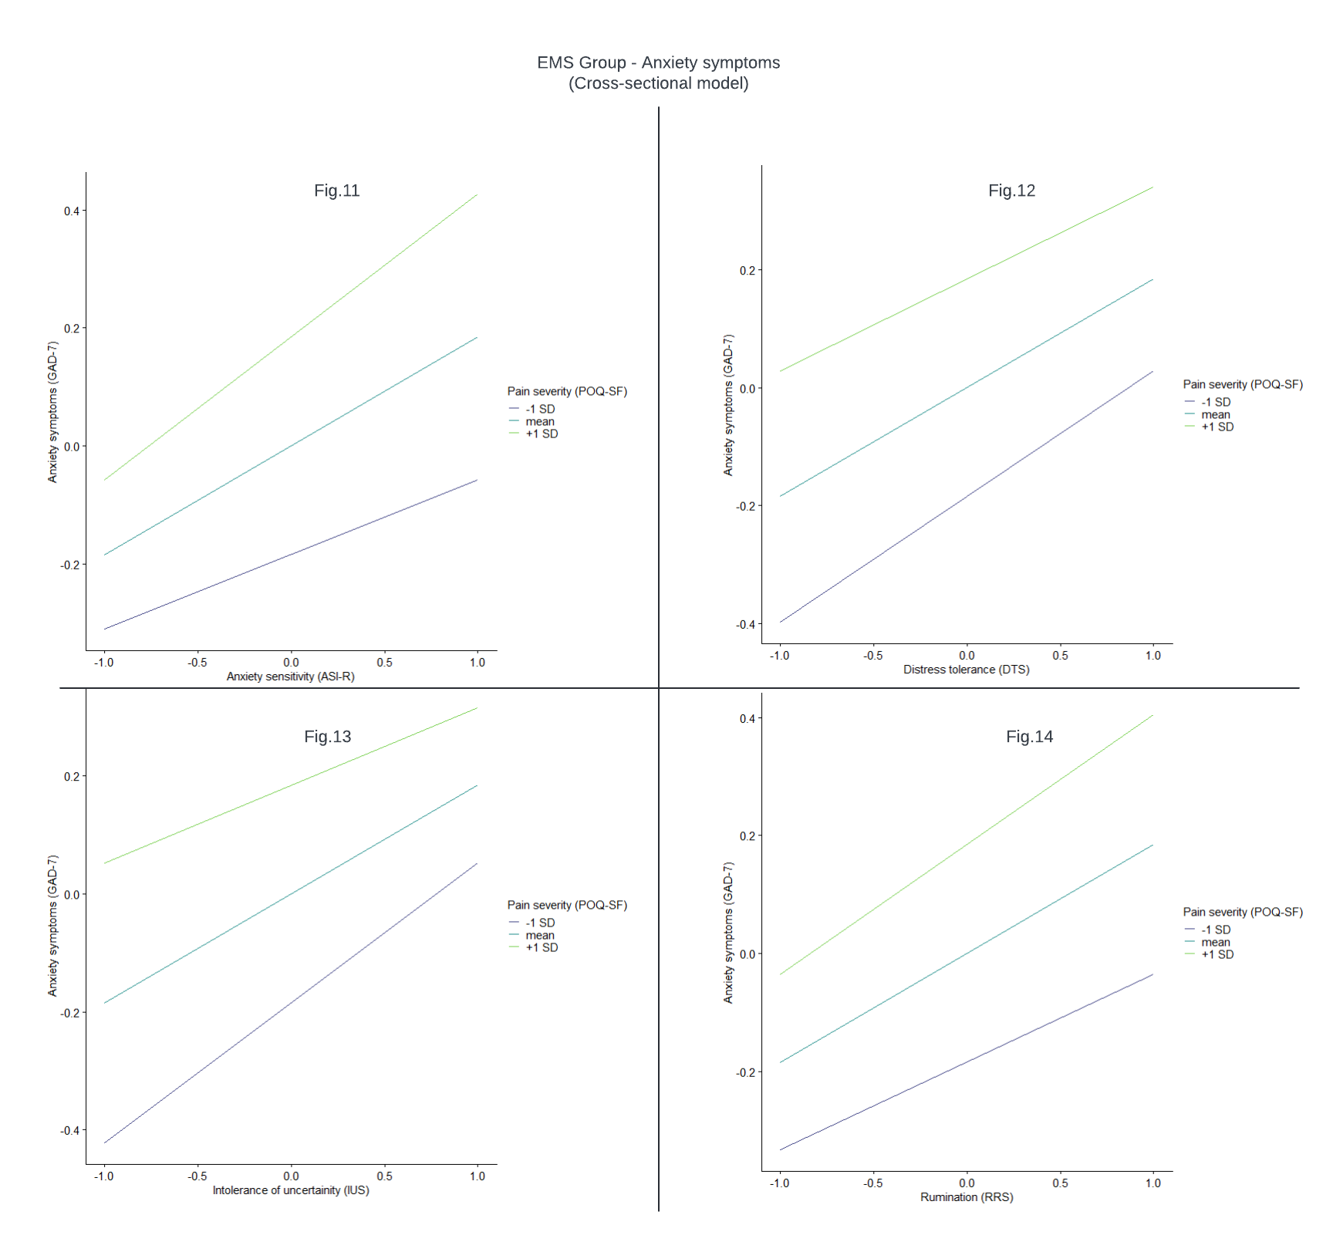

Figures S15-18. Interactions plot illustrating the moderation effects of pain severity (POQ-SF) on the cross-sectional relationships between cognitive factors and depressive symptoms in the EMS group.
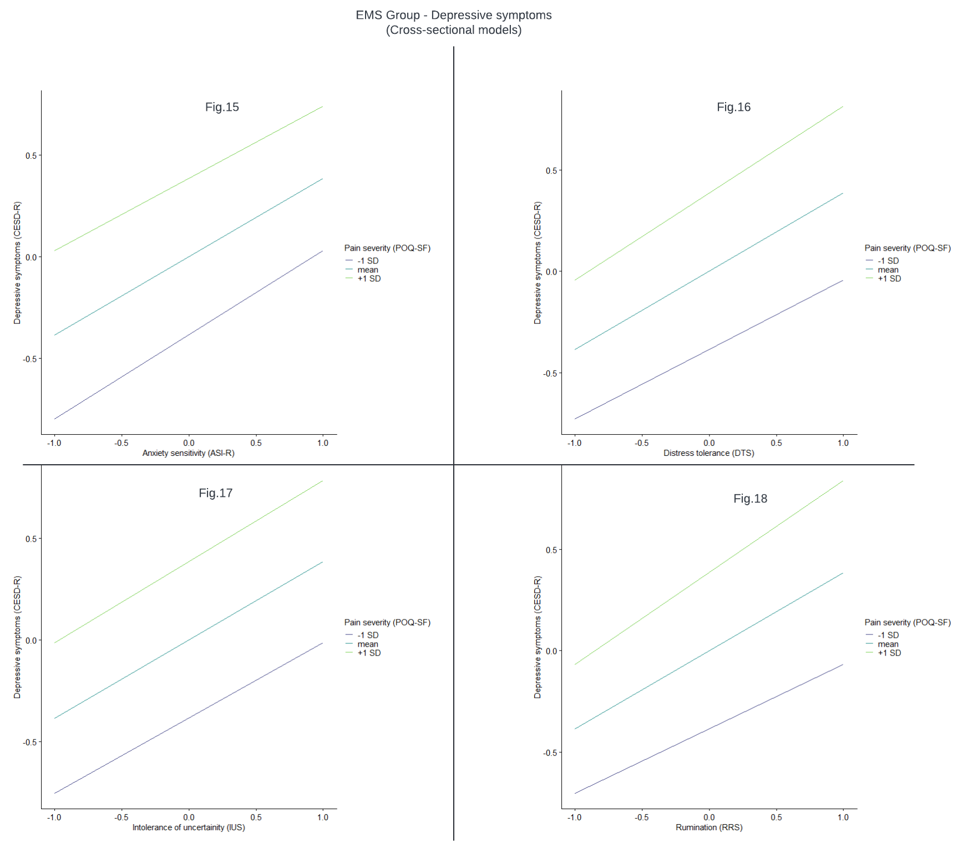

Figures S19-22. Interactions plot illustrating the moderation effects of gait-disability level (SRDSS) on the longitudinal relationships between cognitive factors and anxiety symptoms in the MS group.
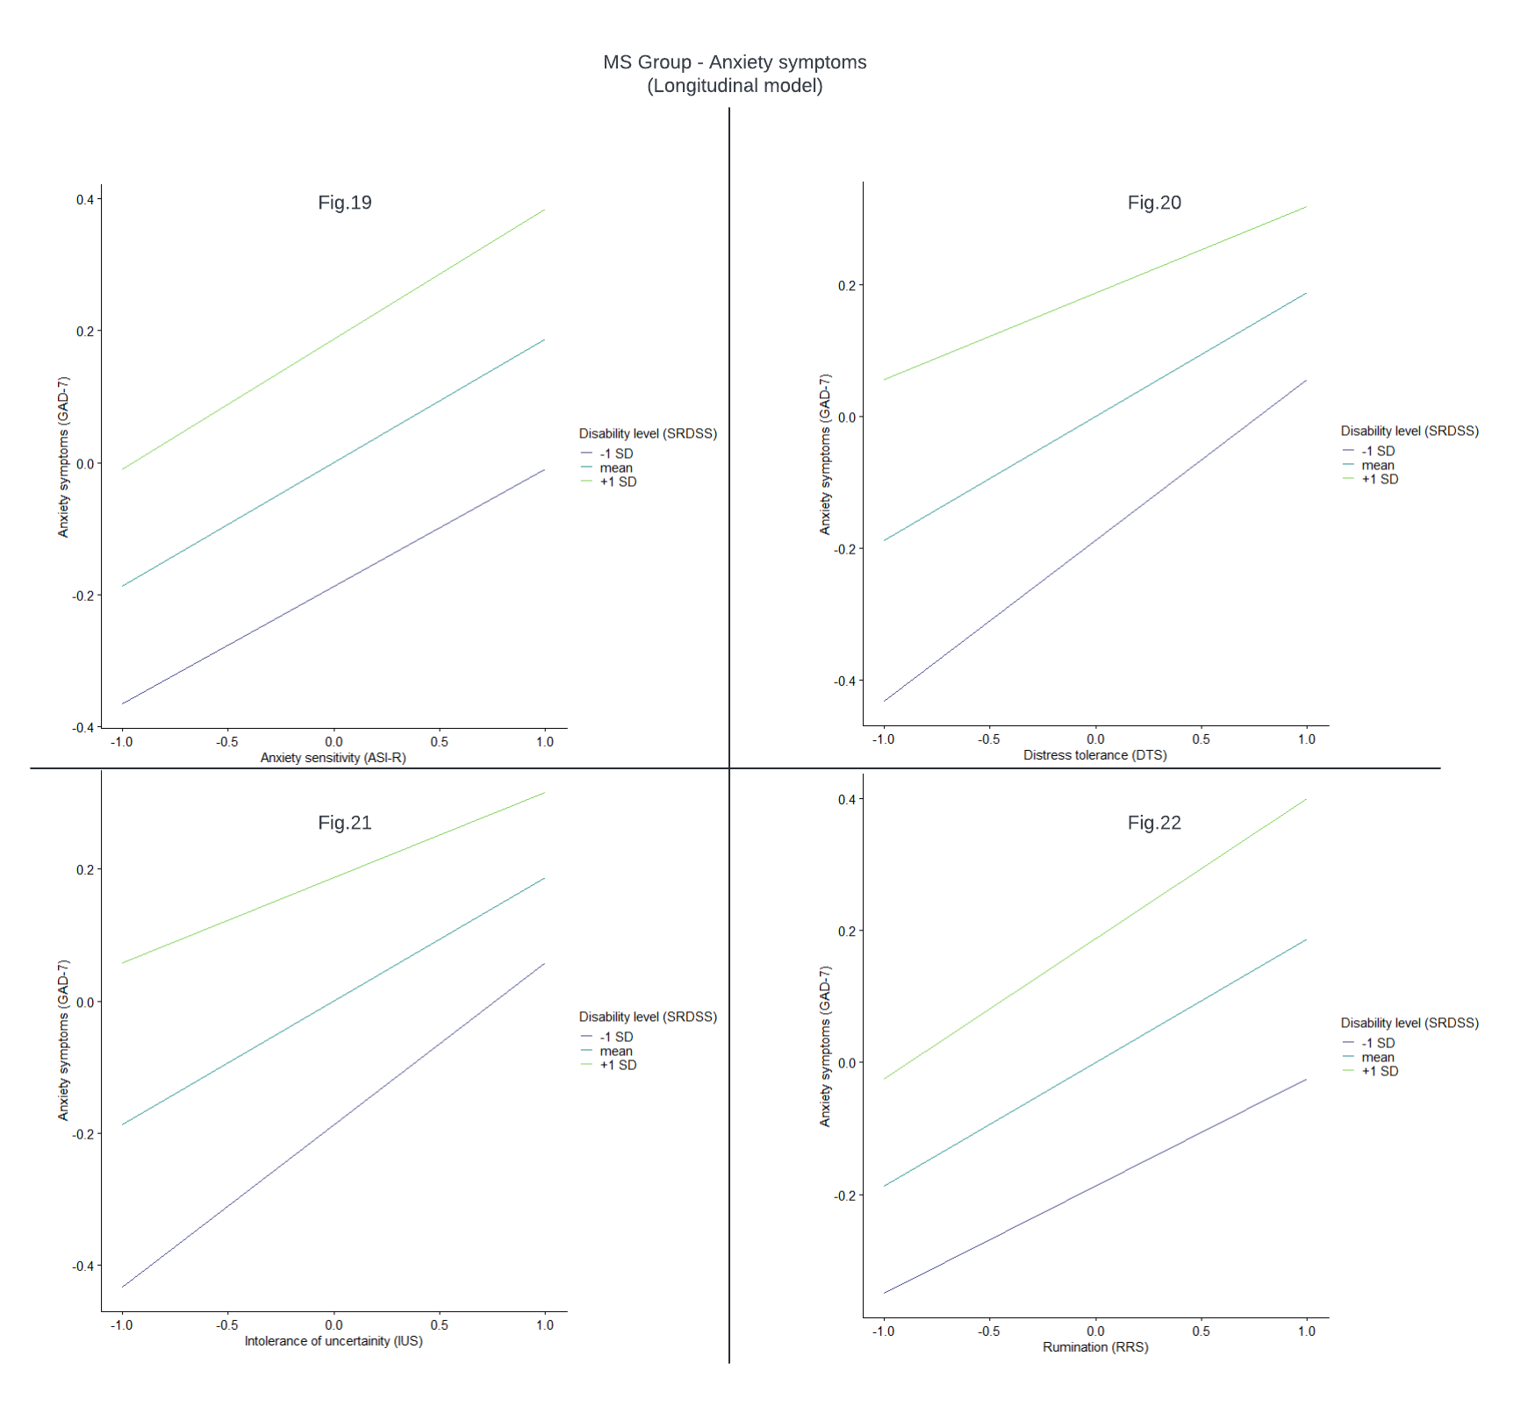

Figures S23-26. Interactions plot illustrating the moderation effects of gait-disability level (SRDSS) on the longitudinal relationships between cognitive factors and depressive symptoms in the MS group.
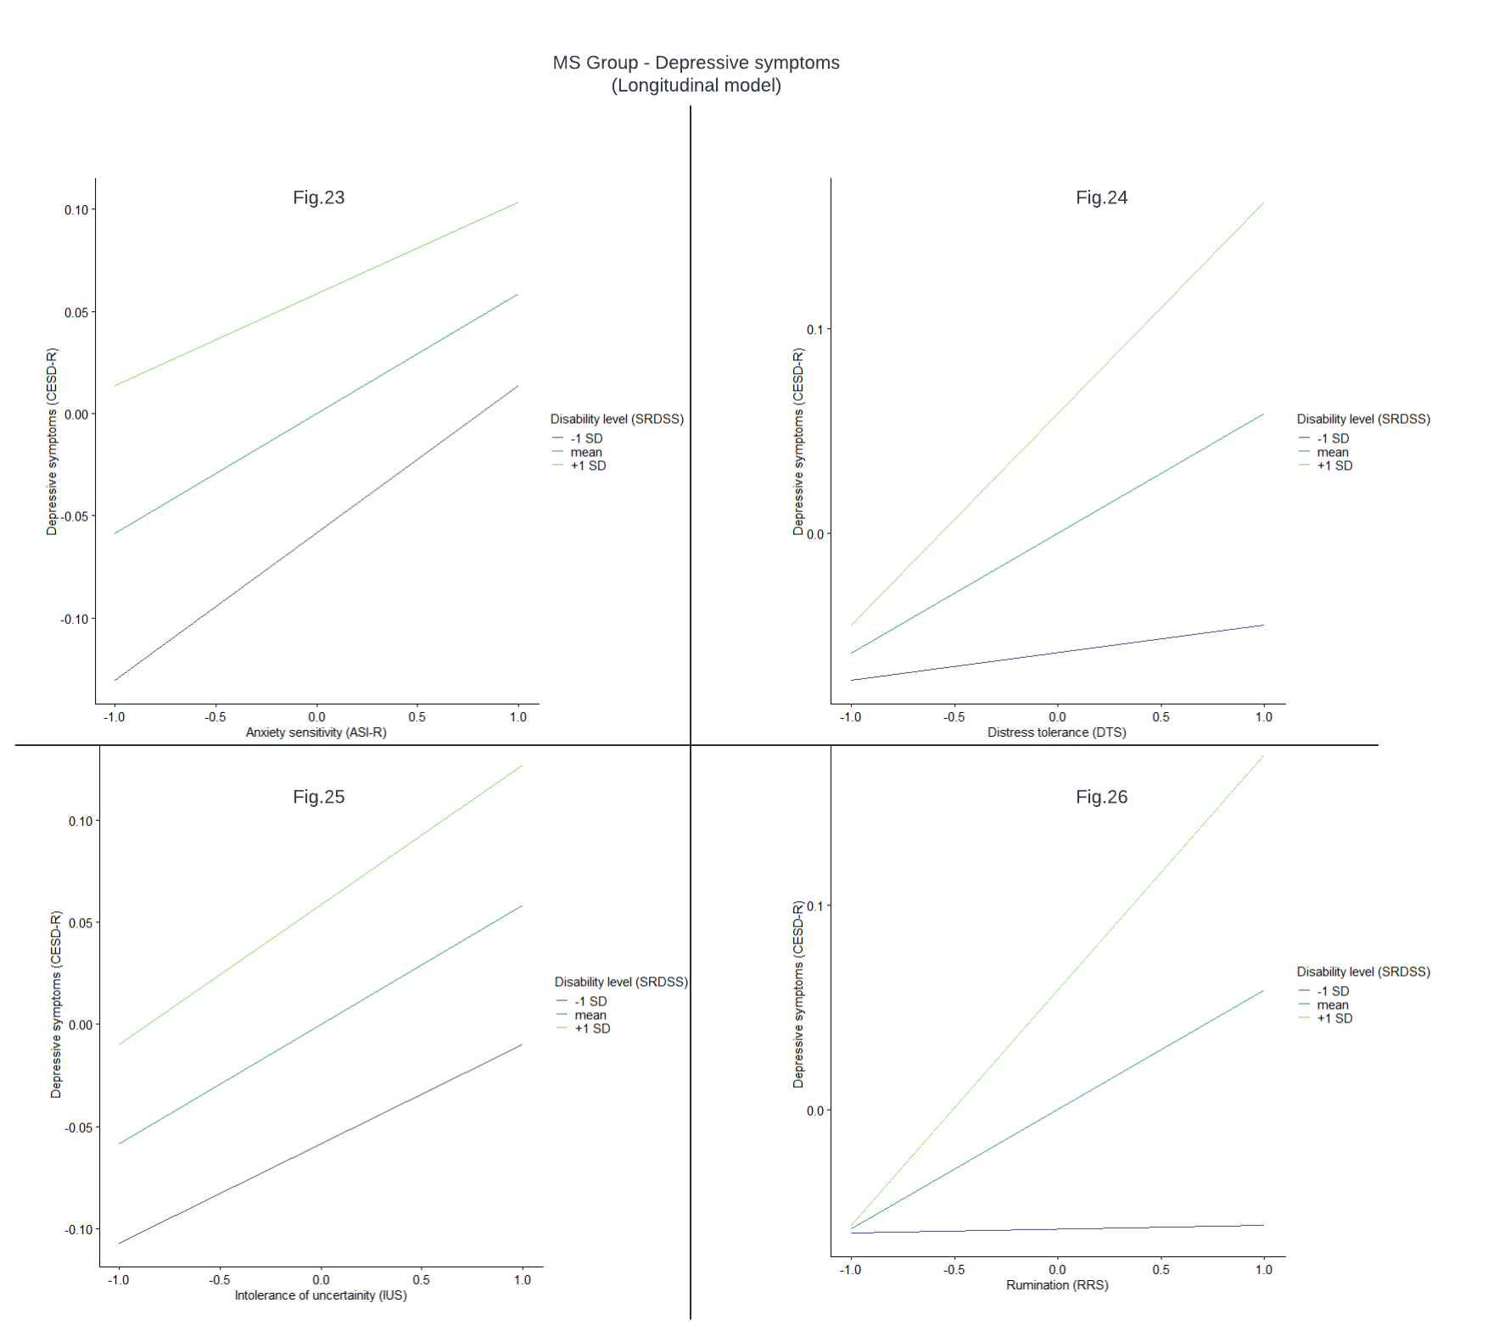

Figures S27-30. Interactions plot illustrating the moderation effects of pain severity (POQ-SF) on the longitudinal relationships between cognitive factors and anxiety symptoms in the EMS group.
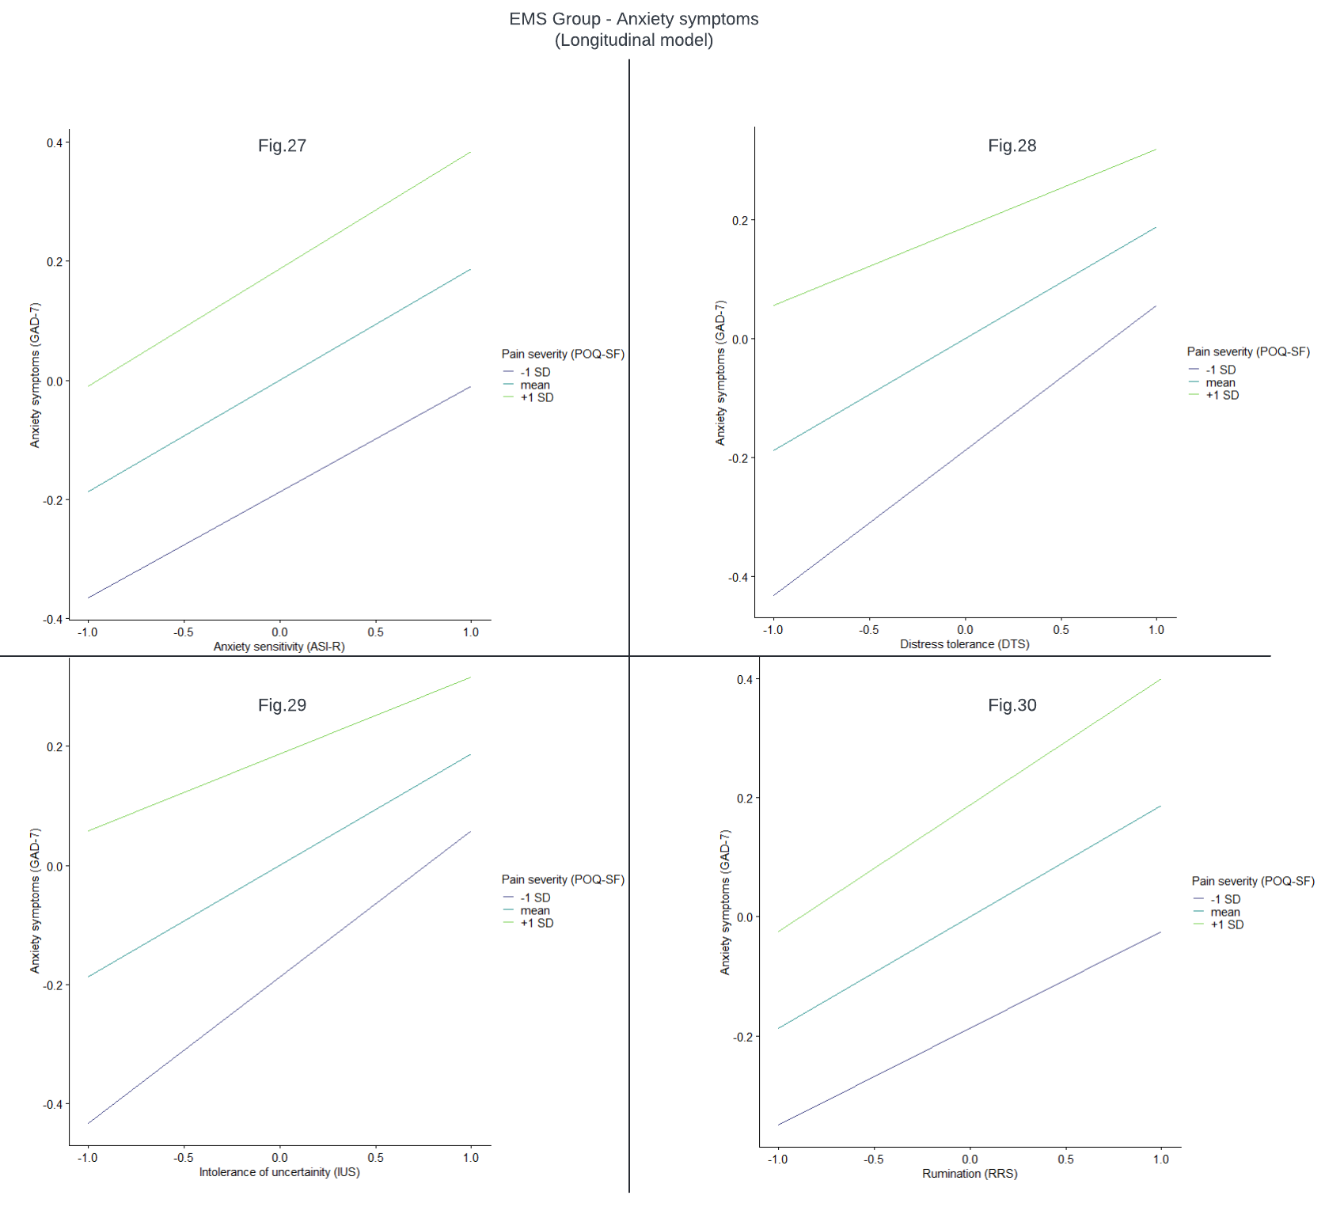

Figures S31-34. Interactions plot illustrating the moderation effects of pain severity (POQ-SF) on the longitudinal relationships between cognitive factors and depressive symptoms in the EMS group.
