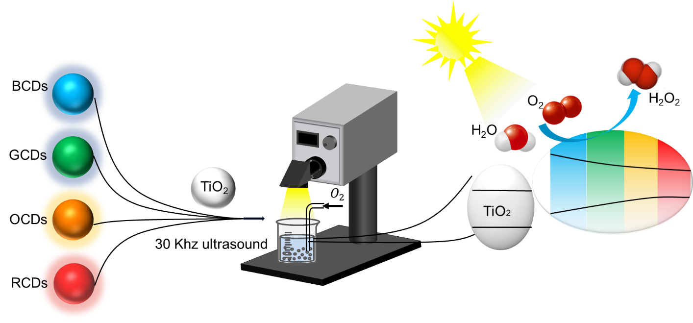

Scheme 1. Schematic illustration of the preparation process for CDs-TiO₂ photocatalysts.

