Supporting Information
Carbon-Dot-Modified TiO₂: Enhanced H₂O₂ Generation Through Synergistic Free Radical and Singlet Oxygen Mechanisms

Song Zhang^{1, #}, Jiaojiao Li¹, Bing Liu^{1, *}, Haiguang Zhao¹, Yuanyuan Zhang¹, Xiaoli yang¹, Yuanming Zhang¹, Zhan Jiang¹
1 College of Materials Science and Engineering, College of Textiles and Clothes, College of Physics, State Key Laboratory of Bio-Fibers and Eco-Textiles, Qingdao University, No. 308 Ningxia Road, Qingdao 266071, P. R. China.
*Corresponding authors. E-mail: liubingo@qdu.edu.cn

Supporting Figures

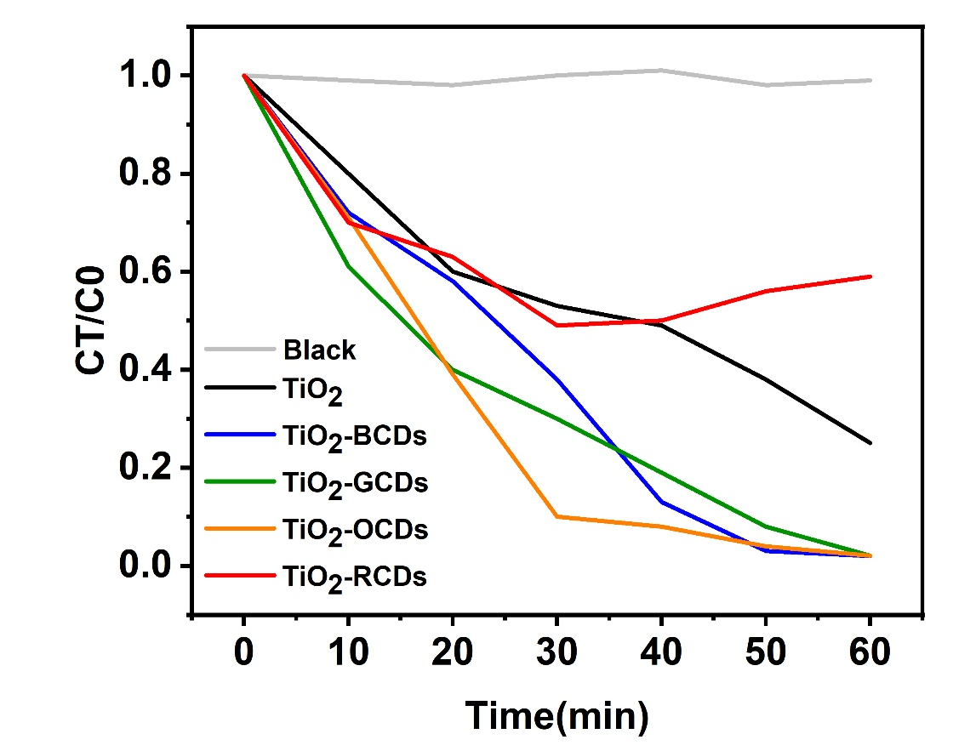

Figure S1. Methyl Orange Degradation Using TiO₂ and CD-Modified TiO₂

(a)

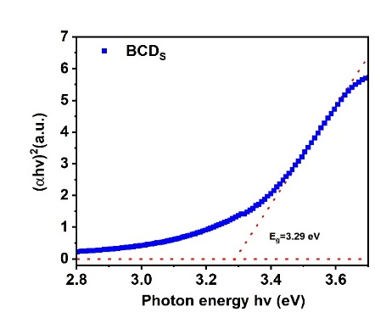
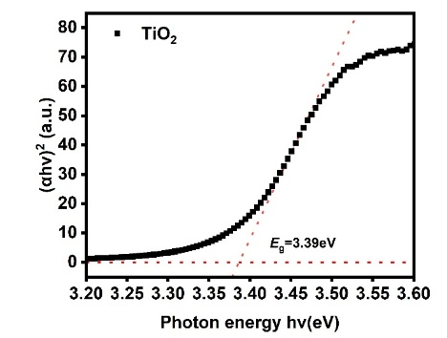
(b)

(c)

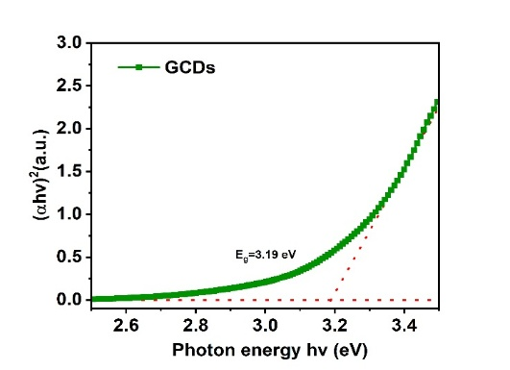
(d)

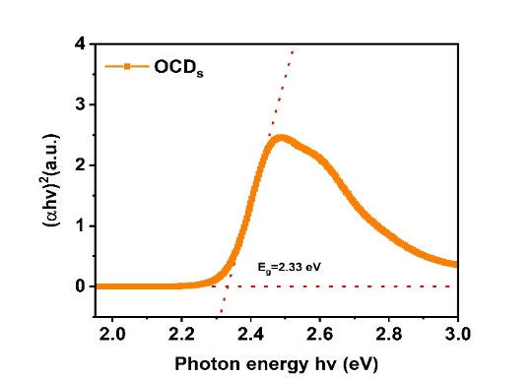

(e)

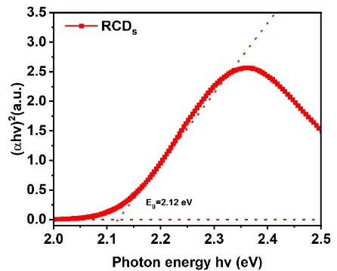

Figure S2. (a-e) Band gap calculation of TiO₂ and CDs-TiO₂ via Tauc equation

(a)

(b)

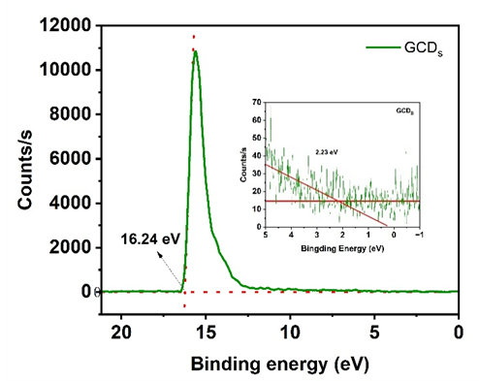
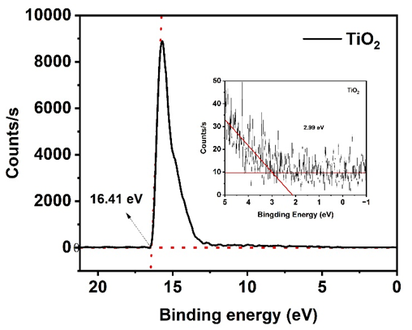
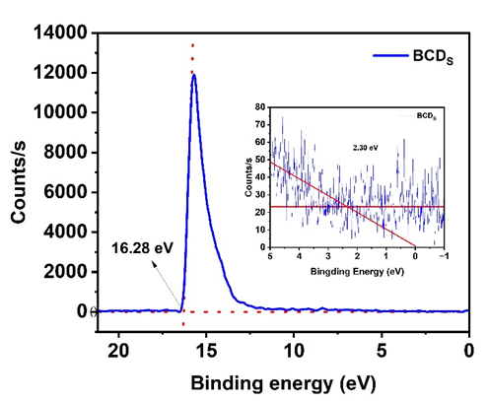
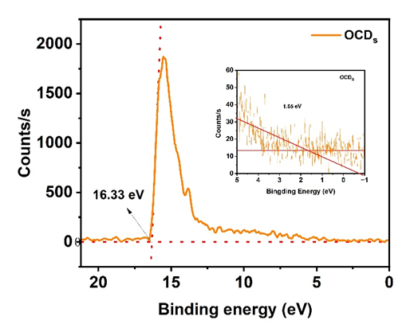

(d)

(c)

(e)

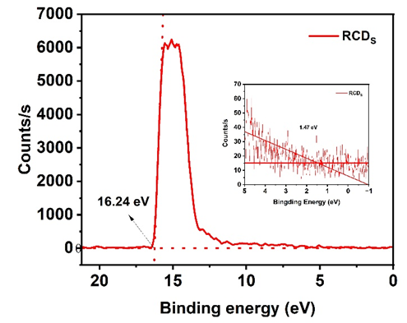

Figure S3. (a-e) UPS spectra of TiO₂ and four different CDs-TiO₂ composites

Supporting Experimental Section

Photocatalytic H₂O₂ Production Experiment
The prepared photocatalyst was added to 100 mL of 10% ethanol/water (v/v) solution, and the mixture was bubbled with O₂ for 30 min to achieve O₂ adsorption/desorption equilibrium in the dark. Subsequently, the reaction solution was exposed to a 300 W xenon arc lamp for 1 hour of irradiation. Every 10 minutes after irradiation, barium carbonate was added to agglomerate TiO₂ and CDs-TiO₂. After that, 1 mL of the solution was collected using a syringe through a 0.45 μm Millipore filter.
The filtered reaction solution was mixed with 1 mL of 0.1 mol·L⁻¹ C₈H₅KO₄ solution and 1 mL of 0.4 mol·L⁻¹ KI solution. The mixture was allowed to react for 30 min, and then subjected to ultraviolet-visible (UV-Vis) spectroscopy analysis.

