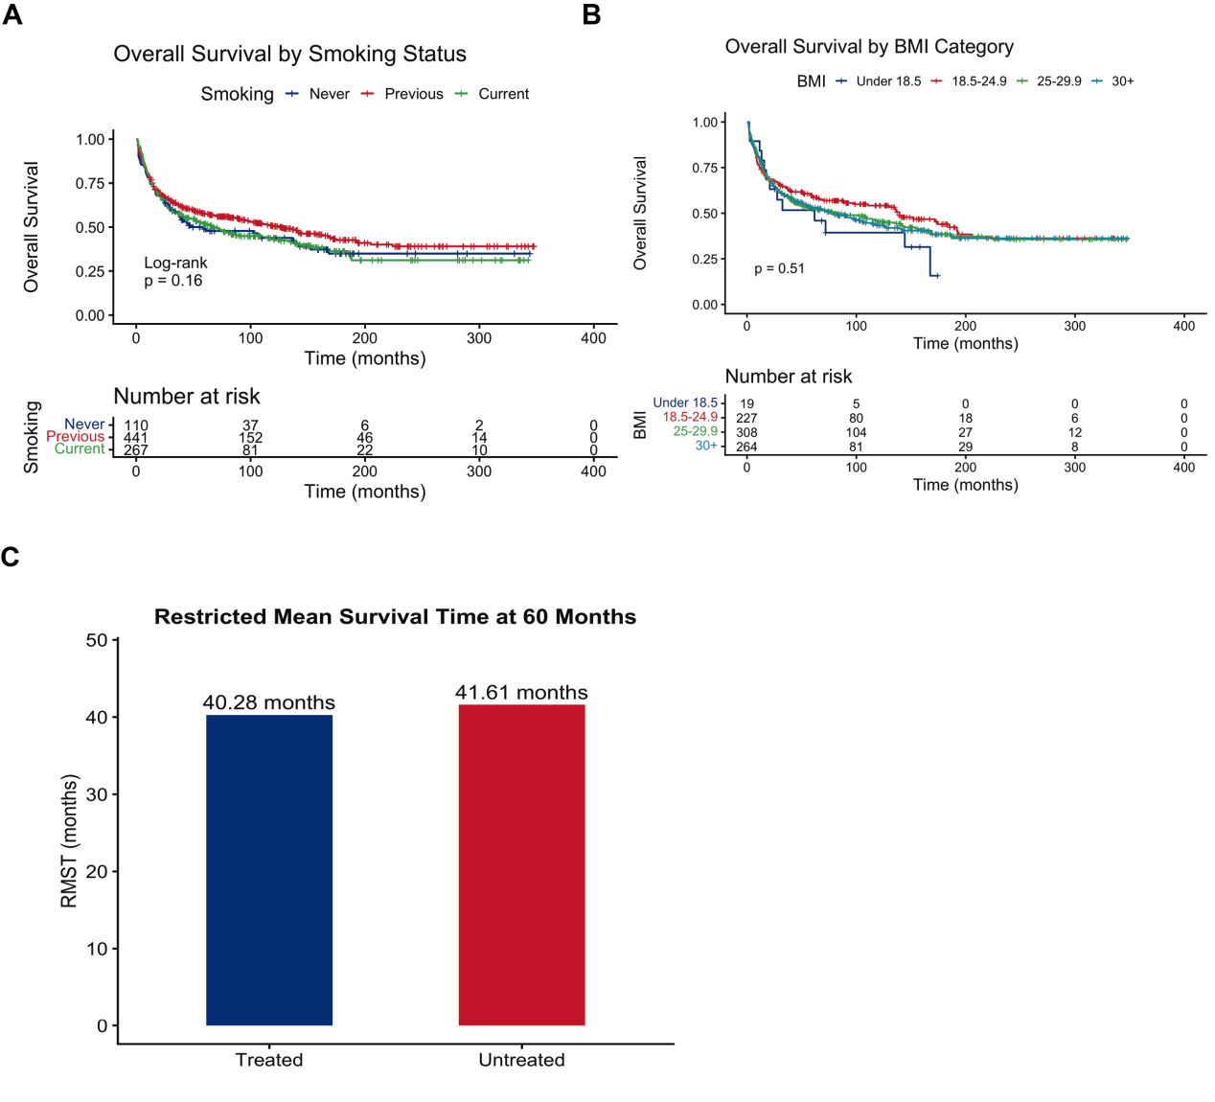
Figure S1. Additional survival analyses in the UK Biobank cohort.
(A) Kaplan–Meier curves for overall survival stratified by smoking status.
(B) Kaplan–Meier curves for overall survival stratified by BMI categories.
(C) Restricted mean survival time (RMST) at 60 months comparing treated and untreated groups.
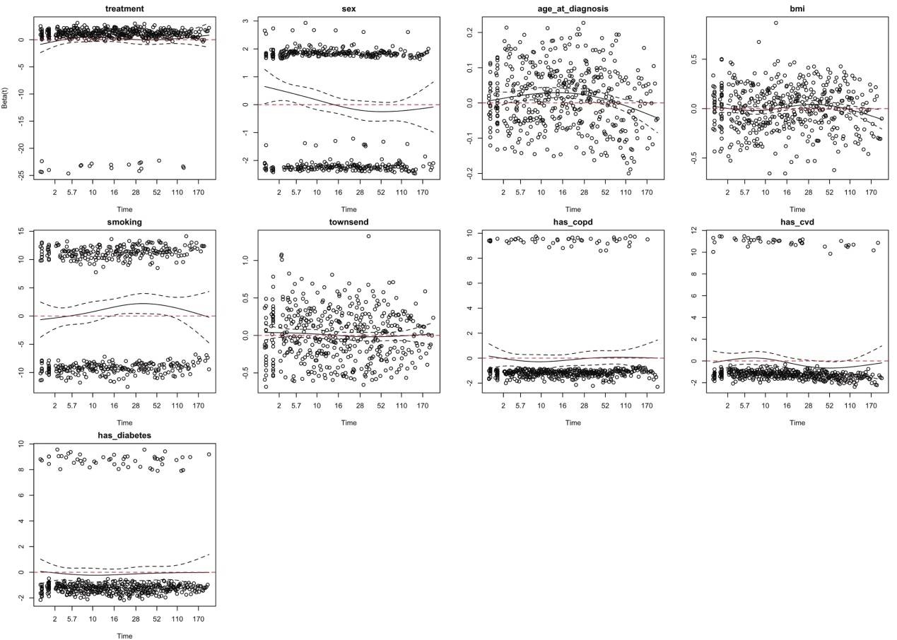
Figure S2. Assessment of proportional hazards assumption.
Schoenfeld residual plots for covariates included in the multivariable Cox proportional hazards model, including treatment status, sex, age at diagnosis, BMI, smoking status, Townsend deprivation index, COPD, cardiovascular disease, and diabetes.

