Online Supplements for：
Two Sides of the Same Coin: Uncovering Differential Roles of Cognitive and Affective Empathy in Adolescent Multidimensional Well-Being Network

List of Appendix Contents:
- Table S1. Centrality indices of the empathy network in study1
- Table S2. Centrality indices of the item-level empathy network in study1
- Table S3. Edge coefficients of key variables of item-level empathy network in Study 1
- Table S4. Confirmatory Factor Analysis in Study 2
- Table S5. Model comparisons in Study 2
- Table S6. Model comparisons in Study 2
- Table S7. Centrality indices of the cognitive empathy and well-being network in study2
- Table S8. Centrality indices of the affective empathy and well-being network in study2
- Figure S1. Accuracy and stability estimation of empathy network in study 1
- Figure S2. Cross-sectional network analysis of item-level empathy
- Figure S3. Accuracy and stability estimation of item-level empathy network in study 1

Table S1. Centrality indices of the empathy network in study1.

Variables | Expected Influence
Autonomy | -0.891
Clear Thinking | -0.128
Competence | 1.134
Emotional Stability | -0.576
Empathy | -2.688
Engagement | 0.873
Meaning | 0.152
Optimism | 1.422
Positive Emotions | 0.808
Positive Relationships | -0.742
Prosocial Behavior | 0.372
Resilience | -0.259
Self-Acceptance | 0.013
Self-Esteem | 0.247
Vitality | 0.263

Table S2. Centrality indices of the item-level empathy network in study1.
Variables | Expected Influence
Autonomy | -0.565
Clear Thinking | 0.165
Competence | -0.387
Emotional Stability | -0.221
Empathy_Item 1 | -0.768
Empathy_Item 2 | -1.971
Empathy_Item 3 | -2.423
Empathy_Item 4 | 0.919
Engagement | 0.263
Meaning | 0.731
Optimism | -0.149
Positive Emotions | -0.069
Positive Relationships | -0.565
Prosocial Behavior | 0.165
Resilience | -0.387
Self-Acceptance | -0.221
Self-Esteem | -0.768
Vitality | -1.971
Note: Empathy_Item 1 = ”My heart goes out to people who are unhappy.”; Empathy_Item 2 = ”I feel others’ emotions.”; Empathy_Item 3 = ”Other people’s misfortunes usually disturb me a great deal.”; Empathy_Item 4 = ”I easily get caught up in other people’s feelings.”.

Table S3. Edge coefficients of key variables of item-level empathy network in Study 1.
 | AU | CT | CO | ES | EN | ME | OP | PE | PR | PB | RE | SA | SE | VI
Empathy_Item1 | – | 0.034 | – | – | 0.038 | – | – | – | 0.085 | 0.293 | – | – | – | 0.002
Empathy_Item2 | 0.008 | 0.098 | 0.020 | 0.016 | 0.023 | 0.007 | – | -0.011 | 0.120 | 0.164 | – | 0.030 | 0.009 | –
Empathy_Item3 | – | – | – | – | – | – | – | -0.025 | – | 0.119 | 0.031 | -0.020 | -0.004 | –
Empathy_Item4 | – | -0.038 | 0.010 | -0.023 | – | -0.007 | -0.023 | – | 0.022 | 0.072 | -0.032 | -0.014 | 0.014 | -0.002
Note: Only non-zero edges retained by the LASSO are displayed in the table. In the study 2, black represent the edges parameters from empathy to other well-being variables, and and red represent edges parameters in the opposite direction.
Empathy_Item1 = ”My heart goes out to people who are unhappy.”; Empathy_Item2 = ”I feel others’ emotions.”; Empathy_Item3 = ”Other people’s misfortunes usually disturb me a great deal.”; Empathy_Item4 = ”I easily get caught up in other people’s feelings.

Table S4. Confirmatory Factor Analysis in Study 2.
Model | $${\text{χ²}}/{\text{df}}$$ | CFI | TLI | RMSEA | SRMR
T1_Single-Factor Model (Model 1) | 6.464 | 0.910 | 0.888 | 0.096 | 0.072
T1_ Two-Factor Model (Model 2) | 3.549 | 0.961 | 0.948 | 0.066 | 0.047
T2_Single-Factor Model (Model 1) | 11.389 | 0.867 | 0.834 | 0.133 | 0.085
T2_Two-Factor Model (Model 2) | 3.079 | 0.976 | 0.967 | 0.060 | 0.044

Table S5. Model comparisons in Study 2.
Sample of Time 1
Model | df | AIC | BIC | Chisq | Chisq diff | RMSEA diff | df diff | Pr(>Chisq)
Single-Factor Model | 41 | 23586 | 23696 | 145.52 | – | – | – | –
Two-Factor Model | 44 | 23719 | 23816 | 284.42 | – | – | – | –
Model diff | – | – | – | – | 138.9​ | 0.2778 | 3 | < 2.2e-16 ***
Note: *** p < 0.001.

Table S6. Model comparisons in Study 2.
Sample of Time 2
Model | df | AIC | BIC | Chisq | Chisq diff | RMSEA diff | df diff | Pr(>Chisq)
Single-Factor Model | 39 | 22547 | 22665 | 120.10 | – | – | – | –
Two-Factor Model | 44 | 22918 | 23015 | 501.13 | – | – | – | –
Model diff | – | – | – | – | 381.03 | 0.35794 | 5 | < 2.2e-16 ***
Note: *** p < 0.001.

Table S7. Centrality indices of the cognitive empathy and well-being network in study2.
Variables | Out-Prediction | In-Prediction
Autonomy | 0.174 | 0.094
Clear Thinking | 0.030 | 0.137
Competence | 0.000 | 0.316
Emotional Stability | 0.041 | 0.076
Cognitive Empathy | 0.009 | 0.057
Engagement | 0.010 | 0.355
Meaning | 0.023 | 0.189
Optimism | 0.192 | 0.177
Positive Emotions | 0.004 | 0.209
Positive Relationships | 0.008 | 0.132
Prosocial Behavior | 0.050 | 0.014
Resilience | 0.002 | 0.260
Self-Acceptance | 0.005 | 0.329
Self-Esteem | 0.019 | 0.227
Vitality | 0.101 | 0.174

Table S8. Centrality indices of the affective empathy and well-being network in study2.
Variables | Out-Prediction | In-Prediction
Autonomy | 0.182 | 0.098
Clear Thinking | 0.028 | 0.158
Competence | 0.000 | 0.301
Emotional Stability | 0.052 | 0.076
Affective Empathy | 0.029 | 0.051
Engagement | 0.014 | 0.362
Meaning | 0.023 | 0.182
Optimism | 0.184 | 0.153
Positive Emotions | 0.008 | 0.211
Positive Relationships | 0.011 | 0.144
Prosocial Behavior | 0.089 | 0.011
Resilience | 0.006 | 0.280
Self-Acceptance | 0.008 | 0.378
Self-Esteem | 0.025 | 0.226
Vitality | 0.106 | 0.182

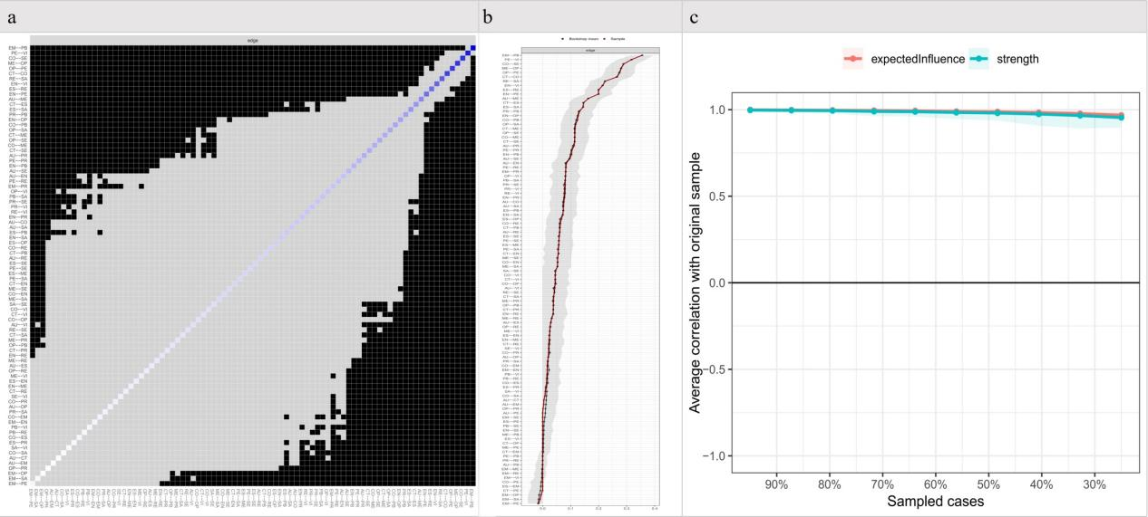
Figure S1. Accuracy and stability estimation of empathy network in study 1.(a) Nonparametric bootstrapped difference test for edges. Gray boxes indicate no significant difference, whereas black boxes indicate statistically significant difference (p < 0.05). Diagonal values represent the strength score of each node. (b) The confidence intervals around the edge-weight estimates. (c) Average correlation with the original sample.
Note: Symptom label descriptions: AU = Autonomy; CT = Clear Thinking; CO = Competence; ES = Emotional Stability; EM = Empathy; EN = Engagement; ME = Meaning; OP = Optimism; PE = Positive Emotions; PR = Positive Relationships; PB = Prosocial Behavior; RE = Resilience; SA = Self-Acceptance; SE = Self-Esteem; VI = Vitality.

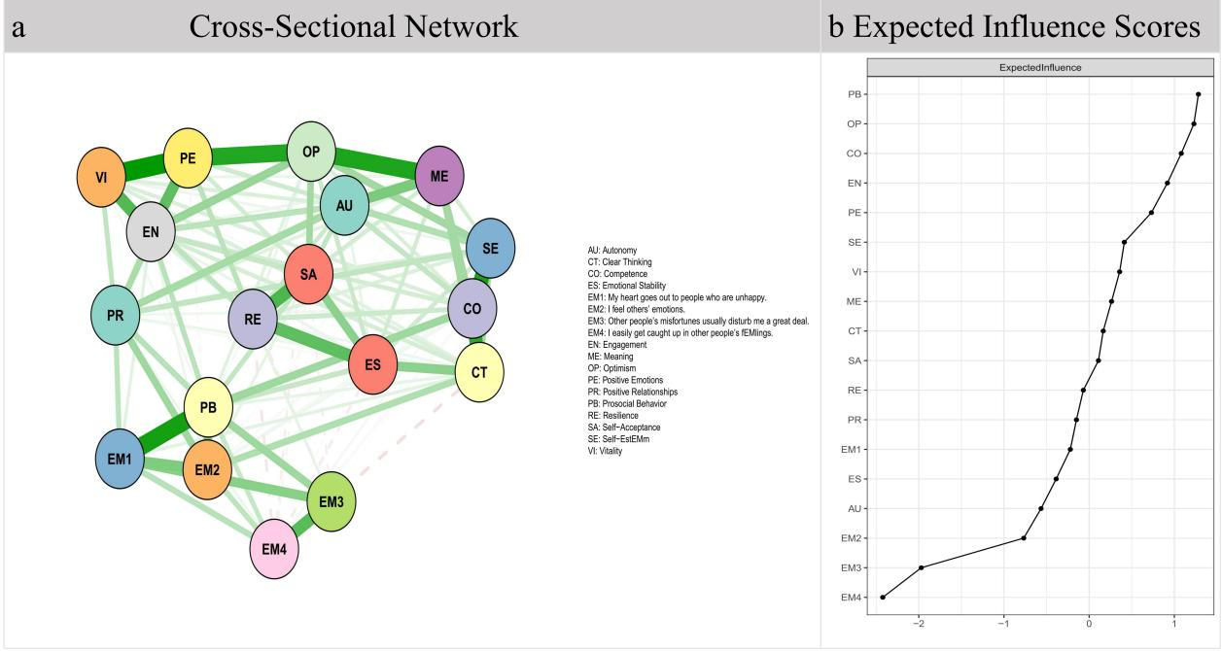
Figure S2. Cross-sectional network analysis of item-level empathy.
Note: (a) Cross-sectional network of item-level empathy networks and other Well-Being nodes. (b) The expected influence centrality indices, shown as standardized z scores.

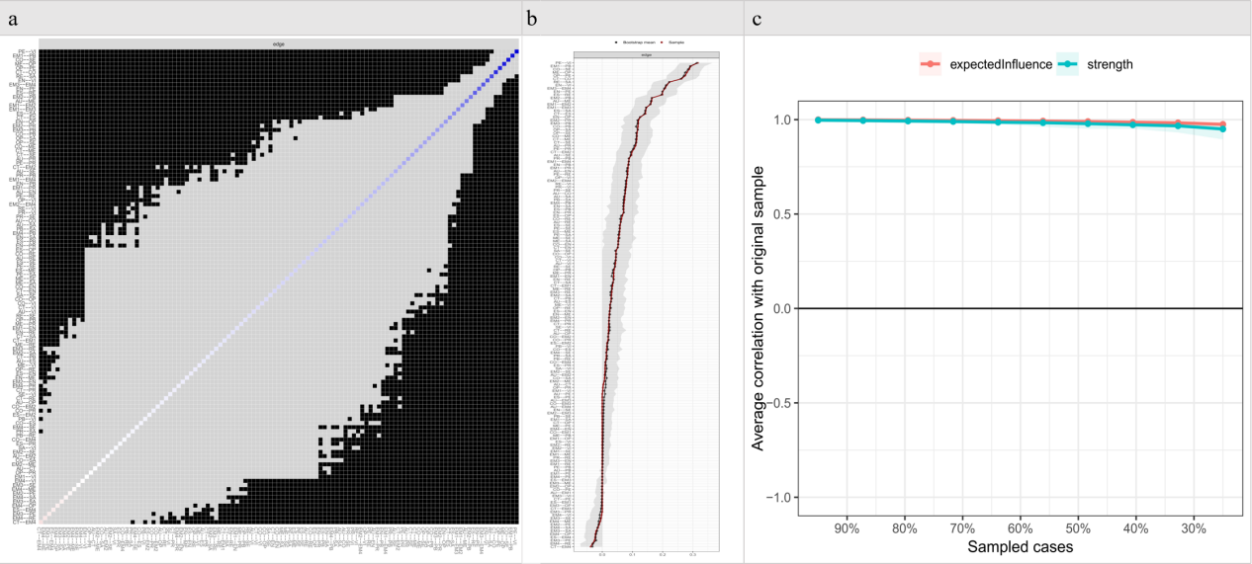
Figure S3. Accuracy and stability estimation of item-level empathy network in study 1. (a) Nonparametric bootstrapped difference test for edges. Gray boxes indicate no significant difference, whereas black boxes indicate statistically significant difference (p < 0.05). Diagonal values represent the strength score of each node. (b) The confidence intervals around the edge-weight estimates. (c) Average correlation with the original sample.
Note: Symptom label descriptions: AU = Autonomy; CT = Clear Thinking; CO = Competence; ES = Emotional Stability; EM = Empathy; EN = Engagement; ME = Meaning; OP = Optimism; PE = Positive Emotions; PR = Positive Relationships; PB = Prosocial Behavior; RE = Resilience; SA = Self-Acceptance; SE = Self-Esteem; VI = Vitality.

