Supplementary Material
Table 1. Univariate associations with all-cause mortality after kidney transplantation

 | HR | 95%-CI | p
recipient age >65y | 3.333 | 1.854;5.992 | <0.001
donor age >65y | 3.537 | 1.867;6.721 | <0.001
deceased donation | 3.051 | 1.093;8.519 | 0.033
ESP | 3.420 | 1.893;6.176 | <0.001
diabetic nephropathy | 1.248 | 0.646;2.412 | 0.510
in-patient days > 20 | 4.027 | 2.110;7.685 | <0.001
delayed graft function | 1.834 | 1.002;3.356 | 0.049
antibacterial therapy | 0.653 | 0.360;1.184 | 0.161
ICU admission due to bacterial infection | 6.019 | 2.921;12.402 | <0.001
fungal infection | 2.793 | 1.511;5.164 | 0.001
Candida albicans | 1.822 | 0.562;5.908 | 0.317
Candida non albicans | 1.440 | 0.347;5.975 | 0.616
Aspergillus fumigatus | 4.896 | 2.050;11.693 | 0.049
Pneumocystis jirovecii | 1.706 | 0.409;7.117 | 0.463
Univariate Cox proportional hazards models assessing associations between recipient and donor characteristics, perioperative factors, infectious complications, and all-cause mortality.
Hazard ratios (HRs) with 95% confidence intervals (CI) and corresponding p values are shown.
Abbreviations: HR = Hazard ratio, 95%-CI = 95% confidence interval, ESP = Eurotransplant Senior Program, ICU = intensive care unit

Figure 1
Most frequently administered antibacterial agents prior to fungal infection, stratified by fungal pathogen. Bars indicate the proportion of patients receiving specific antibiotic classes before the diagnosis of Candida albicans, non-albicans Candida, Aspergillus fumigatus, or Pneumocystis jirovecii infection. Percentages above each group indicate the proportion of patients exposed to any antibacterial therapy prior to fungal infection.

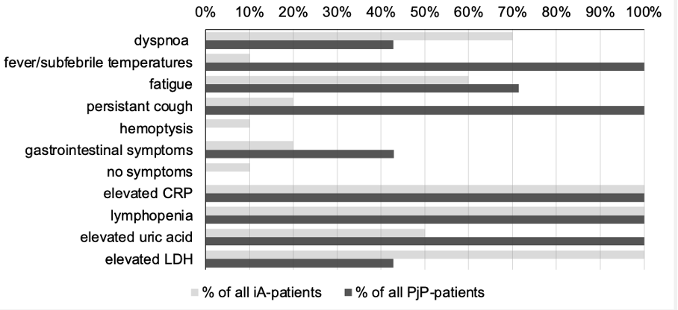
Figure 2a. Clinical presentation and laboratory abnormalities at diagnosis in renal transplant recipients with invasive aspergillosis (iA) and Pneumocystis jirovecii pneumonia (PjP) within the Heidelberg subcohort (n = 495).
Bars represent the proportion of patients presenting with individual symptoms or laboratory findings. Light gray bars indicate iA patients, and dark gray bars indicate PjP patients. CRP, C-reactive protein; LDH, lactate dehydrogenase.

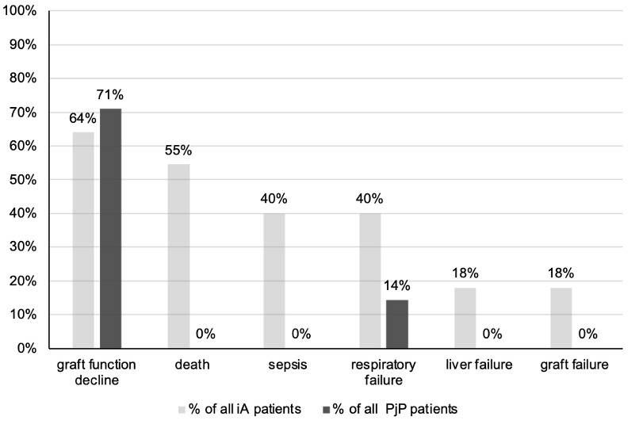
Figure 2b. Clinical outcomes in renal transplant recipients with invasive aspergillosis (iA) and Pneumocystis jirovecii pneumonia (PjP) within the Heidelberg subcohort (n = 495).
Bars represent the proportion of patients with individual outcomes, including graft function decline, death, sepsis, respiratory failure, liver failure, and graft failure. Light gray bars indicate iA patients, and dark gray bars indicate PjP patients.

