Fig. 2
Kaplan-Meier curve for Overall Survival based on surgical treatment.

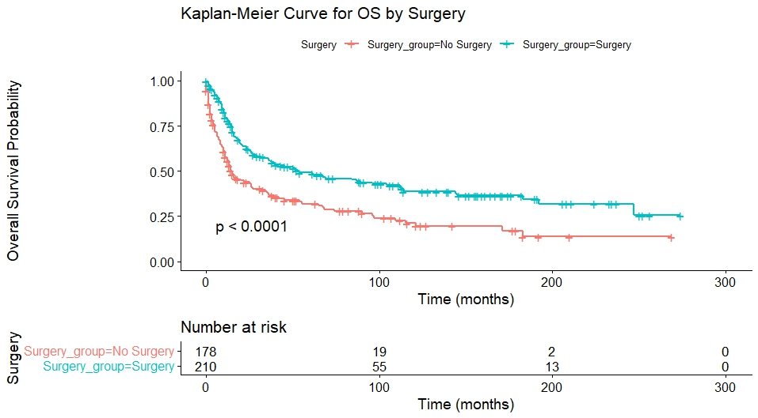

Fig. 3
Kaplan-Meier curve for Overall Survival based on adjuvant radiotherapy.

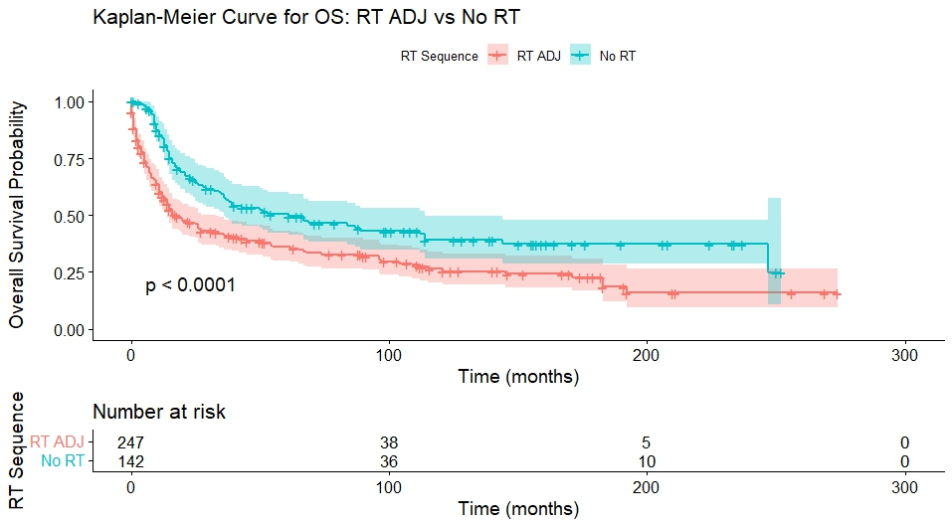

Fig.4
Kaplan-Meier curve for Overall Survival based on radiotherapy treatment.
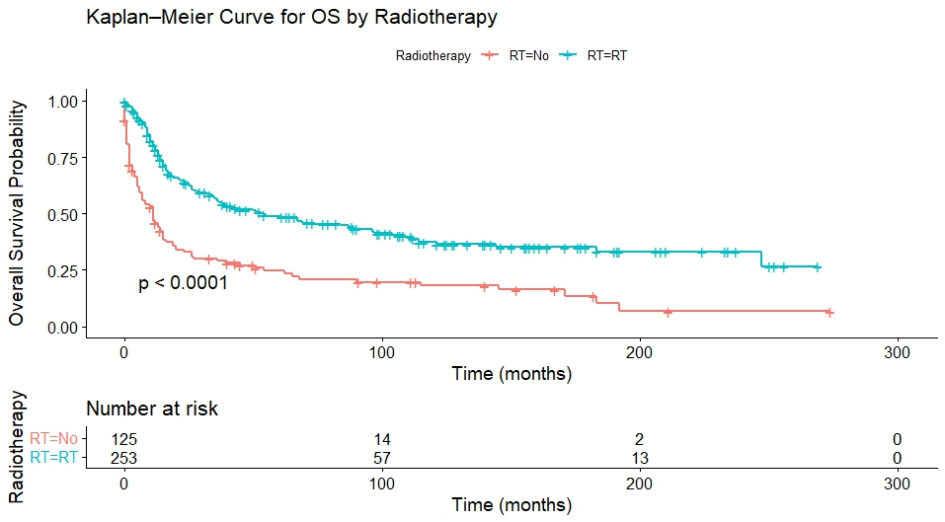

Fig. 5
Kaplan-Meier curve for Overall Survival based on marital status.

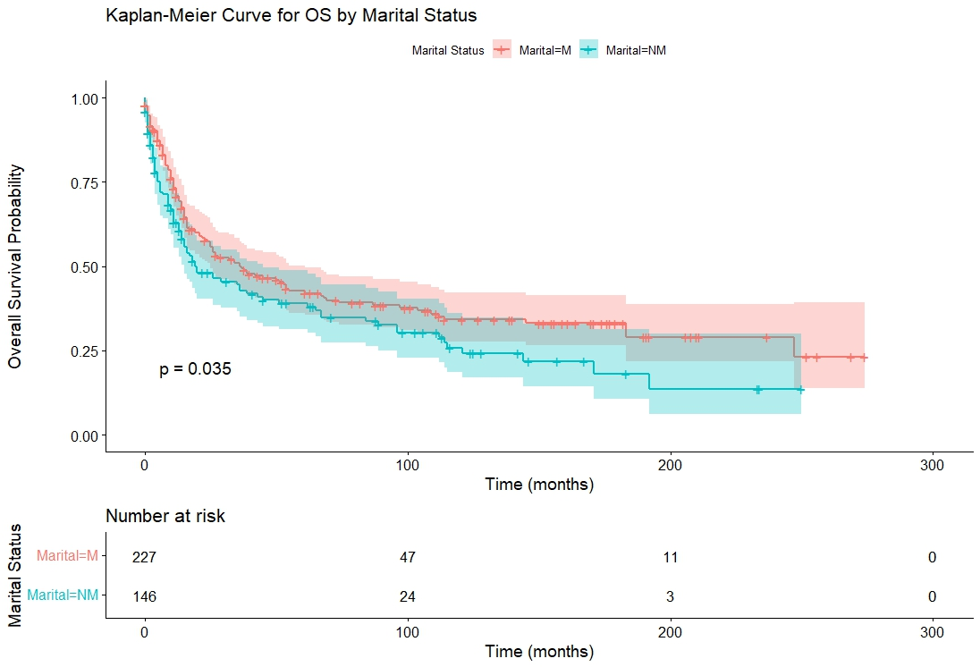

Fig. 6
Kaplan-Meier curve for Overall Survival based on grade (high grade vs low grade tumors).

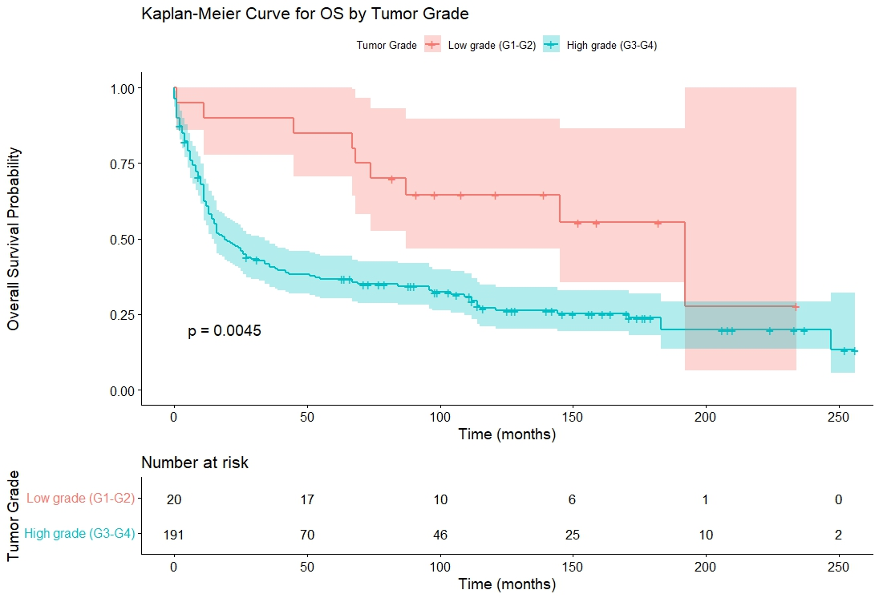

Fig. 7
Kaplan-Meier curve for Overall Survival based on chemotherapy treatment.

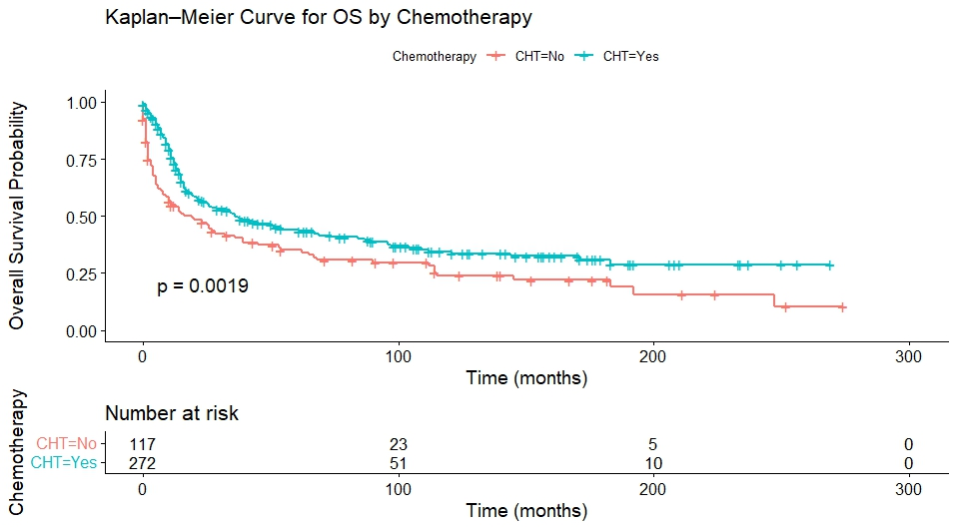

Fig. 8
Kaplan-Meier curve for Overall Survival based on adjuvant chemotherapy.

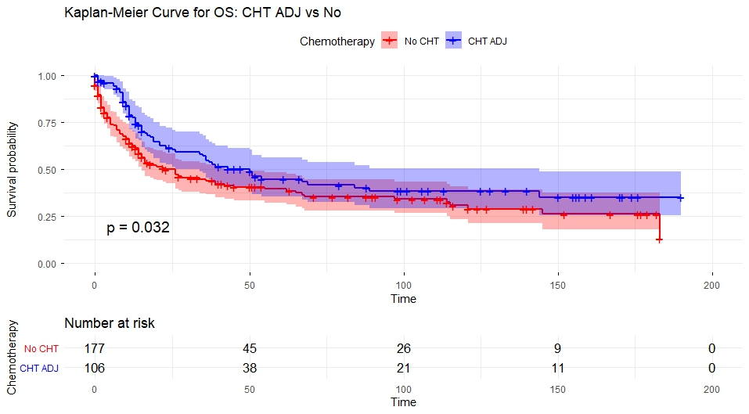

Fig. 9
Kaplan-Meier curve for Disease-Specific Survival based on surgical treatment.
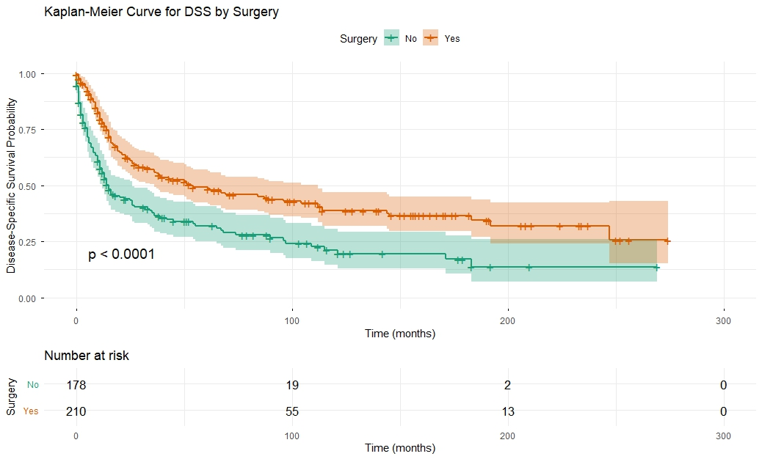

Fig. 10
Kaplan-Meier curve for Disease-Specific Survival based on radiotherapy treatment.

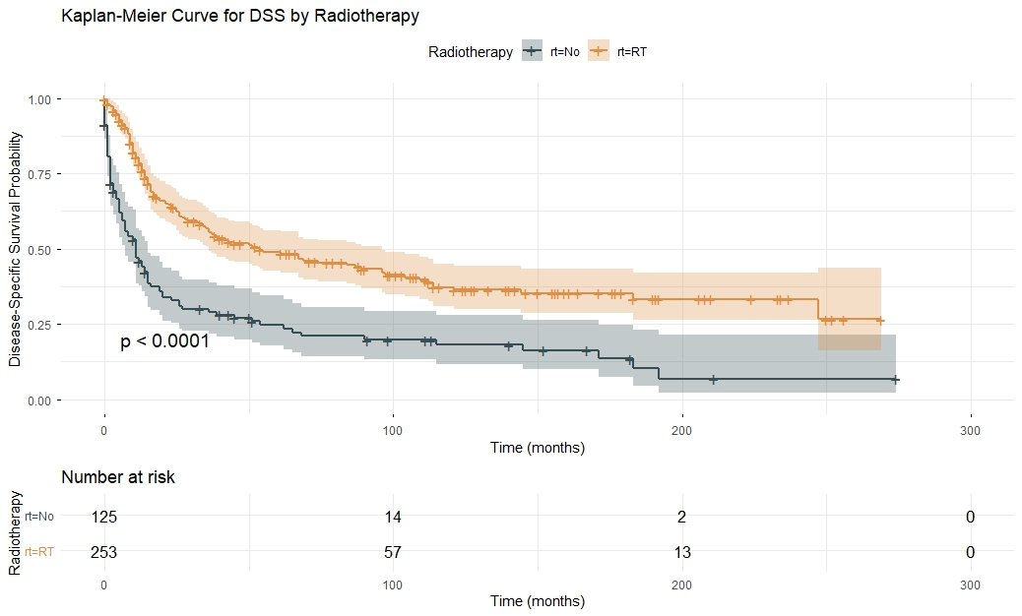

Fig. 11
Kaplan-Meier curve for Disease-Specific Survival based on adjuvant radiotherapy.

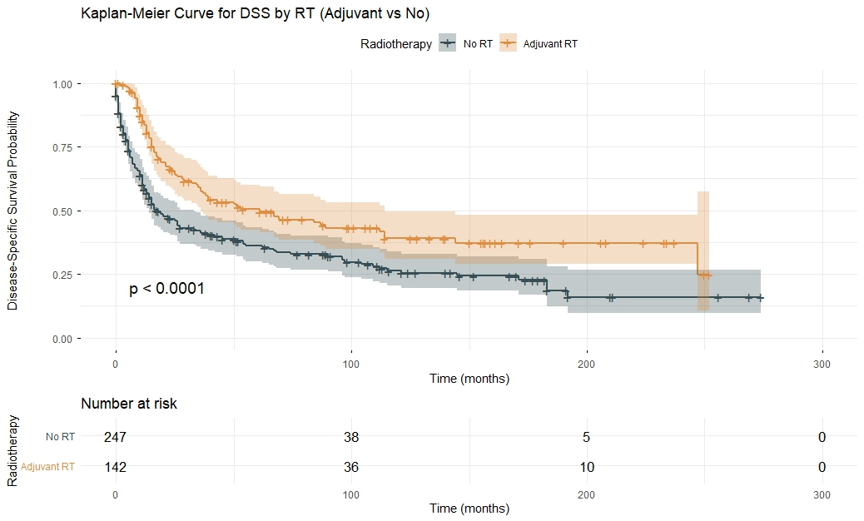

Fig. 12
Kaplan-Meier curve for Disease-Specific Survival based on chemotherapy treatment.

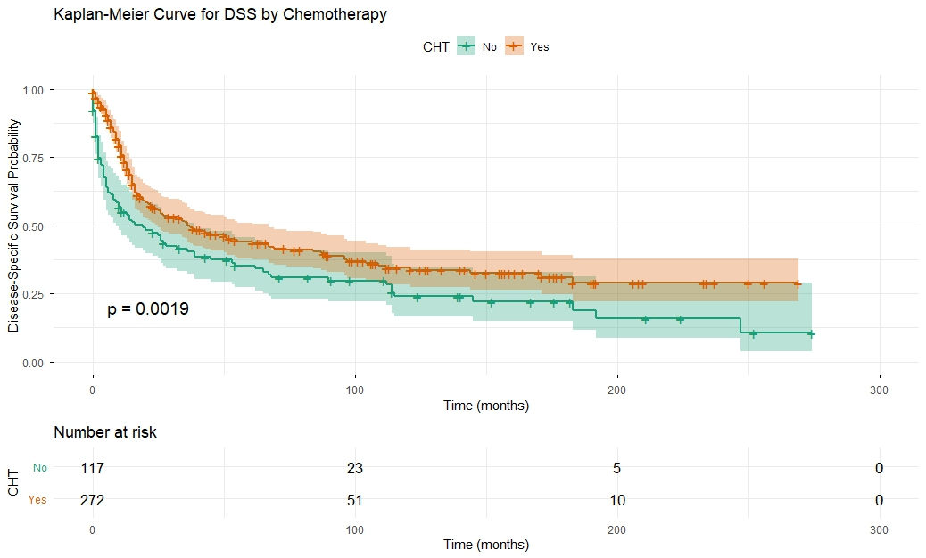

Figure 13.
Kaplan-Meier curve for Overall survival based on surgical treatment type.
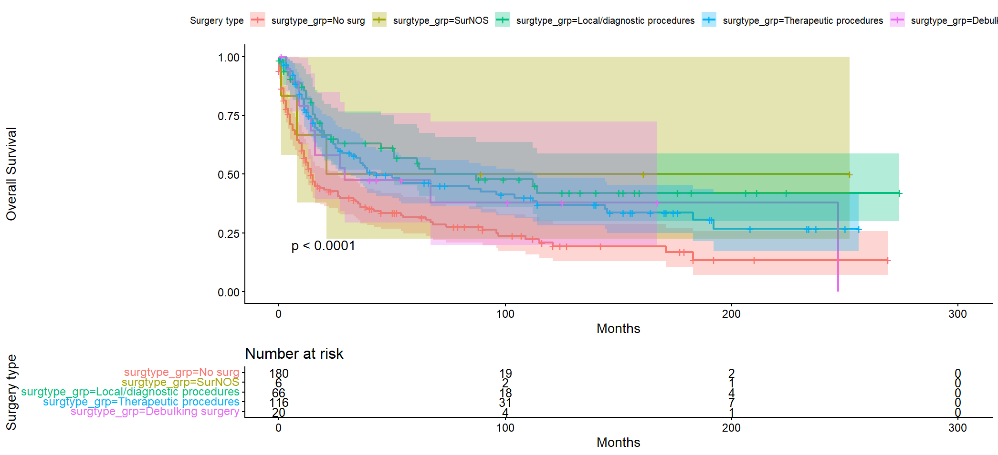

Figure 14.
Kaplan-Meier curve for Disease-Specific Survival based on surgical treatment type.
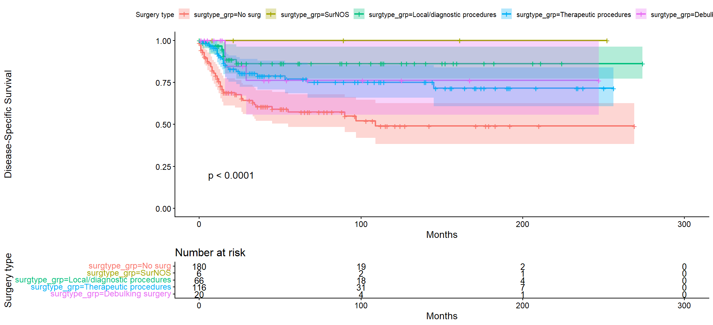

Figure 15.
Kaplan-Meier curve for Overall Survival based on histology type.

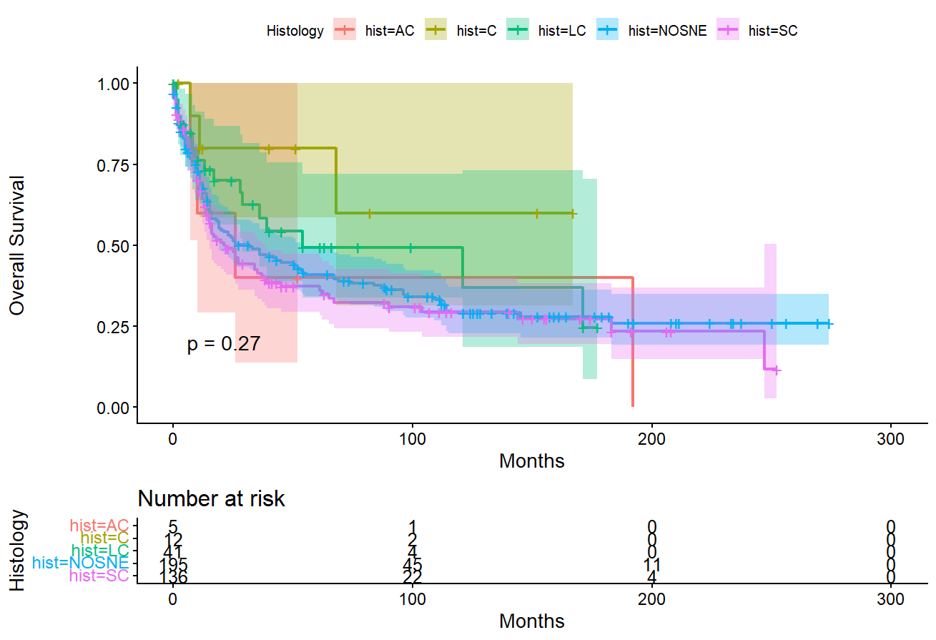

Figure 16.
Kaplan-Meier curve for Disease-Specific Survival based on histology type.
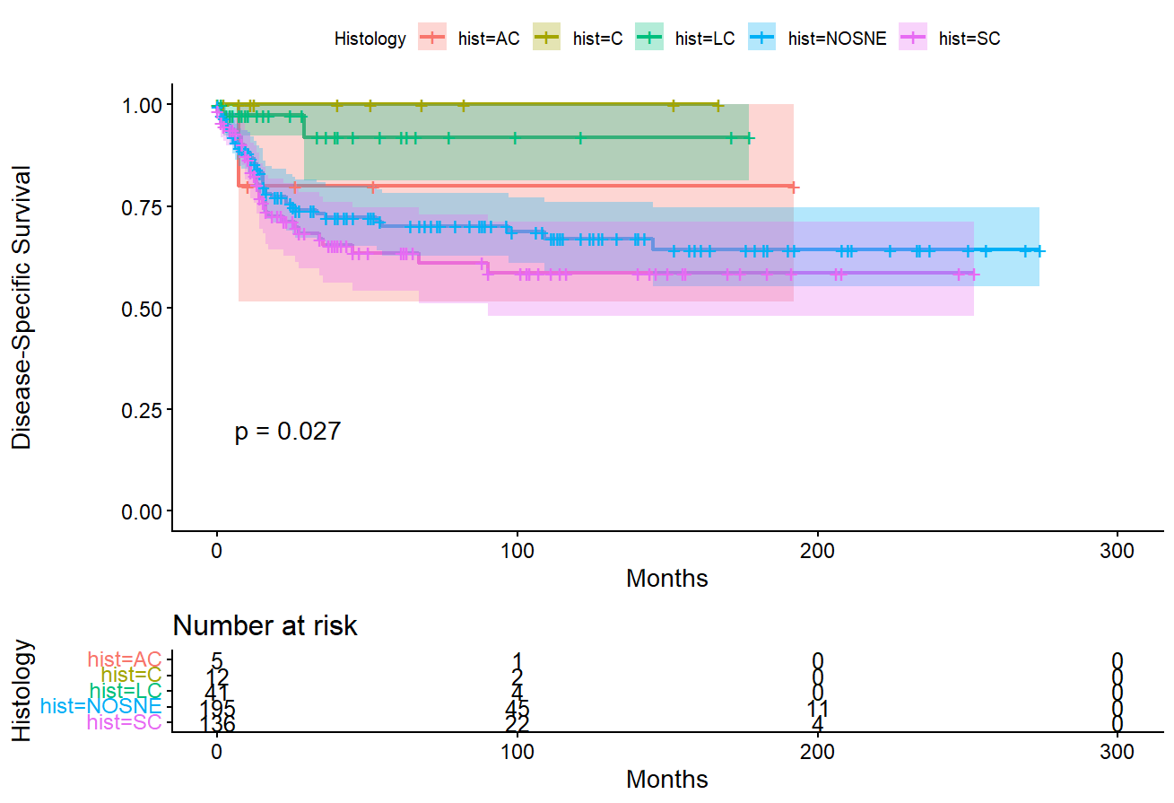
Figure 17.
Kaplan-Meier curve for Overall survival based on multimodal treatment type.
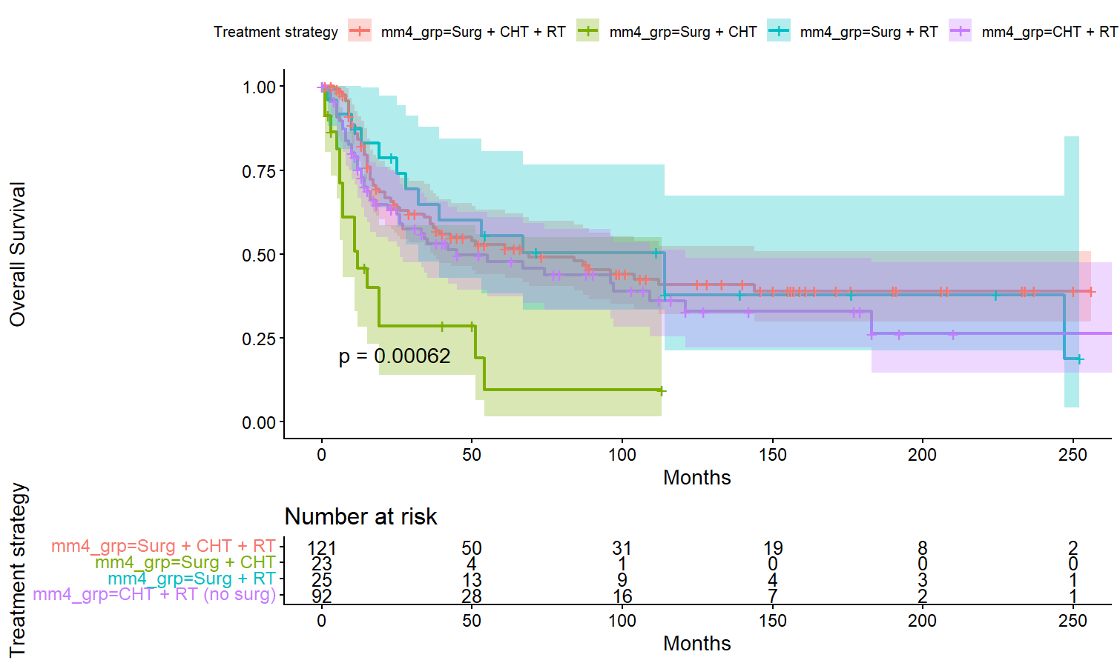

Figure 18.
Kaplan-Meier curve for Disease-specific Survival based on multimodal treatment type.
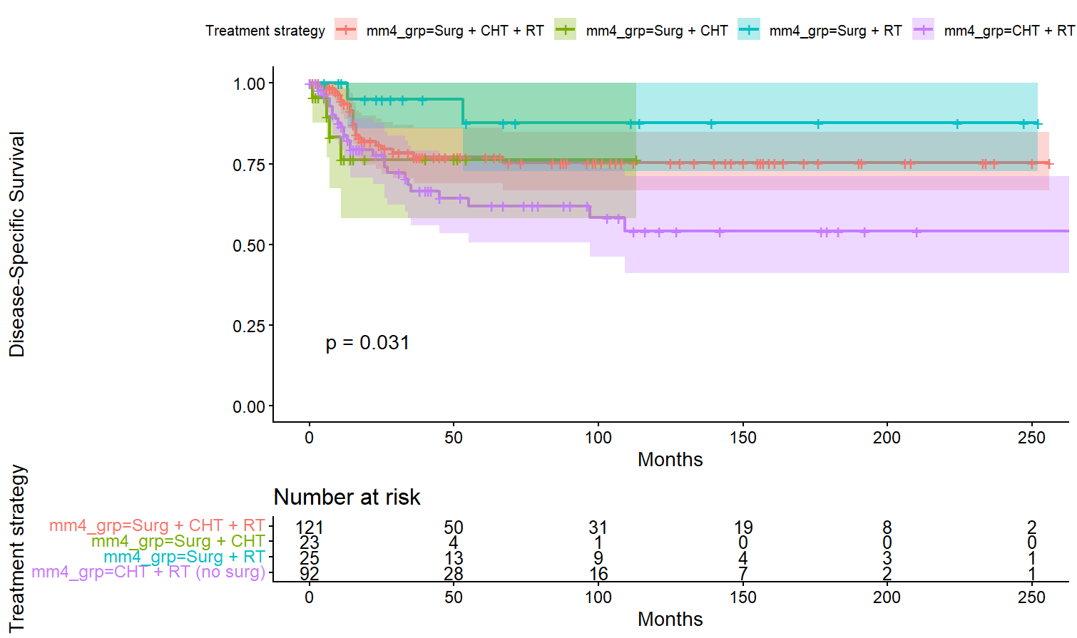

Table 3.
Univariate analysis of multimodal treatment strategies for Overall Survival.

Treatment modalities |  | n | Events | HR (95% CI) | p value
Surgery + RT vs Surgery alone |  | 206 | 114 | 0.58 (0.39-0.85) | 0.005
Surgery + adjuvant RT vs Surgery alone |  | 200 | 112 | 0.67 (0.45-0.98) | 0.040
Surgery + CHT vs Surgery alone |  | 210 | 115 | 0.96 (0.65-1.42) | 0.84
Surgery + adjuvant CHT vs Surgery alone |  | 141 |  | 0.96 | 0.80†
Four-group multimodal strategy |  | 261 | 138 |  | 0.005‡
 | Surgery + CHT vs Surgery + RT |  |  | 3.09 (1.50-6.38) | 0.002
 | Surgery + CHT + RT vs Surgery + RT |  |  | 1.01 (0.57-1.82) | 0.96
 | CHT + RT (no surgery) vs Surgery + RT |  |  | 1.26 (0.69-2.30) | 0.44

HRs derived from univariate Cox proportional hazards models.
† Log-rank p value from Kaplan–Meier analysis.
‡ Global likelihood ratio test for multilevel variable.

Table 4.
Univariate analysis of multimodal treatment strategies for Disease-specific Survival.

Treatment modalities |  | n | Events | HR (95% CI) | p value
Surgery + RT vs Surgery alone |  | 206 | 34 | 0.83 (0.39-1.78) | 0.63
Surgery + adjuvant RT vs Surgery alone |  | 200 | 34 | 1.02 (0.48-2.19) | 0.96
Surgery + CHT vs Surgery alone |  | 210 | 34 | 1.76 (0.76-4.04) | 0.19
Surgery + adjuvant CHT vs Surgery alone |  | 141 | 21 | 1.43 (0.52-3.90) | 0.49
Four-group multimodal strategy |  | 261 | 56 |  | 0.02‡
 | Surgery + CHT vs Surgery + RT |  |  | 1.80 (0.62-5.23) | 0.28
 | Surgery + CHT + RT vs Surgery + RT |  |  | 0.39 (0.09-1.65) | 0.20
 | CHT + RT (no surgery) vs Surgery + RT |  |  | 1.84(1.06-3.22) | 0.031

HRs derived from univariate Cox proportional hazards models.
‡ Global likelihood ratio test for multilevel variable.

