Support material for:
The carbon fluxes over an even-aged pure Pinus massoniana stand
BY: Zheng-Hong Tan, Fang-Jun Ding, et al.,

1. The inferring CWSI connected to decoupling factor
We adopted Jackson’s elegant way in calculating crop water stress index (CWSI) based on canopy temperature measurements as^{[18]},
Eqn. 1
$$WSI=\frac{dT-dT_{min}}{dT_{max}-dT_{min}}$$

where dT is canopy to air temperature difference, dT_{max} and dT_{min} are two limits of dT. The dT term could be expressed as,
Eqn. 2
$$dT=\frac{R_{n}-G}{ρC_{p}g_{a}}\frac{γ(1+g_{a}/g_{c})}{∆+γ(1+g_{a}/g_{c})}-\frac{D_{a}}{∆+γ(1+g_{a}/g_{c})}$$
where g_{a}: aerodynamic conductance for heat flux (m s⁻¹);
g_{c:} surface conductance for water vapor (m s⁻¹);
R_{n}: net radiation flux (w m⁻²);
G: ground heat flux (w m⁻²);
ρ: air density (kg m⁻³);
C_{p}: specific heat at constant pressure (J kg⁻¹ K⁻¹);
γ: psychrometric constant (kPa K⁻¹);
Δ: the slope of saturated vapor pressure versus temperature curve (kPa K⁻¹);
D_{a}: atmospheric water pressure deficit (kPa);
One extreme case is g_{c}→0, then stomatal is fully closed where dT_{max} reached,
Eqn. 3
$$\lim_{g_{c}→0}{dT}=dT_{max}=\frac{R_{n}-G}{ρC_{p}g_{a}}$$

The other extreme case is that g_{c}→∞, the canopy act as a free water surface where dT_{min} reached^{[32]},
Eqn. 4
$$\lim_{g_{c}→∞}{dT}=dT_{min}=\frac{R_{n}-G}{ρC_{p}g_{a}}\frac{γ}{γ+∆}-\frac{D_{a}}{γ+∆}$$

In real case, g_{c} will not approximate ∞ but a limited fixed value called g_{cmax}. Then,
Eqn. 5
$$dT_{min}=\frac{R_{n}-G}{ρC_{p}g_{a}}\frac{γ^{*}}{γ^{*}+∆}-\frac{D_{a}}{γ^{*}+∆}$$
where $γ^{*}=γ(1+g_{a}/g_{cmax})$.
Actually, in case of g_{c} approximating infinite, then
$$WSI=1-\frac{E}{E_{P}}=1-Ω$$

where E and E_{p} is actual and potential evapotranspiration. The Ω also called decoupling factor as shown in Jarvis and McNaughton^{[17]}.

Figure s1. Illustration of the Lasslop equation and ordinary hyperbolic equation in simulating daytime NEE. Since majority of the time, VPD was less than 1 kPa, it is not necessary to includes the VPD term as illustrated in Lasslop but includes the temperature dependence of respiration.

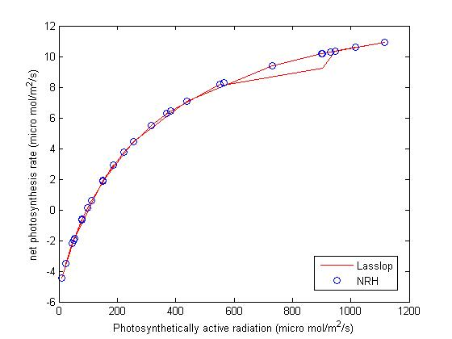

Figure s2. The seasonal pattern on net ecosystem exchange (NEE) cited from Liu YF for a coniferous plantation comprised partly by Masson pine of similar stand age in Qianyanzhou, Jiangxi, China (QYZ) and a 100-year-old mixed broadleaved forest of secondary growth in Dinghushan, Guangdong, China^{[22,24]}.
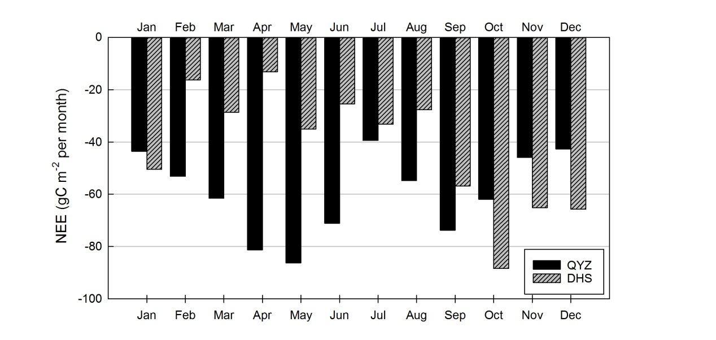

Figure s3. Soil water content measured at different depth in our studied site in Guizhou.
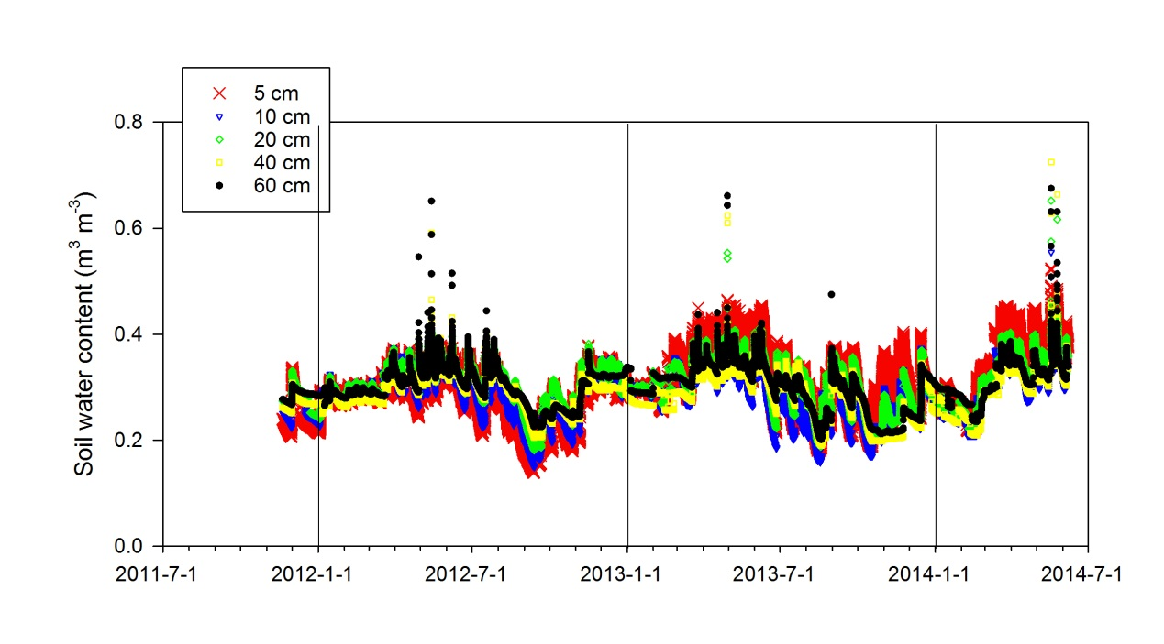

Figure s4. The power spectrum of vertical wind velocity component (blue lines). Data was collected in a clear day July 14, 2013. The red circles are smoothing points. The black line represents the -2/3 slope under log-log plot. The standard Kaimal94 spectrum was showed in pink line.
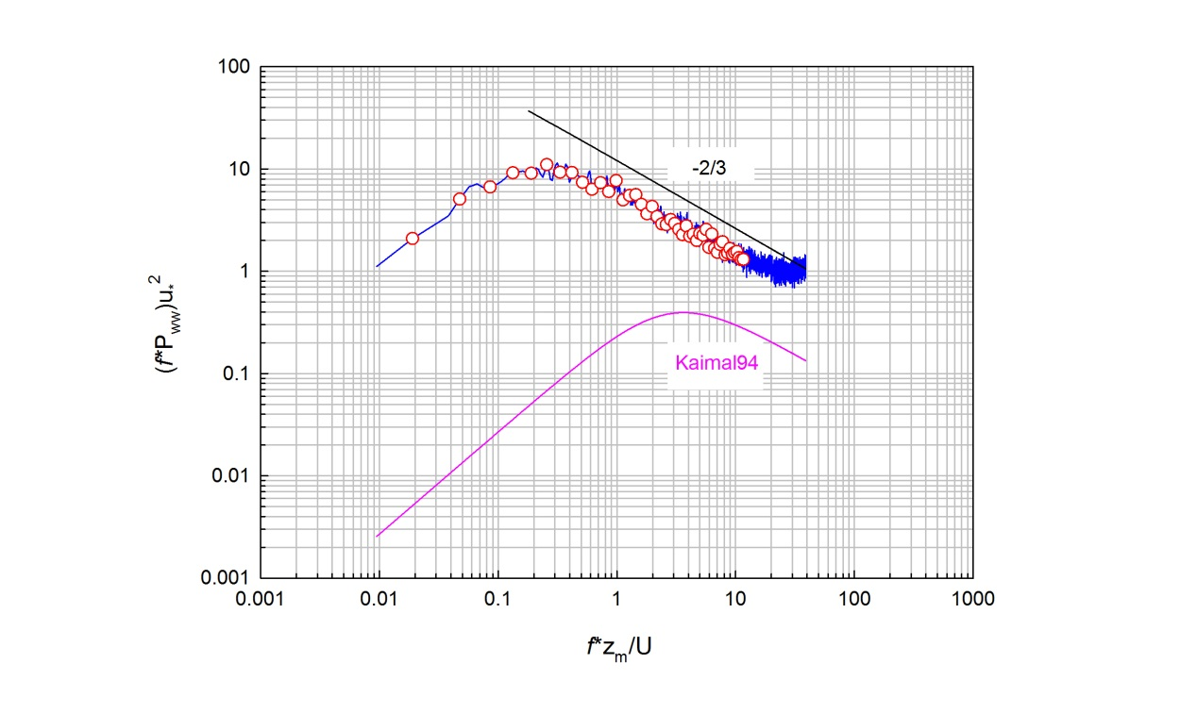

Figure s5. The relationship between water vapor deficit (D) and surface conductance (Gs) expressed by the Kernel density.
