[Supplementary Material]

Urban–Rural and Racial Disparities in Paediatric Congenital Heart Disease Mortality in the United States, 1999–2020

Supplementary Table 1. Overall and Urban v/s Rural deaths in the United States from 1999 to 2020.

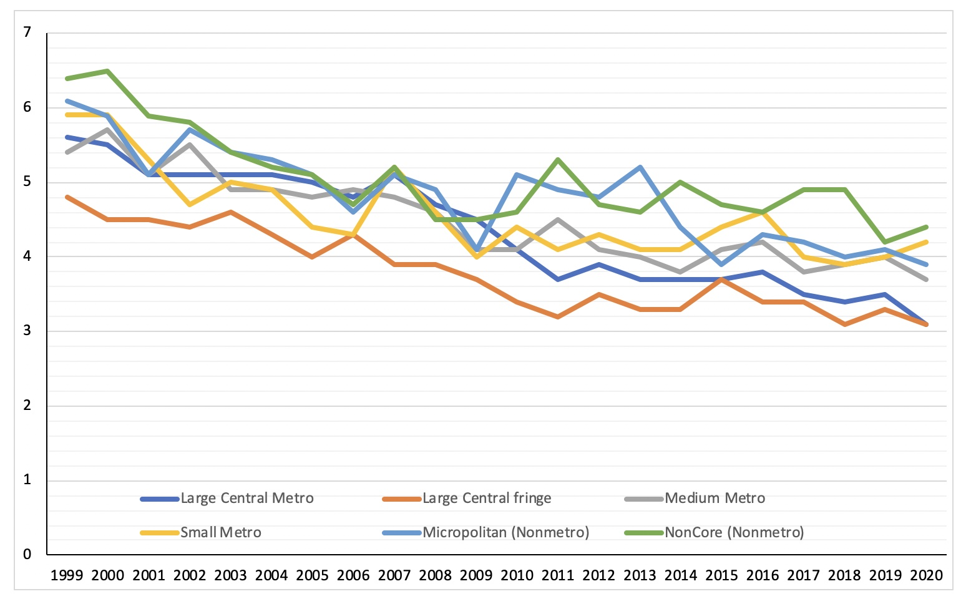Supplementary Chart 1.
Line Chart comparison of Age-adjusted mortality rates (per 100,000) among children with congenital heart disease under the 2013 NCHS rural urban classification scheme.

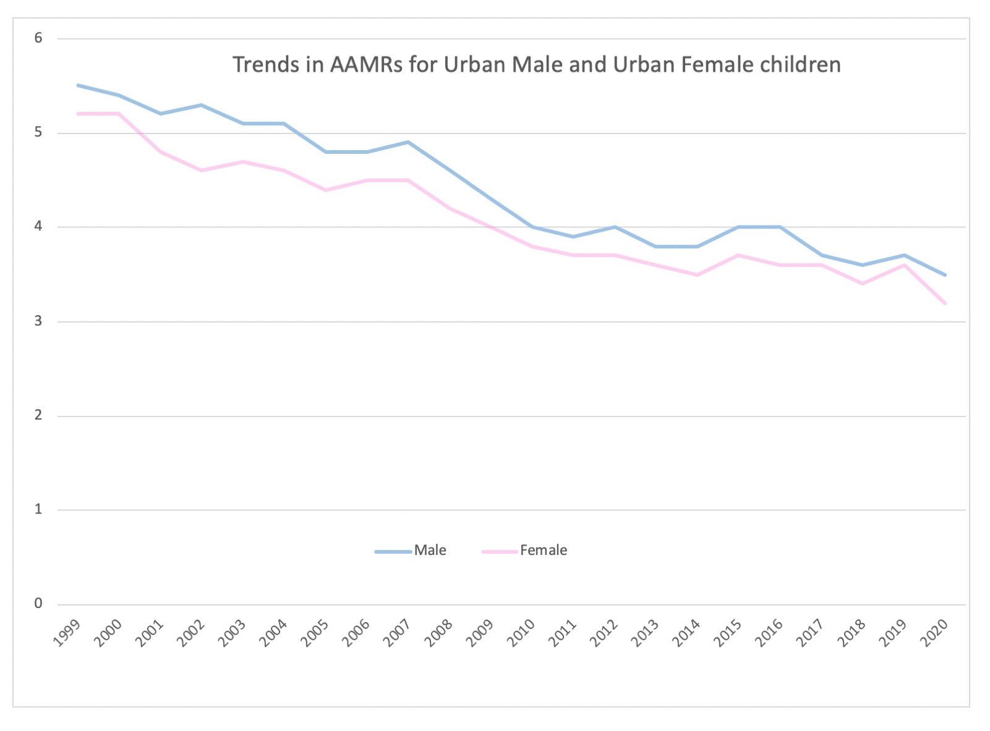

Supplementary Chart 2.
Line Chart comparison of Age-adjusted mortality rates (per 100,000) among urban children with congenital heart disease, stratified by sex, United States, 1999-2020.

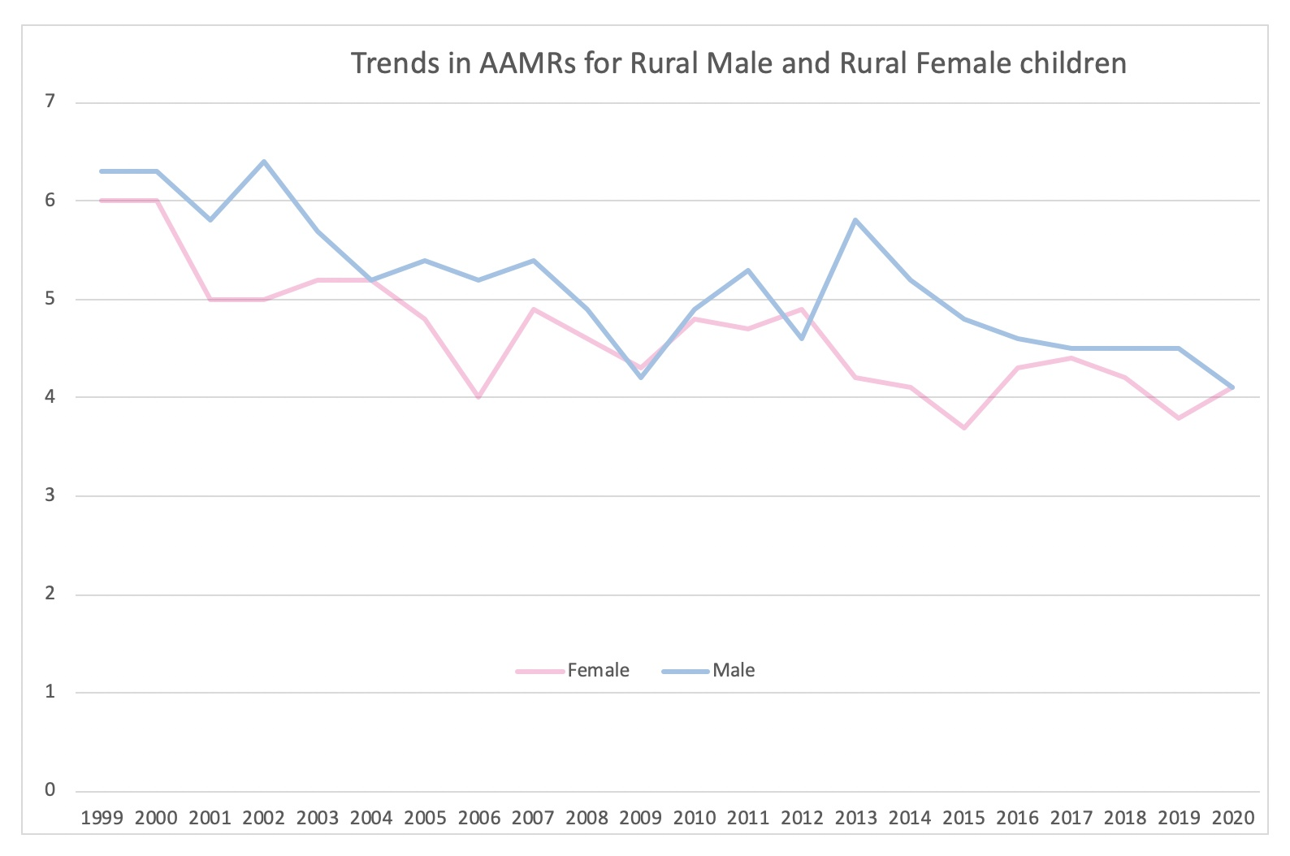

Supplementary Chart 3.
Line Chart comparison of Age-adjusted mortality rates (per 100,000) among rural children with congenital heart disease, stratified by sex, United States, 1999-2020.

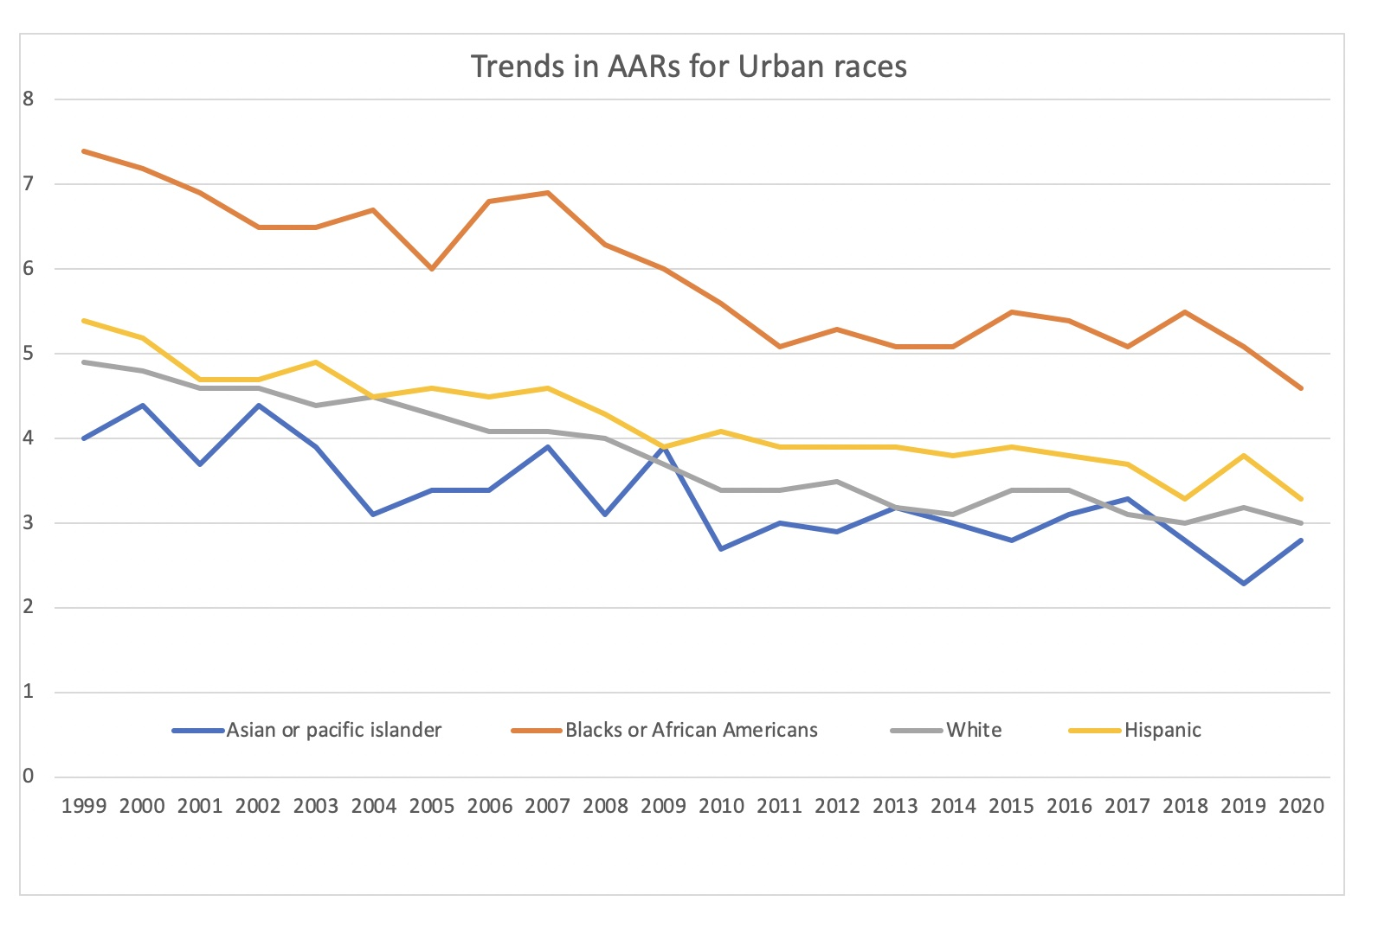

Supplementary Chart 4.
Line Chart comparison of Age-adjusted mortality rates (per 100,000) among urban children with congenital heart disease, stratified by race/ethnicity, United States, 1999-2020.

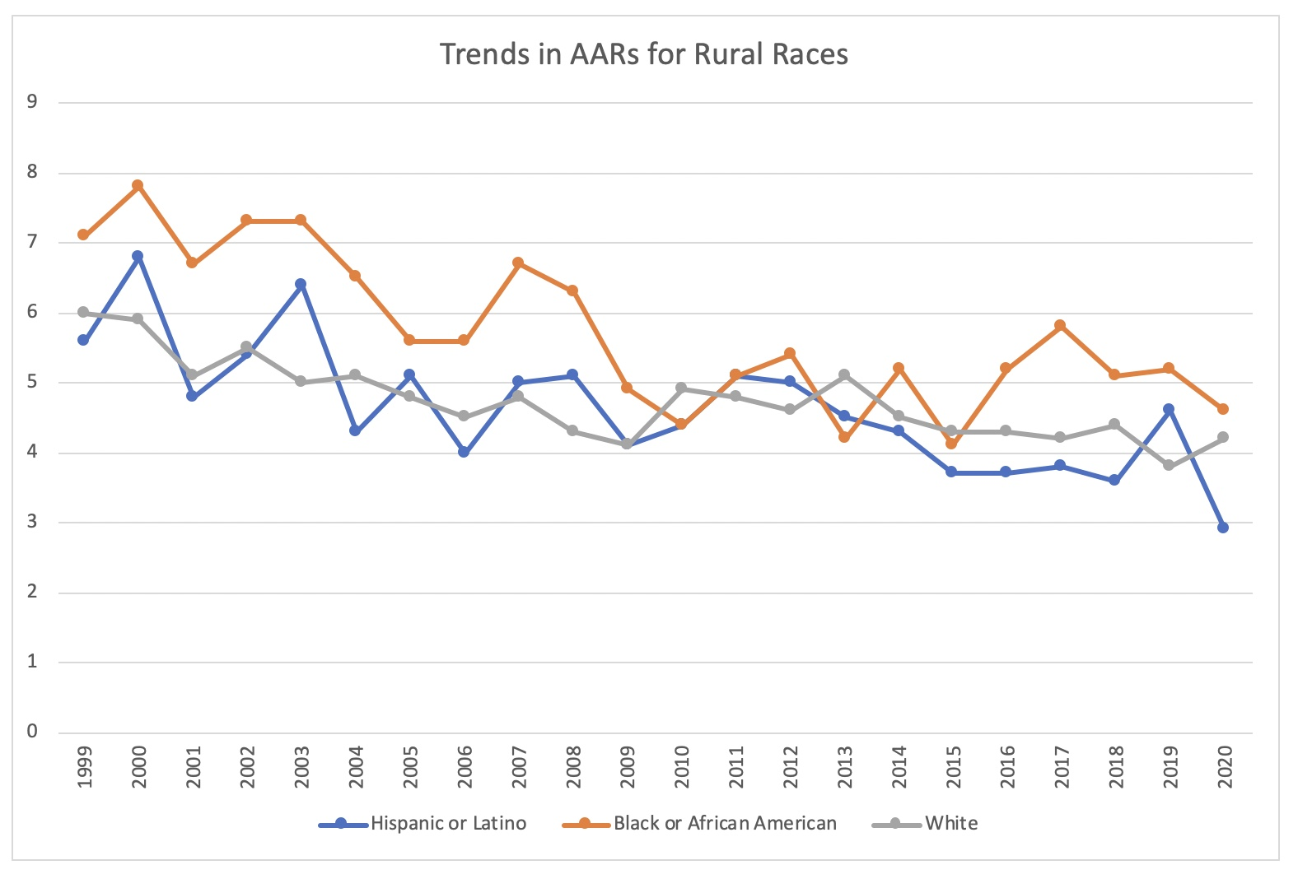

Supplementary Chart 5.
Line Chart comparison of Age-adjusted mortality rates (per 100,000) among rural children with congenital heart disease, stratified by race/ethnicity, United States, 1999-2020.

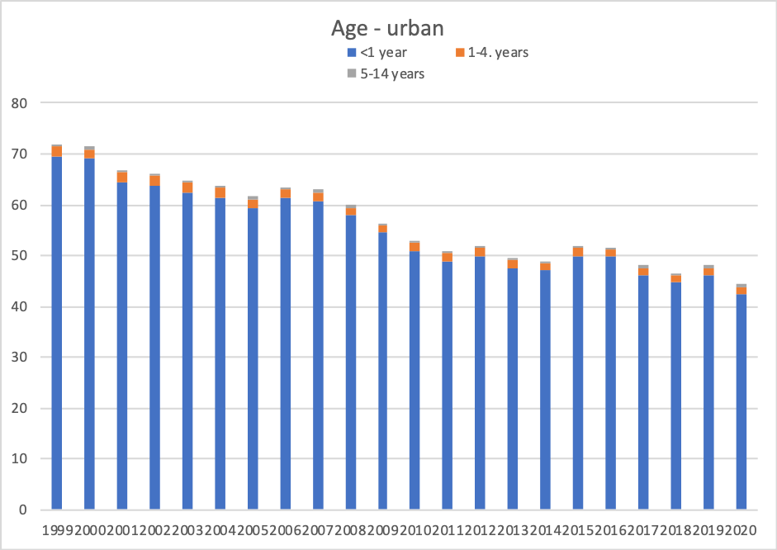

Supplementary Chart 6.
Column Chart comparison of crude mortality data stratified by age groups for the Urban population during 1999 -2020.

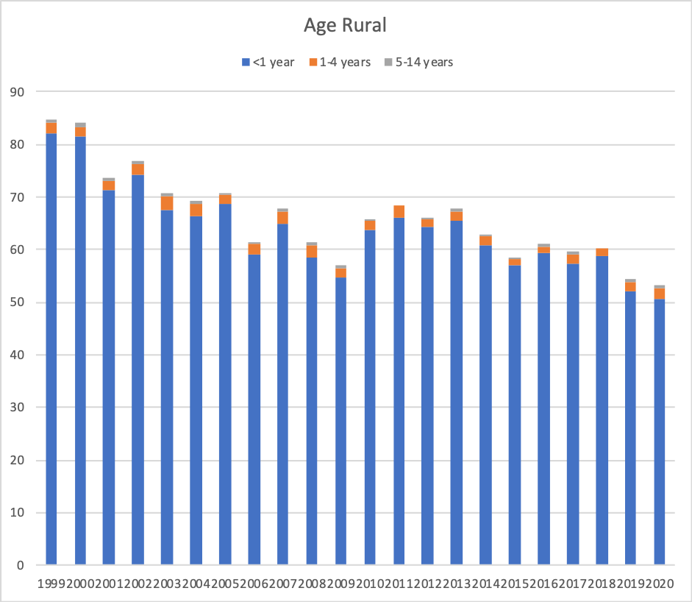

Supplementary Chart 7.
Column Chart comparison of crude mortality data stratified by age groups for the Rural population during 1999 -2020.

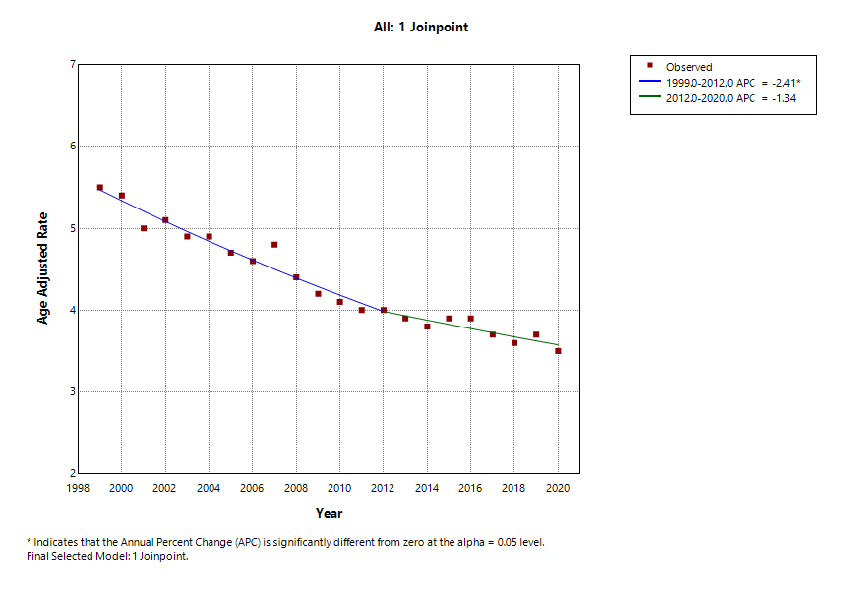
Supplementary Figure 1.
Joinpoint analysis of Age-adjusted mortality rates (per 100,000) among children with congenital heart disease, United States, 1999-2020.

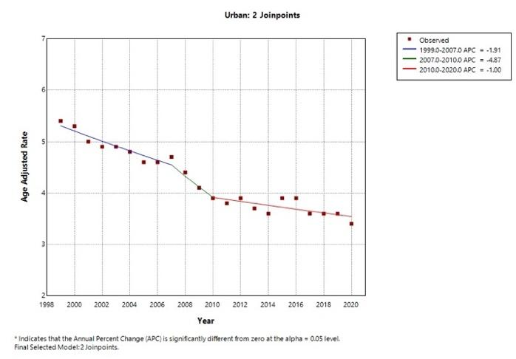

Supplementary Figure 2.
Joinpoint analysis of Age-adjusted mortality rates (per 100,000) among urban children with congenital heart disease, United States, 1999-2020.

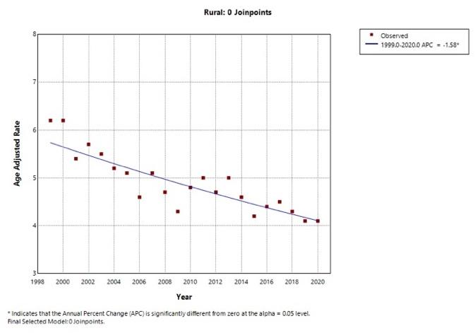

Supplementary Figure 3.
Joinpoint analysis of Age-adjusted mortality rates (per 100,000) among rural children with congenital heart disease, United States, 1999-2020.

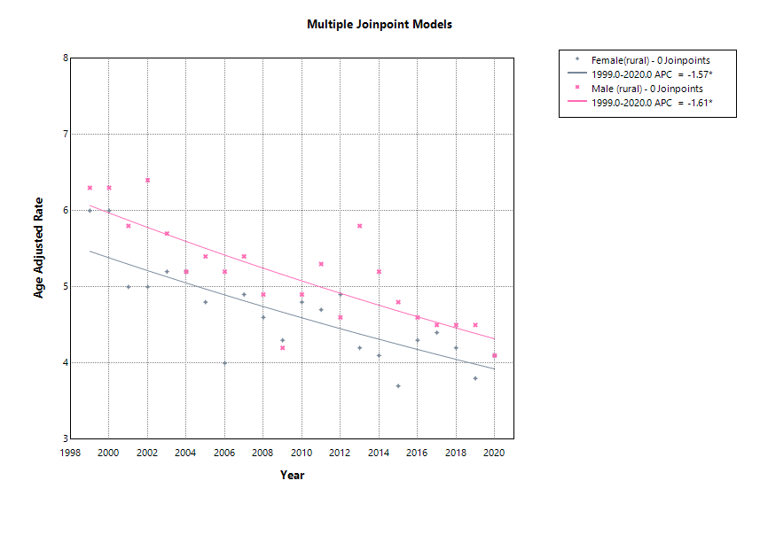

Supplementary Figure 4
Joinpoint analysis of Age-adjusted mortality rates (per 100,000) among rural children with congenital heart disease, stratified by sex, United States, 1999-2020.

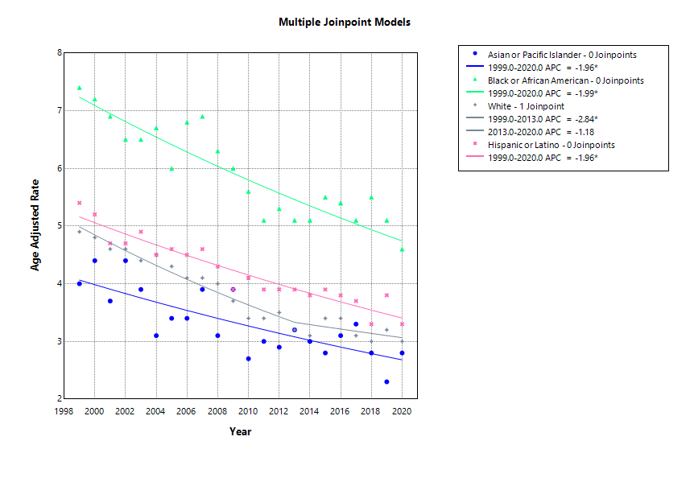

Supplementary Figure 5
Joinpoint analysis of Age-adjusted mortality rates (per 100,000) among urban children with congenital heart disease, stratified by race/ethnicity, United States, 1999-2020.

