Supplemental Table S1. Clinical Comorbidities and Medication Profile Stratified by Fatty Kidney Status.
Variables | All subjects (n=257) | Fatty Kidney(n=173) | Non-Fatty Kidney(n=84) | P value
Diabetes pharmacotherapy
None(diet alone) | 108(42.20%) | 80(46.24%) | 28(33.33%) | 0.049
Metformin | 13(5.06%) | 7(4.05%) | 6(7.14%) | 0.448
Metformin +OHA | 71 (27.63%) | 41 (23.70%) | 30 (35.71%) | 0.043
Insulin ±OHA | 44(17.12%) | 25 (14.45%) | 19 (22.62%) | 0.103
Hepatoprotective medication use | 45 (17.51%) | 35 (20.23%) | 10 (11.90%) | 0.099
Antihypertensive medication use | 81 (31.52%) | 60 (34.68%) | 21 (25.00%) | 0.117
Lipid-lowering therapy utilization | 139 (54.09%) | 89 (51.45%) | 50 (59.52%) | 0.223
Comorbidities
Hypertension, n(%) | 193 (75.10%) | 138 (79.77%) | 55 (65.48%) | 0.013
Vessel Plaque, n(%) | 103 (40.08%) | 75 (43.35%) | 28 (33.33%) | 0.124
Obesity, n(%) | 77 (29.96%) | 57 (32.95%) | 20 (23.81%) | 0.134
CKD, n(%) | 75 (29.20%) | 56 (32.40%) | 19 (22.60%) | 0.095
Note: OHA: oral hypoglycemic agents; CKD: Chronic kidney disease.

Supplemental Table S2. Associations Between Medication therapies and RFF in Univariate and Multivariable Regression Analyses.
Variables | Univariate |  |  |  | Multivariable
Variables | β | S.E | t | P | β | S.E | t | P
None(diet alone) | 0.516 | 0.226 | 2.280 | 0.023 | 0.372 | 0.303 | 0.605 | 0.546
Metformin | -0.318 | 0.514 | 0.618 | 0.537 | -0.130 | 0.556 | -0.168 | 0.867
Metformin + OHA | -0.529 | 0.250 | -2.116 | 0.035 | -0.210 | 0.308 | -0.390 | 0.697
Insulin ± OHA | -0.431 | 0.298 | 1.444 | 0.150 | -0.161 | 0.329 | -0.352 | 0.726
Hepatoprotective medication use | 0.126 | 0.297 | -0.459 | 0.710 | -0.110 | 0.301 | -0.367 | 0.714
Antihypertensive medication use | 0.351 | 0.242 | -0.125 | 0.828 | 0.471 | 0.244 | 1.929 | 0.055
Lipid-lowering therapy utilization | -0.429 | 0.225 | -0.872 | 0.014 | -0.480 | 0.228 | -2.106 | 0.036
Dependent variable: RFF. All variables included in the linear regression analysis had a VIF less than 5.

Supplemental Table S3. Baseline data and metabolic characteristics grouped by quartiles of RFF.
Variables | Q1(n=65) | Q2(n=64) | Q3(n=64) | Q4(n=64) | P for trend
General characteristics
SBP(mmHg) | 135.05±18.50 | 141.64±20.31 | 144.95±18.23* | 153.38±18.83**## | <0.001
DBP(mmHg) | 86.37±11.49 | 86.28±12.28 | 87.19±12.05 | 93.58±16.88*# | 0.005
Blood glucose metabolism index
FINS (mIU/L) | 4.55 (1.94, 6.67) | 9.54 (3.92, 13.58)* | 11.95 (5.30, 19.38)** | 4.36 (0.62, 12.45)## | <0.001
FCP (ng/mL) | 0.64(0.40, 1.18) | 0.85 (0.44, 1.46) | 0.95 (0.59, 1.71) | 2.03 (1.07, 4.34)**##^^ | <0.001
HOMA-IR | 1.45 (0.55, 2.32) | 3.10 (1.32, 5.42)** | 3.60 (1.83, 7.52)** | 1.54 (0.26, 5.37)#^^ | <0.001
Indicators of renal function and renal injury
UA (μmol/L) | 320.64±74.02 | 331.59±92.99 | 343.67±82.91 | 398.85±105.38**##^^ | <0.001
UACR (mg/g) | 10.26(4.36, 17.16) | 11.14 (5.67, 20.11) | 13.04 (7.48, 34.65) | 18.85 (8.34, 64.32)**# | 0.002
Liver function index
ALT (U/L) | 17.70 (12.90, 33.30) | 18.55 (14.57, 29.05) | 18.90 (13.17, 28.52) | 30.60 (20.43, 49.70)**##^^ | <0.001
AST (U/L) | 20.40 (14.60, 30.00) | 20.00 (15.02, 30.20) | 18.80 (15.80, 28.13) | 28.70 (18.95, 42.85)*#^ | 0.012
Lipid metabolism index
TG (mmol/L) | 1.60 (1.13, 2.67) | 1.56 (1.28, 2.16) | 1.74 (1.28, 2.20) | 2.65 (2.07, 3.64) **##^^ | <0.001
HDL-C (mmol/L) | 1.15±0.38 | 0.99±0.28* | 0.98±0.26* | 0.89±0.19** | <0.001
Inflammatory index
hsCRP(mg/L) | 1.57 (0.88, 3.35) | 1.91 (0.93, 3.04) | 3.29 (1.58, 5.77)**## | 3.24 (1.69, 6.11)**## | <0.001
Visceral fat index
RSFF(%) | 70.74±9.39 | 74.95±8.27 | 76.16±8.49** | 81.44±7.93**##^^ | <0.001
PRFF(%) | 80.01±7.74 | 84.04±5.66** | 84.13±4.47**## | 88.22±4.21**## | <0.001
HFF(%) | 5.90 (2.97, 10.57) | 6.35 (5.59, 7.31) | 8.62 (7.75, 10.14)**## | 14.05 (9.91, 17.74)**##^^ | <0.001
Note: All subjects were divided into four groups(Q1/Q2/Q3/Q4) according to RFF quartiles. Differences among groups were tested using the one-way analysis of variance (ANOVA) test or Kruskal-Wallis’one-way ANOVA test for continuous variables, and χ2 test for categorical variables. *P<0.05, and **P<0.01 vs Q1 group; #P<0.05, and ##P<0.01 vs Q2 group; ^P<0.05,^^P<0.01 vs Q3 group (Statistical significance based on Tukey’s HSD post-hoc test and the Bonferroni correction).

Supplemental Table S4. Basic characteristic of 207 fatty liver patients.
Variables | H1(n=47) | H2(n=160) | P value
General characteristics
Age (year) | 46.02±14.68 | 50.99±14.74 | 0.027
Duration (month) | 12.00 (2.00, 60.00) | 36.00 (3.00, 120.00) | 0.002
SBP(mmHg) | 139.28±19.52 | 147.09±19.00 | 0.009
Blood glucose metabolism index
FINS (mIU/L) | 5.33 (2.57, 6.67) | 9.54 (2.77, 16.07) | 0.040
FCP (ng/mL) | 0.67 (0.48, 1.28) | 1.12 (0.62, 2.15) | 0.021
HOMA-IR | 1.78 (0.97, 2.53) | 3.10 (1.07, 5.75) | 0.008
Indicators of renal function and renal injury
UA (μmol/L) | 337.30±84.80 | 365.00±96.69 | 0.001
UACR(mg/g) | 10.66 (5.58, 16.91) | 14.25 (7.24, 34.78) | 0.050
Inflammatory index
hsCRP(mg/L) | 1.65 (0.85, 3.27) | 2.89 (1.38, 5.79) | ＜0.001
Complicating other diseases
hypertension ,n(%) | 29 (63.04%) | 129 (80.62%) | 0.013
Note: We defined H1 as the fatty liver group and H2 as the combination of fatty liver and fatty kidney group. Pearson's χ² test or Fisher's exact test was used for comparing categorical variables between groups, while the Kruskal-Wallis H test and one way Anova was applied for comparing continuous variables between groups.

Supplemental Table S5. Effects of liver fat on metabolic traits and of metabolic traits on fatty kidney.
Trait | Standard coefficient | SE | p value
Fatty liver and metabolic traits
Effect of liver fat on SBP | 0.25 | 0.21 | <0.001
Effect of liver fat on DBP | 0.14 | 0.15 | 0.03
Effect of liver fat on HbA1C | -0.01 | 0.07 | 0.85
Effect of liver fat on FPG | 0.14 | 0.03 | 0.03
Effect of liver fat on FCP | 0.28 | 0.03 | <0.001
Effect of liver fat on HOMAIR | -0.01 | 0.06 | 0.84
Effect of liver fat on UA | 0.39 | 0.96 | <0.001
Effect of liver fat on ALT | 0.53 | 0.18 | <0.001
Effect of liver fat on AST | 0.51 | 0.17 | <0.001
Effect of liver fat on TC | 0.07 | 0.01 | 0.28
Effect of liver fat on TG | 0.33 | 0.02 | <0.001
Effect of liver fat on LDL | -0.08 | 0.01 | 0.24
Effect of liver fat on HDL | -0.02 | 0.003 | <0.001
Effect of liver fat on hsCRP | 0.21 | 0.06 | 0.002
Metabolic traits and fatty kidney
Effect of SBP on fatty kidney | 0.22 | 0.01 | <0.001
Effect of DBP on fatty kidney | 0.10 | 0.01 | 0.07
Effect of HbA1C on fatty kidney | 0.07 | 0.02 | 0.19
Effect of FPG on fatty kidney | 0.14 | 0.04 | 0.44
Effect of FCP on fatty kidney | 0.17 | 0.03 | 0.002
Effect of HOMAIR on fatty kidney | 0.01 | 0.02 | 0.13
Effect of UA on fatty kidney | 0.18 | 0.001 | 0.002
Effect of ALT on fatty kidney | -0.02 | 0.01 | 0.78
Effect of AST on fatty kidney | -0.03 | 0.01 | 0.69
Effect of TC on fatty kidney | 0.09 | 0.09 | 0.09
Effect of TG on fatty kidney | 0.11 | 0.05 | 0.06
Effect of LDL on fatty kidney | 0.06 | 0.11 | 0.27
Effect of HDL on fatty kidney | -0.14 | 0.35 | 0.02
Effect of hsCRP on fatty kidney | 0.12 | 0.02 | 0.03
Single-mediator model with single-level data was used to investigate mediation. All mediation analyses were adjusted for age, gender, WHR, diabetic duration and BMI.

Supplemental Table S6. Indirect and direct effect estimates with bootstrap Cis.
Effect | Estimated coefficient(95%CI) | Proportion mediated (%) | Standardized indirect effect(95%CI)
Direct effect on fatty kidney | 0.15(0.12,0.19) | - | -
Indirect effect through SBP | 0.02(0.01,0.03) | 11.09% | 0.06(0.02,0.10)
Direct effect on fatty kidney | 0.16(0.13, 0.20) | - | -
Indirect effect through DBP | 0.004(-0.001,0.01) | - | 0.01(-0.003,0.03)
Direct effect on fatty kidney | 0.17(0.13,0.20) | - | -
Indirect effect through HbA1c | -0.0003(-0.002,0.002) | - | -0.001(-0.0074,0.006)
Direct effect on fatty kidney | 0.17(0.13,0.20) | - | -
Indirect effect through FPG | 0.002(-0.003,0.01) | - | 0.01(-0.01,0.03)
Direct effect on fatty kidney | 0.15(0.12,0.19) | - | -
Indirect effect through FCP | 0.01(-0.0003,0.04) | - | 0.05(-0.001,0.10)
Direct effect on fatty kidney | 0.17(0.13,0.20) | - | -
Indirect effect through Homa-IR | 0.00(-0.002,003) | - | -0.0001(-0.0054,0.009)
Direct effect on fatty kidney | 0.15(0.11,0.18) | - | -
Indirect effect through UA | 0.02(0.01,0.04) | 15.16% | 0.07(0.03,0.12)
Direct effect on fatty kidney | 0.17(0.13,0.21) | - | -
Indirect effect through ALT | -0.003(-0.03,0.03) | - | -0.01(-0.11,0.10)
Direct effect on fatty kidney | 0.17(0.13,0.21) | - | -
Indirect effect through AST | -0.004(-0.03,0.02) | - | -0.01(-0.10,0.06)
Direct effect on fatty kidney | 0.17(0.13,0.20) | - | -
Indirect effect through TC | 0.002(-0.002,0.01) | - | 0.01(-0.01,0.02)
Direct effect on fatty kidney | 0.16(0.12,0.19) | - | -
Indirect effect through TG | 0.01(0.0002,0.02) | - | 0.04(0.001,0.08)
Direct effect on fatty kidney | 0.17(0.14,0.20) | - | -
Indirect effect through LDL | -0.001(-0.006,0.001) | - | -0.005(-0.02,0.004)
Direct effect on fatty kidney | 0.15(0.12,0.19) | - | -
Indirect effect through HDL | 0.02(0.01,0.03) | 11.09% | 0.06(0.02,0.10)
Direct effect on fatty kidney | 0.16(0.13,0.20) | - | -
Indirect effect through hsCRP | 0.01(0.001,0.02) | 4.62% | 0.02(0.003,0.05)
The single-mediator model with single-level data was used. All mediation analyses were adjusted for age, gender, WHR, diabetic duration and BMI. Proportion mediated represents an estimate of the extent to which the direct effect was accounted for by the pathway through the mediating variable. Significance of mediation was tested by computing bias-corrected bootstrap confidence intervals with 5000 repetitions.

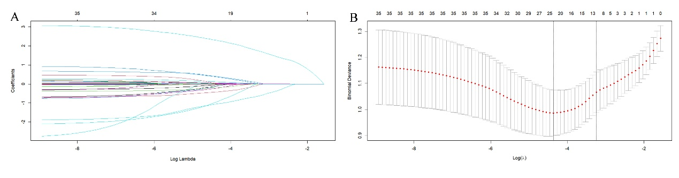
Supplemental Figure S1. LASSO Regression for Feature Selection. After LASSO regression selection, 25 variables remained significant predictors of fatty kidney, including demographics (gender, age, diabetic duration, DBP), metabolic parameters (BMI, WHR, HbA1c, FCP, TG, HDL), clinical factors (fatty liver, HFF, AST, eGFR, UA), inflammatory marker (hsCRP), comorbidities(vessel plaque, CKD， hyper tension) and medication use (metformin monotherapy, metformin combined with OHAs, insulin therapy with or without OHAs, hepatoprotective, lipid-lowering therapies, and antihypertensive medication use).
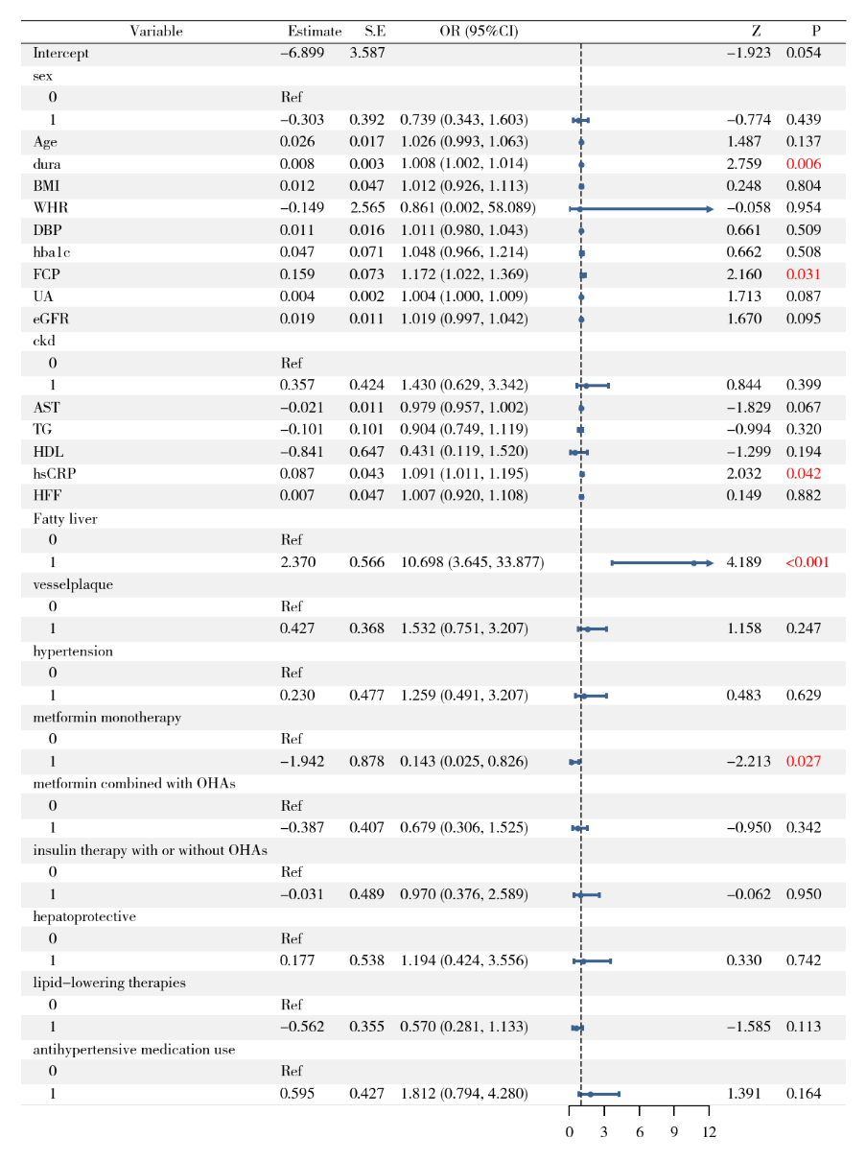
Supplemental Figure S2. Forest Plot of Multivariable Logistic Regression Analysis for Predictors of Fatty Kidney Disease. Given their established roles as potential confounders, dura (diabetes duration) and metformin combined with other OHAs were treated as adjustment variables in the analysis and were not considered for inclusion as independent predictors in the final model.
Supplemental Figure S3. Diagnostic performance of predictive models at different kidney fat thresholds: AUCs of 0.827 at 3%, 0.858 at 4%, and 0.784 at 5% cutoff points.

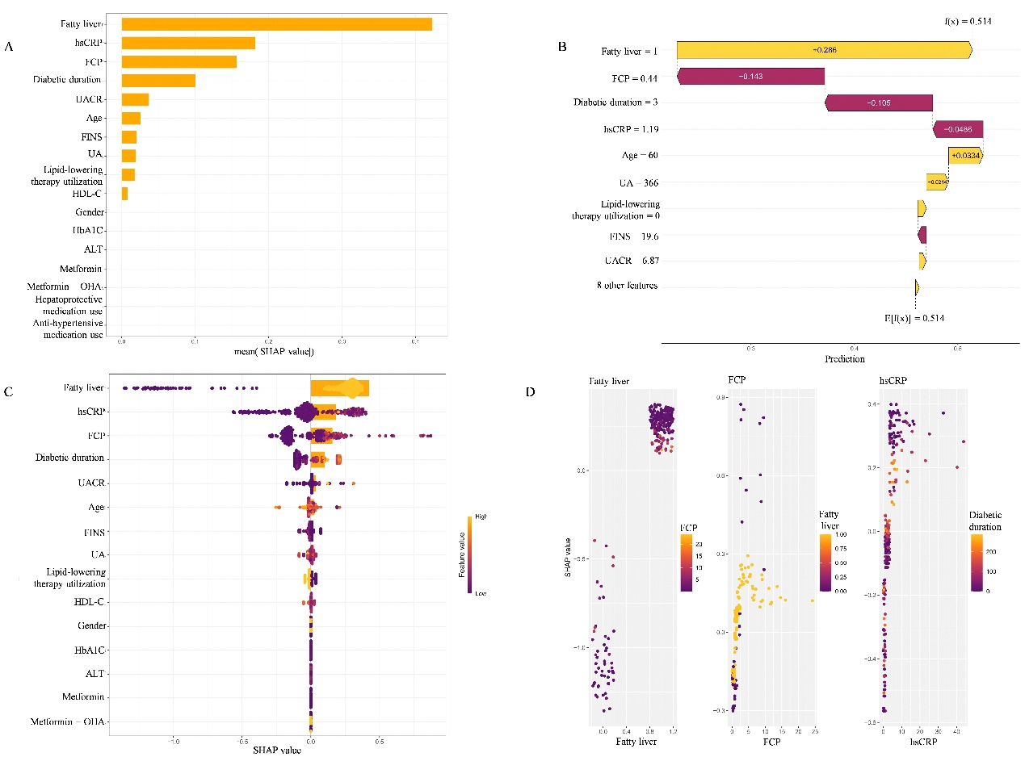
Supplemental Figure S4. SHAP analyses of the XGBoost model. (A) Global SHAP feature importance for the XGBoost model. (B) Individual-level SHAP waterfall plot. (C) SHAP global importance and summary beeswarm for the XGBoost model. (D) SHAP dependence plots for the top predictors(fatty liver, FCP and hsCRP) in the XGBoost model. The coloring variable represents the strongest interactions automatically identified by the model.

