a b c
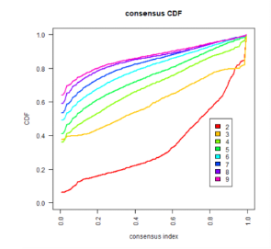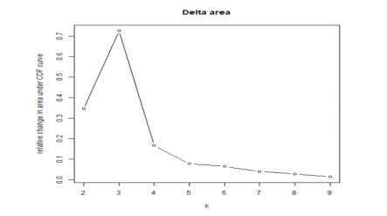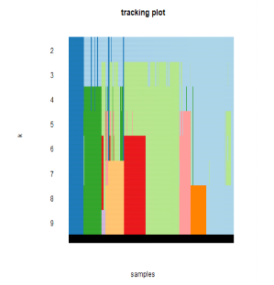
d
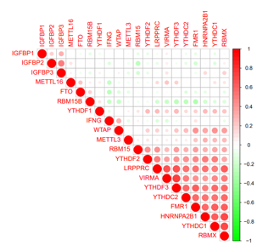
Figure S1.Criteria for selecting number of categories. (a) Consensus clustering cumulative distribution function (CDF) for k=2 to 9. (b) Relative change in area under the CDF curve for k=2 to 9. (c) Tracking plot for k=2 to 9. (d) Spearman correlation analysis of the 19 m⁶A methylation regulators.

a b
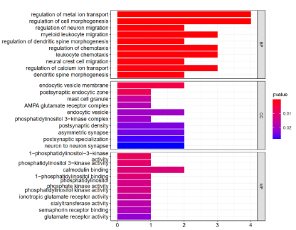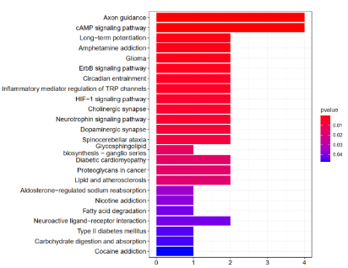
c d e
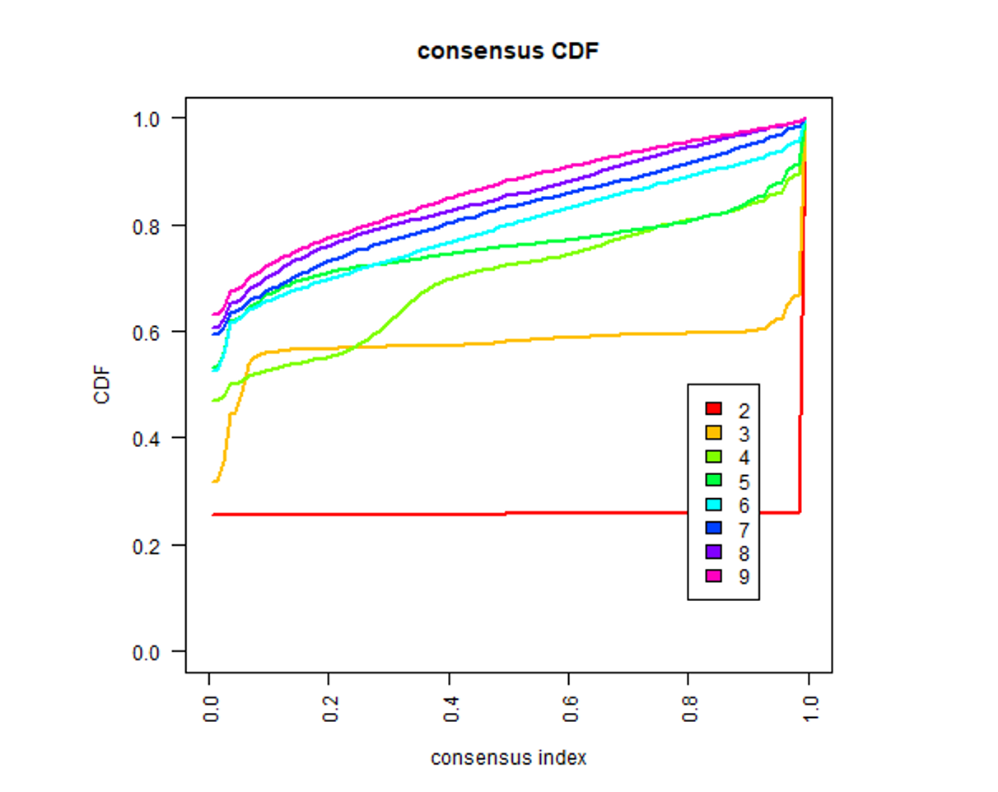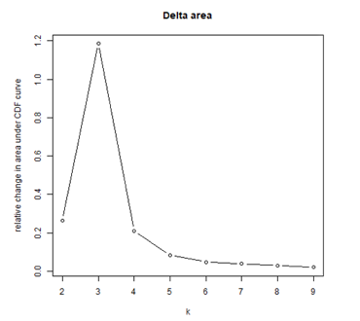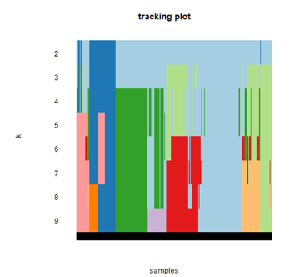
Figure S2. Cluster diff of GSEA（a）Bar-plot of GO enrichment in cellular component terms, biological process terms and molecular function terms. (b) Bar-plot of KEGG enriched terms. (c) Consensus clustering cumulative distribution function (CDF) for k=2 to 9. (d) Relative change in area under the CDF curve for k=2 to 9. (e) Tracking plot for k=2 to 9.

a

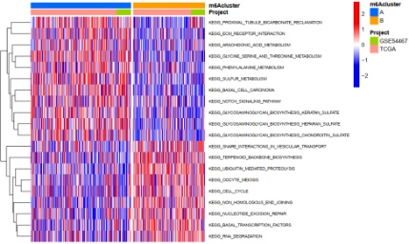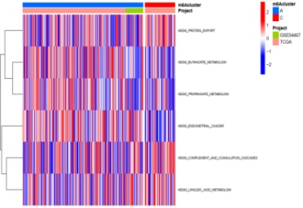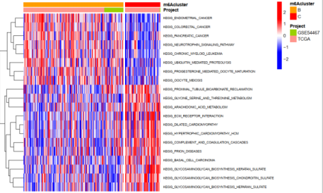
b
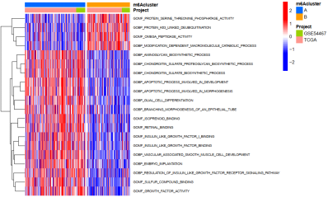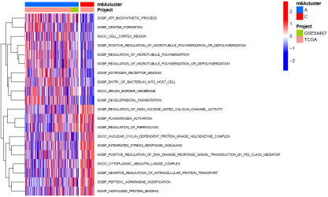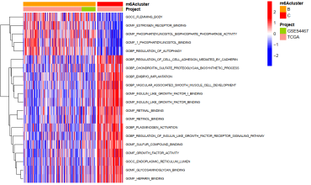

Figure s3. The heatmap of Gene enrichment analysis of m⁶A regulators. (a) Kyoto Encyclopedia of Genes and Genomes (KEGG) pathway enrichment analysis (b) Gene ontology (GO) pathway enrichment analysis (p< 0.001)

a b c d
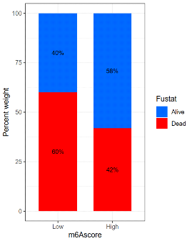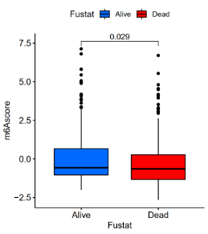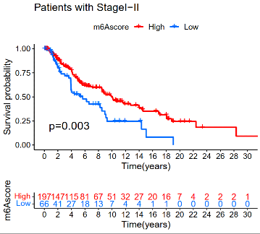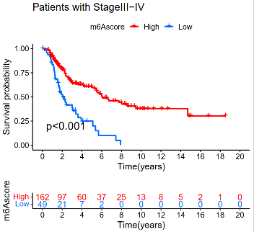

Figure s4. Based on the m⁶Ascore to analysis of patients.(A) Clinical correlation analysis of m⁶Ascore clinicopathological parameters with clinical patients of SKCM. (B)Survival state of m⁶Ascore(p=0.029). Overall survival of patients with stageⅠ,Ⅱ(C)andⅢ，Ⅳ(D)were statistically significant.

