Supplementary Figure
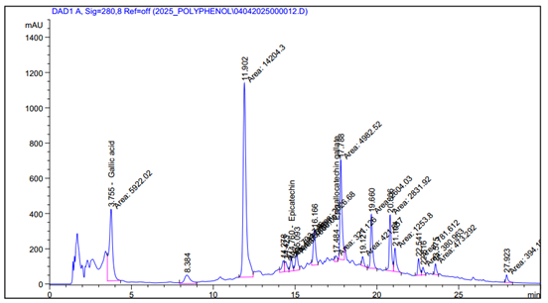
Fig S1 HPLC chromatogram of polyphenolic compounds extracted from Mimosa pigra leaves detected at 280 nm. The chromatographic profile shows the relative abundance and distribution of phenolic constituents across the elution time.
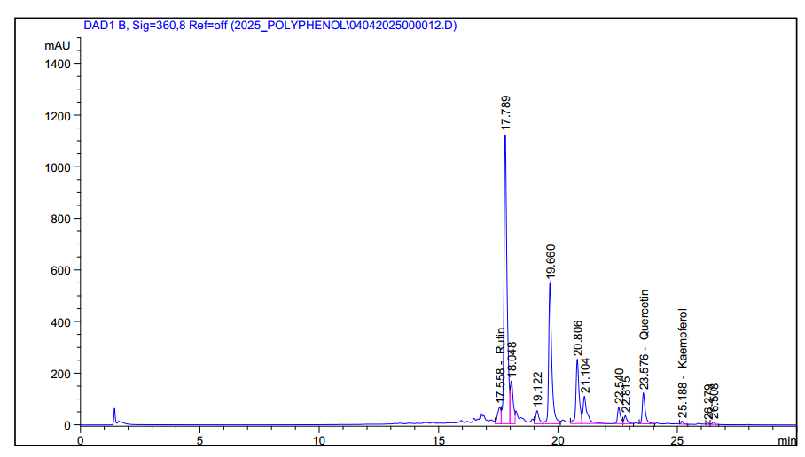

Fig S2 HPLC chromatogram of flavonoid compounds from Mimosa pigra leaf extract detected at 360 nm. Major peaks correspond to rutin, quercetin, and kaempferol, with retention times indicated. The chromatogram illustrates the distribution and relative abundance of flavonoid constituents across the elution profile.

Supplementary Tables
Table S1 Germination responses of competitor species across extract concentrations in Petri-dish assays (7 DAT)
Species | Concentration (mg mL⁻¹) | Germination (%) | Germination inhibition (%) | Mean germination time (days) | Germination index | Seed vigor index
Eleusine indica | 0 | 93.5 ± 1.8 | 0.0 | 2.2 ± 0.1 | 18.3 ± 0.7 | 1410 ± 58
Eleusine indica | 20 | 79.8 ± 2.0 | 14.7 | 2.5 ± 0.1 | 15.1 ± 0.6 | 1032 ± 51
Eleusine indica | 40 | 60.7 ± 2.3 | 35.1 | 3.0 ± 0.2 | 10.8 ± 0.5 | 628 ± 37
Eleusine indica | 80 | 33.9 ± 2.1 | 63.7 | 3.5 ± 0.2 | 6.0 ± 0.4 | 252 ± 21
Eleusine indica | 160 | 11.6 ± 1.5 | 87.6 | 4.0 ± 0.3 | 2.0 ± 0.2 | 74 ± 10
Paspalum conjugatum | 0 | 84.7 ± 2.4 | 0.0 | 2.6 ± 0.1 | 15.7 ± 0.6 | 1098 ± 47
Paspalum conjugatum | 20 | 72.1 ± 2.2 | 14.9 | 2.9 ± 0.1 | 13.0 ± 0.5 | 824 ± 39
Paspalum conjugatum | 40 | 53.6 ± 2.4 | 36.7 | 3.3 ± 0.2 | 9.1 ± 0.4 | 476 ± 31
Paspalum conjugatum | 80 | 29.1 ± 1.9 | 65.6 | 3.9 ± 0.2 | 5.1 ± 0.3 | 183 ± 18
Paspalum conjugatum | 160 | 8.4 ± 1.3 | 90.1 | 4.4 ± 0.3 | 1.5 ± 0.2 | 42 ± 7
Ludwigia hyssopifolia | 0 | 78.9 ± 2.7 | 0.0 | 2.8 ± 0.1 | 14.2 ± 0.5 | 706 ± 35
Ludwigia hyssopifolia | 20 | 67.5 ± 2.5 | 14.4 | 3.0 ± 0.1 | 11.8 ± 0.4 | 540 ± 28
Ludwigia hyssopifolia | 40 | 49.3 ± 2.1 | 37.5 | 3.4 ± 0.2 | 8.3 ± 0.3 | 316 ± 22
Ludwigia hyssopifolia | 80 | 26.8 ± 1.8 | 66.0 | 4.0 ± 0.2 | 4.5 ± 0.3 | 121 ± 14
Ludwigia hyssopifolia | 160 | 6.9 ± 1.1 | 91.3 | 4.6 ± 0.3 | 1.2 ± 0.1 | 24 ± 5
DAT, days after treatment. Seed vigor index integrates germination and seedling length, and therefore captures both emergence probability and early establishment quality.

Table S2 Seedling growth responses across extract concentrations (7 DAT)
Species | Concentration (mg mL⁻¹) | Root length (cm) | Shoot length (cm) | Root inhibition (%) | Shoot inhibition (%) | Fresh biomass (mg seedling⁻¹) | Dry biomass (mg seedling⁻¹)
Eleusine indica | 0 | 5.8 ± 0.2 | 6.7 ± 0.3 | 0.0 | 0.0 | 86.1 ± 3.8 | 15.5 ± 0.7
Eleusine indica | 20 | 4.3 ± 0.2 | 5.6 ± 0.2 | 25.9 | 16.4 | 67.4 ± 3.1 | 12.1 ± 0.5
Eleusine indica | 40 | 2.7 ± 0.1 | 4.3 ± 0.2 | 53.4 | 35.8 | 48.9 ± 2.7 | 8.9 ± 0.4
Eleusine indica | 80 | 1.2 ± 0.1 | 2.8 ± 0.1 | 79.3 | 58.2 | 28.1 ± 2.0 | 4.8 ± 0.3
Eleusine indica | 160 | 0.4 ± 0.1 | 1.5 ± 0.1 | 93.1 | 77.6 | 15.3 ± 1.5 | 2.4 ± 0.2
Paspalum conjugatum | 0 | 5.1 ± 0.2 | 5.9 ± 0.2 | 0.0 | 0.0 | 73.8 ± 3.2 | 13.7 ± 0.6
Paspalum conjugatum | 20 | 3.9 ± 0.2 | 5.0 ± 0.2 | 23.5 | 15.3 | 58.6 ± 2.9 | 10.9 ± 0.5
Paspalum conjugatum | 40 | 2.4 ± 0.1 | 3.9 ± 0.2 | 52.9 | 33.9 | 41.7 ± 2.3 | 7.6 ± 0.4
Paspalum conjugatum | 80 | 1.0 ± 0.1 | 2.4 ± 0.1 | 80.4 | 59.3 | 22.9 ± 1.8 | 4.0 ± 0.3
Paspalum conjugatum | 160 | 0.3 ± 0.1 | 1.1 ± 0.1 | 94.1 | 81.4 | 11.6 ± 1.1 | 1.8 ± 0.2
Ludwigia hyssopifolia | 0 | 4.2 ± 0.2 | 4.8 ± 0.2 | 0.0 | 0.0 | 49.2 ± 2.5 | 8.4 ± 0.4
Ludwigia hyssopifolia | 20 | 3.1 ± 0.1 | 4.0 ± 0.2 | 26.2 | 16.7 | 38.8 ± 2.1 | 6.9 ± 0.3
Ludwigia hyssopifolia | 40 | 1.9 ± 0.1 | 3.0 ± 0.1 | 54.8 | 37.5 | 27.4 ± 1.7 | 5.0 ± 0.3
Ludwigia hyssopifolia | 80 | 0.8 ± 0.1 | 1.9 ± 0.1 | 81.0 | 60.4 | 15.1 ± 1.2 | 2.8 ± 0.2
Ludwigia hyssopifolia | 160 | 0.2 ± 0.0 | 0.8 ± 0.1 | 95.2 | 83.3 | 7.3 ± 0.8 | 1.1 ± 0.1
Across all three species, root growth remained the most sensitive endpoint, a pattern consistent with direct exposure of root tissues to dissolved phytotoxic compounds in the germination substrate.

