Questionnaire on Oral Health Locus of Control for College Students
Dear students, Hello!
Thank you very much for participating in this survey, which is divided into two parts: personal information and responses to questions. Please read the instructions carefully and answer accordingly. This survey will be registered under your real name and will be used as the basis for your subsequent oral consultation. All data will be used solely for experimental purposes and will be kept strictly confidential by the School of Stomatology of Xiamen Medical College. Please fill in with confidence. Thank you for your cooperation and wish you a happy life!

Name [fill-in-the-blank] *
_________________________________

Age [fill-in-the-blank] *
_________________________________

Major (full name) [fill-in-the-blank] *
_________________________________

Contact information (mobile number) *
_________________________________

1. What's your gender? [single-choice question] *
a. Male
b. Female

2. Your urban-rural household registration is [single-choice question] *
a. Urban
b. Rural

3. Which of the following categories does your monthly living expense fall into? [single-choice question] *
a. 1,000 yuan and below
b. 1,000-1,500 yuan
c. 1,500-2,000 yuan
d. 2,000 yuan or more
4. My oral health is largely due to my good luck [single-choice question] *
a. Strongly disagree
b. Disagree
c. A little disagreed
d. Somewhat agree
e. Agree
f. Totally agree

5. The measures taken by oral professionals (healthcare workers, experts, etc.) on me largely determine my oral health condition [single-choice question] *
a. Strongly disagree
b. Disagree
c. A little disagreed
d. Somewhat agree
e. Agree
f. Totally agree

6. My oral health is poor, mainly because I don't take good care of it myself [single-choice question] *
a. Strongly disagree
b. Disagree
c. A little disagreed
d. Somewhat agree
e. Agree
f. Totally agree

7. My oral health problems are often bad luck [single-choice question] *
a. Strongly disagree
b. Disagree
c. A little disagreed
d. Somewhat agree
e. Agree
f. Totally agree

8. The oral professionals I have contact with are the main factor affecting my oral health [single-choice question] *
a. Strongly disagree
b. Disagree
c. I somewhat disagree
d. Somewhat agree
e. Agree
f. Totally agree

9. I'm responsible for this regardless of my oral health condition [single-choice question] *
a. Strongly disagree
b. Disagree
c. A little disagreed
d. Somewhat agree
e. Agree
f. Totally agree

10. How my oral health develops largely depends on luck [single-choice question] *
a. Strongly disagree
b. Disagree
c. A little disagreed
d. Somewhat agree
e. Agree
f. Totally agree

11. When my oral health improves, it is usually because my dentist is doing a good job [single-choice question] *
a. Strongly disagree
b. Disagree
c. A little disagreed
d. Somewhat agree
e. Agree
f. Totally agree

12. If I have any dental health problems, my actions will determine the process of solving that problem [single-choice question] *
a. Strongly disagree
b. Disagree
c. A little disagreed
d. Somewhat agree
e. Agree
f. Totally agree

- Select the one from the following 10 pictures that you think is most similar to your teeth condition [fill-in-the-blank question] *
_________________________________
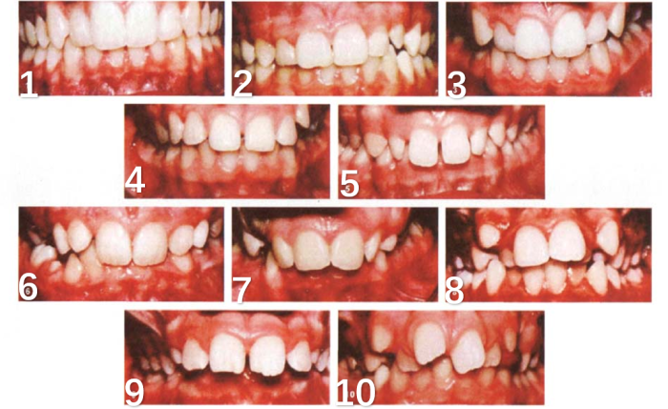

14.What is your history or intention regarding orthodontic treatment? [single-choice question] *
a. I have undergone orthodontic treatment in the past
b. I am planning to undergo orthodontic treatment in the future
c. I have no history or plans for orthodontic treatment.

