Green space exposure predicts manic episodes in bipolar disorder: one year longitudinal analysis using smartphone-derived GPS data
Guth, M. ¹*, Bittendorf, C.A. ², Krug, C. ³, Mühlbauer, E. ³, Severus, W.E. ^{4, 5}, Bauer, M. ³, Reichert, M. ^{6,7} Ludwig, V.M. ³, & Ebner-Priemer, U. W.^{2,7}

1) Faculty of Sport Science, Department of eHealth and Sports Analytics, Ruhr-University Bochum, Bochum, Germany
2) Mental mHealth Lab, Institute of Sports and Sports Science, Karlsruhe Institute of Technology, Karlsruhe, Germany.
3) Department of Psychiatry and Psychotherapy, University Hospital Carl Gustav Carus, Technical University Dresden, Dresden, Germany.
4) Faculty of Medicine Carl Gustav Carus, Technical University Dresden, Dresden, Germany
5) Asklepios Klinik Nord-Ochsenzoll, Hamburg, Germany.
6) Department of Sport and Exercise Science, Faculty of Natural and Life Sciences, University of Salzburg, Salzburg, Austria.
7) Department of Psychiatry and Psychotherapy, Central Institute of Mental Health, University of Heidelberg, Medical Faculty Mannheim, Mannheim, Germany.
*Corresponding author

Supplementary Material
- Clinical and Self-Rated Validation of Phase Definitions
Supplementary Table S1: Mean (± SD) Scores of Clinician-Rated and Self-Rated Measures Across Baseline and the Eleven Mood Phases
Phase | YMRST  Mean | BRMRS  Mean | MADRS  Mean | CGI-S BD  Mean | Self-Rating  Mean | YMRS  SD | BRMRS  SD | MADRS  SD | CGI-S BD  SD | Self-Rating  SD
Euthymia | 1.06 | 0.49 | 4.26 | 1.37 | 49.89 | 1.88 | 1.13 | 5.31 | 0.70 | 10.46
Depression  Early Prodromal | 0.75 | 0.34 | 11.25 | 1.97 | 45.43 | 2.04 | 0.80 | 6.38 | 0.93 | 13.80
Depression  Late Prodroma | 0.78 | 0.28 | 11.76 | 1.86 | 42.89 | 2.03 | 0.77 | 6.91 | 0.92 | 14.77
Depression  First Week | 0.54 | 0.14 | 19.84 | 2.29 | 39.71 | 1.24 | 0.57 | 8.55 | 1.51 | 14.60
Depression  Second Week | 0.59 | 0.15 | 19.86 | 2.36 | 35.27 | 1.28 | 0.59 | 8.66 | 1.52 | 14.82
Depression  Ongoing Weeks | 0.61 | 0.11 | 24.90 | 2.13 | 31.14 | 1.08 | 0.32 | 10.62 | 1.68 | 16.31
Mania  Early Prodromal | 3.44 | 1.75 | 5.89 | 1.87 | 51.90 | 2.79 | 1.74 | 6.43 | 0.87 | 9.43
Mania  Late Prodromal | 3.54 | 1.96 | 5.41 | 1.96 | 50.73 | 2.79 | 1.80 | 6.37 | 0.89 | 10.63
Mania  First Week | 9.57 | 5.33 | 4.52 | 3.00 | 54.88 | 5.07 | 2.74 | 5.82 | 1.12 | 9.37
Mania  Second Week | 9.66 | 5.39 | 4.53 | 3.01 | 57.11 | 5.05 | 2.73 | 5.85 | 1.13 | 10.33
Mania  Ongoing Weeks | 9.98 | 5.32 | 3.92 | 3.25 | 51.24 | 4.42 | 2.22 | 4.49 | 1.03 | 10.40

- ROC Plots
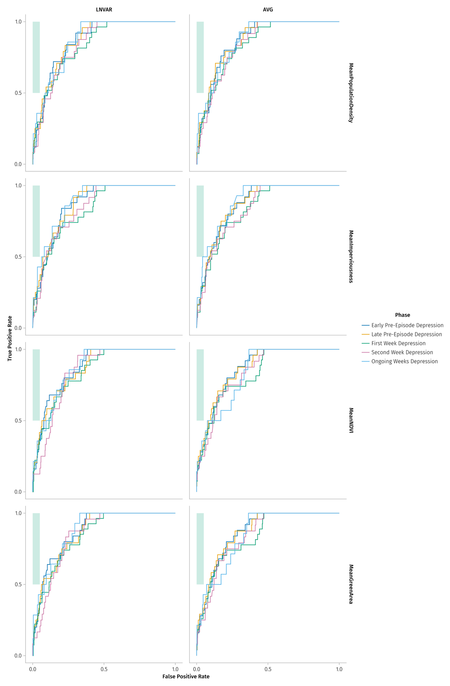
Supplementary Figure S 1: Predictive performance of moving average and Variance for Populations Density, Imperviousness, NDVI and Greenarea in anticipating depressive episodes. ROC curves show the ability to predict different phases of depression. The x-axis represents the false positive rate, and the y-axis the true positive rate. Curves near the top-left indicate higher accuracy. Colors indicate phases: dark blue – Early Pre-Episode depression, yellow – Late Pre-Episode depression, green – First Week depression, pink – Second Week depression, light blue - Ongoing Weeks Depression Additionally, the teal shaded area indicates the combination of high sensitivity (> 50%) and high specificity (> 95%) required for clinical applicability

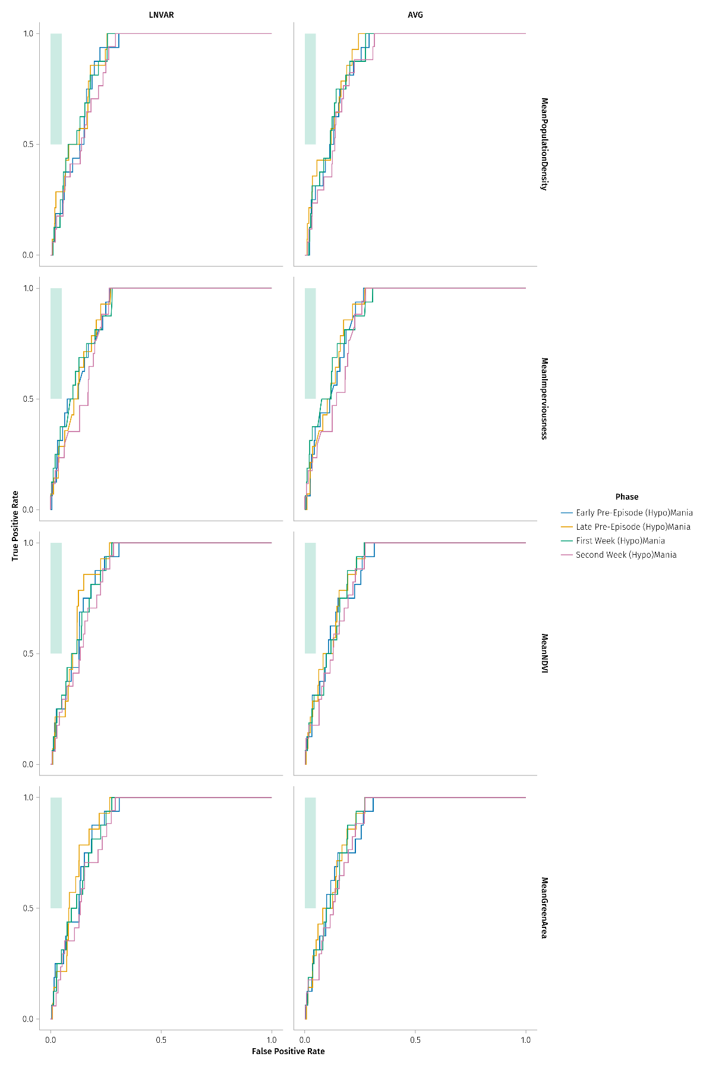

Supplementary Figure S 2: Predictive performance of moving average and Variance for Populations Density, Imperviousness, NDVI and Greenarea in anticipating (hypo)manic episodes. ROC curves show the ability to predict different phases of (hypo)mania. The x-axis represents the false positive rate, and the y-axis the true positive rate. Curves near the top-left indicate higher accuracy. Colors indicate phases: blue – Early Pre-Episode (Hypo)Mania, yellow – Late Pre-Episode (Hypo)Mania, green – First Week (Hypo)Mania, pink – Second Week (Hypo)Mania. Additionally, the blue-green shaded area indicates the combination of high sensitivity (> 50%) and high specificity (> 95%) required for clinical applicability

