Supplementary Material S1: Description of measures

S1.1 Internet Gaming Disorder Scale-Short Form (IGDS9-SF)
IGDS9-SF was used to assess an individual's engagement with internet games and potential gaming disorder. Developed in accordance with DSM-5 diagnostic criteria for gaming disorder, it consists of nine items reflecting core symptoms: preoccupation with gaming, withdrawal symptoms, tolerance, loss of control, loss of interest in other activities, continued use despite negative consequences, deception regarding gaming, use of gaming to escape negative moods, and jeopardizing significant relationships. Responses are summed to yield a total score, with scores ≥21 is indicating a of high risk for IGD. The Chinese version of the scale demonstrates satisfactory psychometric properties, including high internal consistency (Cronbach's α = 0.9), as well as good criterion and construct validity [1]. It has been widely adopted and shows notable advantages over other IGD assessment tools in both clinical and research contexts [2].

S1.2 Depression-Anxiety-Stress Scale (DASS-21)
The DASS-21 is a simplified version of the DASS-42 [3], consisting of three subscales (depression, anxiety, and stress), each containing 7 items. The depression subscale covers aspects such as depressed mood, hopelessness, devaluation of life, self-deprecation, lack of interest/engagement, anhedonia, and inertia. Scoring categories are as follows: normal (0–9), mild (10–13), moderate (14–20), severe (21–27), and extremely severe (28+). The anxiety subscale includes autonomic arousal, skeletal muscle effects, situational anxiety, and subjective experience of anxious affect. Scoring categories: normal (0–7), mild (8–9), moderate (10–14), severe (15–19), and extremely severe (20+). The stress subscale assesses sensitivity to chronic non-specific arousal, difficulty relaxing, nervous arousal, being easily upset/agitated, irritability/over-reactivity, and impatience. Scoring categories: normal (0–14), mild (15–18), moderate (19–25), severe (26–33), and extremely severe (34+). The Chinese version of the DASS-21 demonstrates high internal consistency (Cronbach's α > 0.85) [4] and aligns well with the English version, with Cronbach's α values for depression, anxiety, and stress being 0.94, 0.87, and 0.91, respectively [5].

S1.3 The Eating Attitudes Test (EAT-26)
The EAT-26 is an improved version of the original EAT-40, primarily used to measure an individual's level of eating disorder symptoms and concerns. It serves as a rapid and effective tool for identifying potential eating disorder issues [6]. The Chinese version of the EAT-26 demonstrates good internal consistency (Cronbach's α = 0.822–0.922) and is considered a reliable, valid, and cost-effective instrument [7]. It includes factors such as dieting, bulimia and food preoccupation, and oral control, enabling accurate identification of eating disorders such as anorexia nervosa.

S1.4 Cognitive Failures Questionnaire (CFQ)
The Cognitive Failures Questionnaire (CFQ) assesses the frequency and severity of everyday cognitive errors, such as lapses in attention, memory, and action execution. Higher scores indicate greater susceptibility to cognitive failures in daily functioning.The Chinese version demonstrates high internal consistency (Cronbach's α = 0.96) [8].

S1.5 Interaction Anxiousness Scale (IAS)
The IAS is a scale used to assess the level of anxiety or tension an individual experiences in social interactions. The Chinese version exhibits high internal consistency (Cronbach's α = 0.86) [9]. The IAS typically consists of a series of statements or questions, and individuals rate their feelings on a scale, primarily describing fears related to interactions, such as engaging in conversations.

S1.6 The UPPS-P Impulsive Behavior Scale
The UPPS-P Impulsive Behavior Scale assesses five distinct dimensions of impulsivity: Urgency, lack of Premeditation, lack of Perseverance, Sensation Seeking, and Positive Urgency. The Chinese version demonstrates Cronbach's α values of 0.83, 0.70, 0.69, 0.81, and 0.84 for these subscales, respectively. It is used to assess distinct traits and tendencies related to impulsive behavior [10]. Specific impulsivity traits are associated with distinct behaviors. For example, smoking status and severity of nicotine dependence show significant correlations with all impulsivity-related traits except reward sensitivity [11]. These traits can be used to understand and predict various impulsive behaviors.

S1.7 Behavioral Inhibition/Activation System Scale (BIS/BAS Scale)
The BIS/BAS Scale is based on Gray's theory of the Behavioral Inhibition System (BIS) and Behavioral Activation System (BAS). The BIS is sensitive to signals of punishment and non-reward and is associated with anxiety and avoidance behaviors. The BAS is sensitive to signals of reward and is linked to approach and reward-seeking behaviors. The BAS comprises three subdimensions: Reward Responsiveness, which reflects an individual's sensitivity and positive response to rewards; Drive, which involves the motivation to take active steps to achieve rewards; and Fun Seeking, which focuses on the pursuit and experience of pleasure in the process of seeking rewards. The Chinese version of the scale demonstrates good reliability, with a Cronbach's α of 0.85 [12].

S1.8 Connor-Davidson Resilience Scale (CD-RISC)
The CD-RISC was developed to assess an individual's psychological resilience, which refers to the ability to adapt effectively in the face of adversity, trauma, tragedy, threats, or other significant stressors. The CD-RISC includes three dimensions: toughness, self-reliance, and optimism. The Chinese version demonstrates good reliability, with a Cronbach's α exceeding 0.93 [13].

S1.9 Adverse Childhood Experiences-International Questionnaire (ACE-IQ)
The ACE-IQ assesses child maltreatment and neglect, violence outside the home, household dysfunction, and absence of parent(s). The scale demonstrates good reliability, showing strong internal consistency and significant correlation in comparison with The Childhood Trauma Questionnaire Short Form (CTQ-SF), with a Cronbach's α of 0.818 [14, 15].

Supplementary Material S2: Sample characteristics
Supplementary Table 1: Characteristics of study participants consisting of individuals with internet gaming disorder (IGD) and the healthy control (HC) participants.
Characteristic | Total (N=13512) | IGD (N=2143) | HC (N=11369)
Age (years), median (IQR) | 17.34 (16-19) | 17.69 (16-19) | 17.27 (16-19)
Male, n (%) | 5713 (42.3) | 1213 (56.6) | 4500 (39.6)
IGDSF, median (IQR) | 15.13 (10-18) | 25.44 (22-27) | 13.18 (10-16)
Educational background, n (%)
Elementary school | 45 (0.3) | 13 (0.6) | 32 (0.3)
Junior high school | 577 (4.3) | 120 (5.6) | 457 (4.0)
Senior high school | 3961 (29.3) | 614 (28.7) | 3347 (29.4)
College degree | 6677 (49.4) | 959 (44.8) | 5718 (50.3)
Bachelor's degree | 2105 (15.6) | 404 (18.9) | 1701 (15.0)
Master's degree | 147 (1.1) | 33 (1.5) | 114 (1.0)
DASS-Depression, median (IQR) | 7.83 (0-12) | 12.55 (4-18) | 6.94 (0-12)
DASS-Anxiety, median (IQR) | 8.49 (2-14) | 12.62 (6-18) | 7.71 (2-12)
DASS-Stress, median (IQR) | 9.35 (2-14) | 13.93 (8-18) | 8.48 (2-14)
Self-mutilation, n (%)
Never thought | 9666 (71.6) | 1243 (58.0) | 8423 (74.1)
Intended to but didn't | 2162 (16.0) | 480 (22.4) | 1682 (14.8)
Have tried | 1684 (12.5) | 420 (19.6) | 1264 (11.1)
Suicide, n (%)
Never thought | 10116 (74.9) | 1303 (60.8) | 8813 (77.5)
Intended to but didn't | 2912 (21.6) | 704 (32.9) | 2208 (19.4)
Have tried | 484 (3.6) | 136 (6.3) | 348 (3.1)
Eating attitudes test, median (IQR) | 6.68 (1-9) | 8.54 (2-12) | 6.34 (1-9)
Cognitive failures questionnaire, median (IQR) | 58.54 (48-70) | 66.15 (55-76) | 57.11 (47-68)
Interaction anxiousness scale, median (IQR) | 43.20 (36-49) | 47.22 (40-54) | 42.44 (36-48)
Impulsive behavior scale, median (IQR) | 45.07 (41-49) | 47.58 (44-52) | 44.59 (40-49)
Behavioral Inhibition scale, median (IQR) | 19.52 (18-21) | 19.95 (19-21) | 19.45 (18-21)
Behavioral Activation scale, median (IQR) | 36.98 (35-40) | 37.73 (36-41) | 36.84 (35-40)
Resilience scale, median (IQR) | 51.56 (42-61) | 48.01 (39-55) | 52.22 (43-62)
Adverse Childhood Experiences, median (IQR) | 41.38 (40-44) | 40.27 (38-44) | 41.60 (40-44)
Note. IQR: interquartile range

Supplementary Material S3: Model fit indices for the latent profile analysis
Supplementary Table 2: Model fit indices for latent profile analysis of IGD risk groups
Fit index | Number of Latent Profiles
Fit index | 2 | 3 | 4 | 5
BIC | 119495.4 | 116586.1 | 115962.5 | 115580.2
ICL | 119597.3 | 117444.5 | 116667.9 | 116534.1
AIC | 115720.3 | 111506.6 | 109.155.8 | 107143.1
LMRT | 0.001 | 0.001 | 0.001 | 0.001
Note. BIC: Bayesian Information Criterion; ICL: Integrated Completed Likelihood; AIC: Akaike Information Criterion; LMRT: Lo-Mendell-Rubin Likelihood Ratio Test.

Supplementary Material S4: Discriminative Features for Profile Identification

To evaluate the clinical utility and separability of the four latent profiles, a random forest classification model was implemented using a stratified 70/30 training–test split. The model's performance on the held-out test set was excellent, with an overall accuracy of 85.3%, a Kappa of 0.795, and all class-specific AUCs surpassing 0.95. These results indicate that the identified profiles are statistically robust and clinically distinguishable, supporting their action ability for predictive and screening applications.

To identify the key variables distinguishing the four subgroups, we computed the SHapley Additive exPlanations (SHAP) values based on a representative subset of 500 individuals sampled from the training set, thus aiming to pinpoint the most critical variables to aid in clinical assessment. The mean absolute SHAP values should be interpreted by focusing on their relative magnitudes across features, which reflect their comparative importance for classification.
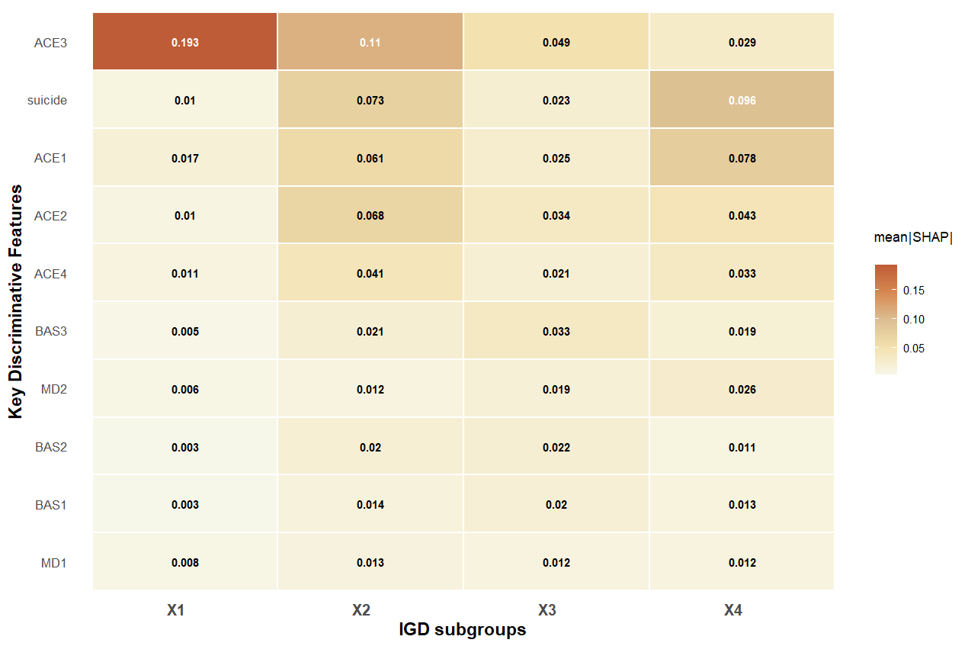
Supplementary Figure 1: Heatmap of mean absolute SHAP values for the top 10 discriminative features

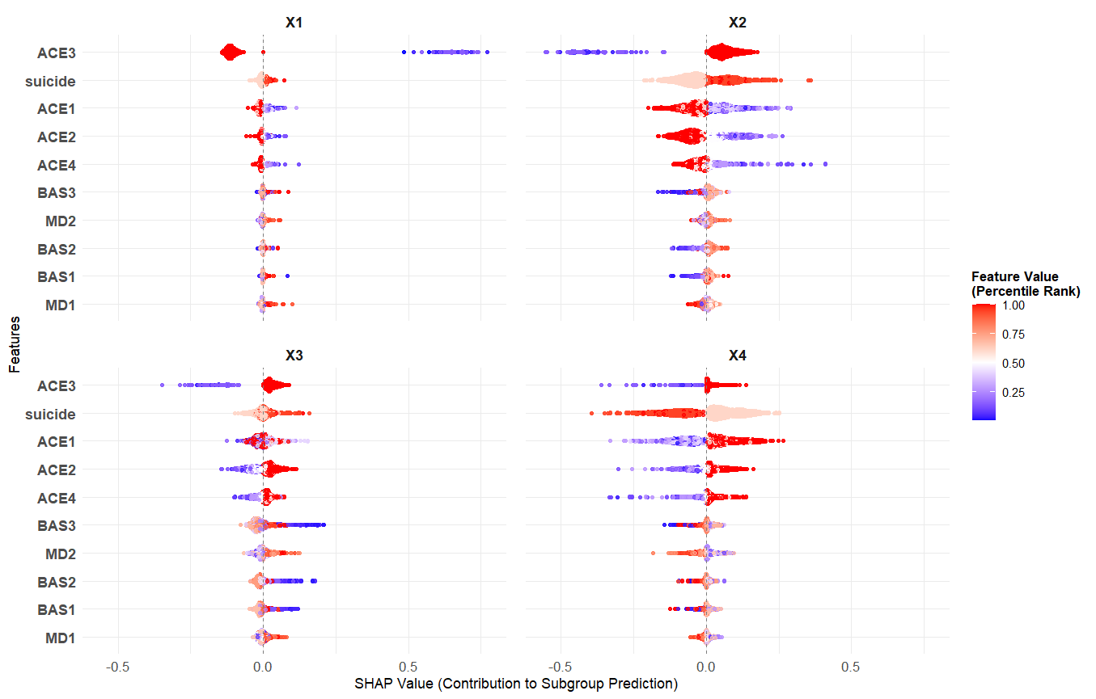
Supplementary Figure 2: Beeswarm plot of SHAP values for the top 10 discriminative features
Note. Based on training set (n=1502), displaying the 10 most important features

The SHAP analysis identified the top 10 features most critical for the random forest model to discriminate between the four pre-defined risk profiles, as visualized in the heatmap (Supplementary Figure 1). Family dysfunction (ACE3) emerged as the most powerful discriminative feature across subgroups, possessing the highest mean SHAP value for classifying X1 (0.193), X2 (0.11), and X3 (0.049). This indicates that despite differing clinical presentations, the presence or absence of family dysfunction is a key marker the model uses to tell these subgroups apart.

The SHAP analysis further delineated the distinct combinations of features that served as the most potent identifiers for each profile. For X1 ("Emotional–Cognitive dysfunction"), the model's classification was predominantly driven by adverse childhood experiences, specifically family dysfunction (ACE3), abuse/neglect (ACE1), and parent loss (ACE4). X2 ("Moderate-Risk with Prevalent Family Dysfunction") was best distinguished by a combination of family dysfunction (ACE3), suicidality, and extra-familial violence (ACE2). The classification of X3 ("Executive Dyscontrol") relied most on family dysfunction (ACE3), extra-familial violence (ACE2), and fun-seeking (BAS3). Finally, the model identified X4 ("High-Adversity Compensatory") most strongly through the features of suicidality, abuse/neglect (ACE1), and extra-familial violence (ACE2).

The beeswarm plot (Supplementary Figure 2) illustrates the decision logic of the random forest classifier in distinguishing the four IGD subgroups. The clear lateral separation of color gradients—representing feature values—along the SHAP value axis demonstrates a strong, monotonic relationship between each feature’s magnitude and its contribution to classification. This pattern aligns closely with the distinct configurations identified through latent profile analysis, reinforcing the internal consistency between the machine-learning and person-centered approaches.

For instance, family dysfunction (ACE3), which was lowest in Profile X1 and higher in Profiles X2-4 according to the LPA, demonstrates a perfectly coherent pattern in the beeswarm plot. In X1, low values of ACE3 (blue points) are clustered on the right (positive SHAP values), pushing samples towards this classification. Conversely, in Profile X2, X3, and X4, high values of ACE3 (red points) are found on the right, confirming that elevated family dysfunction is a key driver for distinguishing these subgroups.

A more complex, non-linear relationship was identified for fun-seeking (BAS3) within Profile X3. Here, both high (red) and low (blue) values of BAS3 are associated with positive SHAP values, pushing samples towards the "Executive Dyscontrol" classification, while medium values are associated with negative SHAP values, pulling samples away from this profile. This U-shaped relationship suggests that the "Executive Dyscontrol" subgroup is characterized by a polarization in fun-seeking tendencies. Individuals in this group may either be highly susceptible to seeking immediate reward through gaming or, conversely, may exhibit an abnormally low drive for pleasure, which could also manifest as a dysregulated behavior. This nuanced pattern was captured by the machine learning model but would be obscured in traditional linear analyses.

In summary, the integration of random forest and SHAP analysis not only validated the robustness of the four-profile solution but also translated it into a clinically actionable framework. By identifying the most discriminative markers for each subgroup, this data-driven approach provides a foundation for more targeted and efficient clinical assessment of the heterogeneous presentations of Internet Gaming Disorder.

Reference
[1] Chen I-H, Ahorsu DK, Pakpour AH, et al. Psychometric Properties of Three Simplified Chinese Online-Related Addictive Behavior Instruments Among Mainland Chinese Primary School Students. Front Psychiatry 2020; 11: 875.
[2] King DL, Chamberlain SR, Carragher N, et al. Screening and assessment tools for gaming disorder: A comprehensive systematic review. Clin Psychol Rev 2020; 77: 101831.
[3] Lovibond PF, Lovibond SH. The structure of negative emotional states: Comparison of the Depression Anxiety Stress Scales (DASS) with the Beck Depression and Anxiety Inventories. Behav Res Ther 1995; 33: 335–343.
[4] Cao C-H, Liao X-L, Jiang X-Y, et al. Psychometric evaluation of the depression, anxiety, and stress scale-21 (DASS-21) among Chinese primary and middle school teachers. BMC Psychol 2023; 11: 209.
[5] Pezirkianidis C, Karakasidou E, Lakioti A, et al. Psychometric Properties of the Depression, Anxiety, Stress Scales-21 (DASS-21) in a Greek Sample. Psychology 2018; 09: 2933–2950.
[6] McLean CP, Kulkarni J, Sharp G. The 26-Item Eating Attitudes Test (EAT-26): Psychometric Properties and Factor Structure in Vegetarians and Vegans. Nutrients 2023; 15: 297.
[7] Kang Q, Chan RCK, Li X, et al. Psychometric Properties of the Chinese Version of the Eating Attitudes Test in Young Female Patients with Eating Disorders in Mainland China. Eur Eat Disord Rev 2017; 25: 613–617.
[8] Yu M, Chair SY, Chan CWH, et al. Testing the psychometric properties of the Chinese version of the Heart Failure Learning Needs Inventory. Heart Lung 2010; 39: 262–274.
[9] Jia G, Dai H, Chu Y, et al. Psychometric evaluation of the Chinese version of social anxiety scale for social media users and cross-sectional investigation into this disorder among college students. Compr Psychiatry 2022; 116: 152328.
[10] Zhang Y, Qiu X, Ren Q, et al. Psychometric Properties of the Chinese version of UPPS-P Impulsive Behavior Scale. Front Psychiatry 2020; 11: 185.
[11] Kale D, Stautz K, Cooper A. Impulsivity related personality traits and cigarette smoking in adults: A meta-analysis using the UPPS-P model of impulsivity and reward sensitivity. Drug Alcohol Depend 2018; 185: 149–167.
[12] Wang W, Liu H. The mediating role of behavioral systems in linking physical activity and anxiety symptoms in college students. Sci Rep 2025; 15: 6724.
[13] Tu Z, He J, Wang Z, et al. Psychometric properties of the 10-item Connor-Davidson Resilience Scale in Chinese military personnel. Front Psychol 2023; 14: 1163382.
[14] Mi XY, Hou SS, Fu ZY, et al. [Reliability and validity of the Chinese version of adverse childhood experiences international questionnaire in parents of preschool children]. Beijing Da Xue Xue Bao 2023; 55: 408–414.
[15] Xu H, Li M, Cai J, et al. Comparison of ACE-IQ and CTQ-SF for child maltreatment assessment: Reliability, prevalence, and risk prediction. Child Abuse Negl 2023; 146: 106529.

