Supplementary Material

Supplementary Tables.

Supplementary Table 1. Anthropometric measures. Female newborns

Gestational Age | Weight (grams) Mean (SD) | Length (cm)  Mean (SD) | Head Circumference (cm)  Mean (SD)
24.1 (1) | 584 | 31 | 21.5
26 | 731.4(98.0) | 30.9(2.5) | 23.1(1.3)
27 | 816(193.1) | 31.8(3.3) | 23.5(2.6)
28 | 855(35.4) | 35.5(0.7) | 25.5(0.7)
29 | 1045.7(38.4) | 37.5(1.5) | 26.8(0.3)
30 | 1438.7(707.0) | 37.7(2.1) | 28.3(3.2)
31 | 1226.5(126.0) | 38.9(0.9) | 27.5(1.1)
32 | 1538(228.8) | 41.0(2.1) | 30.2(1.1)
33 | 2061(245.8) | 42.5(2.7) | 31.3(1.3)
34 | 2053.1(314.8) | 44.4(2.3) | 31.7(1.2)
35 | 2187.8(238.9) | 43.8(2.0) | 32.3(1.5)
36 | 2399.9(299.9) | 45.3(1.7) | 32.5(1.2)
37 | 2606(304.8) | 46.5(1.6) | 33.1(1.3)
38 | 2942(319.5) | 47.9(1.8) | 33.9(1.1)
39 | 3114.1(311.8) | 48.6(1.7) | 34.2(1.2)
40 | 3239(326.5) | 48.9(1.5) | 34.3(1.0)
41 (1) | 3261 | 47.0 | 35.5

Supplementary Table 2. Anthropometric measures. Male newborns

Gestational Age | Weight (grams) Mean (SD) | Length (cm)  Mean (SD) | Head Circumference (cm)  Mean (SD)
23.0 (1) | 586 | 30 | 21.5
26 | 812.0(250.8) | 34.8(3.8) | 24.3(2.0)
27 | 947.5(142.4) | 36.3(2.9) | 25.5(0.7)
28 | 874.3(229.0) | 33.7(1.5) | 25.3(1.3)
29 | 951.5(61.5) | 34.8(0.4) | 24.8(0.4)
30 | 1476.5(94.0) | 40.3(2.5) | 29.3(0.4)
31 | 1533.0(157.7) | 39.7(1.4) | 29.1(1.8)
32 | 1698.3(254.5) | 41.1(2.3) | 30.3(1.5)
33 | 1899.2(287.9) | 43.0(1.4) | 30.7(1.5)
34 | 2162.6(211.6) | 44.8(1.7) | 32.5(1.4)
35 | 2275.9(259.7) | 45.0(1.6) | 32.9(1.4)
36 | 2489.1(309.6) | 46.2(2.0) | 33.5(1.5)
37 | 2763.6(357.7) | 47.2(1.7) | 33.8(1.3)
38 | 3026.4(364.5) | 48.4(1.6) | 34.4(1.2)
39 | 3203.1(331.7) | 49.0(1.7) | 34.7(1.2)
40 | 3375.7(342.8) | 49.5(1.6) | 35.0(1.1)
41 (1) | 3657(338.0) | 51.3(1.8) | 35.0 (0)

Supplementary Figure 1. Smoothed study population (HUSI) vs international postnatal GCs. Length (cm)
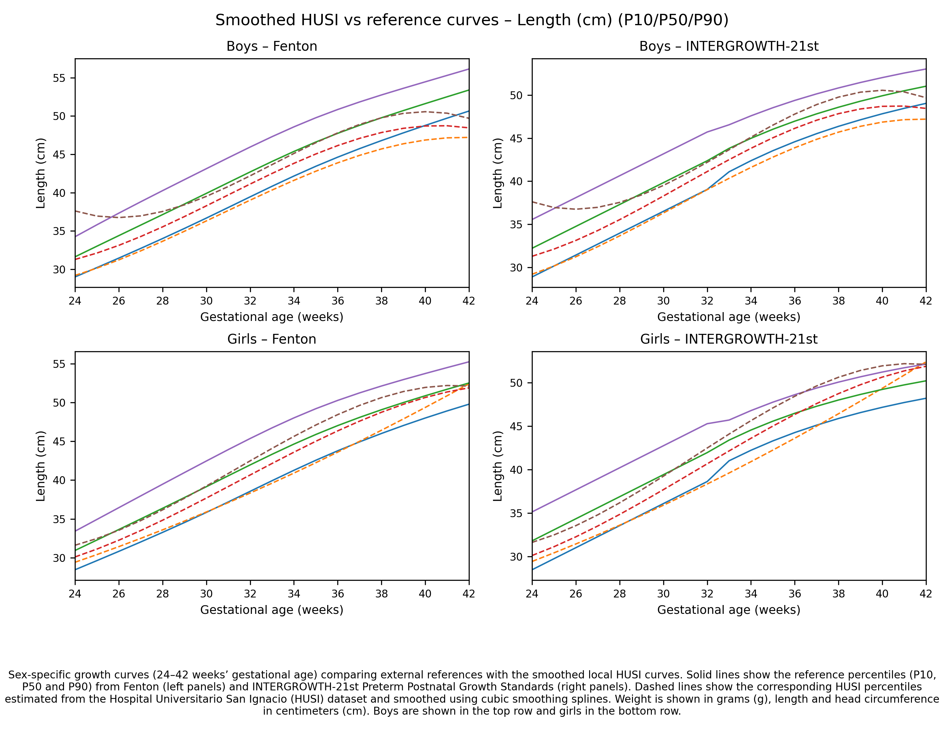

Supplementary Figure 2. Smoothed study population (HUSI) vs international postnatal GCs. Head Circumference (cm)

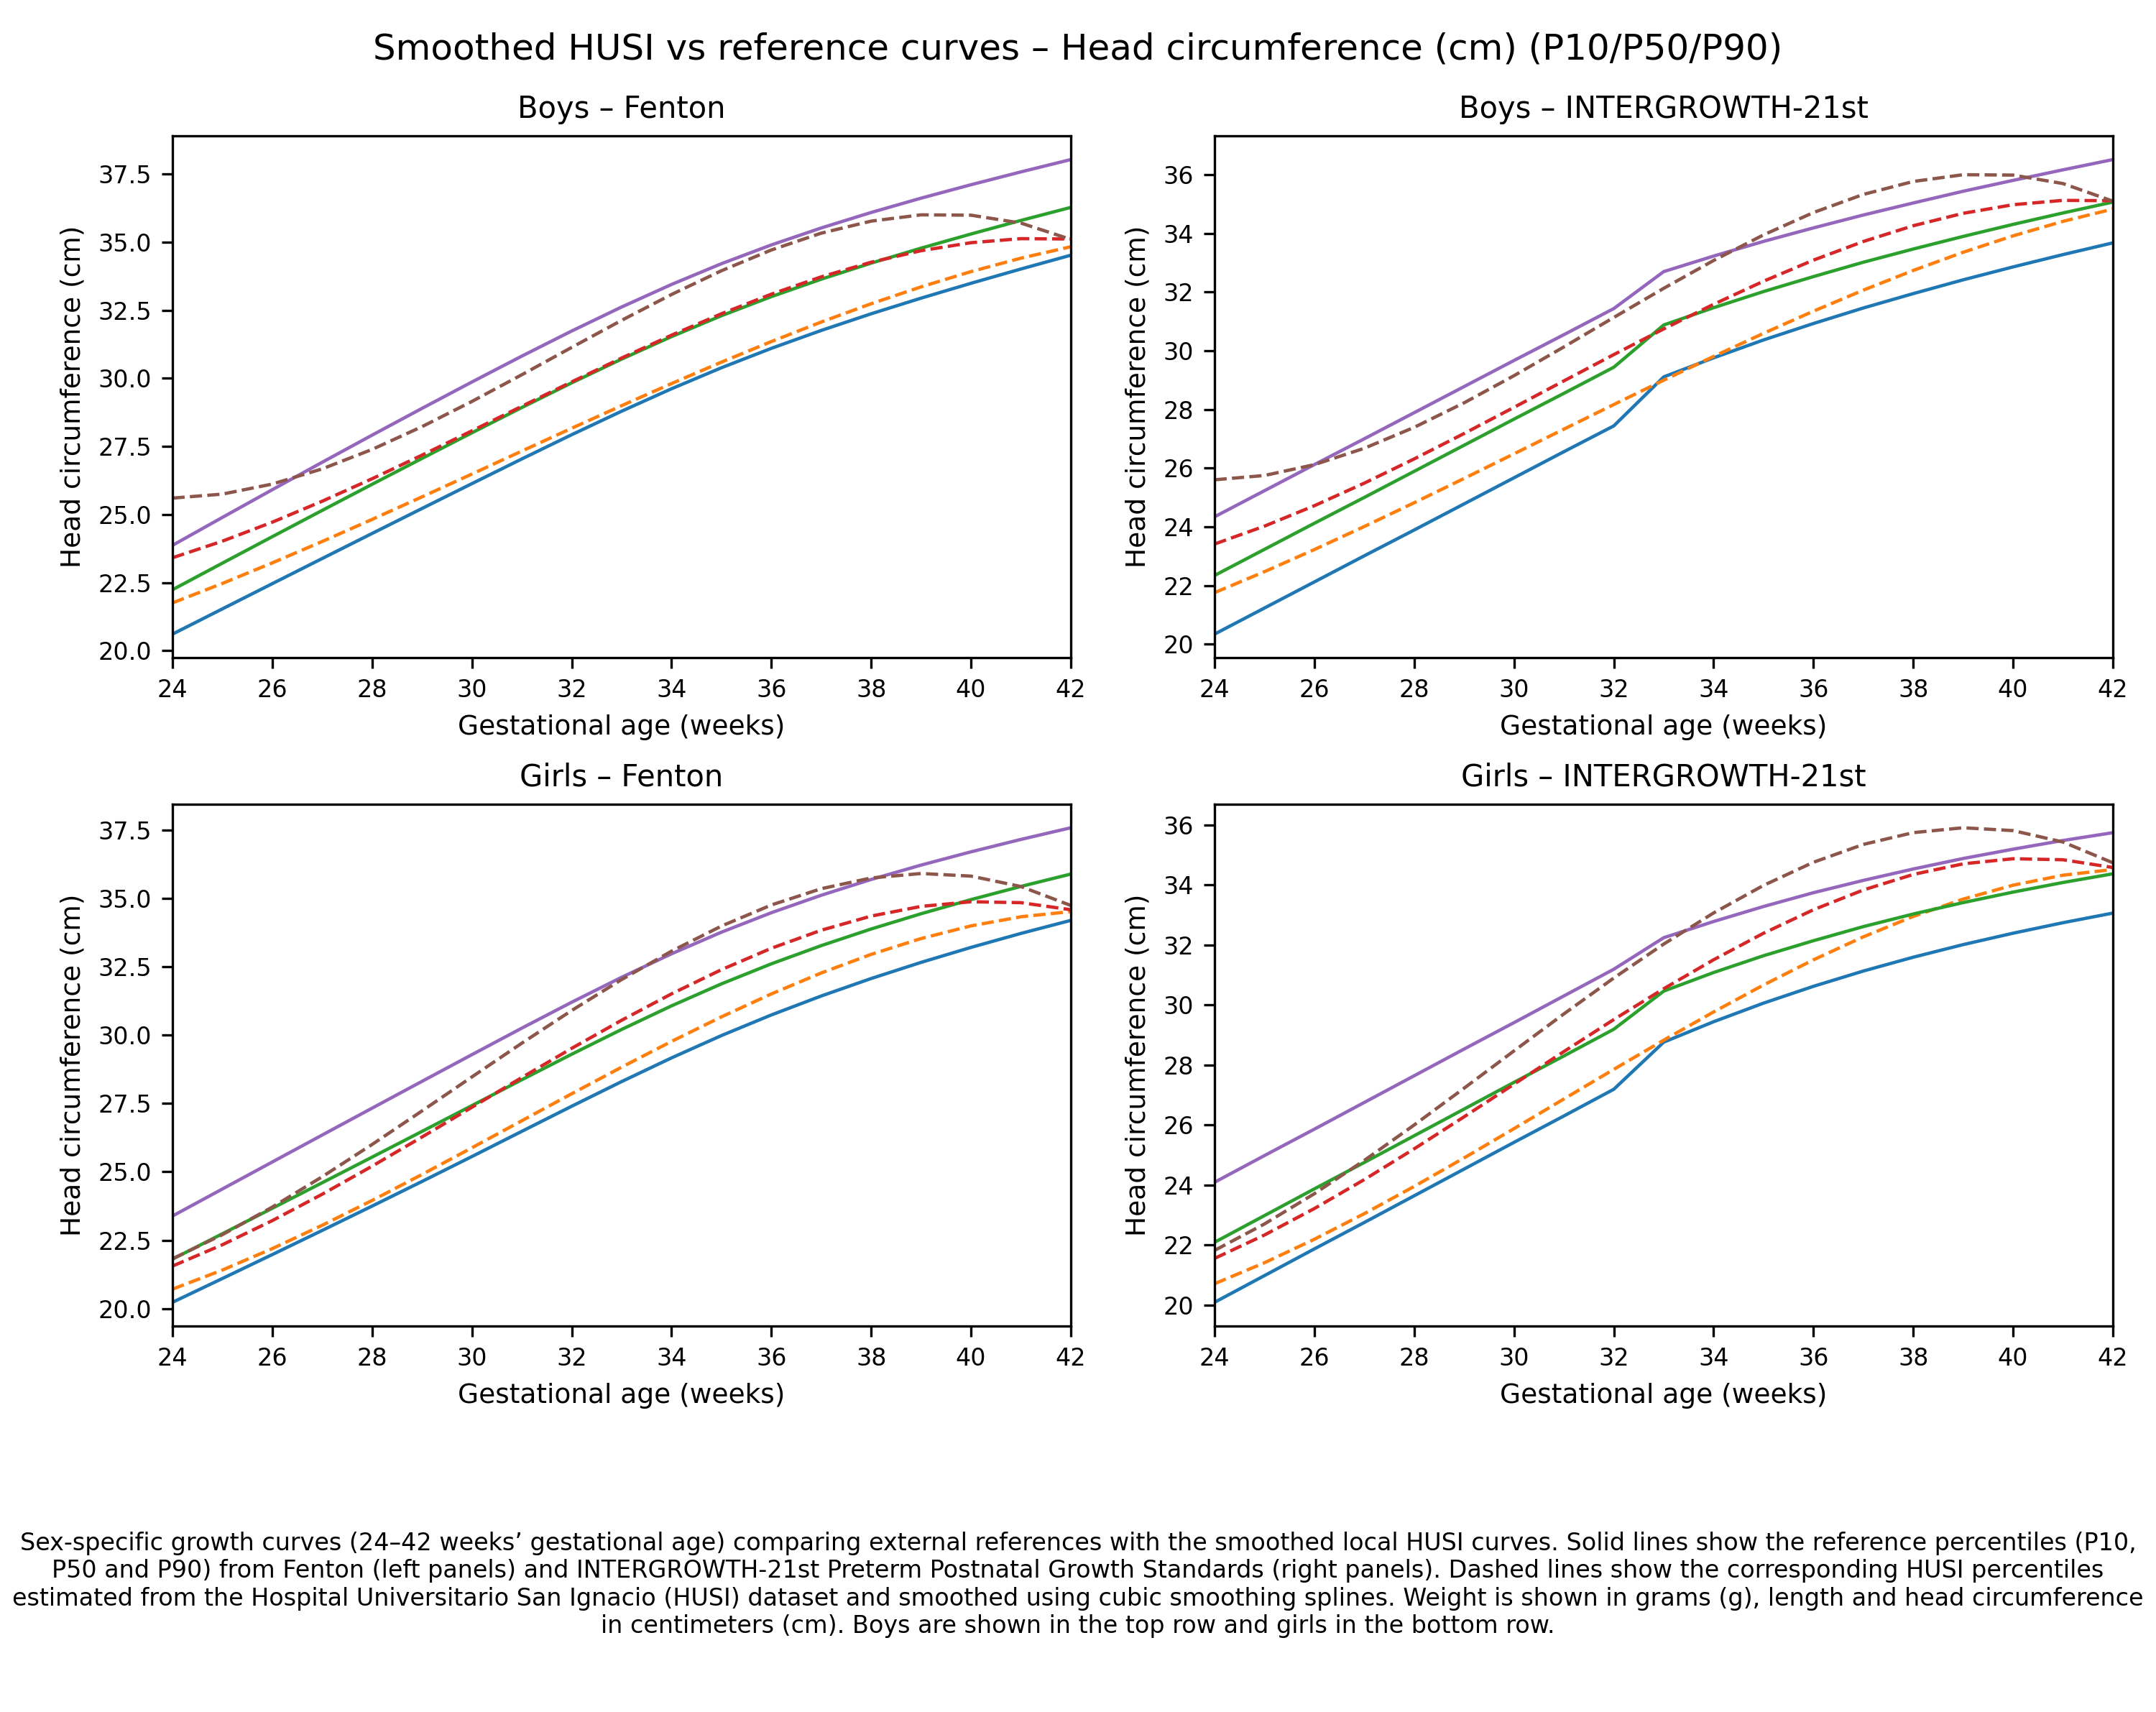

Supplementary Table 3. Perinatal characteristics and main outcomes in the first month of life

Characteristic N=1694 |  | n | (%)
Female |  | 862 | 50.9
Male |  | 832 | 49.1
Delivery room resuscitation |  | 137 | 8.1
Metabolic acidemia without asphyxia criteria |  | 109 | 6.4
Perinatal asphyxia |  | 20 | 1.2
RDS (surfactant deficiency) |  | 77 | 4.6
Transient tachypnea of the newborn |  | 151 | 8.9
Transient respiratory distress (resolution in the first hours of life) |  | 49 | 2.9
Congenital pneumonia |  | 17 | 1.0
Pneumothorax |  | 4 | 0.2
Other respiratory distresses |  | 69 | 4.1
Hypoglycemia |  | 203 | 12.0
Polycythemia |  | 26 | 1.5
Jaundice without incompatibility requiring phototherapy |  | 411 | 24.3
Early sepsis |  | 72 | 4.3
Late sepsis |  | 40 | 2.4
NEC |  | 7 | 0.4
Transient newborn ileus |  | 75 | 4.5
Feeding problems |  | 185 | 10.9
Required mechanical ventilation |  | 63 | 3.7
Required other respiratory support |  | 216 | 12.8
Conventional nasal cannula |  | 150/216 | 69.4
C-PAP |  | 48/216 | 22.2
Nasal ventilation |  | 11/216 | 5.1
High flow nasal cannula |  | 7/216 | 3.2
Intraventricular hemorrhage (IVH) | without IVH | 1679 | 99.1
Intraventricular hemorrhage (IVH) | GI IVH | 6 | 0.4
Intraventricular hemorrhage (IVH) | GII IVH | 3 | 0.2
Intraventricular hemorrhage (IVH) | GIII IVH | 2 | 0.1
Intraventricular hemorrhage (IVH) | GIV IVH | 4 | 0.2
ROP |  | 3 | 0.2
BPD |  | 50 | 3.0
PDA with hemodynamic repercussions |  | 28 | 1.7
Oxygen dependency at hospital discharge without BPD |  | 124 | 7.3
Death |  | 16 | 0.9
Early neonatal death |  | 12/16 | 75.0
Late neonatal death |  | 4/16 | 25.0
Required hospitalization |  | 796 | 47.0
Follow-up in the Kangaroo Mother Care Program (preterm/LBW) |  | 374 | 22.1
SGA= Small for Gestational age; AGA= Adequate for gestational age; LGA= Large for Gestational Age; RDS= respiratory distress
syndrome; NEC=Necrotizing Enterocolitis; CPAP= Continuous Positive Airway Pressure; GI IVH= Grade I Intraventricular Hemorrhage.
GII IVH= Grade II Intraventricular Hemorrhage; GIII IVH= Grade III Intraventricular Hemorrhage; GIV IVH= Grade IV Intraventricular
Hemorrhage; ROP= Retinopathy of prematurity; BPD= Bronchopulmonary dysplasia; PDA= persistent ductus arteriosus; LBW= Low Birth.

