Appendices A–C are provided below to support transparency, traceability, and replication of the reported analysis.

Appendix A. Indicator Matrix (Evaluation Framework)
Table A1 presents the indicator matrix used in this study to evaluate green-school design performance. Indicators are defined as measurable metrics that can be extracted from drawings, schedules, and published project documentation. Each indicator is mapped to the most relevant reference criteria across LEED, CHPS, and Mostadam to support transparent benchmarking.
Table A1. Indicator Matrix (Evaluation Framework).
Dimension | Indicator | Metric / Unit | How measured (from drawings / docs) | Framework reference | Notes
Site & Open Space | Site area per student | m²/student | Site boundary area ÷ total enrolled students | MoE / benchmarking | Used to check compliance and density
Site & Open Space | Green area ratio | % of site | (Total planted/vegetated area ÷ site area) × 100 | LEED / CHPS / Mostadam | Include softscape and planted courtyards
Site & Open Space | Green area per student | m²/student | Total planted/vegetated area ÷ students | LEED / CHPS / Mostadam | Key gap indicator in Saudi cases
Site & Open Space | Outdoor courts/playgrounds per student | m²/student | Outdoor courts + play areas ÷ students | CHPS / MoE | Exclude parking/roads
Site & Open Space | Shaded outdoor area ratio | % of usable outdoor | Shaded area (canopies/trees/arcades) ÷ total usable outdoor area | LEED / CHPS | Critical for hot-arid contexts
Site & Open Space | Outdoor learning spaces | count + m² | Count and area of dedicated outdoor classrooms/gardens | CHPS / LEED (learning) | Supports ESD and experiential learning
Site & Open Space | Heat-mitigation surfaces | % of hardscape treated | High-albedo / permeable / shaded hardscape proportion (if documented) | LEED (heat island) | Where documented
Mobility & Safety | Pedestrian–vehicle separation | qualitative (0–5) | Check if student paths are separated from drop-off/parking | CHPS / CPTED | Site circulation and safety
Water | Irrigation efficiency readiness | qualitative (0–5) | Presence of drip irrigation/zones; native planting strategy | LEED / Mostadam | Design-intent evidence
Water | Stormwater / runoff management | qualitative (0–5) | Permeable areas, bioswales, retention (if shown) | LEED / Mostadam | Design-stage evidence
Energy | Daylighting access | % of regularly occupied areas | Window-to-floor heuristics or daylighting notes | LEED / CHPS | As available in docs
Energy | Natural ventilation potential | qualitative (0–5) | Cross-ventilation paths, operable windows, courtyards | CHPS / climate design | Hot-arid adapted strategies
IEQ | Low-emitting materials intent | qualitative (0–5) | Specs/notes indicating low-VOC materials | LEED / CHPS | Document-based
IEQ | Acoustic comfort provisions | qualitative (0–5) | Notes/specs for acoustic treatment (if provided) | LEED / CHPS | Optional if documented
Learning Spaces | Classroom area per student | m²/student | Net classroom area ÷ students per classroom | MoE / benchmarking | Supports capacity and comfort
Learning Spaces | Flexible learning zones | count + qualitative | Presence of breakout spaces/multi-purpose learning areas | CHPS / pedagogy | Links to hybrid learning readiness
Operations | Waste sorting / recycling points | count | Locations for waste segregation shown on plans | Mostadam / LEED | Operational enabling design
Landscape & Ecology | Biodiversity/edible gardens | count + m² | Dedicated garden/planting zones for learning | CHPS / ESD | Supports curriculum integration

Appendix B. Scoring Rubric and Composite Index
This appendix provides the scoring rubric (1–5) applied in this study for key outdoor/green-space indicators. Thresholds are reported to ensure transparency and enable replication of the scoring and benchmarking procedure.
B1. Example scoring rubric (1–5)
Table B1. Example scoring rubric (1–5) for key outdoor/green-space indicators.
Indicator | Score 1 (Very low) | Score 3 (Moderate) | Score 5 (High / best practice)
Green area ratio (% of site) | <5% | 10–20% | ≥30%
Green area per student (m²/student) | <0.5 | 1.5–3.0 | ≥4.0
Outdoor courts/play areas per student (m²/student) | <1.0 | 1.5–2.5 | ≥3.0
Shaded outdoor area (% of usable outdoor) | <20% | 40–60% | ≥75%
Outdoor learning spaces (availability) | None | At least 1 dedicated space | Multiple integrated spaces across campus
B2. Composite index (illustrative)
To compare cases, each indicator i can be normalized to a 0–1 scale and combined using weights wᵢ:
• Normalization (min–max): Nᵢ = (xᵢ − min(xᵢ)) / (max(xᵢ) − min(xᵢ))
• Composite index: CI = Σ (wᵢ × Nᵢ), where Σwᵢ = 1
Weights may be set as equal across dimensions or assigned based on policy priorities (e.g., higher weight for shading and green-area per student in hot-arid climates).
Appendix C. Case-Study Measurement Sheet and Plan Reference
C1. Measurement sheet template (to document drawing-based measurements)
Table C1. Drawing-based measurement sheet template.
Field | Value | Notes / Source (plan, schedule, appendix)
School name / case code
Site area (m²)
Total student capacity (students)
Green area (m²) – planted/vegetated
Outdoor courts/play areas (m²)
Shaded outdoor area (m²)
Number of outdoor learning spaces (count)
Key notes (circulation separation, shading strategy, planting strategy)
C2. Saudi case indicators (replicating the values used in the manuscript’s Table 1)
Table C2. Saudi case-study indicators (replicating the values used in Table 1).
School | Site area (m²) | Students | Land per student (m²/student) | Courts/outdoor (m²) | Courts per student | Green area (m²) | Green per student | Green ratio (%)
Al-Nafel | 12000 | 2205 | 5.44 | 3153 | 1.43 | 265 | 0.12 | 2.2
Al-Nahdah | 8826.4 | 1835 | 4.81 | 2496 | 1.36 | 165 | 0.09 | 1.9
Al-Rabee | 13925 | 2750 | 5.06 | 3493 | 1.27 | 275 | 0.10 | 2.0
C3. Plan reference (Al-Rabee School – ground floor)
Figure C1 supports drawing-based extraction of outdoor-space and circulation indicators. In the manuscript body, cite this appendix as: “see Appendix C, Figure C1.”
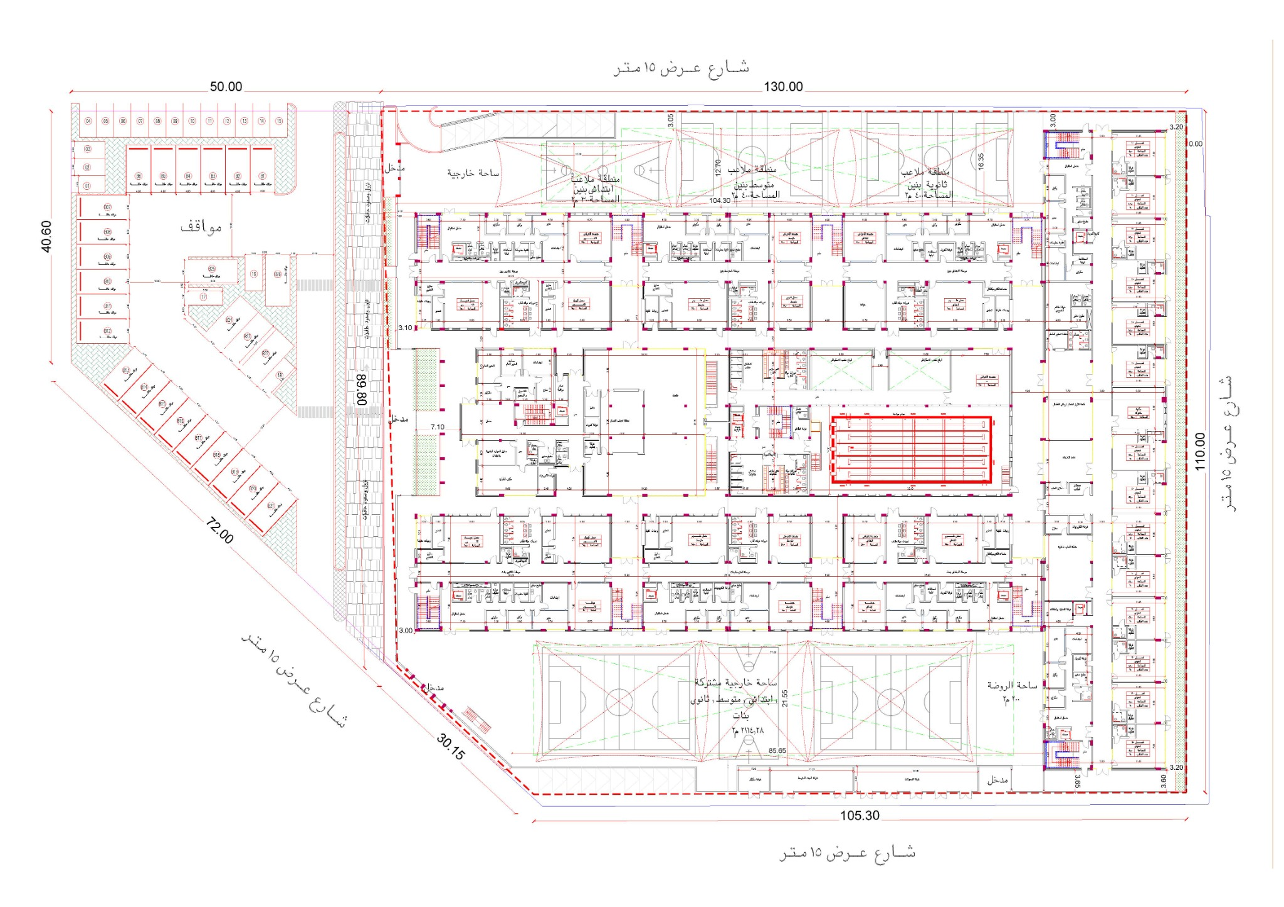
Figure C1. Al-Rabee School – ground floor plan (case-study drawing used for measurements).

