Supplemental Data

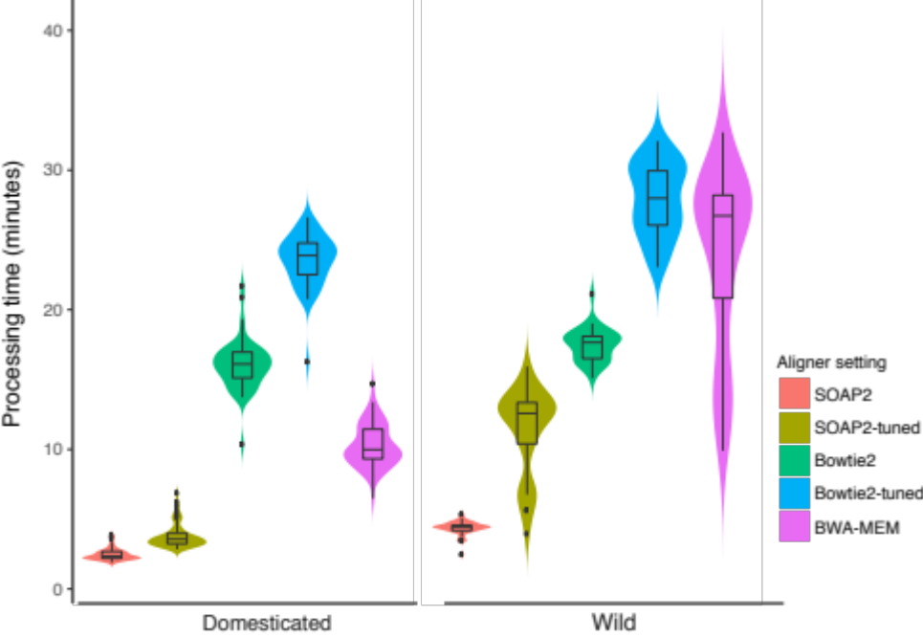

Supplemental Figure 1. Alignment time comparison of different aligners
Alignment percentage of five different aligner settings: SOAP2, SOAP2-tuned, Bowtie2, Bowtie2-tuned and BWA-MEM calculated for domesticated tomatoes and wild relatives. The width of violin plot is proportional to the density of the data. Boxplots inside violin plot indicate quantiles and outliers

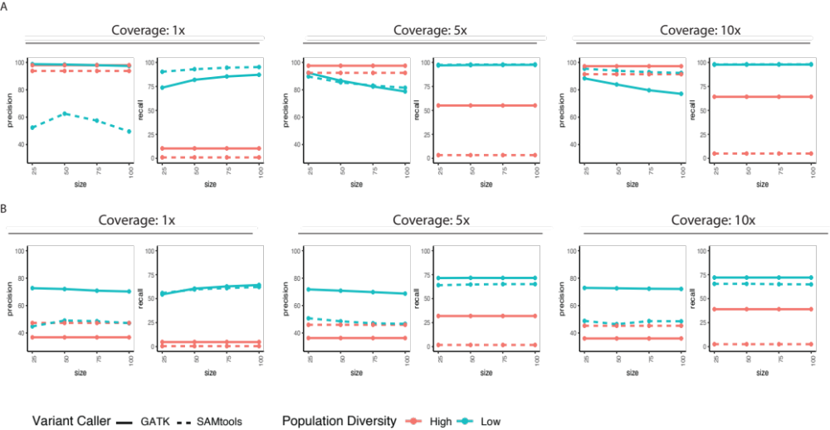
Supplemental Figure 2. Evaluation of variant calling programs using simulated plant genomic datasets
- The comparison of the performance of GATK-HC and SAMtools-mpileup on raw SNPs at different coverages, population diversity and population size.
- The comparison of the performance of GATK-HC and SAMtools-mpileup on raw INDELs at different coverages, population diversity and population size.

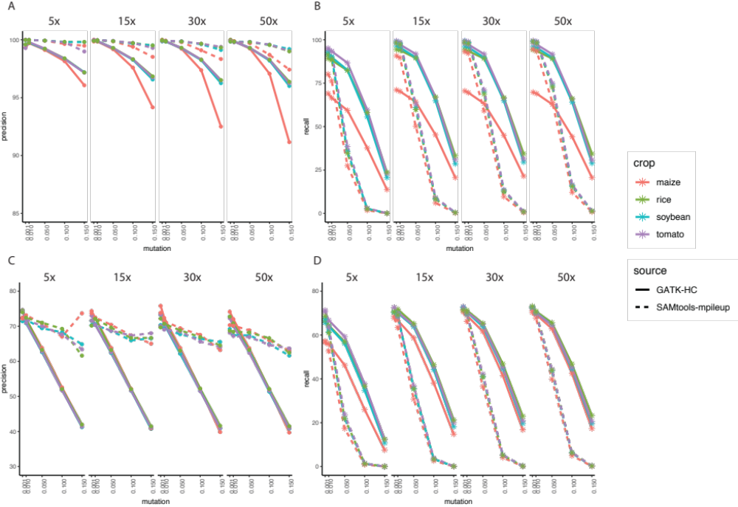
Supplemental Figure 3. Evaluation of different variant calling programs on single genomic dataset
- SNP precision results of GATK-HC and SAMtools-mpileup on single simulated dataset with varied coverages, mutation rates and crop species
- SNP recall results of GATK-HC and SAMtools-mpileup on single simulated dataset with varied coverages, mutation rates and crop species
- INDEL precision results of GATK-HC and SAMtools- on single simulated dataset with varied coverages, mutation rate sand crop species
- INDEL recall results of GATK-HC and SAMtools-mpileup on single simulated dataset with varied coverages, mutation rates and crop species

Supplemental Figure 4. Cross-reference comparison on SNP identification
- Number of SNPs identified using S. lycopersicum or S. pennellii genome assembly as the reference
- SNP identification of four tomato samples was performed in chromosome 1 in S. lycopersicum reference genome. The corresponding physical positions of SNPs in the S. pennellii reference was plotted. The grey dots represented the SNPs that were able to be located at the corresponding positions in S. pennellii genome, red dots represented the SNPs that were unable to be located to corresponding positions in S. pennellii genome. The percentage of corresponding SNPs are written next to the species name.
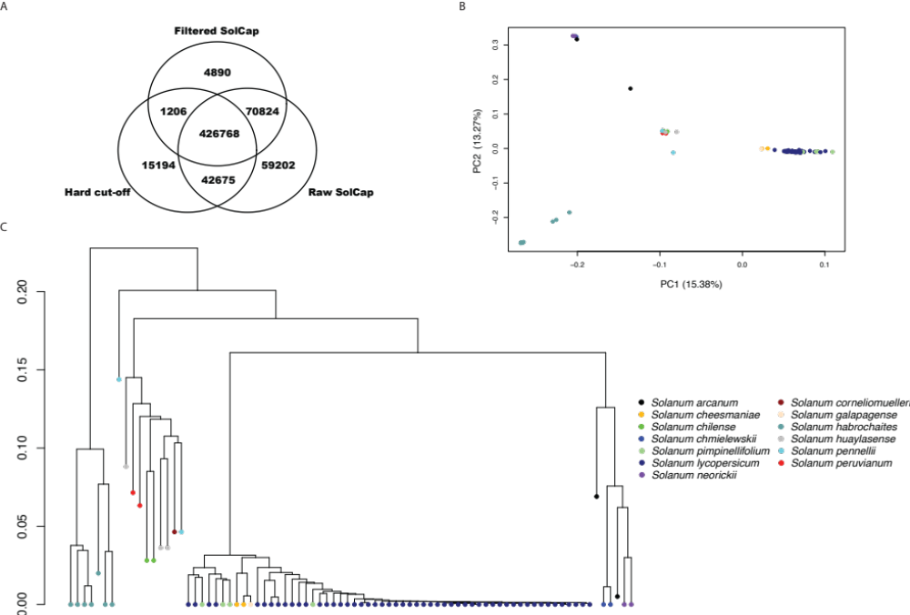

Supplemental Figure 5. Machine-learning based variant filtering
- Venn diagram of SNPs in the 10M region of Chromosome 1 using HARD, ML and COMBINED filtering methods
- Population structure of 82 tomato genomes using high-confidence SNPs
- IBS distance of 82 tomato genomes using high-confidence SNPs

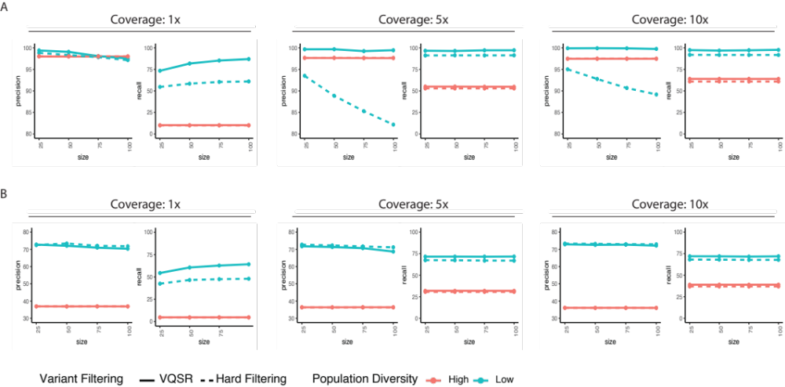
Supplemental Figure 6. Comparison between VQSR and hard-filtering
- The comparison of the performance of VQSR and hard-filtering on SNPs at different coverages, population diversity and population size.
- The comparison of the performance of VQSR and hard-filtering on INDELs at different coverages, population diversity and population size.

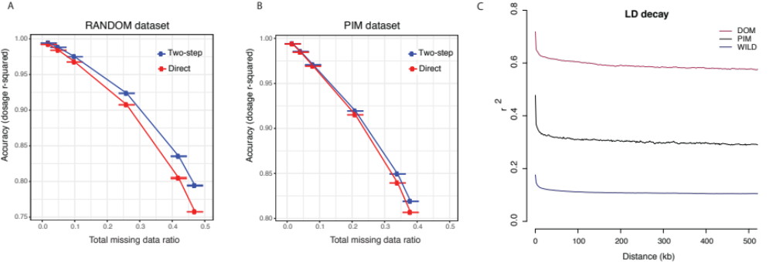
Supplemental Figure 7. Comparison between direct and two-step imputation
- Imputation accuracy using direct imputation and 2-step imputation relative to missing SNPs in 200 random tomato samples
- Imputation accuracy using direct imputation and 2-step imputation relative to missing SNPs in 50 S. pimpinellifolium tomato samples
- Comparison of LD decay of SNPs from different populations.

Supplemental Table 1. Summary of 82 tomato accession
(See excel file SuppTable1_82accession_summary.xlsx)

Supplemental Table 2. Summary of alignment time
(See excel file SuppTable2_alignment_time_summary.xlsx)

Supplemental Table 3. Summary of synteny analysis
(See excel file SuppTable3_SyntenyAnalysisResults.xlsx)

Supplemental Table 4. Summary of different variant filtering results
(See excel file SuppTable4_variant_filtering.xlsx)

