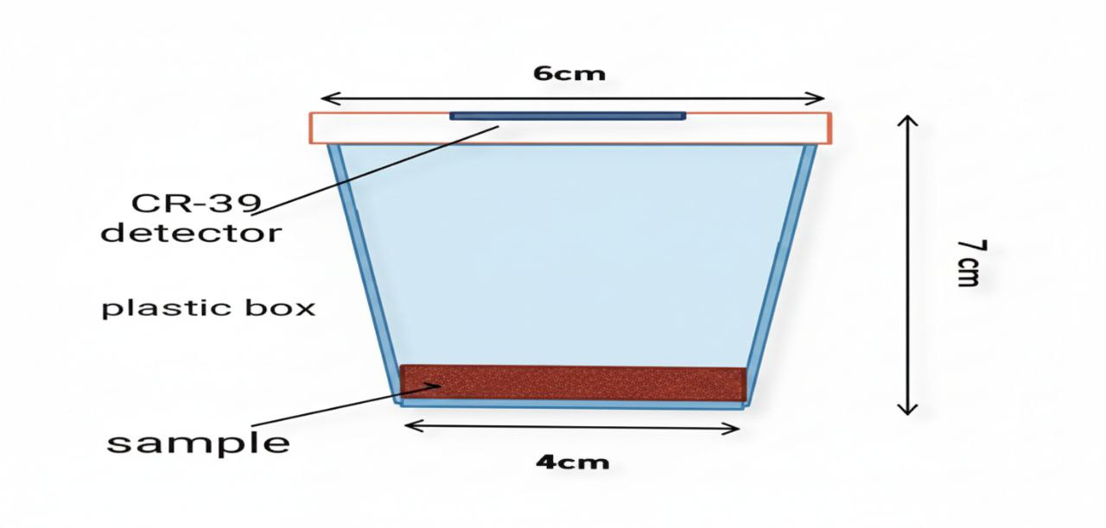
Figure . Special cups for measuring radon gas concentration in fertilizer and pesticide samples.

Table 1. Radon concentrations (Bq.m⁻³) in chemical fertilizer samples.
C_{SRn}  (Bq.m⁻³) | C_{Rn} (Bq.m⁻³) | $ρ$_{Rn}  (Track/mm²) | Origin | Fertilizer name | Sample Cod | Site. No
3957.47 | 34.62 | 198816.568 | Italy | Gardenia | F1
2308.49 | 20.20 | 115976.331 | Belgium | Dab | F2
3038.75 | 26.59 | 152662.721 | Jordan | Smart Fert | F3
6195.45 | 54.21 | 311242.603 | Jordan | Smart Fert | F4
6902.17 | 60.39 | 346745.562 | UAE | Nitropist | F5
4475.74 | 39.16 | 224852.071 | Saudi Arabia | LIBRO | F6
1036.42 | 9.06 | 52071.005 | Netherlands | Ultrasol | F7
3439.20 | 30.09 | 172781.065 | Jordan | Smart Fert | F8
471.07 | 4.12 | 23668.639 | Saudi Arabia | Libro | F9
5088.29 | 44.52 | 255621.301 | Saudi Arabia | Libro | F10
4028.21 | 35.24 | 202366.863 | Netherlands | Ferticrop | F11
2496.94 | 21.84 | 125443.786 | Serbia | Ultrasol | F12
3038.75 | 26.59 | 152662.721 | Turkey | Dab | F13
5276.74 | 46.17 | 265088.757 | Jordan | Dab | F14
3957.47 | 34.62 | 198816.568 | Spain | Single Super  PHOSPHATE | F15
12414.68 | 108.63 | 623668.639 | Jordan | Smart Fert | F16
 | 30.46 | Average

Figure 2. Radon concentration (Bq.m⁻³) in chemical fertilizer samples.

Table 2. Radon concentrations (Bq.m⁻³) in insecticide samples.
C_{SRn}  (Bq.m⁻³) | C_{Rn} (Bq.m⁻³) | $ρ$_{Rn}  (Track/mm²) | Origin | Pesticide name | Sample Cod | Sit. No
1837.42 | 16.07 | 92307.692 | China | Baron | P1
1908.05 | 16.69 | 95857.988 | Lebanon | Cita | P2
1436.86 | 12.57 | 72189.349 | India | Spear | P3
2638.31 | 23.08 | 132544.378 | India | Sword | P4
4876.18 | 42.66 | 244970.414 | Jordan | Cezar | P5
1154.24 | 10.10 | 57988.165 | China | Getara | P6
9399.12 | 82.24 | 472189.349 | China | Efecekt | P7
5394.45 | 47.20 | 271005.917 | Lebanon | Aviator | P8
1319.15 | 11.54 | 66272.189 | Iraq | Qethara | P9
3839.76 | 33.59 | 192899.408 | China | Atlas | P10
1059.96 | 9.27 | 53254.437 | India | Venus | P11
4546.48 | 39.78 | 228402.366 | China | Clipper | P12
1130.70 | 9.89 | 56804.733 | India | Mars | P13
 | 27.28 | Average

Figure 3. Radon concentration (Bq.m⁻³) in insecticide samples.

Table 3. The potential alpha energy(mWL) in chemical fertilizer samples.
PAEC (mWL) | $ρ$_{Rn}  (Track/mm²) |  | Origin | Fertilizer name |  | Sample Cod | Site. No
7.48 | 198816.568 |  | Italy | Gardenia |  | F1
4.36 | 115976.331 |  | Belgium | Dab |  | F2
5.74 | 152662.721 |  | Jordan | Smart Fert |  | F3
11.72 | 311242.603 |  | Jordan | Smart Fert |  | F4
13.05 | 346745.562 |  | UAE | Nitropist |  | F5
8.46 | 224852.071 |  | Saudi Arabia | LIBRO |  | F6
1.96 | 52071.005 |  | Netherlands | Ultrasol |  | F7
6.50 | 172781.065 |  | Jordan | Smart Fert |  | F8
0.89 | 23668.639 |  | Saudi Arabia | Libro |  | F9
9.62 | 255621.301 |  | Saudi Arabia | Libro |  | F10
7.62 | 202366.863 |  | Netherlands | Ferticrop |  | F11
4.72 | 125443.786 |  | Serbia | Ultrasol |  | F12
5.74 | 152662.721 |  | Turkey | Dab |  | F13
9.98 | 265088.757 |  | Jordan | Dab |  | F14
7.48 | 198816.568 |  | Spain | Single Super  PHOSPHATE |  | F15
23.48 | 623668.639 |  | Jordan | Smart Fert |  | F16
8.05 | 213905.325 | Average

Figure 4. The potential alpha energy(mWL) in chemical fertilizer samples.

Table 4. Potential alpha energy (mWL) in pesticide samples.
PAEC (mWL) | $ρ$_{Rn}  (Track/mm²) | Origin |  |  | Pesticide name | Sample Cod | Sit. No
3.47 | 92307.692 | China |  |  | Baron | P1
3.60 | 95857.988 | Lebanon |  |  | Cita | P2
2.71 | 72189.349 | India |  |  | Spear | P3
4.99 | 132544.378 | India |  |  | Sword | P4
9.22 | 244970.414 | Jordan |  |  | Cezar | P5
2.18 | 57988.165 | China |  |  | Getara | P6
17.78 | 472189.349 | China |  |  | Efecekt | P7
10.20 | 271005.917 | Lebanon |  |  | Aviator | P8
2.49 | 66272.189 | Iraq |  |  | Qethara | P9
7.26 | 192899.408 | China |  |  | Atlas | P10
2.05 | 53254.437 | India |  |  | Venus | P11
8.60 | 228402.366 | China |  |  | Clipper | P12
2.13 | 56804.733 | India |  |  | Mars | P13
5.89 | 156668.183 |  |  | Average

Figure 5. Potential alpha energy (mWL) in pesticide samples.

