10. Supplementary material

SM1. Spatial arrangement of the experimental grazing systems at the EPAGRI Experimental Station, Lages, Santa Catarina, Brazil.
This experimental area (Figure SM1) is part of a long-term research platform designed to evaluate multiple ecosystem functions under different pasture management intensities. In addition to nitrous oxide emission studies, the same plots were used for complementary assessments of soil carbon stocks (Camacho et al., 2023), microbial activity (Tomazelli et al., 2023), and carbon cycling, as well as greenhouse gas fluxes associated with livestock systems. The site was selected because it included the four main soil and management gradients representative of the Southern Brazilian Highlands, ensuring regional representativeness for integrated carbon and nitrogen research.
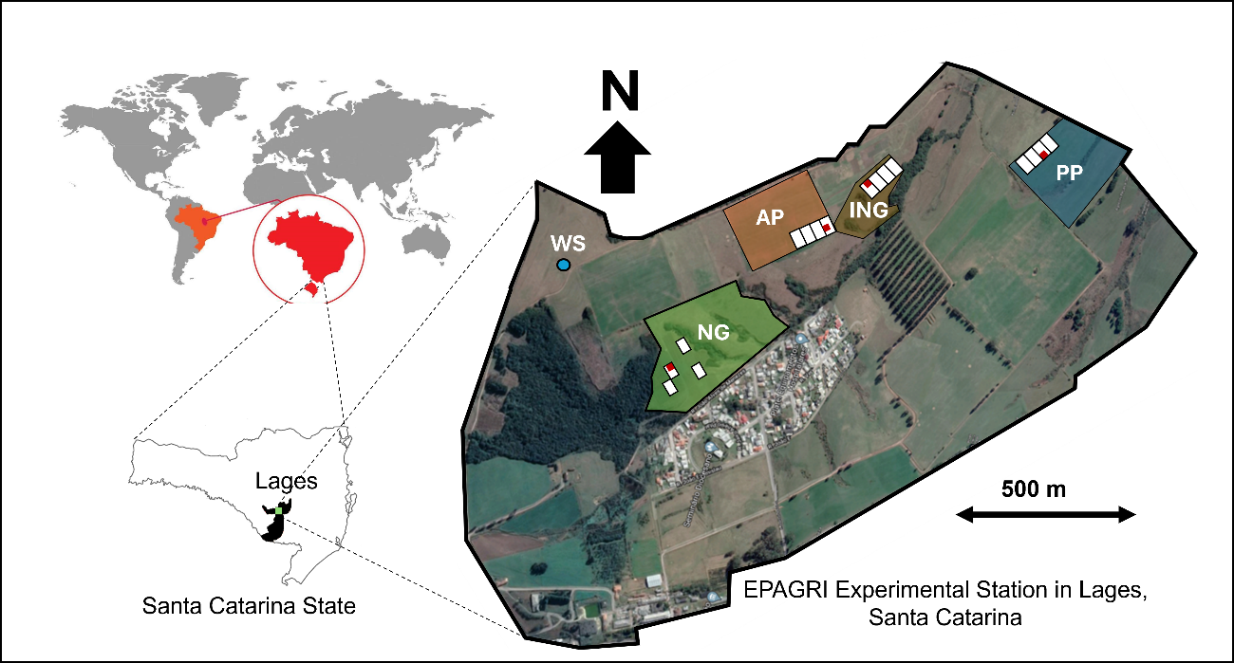
Figure SM1. Spatial arrangement and distribution of the four grazing systems (natural grassland - NG, improved natural grassland - ING, perennial pasture - PP, and annual pasture - AP) at the EPAGRI Experimental Station in Lages, Santa Catarina. The red box within each system indicates the area where N₂O-EF measurements were conducted, and the blue dot marks the location of the meteorological station.

SM2. Physicochemical composition of cattle excreta
Table SM2. Dry matter, pH, carbon, and nitrogen contents of cattle excreta types according to grazing system.
System | DM | pH | C |  | N |  |  | C | N
 | g kg⁻¹ |  | g kg⁻¹ | g L⁻¹ | g kg⁻¹ | g L⁻¹ | kg ha⁻¹ |  | kg ha⁻¹
 | Dung
NG | 155.15 | 6.63 | 549.30 | - | 1.79 | - | 154,089.70 |  | 503.70
ING | 137.59 | 7.09 | 535.35 | - | 2.20 | - | 133,184.50 |  | 547.68
PP | 125.57 | 7.05 | 507.29 | - | 2.15 | - | 115,181.70 |  | 488.72
AP | 128.80 | 7.01 | 529.22 | - | 2.22 | - | 123,249.80 |  | 517.43
 | Urine
NG | - | 8.08 | - | 18.64 | - | 0.43 | 898.69 |  | 21.02
ING | - | 8.08 | - | 5.26 | - | 0.15 | 253.60 |  | 7.49
PP | - | 8.36 | - | 7.39 | - | 0.25 | 356.09 |  | 12.21
AP | - | 8.32 | - | 8.16 | - | 0.35 | 393.30 |  | 17.07
Note: Natural grassland (NG), improved natural grassland (ING), perennial pasture (PP), and annual pasture (AP). For dung: DM=dry matter content, pH (pH-H₂O), C=carbon content, N=nitrogen content, C and N concentration (g kg⁻¹), C and N input (kg m⁻²), and stock of C and N (g m⁻² and kg ha⁻¹). For urine: C and N concentrations (g L⁻¹), and corresponding inputs and stocks of C and N (kg m⁻², g m⁻², and kg ha⁻¹).

SM3. Total nitrogen applied across grazing systems
Table SM3. Total nitrogen applied (Kg N ha⁻¹) from each N source across four grazing systems in the Southern Brazilian Highlands.
 | NG | ING | PP | AP
Dung | 503.70 | 547.68 | 488.72 | 517.43
Urine | 212.57 | 103.74 | 71.91 | 107.55
Urea |  | 180.00 | 180.00 | 180.00
Note: Values represent the total nitrogen applied per hectare for each N source (urea, urine, and dung) according to the management practices of natural grassland (NG), improved natural grassland (ING), perennial pasture (PP), and annual pasture (AP) systems. Nitrogen application rates were standardized among replicates and used to calculate N₂O emission factors (EFs) following the IPCC (2019) methodology.

