SUPPLEMENTARY MATERIALS
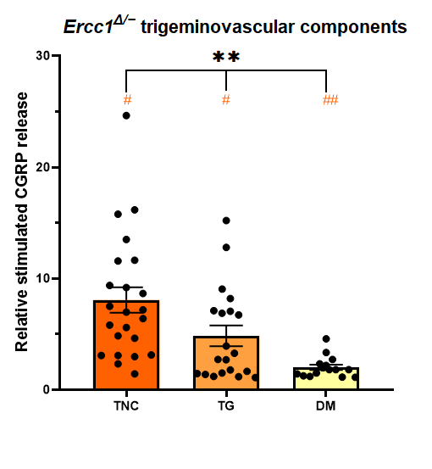
Supplemental figure 1 – Bar plots with the mean ± SEM of the relative stimulated calcitonin gene-related peptide (CGRP) release ratios of the trigeminal nucleus caudalis (TNC, n = 23), trigeminal ganglion (TG, n = 20), and dura mater (DM, n = 15) after potassium chloride (KCl) administration in Ercc1^{Δ/−} mice, indicating overall significant differences between the three groups (** indicates overall P-value < 0.0001).

Post-hoc tests indicated significant differences between TNC versus TG and TNC versus DM, but not between TG versus DM. # indicates statistical significance with an adjusted P-value < 0.05 of TNC versus TG, while ## indicates statistical significance with an adjusted P-value < 0.0001 of TNC versus DM.
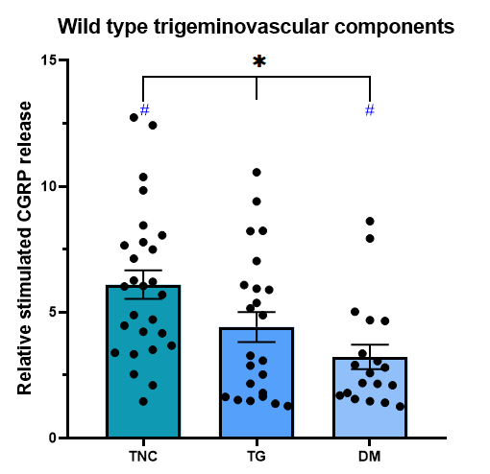
Supplemental figure 2 – Bar plots with the mean ± SEM of the relative stimulated calcitonin gene-related peptide (CGRP) release ratios of the trigeminal nucleus caudalis (TNC, n = 27), trigeminal ganglion (TG, n = 23), and dura mater (DM, n = 19) after potassium chloride (KCl) administration in wild type mice, indicating overall significant differences between the three groups (* indicates overall P-value < 0.05).

Post-hoc tests indicated significant differences between TNC versus DM, but not between TNC versus TG nor between TG versus DM. # indicates statistical significance with an adjusted P-value < 0.05.

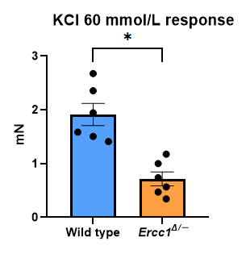
Supplemental figure 3 – Bar plot with the mean ± SEM contractile responses to 60 mmol/L potassium chloride (KCl) of coronaries in wild type (n = 6) and Ercc1^{Δ/−} mice (n = 6). An asterisk (*) indicates a P-value < 0.05).

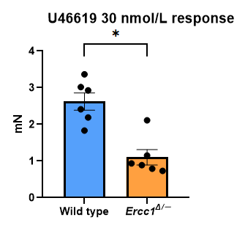
Supplemental figure 4 – Bar plot with the mean ± SEM contractile responses to 30 nmol/L U46619 of coronaries in wild type (n = 6) and Ercc1^{Δ/−} mice (n = 6). An asterisk (*) indicates a P-value < 0.05).

