S-Figure 1. Flow diagram of research screening.
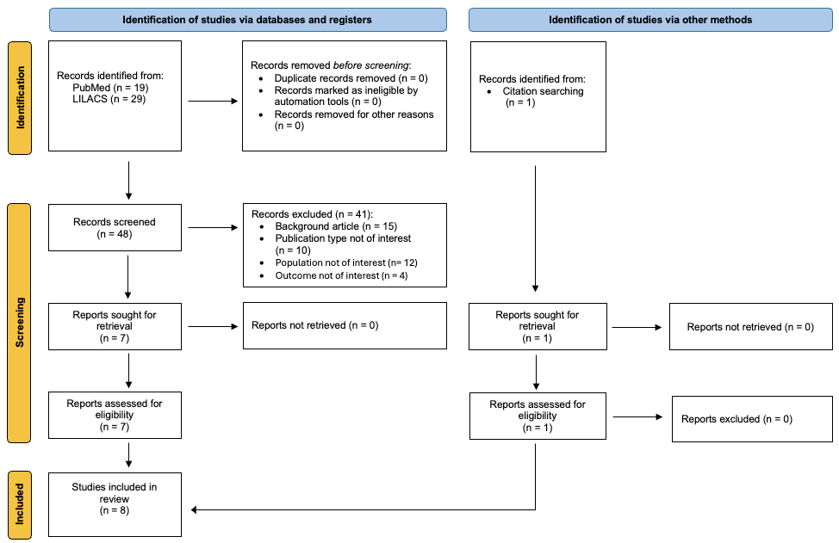

Medline: (((((immunoglobulin prophylaxis[Title/Abstract]) OR (preemptive immunoglobulin[Title/Abstract])) OR (IgRT prophylaxis[Title/Abstract])) OR (IVIg prophylaxis[Title/Abstract])) OR (immunoglobulin supplementation[Title/Abstract])) AND ((myeloma[Title/Abstract]) OR (multiple myeloma[Title/Abstract]))
#1 immunoglobulin prophylaxis [Ti/Ab] OR preemptive immunoglobulin [Ti/Ab] OR IgRT prophylaxis [Ti/Ab] OR IVIg prophylaxis [Ti/Ab] OR immunoglobulin supplementation [Ti/Ab] - #2 myeloma [Ti/Ab] OR multiple myeloma [Ti/Ab].
#1 AND #2

LILACS: (ti:(myeloma)) AND (infection) AND (IgRT) OR (IVIg) OR (SCIg)
S-Table 1. Quality assessment of the studies.
Study | 1 | 2 | 3 | 4 | 5 | 6 | 7 | 8 | 9 | 10 | 11 | 12 | 13 | 14 | 15 | 16 | 17 | 18 | 19 | 20 | Quality score
Vacca  2018 | Y | Y | N | Y | Y | Y | Y | Y | Y | Y | N | Y | Y | Y | Y | Y | Y | Y | Y | Y | 18/20
Lancman  2023 | Y | N | N | Y | Y | Y | Y | Y | Y | Y | N | Y | Y | Y | Y | Y | Y | Y | Y | Y | 17/20
Sheu  2023 | Y | N | N | Y | Y | Y | Y | Y | Y | Y | N | Y | Y | Y | Y | Y | Y | Y | Y | Y | 17/20
Cheruvalat  2024 | Y | N | Y | Y | Y | Y | Y | Y | Y | Y | N | Y | Y | Y | Y | Y | Y | Y | Y | Y | 18/20
Frerichs  2024 | Y | Y | Y | Y | Y | Y | Y | Y | Y | Y | N | Y | Y | Y | Y | Y | Y | Y | Y | Y | 19/20
Mohan  2024 | Y | N | Y | Y | Y | Y | Y | Y | Y | Y | N | Y | Y | Y | Y | Y | Y | Y | Y | Y | 18/20
Piron  2025 | Y | N | N | Y | Y | Y | Y | Y | Y | Y | N | Y | Y | Y | Y | Y | Y | Y | Y | Y | 17/20
Sheu  2025 | Y | N | N | Y | Y | Y | Y | Y | Y | Y | N | Y | Y | Y | Y | Y | Y | Y | Y | Y | 17/20
Y = YES; N = NO; P = PARTIAL; U = UNCLEAR. A study with ≥ 70% of positive responses (12/18 or 14/20) was considered to be of acceptable quality.

Institute of Health Economics (IHE). Quality Appraisal of Case Series Studies Checklist. Edmonton (AB): Institute of Health Economics; 2014. Available from: http://www.ihe.ca/research-programs/rmd/cssqac/cssqac-about
References:
Moga C, Guo B, Schopflocher D, Harstall C. Development of a quality appraisal tool for case series studies using a modified Delphi technique. Edmonton: Institute of Health Economics; 2012. Available at http://www.ihe.ca/advanced-search/development-of-a-quality-appraisal-tool-for-case-series-studies- using-a-modified-delphi-technique . Accessed January 8, 2016.
Guo B, Moga C, Harstall C, Schopflocher D. A principal component analysis is conducted for case series quality appraisal checklist. Journal of Clinical Epidemiology 2016;69:199-207.
S-Table 2. Summary of Findings Table.
Certainty assessment |  |  |  |  |  |  | № of patients |  | Effect |  | Certainty | Importance
№ of studies | Study design | Risk of bias | Inconsistency | Indirectness | Imprecision | Other considerations | cases | controls | Relative  (95% CI) | Absolute  (95% CI) | Certainty | Importance
Infection rate ratio (follow-up: mean 10.6 months; assessed with: hazard ratio)
8ª | randomised and non-randomised studies | serious^{b} | serious^{c} | not serious | serious^{d} | publication bias not suspected^{e} | 358 | 430 | - | 0.25  (0.13 to  0.49) | ⨁⨁◯◯  Low | CRITICAL

CI: confidence interval.

Explanations
a. All included studies scored above 70% on the IHE checklist, indicating good methodological quality.
b. Six out of eight included studies were retrospective observational analyses. As such, they are subject to inherent limitations, including potential selection bias, incomplete outcome reporting, and variability in follow-up and infection ascertainment. However, the outcome (grade 3-4/severe infections) is relatively objective, which mitigates some risk. Overall, the risk of bias was considered serious.
c. High heterogeneity was observed (I²=87.8%, p<0.0001), indicating variability among study estimates. However, the direction of the effect was consistent across studies. Therefore, inconsistency was judged serious.
d. The pooled infection hazard ratio was 0.25 (95% CI 0.13-0.49), with a relative narrow confidence interval indicating a precise estimate of the incidence of patients experiencing severe infection. The sample size and number of events were sufficient to ensure statistical stability, but only one study cross the line of non-effect. Then, imprecision was considered serious.
e. Publication bias was assessed using visual Funnel Plot and Egger’s test. The funnel plot does not indicate a potential publication bias. The Egger's test does not support the presence of funnel plot asymmetry (intercept: -2.41, 95% CI:-5.45 - 0.63, t: -1.551, p-value: 0.172).
S-Table 3. Infection incidence among included studies.
study, year | HR (95% Cis)
Vacca, 2018 | 0.077 (0.046-0.13)
Lancman, 2023 | 0.1 (0.01-0.8)
Sheu, 2023 | 0.57 (0.45-0.72)
Cheruvalath, 2024 | 0.59 (0.38-0.91)
Frerichs, 2024 | 0.086 (0.02-0.37)
Mohan, 2024 | 0.39 (0.2-0.77)
Piron, 2025 | 0.24 (0.08-0.69)
Sheu, 2025 | 0.37 (0.13-1.03)
Cis, confidence intervals; HR, hazard ratio.

S-Figure 2. Sensitivity meta-analysis including all studies after removal of outliers.
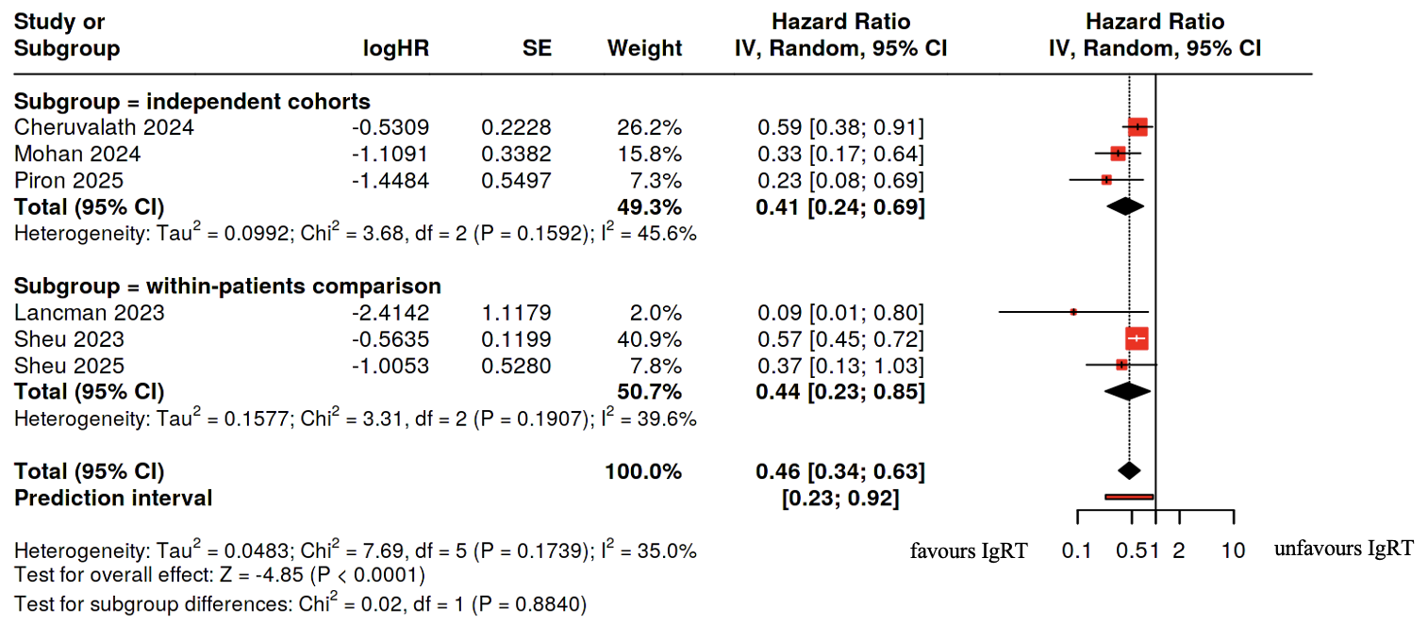

CI, confidence interval; IV, inverse variance; logHR, natural logarithm of the hazard ratio; SE, standard error.

S-Figure 3. Meta-analysis of studies evaluating BiTEs therapy after removal of outlier studies.
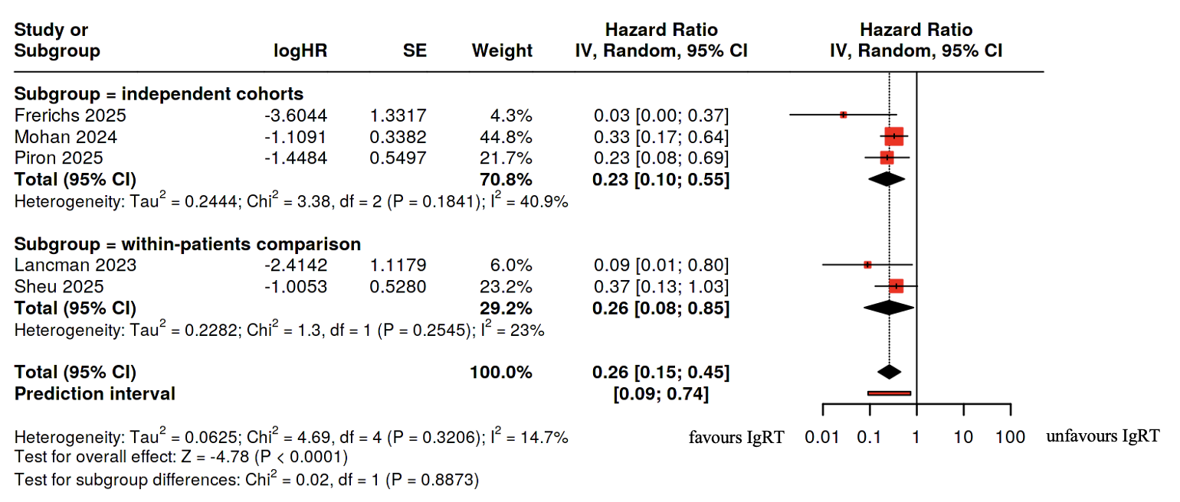
CI, confidence interval; IV, inverse variance; logHR, natural logarithm of the hazard ratio; SE, standard error.
S-Figure 4. Subgroup meta-analysis of IgRT prophylaxis in patients treated with BCMA-directed BiTEs and teclistamab

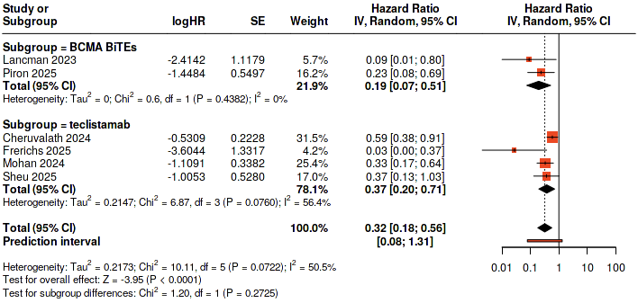

CI, confidence interval; IV, inverse variance; logHR, natural logarithm of the hazard ratio; SE, standard error.

