Supplementary Information
DNA and its rectangular origami nanostructure as substrates for Raman signal enhancement
Priya Dangi^{1.2}, Aniket Chowdhury¹, Shivangi Verma¹, Chandrachur Mukherjee^{2.3}, Kamalika Ghosh¹, Nidhi Maharwal^{1,2}, Rashmi Shrivastava^{1.2*}and Shovan K Majumder^{1.2}
¹Laser Biomedical Applications Division, Raja Ramanna Centre for Advanced Technology, Indore-452013, India
²Homi Bhabha National Institute (HBNI), Training School Complex Anushakti Nagar, Mumbai-400094, India
³High Energy Lasers and Optics Division, Raja Ramanna Centre for Advanced Technology, Indore-452013, India

*Corresponding author: E mail: rshrivastava@rrcat.gov.in

Supplementary Information
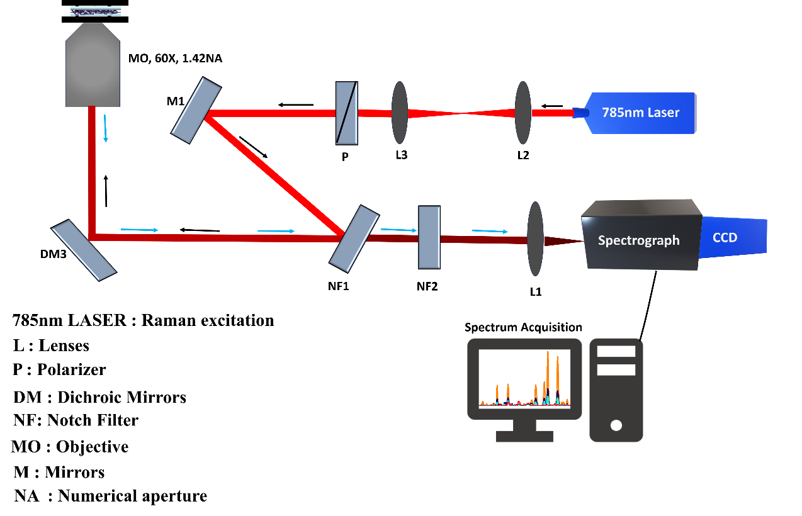
Supplementary Fig. 1 Schematic of the Raman measurement setup.
Raman measurements were performed in reflection geometry using a 785 nm excitation laser (~20 mW at the sample plane) focused with a 60× oil immersion objective on an inverted microscope. The scattered signal was collected by the same objective and directed to a spectrograph coupled to a thermoelectrically cooled CCD detector (−80 °C).

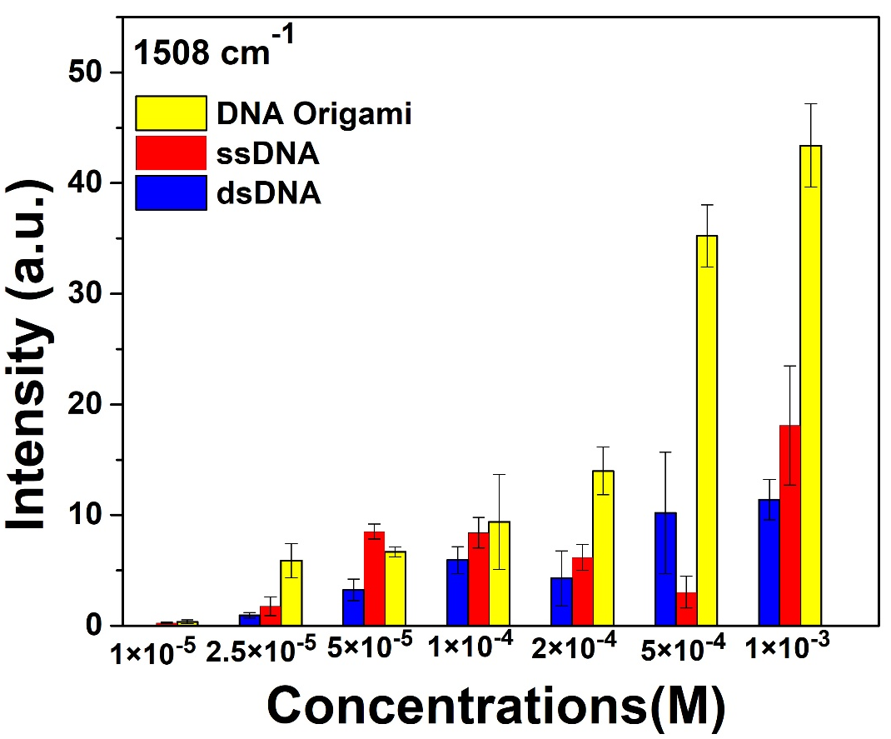
Supplementary Fig. 2 Concentration dependent Raman measurements of R6G on different DNA substrates.
Bar graph showing the log₁₀-transformed Raman intensity of the 1508 cm⁻¹ vibrational mode of R6G measured on three DNA substrates- ssDNA, dsDNA, and rectangular DNA origami at different R6G concentrations. A consistent decrease in Raman intensity with decreasing R6G concentration is observed for the DNA origami substrate, whereas no clear monotonic trend is observed for ssDNA and dsDNA substrates. Bars represent the mean Raman intensity, and error bars indicate the standard deviation from 15 independent measurements.

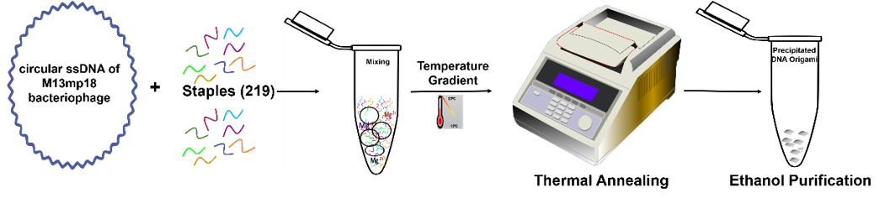
Supplementary Fig.3 Synthesis of rectangular DNA origami nanostructure
Schematic illustration of the synthesis workflow for purified rectangular DNA origami, where the M13mp18 circular ssDNA scaffold and complementary oligonucleotide staples are mixed and assembled via thermal annealing. Briefly, the mixture is subjected to an initial high denaturation temperature followed by a gradual cooling process, enabling the scaffold to fold into the designed two-dimensional structure. The assembled DNA origami is subsequently purified using ethanol precipitation, resulting in purified rectangular DNA origami nanostructures

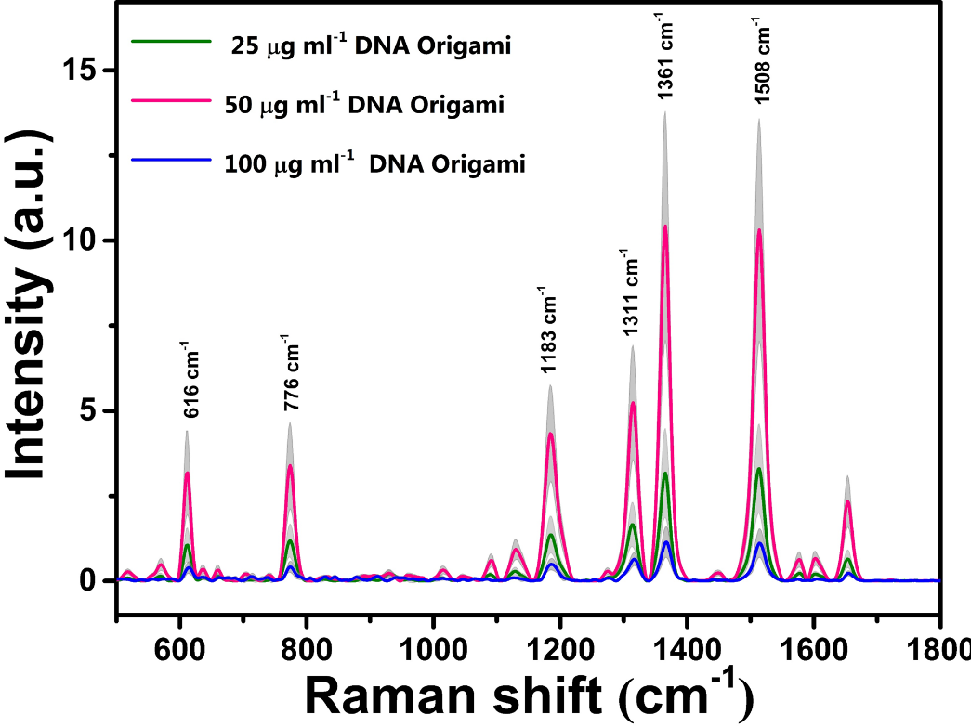
Supplementary Fig. 4 Effect of DNA origami concentration on Raman intensity of R6G.
Raman intensities of 5 x 10⁻⁴ M R6G measured in the presence of different concentrations of rectangular DNA origami (25 µg ml⁻¹, 50 µg ml⁻¹, and 100 µg ml⁻¹). The spectra show that the maximum Raman enhancement is observed at 50 µg ml⁻¹ DNA origami.

Supplementary Table 1. ssDNA sequences used in this study; these sequences also serve as staple strands for the assembly of the rectangular DNA origami structure.

Sl. No. | Staple Sequences
1 | CAAAGGGCGAAAAACCCTGAGAAGT
2 | ATTAAAGACGAGTAAAAGAGTCTGACTTGCCT
3 | TAGGGTTGAGTGTTGTACCGTTGTAGCCGGTT
4 | AATCCCTTATAAATCAGGGTGGTTT
5 | ATCCTGTTTGATGGTGAACAGCTGA
6 | CGGTCCACGCTGGTTTAGAGAGTTGCAGCAAG
7 | ACGGTACGCCAGAATCGTCTATCAAGACAGGA
8 | GTTTTTACCTTGCTGGTAATATCGAAAAACG
9 | AGGCCACACGTGGACTCCAACGT
10 | CAAATTATCCAGTTTGGAACAAGAGTCCACT
11 | TGCGTATTGGGCGCCAAAAGAATAGCCCGAGA
12 | TTCTTTTAGCTGCATTAATGAATGAAATTGT
13 | GACGGGCGTTCCGAAATCGGCAA
14 | TTGCCCTGCCCGCTTTCCAGTCGATACGAGCC
15 | TGGCCCTGGCCCCAGCAGGCGAAA
16 | GAGTAGAACGCTCAATCGTCTGAACATTCTGG
17 | AGAGGAATACTTCTTTGGCAGATTCACGGTCAT
18 | AGCTAACTCACATTAAGGGTGCCTAATGAGTG
19 | CCAGCCATTGCAACAGCAGAACAATATTACCG
20 | CTCATGGACCTGAAAGCGTAAGAATTAGTCTT
21 | ATTTTGAGAACTCAAACTATCGGTAATCAGTG
22 | TTACATTGATTAGTAATAACATCTCCATCACG
23 | AGCTGTTTCCTGTGTCGGCCAACGCGCGGGG
24 | TATCCGCTGAGGATCCCCGGGTACTGCGGGCC
25 | ACACAACGGAAACCTGTCGTGCCCACCAGTGA
26 | GGAAGCATGCCAAGCTTGCATGCAAAGGGGGA
27 | AAGCCTGTTGCGTTGCGCTCACTTCACCGCC
28 | CCAACAGAAACATCGCCATTAAAAACACCGCC
29 | ATCATCAGTCACACGACAGCAGAAGATACTGT
30 | TCCCAGTCACGACGTTGGTAACGCCAGGGTTT
31 | TATTTTTGAATGGCTATACGTGGCACAGACAA
32 | TAATGCGCAGCAGCAAATGAAAAACAAACCCTC
33 | GCCCTAAGATAGAACCCTTCTGAAATACCTAC
34 | GAACCACCCAGTAATAAAAGGGAATGGATTAT
35 | TGGGAAGGGCGATCGGCGAGCTCGAATTCGTA
36 | TCTTCGCTAACCAGGCAAAGCGCCGGATTGAC
37 | GCTGGCGCTGCAGGTCGACTCTACACAATTCC
38 | TGTGCTGGCCAGCTTTCCGGCACGTAGATGGG
39 | TAAGTTGGTAAAACGACGGCCAGTAAAGTGTA
40 | TGCAACAGAATCAACAGTTGAAAGAGAGCCGT
41 | GCGCAAAAACAGAGGTTCTAAAATATCTTCTC
42 | GACAGTATCGGCCTCAAGTTTGAGGGGACGAC
43 | GCTGAACCTCAAATATTCTAAAGCATCACCTT
44 | AATCAATTAGAAGTATTAGACTTTTGCCCGA
45 | GTTGGCATGCCACGCTGAGAGCCGAACTGATA
46 | AAGGTTAGAGGCGGTCAGTATTAATACCGAAC
47 | CGTGGGAACAAACGGCATTCGCCATTCAGGCT
48 | CGTAATGGATCAACATTAAATGTGAGATTGTA
49 | CGTTGGTCGCTTCTGGTGCCGGAATTACGCCA
50 | CGCATCGATTCGCGTCTGGCCTTGTTAATATT
51 | ATCTGCCGGAAGATCGCACTCCACAAGGCGAT
52 | CAATAGATGTAACATTATCATTTTCAGATGAT
53 | TCGGATTTAGGAGCACACCAGAAGGAGAGAAA
54 | TTTTTTAACCAATAGGTTGTTAAATCAGCTCA
55 | ACTCGTATTAAATCCTTACAAACAATTCGACA
56 | ACGTTATTTTGTTTGGATTATACTTCAAAATT
57 | AGTTTGAAATACATTTGAGGATTATCTGGTCA
58 | AGAAACCTAACAACTAATAGATTGAATTGAGG
59 | AGCCCCAAAAACAGGAAGCGAGTAACAACCCG
60 | TAAGCAAAACTAGCATGTCAATCATCACCATC
61 | TGTAAACCCTGTAGCCAGCTTTCGATAGGTCA
62 | TTGTTAAAAACAAGAGAATCGATTGATAAATT
63 | TAAATTTAACGCCATCAAAAATATAACCGTGC
64 | GGCAATTCGAAATTGCGTAGATTTACAATAAC
65 | TAATCCGGAATTATCAATGAATATACAGAAAG
66 | GGCTATCAGGTCATTGTTGAGAGATCTACAAA
67 | GTTAGAACCTACCATATCTGAATAATGGAAGG
68 | ATTTGCACCCAAGTTACAAAATCGAGCAAAAG
69 | AAATAAAATCAATATAATCCTGAAATTTTAAA
70 | ACGTCAGTCATATTCCTGATTATGCGGAACAA
71 | GCCGGAGACAGTCAAATATGTACCCCGGTTGA
72 | AATATGATGCCTGAGTAATGTGTAAAAATTAA
73 | TTCTAGCGAACGGTAATCGTAAATATTTAAAT
74 | AATGCCGTTTTTAGAACCCTCATCTAAATCGG
75 | GCTATTTCCTGAGAGTCTGGAGCAATTCGCAT
76 | GGATTCGCAAACAAAATTAATTACTATATGTG
77 | GGTGAGTAACAGTACCTGAATTACCTTCAGGC
78 | GAGAAGCCTTTATTTCTGTAATACTTTTGCGG
79 | TCATTTCAATTACCTGCGCAGAGGCGAATTAT
80 | AAGATGATTCGTCGCTATTAATTATAGCTTAG
81 | ATCAAGACTGATTGCTTTGAATAGTAAAACAG
82 | TTTCATTTTTTACATCGGGAGAATCAGGTTTA
83 | AAGGCAAAGAATTAGCGGTAAAGATTCAAAAG
84 | GCAATAAATACTAATAGTAGTAGCAAGTTTCA
85 | CATAAAGATATTTTAAATGCAATATTCAACCG
86 | TTGTACCTGGGGCGCGAGCTGAATTCTGCGAA
87 | ATGACCCAACGCAAGGATAAAAAGAGAGGGTA
88 | AGTGAATAAGTGAATTTATCAAAACTATATGT
89 | TCATATTTTAATGGAACTACCTTTTTACAACT
90 | TGGTCAATAACCTGTTAGATACATTTCGCAAA
91 | CTTGAAAACATAGCGAATTTTCCCTTAGAATC
92 | ATTAAGACAAGACAAAGAACGCGACATCTTCT
93 | AGTCAATACCTTGCTTCTGTAAAGAAACAAAC
94 | TGAGAGAACAGTACATAAATCAAATTTAACAA
95 | AAAGTACGGTGTCTGGATTAACATCCAATAAA
96 | TTCCATATTGAATATAATGCTGTAAAAGACTT
97 | TTCCCAAAAGGTGGCATCAATTCGCCTCAGAG
98 | CGAGTAGTCATTTTTGCGGATGGTTCAAAGCG
99 | GACCATTTAGCTATATTTTCATTAAAAACATT
100 | AAATGCTGACCGACCGTGTGATAATTTAGTAT
101 | ATATGACCTCCGGCTTGAATAAACACCAAAAG
102 | GAGTACCTTTAATTGCACAGGTCAGGATTAGA
103 | ATATTTTAGTTAATTTGAAAACTTTTTCAAAT
104 | GACCTAAACAGTATAAAGCCAACGATTTAACA
105 | TTGAAATATGCAAATCCAATCGCGCTGAGAAG
106 | TAAATAAAGGTTGGGTTATATAATCATAGGTC
107 | ATTAAGAGGAAGCCCGGCTCAACATGTTTTAA
108 | CAAATATCCTGACTATTATAGTCAGCCAGAGG
109 | TTCGAGCCTTAGAGCTTAATTGCAACAGTTGA
110 | AACCAGAAATGACCATAAATCAAGGATAGCGT
111 | AACTCCATCCTTTTGATAAGAGGATTTAGTTT
112 | CATATGCGGGCATTTTCGAGCCAGGACAATAA
113 | CATCAGGAATCATAATAGTACCGACAAGGCTT
114 | CCTCAAATGCTTTAAAATATTCATTGAATCCC
115 | AATTGAGAATCGCCATCTCAACAGTAGGGCTT
116 | ACGCCAACCGCGCCTGTTTATCAATCCCATCC
117 | AGGCAGATTATACAAATTCTTACTTTAATGGT
118 | AATATAATACTAGAAAAAGCCTGATAAGGCGT
119 | TTGCAAAAGAAGTTTTGAAGCAAAGCGGATTG
120 | GGGTAATACGTTTACCAGACGACGTAATAAAA
121 | TTAGACTAAATCAGGTCTTTACCGCGTTTTAA
122 | CCAATACAGGCATAGTAAGAGCACAGGTAGAA
123 | GTCATAACAGTTCAGAAAACGAGCCGGAAGCA
124 | ACAACATGATCAATAATCGGCTGTACAAGCAA
125 | CGAGAAAGGTAAAGTAAAGAACGGGTAGTTGG
126 | AATGCAGATACATAACAATACCACATTCAACT
127 | AACAAGAAAAATAATACAATAGATAAGTCCTG
128 | TAATTTACATCATTACCGCGCCCACGGTATTC
129 | GAAACCATTCAGCTAATGCAGAAATGTAATTT
130 | TCATTCCATTCTGTCCAGACGACTAATAAGAG
131 | GAAGAAAAATCTACGTATAAAAACCAAAATAG
132 | CGAACTAAGCGATTTTAAGAACTGAACCGGAT
133 | ATTATTAACACTATCATAACCCTGTAAAATGT
134 | AGATTCAATTTCAACTTTAATCAAAAGCTGC
135 | ATTTAGGGCCAAAAGGAATTACGTGCGGAATC
136 | GCCGTTTTACCTCCCGACTTGCGGTTTATCCT
137 | AGGACTTAAACCAAGTAAATCAAGATTATCAA
138 | AACGAGTAGTAAATTGTGACGAGAAACACCAG
139 | ATATAGAAGGCTTATCATAGCAAGCAAATCAG
140 | TAAGAACGTCTTTCCAGAGCCTAATTATCCCA
141 | TTAGCGATATTTTCATCGTAGGAGAGCATGTA
142 | AAGCCTTACCGCACTCATCGAGACTTTCCTTA
143 | GAGTAATCTTGACAAGGCTCATTATACCAGTC
144 | ATTCATTACGGTGTACAGACCAGGACAAAGTA
145 | ACGTAACTTGTGAATTACCTTATCGGAACAAC
146 | TCATTCAGGAACTGACCAACTTTGGATAAATT
147 | CTTGCCCGGCTTGAGATGGTTTATCAGTTGAG
148 | GAATCTTATTTAACGTCAAAAATGGGGAGAAT
149 | CCTTCAGTTGCTATTTCAGAGAGAATAAGCGA
150 | ACGAGGCGCAGACGGTATGTTACTTAGCCGGA
151 | TAAACAGCCATATTATTTTGCCAGTTACAAAA
152 | ATCCAAATAGAGGGTAATTGAGCGGTTAAGCC
153 | TTTTTTGCCAACGCTAACGAGCGCGAGGCGTT
154 | GCCTTTATGCACCCAGCTACAATGAGGTTTTG
155 | TTATACCAAGCGCGAACGCATAGGCTGGCTGA
156 | CAACGGAGGCAAAAGAATACACTACTCAGCAG
157 | ATCGCCTAAAGAGGACAGATGAACCCAAATCA
158 | GTGTCGAACACTACGAAGGCACCATAGCAACG
159 | CTGCTCCCAATCATAAGGGAACCTGAATAAGG
160 | TAACTGAAAAATAGCAATAGCTATAAGGAAAC
161 | CCCCCACATAAAAACATTAAGAAAAGTCGCTT
162 | AGTTTCCATTAAACGGGACTTTTTCATGAGGA
163 | AACCCACAAGAATTGACTAATATCAGAGAGAT
164 | CAATAATATACCCAAAAGAACTGGAGCAAACG
165 | AACAATGCACCCTGAACAAAGTCAAGAAACGA
166 | GCCCTTTGGGAAGCGCATTAGACAAAATAGCA
167 | TTGCGGGATCGTCACCAAACACTCATCTTTGA
168 | CGAAAGACTATATTCGGTCGCTGAGTTGAAAA
169 | ACGAGGGACCTAAAACGAAAGAGATTTGTATC
170 | GCTACAGAAATGACAACAACCATCGAGCCTTT
171 | GACTAAAGTAAAATACGTAATGCATCCGCGAC
172 | CGAGGAAACAACATATAAAAGAAATGGTTTAC
173 | AAGGCAAGCAGATAGCAATAAGTTTATTGCGA
174 | TTAAACAGCTTGATACTTTCGAGGTGAATTTC
175 | TATTACGCAGTATGTTCATGATTAAGACTCCT
176 | TAGAAAATATTCAACCGATTGAGGTTAAAGGT
177 | AAGGTGGCGCAATAATAACGGAAAGAGCAAGA
178 | ACCACGGCGAACAAAGTTACCAGCTTACCGAA
179 | ATAATAATTTTTTCACGGCTTGCAGGGAGTTA
180 | TCTCCAAACAGCGGAGTGAGAATACGTCACCA
181 | CCAAAAGGCCCACGCATAACCGAAGCATCGGA
182 | AATTGTATATGGGATTTTGCTAAATTCCACAG
183 | AGCTTGCCGATAGTTGCGCCGACGGCTTTGAG
184 | CAGCGCCAGCCATTTGGGAATTAGCAATGAAA
185 | GGAATTTTGTCACAATAGTAGCACCATATGTA
186 | TCTTTCCAGACGTTAGATCTAAAGTTTTGTCG
187 | TGACGGAAATTATTCAGAGGGAAGGTAAATAT
188 | GAATTATCGTAGCGACAGAATCAATCATCGGC
189 | GACTTGAAAGACAAAAGGGCGACACATACATA
190 | AATCACCCAATAGAAAATTCATACGCAAAGAC
191 | CCGTAACACTGAGTTTGAAAGGAACAACTAAA
192 | GTACAAACCCCTCATTTTCAGGGATTTTGCTC
193 | TGTAGCACAACTTTCAACAGTTTAAAAAGGCT
194 | ACAGCCCTCACCCTCAGAACCGCCGAGAGGGT
195 | CGTAACGTAAATGAATTTTCTGTCGGTTTATC
196 | CCATCGATAGCGTTTGCCATCTTTCCGCCACC
197 | AACCCTACCATTAGCACGGAACCAGAGGAAGG
198 | AGGAGGTTTAGTACCGGTGTATCACCGTACTC
199 | AGACTGTAGCGCGTTTGTTTGCCTTTAGCGTC
200 | ATTTTCGGACCACCCTCAGAGCCGATTGA
201 | CCTTATTAGCAGCACCGTAATCAACCGTCACC
202 | AAATCACAGGCCGGAAACGTCACAGCCAGCAA
203 | ATTAGGATTAGCGGGGTAGCAAGCCCAATAGG
204 | AGTACCAGAAACATGAAAGTATTATTTAC
205 | TGCCGTCACCCTCAGAGCCACCATACAACGCC
206 | TGATATAAGCCCCCTGCCTATTTCTTGAT
207 | GGAATAGCCACCCTCAGAACCGCCATAGTTAG
208 | CTCAGAACGGCCTTGATATTCACAAACAAATA
209 | CAAGACCACCACCGGATTAAAGCCAGAATGGA
210 | CTTGAGTAACAGTGCCTTAACGGGGTCAGTGC
211 | CAGAGCCGCCGCCAGCCCACCAGAACCACCAC
212 | CAGGAGGTTGAGGCAGGTCAGA
213 | CGATTCGCCACCCTCAGAGCCTCATAGCCC
214 | AATCCTCAACCGCCTCCCTCAGAGTCATAATCA
215 | AAGCGCAGTCTCTGAAAGAGGCTGAGACTCCT
216 | CGTTCCAGTAAGCGTCATACAT
217 | GGCTTGGAACCTATTATTCTGGCGGATAAG
218 | GATACAGGAGTGTACTGGTAAT
219 | AAGTTCGTATAAACAGTTAATGTATAGCCC

