Supplemental Figure 1. Radiographic image of a 32-year-old male patient with lumbar tuberculosis. A, B. Anteroposterior and lateral radiographs of the lumbar spine showing L5/S1 lesions. C, D. CT of the lumbar spine suggesting infectious lesions in the L5/S1 intervertebral space, indicating a high possibility of tuberculosis. E, F. MRI of the lumbar spine suggesting infectious lesions in the L5/S1 intervertebral space, indicating a high possibility of tuberculosis.

Supplemental Figure 2. Expression of CALCR, ACP5 and MMP9 in bone tissues from STB patients (n=4) and control subjects (n=4).
【Note: 1= control subjects、0= STB patients 】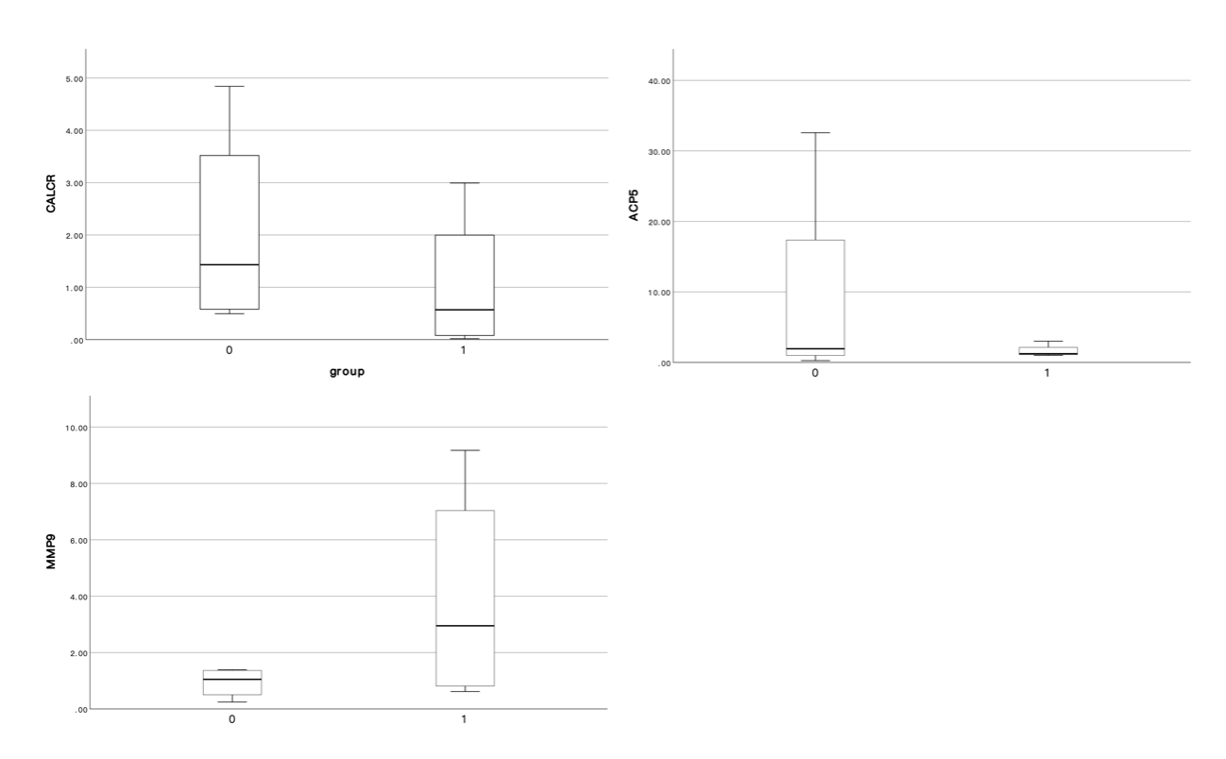

Supplementary material
Supplemental Table 1. Sequences of the human GAPDH, ACP5, MMP9 and CALCR primers.
Gene | Primer sequence (5′–3′)
GAPDH | Forward: ACAGCCTCAAGATCATCAGC
 | Reverse: GGTCATGAGTCCTTCCACGAT
CALCR | Forward: TGCATTCGGTCATAGCATTTGTA
 | Reverse: CCTATCCAACAATAGAGCCCAAG
ACP5 | Forward: CACGCCATTCTCATCTTGCA
 | Reverse: GCTGTCCTGGCTCAAGAAAC
MMP9 | Forward: GGGACGCAGACATCGTCATC
 | Reverse: TCGTCATCGTCGAAATGGGC

Supplemental Table 2. Clinical data of 4 STB patients and 4 controls included in the RNA-seq analysis.
Number | Sex | Age | Preoperative BMD（g/cm²） | Diagnosis on the basis of BMD | Preoperative ESR（mm/h） | ESR 6 months after surgery (mm/h） | Prognosis | Grouping
STB1 | Male | 32 | 0.869 | Osteopenia | 55 | 33 | Bad | T2
STB2 | Male | 54 | 0.776 | Severe osteoporosis | 98 | 11 | Good | T1
STB3 | Female | 56 | 0.792 | Osteoporosis | 31 | 20 | Bad | T2
STB4 | Female | 56 | 0.694 | Severe osteoporosis | 85 | 19 | Good | T1
Control1 | Male | 36 | 1.062 | Normal | Normal | Normal | Good | -
Control2 | Male | 58 | 0.909 | Osteopenia | Normal | Normal | Good | -
Control3 | Female | 54 | 0.895 | Osteopenia | Normal | Normal | Good | -
Control4 | Female | 56 | 0.995 | Normal | Normal | Normal | Good | -

Supplemental Table 3. Comparison of albumin level in patients with spinal tuberculosis and Low end of the medical reference value range (M(Q1,Q3)).

 | STB(n=53) | P value
Albumin（g/L） | 37.90(36.25,40.80) | 0.0072

Supplemental Table 4. Comparison of Albumin levels(g/L) and BMI between the two groups in the wound healing assay (±s).
 | STB(n=5) | NSTB(n=5) | P value
Albumin(g/L) | 39.26±1.84 | 41.72±2.84 | 0.1425
BMI | 23.37±3.87 | 24.14±2.36 | 0.7141

Supplemental Table 5. Comparison of Albumin levels(g/L) and BMI between the two groups in the osteogenesis induces differentiation (±s).
 | STB(n=3) | NSTB(n=3) | P value
Albumin(g/L) | 38.90±2.14 | 40.77±2.50 | 0.3808
BMI | 22.63±4.81 | 23.39±3.00 | 0.8274

Supplemental Table 6. Comparison of BMI between the two groups (±s).
 | STB(n=53) | NSTB(n=55) | P value
BMI | 22.30±3.63 | 24.19±3.57 | 0.0074

Supplemental Table 7. Binary logistic regression
 | P value | Exp (B, 95CI)
BMI | 0.082 | 0.895(0.789,1.014)
BMD | <0.001 | 0.000(0.000,0.013)

