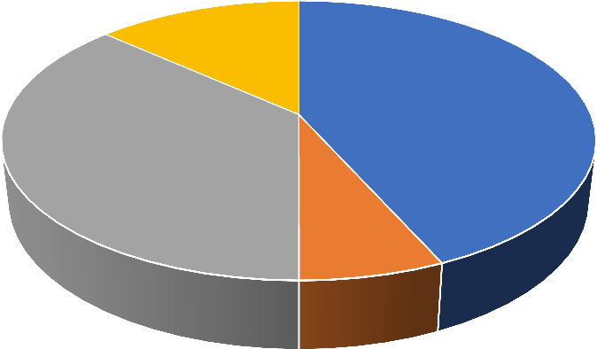
Graph 2: Diagnosis within the sample
N
SDNS
13%
First episode
Infrequent 43%
relapser
37% Frequent relapser
7%
First episode Frequent relapser Infrequent relapser SDNS

