Domain-swapped multimerization of recombinant Anti-Rh(D) scFv expressed in E. coli: structural and functional insights
Saleha Hafeez¹ and Muhammad Asghar^{1,2,3,4,5}*

¹Department of Biomedicine, Atta-Ur-Rahman School of Applied Biosciences, National University of Sciences and Technology, H-12 Sector, Islamabad 44000, Pakistan.
²Department of Biomedical Engineering, School of Mechanical and Manufacturing Engineering, National University of Sciences & Technology, H-12 Sector, Islamabad 44000, Pakistan.
³Department of Biology, Lund University Sweden
⁴Department of Protein Science, KTH Royal Institute of Technology, Sweden.
⁵Department of Sports Sciences and Clinical Biomechanics, University of Southern Denmark.

*Corresponding Author: Muhammad Asghar
Email: muhammad.asghar@biol.lu.se, muhammad.asghar@smme.nust.edu.pk

Cloning
Restriction digestion was performed using NcoI and XhoI enzymes (reaction details provided in Supplementary Table 1) at 37 °C for 3 h, followed by enzyme inactivation at 65 °C for 20 min. The digested plasmid was separated on a 1% agarose gel, and the linearized band was purified using a gel extraction kit. DNA concentration was determined using a NanoDrop spectrophotometer (Thermo Fisher Scientific).
Table S1: Reaction components for restriction digestion
Component | Volume µL
Plasmid | 1
10x buffer | 5
Nco1 10 U/µL | 1
Xho1 10 U/µL | 1
Nuclease-free water | Up to 50
Total volume | 50

Ligation was carried out using a 3:1 molar ratio of insert to vector (details in Supplementary Table 2) and incubated at room temperature for 3 h. Subsequently, 2 µL of the ligation mixture was transformed into chemically competent Escherichia coli DH5α cells via the heat shock method. Cells were recovered in LB medium and plated on LB agar plates containing kanamycin (50 µg/mL), followed by incubation overnight at 37 °C.
Individual colonies were inoculated into 5 mL LB broth with kanamycin and grown at 37 °C for 16 h. Plasmid DNA was extracted using a miniprep kit and analyzed on a 1% agarose gel. Plasmids showing the expected insert size were selected for further transformation into E. coli DH5α (for propagation) and E. coli Lemo21(DE3) (for protein expression studies).
Table S2: Components of ligation reaction
Component | Volume µL
Plasmid (45 ng/µL) | 1
Insert (100 ng/µL) | 0.22
10X T4 DNA ligase buffer | 2
T4 DNA Ligase (1–3 U) | 1
Nuclease-free water | 15.78
Total volume | 20

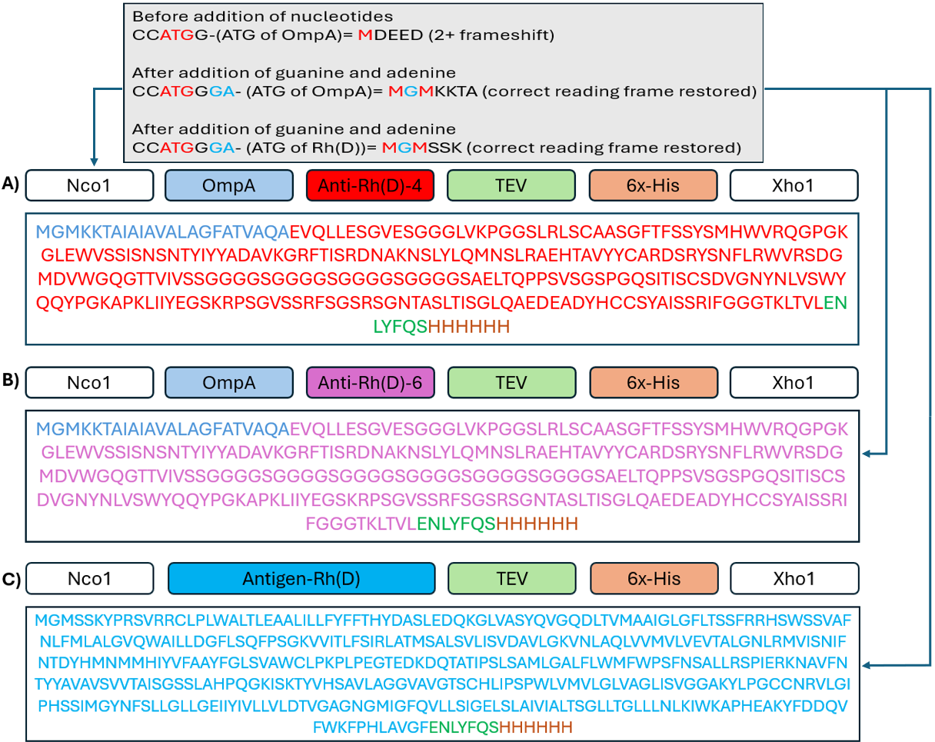
Figure S1: Designs of recombinant gene constructs of A) anti-Rh(D)-4 scFv, B) anti-Rh(D)-6 scFv and C) antigen-Rh(D). Anti-Rh(D) scFv variants were expressed as periplasmic proteins, whereas antigen-Rh(D) was expressed as a cytoplasmic protein. Additional nucleotides guanine (G) and adenine (A) were introduced into the anti-Rh(D) scFv antigen-Rh(D) gene constructs to prevent a frameshift at the Nco1 restriction site. This modification resulted in the insertion of an additional glycine residue between two methionine residues (red), as indicated in blue in the grey box.
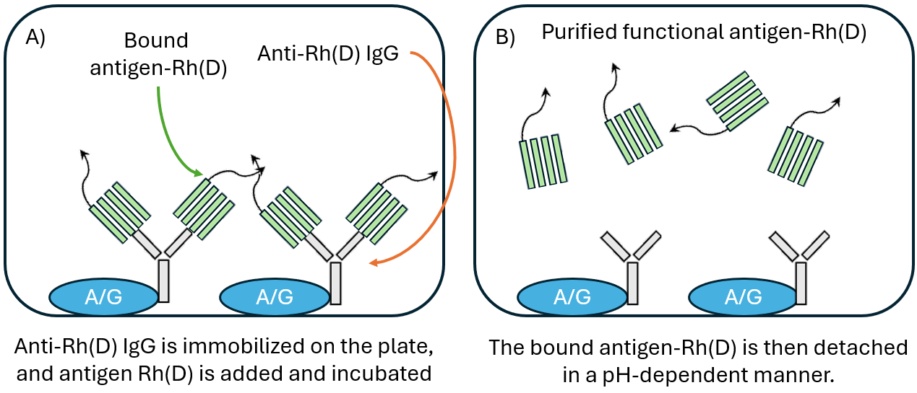
Figure S2: Purification of functional antigen-Rh(D) using immobilized anti-Rh(D) IgG antibody.
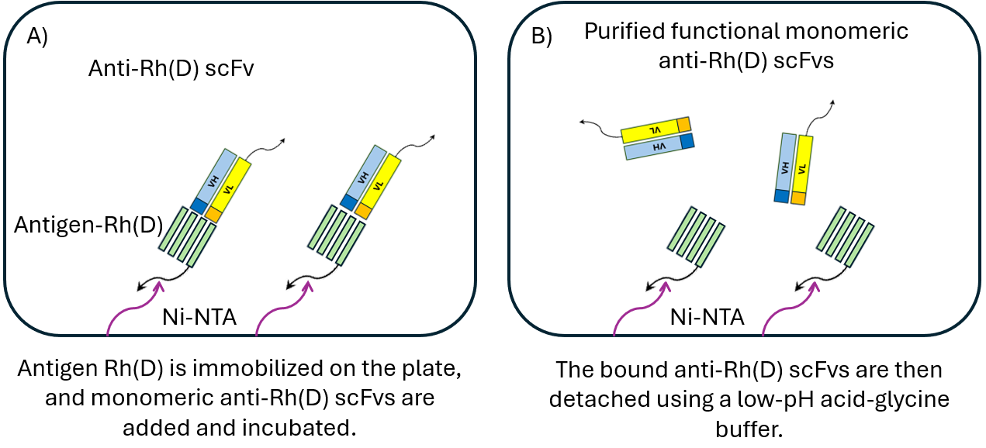
Figure S3: Purification of functional monomeric anti-Rh(D) scFvs using immobilized his-tagged antigen-Rh(D).
Formulas for determining functional proteins
Functional species yield (%)
$$\text{FY}=\frac{C_{pf}}{C_{cs}}×100$$
FY = Functional yield percentage
$C_{pf}$= Concentration of purified functional species (monomer, dimer, or trimer fraction)
$C_{cs}$= Concentration of crude starting sample before purification
Overall functional protein yield (%)
$$\text{OFY}=\frac{∑C_{pf}}{C_{cs}}×100$$
OFY = Overall functional yield percentage
$∑C_{pf}$= Sum of concentrations of all purified functional species
$C_{cs}$= Concentration of crude starting sample before purification
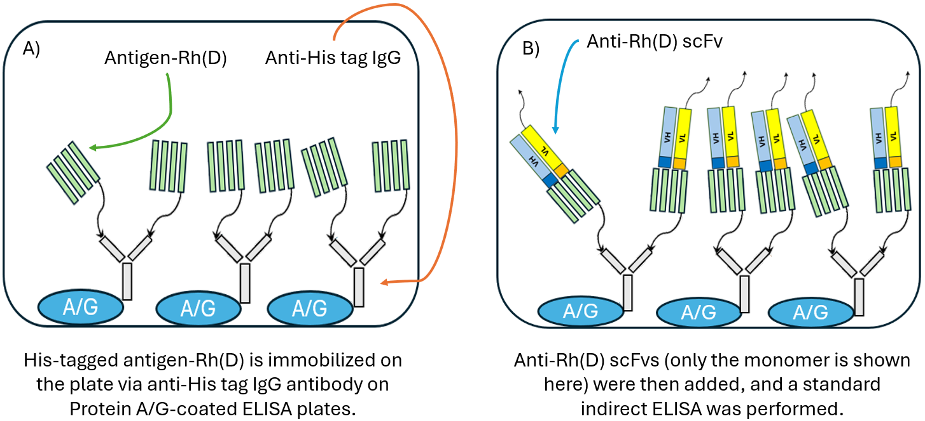
Figure S4: An overview of the ELISA-based experiment for determining the binding parameters K_{D} and B_{max} of the monomeric and multimeric forms of anti-Rh(D) scFv variants.
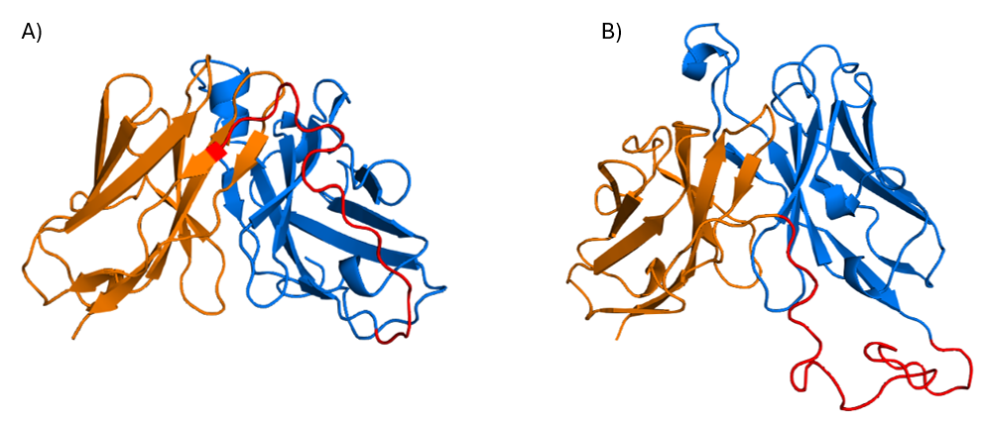
Figure S5: Protein Models of A) anti-Rh(D)-4 scFv and B) anti-Rh(D)-6 scFv. Blue, orange and red colors represent VH, VL and GS linker respectively.
Table S3: Theoretical molecular weights of antigen-Rh(D) and anti-Rh(D) scFv variants.
Protein | Molecular Weight (kDa)
Antigen-Rh(D) | 45.2
Anti-Rh(D)-4 Monomer | 26.6
Anti-Rh(D)-4 Dimer | 53.2
Anti-Rh(D)-4 Trimer | 79.8
Anti-Rh(D)-6 Monomer | 27.2
Anti-Rh(D)-6 Dimer | 54.5
Anti-Rh(D)-6 Trimer | 81.7

Table S4: Theoretical molecular weights of complexes of monomeric and multimeric anti-Rh(D) scFv variants with antigen-Rh(D).
Complex | Molecular Weight (kDa)
Monomer-antigen (anti-Rh(D)-4) | 71.8
Monovalent dimer-antigen (anti-Rh(D)-4) | 98.4
Bivalent dimer-antigen (anti-Rh(D)-4) | 143.6
Monovalent trimer-antigen (anti-Rh(D)-4) | 125
Trivalent trimer-antigen (anti-Rh(D)-4) | 215.4
Monomer-antigen (anti-Rh(D)-6) | 72.4
Monovalent dimer-antigen (anti-Rh(D)-6) | 99.7
Bivalent dimer-antigen (anti-Rh(D)-6) | 144.8
Monovalent trimer-antigen (anti-Rh(D)-6) | 126.9
Trivalent trimer-antigen (anti-Rh(D)-6) | 217.3

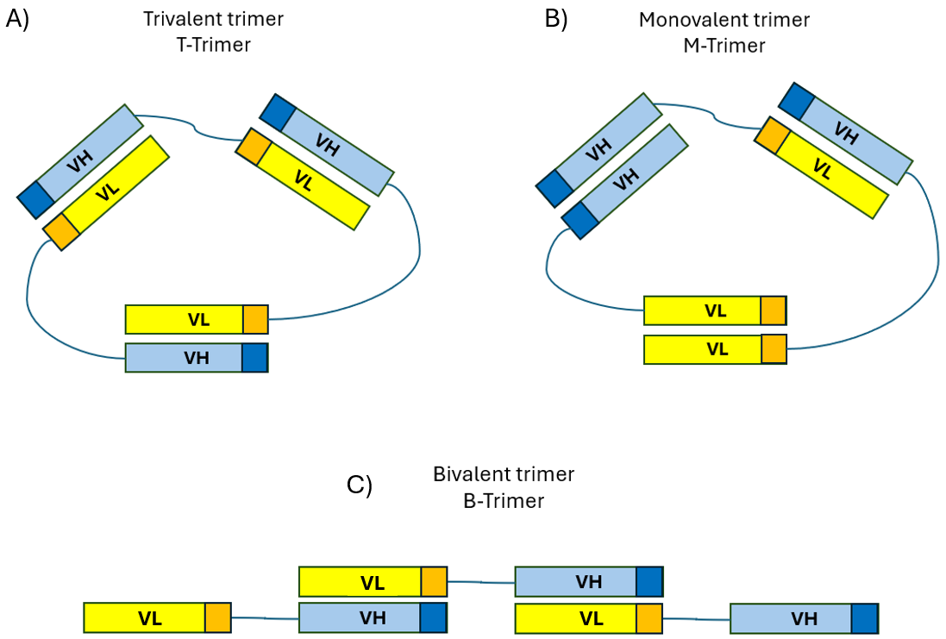
Figure S6: Possible structures of trimeric anti-Rh(D) scFv. A) trivalent trimer, B) Monovalent trimer and C) Bivalent trimer. Only closed trimers could be observed in trivalent or monovalent forms. For a bivalent form to exist, the trimer must adopt an open conformation. This open conformation, due to unbound or free end domains, could lead to the formation of higher-order multimers.

