Chitosan Enhances Germination and Growth of Rice Plant (Oryza sativa) while controlling Rhizoctonia solani Infection
Subhransu Sekhar Beheraª, Seemon Giriª, Zahra Parwezª,
Smaranika Pradhanª, Lopamudra Ray^{a*}
ªSchool of Biotechnology, KIIT Deemed to be University, Bhubaneswar, Odisha, India
* Corresponding Author
Dr Lopamudra Ray,
Asst. Professor, School of Biotechnology,
Kalinga Institute of Industrial Technology (KIIT), Deemed to be University, Bhubaneswar, Odisha, India.
Email: loparay@gmail.com, lray@kiitbiotech.ac.in

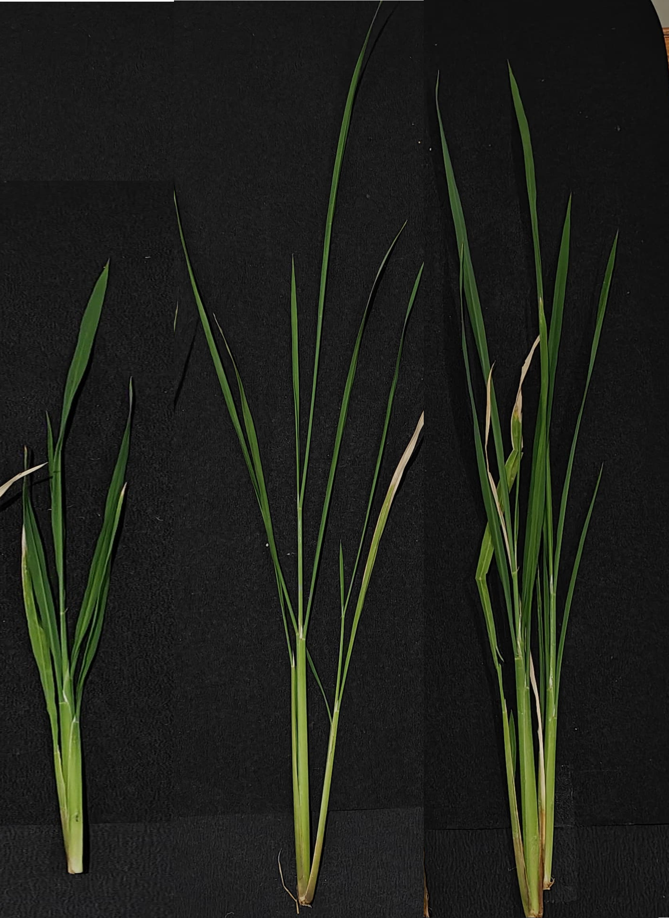

Synthesized chitosan Plant
Commercial chitosan Plant
Control Plant

Supplementary Fig. 1 The stem length of the control plant (only water), seed primed by synthesized chitosan, and seed primed with commercial chitosan
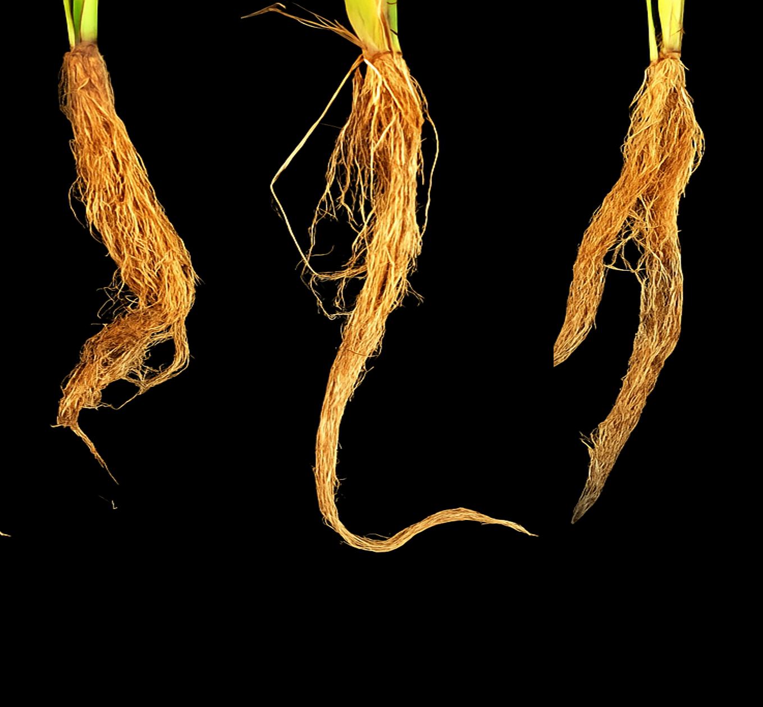
Commercial chitosan Plant
Synthesized chitosan Plant
Control Plant

Supplementary Fig. 2 The root length and thickness of the control plant (only water), seed primed by synthesized chitosan, and seed primed with commercial chitosan

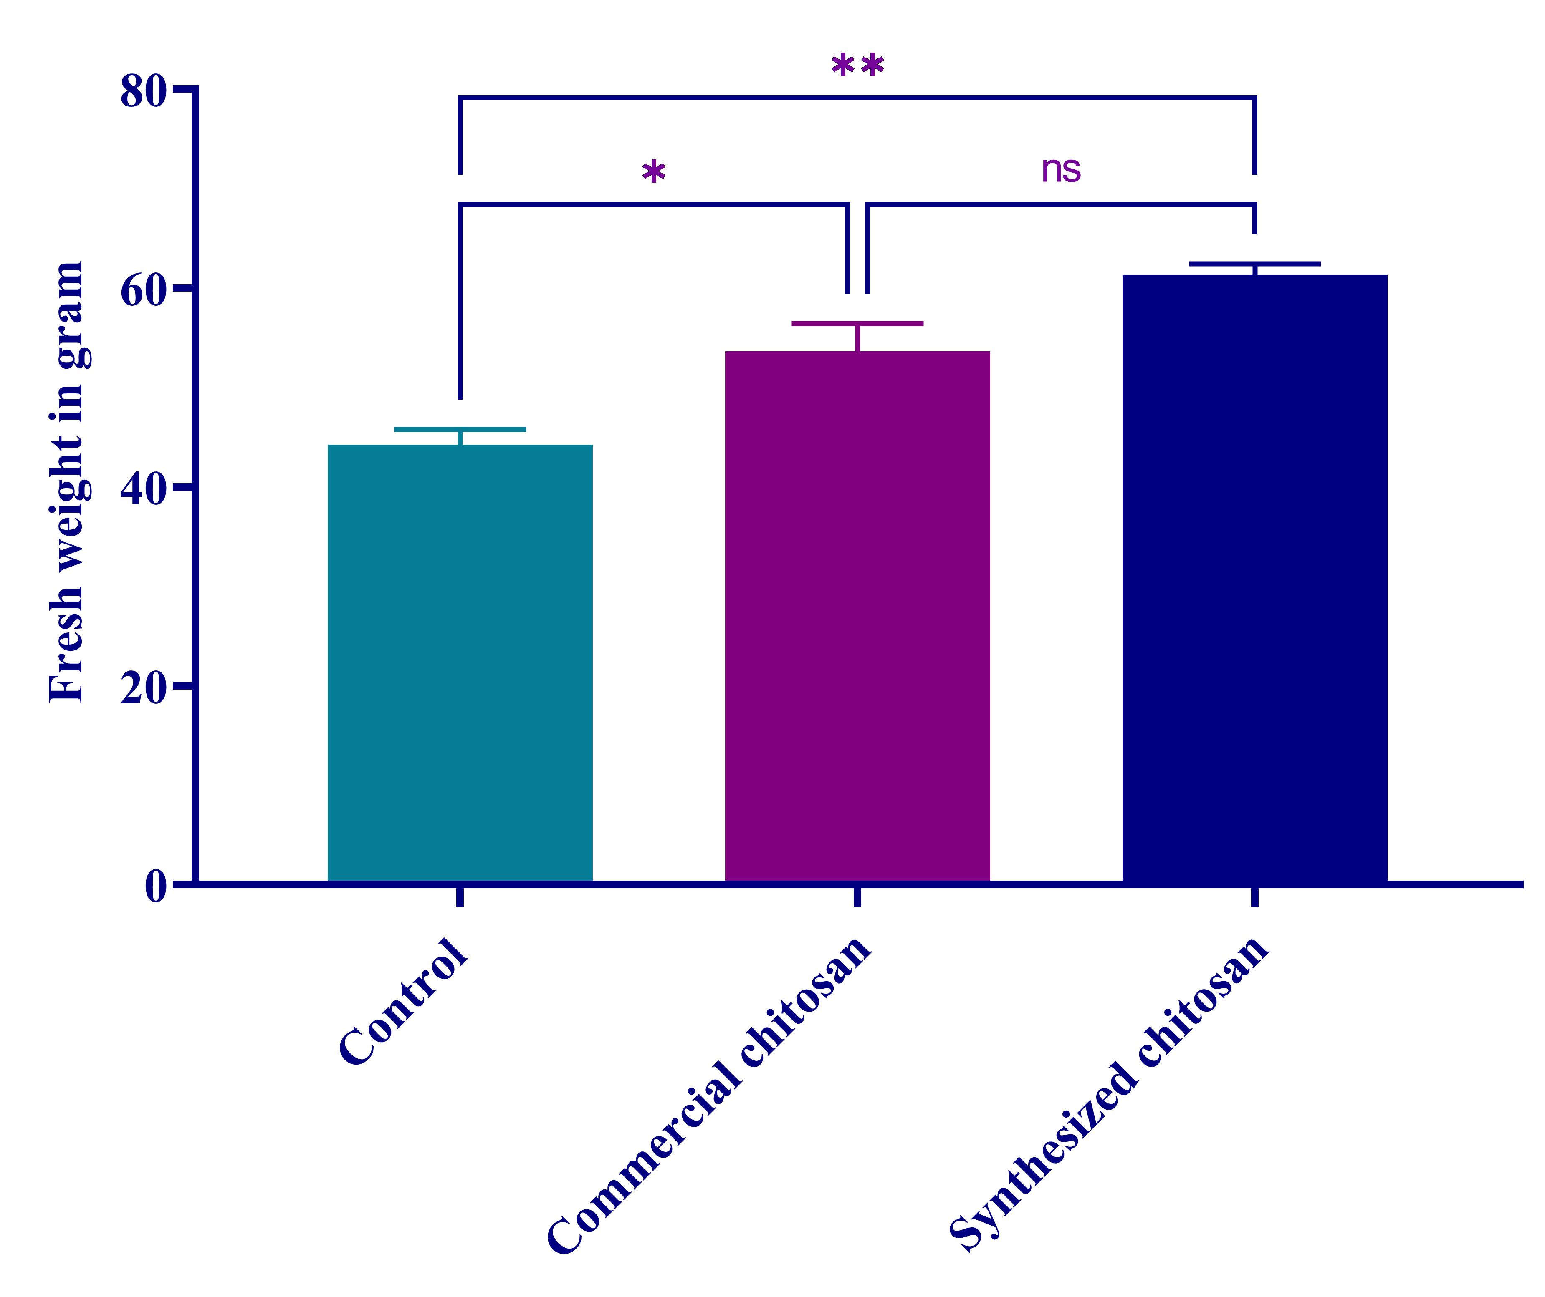
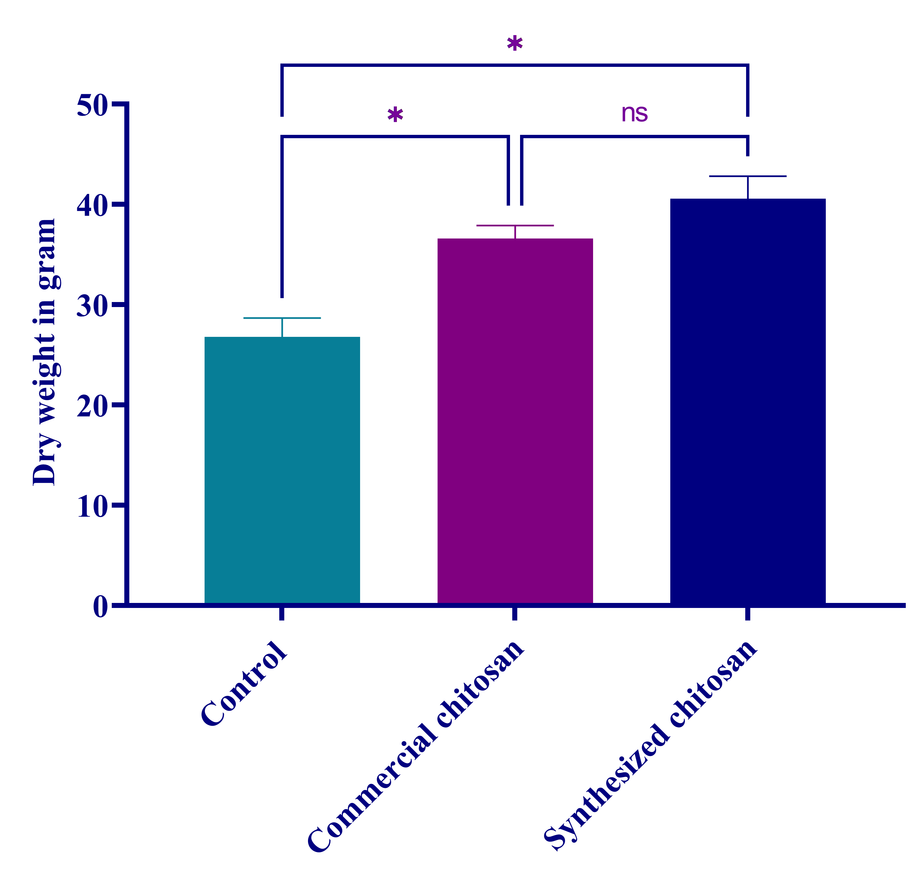
3a
3b

Supplementary Fig. 3 Effect of the chitosan on biomass accumulation of the rice plants: A) Fresh weight; B) Dry weight. Data were expressed as mean ± standard deviation (SD), and differences between treatment groups were analyzed using one-way ANOVA, followed by Tukey’s post hoc test. Statistical significance was determined at p ≤ 0.05. The following notation was used to indicate significance levels: ns (not significant) for p > 0.05, p = 0.03 as *, p = 0.0021 as **, and p = 0.0002 as ***.
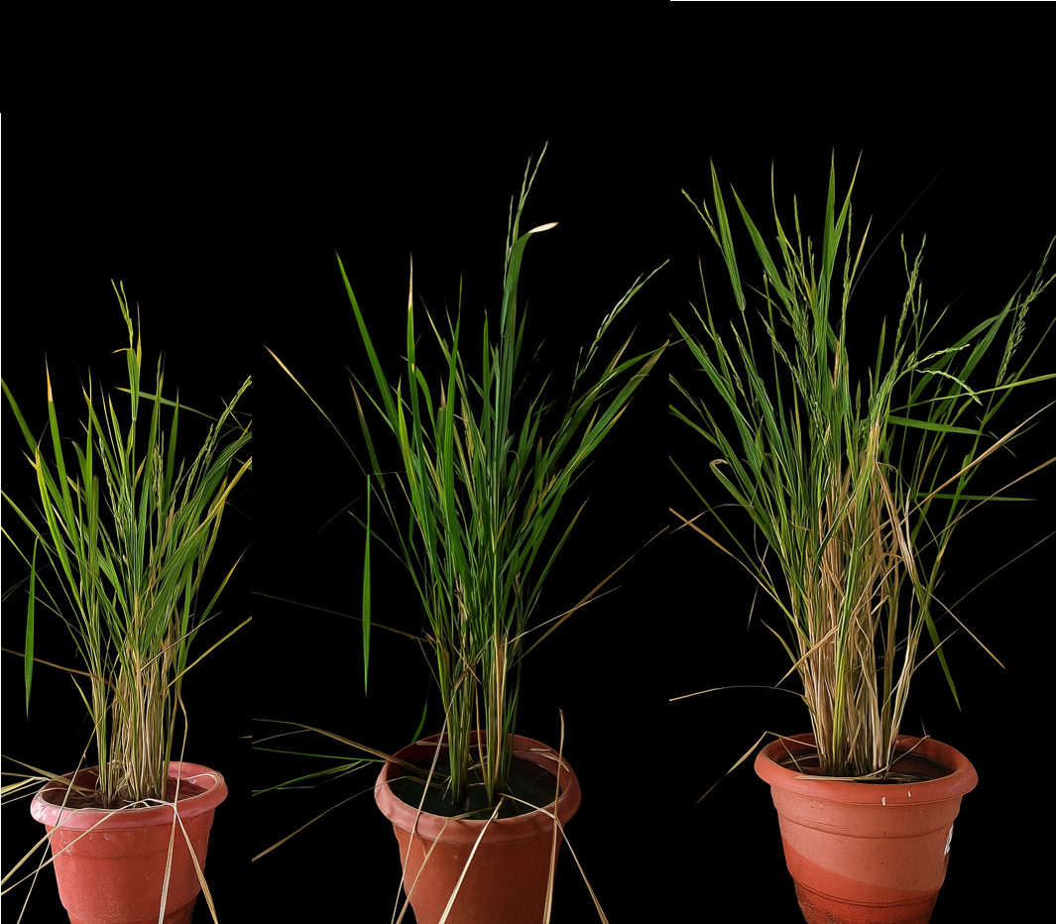
Control Plant
Synthesized chitosan Plant
Commercial chitosan Plant

Supplementary Fig. 4 Efffect of chitosan on physiological and reproductive traits on rice plants

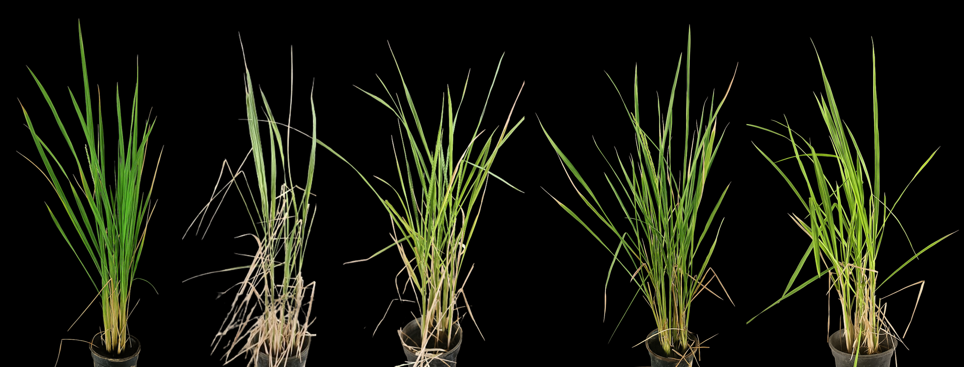
Control Plant
Only Fungus
Fungus + Commercial chitosan
Fungus + Synthesized chitosan
Fungus + Fungicide
Control Plant

Supplementary Fig. 5: Physiological conditions of the plants after foliar application of chitosan and commercial fungicide (Trichoderma viridae) on the fungus affected plants

