Supporting Information for
U.S. water system responses to future global human-Earth system change
Mengqi Zhao¹, Thomas B. Wild², Hamza Ahsan², Pralit L. Patel², Abigail Snyder², Matthew Binsted², Chris R. Vernon¹, Zarrar Khan^{2,3}, Ning Sun¹, Casey D. Burleyson¹, Hassan Niazi², Neal Graham², Paul Wolfram², Jennie S. Rice¹
¹Pacific Northwest National Laboratory, Richland, WA, USA.
²Joint Global Change Research Institute, Pacific Northwest National Laboratory, College Park, MD, USA.
³Climate Analytics, New York, NY, USA.

Socioeconomic Scenarios
The population in the U.S. and the rest of the world (ROW) shows the opposite trends for the SSP3 and SSP5 scenarios. In the low population and economic growth scenario (SSP3), the U.S. population starts from 320 million and peaks at 338 million by 2035 and then decreases to 246 million by 2100, while the ROW population increases from about 7 billion to 12.5 billion. In the high population and economic growth scenario (SSP5), the U.S. population rises steadily to 432 million by 2050 and then to 650 million by 2100, while the ROW population peaks at 8.3 billion in 2050, and declines to 6.8 billion by 2100.
The GDP trends are similar between the U.S. and the ROW. The U.S. GDP begins at $10 trillion in 2015 and gradually increases to between $15.7 trillion (ATM4.5) and $23.9 trillion (ATM8.5) in the SSP3 scenarios, while in the SSP5 scenarios, it rises more rapidly to approximately $75 trillion. For the ROW, the GDP starts from $38.7 trillion in 2015 and increases to between approximately $12.3 to $18.7 trillion. All values are expressed in 1990 U.S. dollars (1990 USD).

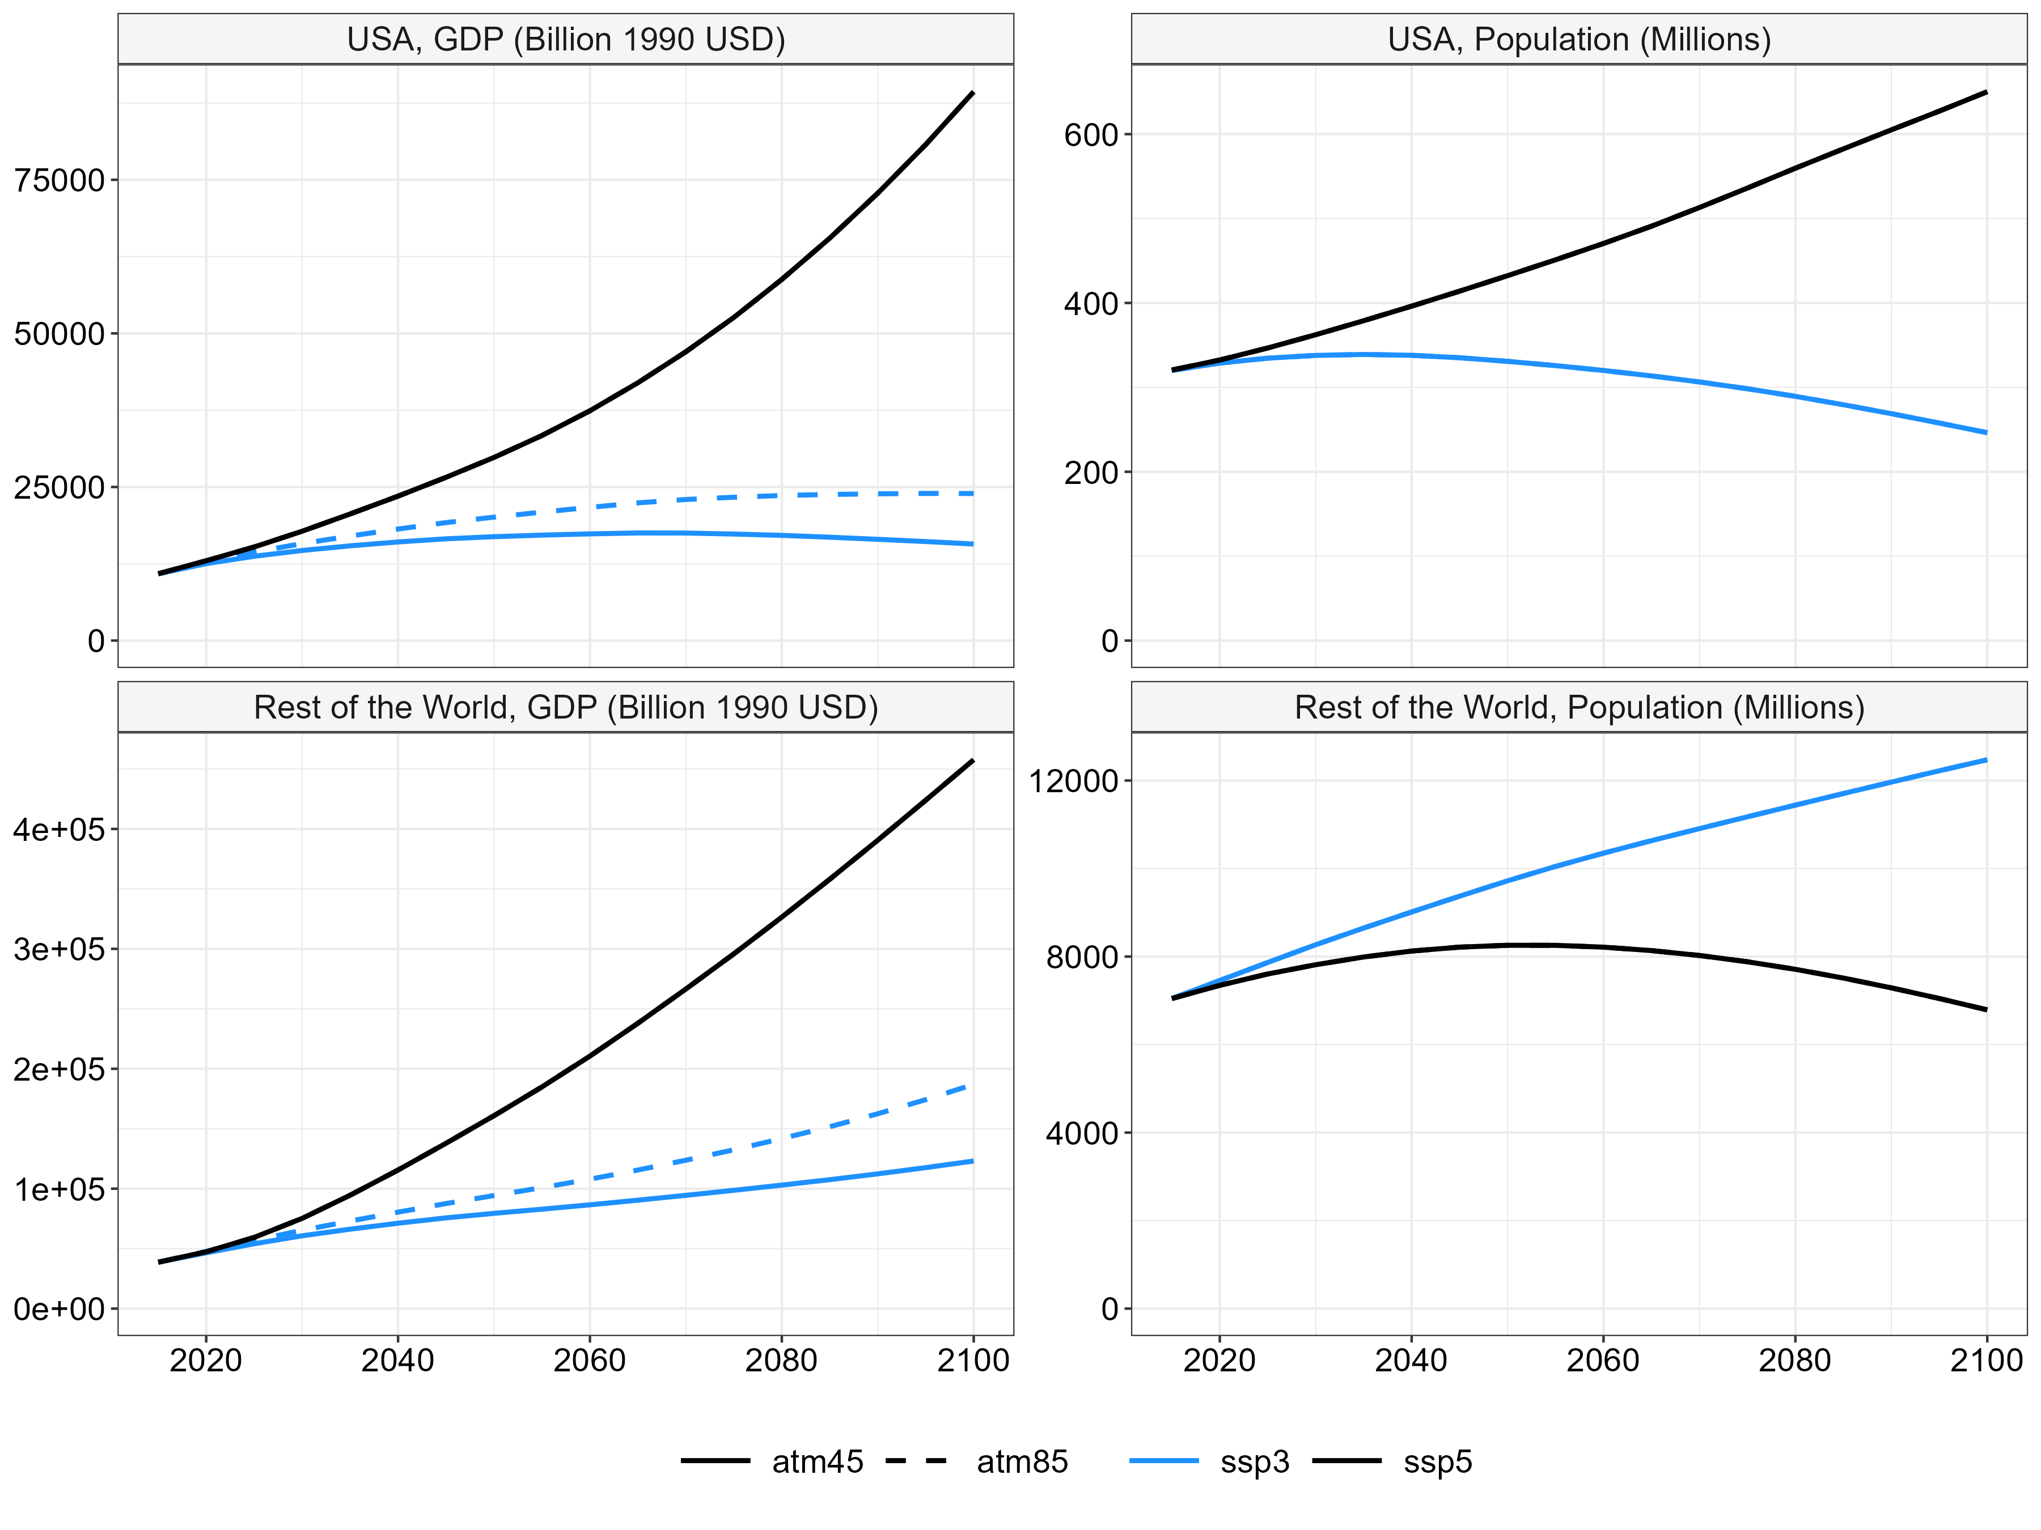

Figure S1. Population and GDP for CONUS (top) and for the rest of the world (bottom). The unit “1990 USD” means that the GDP is represented by the U.S. dollar value from 1990.

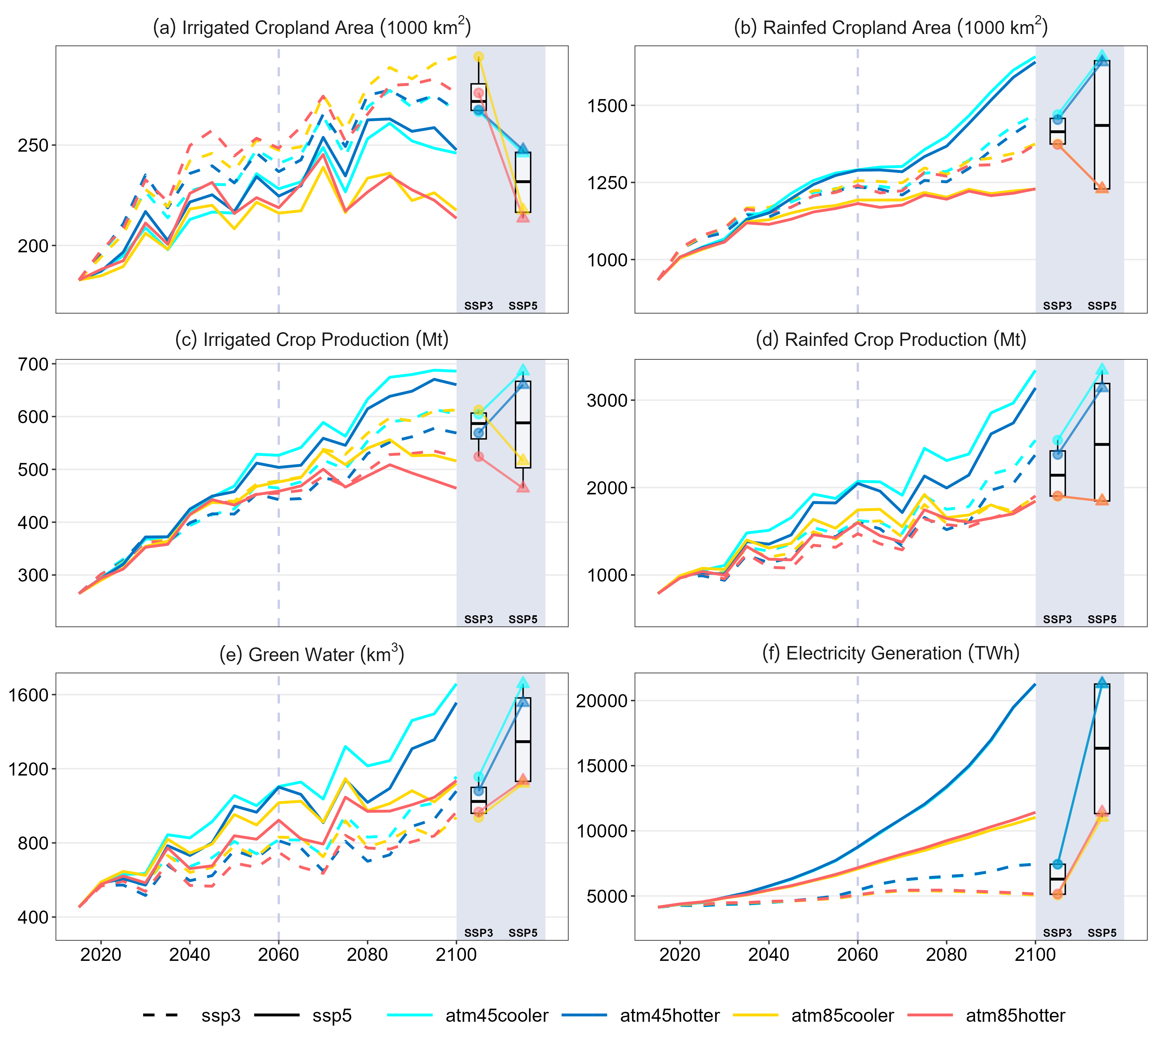

Figure S2. Future evolution across CONUS for eight canonical scenarios: (a) irrigated cropland area; (b) rainfed cropland area; (c) irrigated crop production; (d) rainfed crop production; (e) green water withdrawals; and (f) electricity generation. The right-hand panel shows boxplots representing the distribution of the metric for low- and high-growth SET scenario in the year 2100. Connecting lines illustrate how the metric changes from low to high SET growth under each climate scenario.

(a)
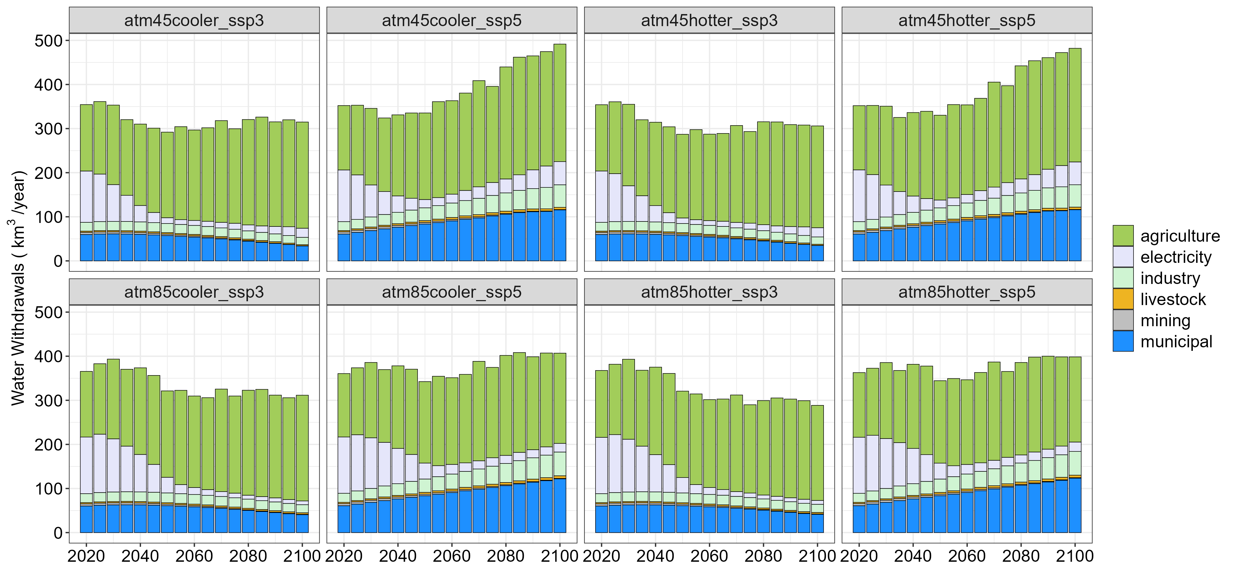
(b)
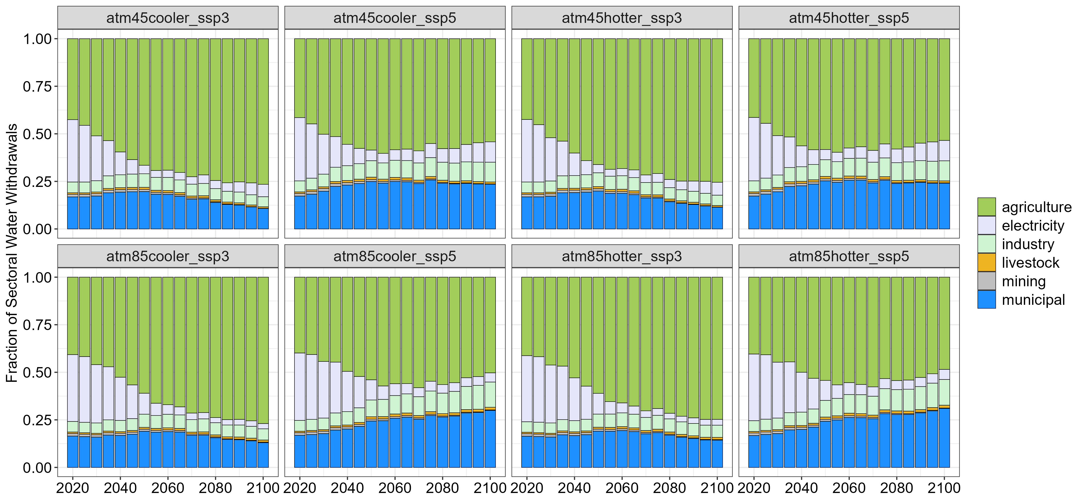

Figure S3. (a) Sectoral water withdrawals by demand sector, and (b) fraction of sectoral water withdrawals by demand sector over CONUS.

(a)
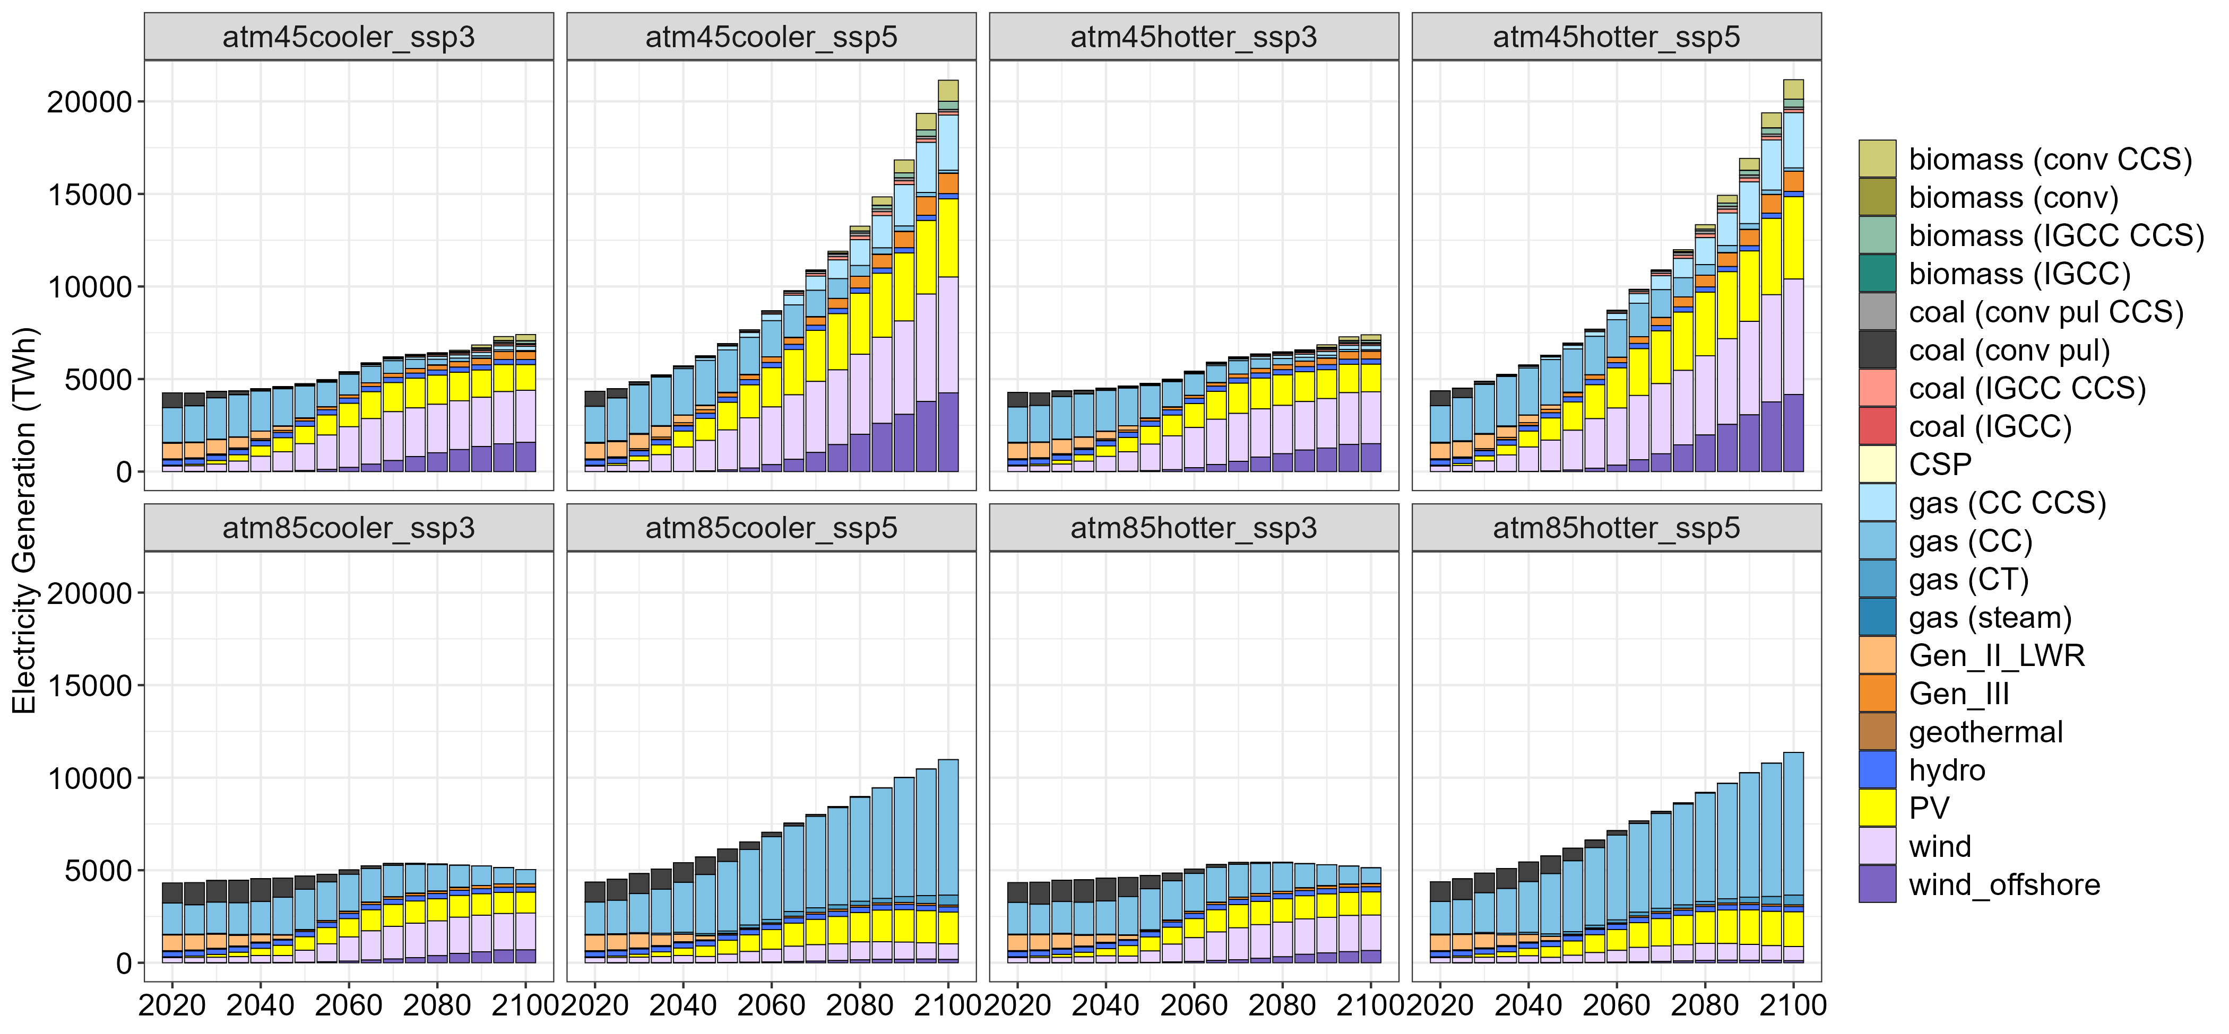
(b)
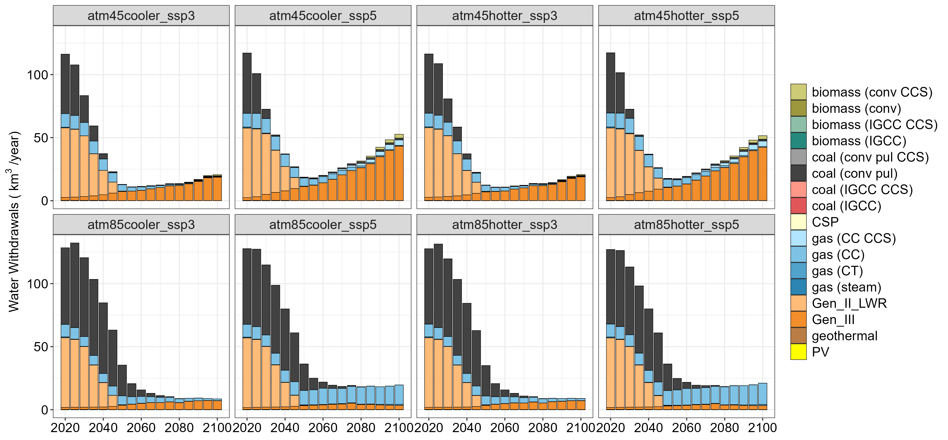
(c)
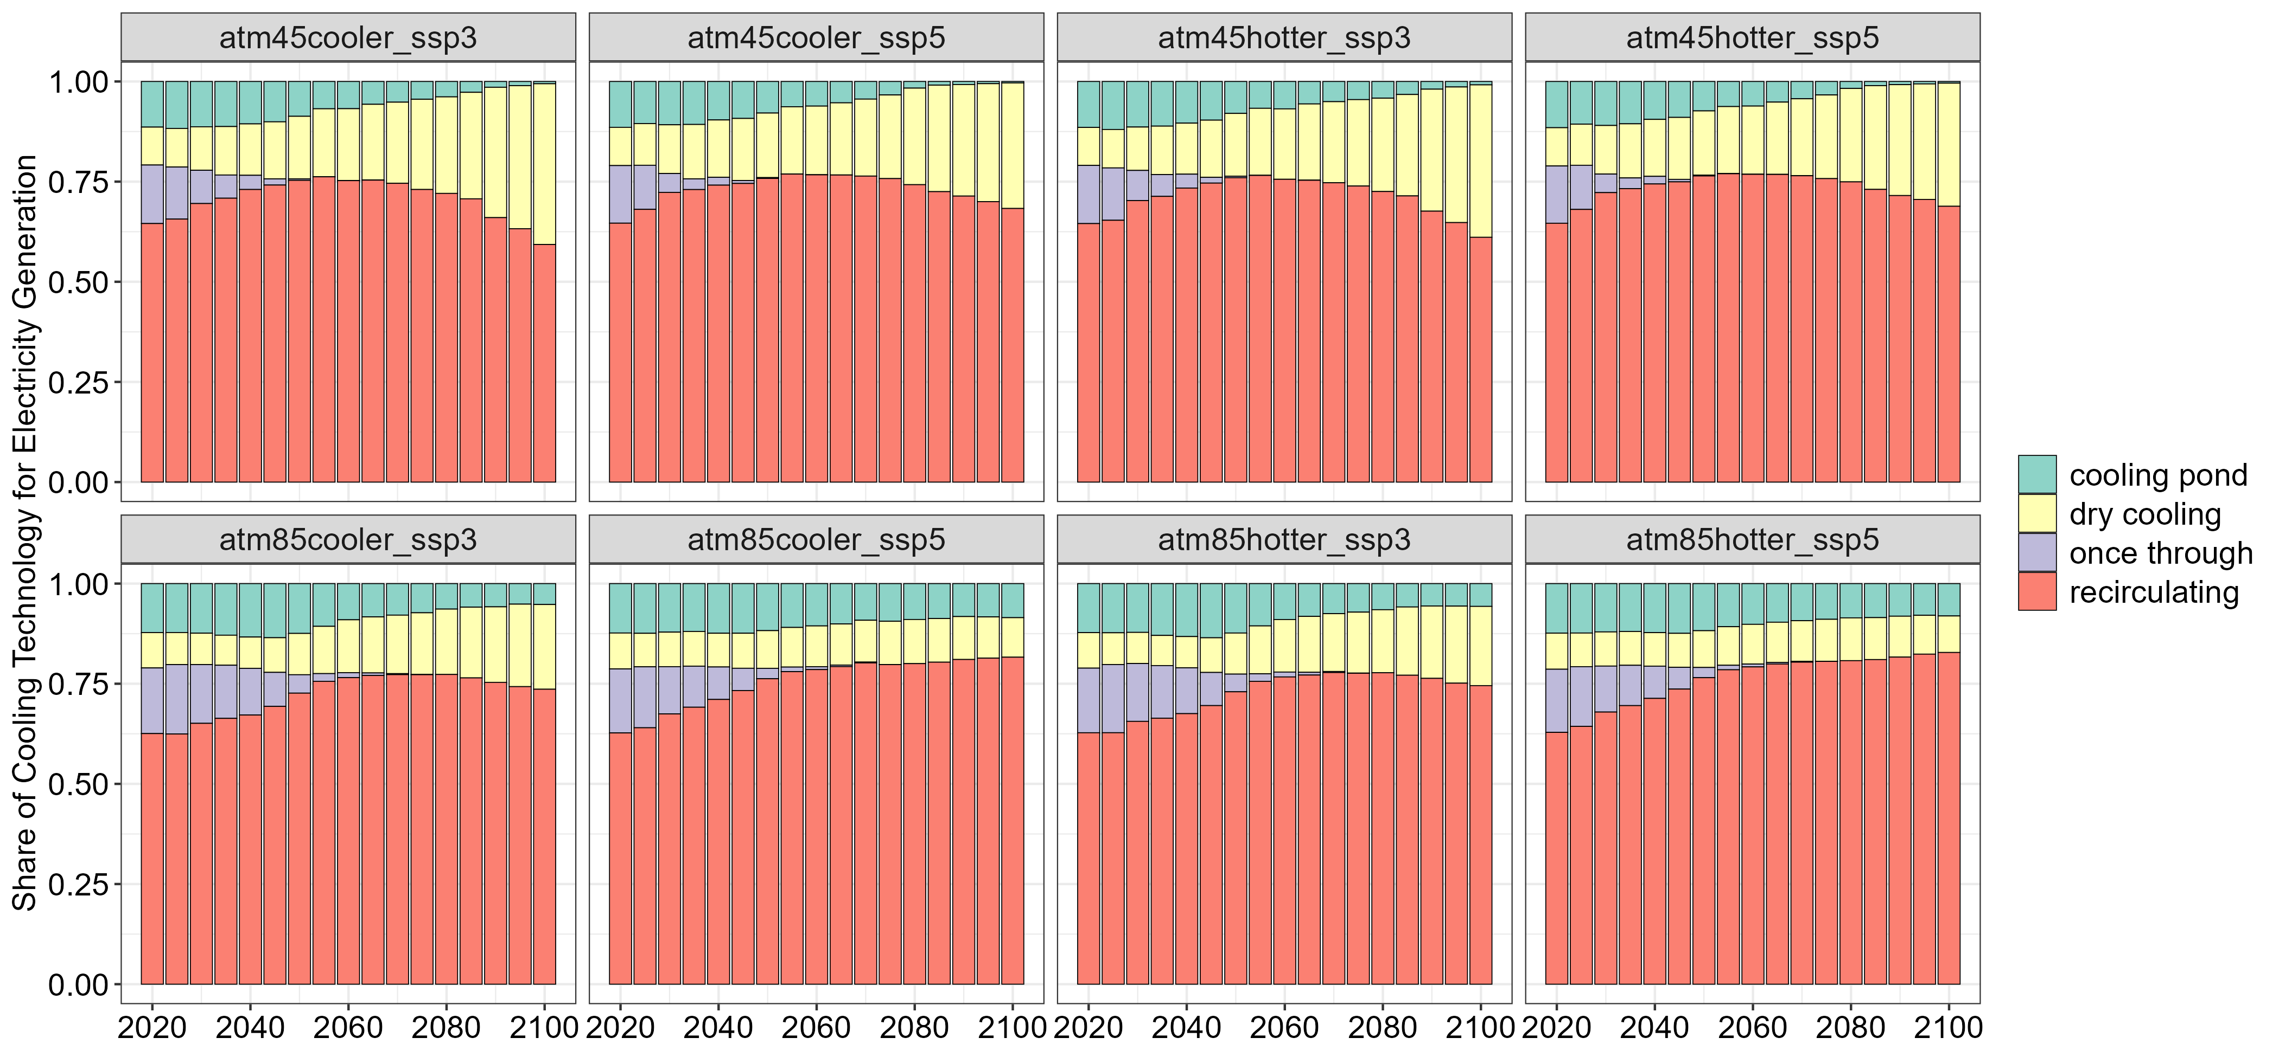

Figure S4. (a) Electricity generation; (b) electricity water withdrawals by generation technology; and (c) share of cooling technology for electricity generation over CONUS.

Regional crop production depends on the comparative advantage to optimize the global crop profits under resources cost and availability. A region with lower resource cost (e.g., water, fertilizer) and higher yield of one crop may potentially grow that crop rather than in a different region with higher resource cost and lower yield. However, more complexity is introduced considering historical crop mix of a region and their relative profitability.

(a)
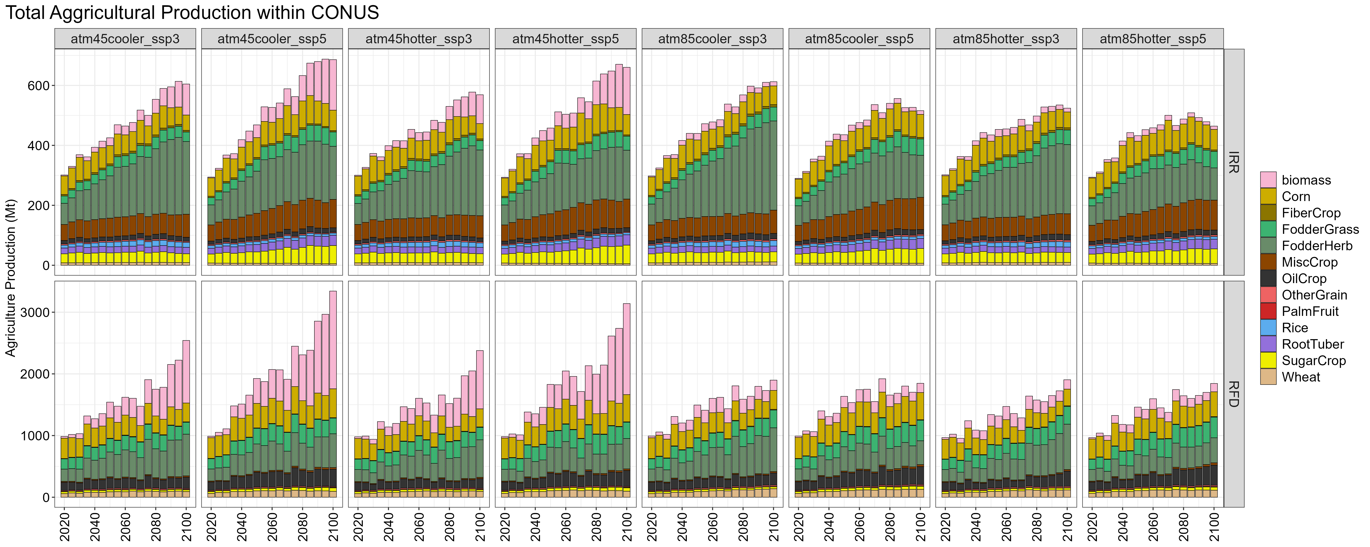
(b)
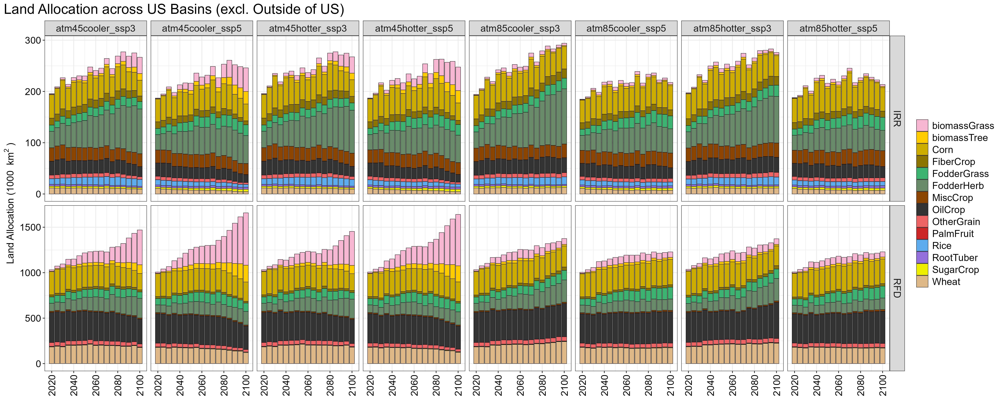
(c)
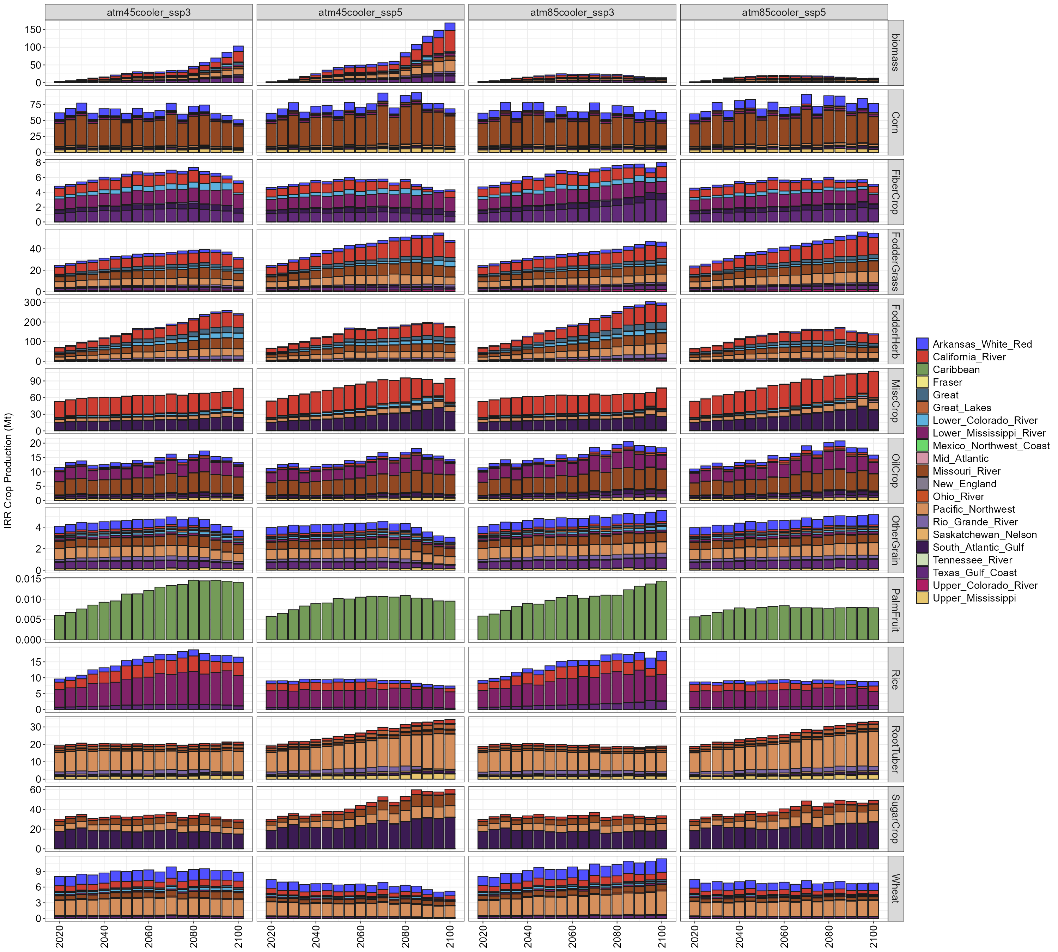
(d)
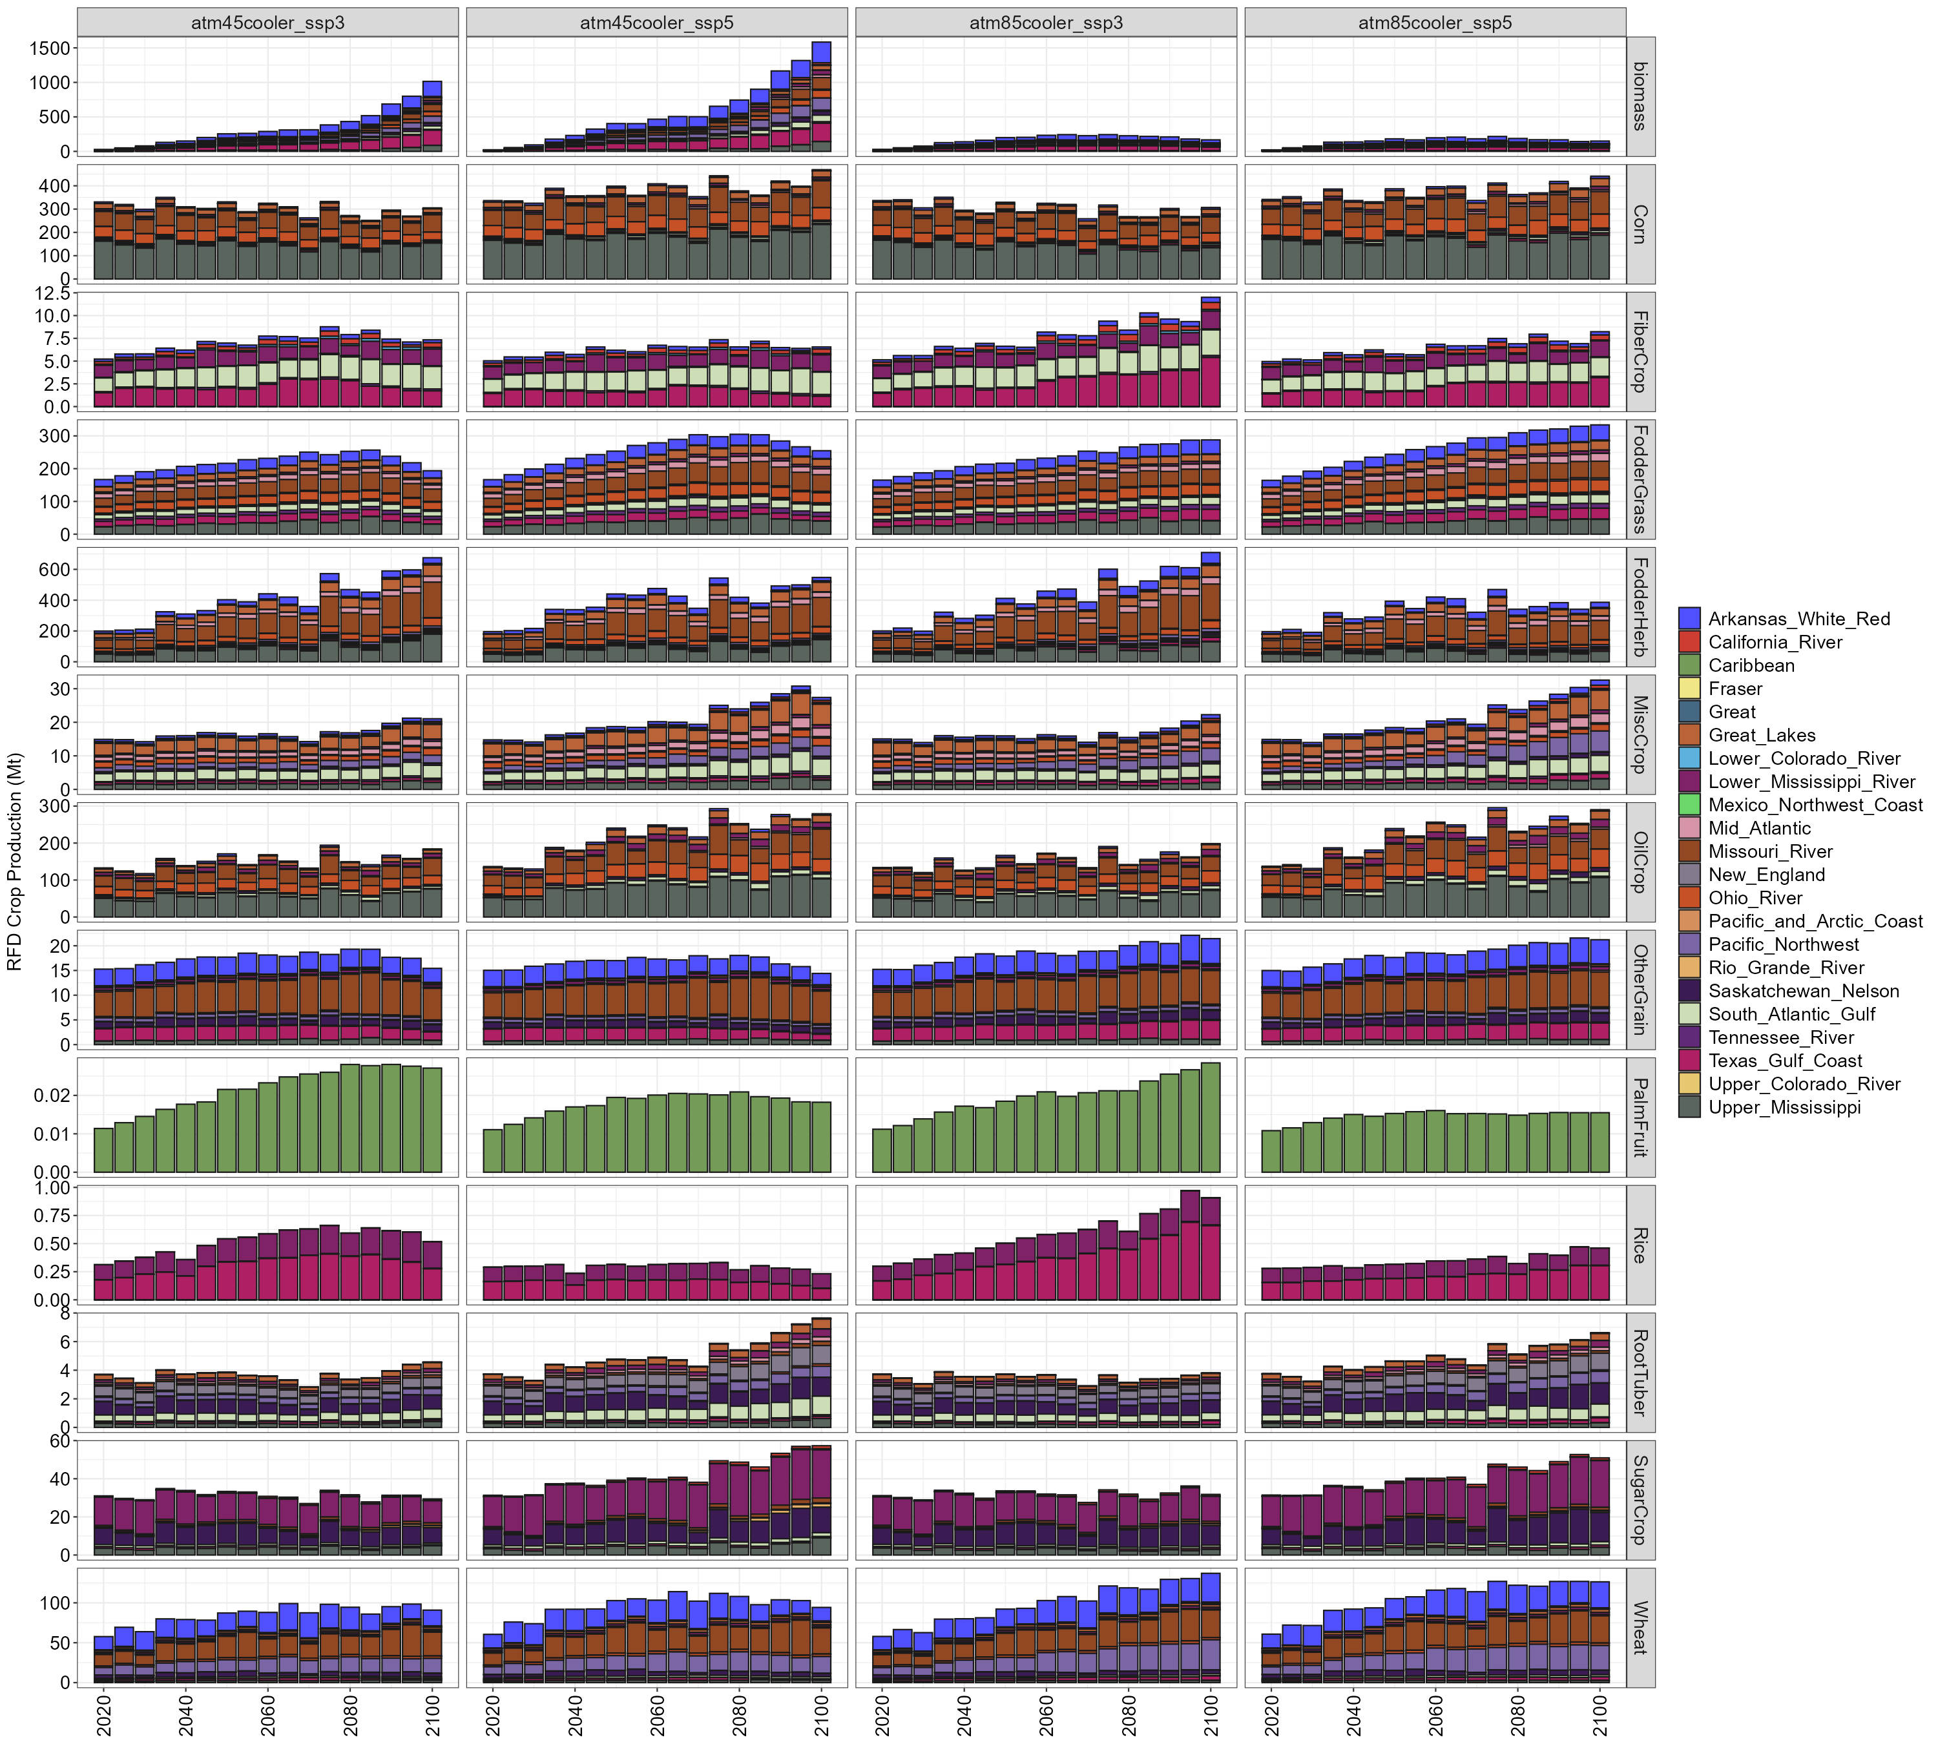

Figure S5. (a) Agricultural production by crop type, (b) agricultural land allocation by crop type, (c) irrigated crop production by basin and crop type (cooler scenarios), and (d) rainfed crop production by basin and crop type (cooler scenarios) over CONUS.

(a) Absolute change
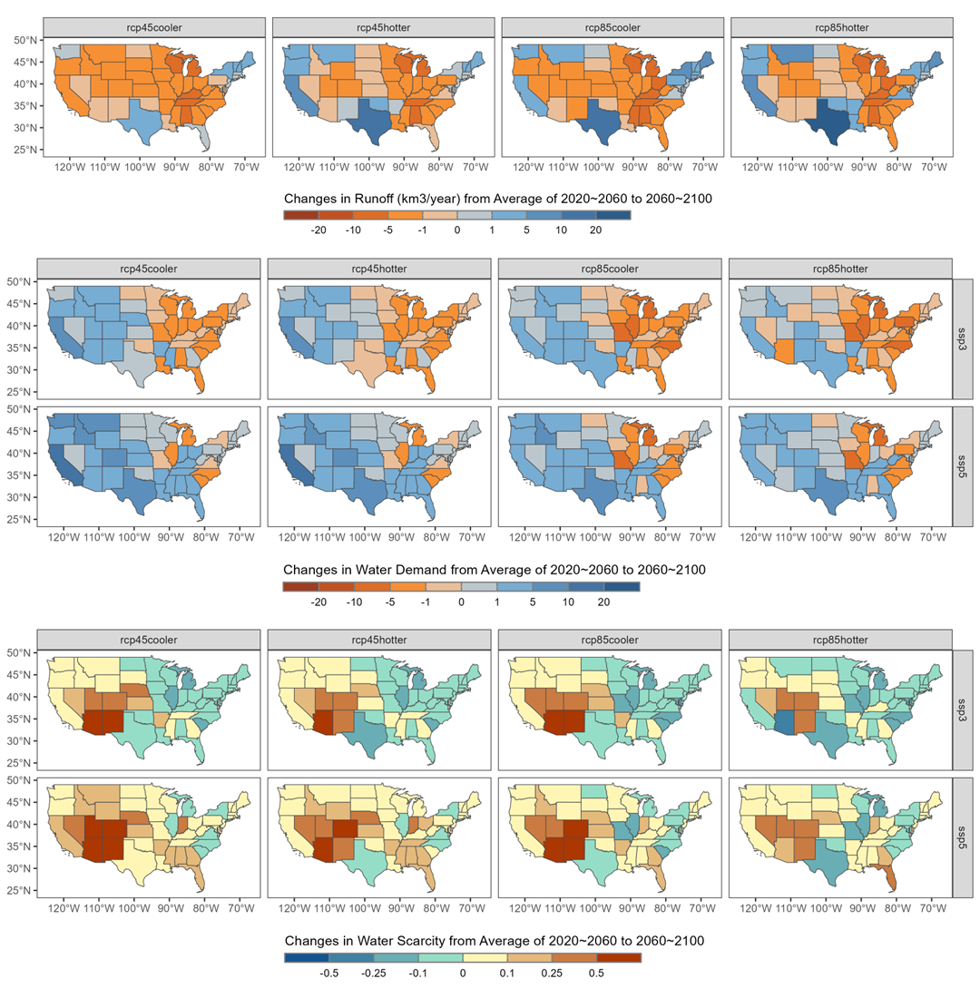
(b) Percent Change
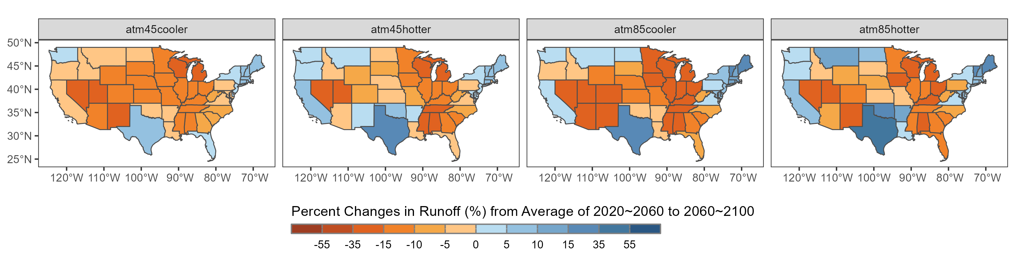
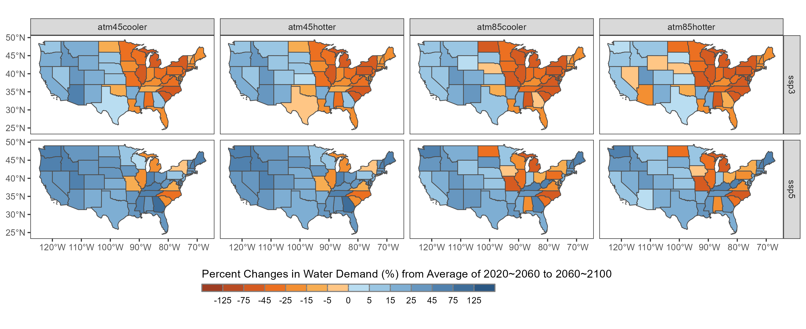
(c)
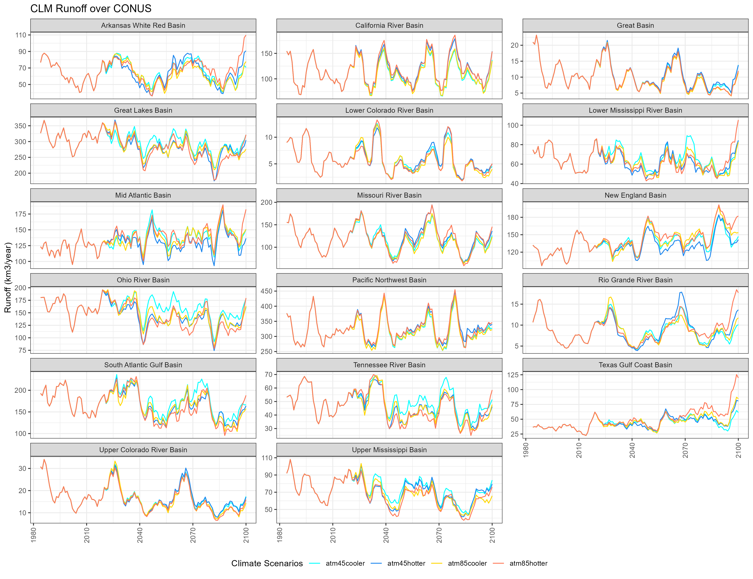

Figure S6. (a) Absolute changes and (b) percent in runoff, water demand, and water scarcity from near future to far future, (c) 5-year smoothed runoff time series across CONUS.

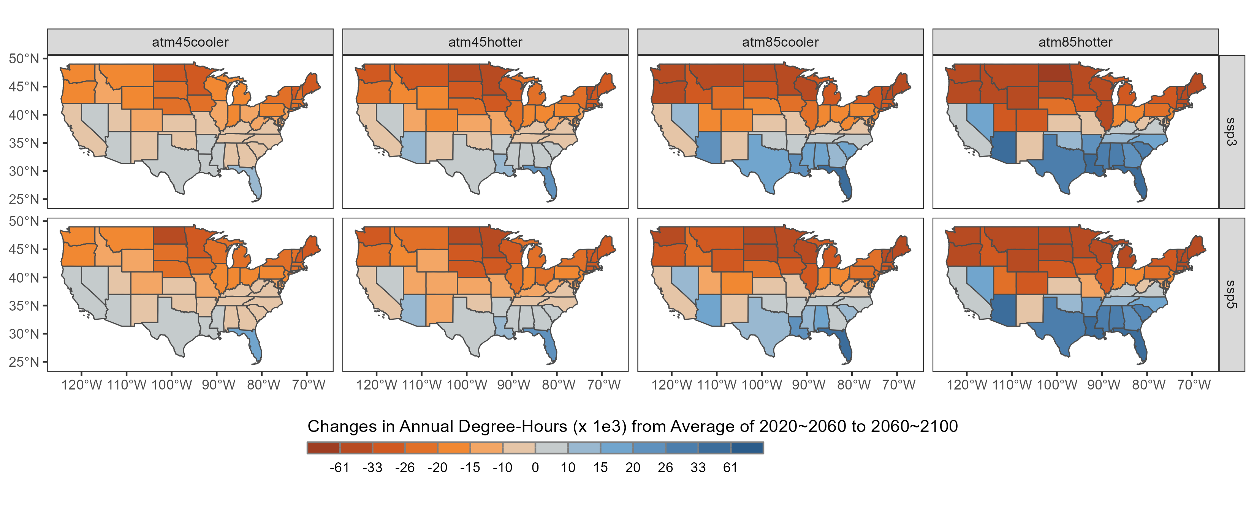

Figure S7. Absolute changes in annual total heating and cooling degree-hours from near future to far future across CONUS states.

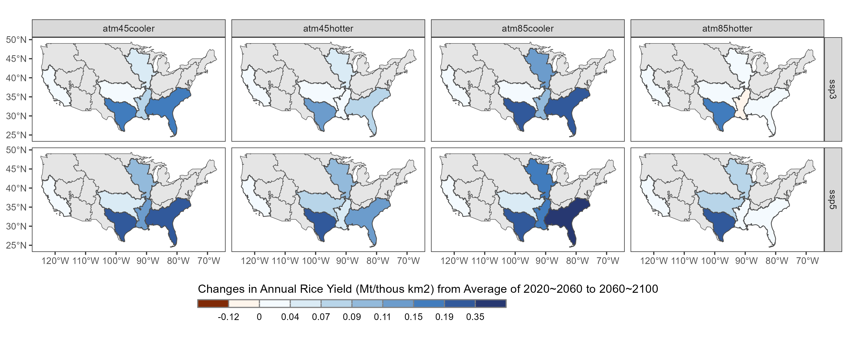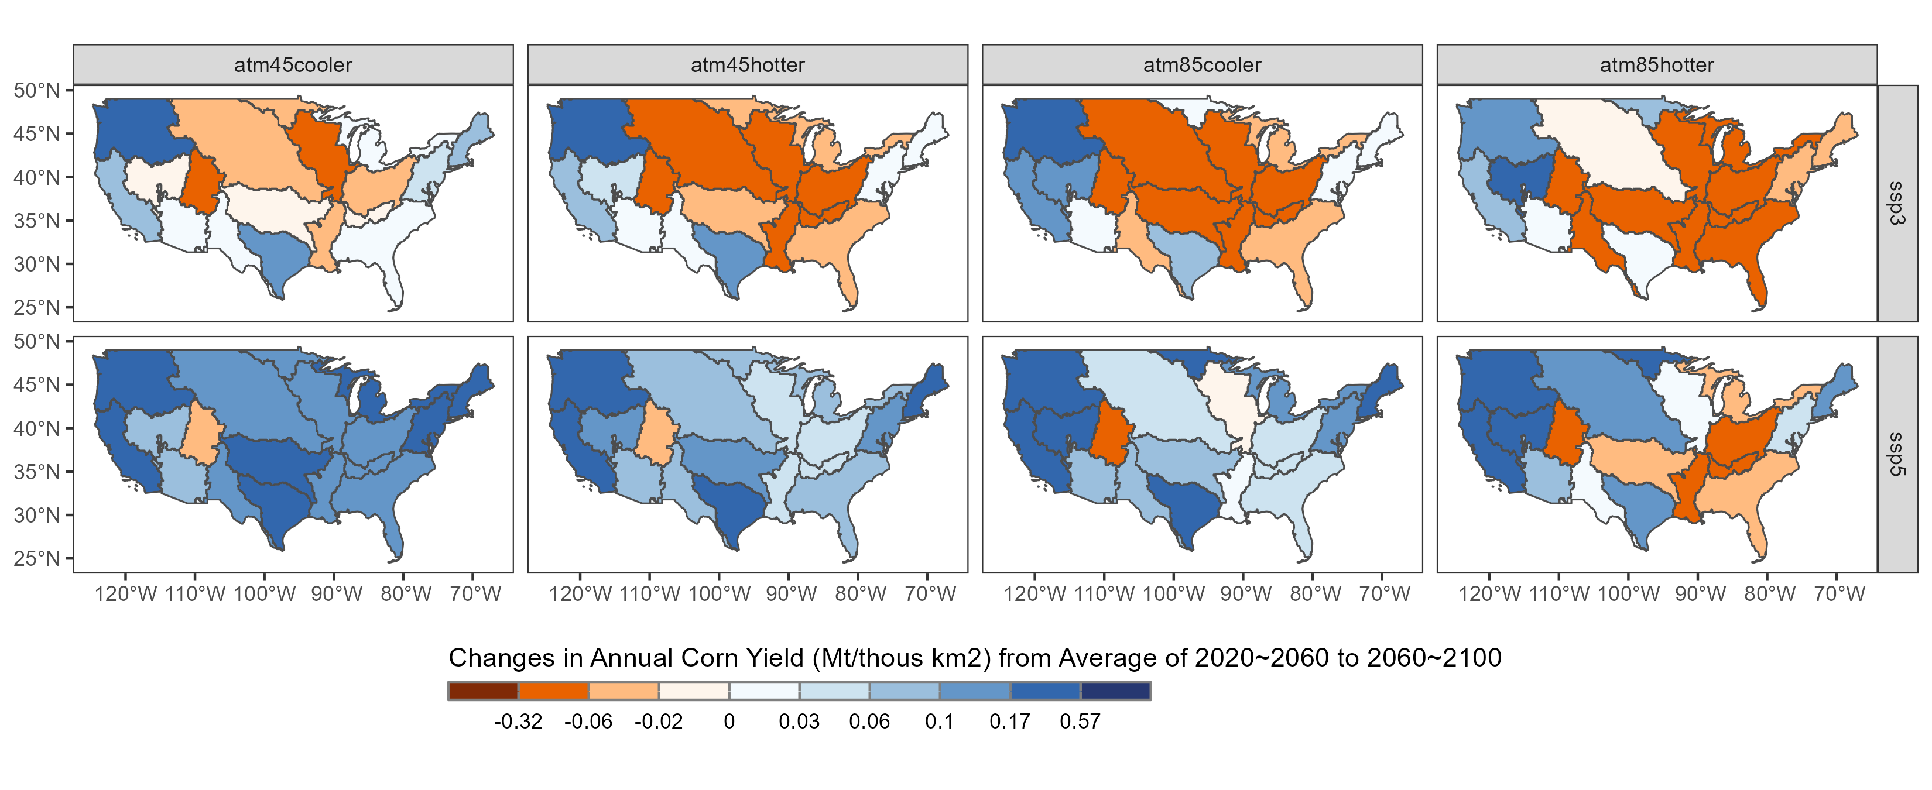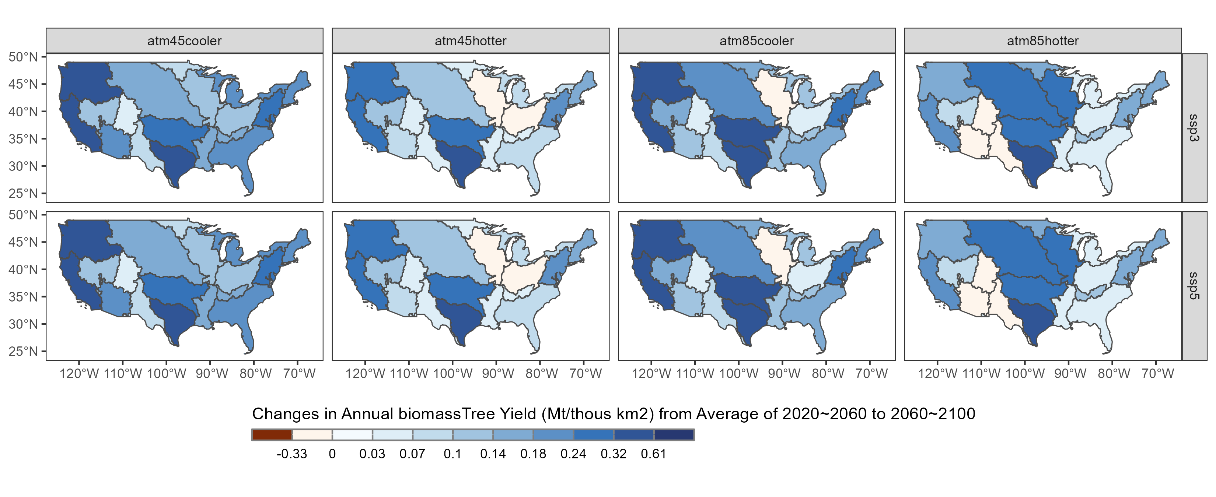

Figure S8. Absolute changes in rainfed crop yield with high technology from near future to far future across CONUS basins for selected crops: rice, corn, and biomass.

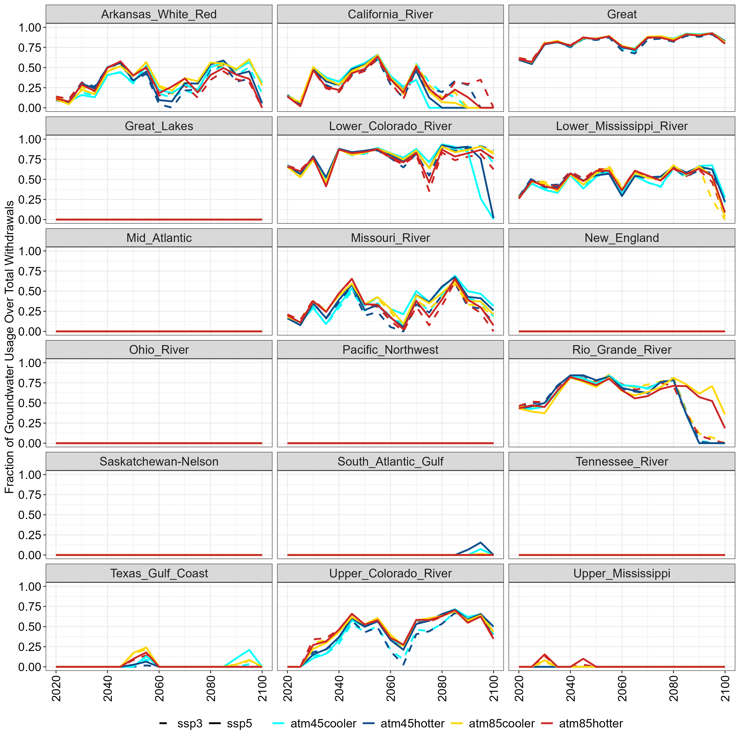

Figure S9. Fraction of non-renewable groundwater withdrawals over total water withdrawals across CONUS basins.

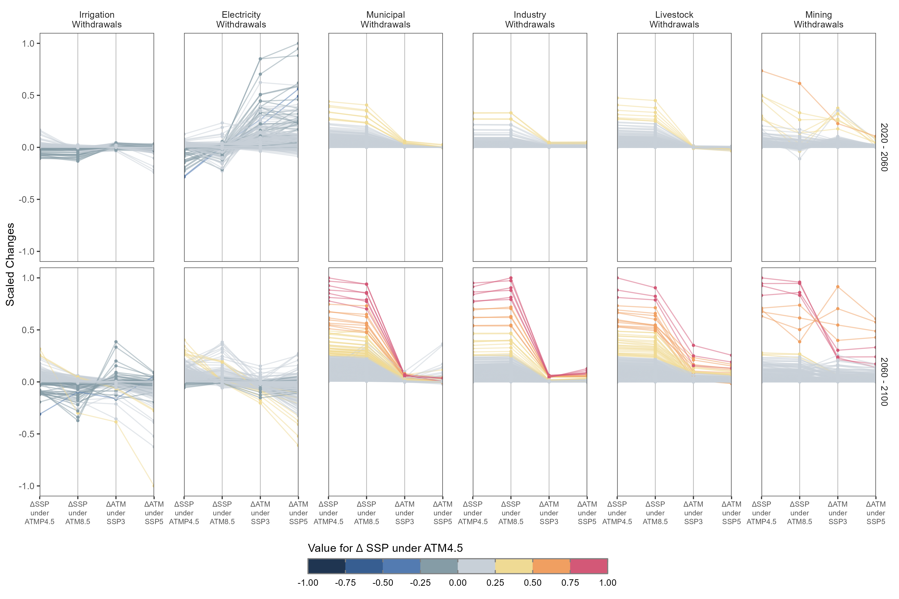

Figure S10. Parallel coordinates plot for the cross-comparison of the normalized change in six water withdrawals by sector metrics.

(a)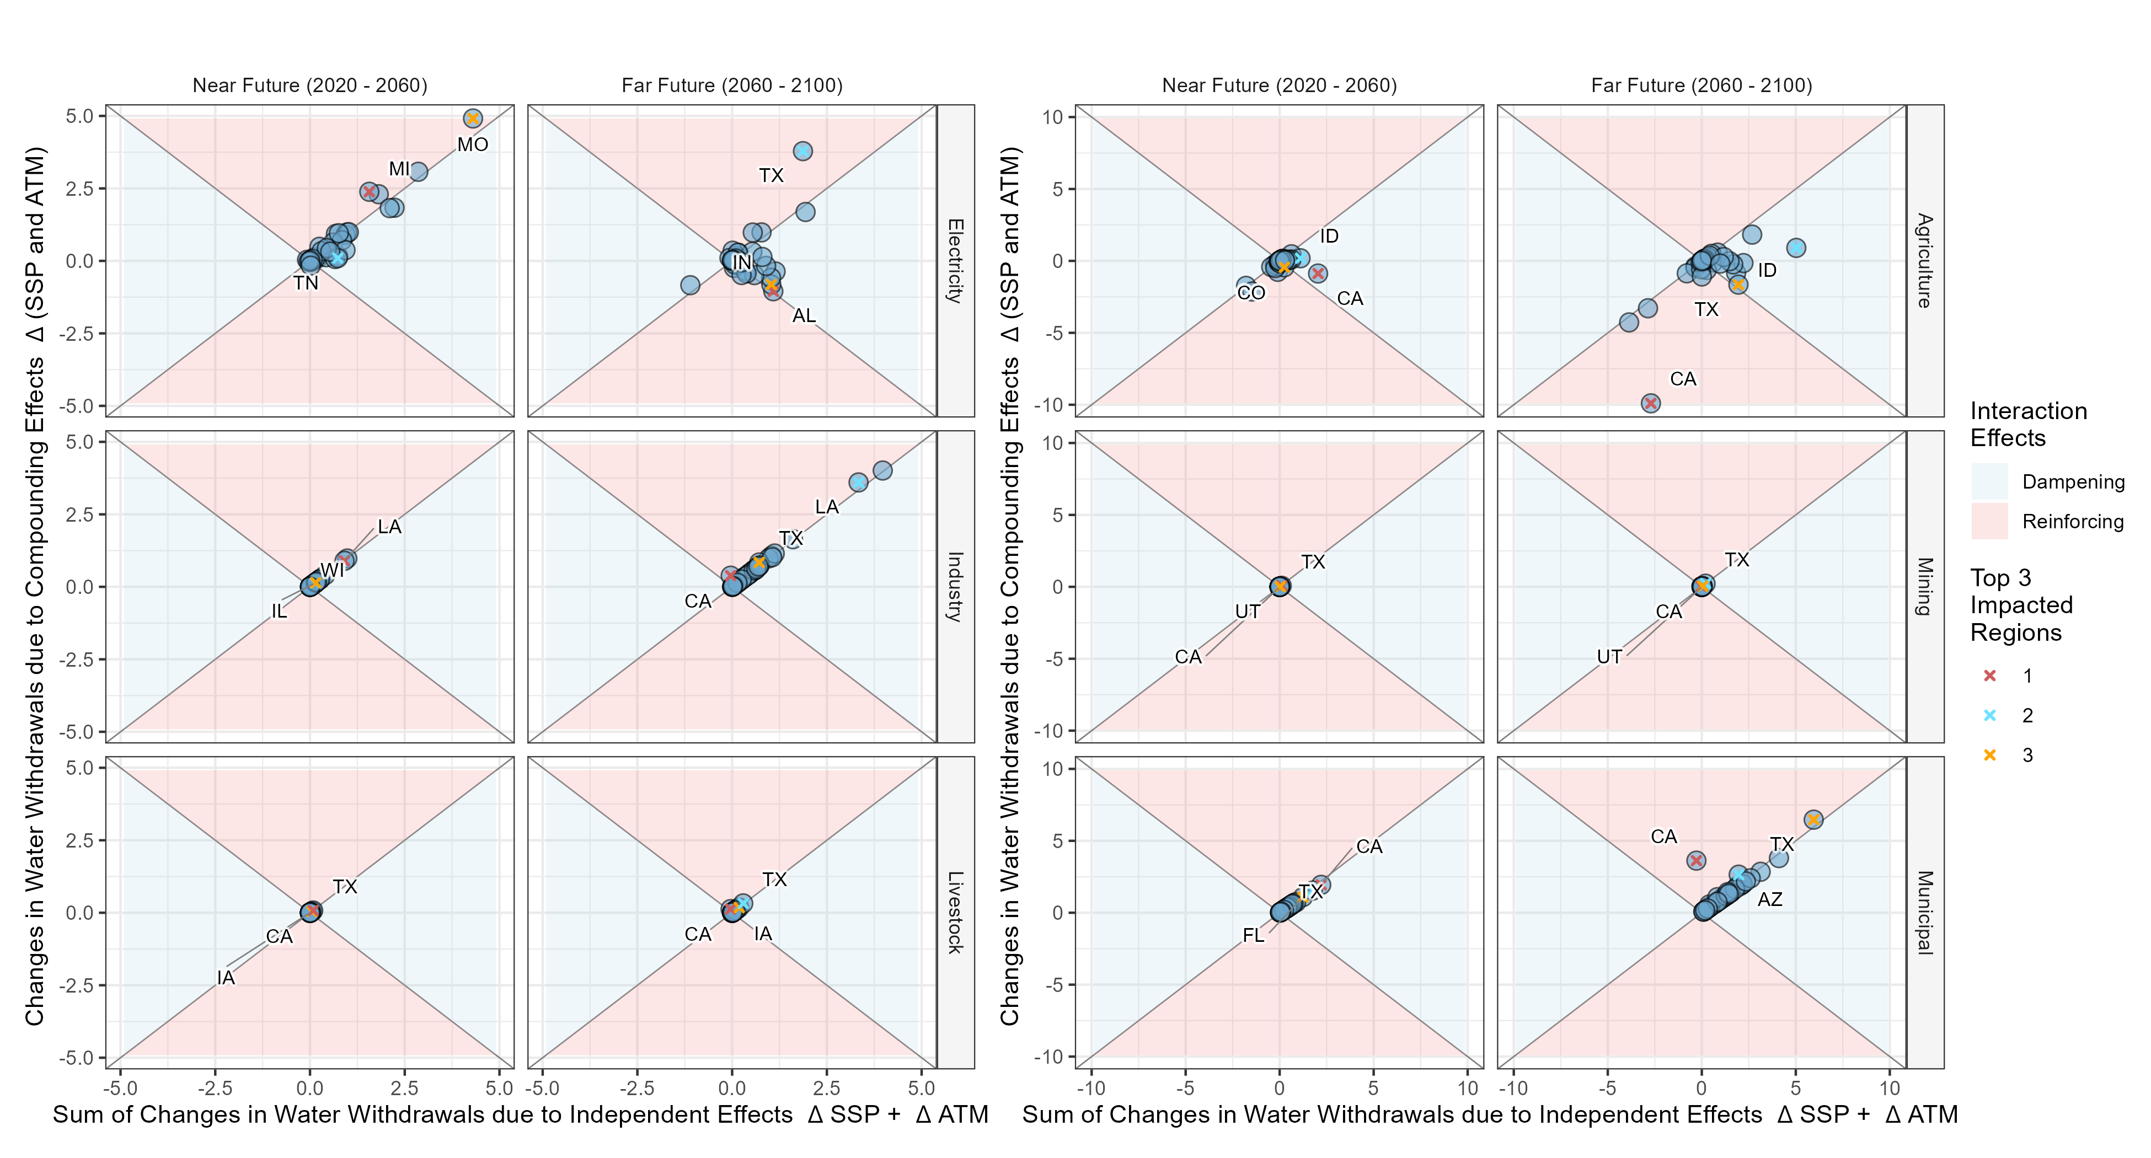
(b)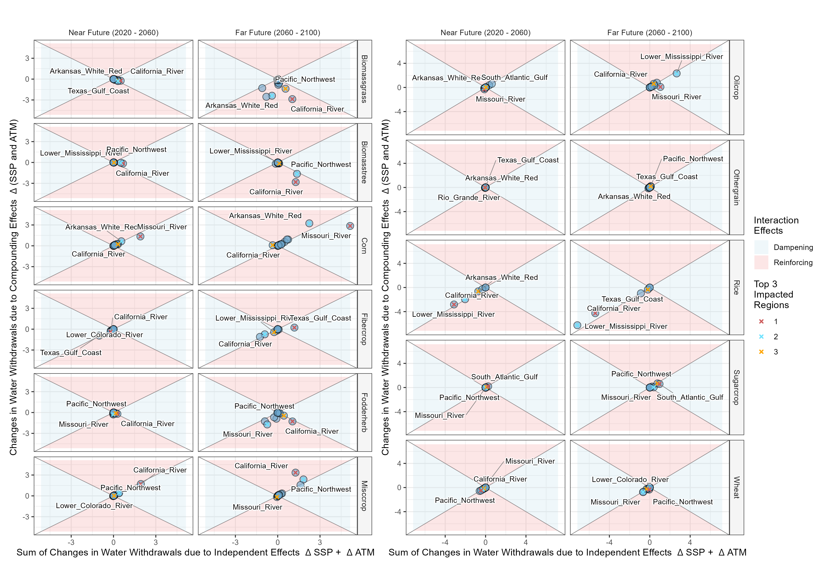

Figure S11. The correlation between the changes of (a) water withdrawal by demand sector and (b) water withdrawal by crop type from ∆SSP + ∆ATM and ∆ (SSP and ATM) in 2025, 2065, 2100, and 2100 for CONUS basins.

(a)
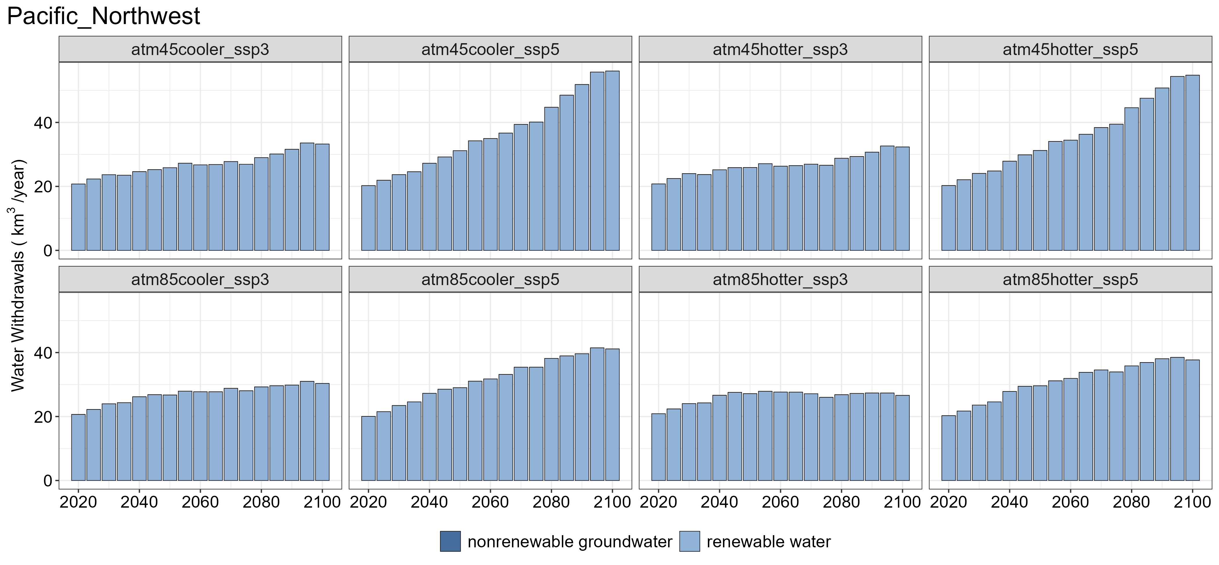
(b)
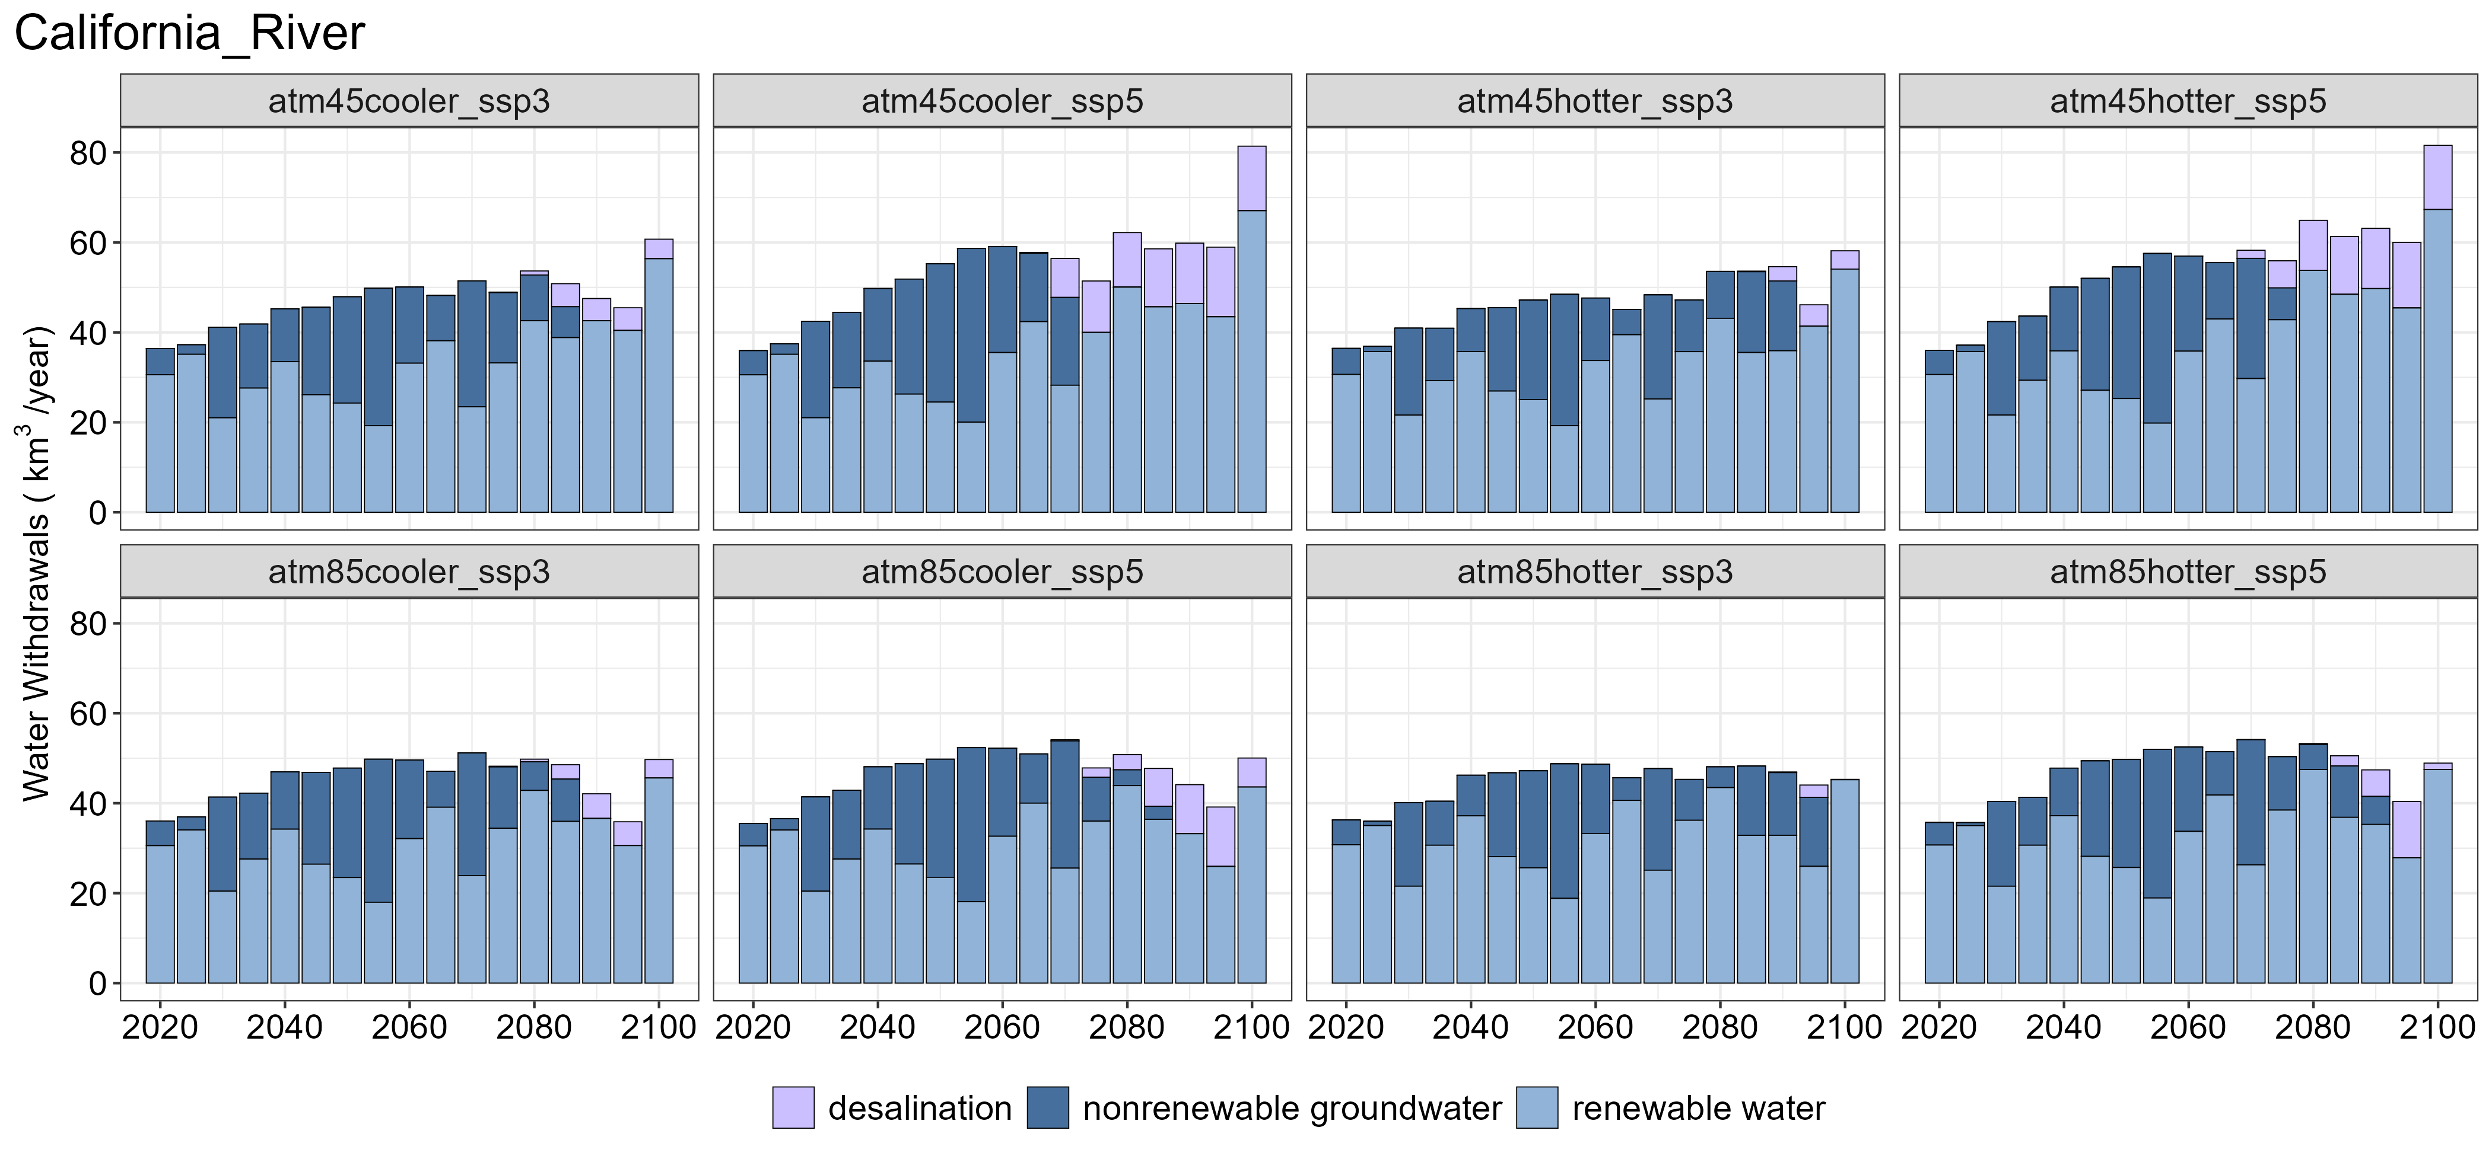
(c)
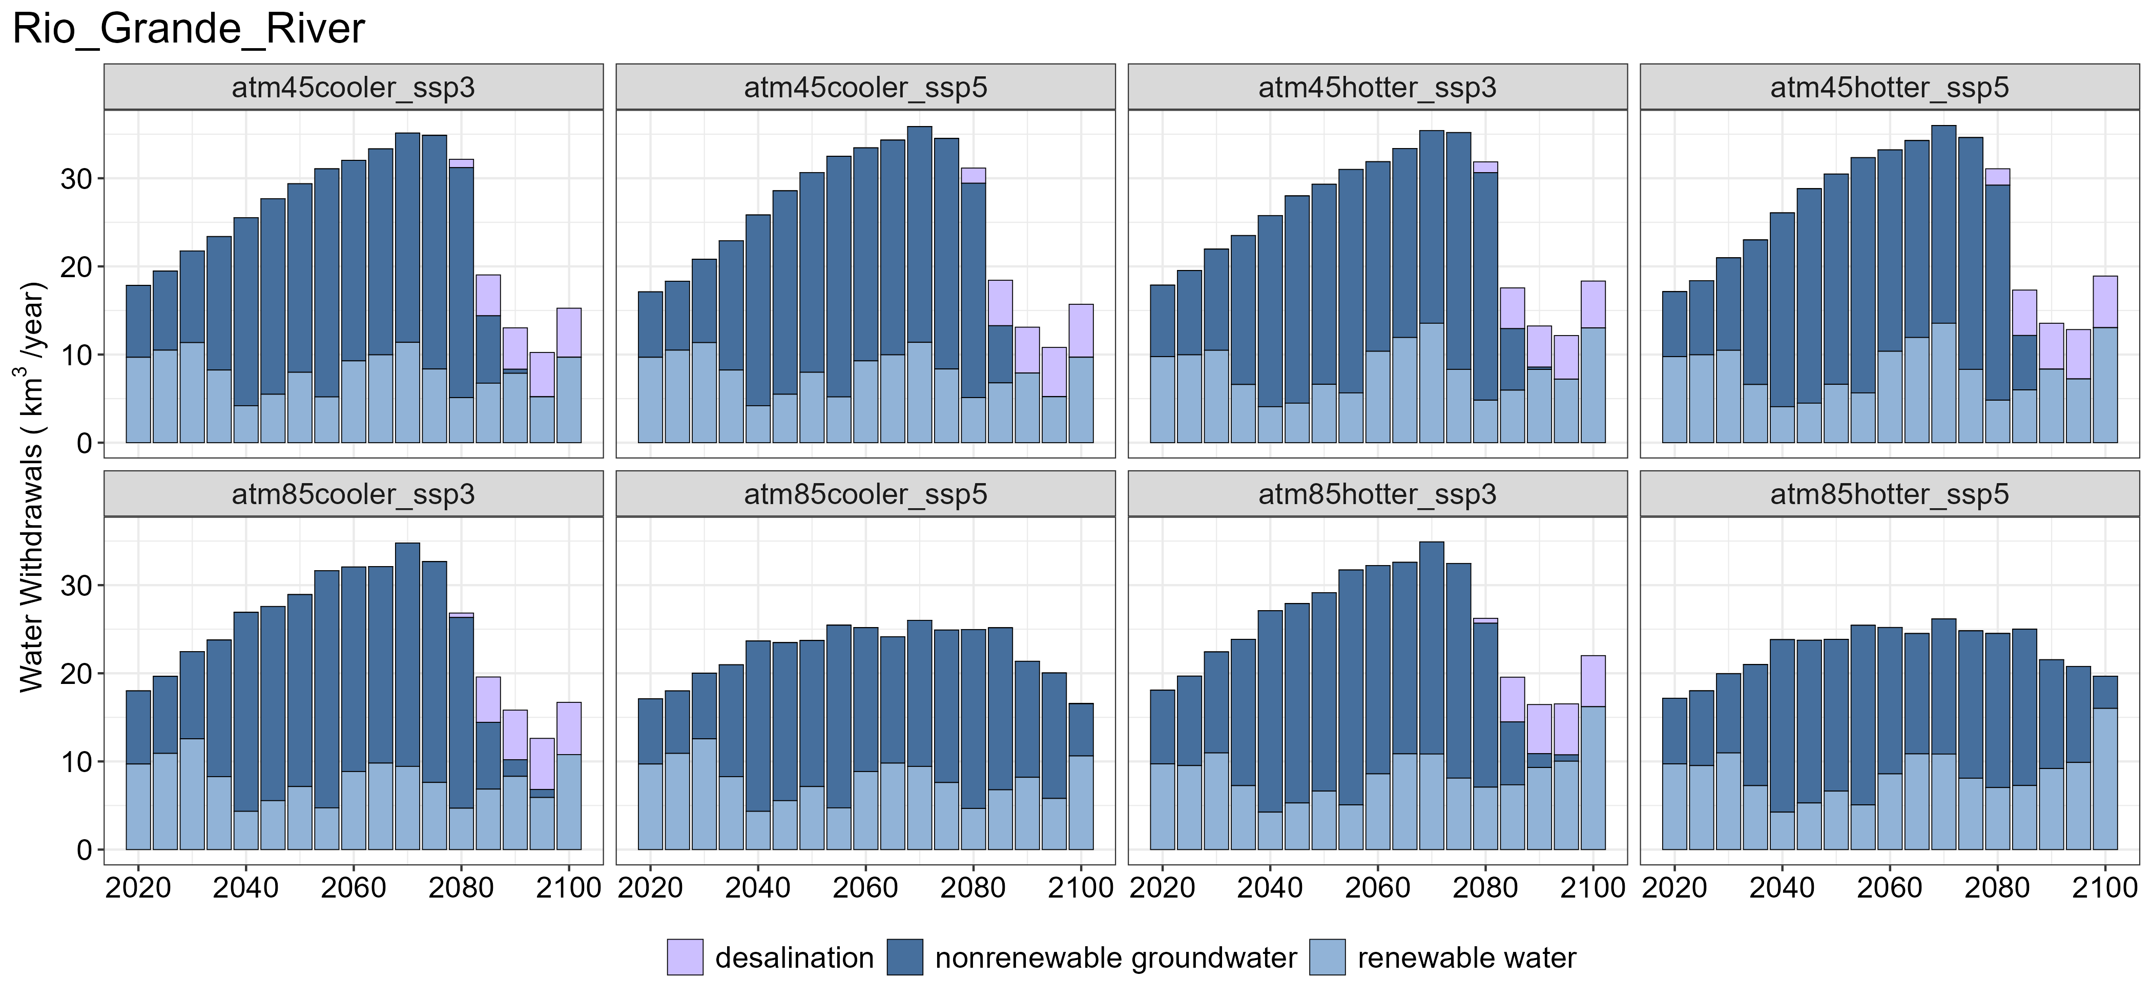
(d)
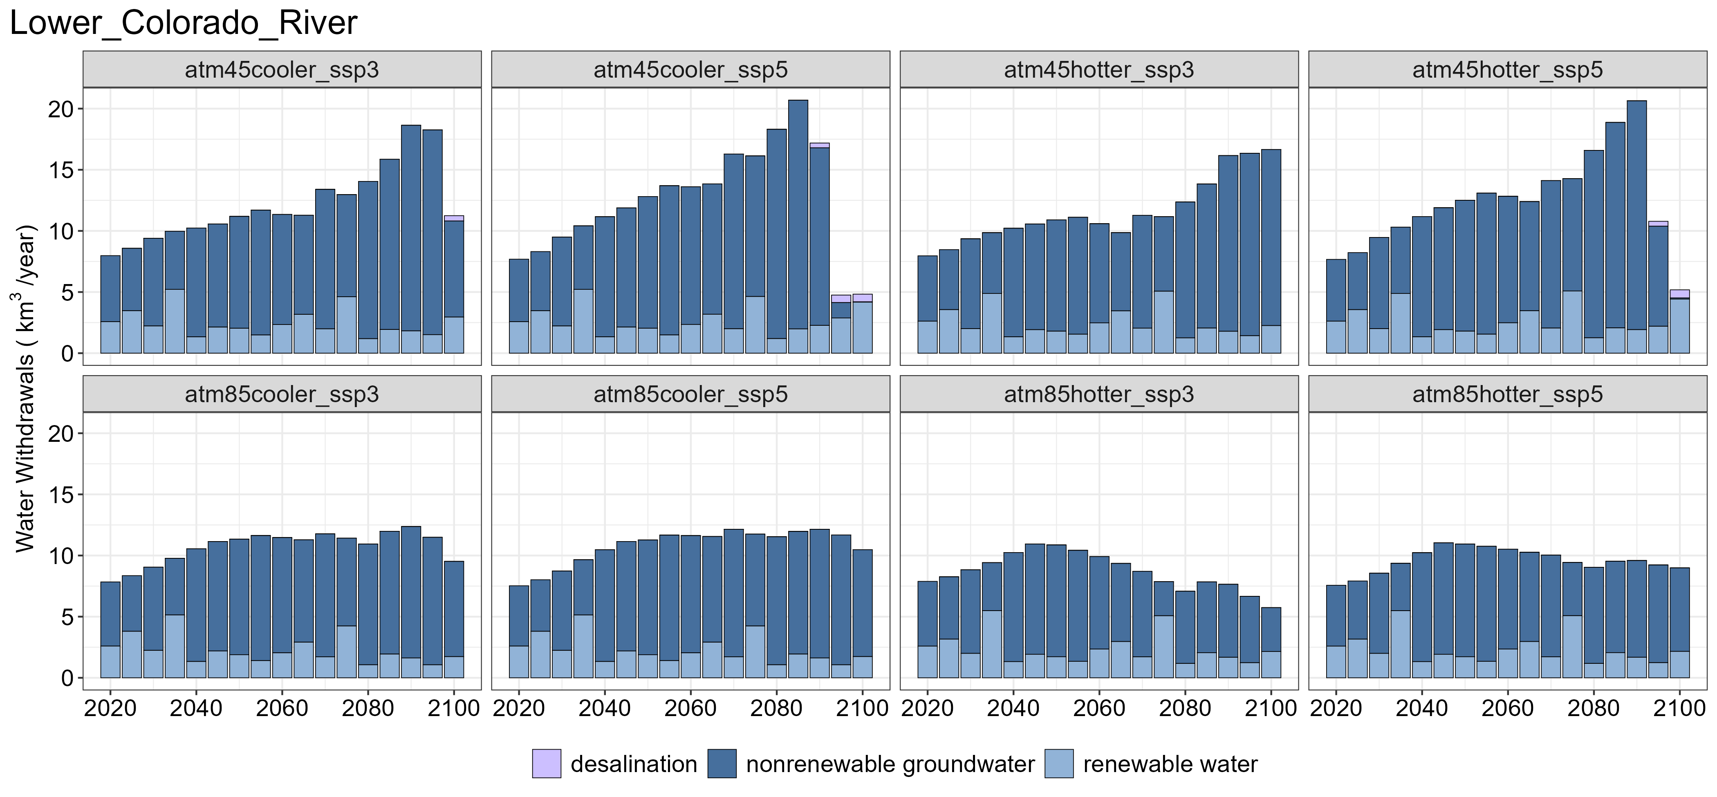

Figure S12. Water withdrawals by source for (a) Pacific Northwest basin, (b) California River basins, and (c) Rio Grande River basin (including outside of CONUS), and (d) Lower Colorado River basin (including outside of CONUS) across 8 scenarios.

(a) | (b)
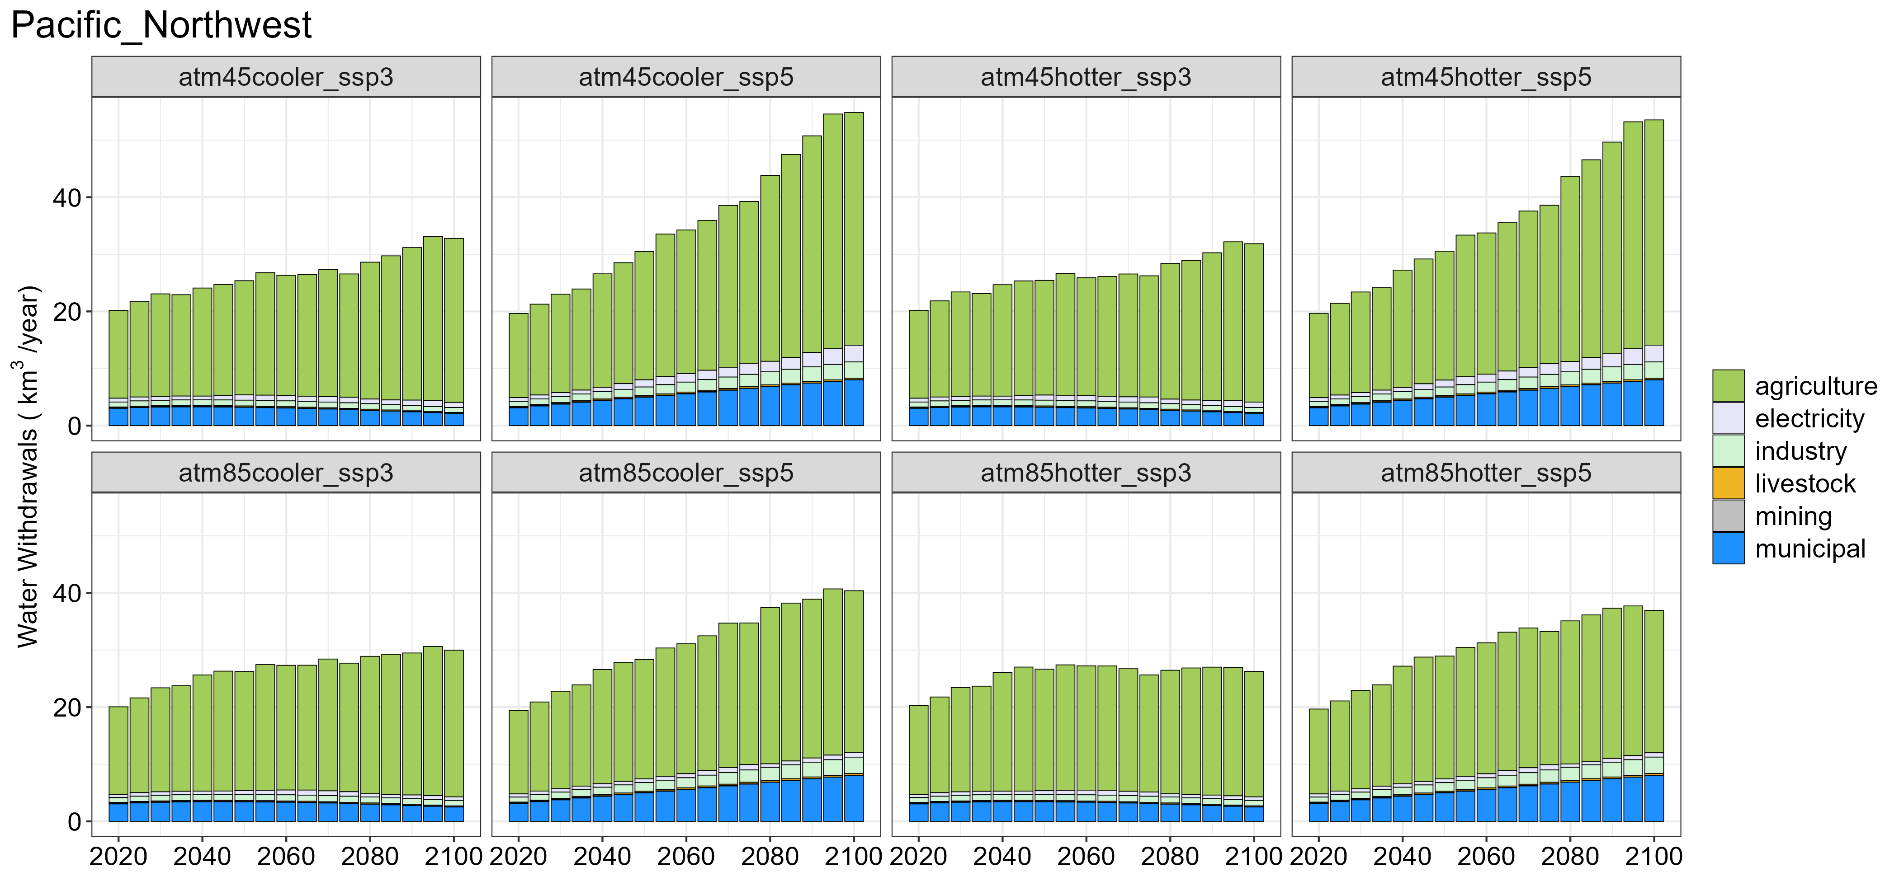 | 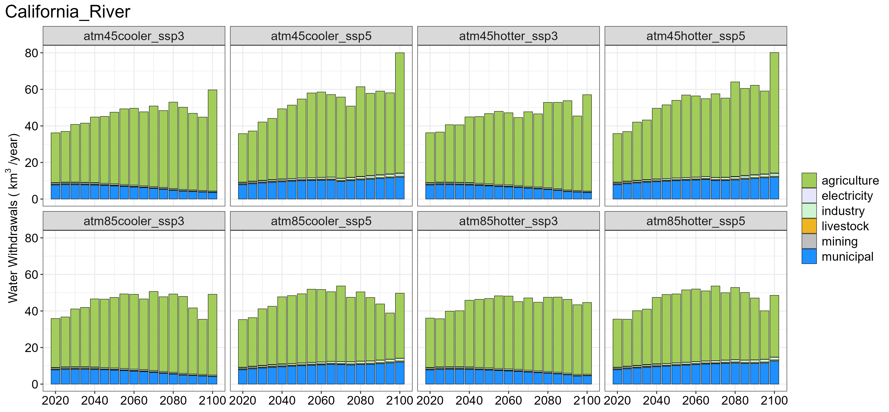
(c) | (d)
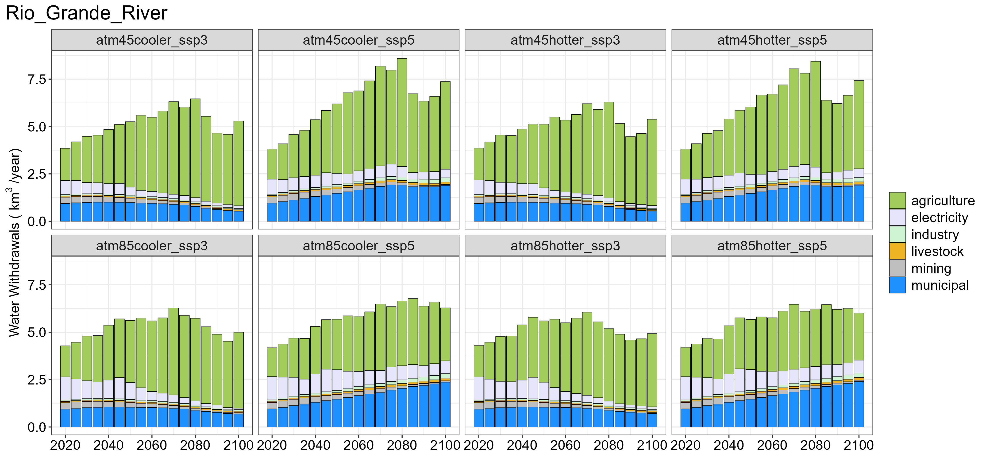 | 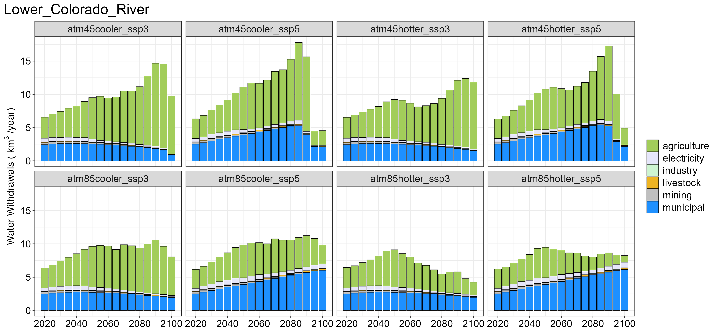
(e) | (f)
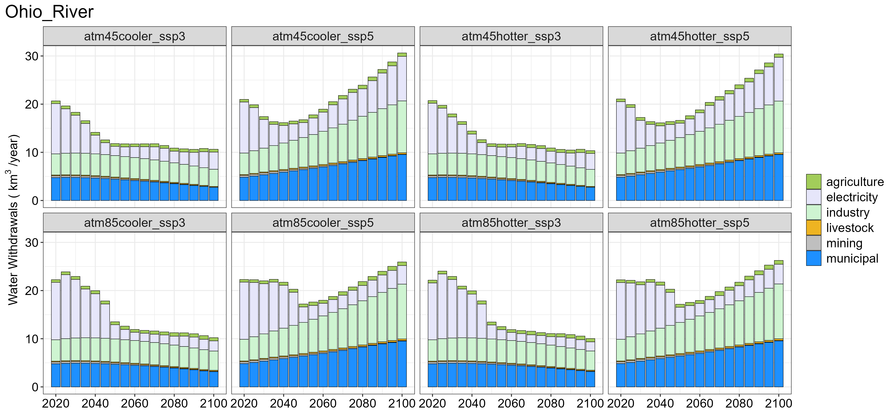 | 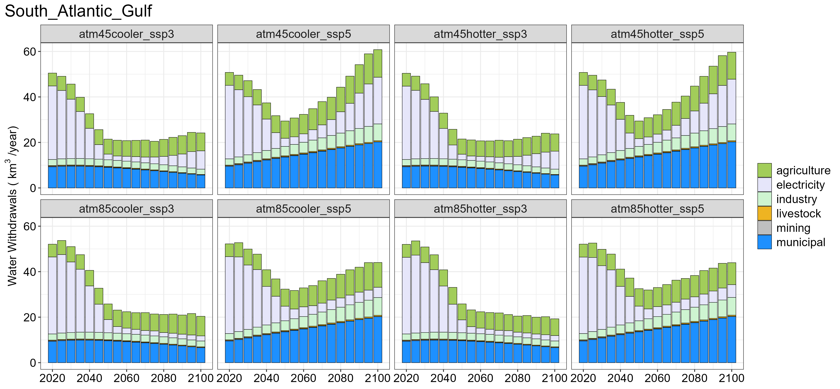

Figure S13. Water withdrawals by sector for (a) Pacific Northwest basin, (b) California River basins, (c) Rio Grande River basin (excluding outside of CONUS), (d) Lower Colorado River basin (excluding outside of CONUS), (e) Ohio River basin, and (f) South Atlantic Gulf basin across 8 scenarios.

(a) | (b)
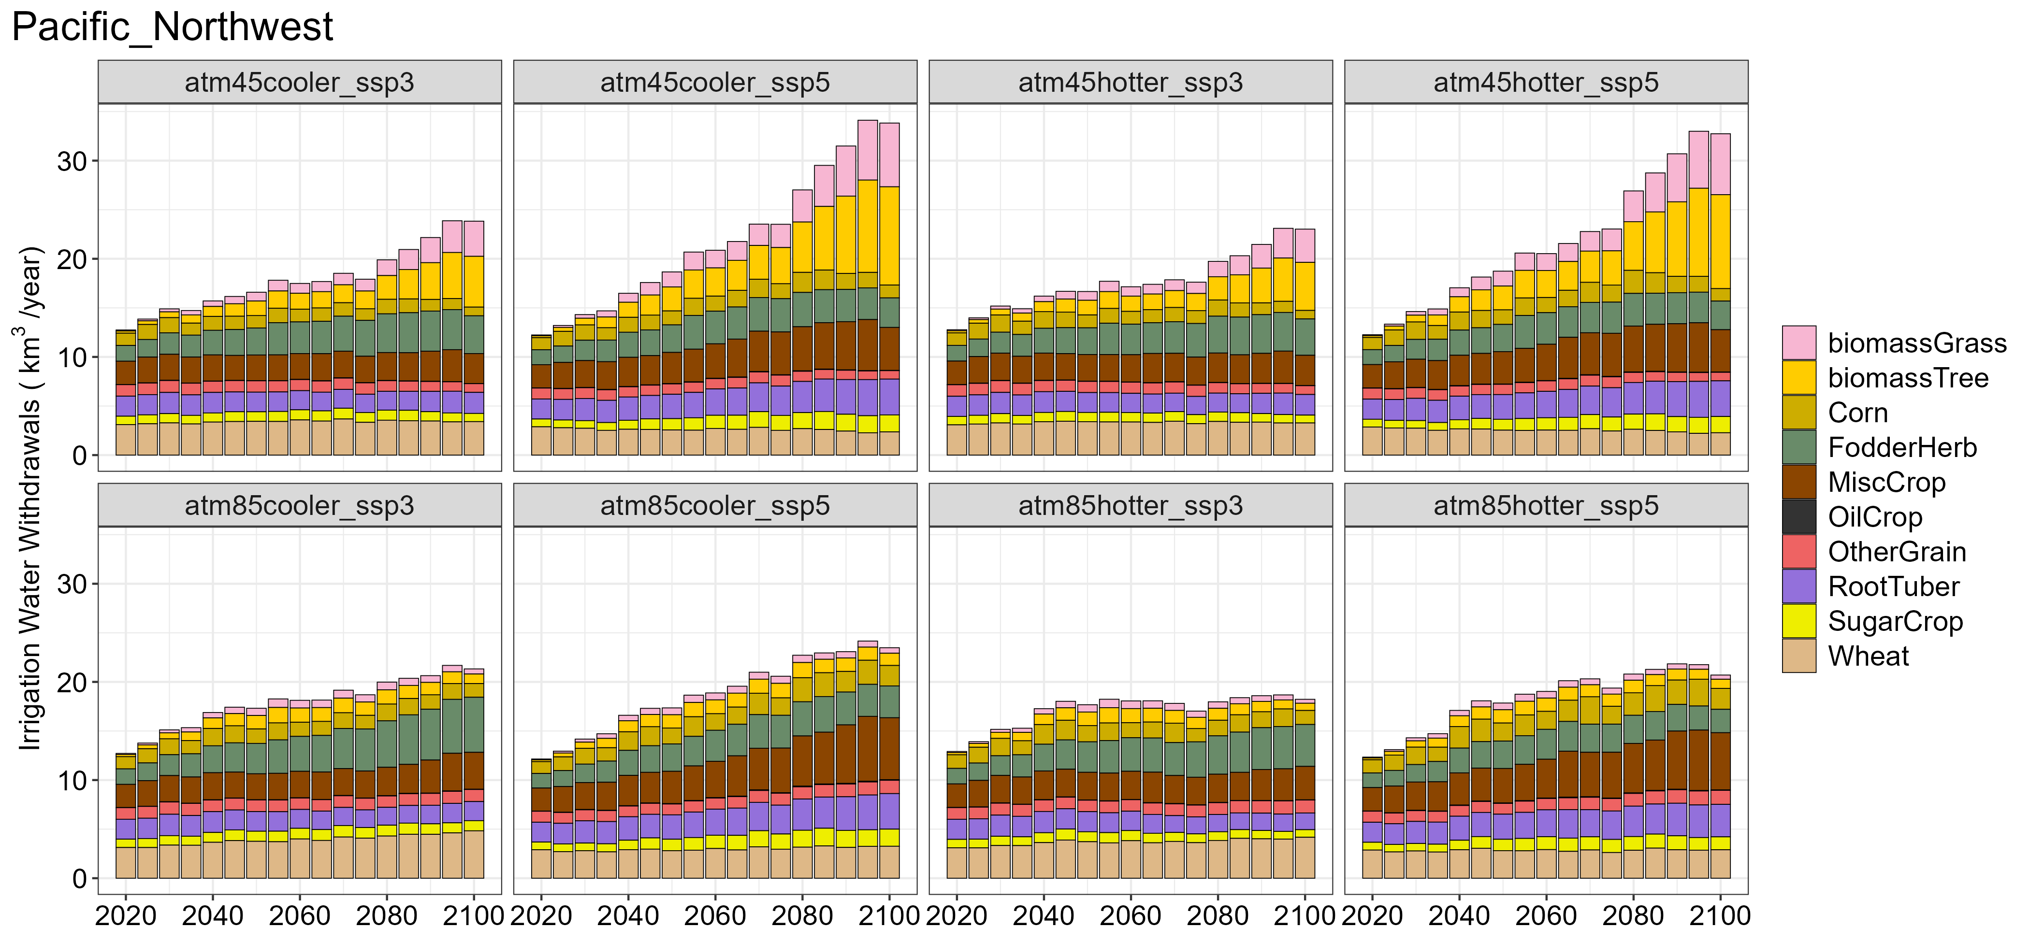 | 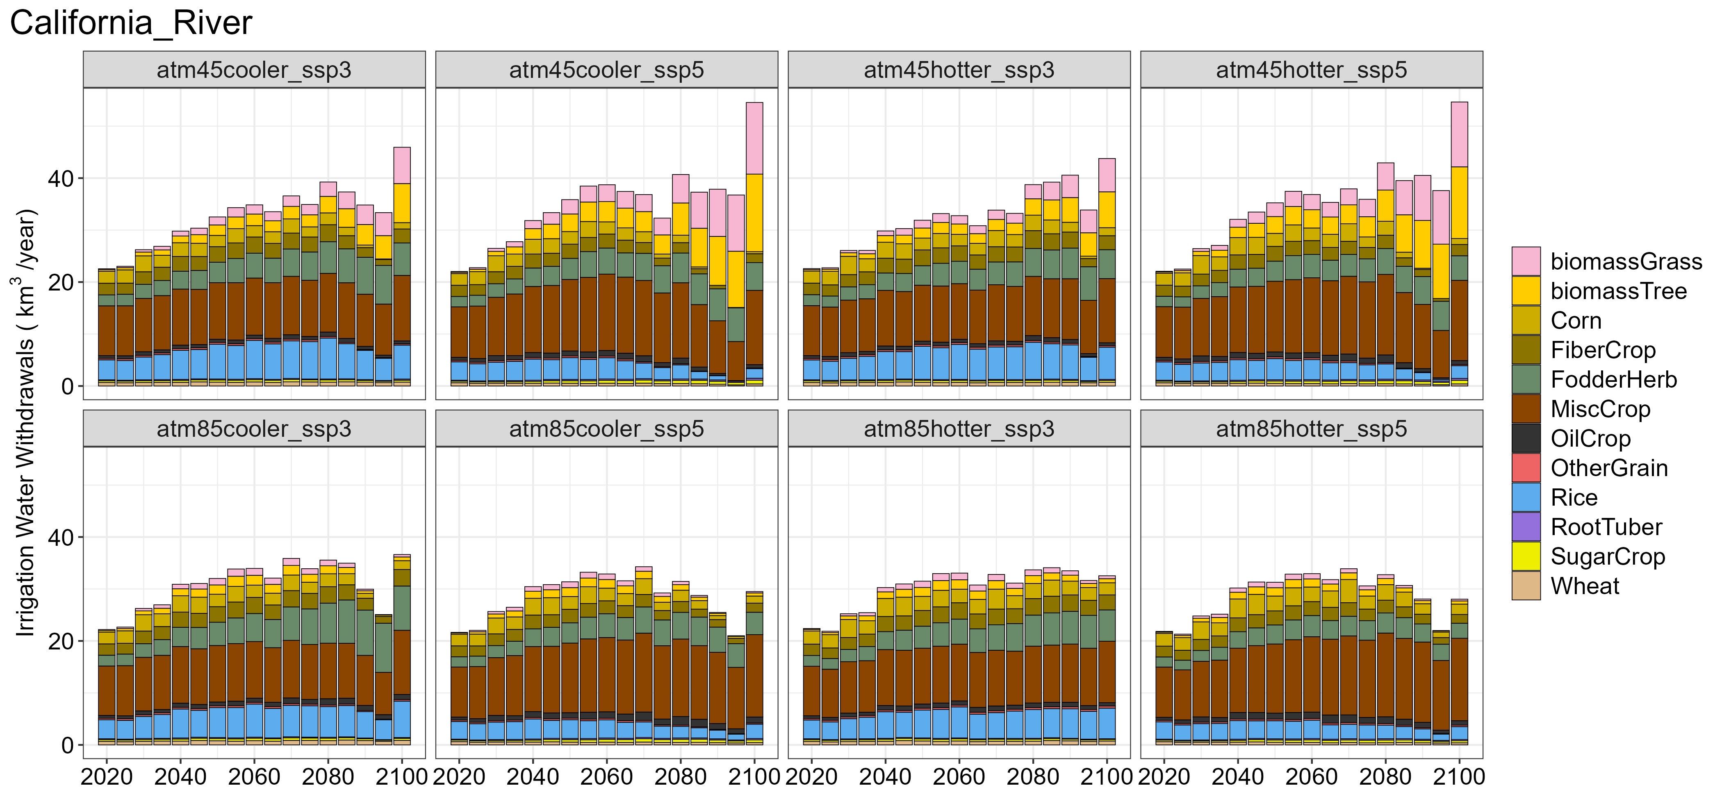
(c) | (d)
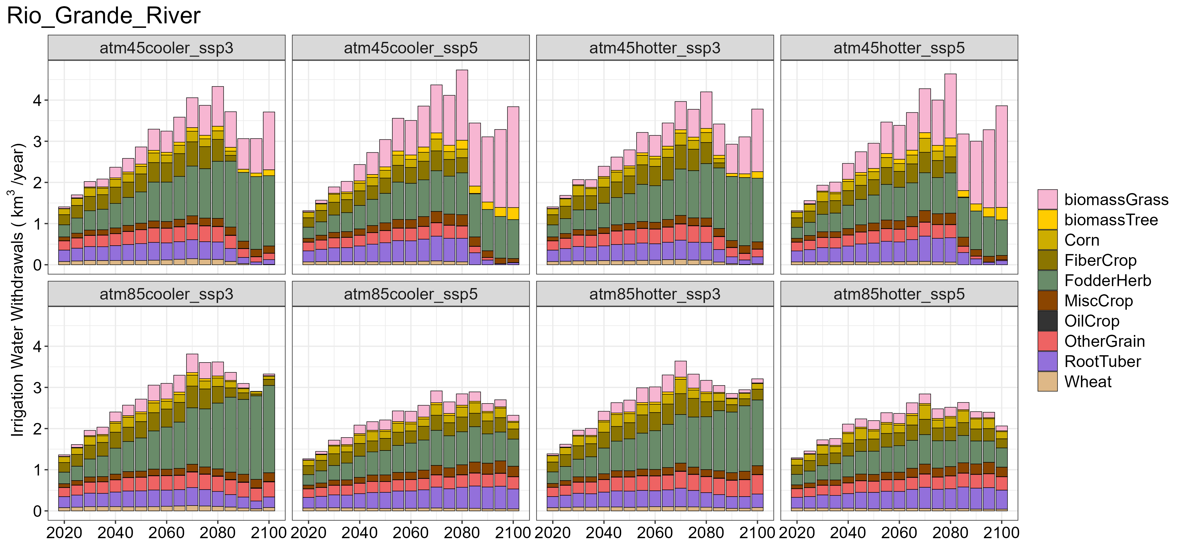 | 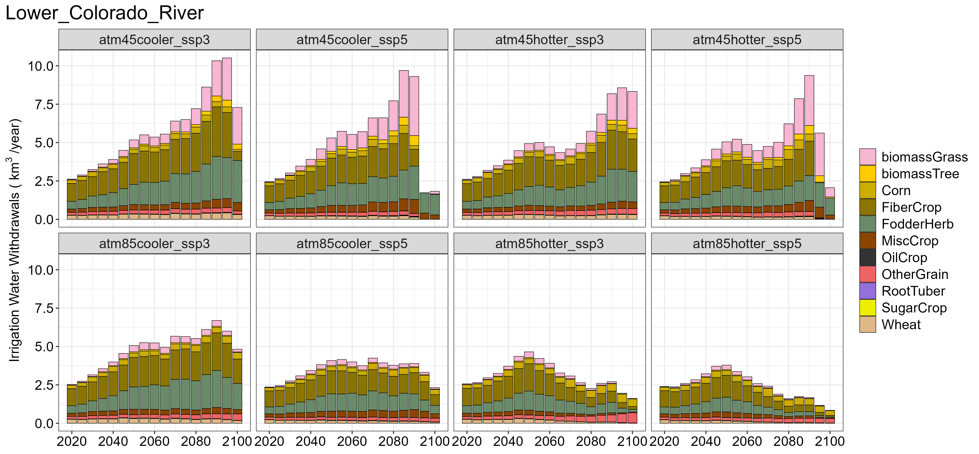
(e) | (f)
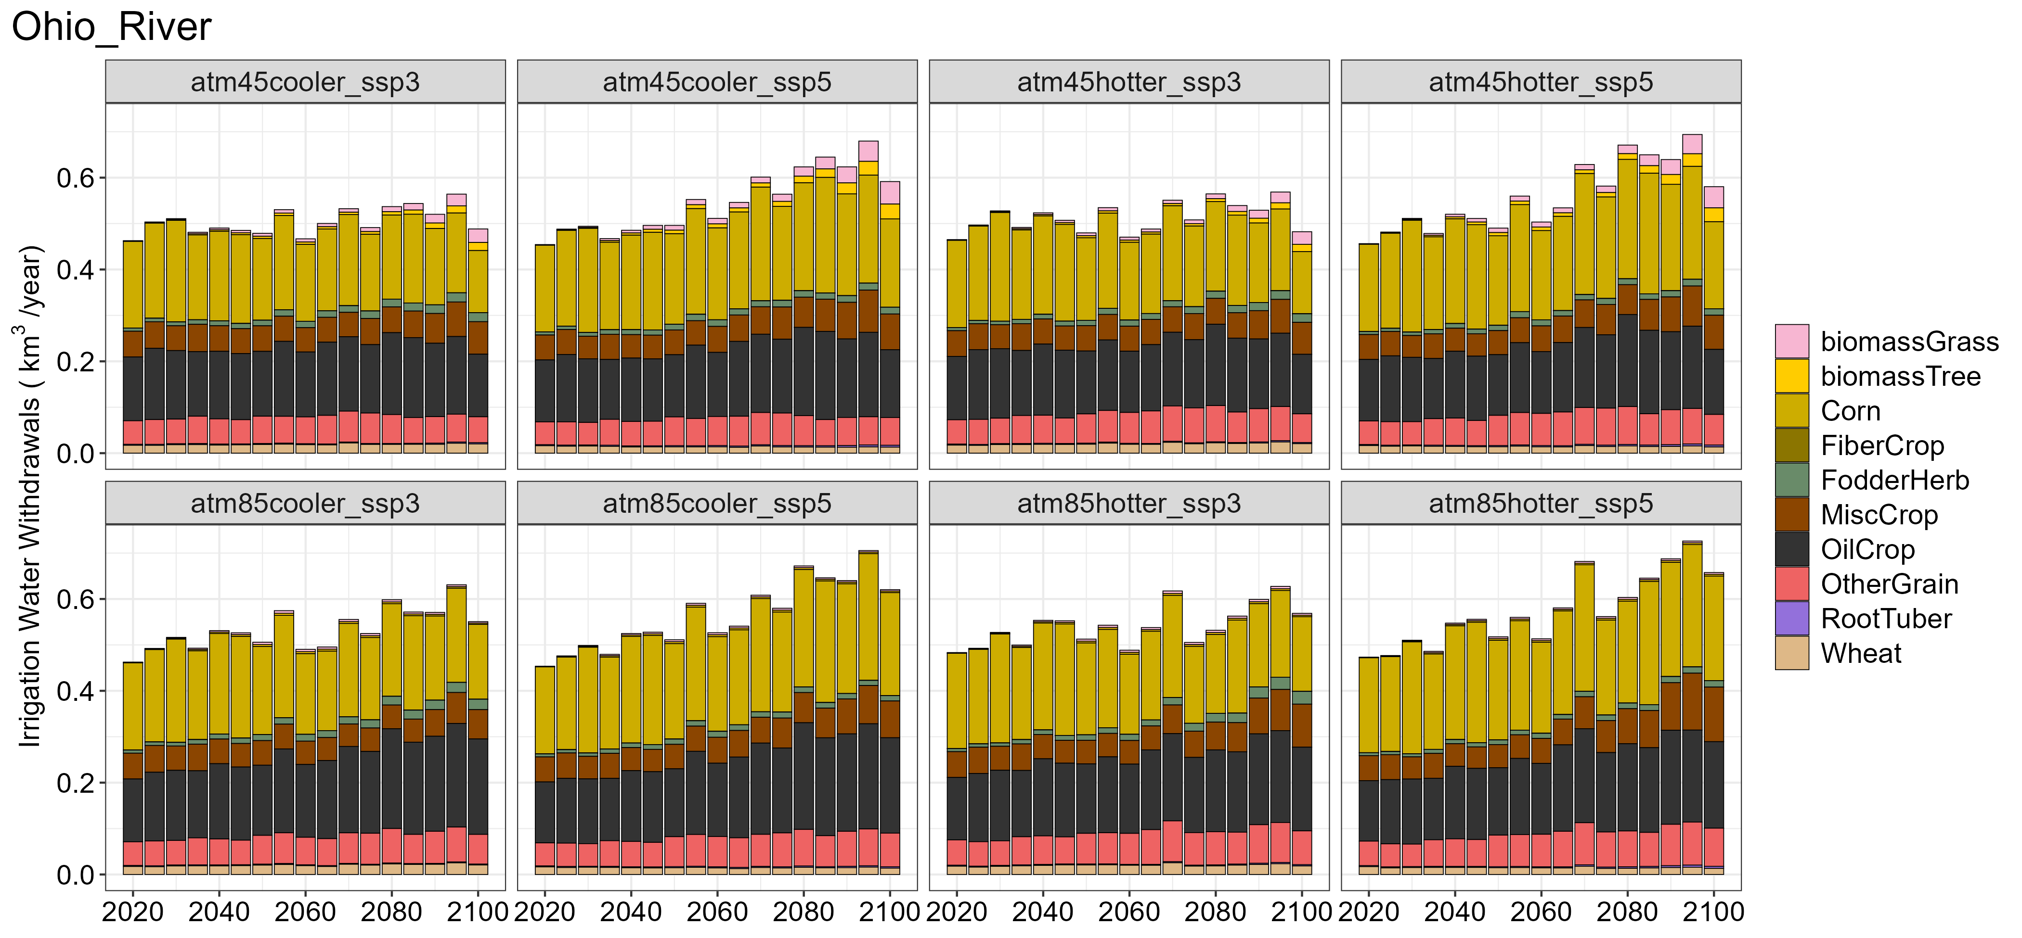 | 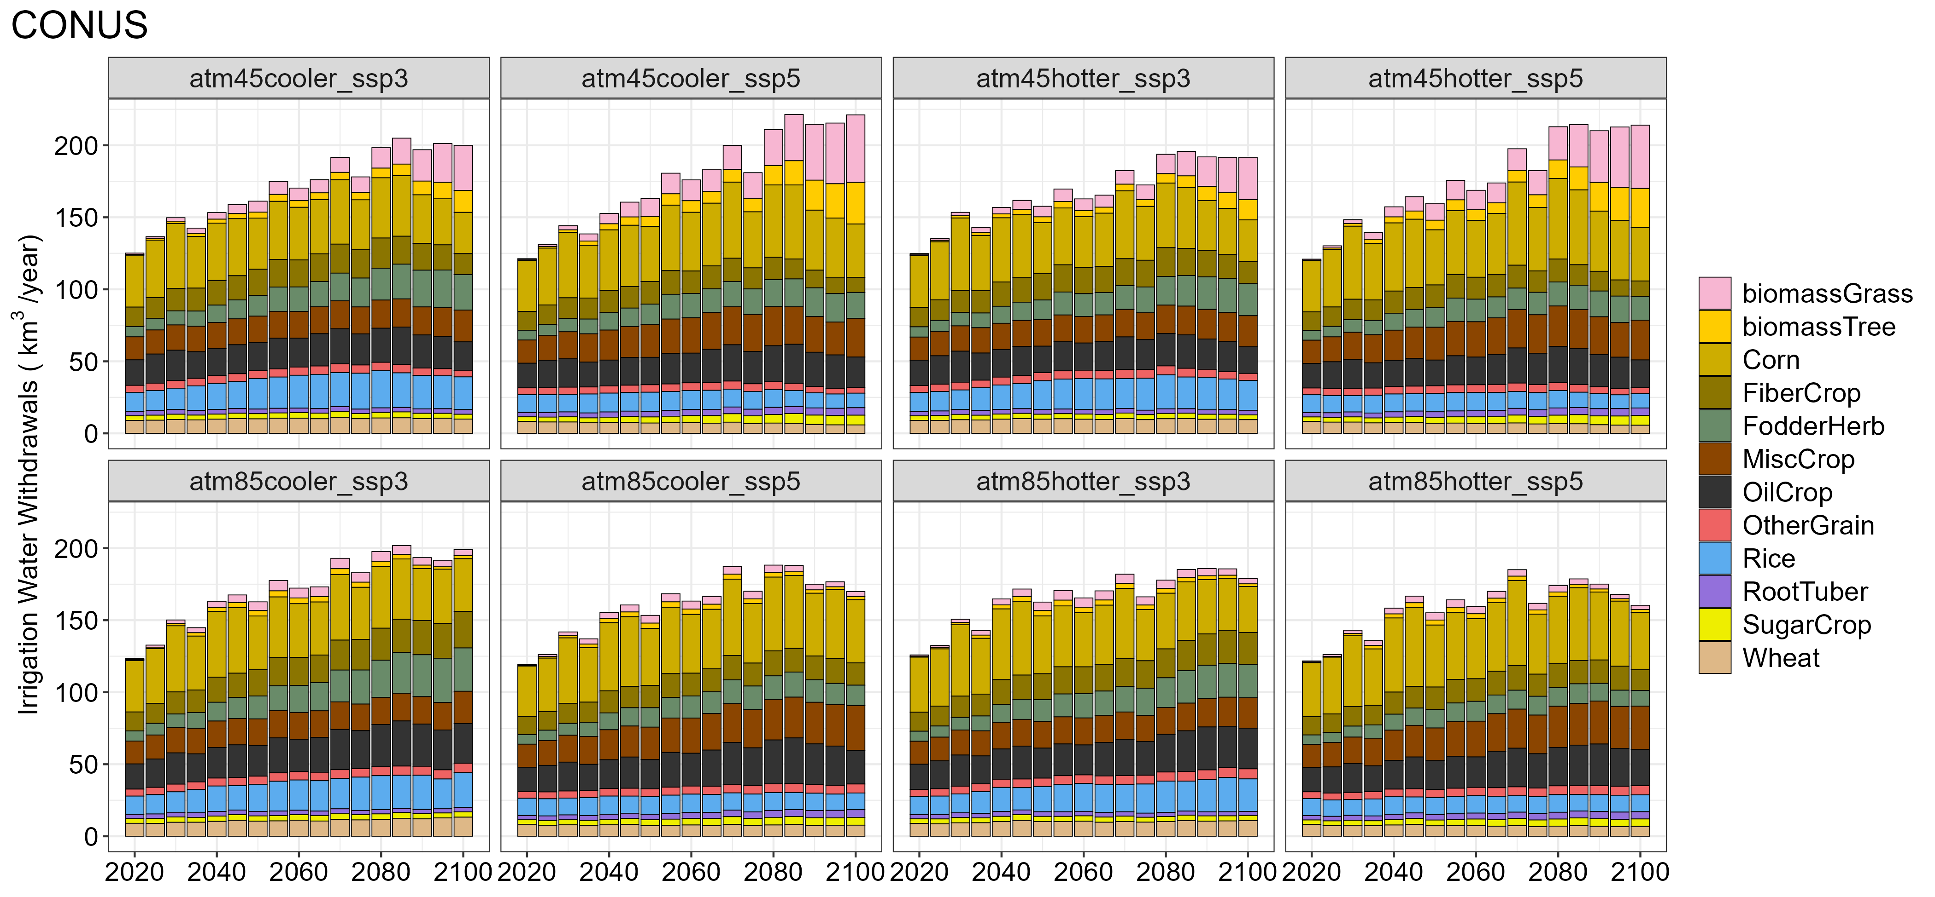

Figure S14. Irrigation water withdrawals by crop type for (a) Pacific Northwest basin, (b) California River basins, (c) Rio Grande River basin (excluding outside of CONUS), (d) Lower Colorado River basin (excluding outside of CONUS), (e) Ohio River basin, and (f) entire CONUS across 8 scenarios.

(a) | (b)
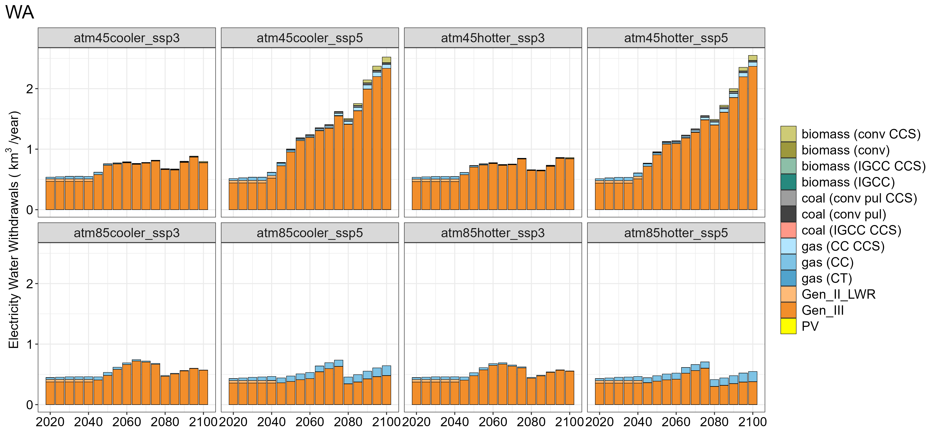 | 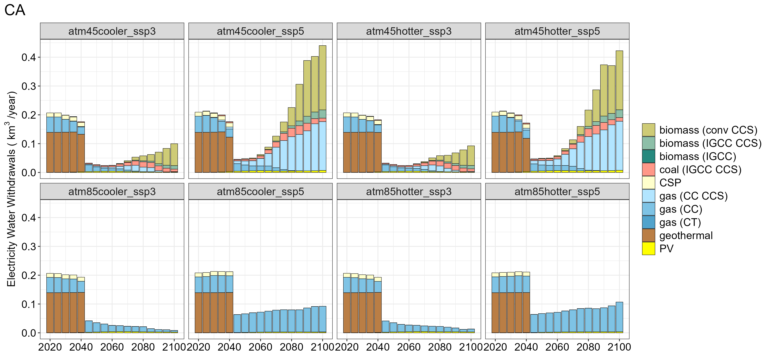
(c) | (d)
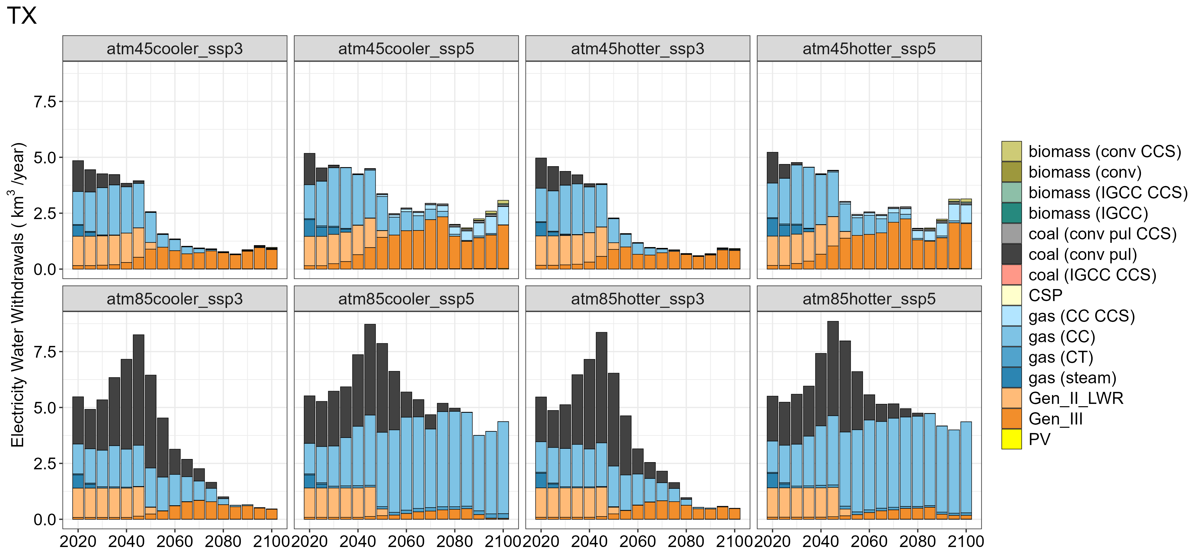 | 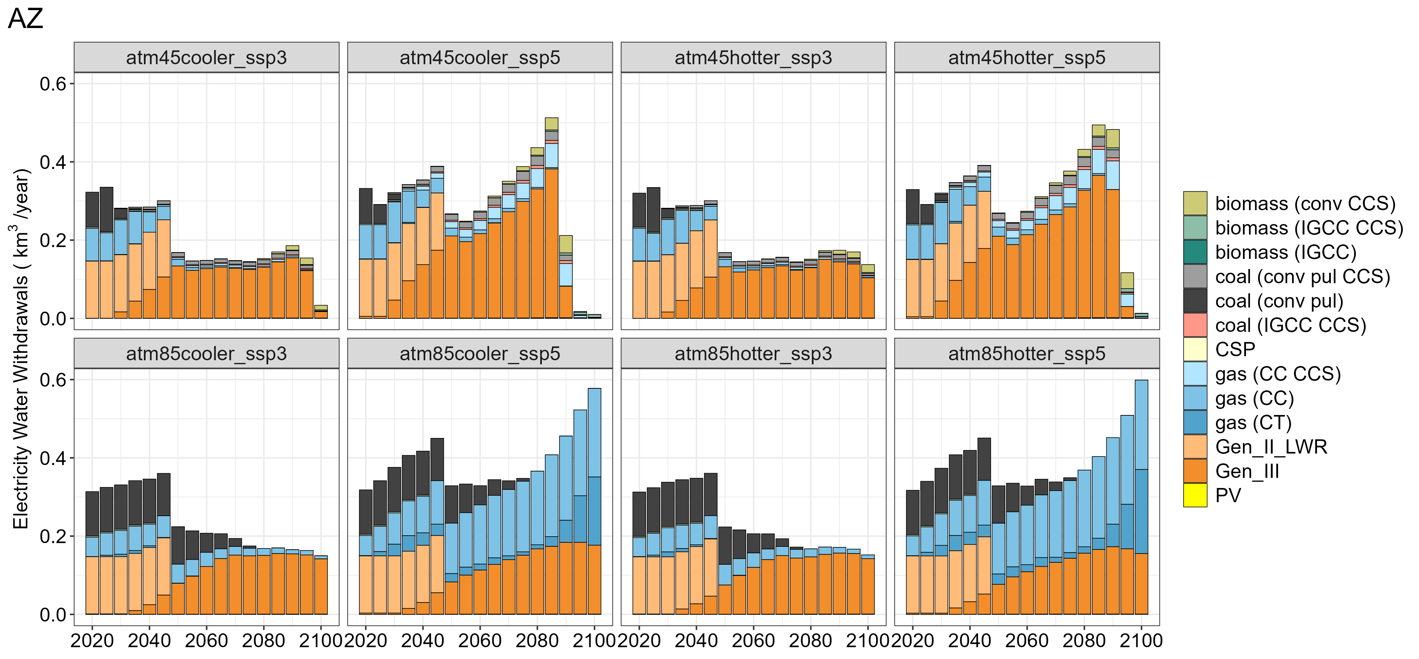
(e) | (f)
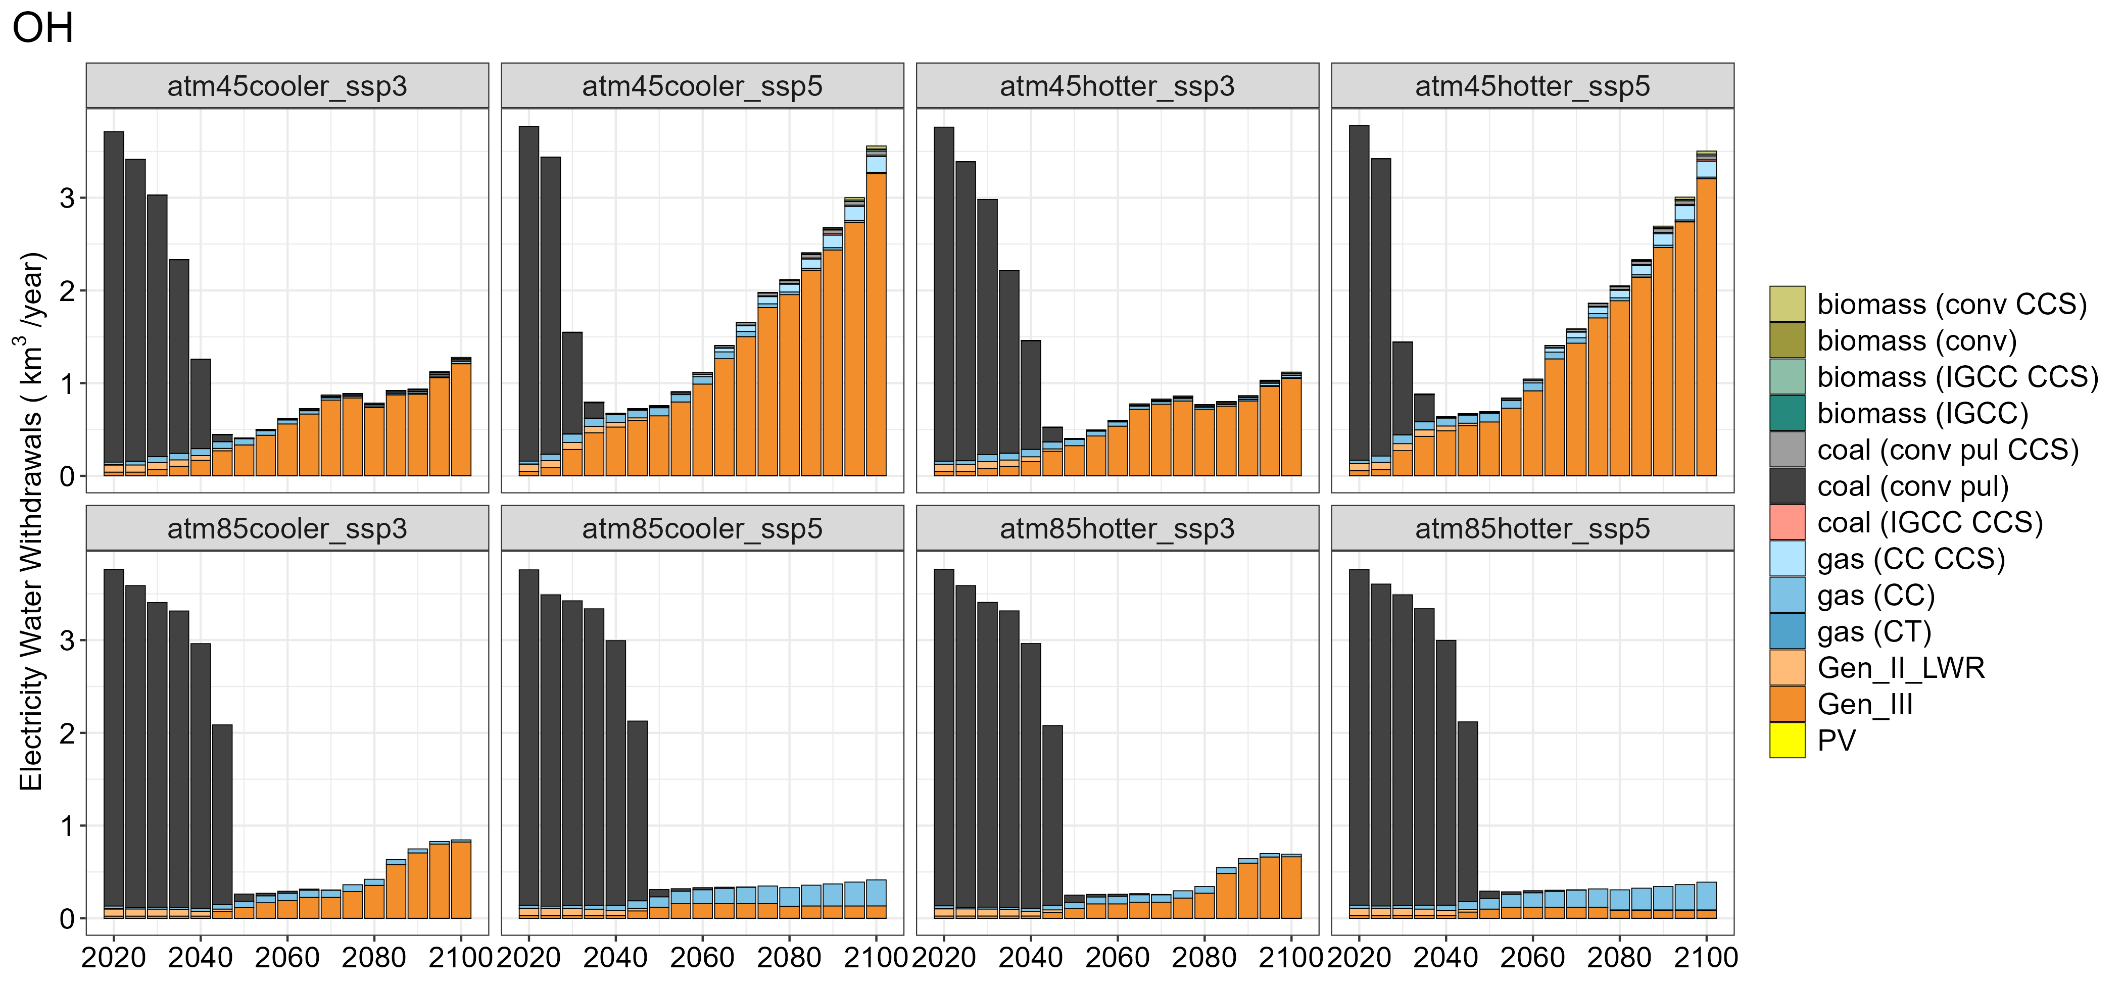 | 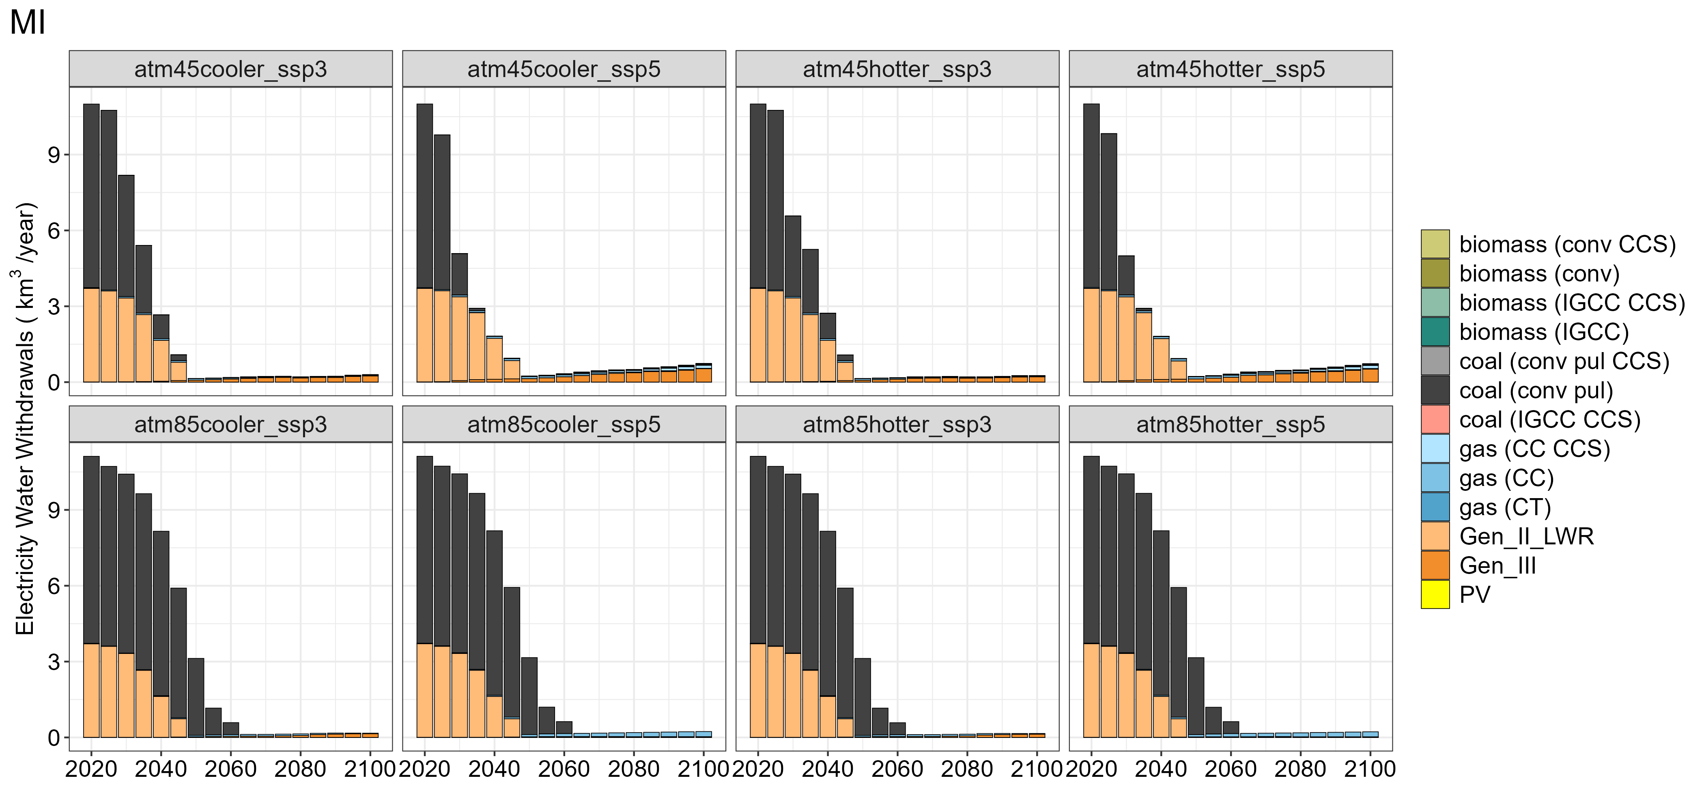

Figure S15. Electricity water withdrawals by technology for (a) Washington, (b) California, (c) Texas, (d)Arizona, (e) Ohio, and (f) Michigan across 8 scenarios.

(a) | (b)
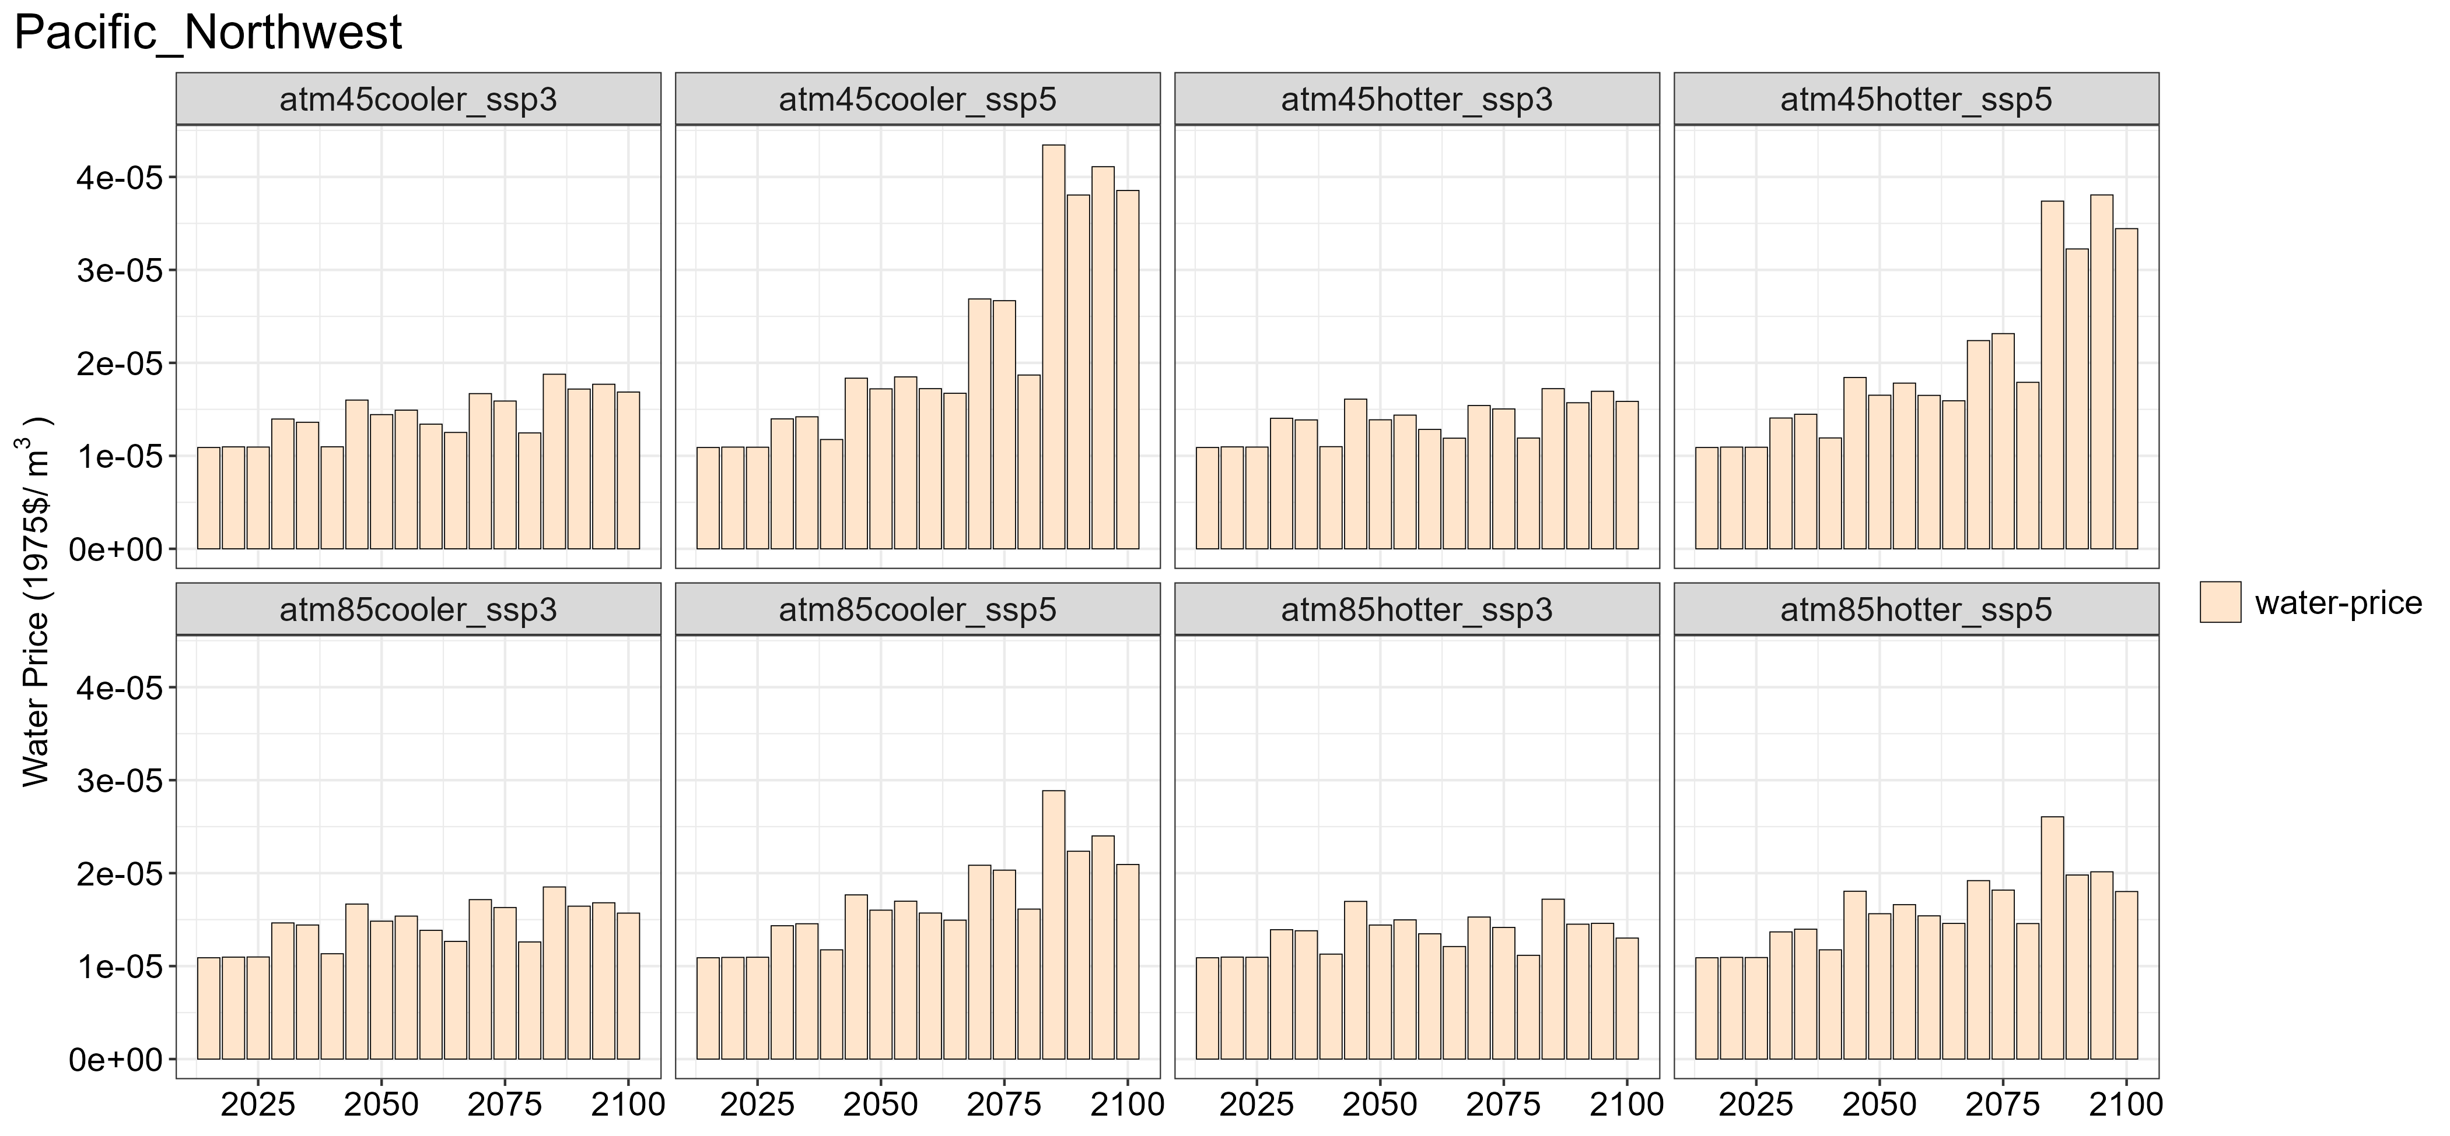 | 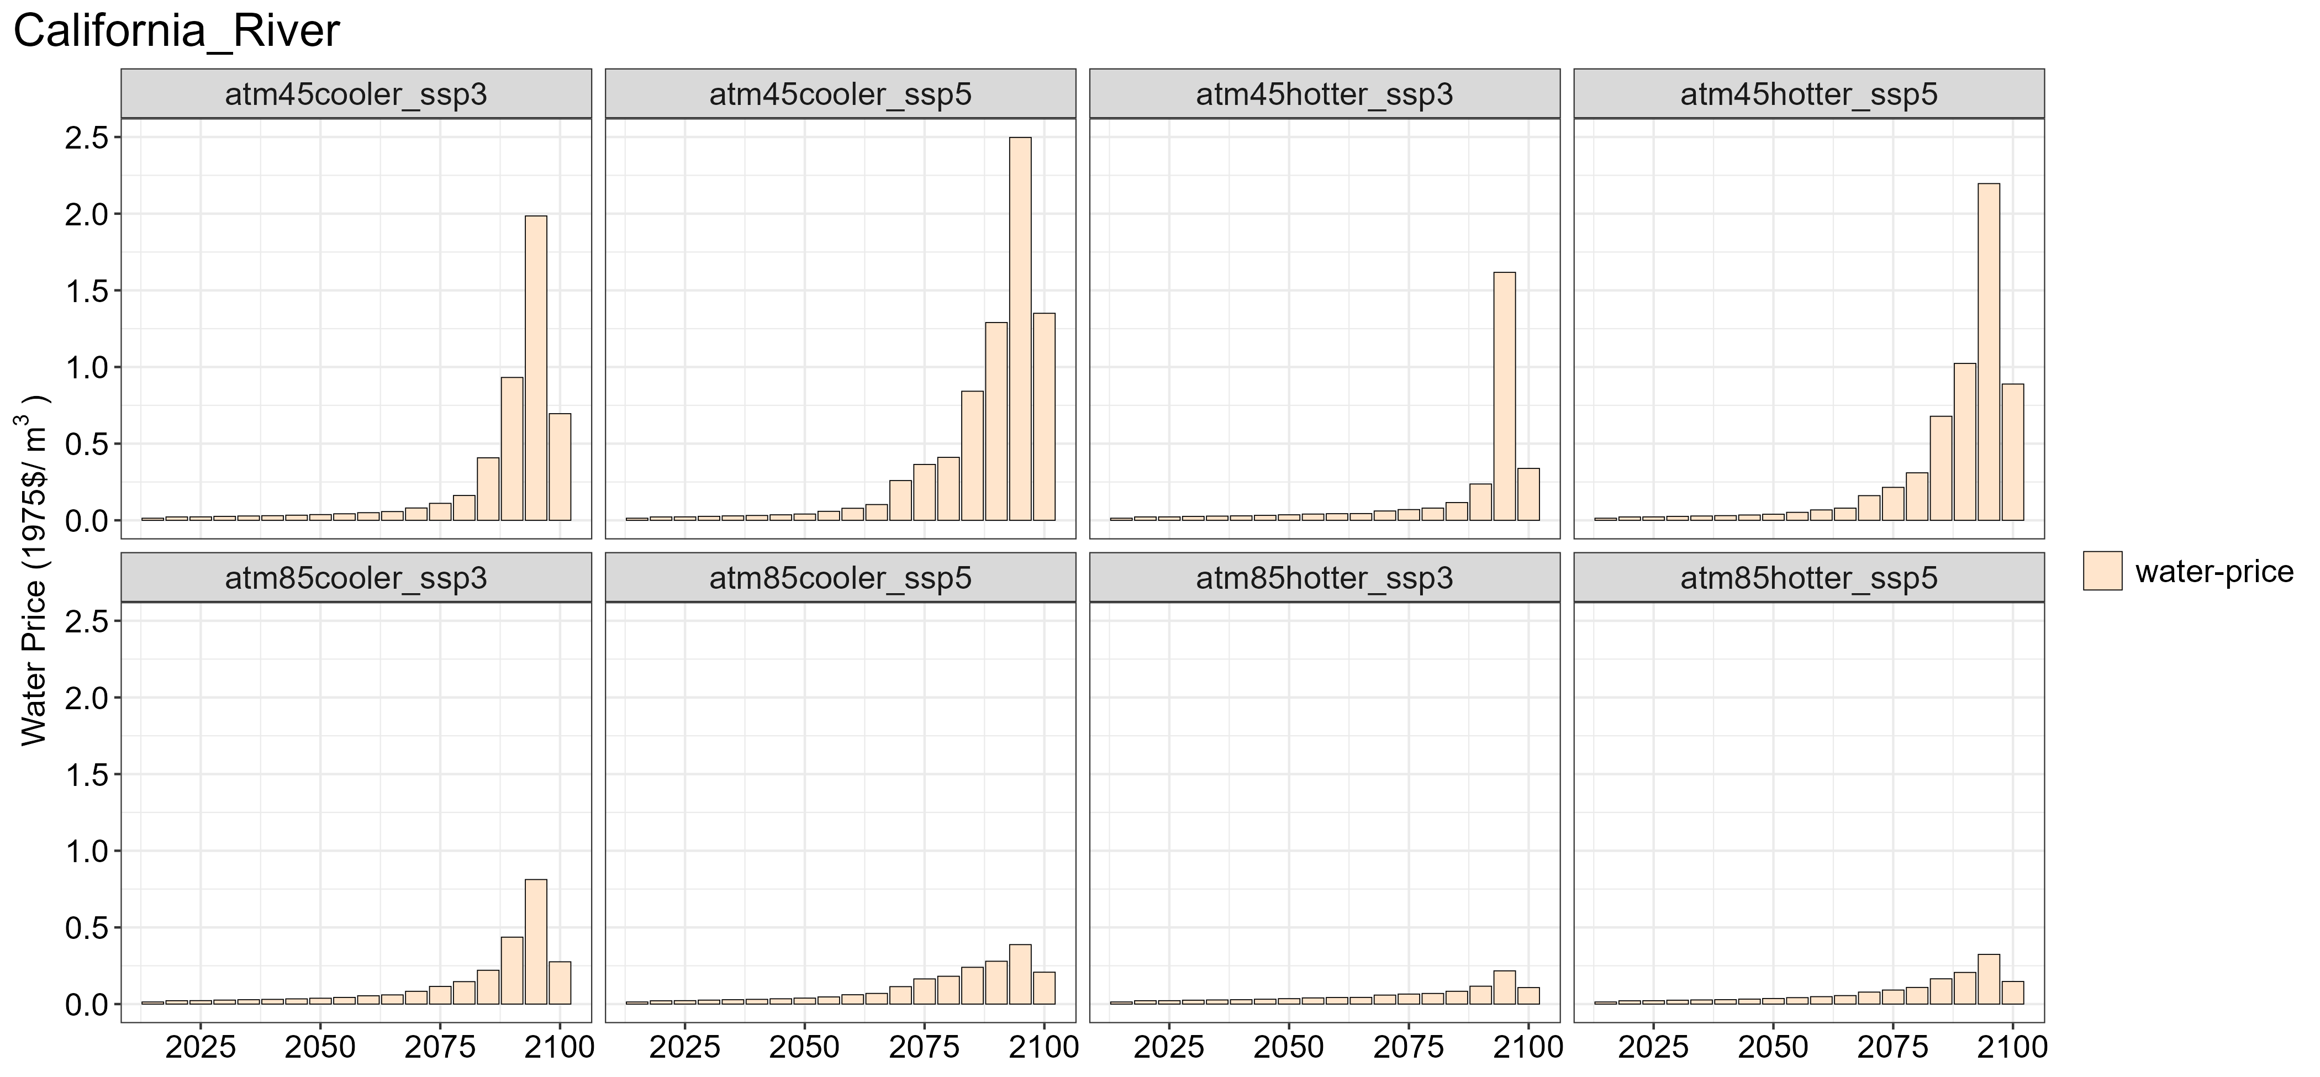
(c) | (d)
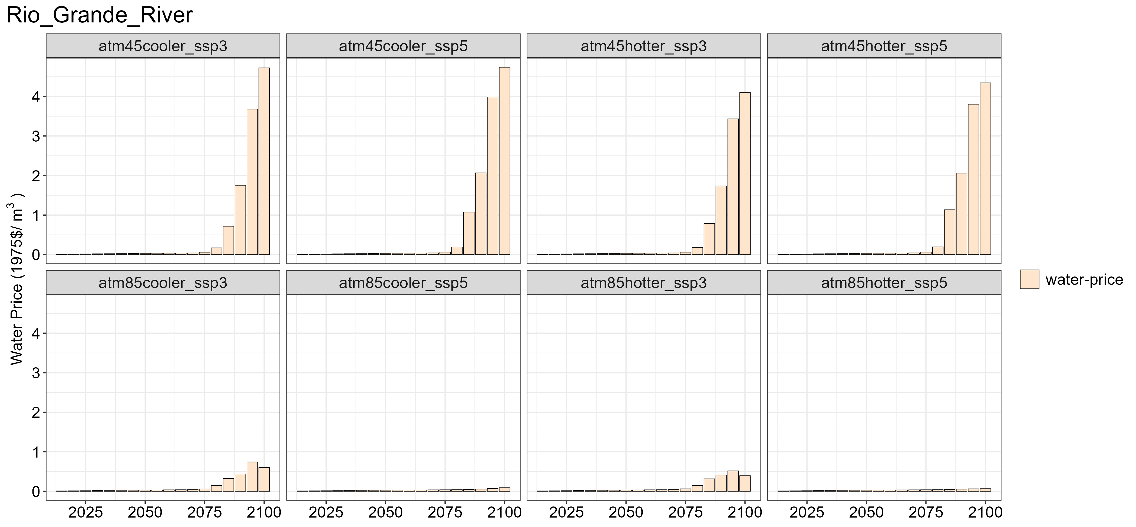 | 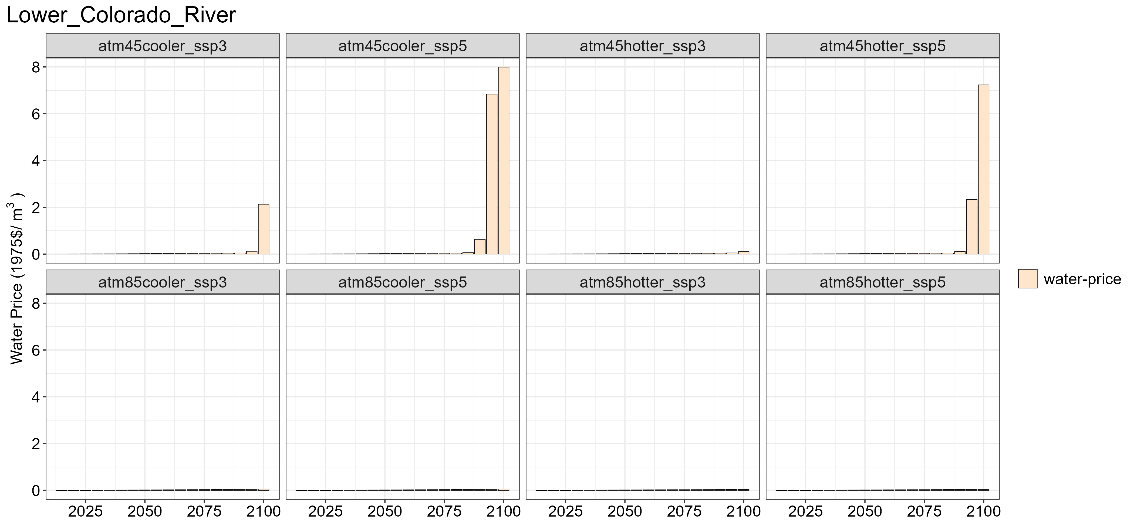

Figure S16. Water price for (a) Pacific Northwest basin, (b) California River basin, (c) Rio Grande River basin, and (d) Lower Colorado River basin across 8 scenarios.

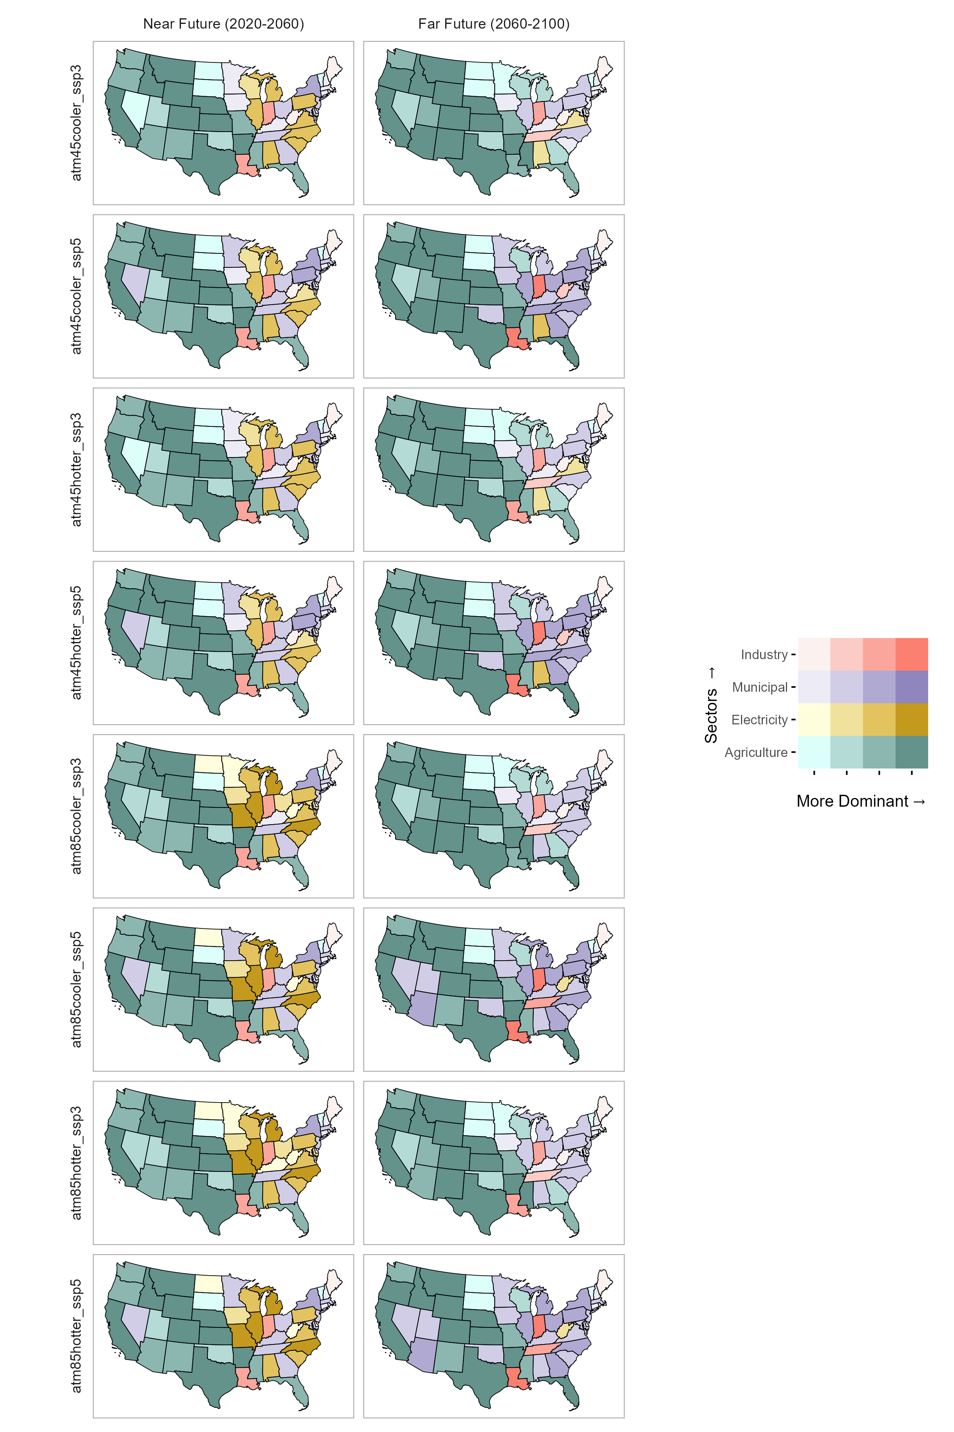

Figure S17. The dominant demand sector in the near future and far future across eight scenarios.

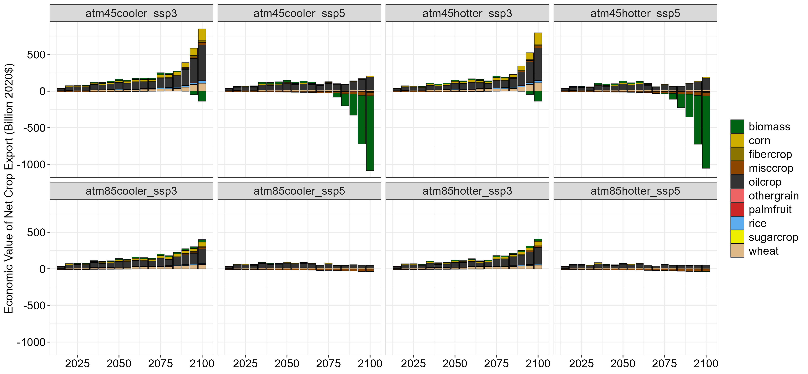

Figure S18. Economic value of net agricultural export by crop type for 8 scenarios.

(a)
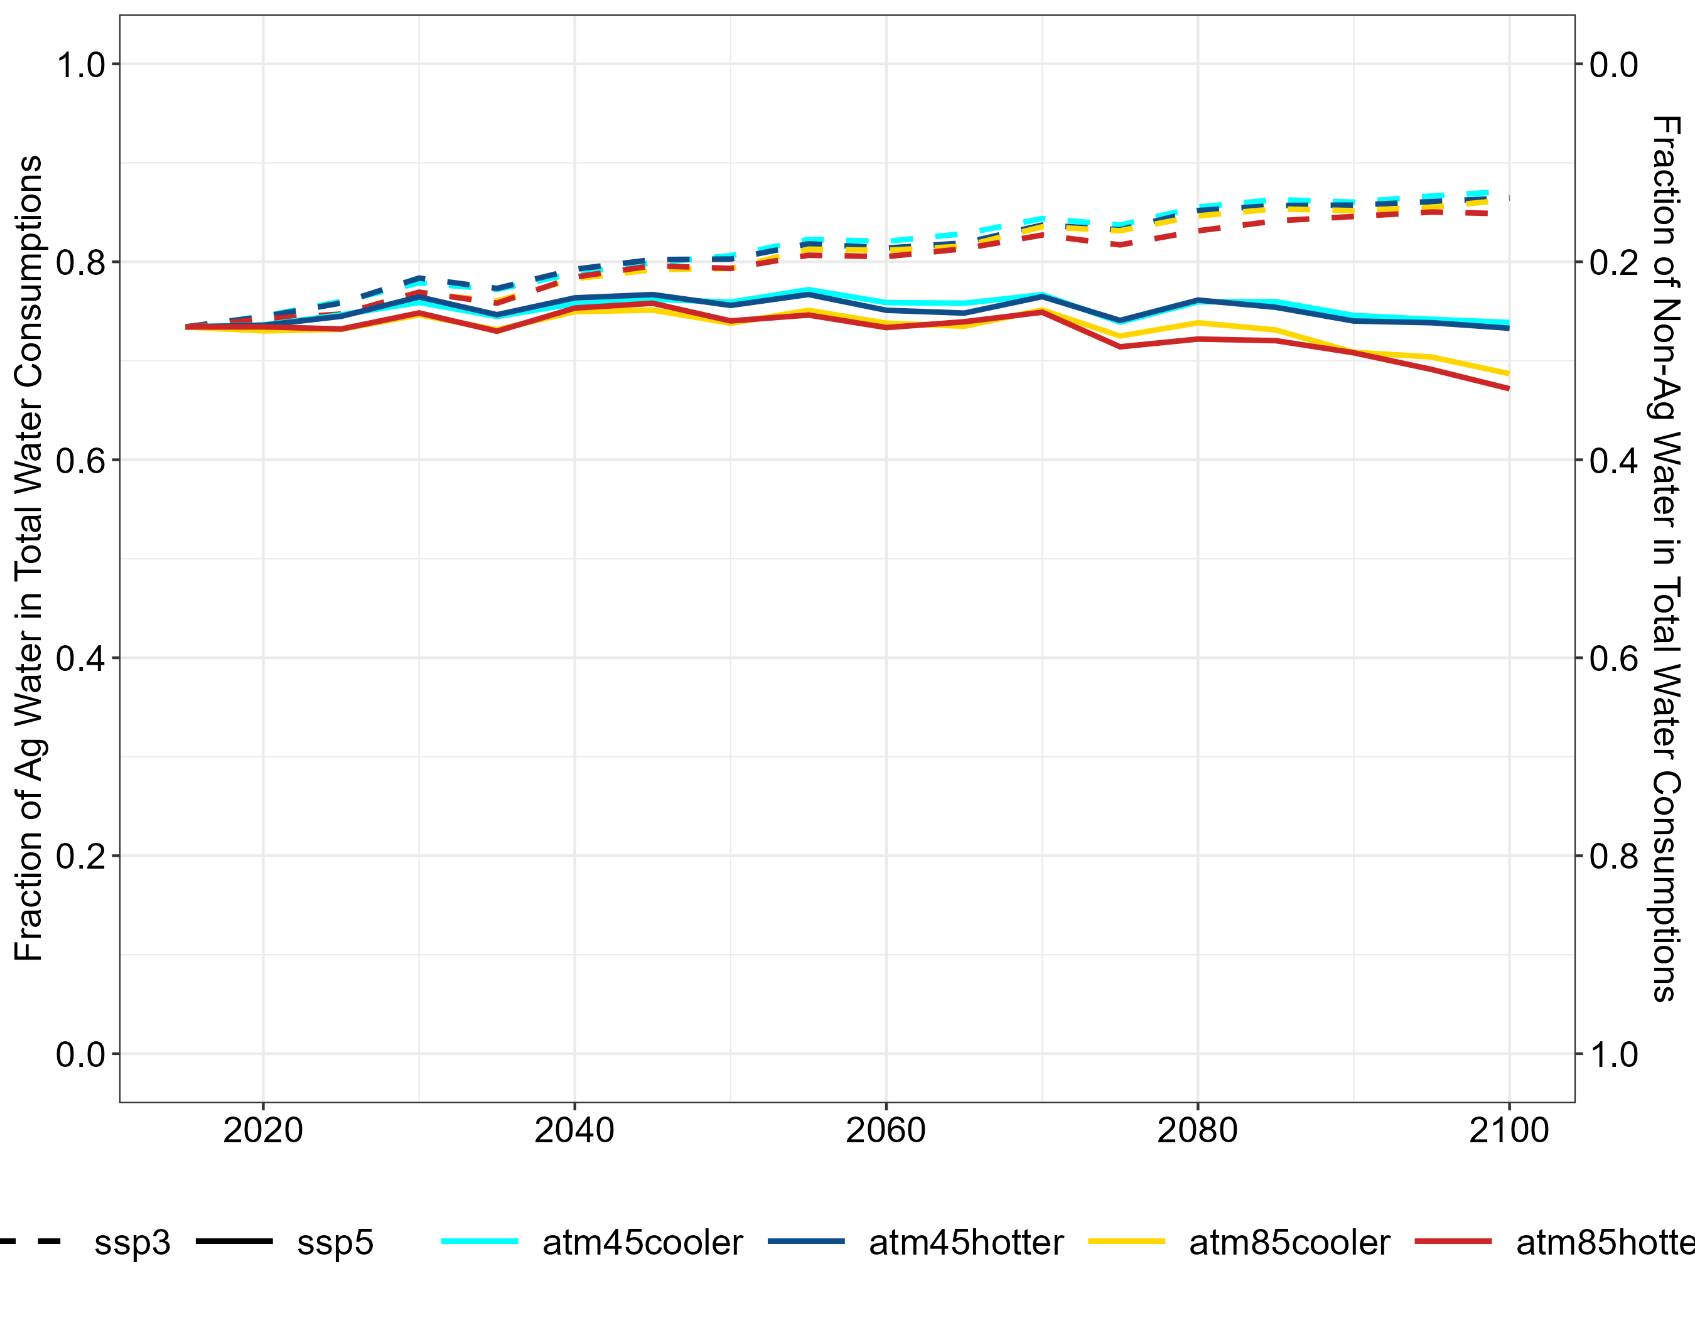
(b)
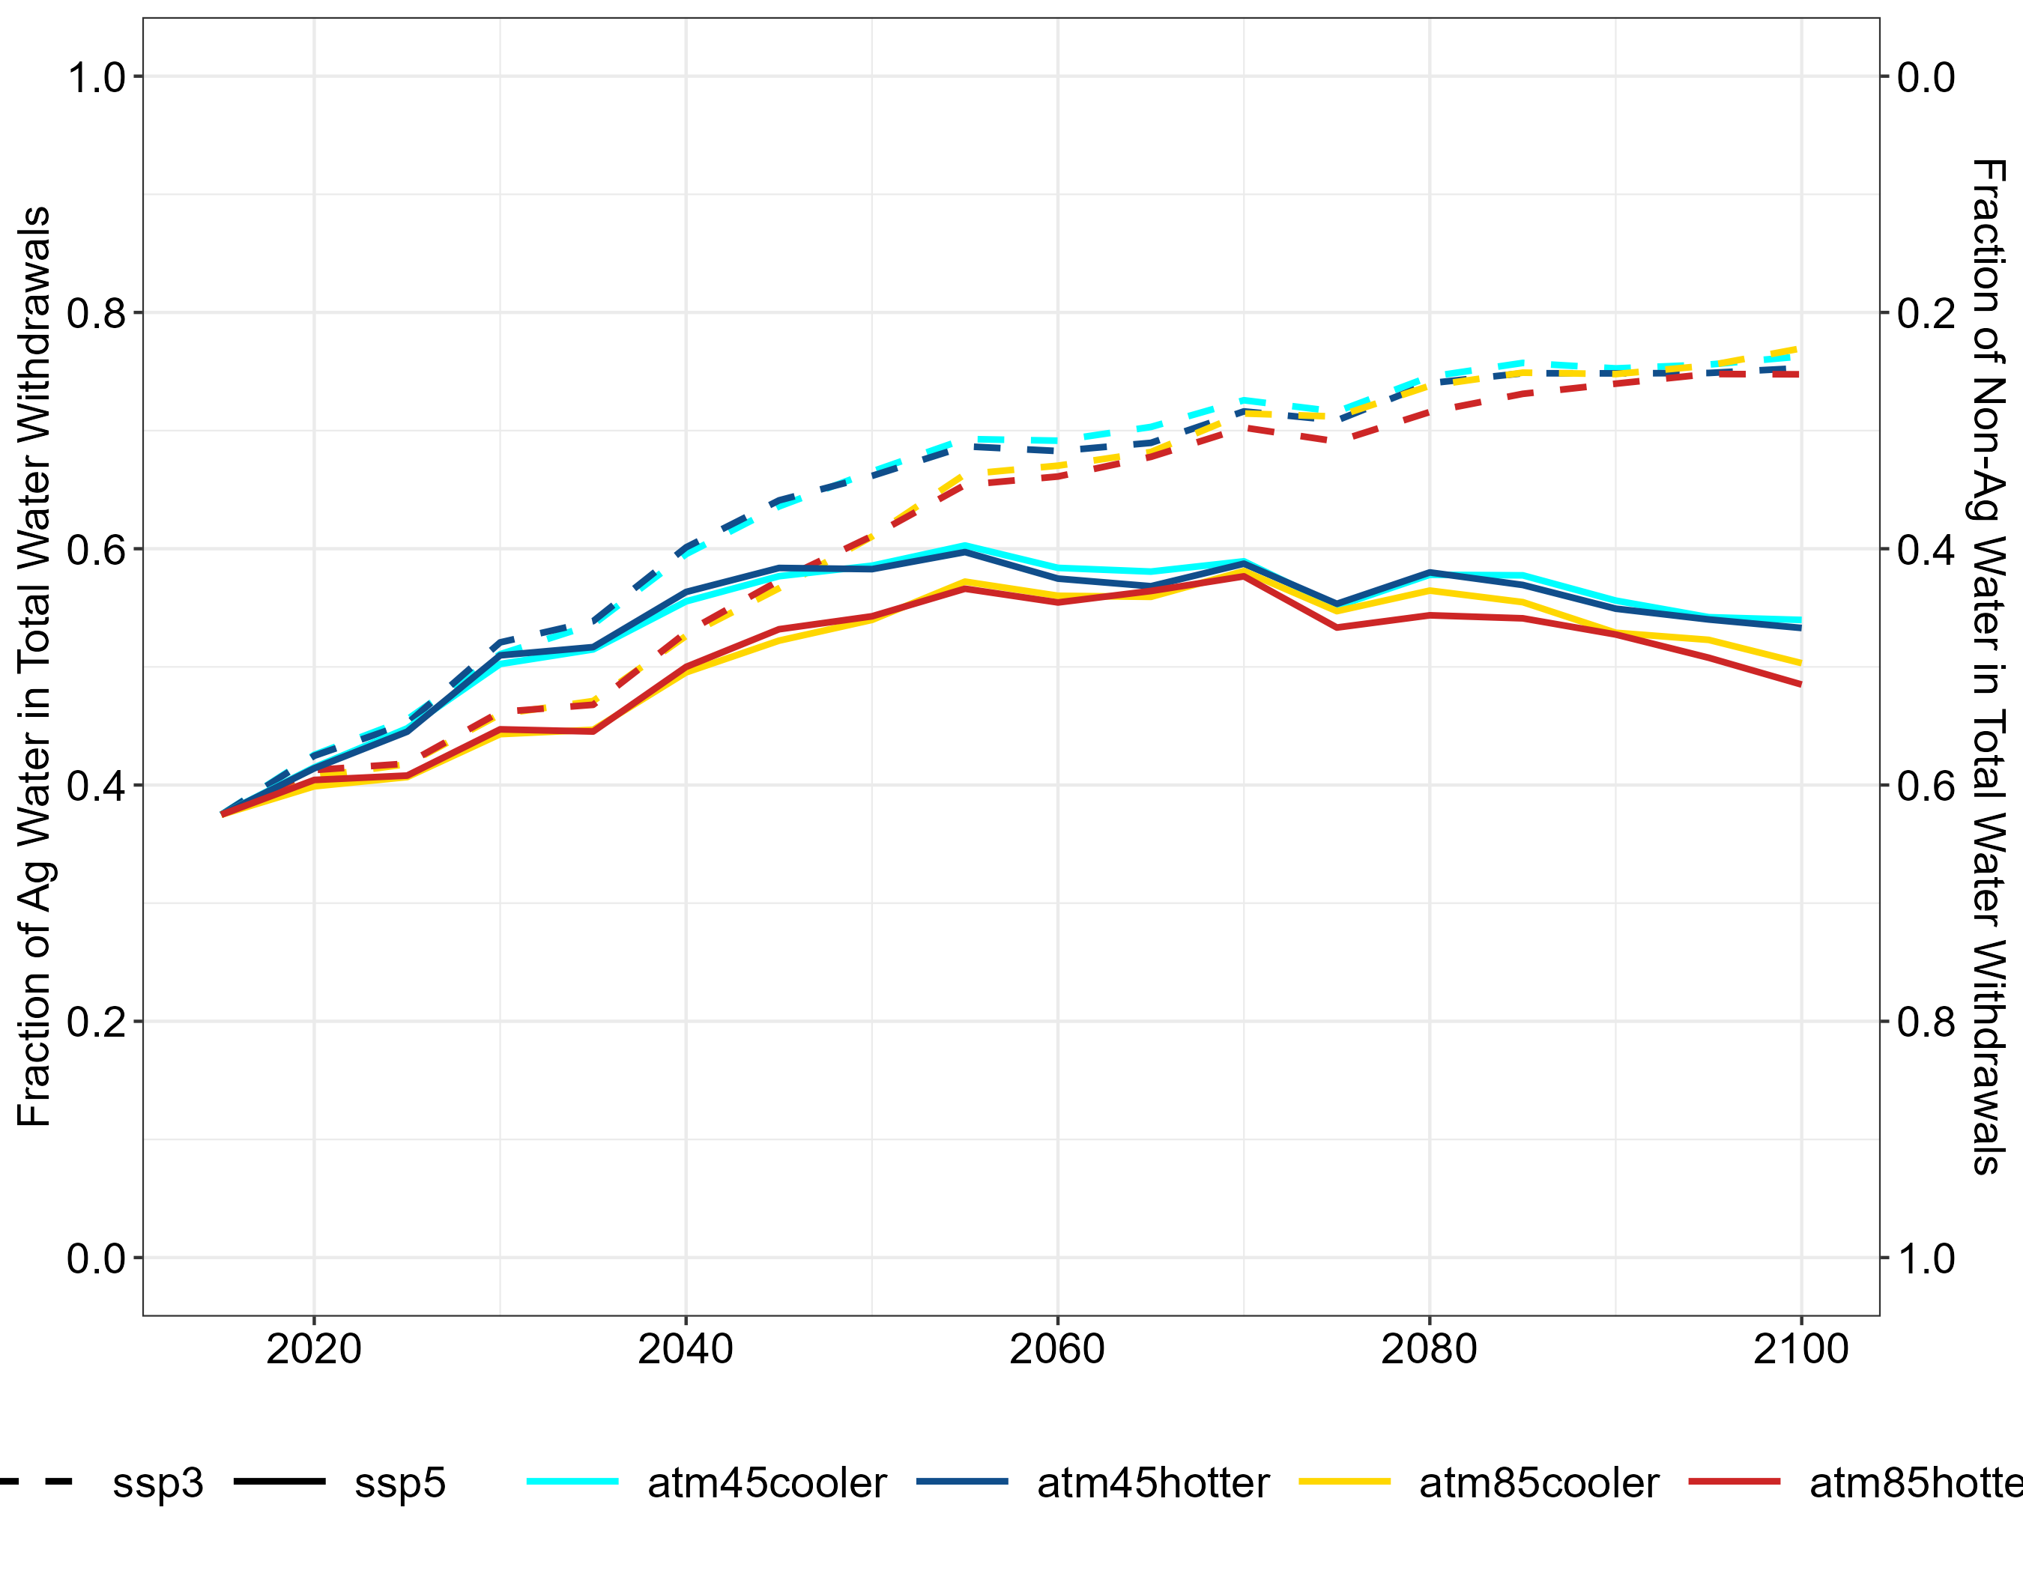

Figure S19. Fraction of (a) agricultural vs. non-agricultural water withdrawals in total water withdrawals; and (b) agricultural vs. non-agricultural water consumptions in total water consumptions.

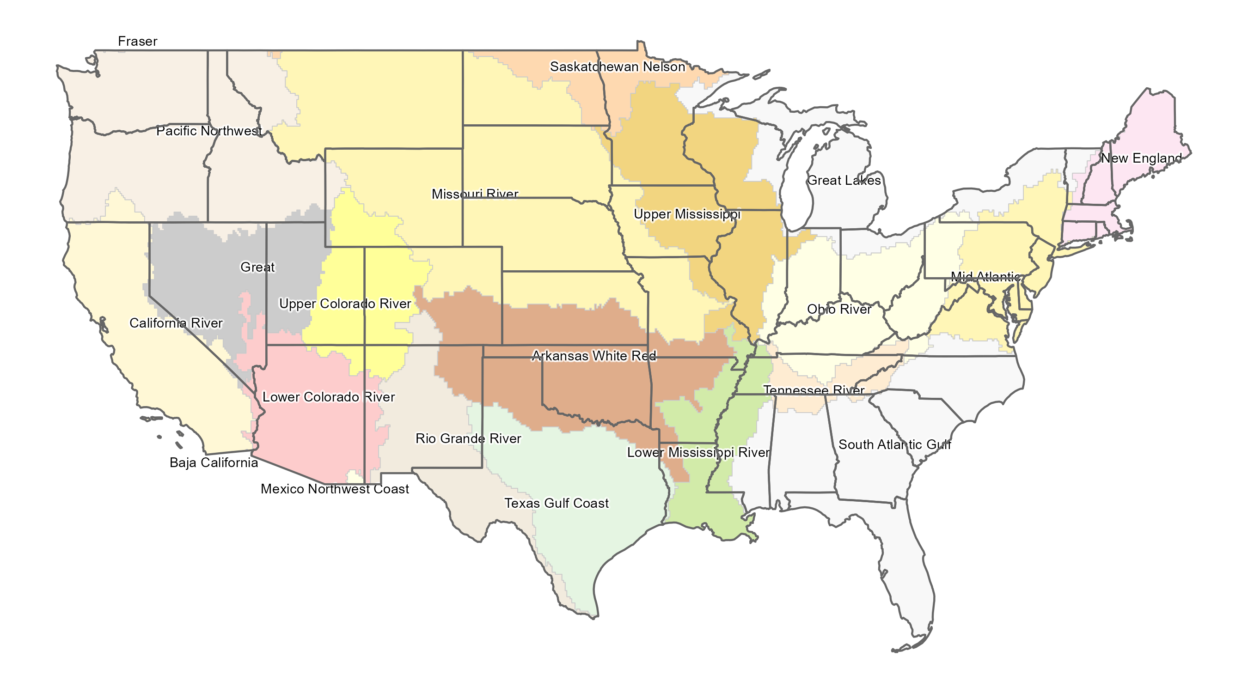

Figure S20. Mapping of 2-digit hydrologic unit code (HUC2) river basins and states within CONUS.

Data and Code Availability
Table S1 maps the scenario names used in the manuscript to the minted dataset names listed in Table S2 and S3. This study uses meteorological simulations from Jones et al., 2023 based on the CMIP6 scenarios, namely SSP245 and SSP585. RCP4.5 and 8.5 are two representative scenarios from CMIP5. Thus, the terminology “atm” (referring to atmospheric conditions) is used in the manuscript to avoid confusions between CMIP5 and CMIP6 scenario naming.

Table S1: Mapping of scenario names.
Minted GCAM-USA Dataset Name | Scenario Names used in Manuscript
rcp45cooler_ssp3 | atm45cooler_ssp3
rcp45cooler_ssp5 | atm45cooler_ssp5
rcp45hotter_ssp3 | atm45hotter_ssp3
rcp45hotter_ssp5 | atm45hotter_ssp5
rcp85cooler_ssp3 | atm85cooler_ssp3
rcp85cooler_ssp5 | atm85cooler_ssp5
rcp85hotter_ssp3 | atm85hotter_ssp3
rcp85hotter_ssp5 | atm85hotter_ssp5

Details of all the models used as well as input and output datasets are provided in the accompanying meta-repository (https://github.com/IMMM-SFA/canonical_gcam_runs) as well as in Table S2 for models and Table S3 for input and output data below. This allows interested users to explore any of the datasets and models of interest in more detail as well as reproduce any part of this experiment as needed.

Table S2: Models versions and DOIs.
Model | Version | Details | DOI or link
GCAM-USA | v5.3 | Global Change Analysis Model | https://doi.org/10.5281/zenodo.16923703
Xanthos | v2.4.1 | Global Hydrological Model | https://doi.org/10.5281/zenodo.5177210
CLM | v5.1 | Community Land Model | N/A
Helios | v1.0.0 | Heating/Cooling Degree-Hours | https://doi.org/10.5281/zenodo.14902226
Osiris | v1.0.4 | Agricultural Yield Emulator | https://doi.org/10.5281/zenodo.15733632

Table S3: Input and output datasets from this study.
Data | Type | Resolution | DOI
Population | Input | 12 x 12 km/State | https://doi.org/10.57931/2479357
TGW-WRF Climate | Input | 12 x 12 km | https://doi.org/10.57931/1885756
GCAM-USA | Output | Vary | https://doi.org/10.57931/2428940
Runoff | Output | Basin | https://doi.org/10.57931/2571309
HDH/CDH | Output | State | https://doi.org/10.57931/2569924
Agricultural Yield | Output | Region-basin intersection | https://doi.org/10.5281/zenodo.15733442

