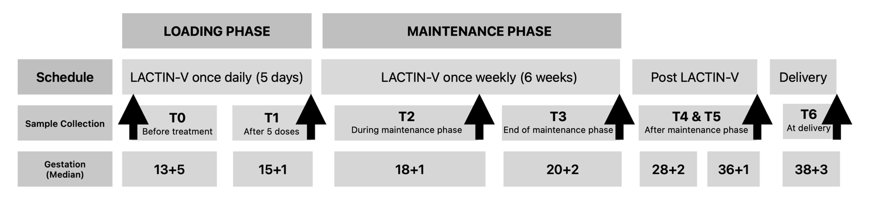

Extended Data Figure 1
Flow chart of the FLIP-1 schedule of events and study procedures
LACTIN-V administration schedule of loading dose, once daily for five days, and weekly for six weeks as maintenance phase. Samples were collected longitudinally at Timepoint 0 (T0) median gestational age 13⁺⁵ (IQR 13⁺⁰-14⁺⁴), and at 6 subsequent longitudinal timepoints; T1 (Median GA 15⁺¹ [IQR 14⁺³-16⁺¹]), T2 (18⁺¹ [17⁺¹-18⁺⁶]), T3 (20⁺² [19⁺²-20⁺⁶]), T4 (28⁺² [27⁺⁵-29⁺⁴]), T5 (36⁺¹ [34⁺⁶-36⁺³]), and T6 (at delivery (38⁺³ [37⁺⁴-39⁺²].

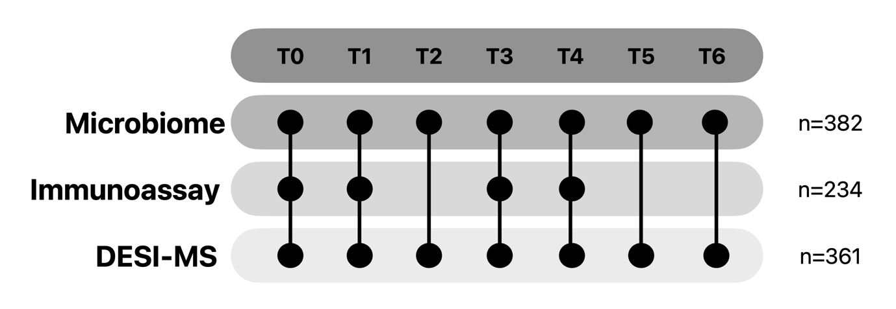

Extended Data Figure 2
Graphic representation of the participant clinical samples analysed in the FLIP-1 study
Samples were analysed for microbial composition (n=382), immune mediator analyses (n=234) and metabolic profiles using DESI-MS (n=361).

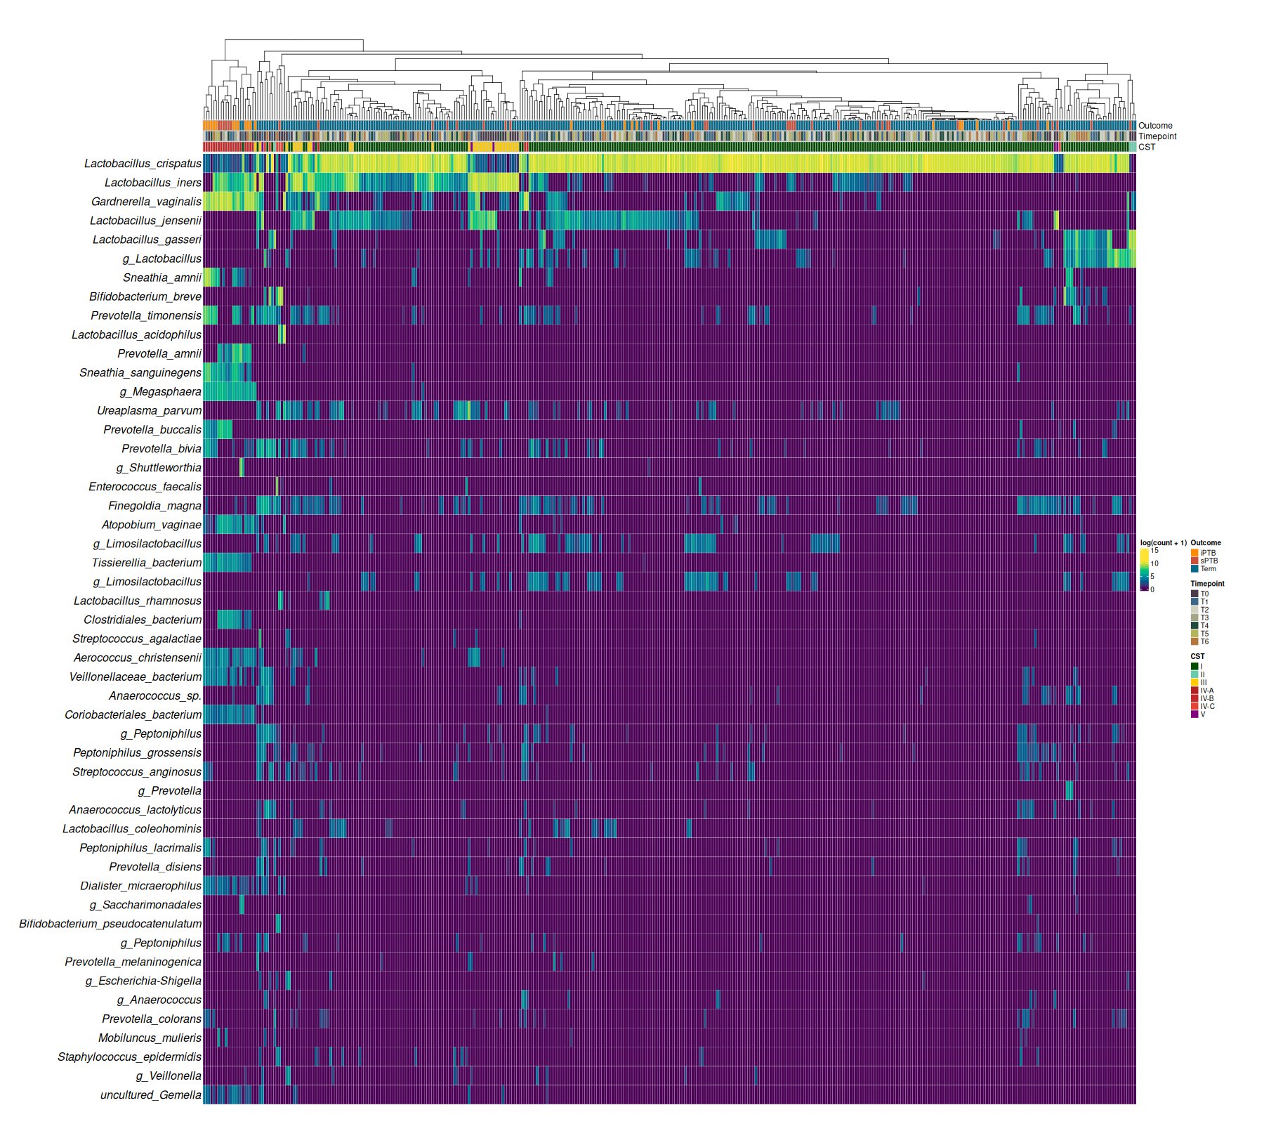

Extended Data Figure 3
Heatmap showing Log-transformed relative abundance values of microbial taxa analysed using hierarchical clustering.
Log-transformed relative abundance of microbial taxa across individual samples from the FLIP-1 study are presented. Individual samples are colour coded by their timepoint, assigned VALENCIA CST and pregnancy outcome. Hierarchical clustering was performed using complete linkage and Euclidean distance.

Extended Data Table 1. Gestational age at delivery for participants enrolled in the VMET-2 and FLIP-1 studies between September 2019 and September 2020.
Numbers and percentages are presented.

Outcome | VMET-2  N=262  (n,%) | FLIP-1  N=61  (n,%) | P value
Term | 211 (80.5) | 49 (80.3) | ns
sPTB 36⁺⁶-34⁺⁰ | 16 (6.1) | 3 (4.9) | ns
sPTB <33⁺⁶-24⁺⁰ | 22 (8.4) | 2 (3.3) | ns
sPTB/MTL <23⁺⁶-16⁺⁰ | 4 (1.5) | 1 (1.6) | ns
iPTB <37⁺⁰ | 9 (3.4) | 5 (8.2) | ns
Miscarriage < 16⁺⁰ | 0 (0) | 1 (1.6) | ns

Extended Data Table 2. Immune analyte concentrations for the matched VMET-2 (n=53) and FLIP-1 (n=54) cohorts.
Median values and interquartile ranges are presented. Statistical significance was assessed using the paired Wilcoxon signed-rank test two tailed.

Immune analyte pg/ml  Median [IQR] | TA  VMET-2 | TB  VMET-2 | P value | T0  FLIP-1 | T3  FLIP-1 | P value
IL-1β | 23.93 [8.527-83.57] | 37.58 [6.978 – 112.2] | 0.615 | 14.56 [0.5720 – 69.35] | 10.06 [0.8665 – 41.94] | 0.087
IL-6 | 0.8500 [0.07778-0.8500] | 0.8500 [0.8500 – 0.8500] | 0.877 | 0.8500 [0.1843 – 0.8500] | 0.8500 [0.03353 – 0.8500] | 0.286
IL-8 | 537.5 [179.1-1481] | 680 [247.1 – 1750] | 0.848 | 447.9 [134.9 – 1488] | 462.5 [117.4 – 1829] | 0.993
C1q | 0.03946 [0.03350 – 0.1966] | 0.3350 [0.3350 – 0.1222] | 0.914 | 0.1676 [0.0335 – 0.6347] | 0.09642 [0.0335 – 0.2162] | 0.084
C2 | 22.72 [5.337 – 157.7] | 19.26 [7.741 – 427.2] | 0.030 | 7.773 [3.272 – 25.77] | 7.7158 [4.129 – 17.91] | 0.541
C3 | 0.1100 [0.1100 – 0.1100] | 0.1100 [0.1100 – 0.1100] | 0.755 | 0.1100 [0.1100 – 0.1100] | 0.1100 [0.1100 – 0.1100] | 0.529
C3a | 219/6 [117.8 – 624.2] | 273.2 [153.8 – 621.3] | 0.357 | 147.7 [83.85 – 271.8] | 109.8 [31.38 – 186.4] | 0.017
C3b/iC3b | 2.388 [2.388 – 5.268] | 2.388 [2.388 – 17.45] | 0.116 | 5.613 [2.477 – 35.59] | 2.75 [2.290 – 8.415] | 0.014
C4 | 3.415 [1.207 – 22.04] | 7.328 [1.527 – 25.29] | 0.259 | 9.903 [4.321 – 68.96] | 1.907 [0.4479 – 12.03] | 0.001
C4b | 0.4689 [0.1650 – 1.384] | 0.6269 [0.1650 – 2.752] | 0.378 | 0.3122 [0.1650 – 1.370] | 0.5006 [1.650 – 1.195] | 0.909
C5 | 2.005 [0.400 – 10.33] | 2.005 [0.8091 – 12.73] | 0.278 | 2.516 [0.400 – 4.116] | 2.650 [0.400 – 2.701] | 0.375
C5a | 40.19 [8.316 – 79.17] | 40.24 [15.01 – 104.0] | 0.056 | 19.00 [5.925 – 37.94] | 17.04 [10.81 – 30.04] | 0.547
Factor D | 0.1555 [0.01350 – 0.5372] | 0.1429 [0.03153 – 0.5829] | 0.030 | 0.03196 [0.1350 – 0.1146] | 0.1350 [0.1350 – 0.03038] | 0.00043
Factor H | 9.046 [4.225 – 39.95] | 13.69 [6.760 – 38.98] | 0.242 | 13.12 [6.472 – 80.84] | 6.919 [2.780 – 35.92] | 0.008
Factor I | 0.2228 [0.900 – 2.815] | 1.296 [0.900 – 3.615] | 0.041 | 0.1516 [0.09 – 0.7274] | 0.09 [0.09 – 0.1571] | 0.011
MBL | 0.3260 [0.07263 – 0.8709] | 0.4776 [0.1519 – 1.238] | 0.203 | 0.2291 [0.05011 – 0.5705] | 0.1546 [0.05634 – 0.5168] | 0.447
MMP-2 | 643.1 [54.00 – 2553] | 994.9 [54.00 – 2560] | 1.000 | 508.5 [54 – 2293] | 648.1 [178.5 – 1570] | 0.992
MMP-8 | 3737 [1109 – 29101] | 5823 [1508 – 23144] | 0.427 | 3362 [884.8 – 11050] | 2298 [821.3 – 7081] | 0.449
MMP-9 | 22321 [4792 – 48238] | 26239 [10653 – 72308] | 0.237 | 31541 [6797 – 52047] | 22714 [5189 – 44442] | 0.194

