Figure 1: Examples of radiological signs of osteomalacia from our patients’ records.

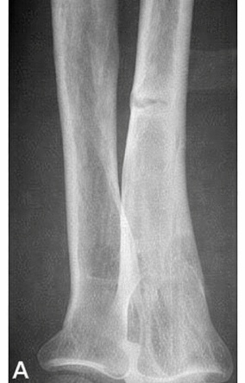
Looser-Milkman zones in the ulna (A)
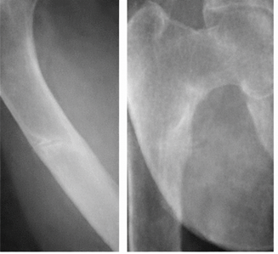
Looser-Milkman zones in the femur (B,C)
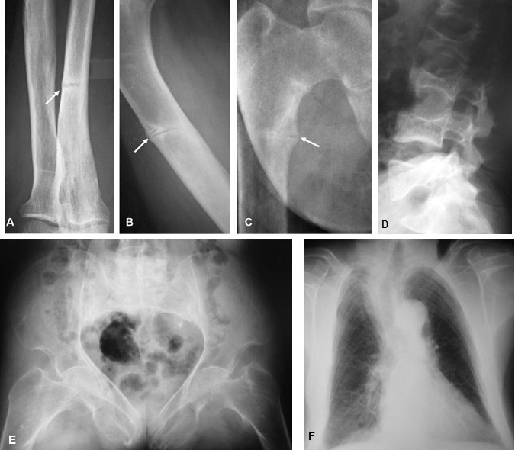
Lumbar vertebral fractures with fuzzy demineralization (D)

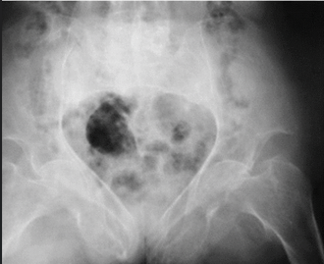
triradiate pelvis deformation (E)
bell-shaped thorax deformation (F).

