Submitted to: Microbiome
Supplementary material
Gut microbiota structure in stingless bees is shaped by ontogeny, caste, and sex
Mateus L. Vidigal¹, Lorena L. Botina²*, Gustavo F. Martins²
¹Laboratorio de Biologia molecular de Insetos. Programa de Pós-graduação em Entomologia, Universidade Federal de Viçosa, Viçosa, MG, Brasil.
²Laboratorio de Biologia molecular de Insetos. Departamento de Biologia Geral, Universidade Federal de Viçosa, Viçosa, MG, Brasil.
* Corresponding author: lorena.jojoa@ufv.br (L.L. Botina)
E-mail addresses: mateus.vidigal@ufv.br (M.L. Vidigal), lorena.jojoa@ufv.br (L.L. Botina), and gmartins@ufv.br (G.F. Martins).

1. Supplementary results
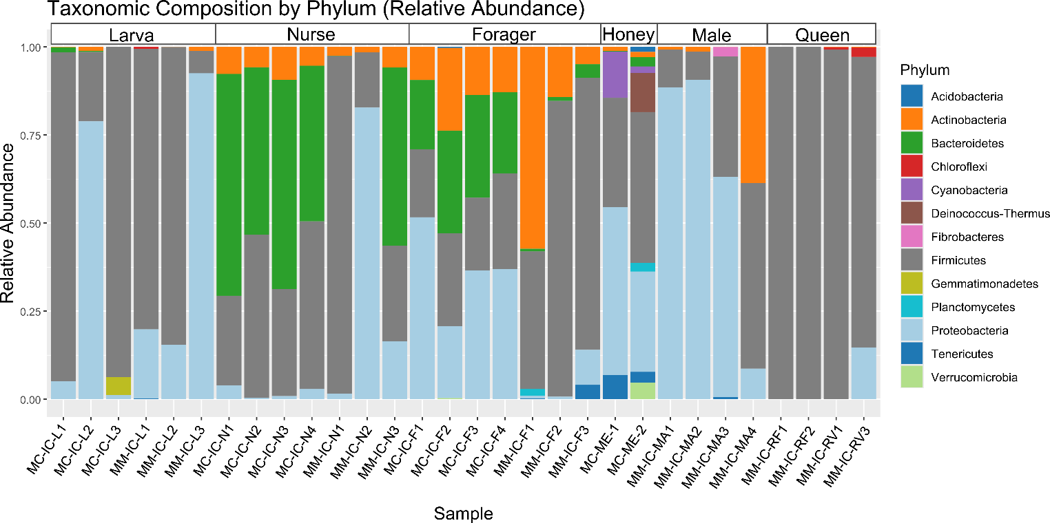
Supplementary Figure S1. Relative abundance of bacterial phyla across gut microbiota samples of Melipona capixaba and Melipona mondury. Each bar represents an individual sample, and colours indicate the proportional abundance of bacterial phyla. Sample codes on the x-axis denote species identity, where MC corresponds to M. capixaba and MM corresponds to M. mondury.
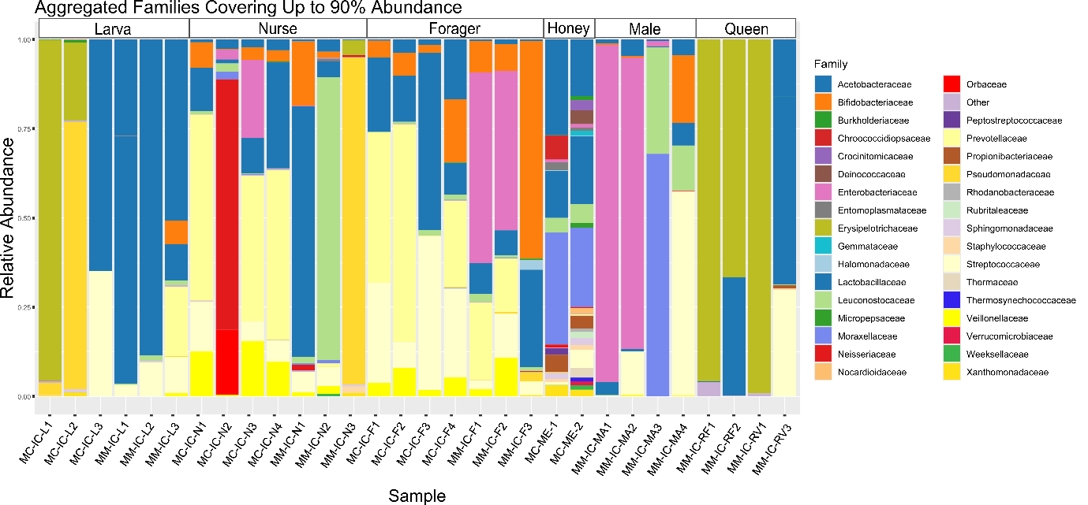Supplementary Figure S2. Relative abundance of bacterial families accounting for up to 90% of the total microbial community across samples of Melipona capixaba and Melipona mondury. Each bar represents an individual sample, with colours indicating the proportional contribution of bacterial families. Sample codes shown on the x-axis denote species identity, where MC corresponds to M. capixaba and MM corresponds to M. mondury.
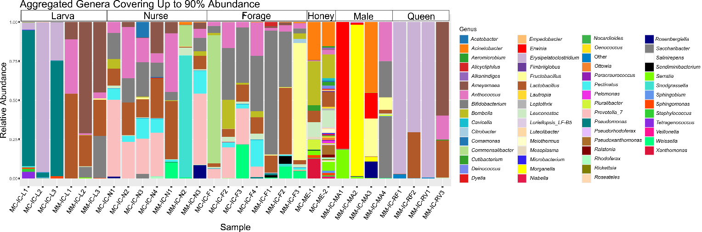
Supplementary Figure S3. Relative abundance of bacterial genera accounting for up to 90% of the total microbial community across samples of Melipona capixaba and Melipona mondury. Each bar represents an individual sample, with colours indicating the proportional contribution of bacterial genera. Sample codes on the x-axis denote species identity, where MC corresponds to M. capixaba and MM corresponds to M. mondury.
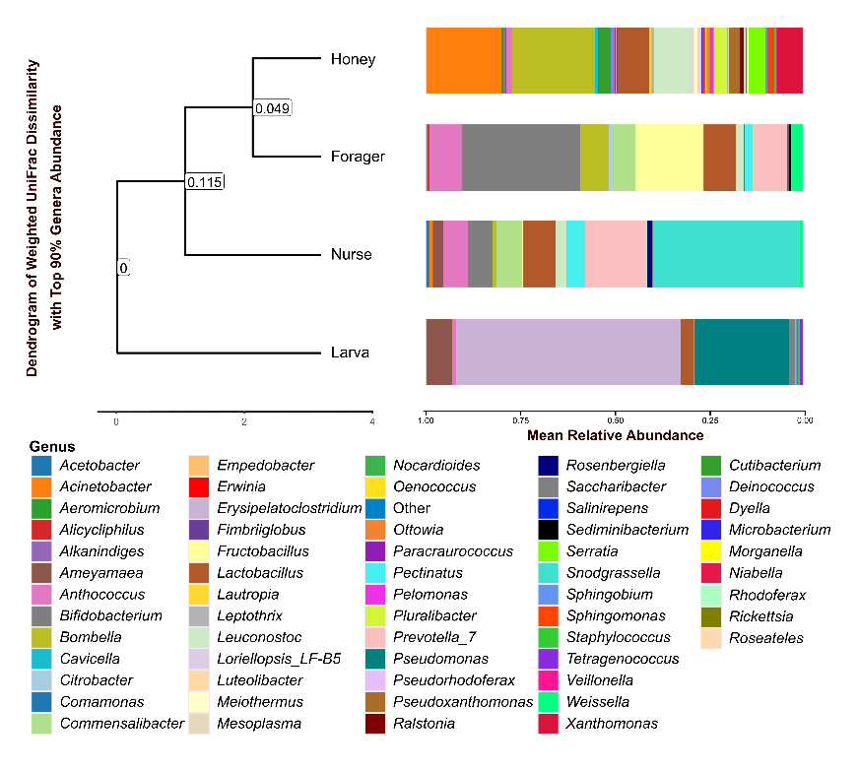
Supplementary Figure S4. Microbial community similarity across life stages and honey. Dendrogram based on Weighted UniFrac distances illustrating the phylogenetic beta-diversity among bacterial communities of honey, foragers, nurses, and larvae of Melipona capixaba. The adjacent bar plot displays the mean relative abundance of the top genera, which collectively represent 90% of the total microbial abundance across all samples.

1.1. Colonization and stress tolerance in worker and male microbiota
Worker (nurses and foragers) and male microbiota exhibit strong enrichment of predicted pathways related to resistance and adaptive capacity to environmental stressors, bacterial colonization, and adherence (Figure 4; Supplementary Tables S7 and S8, p < 0.05). Biofilm formation – E. coli (ko02026) is highly enriched in worker microbiota (LFC = 10.14, p = 0.002), and biofilm formation – Vibrio cholerae shows a similar magnitude (ko05111; LFC = 9.02, p = 0.015). In male microbiota, lipopolysaccharide biosynthesis (ko00540; LFC = 16.07, p = 0.001) is enriched, indicating a potential relation to enhanced cell wall integrity and modulation of the outer membrane barrier, while the two-component system (ko02020; LFC = 12.68, p < 0.001) is similarly elevated, indicating a possible capacity for adaptive environmental response and signal transduction. Predicted pathways related to metabolic processes supporting the biofilm matrix, such as carbohydrate biosynthesis, fatty acid and lipid biosynthesis, and 1,5-anhydrofructose degradation, cluster alongside workers and males in ordination space (Figure 4 C).
Predicted pathways related to tolerance to host- and environment-derived antimicrobial peptides, as well as increased transmembrane transport of nutrients and efflux of xenobiotics are also upregulated in worker and male microbiota (Figure 4; Supplementary Tables S7 and S8, p < 0.05). The Cationic Antimicrobial Peptide (CAMP) resistance pathway is among the most upregulated functions in both groups (ko01503; LFC = 19.87 – 9.70, p < 0.001). In males, the enrichment of porphyrin metabolism (ko00860; LFC = 11.76, p < 0.001) may indicate a facilitated efficient cellular energetics and substrate translocation. Similarly, the ABC transporter system (ko02010) is enriched in workers (LFC = 6.56, p > 0.001). Worker microbiota is further enriched in predicted functions related to osmoprotection and membrane-strengthening. Ectoine biosynthesis (LFC = 6.78, p > 0.001) may indicate a microbiota protected against osmotic and thermal stress, norspermidine biosynthesis (LFC = 5.88, p = 0.001) may be related to biofilm formation, while peptidoglycan biosynthesis IV (LFC = 2.72, p = 0.001) and (Kdo)₂-lipid A biosynthesis (LFC = 3.80, p > 0.001) may indicate enhanced cell-wall integrity and barrier resistance. The combined enrichment of these pathways may indicate a microbiota optimized for persistence under the fluctuating physicochemical conditions characteristic of the foraging environment.

1.2. Metabolic versatility and oxidative adaptation in worker and male microbiota
Both worker and male microbiotas display strong enrichment of predicted functions related to oxidative and energy-intensive metabolism, consistent with a more aerobic lifestyle and diverse diet (Figure 4; Supplementary Tables S7 and S8, p < 0.05). In M. mondury, predicted pathways related to respiration and redox metabolism, such as menaquinol biosynthesis (series 6–13; LFC = 2.8 – 3.9, p = 0.027 – 0.042) and TCA cycle VIII (LFC = 3.71 –9.21, p = 0.012 –0.013) are enriched in worker and male microbiotas. Complementary enrichment of fatty acid β-oxidation I (LFC = 3.64, p = 0.016) and oxidative phosphorylation (ko00190; LFC = 8.37, p = 0.029) in worker and males microbiota may indicate a high-energy metabolic potential suitable for processing nectar and pollen. Additionally, sulphur metabolism (ko00920; LFC = 15.78, p > 0.001), and ubiquinone and terpenoid-quinone biosynthesis (ko00130; LFC = 12.84, p > 0.001) may be functionally linked to oxidative respiration and electron transport in male gut communities.

1.3. Functional connectivity and community stability
Functional network analysis corroborates the ecological robustness of worker and male microbiotas (Supplementary Figure S6; Supplementary Table S10). The predicted functional network is highly connected (SpiecEasi: 104 nodes, 169 edges; SparCC: 104 nodes, 2666 edges; density = 0.50; modularity = 0.64), with the strongest linkages among amino acid biosynthesis, cofactor and vitamin biosynthesis, fermentation, and carbohydrate metabolism. Worker and male microbiotas display central hub functions involving cell structure biosynthesis (176 edges) and fatty acid and lipid biosynthesis (143 edges), both potentially linked to biofilm matrix production and stress resilience. In microbial association networks (Supplementary Figure S6; Supplementary Table S11), Bifidobacterium, Leuconostoc, and Bombella emerge as key nodes (degree = 16–22; modularity = 0.88), supporting community stability and ecological cooperation under environmental fluctuations.

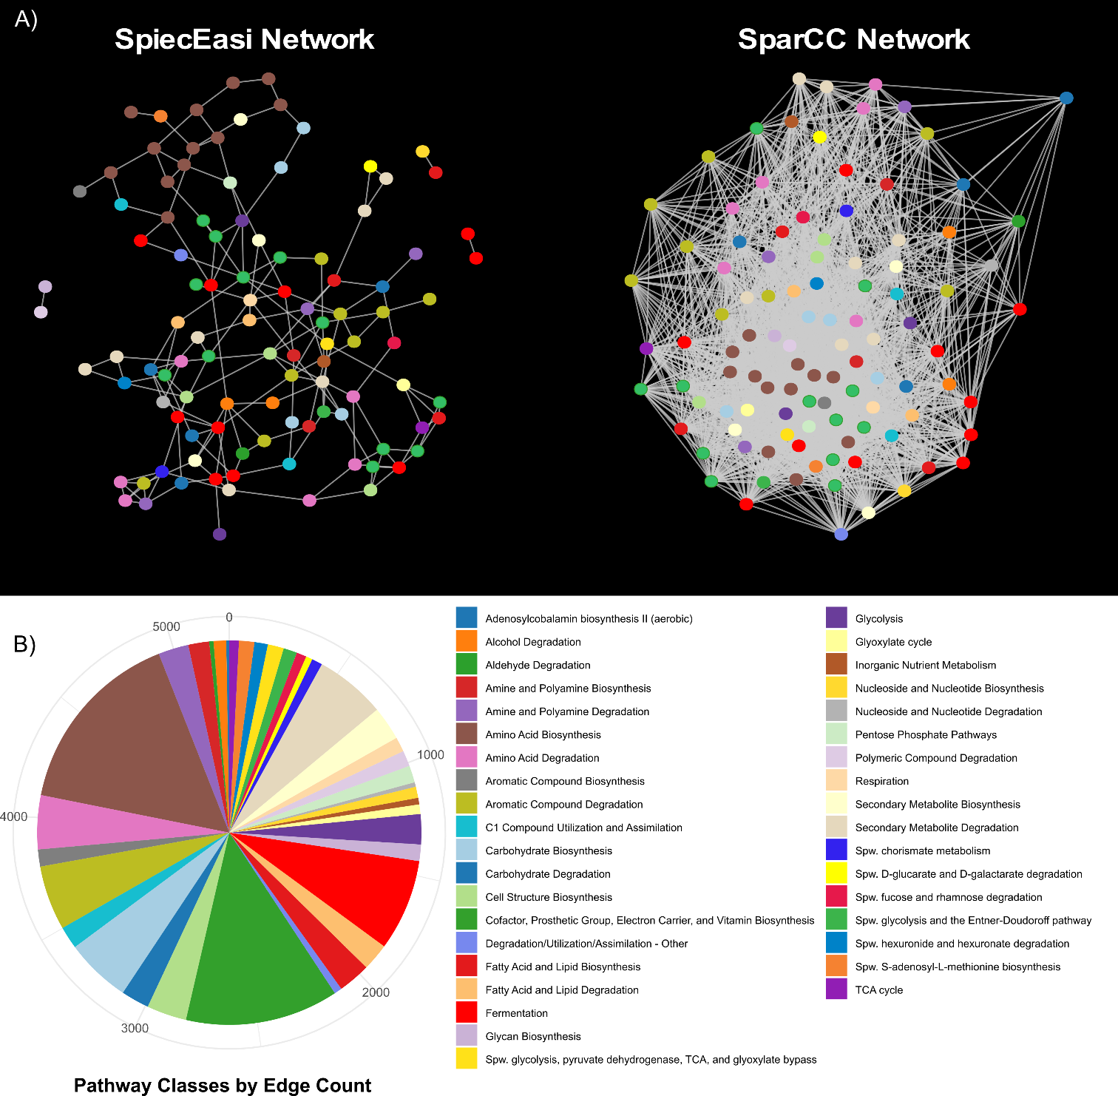
Supplementary Figure S5. Functional (MetaCyc) Co-occurrence Networks and Pathway Connectivity. A) Functional networks inferred from MetaCyc pathway profiles, encompassing the complete dataset for Melipona mondury and Melipona capixaba. The left panel shows the SpiecEasi network (Meinshausen–Bühlmann graphical model), which identifies sparse conditional dependence relationships among predicted MetaCyc pathways. The right panel shows the SparCC network, which infers correlation-based associations robust to compositionality. Each node represents a predicted MetaCyc metabolic pathway, coloured according to its functional class (same colour scheme as in previous figures), and edges represent inferred co-occurrence relationships. B) Distribution of predicted MetaCyc pathway classes by total edge count across both networks. The pie chart summarizes how frequently pathways from each functional class participate in co-occurrence associations, providing an overview of which metabolic categories contribute most strongly to the functional connectivity of the gut microbiome. Larger slices correspond to pathway classes with higher total edge counts across the combined SpiecEasi and SparCC networks.
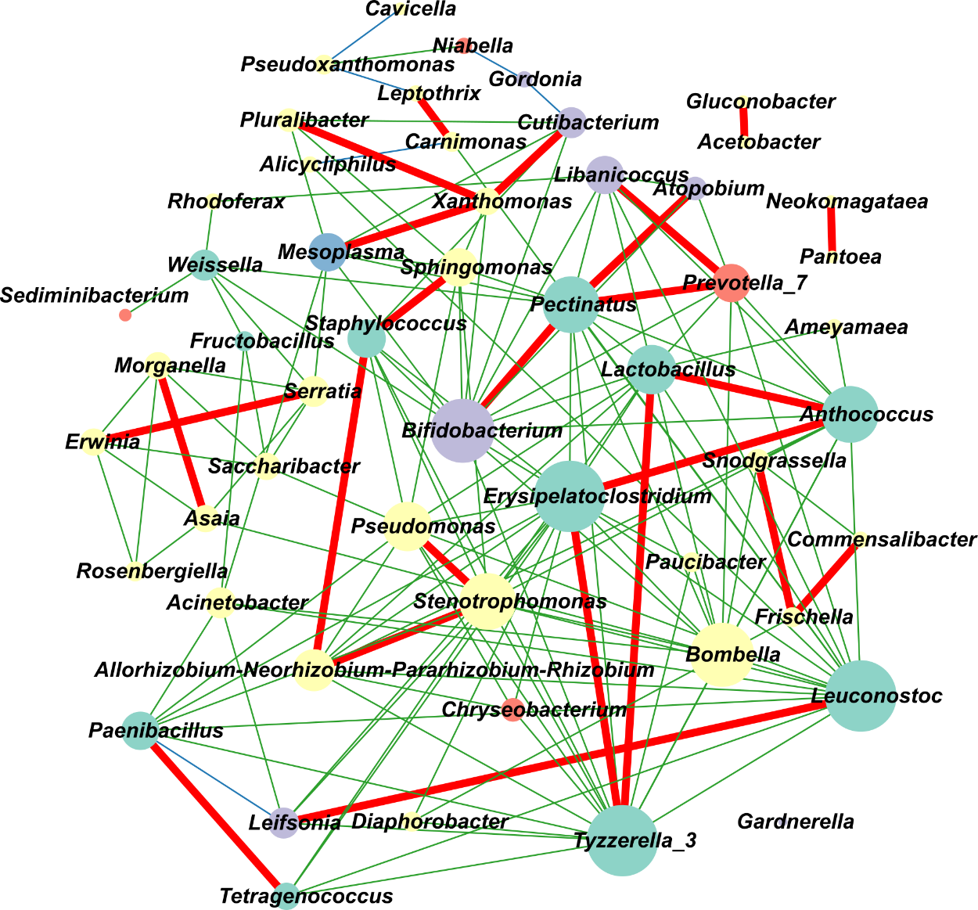
Supplementary Figure S6. Consensus co-occurrence network of M. capixaba and M. mondury gut bacteria. Network was constructed by merging edges inferred independently by SpiecEasi and SparCC. Blue edges represent associations detected only by SpiecEasi, green edges represent associations detected only by SparCC, and red edges indicate consensus edges recovered by both methods. Nodes represent bacterial genera; node size is proportional to degree (number of connections), and node colour denotes bacterial phylum (Proteobacteria = yellow, Firmicutes = green, Actinobacteria = purple, Bacteroidetes = orange, Tenericutes = blue).

1.4. Predicted pathways for anaerobic fermentation and aromatic compound catabolism in larvae and queens
Across both M. mondury and M. capixaba, ANCOM-BC analysis of MetaCyc pathways reveals that bacteria in larvae guts are enriched in predicted functions related to aromatic compound degradation and fermentation (Figure 4; Supplementary Tables S7 and S8, p < 0.05). In M. capixaba larvae gut communities, key routes in aromatic compound catabolism are enriched, including the beta-ketoadipate and catechol degradation pathways (LFC = 6.85, p > 0.001), 4-methylcatechol degradation (LFC = 5.01, p = 0.002), and aerobic phenylacetate degradation I (LFC = 3.23, p = 0.015). Potential fermentative capabilities are equally pronounced. Larval gut displays enrichment for predicted pathways that may indicate production of short-chain fatty acids under low-oxygen conditions, such as acetyl-CoA fermentation to butanoate II (LFC = 4.77, p = 0.009) and pyruvate fermentation to propanoate I (LFC = 2.72, p = 0.009). The overrepresentation of nitrate reduction I (denitrification; LFC = 7.22, p > 0.001) may also indicate the prevalence of an ecosystem tailored to fermentation and acid tolerance. This is further supported by the enrichment of cobalamin synthesis (cob(II)yrinate a,c-diamide biosynthesis II; LFC = 4.95, p > 0.001), which is critical for a potential sustained anaerobic fermentative metabolism. In M. mondury, larval gut is enriched for reductive TCA cycle I (LFC = 5.67, p = 0.003) and metabolic regulator biosynthesis (LFC = 5.05, p = 0.009), consistent with the hypothesis of energy generation under microaerophilic or anaerobic conditions.
The dominance of Erysipelatoclostridium, Ameyamaea, and Anthococcus, all central network hubs in the hive-associated community (Figure 3E; Supplementary Table S11), aligns precisely with these predicted functional signatures of fermentation and acid tolerance, demonstrating that the queen and larval gut microbiota is not only diet-derived but may also be metabolically attuned to thrive in the highly acidic, sugar-rich, and oxygen-limited environment of their diet.

Supplementary discussion

Worker and male microbiota exhibit metabolic versatility and environmental resilience
Compared to the stable, homeostatic conditions experienced by queens and larvae, flying workers (foragers) and males are subject to substantial physiological and environmental stressors. These include thermal fluctuations during foraging and the elevated oxidative demands associated with sustained flight (Frunze et al., 2026; Margotta et al., 2018; Quezada-Euán et al., 2024; Simone-Finstrom et al., 2016). Correspondingly, the microbiota of these groups is enriched with predicted pathways associated with environmental resilience, including biofilm formation (ko02026, ko02027) and lipopolysaccharide (LPS) biosynthesis (ko00540). The presence of these pathways suggests that gut bacteria in foragers and males may possess an enhanced capacity to construct protective extracellular matrices and robust cell-wall components, traits that could help microbial communities withstand fluctuating environmental conditions encountered during foraging (Motta et al., 2024; Quinn et al., 2024; Tang et al., 2025). Notably, although nurses do not fly and remain nest-bound, they still share these enriched functions. This likely results from the social homogenization of the worker microbiota, where intense trophallaxis and physical contact redistribute resilient taxa throughout the worker caste (Kwong et al., 2017; Powell et al., 2014).
Our results showed that several predicted pathways associated with matrix-building and cell-envelope are enriched in worker and male microbiotas. These include carbohydrate and fatty acid biosynthesis pathways that can be associated with membrane and biofilm structure. These metabolic pathways are involved in the processes of production of cell envelope components such as lipopolysaccharides and other structural molecules that contribute to membrane integrity and biofilm stability, which are essential for bacterial colonization (Motta et al., 2024; Tang et al., 2025). Interestingly, although biofilm formation is a characteristic feature of adult stingless bee guts, Melipona species lack Gilliamella, a core symbiont responsible for biofilm architecture in Apis and Bombus (Hammer et al., 2021; Kwong and Moran, 2016; Tang et al., 2025). The enrichment of biofilm-related pathways in our dataset therefore suggests a potential case of functional substitution, whereby other members of the Melipona microbiota may fulfil analogous structural roles within the gut community.
Workers and males also exhibited enrichment of predicted pathways linked to oxidative metabolism, including the tricarboxylic acid (TCA) cycle, oxidative phosphorylation, and ubiquinone biosynthesis. These pathways are central components of aerobic respiration (Abby et al., 2020; Vercellino and Sazanov, 2022; Wang et al., 2025), and their enrichment suggests that bacteria inhabiting these individuals may be able to utilize oxidative metabolic strategies. Such metabolic profiles may reflect the oxidative stress associated with active foraging and sustained flight (Margotta et al., 2018). Consistent with this interpretation, the observed enrichment of predicted pathways associated with osmoprotectants such as ectoine, as well as membrane-stabilizing molecules including norspermidine and peptidoglycan, suggests that the microbiota of workers and males may possess mechanisms that enhance tolerance to osmotic stress, dehydration, and thermal variation during flight during flight (Orhan et al., 2023; Prentice et al., 2024; Yu et al., 2024). These microbial traits could be particularly advantageous for hosts regularly exposed to variable environmental conditions during long-distance foraging flights.
Additionally, enhanced microbial resilience in worker and male microbiota is further supported by the observed enrichment of predicted pathways related to cationic antimicrobial peptide (CAMP) resistance (ko01503) and ABC transporter systems (ko02010). These metabolic pathways suggest that bacteria within worker and male microbiotas may possess increased capacities for toxin resistance and nutrient transport under fluctuating environmental conditions (How et al., 2025; Kuiack et al., 2020). Network analyses reinforce this interpretation, identifying taxa such as Bifidobacterium, Leuconostoc, and Bombella as central hubs within the community. These genera are widely documented in social bees for their ability to metabolize diverse carbohydrates and produce metabolites that stabilize gut microbial communities (Cao et al., 2026; Endo et al., 2022; Härer et al., 2022; Zheng et al., 2019).
Patterns observed in males provide further evidence of microbiota adaptation to external environments. We found that male microbiota exhibits enrichment in two-component systems (ko02020), a major bacterial mechanism for environmental sensing and signal transduction (Ishii and Eguchi, 2021; Liu et al., 2023). Because males do not return to the colony and interact with a wide range of substrates, the presence of these pathways suggests that bacterial populations associated with males may have a greater capacity to detect and respond to rapidly changing environmental conditions.
Predicted pathways for anaerobic fermentation and aromatic compound catabolism in larvae and queens
The enrichment of predicted pathways for detoxification of xylene, benzoate, and polycyclic aromatic hydrocarbons is particularly notable in larvae. This suggests that the larval microbiota may be capable of neutralizing secondary metabolites from pollen or nest materials, like propolis (Kešnerová et al., 2020; Tan et al., 2024). The presence of Pseudomonas in this context highlights the influence of hive architecture on microbiota assembly; these bacteria are likely ingested with nest-derived materials and persist in the larval gut due to its extensive metabolic repertoire for degrading aromatic compounds (Fasolato and Andreani, 2025). While Pseudomonas is prominent in the larval stage, its abundance declines sharply in nurses and foragers. This pattern suggests that although nurses are the primary builders and maintainers of the nest, as the gut matures and the "social core" is established, environmental opportunists are outcompeted by more robust, specialized symbionts (Jones et al., 2024; Mateus et al., 2019; Miller et al., 2019).
The prevalence of anaerobic pathways in larvae, including butanoate fermentation and nitrate reduction, suggests that larval gut bacteria thrive in an ecosystem tailored to oxygen limitation, as these pathways are related to anaerobic fermentation (Buckel, 2021; Kowles, 2018). The synthesis of cobalamin (Vitamin B12) further supports this anaerobic lifestyle, as it is a critical cofactor for enzymes involved in fermentative pathways (Darbyshire and Wolthers, 2024; Vásquez et al., 2022). While no specific pathways were significantly enriched in queens relative to other groups, their extreme taxonomic similarity to larvae suggests a strong functional convergence. This alignment is likely driven by dietary consistency and the stable, sheltered hive environment they share. In both groups, the microbiota appears optimized for the slow, fermentative processing of the acidic, sugar-rich provisions found within the nest, contrasting sharply with the energy-intensive, oxidative metabolism observed in the external worker and male populations.

Supplementary methods

Verification-step PCR
Each 25 µL PCR reaction mixture contained 1.0 µL of extracted DNA, 2.5 µL of PCR buffer, 0.75 µL of MgCl₂, 1 µL of each 005F and 1315R primer (10 µmol/µL concentration), 0.5 µL of dNTPs (10 mM/µL concentration each), 0.2 µL of Platinum Taq DNA Polymerase (Thermo Fisher Scientific), and nuclease-free water to complete the final volume (Botina et al., 2023). The amplification was performed over 29 cycles, consisting of an initial denaturation step at 94 °C for 2 minutes, followed by the cycles detailed as: denaturation at 94°C for 30 seconds, annealing at 50°C for 1 minute, and extension at 72°C for 1 minute and 30 seconds. A final extension step was carried out at 72°C for 5 minutes. Amplification products, including negative and positive controls, were visualized by electrophoresis on a 1% (w/v) agarose gel stained with GelRed.

16S rRNA gene amplification and sequencing
Samples positive for bacterial DNA were subjected to high-throughput amplicon sequencing of the V4–V5 hypervariable region of the 16S rRNA gene. Amplifications were performed using primers 515F (GTGCCAGCMGCCGCGGTAA) and 926R (CCGYCAATTYMTTTRAGTTT) following Walters et al. (2016). The library preparation and sequencing were outsourced to a commercial service provider.

Sequence processing and ASV inference (DADA2 pipeline)
Raw paired-end reads were processed using the DADA2 pipeline (Callahan et al., 2016) implemented in R v4.5.1 (R Core Team, 2025), following the established DADA2 tutorial workflow. Initial quality assessment of the forward and reverse reads guided the determination of filtering and trimming parameters. Primer sequences were removed using Cutadapt (Martin, 2011), with an error tolerance (-e) of 0.12 and a minimum overlap (-O) of 12 bases. Reads were then filtered using the filterAndTrim() function with the following parameters: maximum expected errors (maxEE) set to two for both forward and reverse reads, minimum quality score for trimming the 3' end (truncQ) set to two, and reads containing ambiguous bases (maxN) set to 0 were discarded. Additionally, low-quality tails and adapters were trimmed. Error rates were learned independently for each read direction using the learnErrors() function, and Amplicon Sequence Variants (ASVs) were inferred using the DADA algorithm (dada() function). Forward and reverse reads were merged (mergePairs() function) requiring sufficient overlap and zero mismatches. Chimeric sequences were subsequently identified and removed using the removeBimeraDenovo() function with the consensus method. Taxonomy was assigned using DADA2's assignTaxonomy() function, employing the naïve Bayesian classifier trained on the SILVA v138.2 (Quast et al., 2012) database for classification from phylum to species level where the confidence permitted. The resulting ASV table, taxonomy table, and sample metadata were then imported into the phyloseq package v1.52.0 (McMurdie and Holmes, 2013) to construct an integrated microbiome object. To ensure biological relevance, non-bacterial sequences were computationally removed, including those identified as mitochondria, chloroplasts, eukaryotic contaminants, and poorly classified ASVs (unassigned above family level). This comprehensive filtering reduced the initial dataset from 1574 raw ASVs to 1296 high-confidence ASVs used for all downstream analyses.

Alpha and beta diversity analyses
The taxonomic and phylogenetic analysis began by constructing a phyloseq object to integrate the ASV count table, taxonomic assignments, sample metadata, and ASV sequences. The ASV sequences were aligned using the AlignSeqs() function in DECIPHER v3.4.0 (Wright, 2016), and the resulting alignment was converted to a phyDat object. A preliminary neighbor-joining tree (NJ()) was computed from a maximum likelihood distance matrix (dist.ml()), which was then optimized using a maximum likelihood approach (optim.pml()) under the General Time-Reversible (GTR) model, including rate variation across sites (optGamma = TRUE) and invariant sites (optInv = TRUE). This finalized phylogenetic tree was subsequently added to the phyloseq object for downstream phylogenetic diversity metrics.
Initial visualization of community composition was performed by calculating the mean relative abundance of taxa across biological groups. Specifically, we analysed the relative abundance of the selected genera that together accounted for 90% of the total abundance (top 90% abundance genera) after filtering out low-abundance taxa and aggregating the remaining rare genera into an "Other" category. This approach provided a clear, high-level overview of the dominant bacterial composition across castes and life stages.
Alpha diversity metrics, including Shannon, Simpson, and Observed Features, were calculated using the estimate_richness() function from the phyloseq package. To account for the compositional nature of the data and the inherent variability in sequencing depth, and to avoid the statistical artifacts associated with rarefaction, we utilized an ANCOVA-based approach. This method avoids discarding valuable data (as rarefaction does) by incorporating the log₁₀-transformed library size for each sample as a continuous covariate. Group differences in Shannon and Simpson diversity were evaluated using ANCOVA models (aov() function), with biological group (caste, sex, or life stage) as the main factor and log₁₀-library size as a covariate. Post-hoc comparisons were performed using the emmeans (v2.0.0) package (Lenth and Piaskowski, 2017), which calculates estimated marginal means (EMMeans), applying Tukey-adjusted p-values for multiple comparisons. Compact letter displays (CLD) were generated using the cld() function on the EMMeans results for visual interpretation of significant group contrasts.
Beta diversity was systematically analysed by partitioning the main phyloseq object into several ecologically relevant subsets to address specific hypotheses related to life stage, species, and diet. The subsets created included: Simple Stage Progression (SSP), isolating larva and worker castes across both species to assess differentiation with age; Stage Progression per Species (SPS), separating the SSP analysis for M. mondury (SPSM) and M. capixaba (SPSC) to examine species-specific effects; and Caste and Sex (CS), including workers, queens (physogastric and virgin), and males from M. mondury to test for reproductive differences. Since virgin queens and physogastric queens did not differ, we combined virgin and physogastric queens into a single "queen" group to increase statistical power and simplify caste comparisons.
Community distance matrices were computed using both abundance-weighted and phylogenetic metrics: Bray–Curtis (bray), Unweighted UniFrac (unifrac, weighted = FALSE), and Weighted UniFrac (unifrac, weighted = TRUE). These matrices were subjected to dimensionality reduction using Principal Coordinates Analysis (PCoA) and Non-metric Multidimensional Scaling (NMDS) via the ordinate() function, producing ordination objects for each distance-subset combination. For visualization of the Simple Stage Progression (SSP), we specifically plotted the PCoA results using sample centroids and directional arrows to illustrate the hypothesized temporal trajectory of microbial change from larva to nurse to forager. Differences in community structure were formally tested using Permutational Multivariate Analysis of Variance (PERMANOVA), implemented by the adonis2() function in the vegan package v2.7-2 (Oksanen et al., 2025), running 999 permutations. This tested the effect of variables like age (life stage), species, caste, and sex on the measured distance matrices. To visualize hierarchical relationships, sample distances were used to construct dendrograms that collapsed samples by their respective grouping variable, using average-linkage hierarchical clustering (hclust()) and plotted with ggtree() to show the overall similarity topology among the averaged groups.

Differential abundance analysis of bacterial taxa
The identification of specific microbial taxa driving the observed community structure differences was performed using differential abundance analysis. To enhance interpretability and focus on ecologically relevant units, all Amplicon Sequence Variants (ASVs) were initially collapsed to the genus level using the tax_glom() function in phyloseq. Before analysis, low-abundance taxa and unclassified genera were removed to create a refined phyloseq object. Given the compositional nature of sequencing data, we employed two distinct statistical approaches, DESeq2 and ANCOM-BC2, to ensure robust results that account for variations in sequencing depth and compositional bias.
DESeq2 v1.48.1 (Love et al., 2014) was applied via the phyloseq_to_deseq2 wrapper, which models count data using a negative binomial distribution to test for differences in abundance. The analysis was structured around seven key contrasts reflecting biological hypotheses: A. foragers versus nurses (worker ages); B. workers versus larvae (overall and species-specific); C. species effect (comparing M. mondury to M. capixaba across workers and larvae); and comparisons within M. mondury for reproductive roles: D. workers versus males, E. queens versus males, F. queens versus workers, and G. queens versus larvae. Log-fold changes were shrunken using the ashr method (lfcShrink()) to stabilize estimates, particularly for taxa with low mean counts. As a crucial complementary method, we also utilized ANCOM-BC2 v2.10.1 (Lin and Peddada, 2020), which is specifically designed for compositional data and provides bias-corrected log-fold change estimates and robust hypothesis testing. ANCOM-BC2 was run using the same subsetted objects and fixed effects formulas as the DESeq2 tests, ensuring direct comparison of results. A minimum prevalence cutoff (prv_cut = 0.10) was applied to focus on genera present in at least 10% of samples.

Temporal dynamics of microbiota during worker aging
To visually assess the dynamic shifts in the community structure associated with the forager - nurse – larva and queen microbial transition, we constructed alluvial plots (ggalluvial v0.12.5). The analysis focused on the ten most highly abundant genera across the host groups (Erysipelatoclostridium, Ameyamaea, Lactobacillus, Pseudomonas, Anthococcus, Bifidobacterium, Snodgrassella, Prevotella_7, Commensalibacter, and Fructobacillus), with the remaining rare genera aggregated into an "Other" category. The relative abundance of each genus was calculated and visually tracked. To statistically confirm these observed shifts in relative abundance, we performed non-parametric testing on the per-sample relative abundance data for each collapsed genus. The Kruskal-Wallis test (kruskal_test() function in rstatix v0.7.3) was used to determine the overall significance of the change for each genus. For genera where the Kruskal-Wallis test indicated a significant overall difference, Dunn's post-hoc test (dunn_test()), with p-value adjustment for multiple comparisons, was executed to identify the specific pairwise differences driving the observed variation.

Functional prediction profiling and microbial network inference
Following the taxonomic analysis, we sought to predict the functional potential of the microbial communities using PICRUSt2 v2.3.0-b (Douglas et al., 2020). This tool utilizes evolutionary placement of ASVs onto a reference phylogeny to infer the abundance of KEGG Orthology (KO) terms, Enzyme Commission (EC) numbers, and MetaCyc metabolic pathways. The PICRUSt2 pipeline was executed on a high-performance cluster, taking the filtered ASV sequence data and count table as input. To ensure high-quality functional predictions, we examined the Nearest Sequenced Taxon Index (NSTI) scores of all ASVs. Across the full ASV table (1296 ASVs), the mean NSTI was 0.226 and the median NSTI was 0.179, consistent with typical values for insect-associated microbiomes. Following established thresholds for non-model hosts (NSTI ≤ 0.35, (Douglas et al., 2020), we removed 258 ASVs (19.9%) that exceeded this cutoff. After applying both NSTI filtering and relative-abundance criteria (≥0.1% in at least one sample), 298 high-confidence ASVs were retained for subsequent PICRUSt2 functional prediction. This filtering strategy ensured that functional inferences were based only on ASVs with reliable phylogenetic placement. NSTI values below 0.25 are considered high quality for environmental samples (Douglas et al. 2020), indicating that the majority of ASVs in our dataset fall within a reliable prediction range.
The filtered ASV count table was computationally multiplied by the PICRUSt2-predicted functional tables (KO and EC counts per ASV) to generate functional counts per sample. These new functional count tables were then merged with the sample metadata to create phyloseq objects. The same DESeq2 differential abundance analysis workflow previously applied to taxonomic genera was re-run on these functional counts across all seven key contrasts (e.g., foragers vs. nurses, workers vs. larvae), yielding log2-fold change estimates and adjusted p-values for individual KO terms and EC numbers. Shrinkage of LFC estimates was performed using lfcShrink (type = "ashr") to improve interpretability.
To translate individual KO differences into pathway-level patterns, we conducted KEGG enrichment analyses using clusterProfiler v4.16.0 (Yu et al., 2012). First, a custom TERM2GENE mapping database was generated by downloading all KEGG pathways and their associated KO identifiers via KEGGREST v1.48.1 (Tenenbaum and Maintainer, 2025. For each DESeq2 contrast, significantly differentially abundant KOs (padj < 0.05) were tested for over-representation in KEGG pathways using a hypergeometric model. We also calculated the mean log₂-fold change (LFC) of all significant KO terms belonging to each enriched pathway, providing an estimation of the pathway's overall direction of change (enriched or depleted).
MetaCyc pathway abundance predictions were also imported from PICRUSt2’s output. Pathway metadata (MetaCyc IDs, hierarchical levels, functional descriptions) were added as a taxonomy table (taxa_table()) to a phyloseq object. Principal Coordinates Analysis (PCoA) based on Bray-Curtis distance was used to visualize the overall separation of functional potential (MetaCyc pathways) between the different groups, and PERMANOVA was performed to statistically test the significance of factors like age and caste on the functional profile. Because pathway tables represent compositional count data, we employed ANCOM-BC2 for robust differential abundance tests. For each key biological contrast, we ran ANCOM-BC2 with bias correction and detection thresholding (prevalence cutoff = 10%). Significant pathways (q < 0.05) were used to create “focused” functional ordinations, allowing visualization of only biologically meaningful pathways that contributed to group separation.

Microbial and pathway co-occurrence networks
To infer putative ecological interactions among gut bacterial taxa, we constructed co-occurrence networks using two complementary approaches designed for compositional metagenomic data: SpiecEasi and SparCC. Because correlation estimates from relative abundance data are highly sensitive to sparsity and compositional constraints, we first applied a stringent filtering procedure to the genus-level abundance table to reduce noise and prevent spurious associations. ASVs were agglomerated to the genus level, and genera lacking taxonomic assignments were removed. We calculated per-genus total read count, prevalence across samples, and maximum relative abundance, and retained only genera that satisfied at least one of the following criteria: prevalence in ≥15% of samples, total counts ≥50 reads, or a maximum relative abundance ≥0.1% in at least one sample. This hybrid filtering strategy removes extremely rare taxa, attenuates compositional distortions caused by dominant genera, and yields a more stable input matrix for network inference.
Filtered count tables were extracted from the resulting phyloseq object and formatted as sample-by-taxon matrices with samples in rows. Network inference using SpiecEasi v1.1.13 (Kurtz et al., 2015) was performed with the Meinshausen–Bühlmann (MB) neighborhood selection method, which estimates sparse inverse covariance matrices while correcting for compositionality through graphical model inference. Regularization parameters were explored along a sequence of 20 λ values, with model selection guided by the Stability Approach to Regularization Selection (StARS), using 20 subsampling replicates. The final refit adjacency matrix was converted into an igraph object, in which edges represent conditional dependencies (putative ecological interactions) that persist after accounting for the joint covariance structure of all taxa.
A second, correlation-based network was generated using SparCC (Friedman and Alm, 2012), as implemented in the SpiecEasi package. SparCC estimates linear correlations that are robust to compositional data by inferring correlations from log-ratio transformed abundances. Correlation matrices were computed for all pairs of genera, and edges were defined as associations with absolute correlations exceeding 0.3. Although SparCC is less conservative than covariance-based methods, its sensitivity complements the specificity of SpiecEasi, allowing cross-validation of co-occurrence patterns.
To compare network structures, edges from the SpiecEasi and SparCC graphs were converted into data frames, labelled by method, and merged to identify consensus and method-specific associations. A combined “consensus network” was created by unifying the two edge sets and assigning each edge a weight corresponding to the number of methods supporting it (1 = unique to one method; 2 = shared by both). Taxonomic metadata (genus and phylum) were mapped to each node, and node-level metrics (degree, connectivity class) were computed using igraph v2.2.1 (Csárdi et al., 2025). Network statistics were estimated for each network independently and for the consensus network. These included number of nodes and edges, density, mean degree, global transitivity, and modularity (fast-greedy community detection.
For visualization and topological exploration, the consensus edge list and annotated node table were imported into Cytoscape v3.10.4 (Shannon et al., 2003) via RCy3 v2.28.1. Edges were styled according to their weight (method consensus), using thicker or coloured edges to highlight associations recovered by both methods. Nodes were coloured by bacterial phylum and scaled by degree to emphasize highly connected taxa (putative hubs). A force-directed layout algorithm was applied to optimize readability and reveal community structure.
In addition to taxonomic networks, we also constructed functional co-occurrence networks using MetaCyc pathways predicted by PICRUSt2. After filtering pathways to those significantly associated with group differences (ANCOM-BC2 and DESeq2), we repeated the same two-method inference workflow using SpiecEasi MB graphical models and SparCC correlations. Pathways were annotated with their second-level and top-level MetaCyc classifications, enabling visualization of functional modules and identification of highly connected pathway hubs. SpiecEasi- and SparCC-derived functional networks were analysed separately, and their shared edges were combined into a consensus functional network. To identify the most interconnected functional categories, we plotted a pie chart showing the distribution of edge counts across MetaCyc pathway classes in the consensus functional network.

Legends
Supplementary Table S1. Sample metadata, including developmental stage, caste, sex, and numbers of different categories of individuals of Melipona capixaba and Melipona mondury
Supplementary Table S2. Alpha diversity metrics for individual gut microbiota samples of Melipona capixaba (MC) and Melipona mondury (MM) across different life stages, castes, and sex. Metrics include Observed richness (ASVs), Shannon diversity index, and Simpson evenness index. Sample prefixes denote the host species
Supplementary Table S3. Analysis of Covariance (ANCOVA) and post-hoc contrast tests of alpha diversity indices (Shannon and Simpson) across biological groups and developmental stages of Melipona capixaba and Melipona mondury. It includes estimated marginal means, standard errors, and pairwise comparisons (contrasts) with adjusted p-values for Shannon and Simpson diversity indices
Supplementary Table S4. PERMANOVA models testing differences in gut microbiota composition across life stages, castes, sexes
Supplementary Table S5. Differentially abundant bacteria identified among biological groups of Melipona capixaba and Melipona mondury. The table presents pairwise contrasts (e.g., workers vs. larvae) with their respective Log2 Fold Change (LFC) and adjusted p-values (p.adjust). Positive LFC values indicate enrichment in the first group of the contrast, while negative values indicate enrichment in the second. Results are integrated from two statistical frameworks, ANCOM-BC and DESeq2, to ensure the robustness of the taxonomic signatures identified
Supplementary Table S6. Dunn’s post hoc test results for comparisons shown in Figure 3, and relative abundances of the top bacterial genera, families, and phyla by host group
Supplementary Table S7. Differential abundance analysis of MetaCyc functional pathways. Analysis was performed using ANCOM-BC on output from the PICRUSt2 pipeline. The table displays pairwise contrasts between specific host groups (e.g., Larvae vs. Workers), including pathway names, MetaCyc ontologies (Superclass and Class), and statistical parameters such as Log Fold Change (LFC), Standard Error (SE), and W-statistics. Positive LFC values indicate functional enrichment in the first group of the contrast, while negative values indicate enrichment in the second. Multiple testing was corrected using the Benjamini-Hochberg method, with adjusted p-values (q-values) used to determine significance (q < 0.05). Robustness of the results is indicated by the "passed_ss" and "diff_robust" logical flags
Supplementary Table S8. KEGG pathway enrichment analysis of the functional potential within the gut microbiotas of Melipona capixaba and Melipona mondury. Enrichment was performed using the clusterProfiler R package based on Kyoto Encyclopedia of Genes and Genomes (KEGG) Orthology (KO) terms predicted by the PICRUSt2 pipeline. The table details pairwise contrasts between biological groups (e.g. larvae vs. workers), including Pathway IDs, Descriptions, Gene Ratios, and Fold Enrichment scores. Statistical significance was assessed using p-values and q-values (Benjamini-Hochberg adjusted). The direction of functional shifts is indicated by the mean and median Log Fold Change (LFC) of all significantly differential KOs (n_sig_KOs) contributing to each specific metabolic pathway
Supplementary Table S9. Permutational Multivariate Analysis of Variance (PERMANOVA) based on Bray-Curtis distances of MetaCyc functional pathways. Analyses were performed on two distinct datasets: (i) the "Whole data," encompassing all predicted MetaCyc pathways, and (ii) the "ANCOM-BC data," restricted to pathways identified as significantly differentially abundant. Permutations (999) were used to determine the significance of the pseudo-F statistic. R² values represent the proportion of variance explained by the biological group. Significance levels: * P < 0.05; ** P < 0.01; *** P < 0.001
Supplementary Table S10. Topological properties and co-occurrence patterns of MetaCyc functional pathway networks in the Melipona gut microbiota. The table summarizes the network architecture derived from two distinct correlation frameworks: SpiecEasi and SparCC. Edge data includes source-target pairs and their associated weights, while Node data details the MetaCyc ontologies (Pathway Class and Superclass) and node degree (connectivity). Global network metrics are provided
Supplementary Table S11. Topological properties and node metadata for the microbial co-occurrence networks of the Melipona gut microbiota. The table details node-level attributes, including taxonomic identification (Genus and Phylum) and node degree (connectivity). Global network statistics are provided for networks generated via SpiecEasi, SparCC, and a Merged approach. The "methods" column indicates which correlation frameworks identified each specific node or edge

Supplementary references
Abby, S.S., Kazemzadeh, K., Vragniau, C., Pelosi, L., Pierrel, F., 2020. Advances in bacterial pathways for the biosynthesis of ubiquinone. Biochim. Biophys. Acta Bioenerg. 1861. https://doi.org/10.1016/j.bbabio.2020.148259
Botina, L.L., Barbosa, W.F., Acosta, J.P.L., Bernardes, R.C., Cortes, J.E.Q., Pylro, V.S., Mendonça, A.C., Barbosa, R.C., Lima, M.A.P., Martins, G.F., 2023. The impact of early-life exposure to three agrochemicals on survival, behavior, and gut microbiota of stingless bees (Partamona helleri). Environmental Science and Pollution Research 30, 70143–70158. https://doi.org/10.1007/s11356-023-27385-4
Buckel, W., 2021. Energy Conservation in Fermentations of Anaerobic Bacteria. Front. Microbiol. https://doi.org/10.3389/fmicb.2021.703525
Callahan, B.J., McMurdie, P.J., Rosen, M.J., Han, A.W., Johnson, A.J.A., Holmes, S.P., 2016. DADA2: High-resolution sample inference from Illumina amplicon data. Nat. Methods 13, 581–583. https://doi.org/10.1038/nmeth.3869
Cao, W., Yang, S., Wang, J., Chen, S., Byarlay, M., Shi, X., Li-Byarlay, H., Ma, C., 2026. Field-realistic cyfluthrin exposure alters multi-omics profiles in Bombus terrestris: Implications for wild pollinator health. Pestic. Biochem. Physiol. 217, 106896. https://doi.org/10.1016/j.pestbp.2025.106896
Csárdi, G., Nepusz, T., Traag, V., Horvát, S., Zanini, F., Noom, D., Kirill Müller, Schoch, D., Salmon, M., 2025. igraph: Network Analysis and Visualization in R. https://doi.org/10.5281/zenodo.7682609
Darbyshire, A.L., Wolthers, K.R., 2024. Characterization of a Structurally Distinct ATP-Dependent Reactivating Factor of Adenosylcobalamin-Dependent Lysine 5,6-Aminomutase. Biochemistry 63, 913–925. https://doi.org/10.1021/acs.biochem.3c00653
Douglas, G.M., Maffei, V.J., Zaneveld, J.R., Yurgel, S.N., Brown, J.R., Taylor, C.M., Huttenhower, C., Langille, M.G.I., 2020. PICRUSt2 for prediction of metagenome functions. Nat. Biotechnol. 38, 685–688. https://doi.org/10.1038/s41587-020-0548-6
Endo, A., Maeno, S., Liu, S.Q., 2022. Lactic Acid Bacteria: Leuconostoc spp., in: Encyclopedia of Dairy Sciences. Elsevier, pp. 226–232. https://doi.org/10.1016/B978-0-08-100596-5.00859-3
Fasolato, L., Andreani, N.A., 2025. The genus Pseudomonas, in: The Microbiological Quality of Food. Elsevier, pp. 23–55. https://doi.org/10.1016/B978-0-323-91160-3.00007-6
Friedman, J., Alm, E.J., 2012. Inferring Correlation Networks from Genomic Survey Data. PLoS Comput. Biol. 8, e1002687. https://doi.org/10.1371/journal.pcbi.1002687
Frunze, O., Kim, H., Woo, S.O., Lee, S.J., Kwon, H.W., 2026. Chronic heat stress disrupts foraging motivation in honey bees. J. Insect Physiol. 169. https://doi.org/10.1016/j.jinsphys.2026.104945
Hammer, T.J., Le, E., Martin, A.N., Moran, N.A., 2021. The gut microbiota of bumblebees. Insectes Soc. https://doi.org/10.1007/s00040-021-00837-1
Härer, L., Hilgarth, M., Ehrmann, M.A., 2022. Comparative Genomics of Acetic Acid Bacteria within the Genus Bombella in Light of Beehive Habitat Adaptation. Microorganisms 10. https://doi.org/10.3390/microorganisms10051058
How, S.S., Nathan, S., Lam, S.D., Chieng, S., 2025. ATP-binding cassette (ABC) transporters: structures and roles in bacterial pathogenesis. J. Zhejiang Univ. Sci. B. https://doi.org/10.1631/jzus.B2300641
Ishii, E., Eguchi, Y., 2021. Diversity in sensing and signaling of bacterial sensor histidine kinases. Biomolecules. https://doi.org/10.3390/biom11101524
Jones, L.C., Lau, I.H., Smith, T.J., Walter, G.H., Hereward, J.P., 2024. Age-related task progression in two Australian Tetragonula stingless bees. Insectes Soc. 71, 309–322. https://doi.org/10.1007/s00040-024-00978-z
Kešnerová, L., Emery, O., Troilo, M., Liberti, J., Erkosar, B., Engel, P., 2020. Gut microbiota structure differs between honeybees in winter and summer. ISME Journal 14, 801–814. https://doi.org/10.1038/s41396-019-0568-8
Kowles, C.J., 2018. Diversity of Bacterial Respiratory Systems. CRC Press. https://doi.org/10.1201/9781351071505
Kuiack, R.C., Veldhuizen, R.A.W., McGavin, M.J., 2020. Novel Functions and Signaling Specificity for the GraS Sensor Kinase of Staphylococcus aureus in Response to Acidic pH. J. Bacteriol. 202. https://doi.org/10.1128/JB.00219-20
Kurtz, Z.D., Müller, C.L., Miraldi, E.R., Littman, D.R., Blaser, M.J., Bonneau, R.A., 2015. Sparse and Compositionally Robust Inference of Microbial Ecological Networks. PLoS Comput. Biol. 11, e1004226. https://doi.org/10.1371/journal.pcbi.1004226
Kwong, W.K., Medina, L.A., Koch, H., Sing, K.-W., Soh, E.J.Y., Ascher, J.S., Jaffé, R., Moran, N.A., 2017. Dynamic microbiome evolution in social bees. Sci. Adv. 3. https://doi.org/10.1126/sciadv.1600513
Kwong, W.K., Moran, N.A., 2016. Gut microbial communities of social bees. Nat. Rev. Microbiol. https://doi.org/10.1038/nrmicro.2016.43
Lenth, R. V., Piaskowski, J., 2017. emmeans: Estimated Marginal Means, aka Least-Squares Means. CRAN: Contributed Packages. https://doi.org/10.32614/CRAN.package.emmeans
Lin, H., Peddada, S. Das, 2020. Analysis of compositions of microbiomes with bias correction. Nat. Commun. 11, 3514. https://doi.org/10.1038/s41467-020-17041-7
Liu, L., Ji, L., Lai, Y., Yang, L., He, G., Zhang, D., 2023. Molecular mechanism of Phoebe bournei essential oils inhibiting the survival of Staphylococcus aureus and Bacillus cereus. Ind. Crops Prod. 204. https://doi.org/10.1016/j.indcrop.2023.117229
Love, M.I., Huber, W., Anders, S., 2014. Moderated estimation of fold change and dispersion for RNA-seq data with DESeq2. Genome Biol. 15, 550. https://doi.org/10.1186/s13059-014-0550-8
Margotta, J.W., Roberts, S.P., Elekonich, M.M., 2018. Effects of flight activity and age on oxidative damage in the honey bee, Apis mellifera. Journal of Experimental Biology 221. https://doi.org/10.1242/JEB.183228
Martin, M., 2011. Cutadapt removes adapter sequences from high-throughput sequencing reads. EMBnet. J. 17, 10. https://doi.org/10.14806/ej.17.1.200
Mateus, S., Ferreira-Caliman, M.J., Menezes, C., Grüter, C., 2019. Beyond temporal-polyethism: division of labor in the eusocial bee Melipona marginata. Insectes Soc. 66, 317–328. https://doi.org/10.1007/s00040-019-00691-2
McMurdie, P.J., Holmes, S., 2013. phyloseq: An R Package for Reproducible Interactive Analysis and Graphics of Microbiome Census Data. PLoS One 8, e61217. https://doi.org/10.1371/journal.pone.0061217
Miller, D.L., Parish, A.J., Newton, I.L., 2019. Transitions and transmission: behavior and physiology as drivers of honey bee-associated microbial communities. Curr. Opin. Microbiol. https://doi.org/10.1016/j.mib.2019.08.001
Motta, E.V.S., de Jong, T.K., Gage, A., Edwards, J.A., Moran, N.A., 2024. Glyphosate effects on growth and biofilm formation in bee gut symbionts and diverse associated bacteria. Appl. Environ. Microbiol. 90. https://doi.org/10.1128/aem.00515-24
Oksanen, J., Simpson, G.L., Blanchet, F.G., Kindt, R., Legendre, P., Minchin, P.R., O’Hara, R.B., Solymos, P., Stevens, M.H.H., Szoecs, E., Wagner, H., Barbour, M., Bedward, M., Bolker, B., Borcard, D., Borman, T., Carvalho, G., Chirico, M., De Caceres, M., Durand, S., Evangelista, H.B.A., FitzJohn, R., Friendly, M., Furneaux, B., Hannigan, G., Hill, M.O., Lahti, L., Martino, C., McGlinn, D., Ouellette, M.-H., Ribeiro Cunha, E., Smith, T., Stier, A., Ter Braak, C.J.F., Weedon, J., 2025. vegan: Community Ecology Package. R package. https://doi.org/doi:10.32614/CRAN.package.vegan
Orhan, F., Ceyran, E., Akincioğlu, A., 2023. Optimization of ectoine production from Nesterenkonia xinjiangensis and one-step ectoine purification. Bioresour. Technol. 371. https://doi.org/10.1016/j.biortech.2023.128646
Powell, J.E., Martinson, V.G., Urban-Mead, K., Moran, N.A., 2014. Routes of acquisition of the gut microbiota of the honey bee Apis mellifera. Appl. Environ. Microbiol. 80, 7378–7387. https://doi.org/10.1128/AEM.01861-14
Prentice, J.A., van de Weerd, R., Bridges, A.A., 2024. Cell-lysis sensing drives biofilm formation in Vibrio cholerae. Nat. Commun. 15. https://doi.org/10.1038/s41467-024-46399-1
Quast, C., Pruesse, E., Yilmaz, P., Gerken, J., Schweer, T., Yarza, P., Peplies, J., Glöckner, F.O., 2012. The SILVA ribosomal RNA gene database project: improved data processing and web-based tools. Nucleic Acids Res. 41, D590–D596. https://doi.org/10.1093/nar/gks1219
Quezada-Euán, J.J.G., Medina, R.G., Soto-Correa, A., Pech-Jiménez, C., Paxton, R.J., Solís, T., Aragón-Pech, R., Moo-Valle, H., 2024. Heat domes increase vulnerability of native stingless bees by simultaneously weakening key survival traits. Science of the Total Environment 957. https://doi.org/10.1016/j.scitotenv.2024.177705
Quinn, A., El Chazli, Y., Escrig, S., Daraspe, J., Neuschwander, N., McNally, A., Genoud, C., Meibom, A., Engel, P., 2024. Host-derived organic acids enable gut colonization of the honey bee symbiont Snodgrassella alvi. Nat. Microbiol. 9, 477–489. https://doi.org/10.1038/s41564-023-01572-y
R Core Team, 2025. R: A Language and Environment for Statistical Computing. R Foundation for Statistical Computing. https://www.R-project.org/
Shannon, P., Markiel, A., Ozier, O., Baliga, N.S., Wang, J.T., Ramage, D., Amin, N., Schwikowski, B., Ideker, T., 2003. Cytoscape: A Software Environment for Integrated Models of Biomolecular Interaction Networks. Genome Res. 13, 2498–2504. https://doi.org/10.1101/gr.1239303
Simone-Finstrom, M., Li-Byarlay, H., Huang, M.H., Strand, M.K., Rueppell, O., Tarpy, D.R., 2016. Migratory management and environmental conditions affect lifespan and oxidative stress in honey bees. Sci. Rep. 6. https://doi.org/10.1038/srep32023
Tan, Y., An, K., Su, J., 2024. Review: Mechanism of herbivores synergistically metabolizing toxic plants through liver and intestinal microbiota. Comparative Biochemistry and Physiology Part - C: Toxicology and Pharmacology. https://doi.org/10.1016/j.cbpc.2024.109925
Tang, M., Li, C., Ge, X., Kuang, Y., Qiu, L., Chan, K.C., Chen, Z., Guo, L., Zhao, Z., Zhang, B., Liu, S., Zhou, X., 2025. Honeybee-Gilliamella synergy in carbohydrate metabolism enhances host thermogenesis in cold acclimation. NPJ Biofilms Microbiomes 11. https://doi.org/10.1038/s41522-025-00798-4
Tenenbaum, D., Maintainer, B.P., 2025. KEGGREST: Client-side REST access to the Kyoto Encyclopedia of Genes and Genomes (KEGG). https://doi.org/DOI:10.18129/B9.bioc.KEGGREST
Vásquez, L., Parra, A., Quesille-Villalobos, A.M., Gálvez, G., Navarrete, P., Latorre, M., Toro, M., González, M., Reyes-Jara, A., 2022. Cobalamin cbiP mutant shows decreased tolerance to low temperature and copper stress in Listeria monocytogenes. Biol. Res. 55. https://doi.org/10.1186/s40659-022-00376-4
Vercellino, I., Sazanov, L.A., 2022. The assembly, regulation and function of the mitochondrial respiratory chain. Nat. Rev. Mol. Cell Biol. https://doi.org/10.1038/s41580-021-00415-0
Walters, W., Hyde, E.R., Berg-Lyons, D., Ackermann, G., Humphrey, G., Parada, A., Gilbert, J.A., Jansson, J.K., Caporaso, J.G., Fuhrman, J.A., Apprill, A., Knight, R., 2016. Improved Bacterial 16S rRNA Gene (V4 and V4-5) and Fungal Internal Transcribed Spacer Marker Gene Primers for Microbial Community Surveys. mSystems 1. https://doi.org/10.1128/mSystems.00009-15
Wang, Z., Ji, G., Liu, X., Sun, D., 2025. MIL-100(Fe)@PUS enhances inorganic carbon fixation and organic pollutant removal via coupled adsorption-transport-metabolism in continuous algal-bacterial biofilms. Chemical Engineering Journal 522. https://doi.org/10.1016/j.cej.2025.167276
Wright, E.S., 2016. Using DECIPHER v2.0 to Analyze Big Biological Sequence Data in R. R J. 8, 352. https://doi.org/10.32614/RJ-2016-025
Yu, G., Wang, L.-G., Han, Y., He, Q.-Y., 2012. clusterProfiler: an R Package for Comparing Biological Themes Among Gene Clusters. OMICS 16, 284–287. https://doi.org/10.1089/omi.2011.0118
Yu, J., Zhang, Y., Liu, H., Liu, Y., Mohsin, A., Liu, Z., Zheng, Y., Xing, J., Han, J., Zhuang, Y., Guo, M., Wang, Z., 2024. Temporal dynamics of stress response in Halomonas elongata to NaCl shock: physiological, metabolomic, and transcriptomic insights. Microb. Cell Fact. 23. https://doi.org/10.1186/s12934-024-02358-5
Zheng, H., Perreau, J., Elijah Powell, J., Han, B., Zhang, Z., Kwong, W.K., Tringe, S.G., Moran, N.A., 2019. Division of labor in honey bee gut microbiota for plant polysaccharide digestion. PNAS 116. https://doi.org/10.1073/pnas.1916224116/-/DCSupplemental

