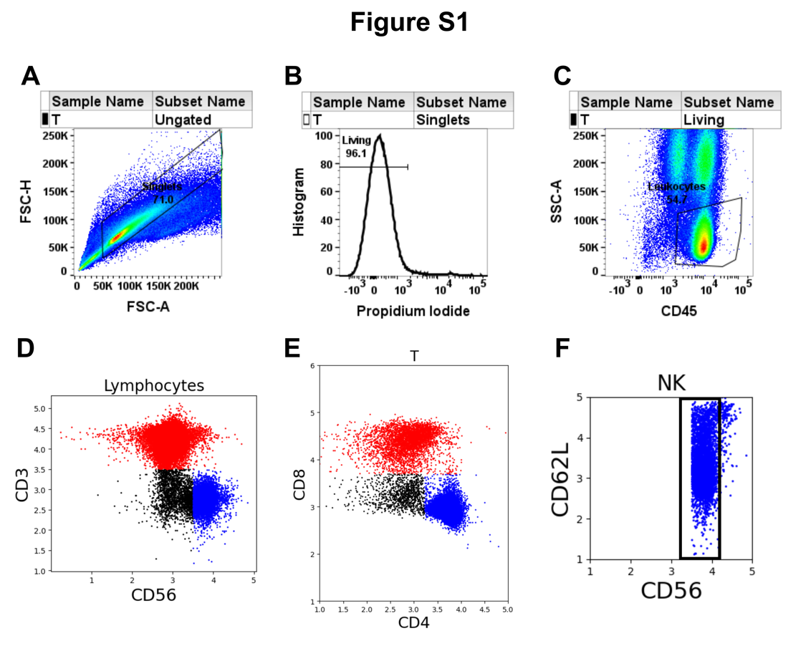
Supplementary Figure 1: Gating strategy to define lymphocyte populations from a representative sample. (A) Single cells were gated by forward scatter area and height. (B) Viable cells were gated as Ghost Red dye 710 negative. (C) Lymphocytes were selected as CD45⁺ side scatter low. Subsequent analysis of lymphocyte sub-populations was done in Python version 3.9 to facilitate mathematical analysis of the subsets. (D) T cells were identified as CD3⁺ and NK cells as CD3⁻ CD56⁺. (E) CD4⁺ and CD8⁺ T cells were selected with double positives included in the CD8⁺ population. (F) CD56^{dim} and CD56^{bright} subsets of NK cells were selected with reference to CD62L, which is highly expressed on the CD56^{bright} subset.

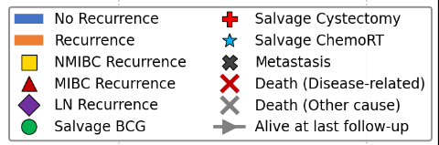
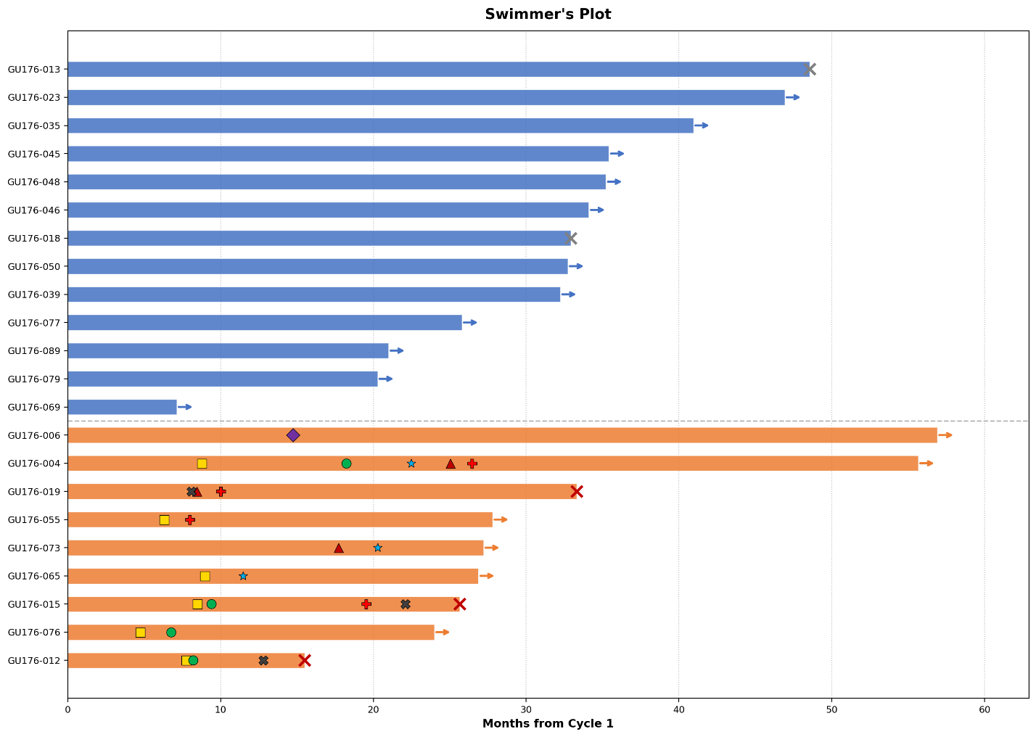
Supplementary Figure 2: Swimmer’s plot with each lane representing a patient on active surveillance in RETAIN-2 trial

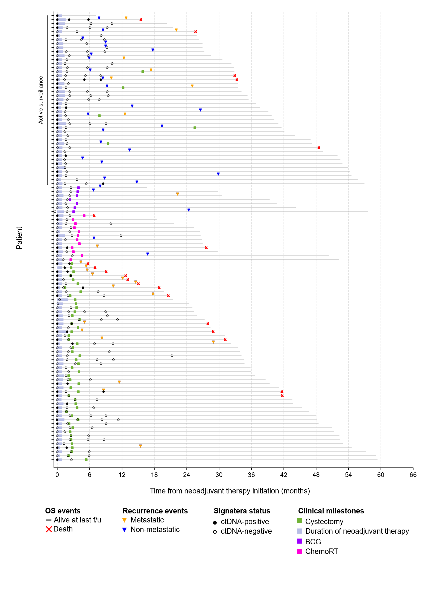
Supplementary Figure 3: Swimmer’s plot with each lane representing a patient in the integrated ctDNA analysis cohort (RETAIN-1 and RETAIN-2)

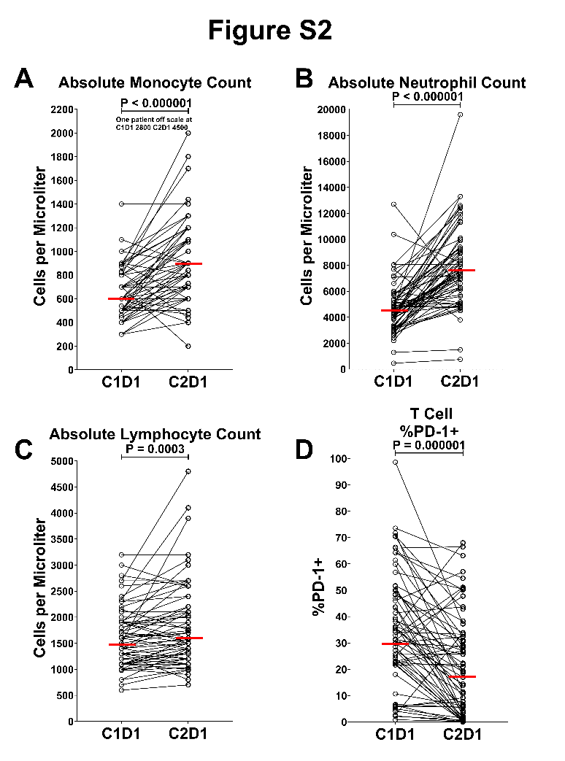
Supplementary Figure 4: Changes in peripheral blood cell counts and T cell PD-1 expression from pre-treatment to cycle 2. Pre-treatment (C1D1) and cycle 2 day 1 (C2D1) values for individual patients are shown as open circles connected by lines, with horizontal red bars indicating median values. P values were calculated using a Wilcoxon matched-pairs signed-rank test throughout. Absolute cell counts in panels A–C were derived from complete blood count (CBC) measurements. (A) Absolute monocyte counts at C1D1 and C2D1. One patient with an off-scale value at C1D1 (2,805 cells/µL) and C2D1 (4,586 cells/µL) is noted in the panel. (B) Absolute neutrophil counts at C1D1 and C2D1. (C) Absolute lymphocyte counts at C1D1 and C2D1. (D) %PD-1+ on CD3+ T cells gated as described above, at C1D1 and C2D1. Percent PD-1+ was calculated relative to a fluorescence-minus-one control tube containing all gating antibodies but no anti-PD-1 antibody.

Web-link | Target Biomarker | Fluorophore | Clone | Catalog number | Manufacturer
1 | CD19 | BV605 | HIB19 | 302244 | BioLegend
2 | CD3 | PE/Cy7 | SK7 | 344816 | BioLegend
3 | CD38 | AF488 | HIT2 | 303512 | BioLegend
4 | CD4 | Alexa Fluor 700 | OKT4 | 317426 | BioLegend
5 | CD4 | PerCP/Cy5.5 | OKT4 | 317428 | BioLegend
6 | CD8a | Pacific Blue | HIT8a | 300928 | BioLegend
7 | CD45 | PE/Cy7 | 2D1 | 560178 | BD Pharmingen
8 | CD56 | FITC | B159 | 562794 | BD Biosciences
9 | CD56 | BUV563 | NCAM16.2 | 612928 | BD Horizon
10 | CD62L | FITC | DREG-56 | 304838 | BioLegend
11 | CD62L | PE | DREG-56 | 304806 | BioLegend
12 | CD62L | BUV737 | SK11 | 749210 | BD OptiBuild
13 | CX3CR1 | APC | 2A9-1 | 341608 | BioLegend
14 | CD69 | APC | FN50 | 310910 | BioLegend
15 | TIM3 | PerCP/Cy5.5 | F38-2E2 | 345016 | BioLegend
16 | Viability Dye | Ghost Red 710 |  | 13-0871-T100 | Tonbo Biosciences
17 | PD-1 | unlabeled | Pembrolizumab |  | Merck
18 | Ki-67 | BUV395 | B56 | 564071 | BD Horizon
19 | TOX | APC | REA473 | 130-118-335 | Miltenyi
20 | TCF1 | Alexa Fluor 488 | C6309 | 6444S | Cell Signaling
21 | Anti-human IgG4 (2° for PD-1) | PE | HP6025 | 9200-09 | SouthernBiotech

Supplementary Table S1 – Staining reagents for flow cytometry correlative studies

Manufacturer’s weblinks for validation of flow cytometry antibodies used in this study
- https://www.biolegend.com/en-us/products/brilliant-violet-605-anti-human-cd19-antibody-8483
- https://www.biolegend.com/en-us/products/pe-cyanine7-anti-human-cd3-antibody-6934
- https://www.biolegend.com/en-us/products/alexa-fluor-488-anti-human-cd38-antibody-3263
- https://www.biolegend.com/en-us/products/alexa-fluor-700-anti-human-cd4-antibody-3661
- https://www.biolegend.com/en-us/products/percp-cyanine5-5-anti-human-cd4-antibody-5011
- https://www.biolegend.com/en-us/products/pacific-blue-anti-human-cd8a-antibody-6659
- https://www.bdbiosciences.com/en-us/products/reagents/flow-cytometry-reagents/research-reagents/single-color-antibodies-ruo/apc-h7-mouse-anti-human-cd45.560178?tab=product_details
- https://www.bdbiosciences.com/en-us/products/reagents/flow-cytometry-reagents/research-reagents/single-color-antibodies-ruo/fitc-mouse-anti-human-cd56-ncam-1.562794?tab=product_details
- https://www.bdbiosciences.com/en-us/products/reagents/flow-cytometry-reagents/research-reagents/single-color-antibodies-ruo/buv563-mouse-anti-human-cd56.612928?tab=product_details
- https://www.biolegend.com/en-us/products/fitc-anti-human-cd62l-antibody-651
- https://www.biolegend.com/en-us/products/pe-anti-human-cd62l-antibody-653
- https://www.bdbiosciences.com/en-us/products/reagents/flow-cytometry-reagents/research-reagents/single-color-antibodies-ruo/buv737-mouse-anti-human-cd62l.749210?tab=product_details
- https://www.biolegend.com/en-us/products/alexa-fluor-647-anti-human-cx3cr1-antibody-5941
- https://www.biolegend.com/en-us/products/apc-anti-human-cd69-antibody-1674
- https://www.biolegend.com/en-us/products/percp-cyanine5-5-anti-human-cd366-tim-3-antibody-8438
- https://cytekbio.com/products/ghost-dye-red-710?variant=40581221318692
- PD-1. Unlabeled. Pembrolizumab. Merck
- https://www.bdbiosciences.com/en-us/products/reagents/flow-cytometry-reagents/research-reagents/single-color-antibodies-ruo/buv395-mouse-anti-ki-67.564071?tab=product_details
- https://www.miltenyibiotec.com/US-en/products/tox-antibody-anti-human-mouse-reafinity-rea473.html#conjugate=apc:size=100-tests-in-200-ul
- https://www.cellsignal.com/products/antibody-conjugates/tcf1-tcf7-c63d9-rabbit-monoclonal-antibody-alexa-fluor-488-conjugate/6444
- https://www.southernbiotech.com/mouse-anti-human-igg4-fc-pe-hp6025-9200-09

Toxicity Type | Grade 3 | Grade 4 | Grade 5
Thrombocytopenia | 6 (7.5%) | 5 (6.2%) | -
Mucositis | 8 (10.0%) | - | -
Leukopenia | 6 (7.5%) | 2 (2.5%) | -
Anemia | 7 (8.8%) | - | -
Acute kidney injury | 6 (7.6%) | - | -
Hyponatremia | 3 (3.8%) | 1 (1.2%) | -
Febrile neutropenia | 3 (3.8%) | - | -
Pyelonephritis | 3 (3.8%) | - | -
Pancytopenia | 2 (2.5%) | - | 1 (1.2%)
Aspartate aminotransferase increased | 2 (2.5%) | 1 (1.2%) | -
Dehydration | 2 (2.5%) | - | -
Fatigue | 2 (2.5%) | - | -
Blood bilirubin increased | 1 (1.2%) | 1 (1.2%) | -
Hypoxia | 1 (1.2%) | 1 (1.2%) | -
Neutrophil count decreased | - | 2 (2.5%) | -
Urinary tract infection | 2 (2.5%) | - | -
Syncope | 2 (2.5%) | - | -
Diarrhea | 2 (2.5%) | - | -
Fall | 2 (2.5%) | - | -
Generalized muscle weakness | 2 (2.5%) | - | -
Dysphagia | 1 (1.2%) | - | -
Dizziness | 1 (1.2%) | - | -
Alanine aminotransferase increased | 1 (1.2%) | - | -
Enterocolitis | 1 (1.2%) | - | -
Hypocalcemia | - | 1 (1.2%) | -
Hyperglycemia | 1 (1.2%) | - | -
Fever | 1 (1.2%) | - | -
Insomnia | 1 (1.2%) | - | -
Hypokalemia | 1 (1.2%) | - | -
Hypomagnesemia | - | 1 (1.2%) | -
Hypothyroidism | 1 (1.2%) | - | -
Hyperkalemia | 1 (1.2%) | - | -
Hyperlipidemia | 1 (1.2%) | - | -
Hypoalbuminemia | 1 (1.2%) | - | -
Multi-organ failure | - | - | 1 (1.2%)
Nausea | 1 (1.2%) | - | -
Lung infection | 1 (1.2%) | - | -
Portal vein thrombosis | 1 (1.2%) | - | -
Sepsis | 1 (1.2%) | - | -
Urinary retention | 1 (1.2%) | - | -
Thromboembolic event | 1 (1.2%) | - | -
* All patients treated with at least one dose of AMVAC and nivolumab
Supplementary Table 2: RETAIN-2 grade 3 to 5 Treatment-related Adverse Events of all treated patients (including those unevaluable for the primary endpoint)*

MFS
Covariate | HR | HR lower 95% CI | HR upper 95% CI | p
Post-NAT ctDNA status | 4.02 | 1.66 | 9.63 | 0.00257
Baseline ctDNA status | 8.54 | 2.83 | 33.75 | 0.0000635
Post-NAT non-cCR | 2.02 | 0.87 | 4.89 | 0.0997
OS
Covariate | HR | HR lower 95% CI | HR upper 95% CI | p
Post-NAT ctDNA status | 2.01 | 0.74 | 5.44 | 0.169
Baseline ctDNA status | 8.92 | 2.43 | 32.77 | 0.000981
Post-NAT non-cCR | 4.08 | 1.42 | 11.67 | 0.00884

Supplementary Table 3: Multivariable analysis of pre- and post-NAT ctDNA status and clinical CR status in overall cohort

