Baseline clinical features outperform structural MRI in predicting rapid cognitive and motor decline in Parkinson's Disease
Yusen Wu^{1,2} PhD, Jose A. Santiago^{1,2} MD, Tatjana Rundek ^{1,2} MD PhD, Phuong Nguyen³ PhD, Yelena Yesha^{3,4} PhD, Matthew Feldman¹ MD, Marina Lucia Sarno¹ Psy.D., Priyanka Atit¹ MD, Jacob Miller^{2,5} PhD, Tara Najafi¹, Ayham Alkhachroum¹ MD, Ihtsham Haq^{1,2} MD

¹ Department of Neurology, Miller School of Medicine, University of Miami, Miami, FL, USA
² Evelyn F. McKnight Brain Institute, University of Miami, Miami, FL, USA
³ Department of Computer Science, University of Miami, Miami, FL, USA
⁴ Department of Radiology, University of Miami, Miami, FL, USA
⁵ Department of Psychology, University of Miami, Miami, FL, USA

Corresponding author: Ihtsham ul Haq MD
Contact email: ihaq@med.miami.edu

Figure S1. Machine learning-based cognitive decline risk stratification in the UM internal pre-DBS cohort.
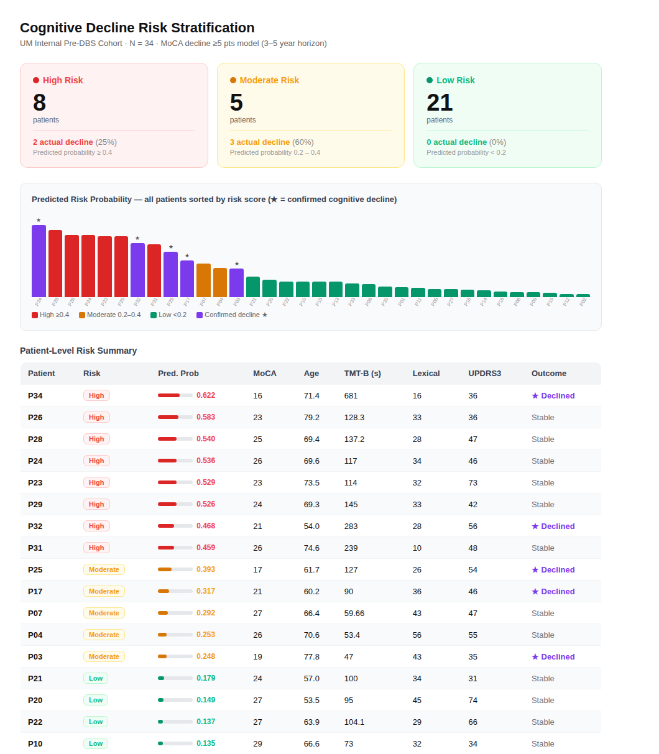

Discussion: Cognitive Risk Stratification in the UM Pre-DBS Cohort
Of the 157 patients in the UM pre-DBS cohort, 34 had complete data across all model-required features and were included in the risk stratification analysis. The Voting (All 5) ensemble model, trained on PPMI clinical features, was applied directly without retraining, providing an independent out-of-sample test.

Patients fell into three tiers: 8 high-risk (≥0.4), 5 moderate-risk (0.2–0.4), and 21 low-risk (<0.2). The low-risk group showed a decline rate of 9.5% (2 of 21), broadly consistent with the high NPV reported in the PDBP validation and supporting the model’s utility as a screening tool for ruling out rapid progression. The moderate-risk group showed a higher observed decline rate (60%) than the high-risk group (25%), a pattern that likely reflects the post-DBS nature of the outcome assessment: cognitive trajectories in this cohort were measured after surgery, and patients at the highest predicted risk (the lowest baseline cognition) were most likely to have undergone DBS, which may itself have partially modified their subsequent cognitive course.

These observations raise two questions that will guide future work. First, why did some high-risk patients continue to decline despite surgical intervention, whether this reflects insufficient cognitive reserve, disease subtype, or DBS target selection warrants deeper investigation. Second, what distinguishes the two low-risk patients who nonetheless declined; identifying their clinical and biological profiles may reveal vulnerability factors not captured by the current feature set. Our preliminary review of these cases suggests that comorbidities (e.g., two strokes) may play a role in driving unexpected decline, though this remains speculative and warrants systematic investigation in future work. Given the small sample and the highly selected surgical context, these results are best read as preliminary, but they point toward a richer characterization of individual-level trajectories that larger prospective cohorts could address.

