Supplemental Method: Data-Driven Method for Determining Optimal Gap Threshold for Bout Definition
To objectively define bouts of vomiting-related events (retching and/or expulsion), we developed a data-driven framework to identify the optimal maximum time gap between two consecutive events for them to be considered part of the same bout. This approach avoids arbitrary threshold selection and ensures that bout definitions reflect meaningful temporal clustering of symptoms observed in real-world data.
We evaluated candidate thresholds ranging from 1 to 20 seconds, each representing the maximum interval allowed between two events to be grouped into a single bout. For each threshold, two bout-level metrics were computed for every participant: the daily number of bouts and the mean bout duration. To ensure comparability, both metrics were z-score normalized using the training distribution.
Generalizability was assessed using a repeated cross-validation procedure. In each iteration, five participants were held out for validation, and the remaining participants were used for training. For each validation set, z-normalized bout counts and durations were calculated using training-derived means and standard deviations. An imbalance score was then computed as $Score = (z_{count} - z_{duration})^2$, reflecting the extent to which a threshold produced too many short bouts (over-fragmentation) versus too few long bouts (over-merging).
This process was repeated 1,000 times per candidate threshold with different random splits, and the average imbalance score was calculated. The threshold yielding the lowest average score was selected as optimal. This approach balanced interpretability (a clinically reasonable number of bouts) with robustness (stable bout durations across participants), ensuring that the resulting definitions were both temporally consistent and clinically meaningful.

Supplementary materials:

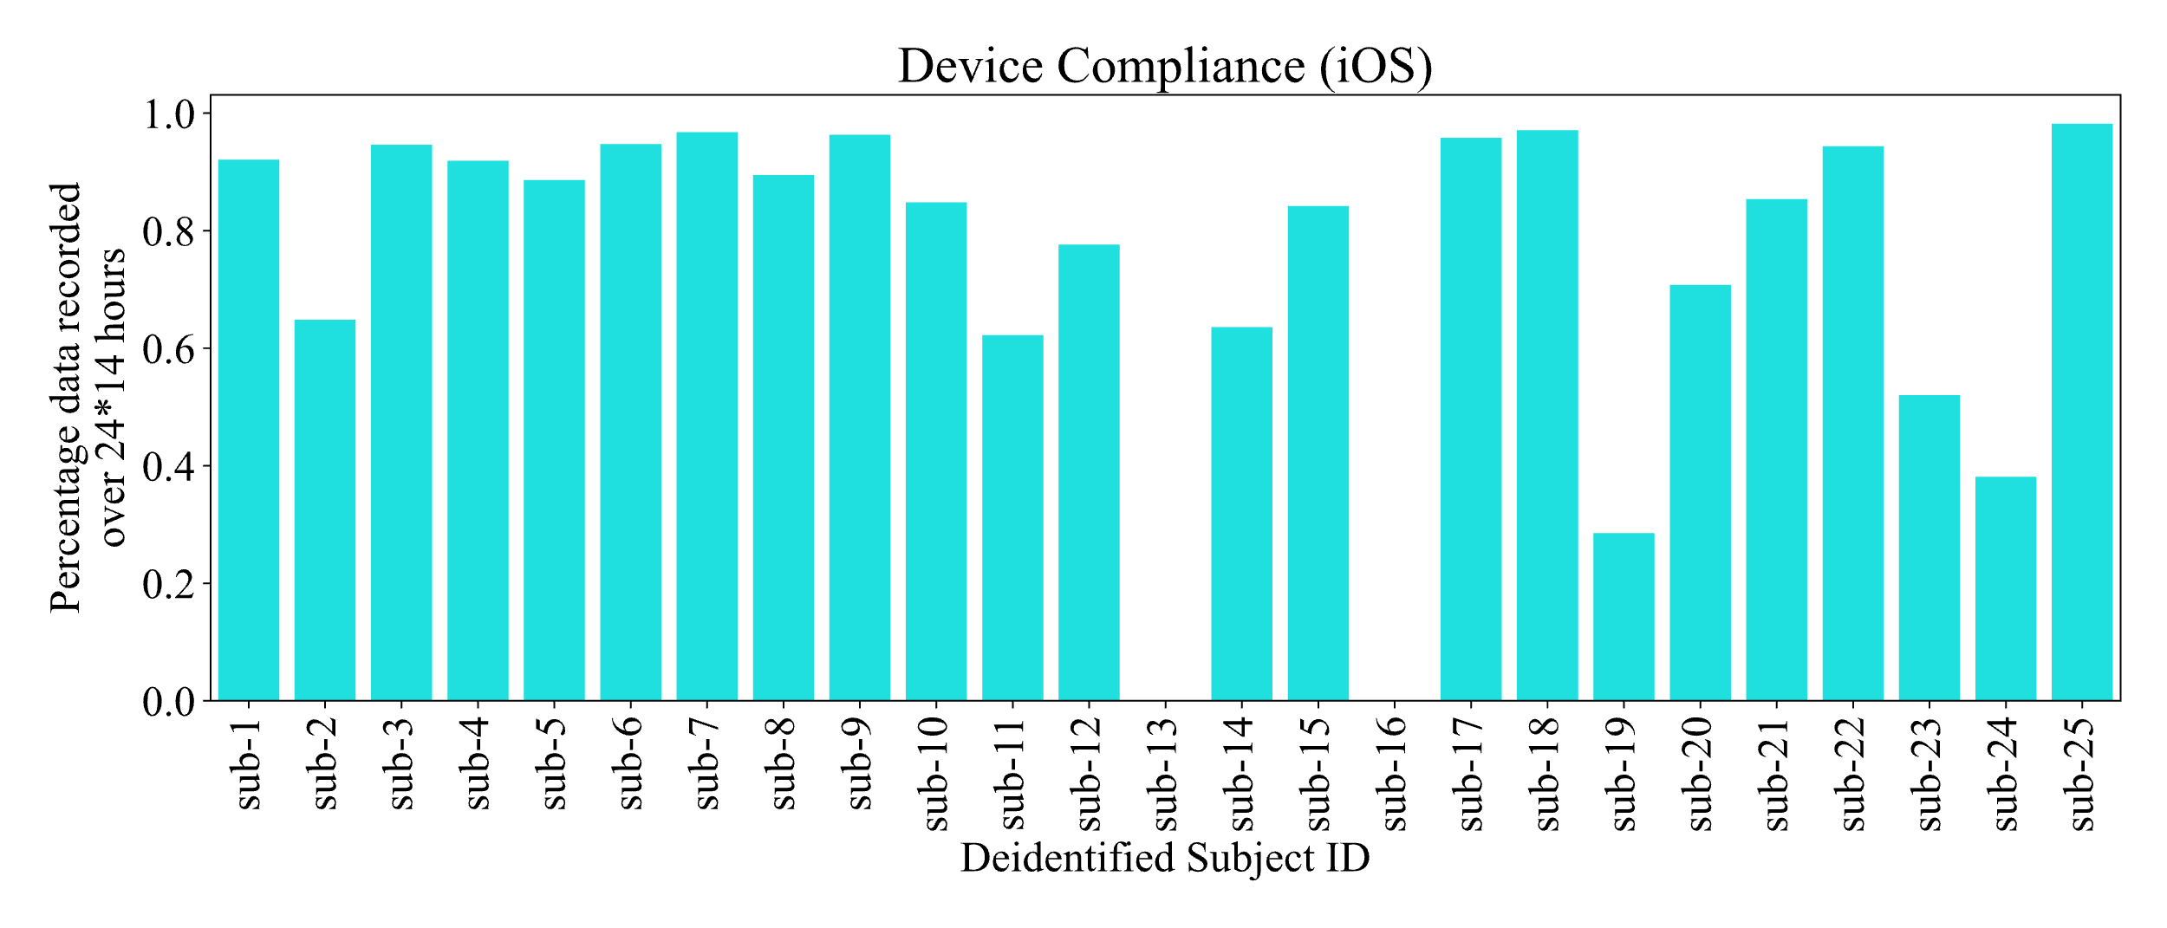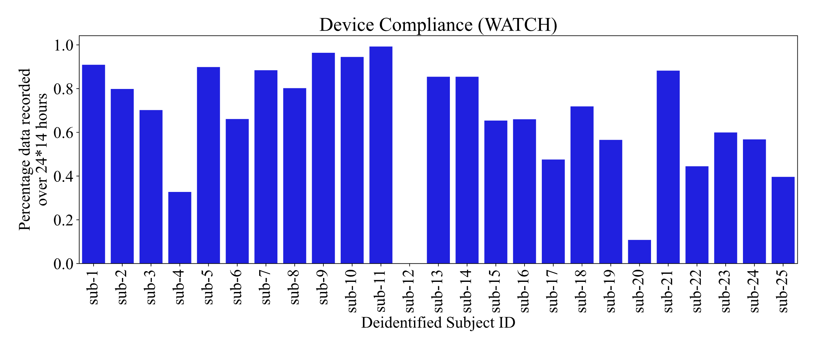
Supplementary Figure 1. Compliance for GP patients with iOS device (top) and Watch (bottom).

Supplementary Table 1. Repeated measures correlations of daily event counts collected via Watch, iOS device, and ePRO with PGI-S and PGI-F in GP participants. 95%CI is nominal.
Source | Measure | Scale | rmcorr (95% CI)
Watch | R (Daily) | PGI-F | 0.16 (0.019, 0.294)
Watch | R (Daily) | PGI-S | 0.269 (0.151, 0.38)
Watch | E (Daily) | PGI-F | 0.341 (0.21, 0.46)
Watch | E (Daily) | PGI-S | 0.362 (0.25, 0.465)
Watch | R + E (Daily) | PGI-F | 0.266 (0.129, 0.392)
Watch | R + E (Daily) | PGI-S | 0.346 (0.232, 0.45)
Watch | R + E Bout (Daily) | PGI-F | 0.266 (0.135, 0.387)
Watch | R + E Bout (Daily) | PGI-S | 0.374 (0.268, 0.472)
iOS device | R (Daily) | PGI-F | 0.085 (-0.055, 0.221)
iOS device | R (Daily) | PGI-S | 0.195 (0.076, 0.309)
iOS device | E (Daily) | PGI-F | 0.308 (0.177, 0.429)
iOS device | E (Daily) | PGI-S | 0.321 (0.208, 0.426)
iOS device | R + E (Daily) | PGI-F | 0.187 (0.049, 0.318)
iOS device | R + E (Daily) | PGI-S | 0.27 (0.154, 0.379)
iOS device | R + E Bout (Daily) | PGI-F | 0.291 (0.158, 0.415)
iOS device | R + E Bout (Daily) | PGI-S | 0.326 (0.213, 0.430)
ePRO | R (Daily) | PGI-F | 0.214 (0.094, 0.329)
ePRO | R (Daily) | PGI-S | 0.359 (0.26, 0.452)
ePRO | E (Daily) | PGI-F | 0.656 (0.58, 0.721)
ePRO | E (Daily) | PGI-S | 0.651 (0.583, 0.71)
ePRO | R + E (Daily) | PGI-F | 0.508 (0.41, 0.594)
ePRO | R + E (Daily) | PGI-S | 0.589 (0.513, 0.657)

Supplementary Table 2. Z-score and adjusted p-values for pairwise comparisons of retch, expulsion and combined retch and expulsion events across PGI-F and PGI-S levels, stratified by device (Watch, iOS device, ePRO). P-values were adjusted using the Bonferroni correction.

Scale | Source | Measure | PGIF 3 levels Comparison | z | Adj p
PGIF | WATCH | R (daily) | None - Rarely/Sometimes | -2.20 | 0.143
PGIF | WATCH | R (daily) | None - Often/Very often | -5.91 | <0.001
PGIF | WATCH | R (daily) | Rarely/Sometimes - Often/Very often | -4.40 | <0.001
PGIF | WATCH | E (daily) | None - Rarely/Sometimes | -3.27 | 0.001
PGIF | WATCH | E (daily) | None - Often/Very often | -4.71 | <0.001
PGIF | WATCH | E (daily) | Rarely/Sometimes - Often/Very often | -2.60 | 0.112
PGIF | WATCH | R + E (daily) | None - Rarely/Sometimes | -2.51 | 0.072
PGIF | WATCH | R + E (daily) | None - Often/Very often | -5.64 | <0.001
PGIF | WATCH | R + E (daily) | Rarely/Sometimes - Often/Very often | -3.96 | <0.001
PGIF | WATCH | R + E bout (daily) | None - Rarely/Sometimes | -2.35 | 0.1131
PGIF | WATCH | R + E bout (daily) | None - Often/Very often | -5.47 | <0.001
PGIF | WATCH | R + E bout (daily) | Rarely/Sometimes - Often/Very often | -3.99 | <0.001
PGIF | iOS | R (daily) | None - Rarely/Sometimes | -1.46 | 0.512
PGIF | iOS | R (daily) | None - Often/Very often | -7.89 | <0.001
PGIF | iOS | R (daily) | Rarely/Sometimes - Often/Very often | -7.00 | <0.001
PGIF | iOS | E (daily) | None - Rarely/Sometimes | -2.41 | 0.045
PGIF | iOS | E (daily) | None - Often/Very often | -7.38 | <0.001
PGIF | iOS | E (daily) | Rarely/Sometimes - Often/Very often | -6.03 | <0.001
PGIF | iOS | R + E (daily) | None - Rarely/Sometimes | -1.88 | 0.362
PGIF | iOS | R + E (daily) | None - Often/Very often | -7.68 | <0.001
PGIF | iOS | R + E (daily) | Often/Very often - Rarely/Sometimes | -6.59 | <0.001
PGIF | iOS | R + E bout (daily) | None - Rarely/Sometimes | -2.19 | 0.171
PGIF | iOS | R + E bout (daily) | None - Often/Very often | -7.28 | <0.001
PGIF | iOS | R + E bout (daily) | Rarely/Sometimes - Often/Very often | -6.09 | <0.001
PGIF | ePro | R (daily) | None - Rarely/Sometimes | -5.19 | 0.463
PGIF | ePro | R (daily) | None - Often/Very often | -7.89 | <0.001
PGIF | ePro | R (daily) | Rarely/Sometimes - Often/Very often | -0.86 | 1.000
PGIF | ePro | E (daily) | None - Rarely/Sometimes | -10.00 | <0.001
PGIF | ePro | E (daily) | None - Often/Very often | -7.99 | <0.001
PGIF | ePro | E (daily) | Rarely/Sometimes - Often/Very often | -2.61 | 0.054
PGIF | ePro | R + E (daily) | None - Rarely/Sometimes | -4.73 | <0.001
PGIF | ePro | R + E (daily) | None - Often/Very often | -8.47 | <0.001
PGIF | ePro | R + E (daily) | Often/Very often - Rarely/Sometimes | -0.29 | 1.000
PGIS | WATCH | R (daily) | None - Mild/Moderate | -2.77 | 0.047
PGIS | WATCH | R (daily) | None - Severe/Very severe | -7.41 | <0.001
PGIS | WATCH | R (daily) | Mild/Moderate - Severe/Very severe | -5.54 | <0.001
PGIS | WATCH | E (daily) | None - Mild/Moderate | -3.09 | 0.003
PGIS | WATCH | E (daily) | None - Severe/Very severe | -7.56 | <0.001
PGIS | WATCH | E (daily) | Mild/Moderate - Severe/Very severe | -5.47 | <0.001
PGIS | WATCH | R + E (daily) | None - Mild/Moderate | -3.01 | 0.016
PGIS | WATCH | R + E (daily) | None - Severe/Very severe | -7.20 | <0.001
PGIS | WATCH | R + E (daily) | Mild/Moderate - Severe/Very severe | -5.16 | <0.001
PGIS | WATCH | R + E bout (daily) | None - Mild/Moderate | 2.64 | 0.049
PGIS | WATCH | R + E bout (daily) | None - Severe/Very severe | -6.89 | <0.001
PGIS | WATCH | R + E bout (daily) | Mild/Moderate - Severe/Very severe | -5.17 | <0.001
PGIS | iOS | R (daily) | None - Mild/Moderate | -2.21 | 0.101
PGIS | iOS | R (daily) | None - Severe/Very severe | -7.04 | <0.001
PGIS | iOS | R (daily) | Mild/Moderate - Severe/Very severe | -5.55 | <0.001
PGIS | iOS | E (daily) | None - Mild/Moderate | -2.76 | 0.019
PGIS | iOS | E (daily) | None - Severe/Very severe | -8.13 | <0.001
PGIS | iOS | E (daily) | Mild/Moderate - Severe/Very severe | -6.27 | <0.001
PGIS | iOS | R + E (daily) | None - Mild/Moderate | -2.85 | 0.026
PGIS | iOS | R + E (daily) | None - Severe/Very severe | -7.05 | <0.001
PGIS | iOS | R + E (daily) | Mild/Moderate - Severe/Very severe | -5.10 | <0.001
PGIS | iOS | R + E bout (daily) | None - Mild/Moderate | -2.66 | 0.046
PGIS | iOS | R + E bout (daily) | None - Severe/Very severe | -6.65 | <0.001
PGIS | iOS | R + E bout (daily) | Mild/Moderate - Severe/Very severe | -4.89 | <0.001
PGIS | ePro | R (daily) | None - Mild/Moderate | -6.23 | <0.001
PGIS | ePro | R (daily) | None - Severe/Very severe | -3.59 | 0.001
PGIS | ePro | R (daily) | Mild/Moderate - Severe/Very severe | 0.43 | 1.000
PGIS | ePro | E (daily) | None - Mild/Moderate | -9.34 | <0.001
PGIS | ePro | E (daily) | None - Severe/Very severe | -9.22 | <0.001
PGIS | ePro | E (daily) | Mild/Moderate - Severe/Very severe | -3.24 | 0.004
PGIS | ePro | R + E (daily) | None - Mild/Moderate | -6.18 | <0.001
PGIS | ePro | R + E (daily) | None - Severe/Very severe | -9.03 | <0.001
PGIS | ePro | R + E (daily) | Mild/Moderate - Severe/Very severe | -0.46 | 1.000

Supplementary Table 3. Test-retest reliability of daily retch, expulsion, and combined retch and expulsion events in GP participants across various day-pair comparisons.

Source | Measure | N | Comparison (days) | ICC (95%)
Watch | R (Daily) | 21 | 1 vs 8 | 0.52 (-0.25, 0.89)
Watch | R (Daily) | 23 | 1 vs 14 | 0.33 (-0.35, 0.79)
Watch | R (Daily) | 24 | 7 vs 14 | 0.98 (-1.00, 1.00)
Watch | E (Daily) | 21 | 1 vs 8 | 0.39 (-0.53, 0.89)
Watch | E (Daily) | 23 | 1 vs 14 | 0.38 (-0.46, 0.86)
Watch | E (Daily) | 24 | 7 vs 14 | 0.15 (-0.44, 0.64)
Watch | R + E (Daily) | 21 | 1 vs 8 | 0.49 (-0.34, 0.89)
Watch | R + E (Daily) | 23 | 1 vs 14 | 0.37 (-0.34, 0.81)
Watch | R + E (Daily) | 24 | 7 vs 14 | 0.80 (-0.99, 1.00)
Watch | R + E bout (Daily) | 21 | 1 vs 8 | 0.44 (-0.24, 0.95)
Watch | R + E bout (Daily) | 23 | 1 vs 14 | 0.25 (-0.26, 0.76)
Watch | R + E bout (Daily) | 24 | 7 vs 14 | 0.67 (-0.13, 0.96)
iOS device | R (Daily) | 22 | 1 vs 8 | 0.65 (-0.19, 0.94)
iOS device | R (Daily) | 23 | 1 vs 14 | 0.14 (-0.27, 0.51)
iOS device | R (Daily) | 22 | 7 vs 14 | 0.42 (-0.38, 0.86)
iOS device | E (Daily) | 22 | 1 vs 8 | 0.61 (-0.75, 0.98)
iOS device | E (Daily) | 23 | 1 vs 14 | 0.39 (-0.68, 0.93)
iOS device | E (Daily) | 22 | 7 vs 14 | 0.20 (-0.57, 0.66)
iOS device | R + E (Daily) | 22 | 1 vs 8 | 0.67 (-0.18, 0.95)
iOS device | R + E (Daily) | 23 | 1 vs 14 | 0.31 (-0.38, 0.78)
iOS device | R + E (Daily) | 22 | 7 vs 14 | 0.22 (-0.36, 0.68)
iOS device | R + E bout (Daily) | 22 | 1 vs 8 | 0.72 (0.14, 0.99)
iOS device | R + E bout (Daily) | 23 | 1 vs 14 | 0.29 (-0.31, 0.89)
iOS device | R + E bout (Daily) | 22 | 7 vs 14 | 0.25 (-0.35, 0.85)
ePRO | R (Daily) | 25 | 1 vs 8 | 0.28 (-0.08, 0.57)
ePRO | R (Daily) | 25 | 1 vs 14 | 0.45 (0.09, 0.71)
ePRO | R (Daily) | 25 | 7 vs 14 | 0.29 (-0.06, 0.58)
ePRO | E (Daily) | 25 | 1 vs 8 | 0.41 (-0.16, 0.78)
ePRO | E (Daily) | 25 | 1 vs 14 | 0.50 (-0.14, 0.84)
ePRO | E (Daily) | 25 | 7 vs 14 | 0.66 (-0.05, 0.93)
ePRO | R + E (Daily) | 25 | 1 vs 8 | 0.40 (0.01, 0.69)
ePRO | R + E (Daily) | 25 | 1 vs 14 | 0.58 (0.20, 0.81)
ePRO | R + E (Daily) | 25 | 7 vs 14 | 0.56 (0.15, 0.80)

