Supplementary Information
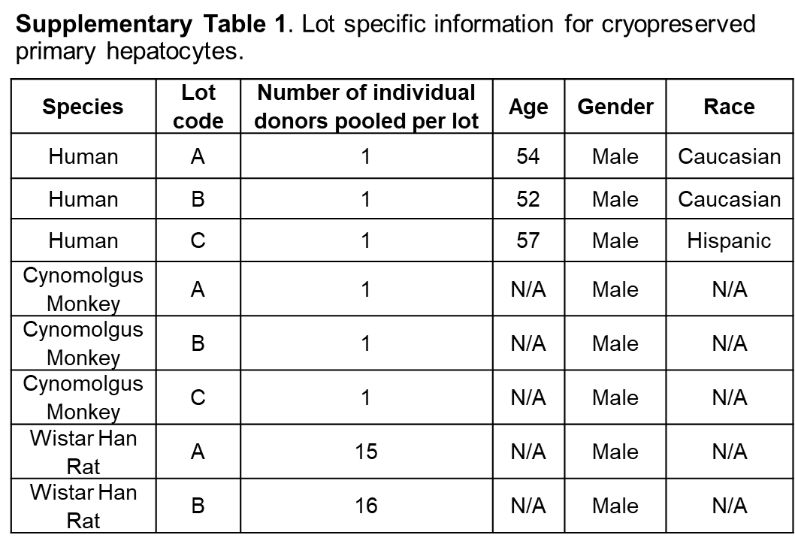

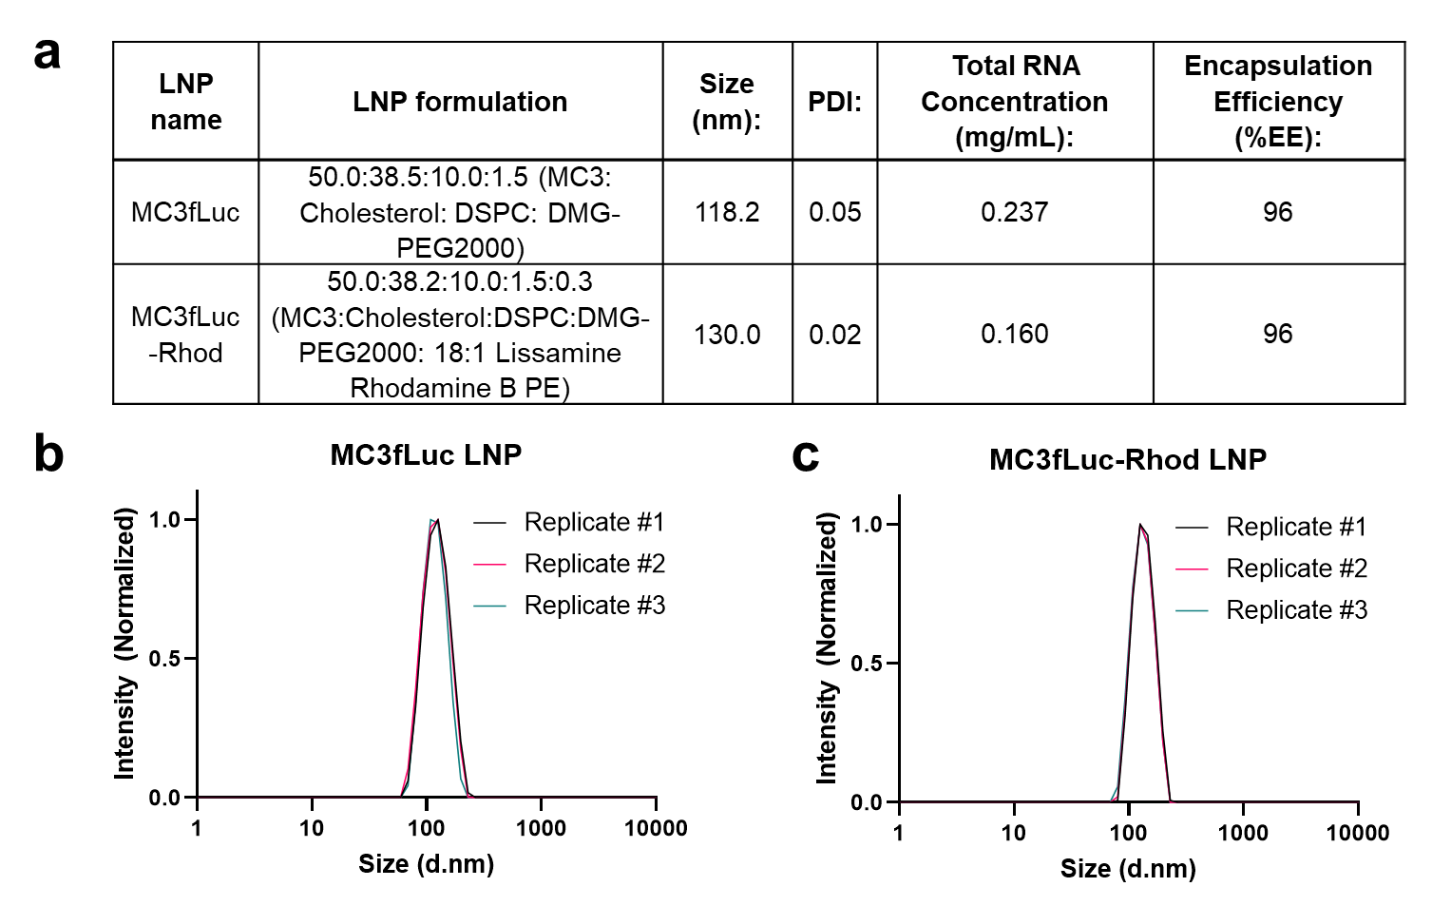
Supplementary Fig. 1. LNP characterization. LNP were formulated by microfluidic mixing, incorporating components listed in the table at ratios indicated (a). To determine average hydrodynamic particle size and poly-dispersity index (PDI), resulting LNP were characterized by dynamic light scattering (b and c). Total RNA concentration and mRNA encapsulation efficiency (EE%) were determined with Quant-iT Ribogreen RNA assay kit (a).

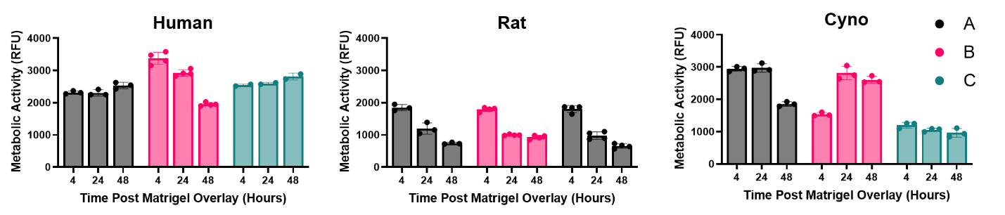
Supplementary Fig. 2. Metabolic activity analysis in primary hepatocytes. Measurements were conducted in the cell lysates from lots A, B and C, after Matrigel overlay at the time points corresponding to the time points of luciferase activity assays. Data shown as mean and SD of technical replicates, n=2-4. RFU, relative fluorescence units.

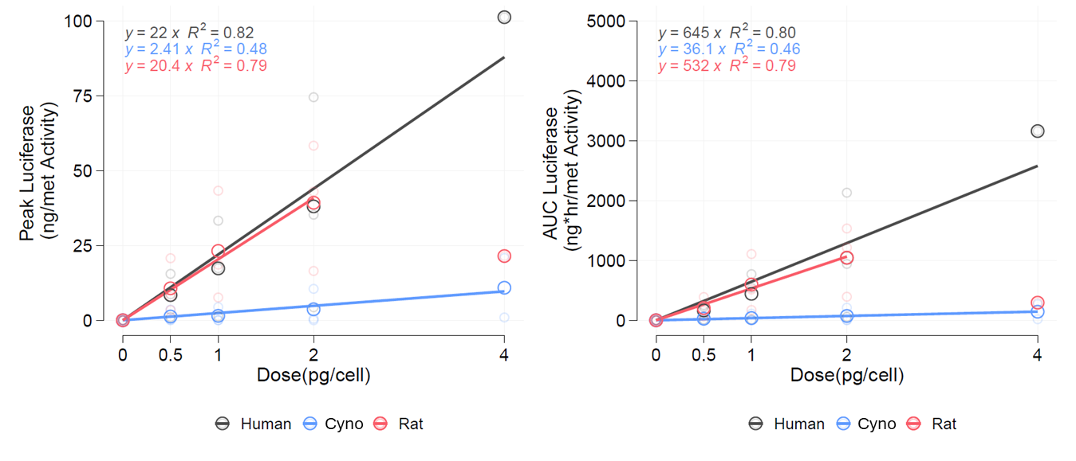
Supplementary Fig. 3. Plots of dose-response relationships for luciferase expression in human, cyno and rat hepatocytes calculated based on the data included in Fig.1 of the main manuscript. Large and small circles represent mean and individual replicate measurements Lines represent linear regression fits to data. Both peak luciferase and area-under the curve (AUC) luciferase (0-48 hours) exhibited linear dose-dependence in hepatocytes from the three examined species. However, whereas dose-response in human (black symbols) and rat (red symbols) cells was comparable, ~10x lower response was observed in cyno hepatocytes (blue symbols) at all tested LNP doses.

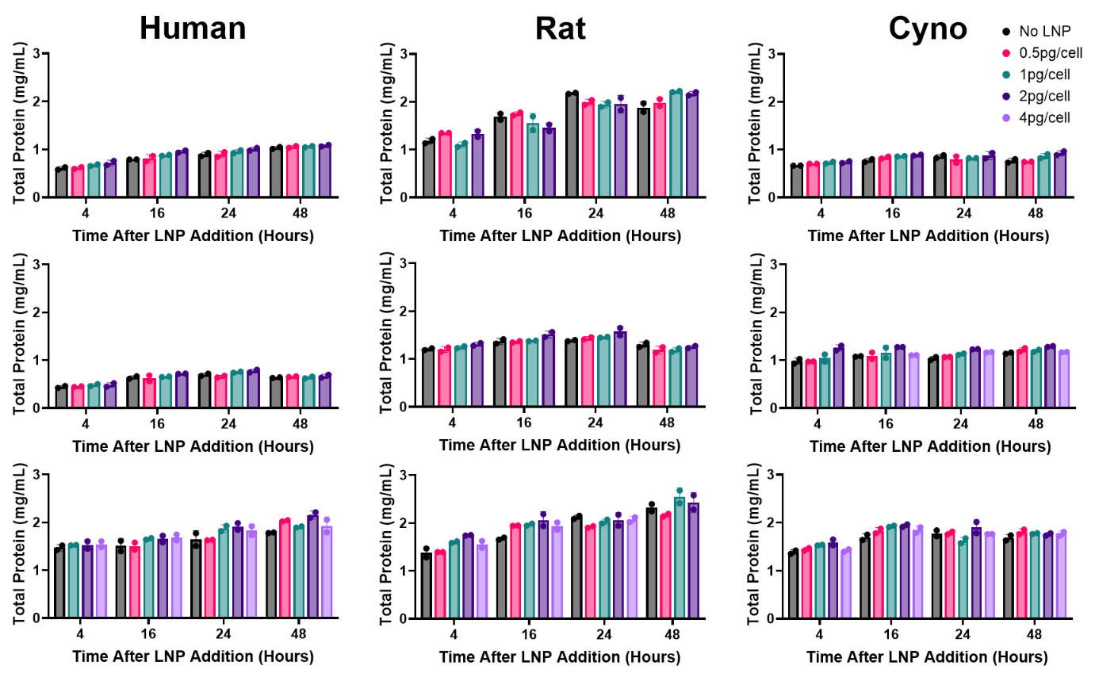
Supplementary Fig. 4. Total protein concentration measurements in primary hepatocytes transfected with MC3fLuc LNPs. Primary hepatocytes from each species were transfected with indicated doses of MC3fLuc LNPs and cell lysates were prepared at indicated times after LNP addition corresponding to the time points of luciferase activity assays. Each row represents an individual lot of cells tested. Data shown as mean and SD of technical duplicates.

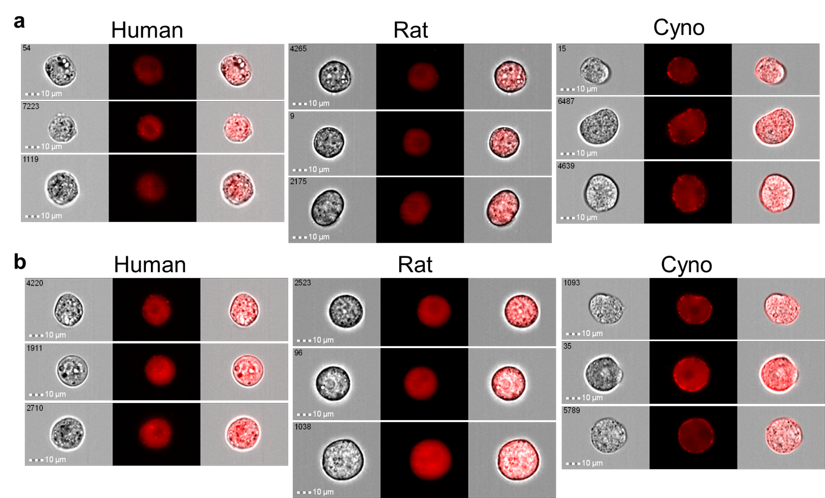
Supplementary Fig. 5. Imaging flow cytometry analysis of LNP internalization in species hepatocytes. Human, rat and cyno hepatocytes were incubated with 2 pg/cell of fluorescently labelled MC3fLuc-Rhod LNPs for 20 min (a) and 120 min (b) at 37°C. Representative images are shown. Cells (brightfield illumination, left column), LNP (fluorescence signal, middle column), overlays of brightfield and MC3fLuc-Rhod LNP florescence signal (right column). Note predominantly surface LNP signal in cyno hepatocytes at both time points.

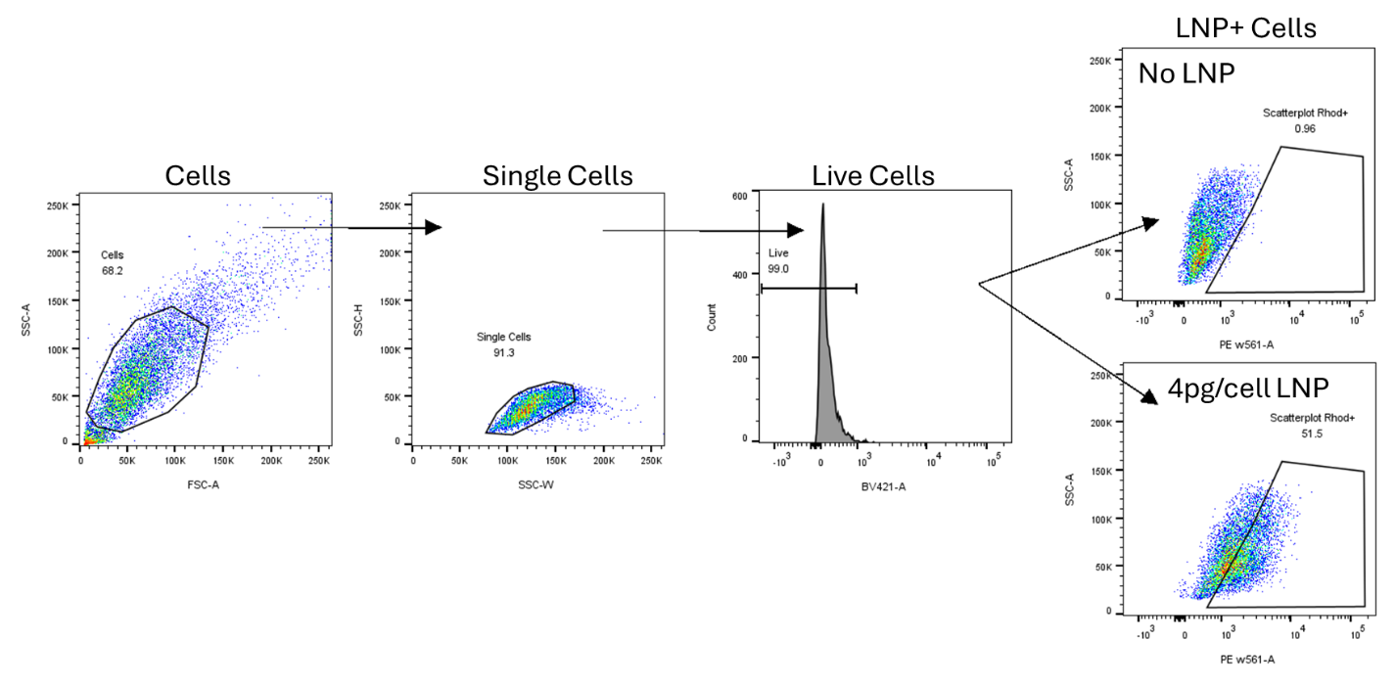
Supplementary Fig. 6. Flow cytometry analysis of LNP association with hepatocytes. Plots depicting representative strategy for the measurements of MC3fLuc-Rhod LNPs signal: following gating on a main event population of “Cells” (FSC-A vs SSC-A), “Single Cells” gate (SSC-H vs SSC-W) was created to exclude cell-cell aggregates, and then a DAPI-negative “Live Cells” gate (histogram, BV421-A) was used to create a daughter gate of rhodamine-positive “LNP+ Cells” (SSC-A vs PE-A) based on control samples not treated with MC3flucRhod LNP (No LNP).

