Supplementary Material
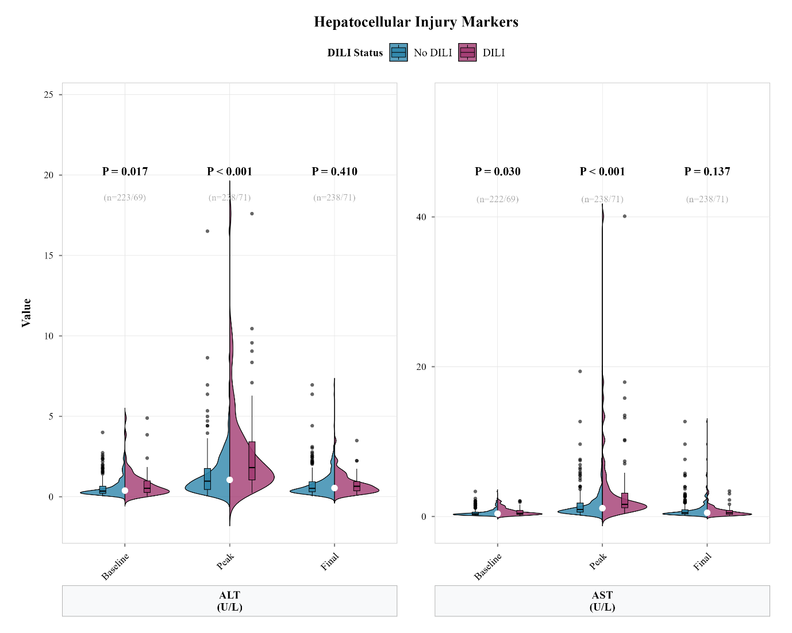

Figure S1. The violin plot was presented the distributions of hepatocellular injury markers between tigecycline-associated DILI status.
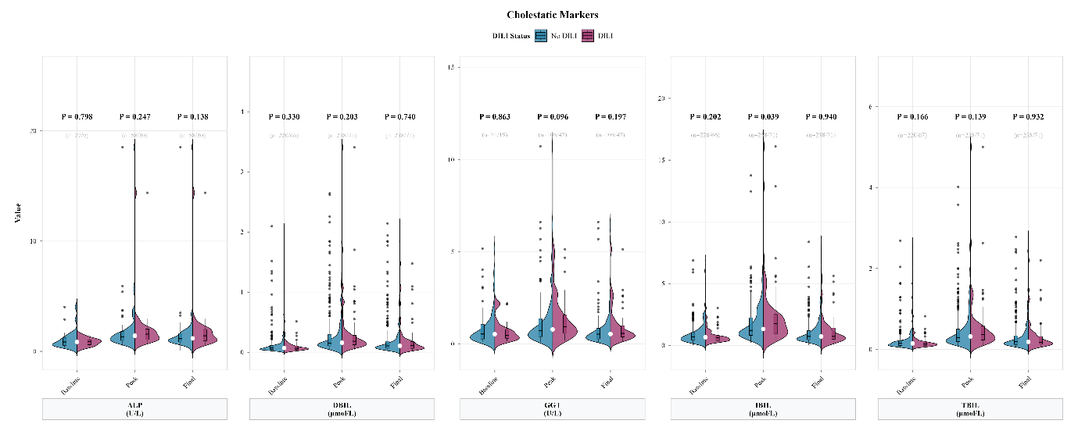

Figure S2. The violin plot was presented the distributions of cholestatic markers between tigecycline-associated DILI status.
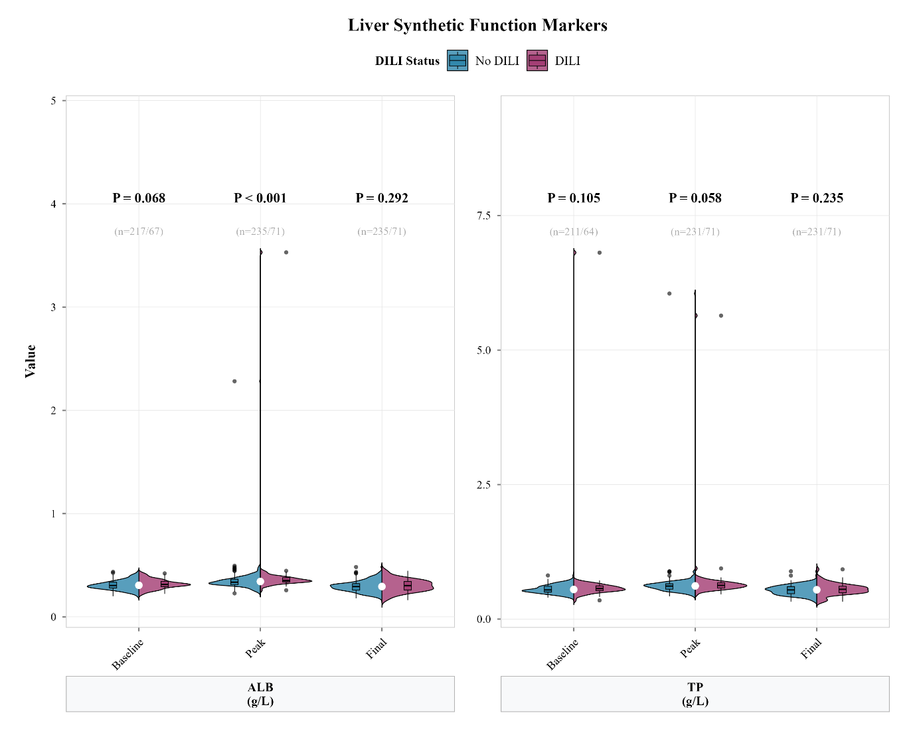

Figure S3. The violin plot was presented the distributions of liver synthetic function markers between tigecycline-associated DILI status.
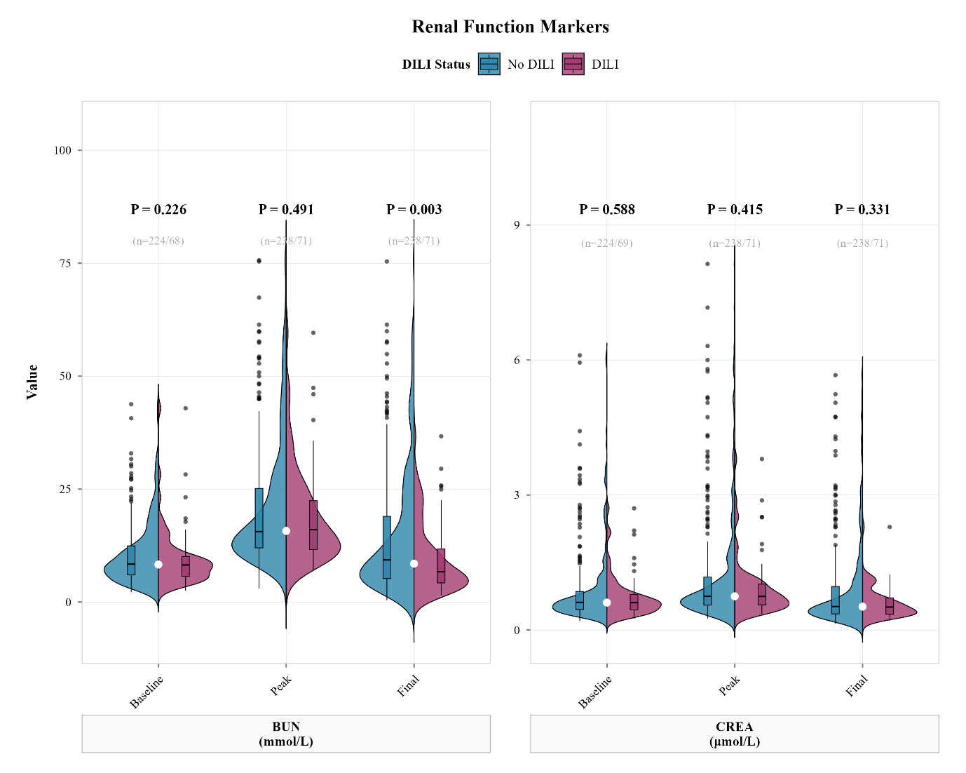

Figure S4. The violin plot was presented the distributions of renal function markers between tigecycline-associated DILI status.
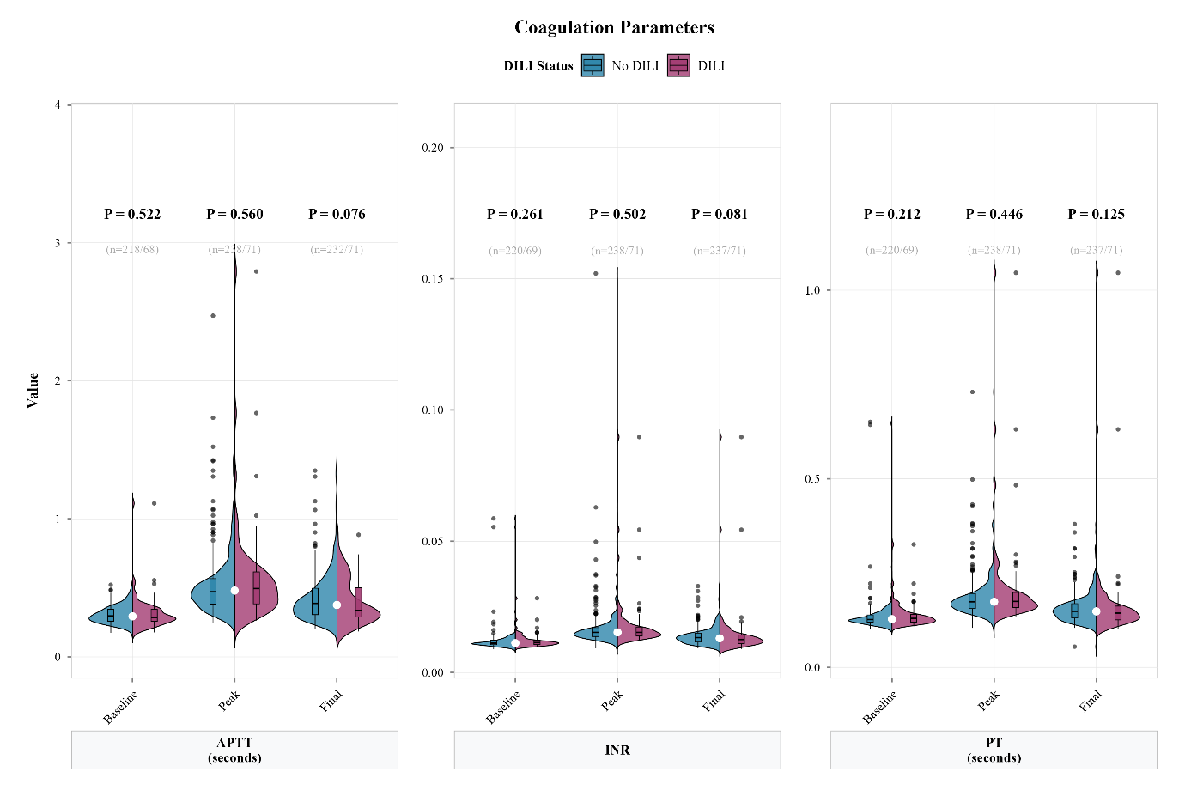

Figure S5. The violin plot was presented the distributions of coagulation parameters between tigecycline-associated DILI status.
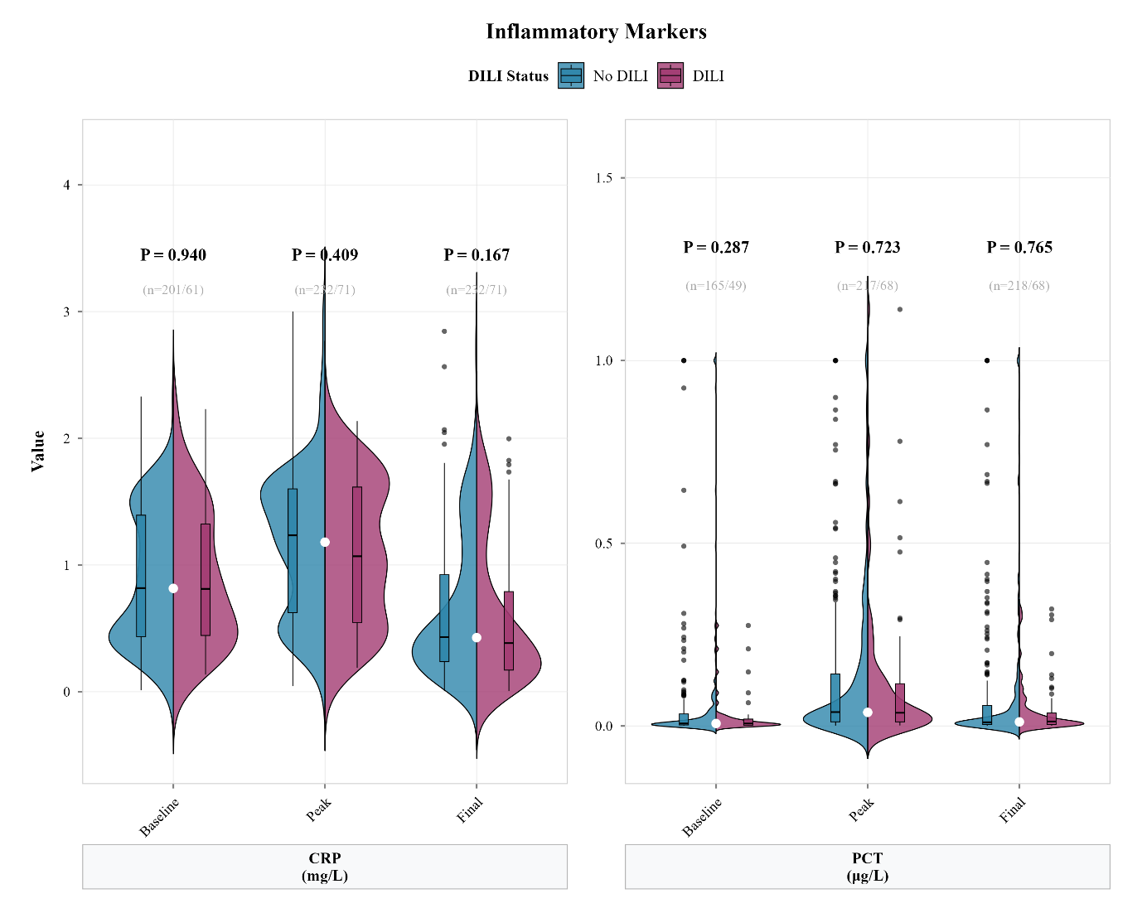

Figure S6. The violin plot was presented the distributions of inflammatory markers between tigecycline-associated DILI status.
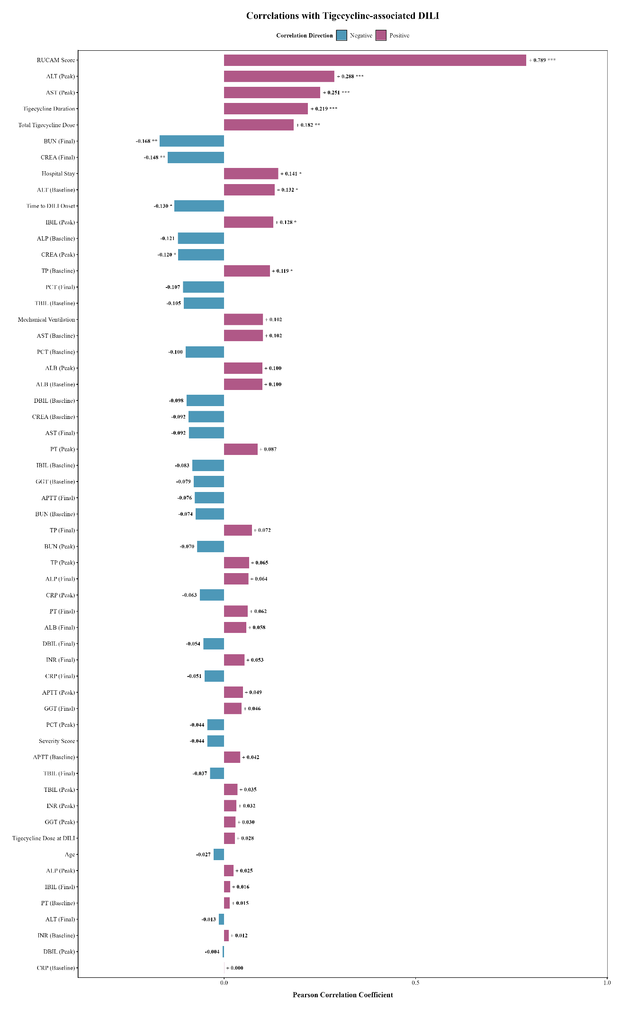

Figure S7. the correlations between all clinical parameters and tigecycline-associated DILI status by Pearson correlation

