Bi₂Fe₄O₉/reduced graphene oxide nanocomposites with enhanced peroxidase activity for sensitive glutathione detection

Jinxiu Guo^{a, b, *}, Haozhe Jia^{a, c}, Runtian Ma^{a, b}, Zuoxiang Maª, Yanjun Cuiª, Bing Huª, Zhifang Zhangª，Haijiao Xie ^{d}

ª College of Science, Gansu Agricultural University, Lanzhou 730070, China
^{b} Key Laboratory of Eco-functional Polymer Materials, Northwest Normal University, Lanzhou 730070, China
^{c} School of Chemistry and Chemical Engineering, Southwest Petroleum University, Chengdu 610500, China
^{d} Hangzhou Yanqu Information Technology Co., Ltd., Hangzhou 310003, China

Corresponding authors:
Jinxiu Guo
E-mail: guojx@gsau.edu.cn

Fig. S1 The photographs of (a) Bi₂Fe₄O₉/rGO-50, (b) Bi₂Fe₄O₉/rGO-100, (c) Bi₂Fe₄O₉/rGO-200 and (d) Bi₂Fe₄O₉/rGO-400

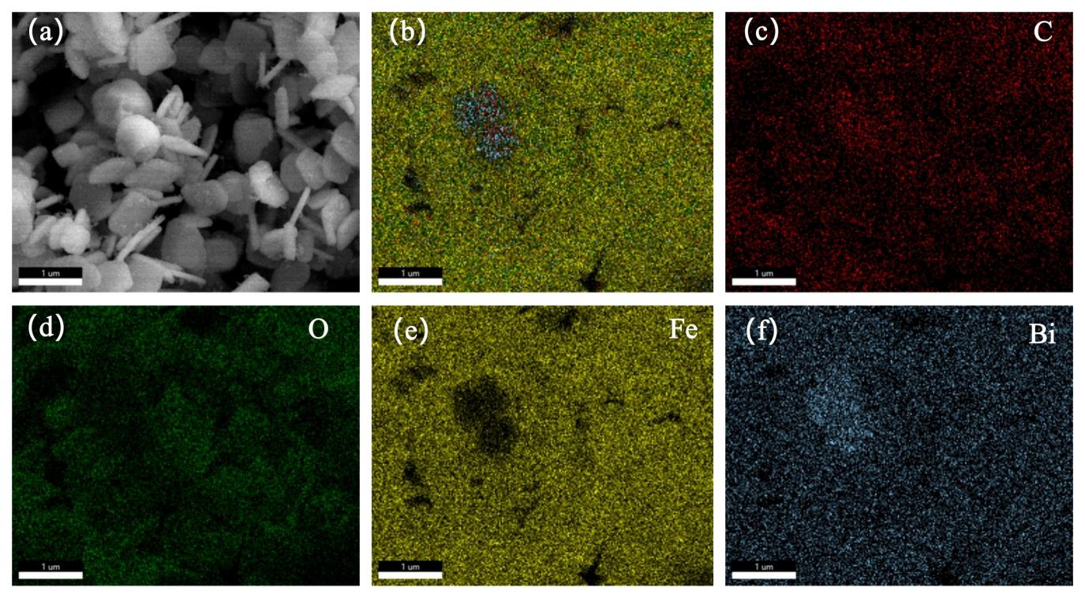
Fig. S2 (a) SEM image and the corresponding elemental mapping results of Bi₂Fe₄O₉/rGO-100: (b) element overlay, (c) C, (d) O, (e) Fe and (f) Bi
Fig. S3 FTIR spectra of Bi₂Fe₄O₉ NPs and Bi₂Fe₄O₉/rGO NCs
Fig. S4 TG and DTG curves of Bi₂Fe₄O₉ NPs and Bi₂Fe₄O₉/rGO NCs

Fig. S5 TG and DTG curves of Bi₂Fe₄O₉ NPs and Bi₂Fe₄O₉/rGO NCs
Fig. S6 Michaelis-Menten curves of Bi₂Fe₄O₉ with (a) TMB and (b) H₂O₂ used as substrate, Lineweaver–Burk plots of Bi₂Fe₄O₉ from the activity data of the varied concentration of (c) TMB and (d) H₂O₂

Table S1 Comparison of kinetic parameters of Bi₂Fe₄O₉/rGO and HRP or other nanozymes
Catalysts | K_{m} (mM) |  |  | V_{max} (10⁻⁸ M·s⁻¹) |  | Ref.
Catalysts | TMB | H₂O₂ | TMB |  | H₂O₂ | Ref.
HRP | 0.43 | 3.7 | 10.00 |  | 8.71 | [1]
Fe₃O₄ | 0.098 | 154 | 3.44 |  | 9.78 | [1]
GO-Fe₃O₄ | 0.43 | 0.71 | 13.08 |  | 5.31 | [2]
CoFe₂O₄ | 0.007 | 0.036 | -ª |  | - | [3]
rGO-CoFe₂O₄ | 0.046 | 14.72 | 1.12 |  | 21.71 | [4]
ZnFe₂O₄ | 0.85 | 1.66 | 13.31 |  | 7.74 | [5]
ZnFe₂O₄/rGO | 0.12 | 0.06 | 4.15 |  | 2.61 | [6]
GO-COOH | 0.0237 | 3.99 | 3.45 |  | 3.85 | [7]
Bi₂Fe₄O₉ | 0.07 | 0.73 | 2.17 |  | 1.56 | [8]
Bi₂Fe₄O₉ | 0.42 | 0.98 | 2.05 |  | 0.82 | This work
Bi₂Fe₄O₉/rGO | 0.09 | 0.24 | 3.23 |  | 1.93 | This work
ª“-” indicates the data were not reported in the cited reference.
Table S2 Comparison of the analytical performance of GSH with Bi₂Fe₄O₉/rGO and different peroxidase mimics
Peroxidase mimics | Linear Range(μM) | LOD (nM) | Ref.
Fe₃O₄ | 3-30 | -ª | [9]
GO-Fe₃O₄ | 0.1-10 | 9.17 | [10]
ZnFe₂O₄/rGO | 2-40 | 760 | [6]
MnCe_{0.1} | 2.5-20 | 370 | [11]
Cu@Co-MOFs | 1-1200 | 720 | [12]
MOF-Fe(DTNB) | 0-80 | 280 | [13]
KV₆O₁₅/V₂O₅ | 0.1-35 | 38.8 | [14]
MoSe₂@Fe | 1.67-33.3 | 3070 | [15]
Bi₂Fe₄O₉/rGO | 0.01-0.25 | 3.1 | This work
ª“-” indicates the data were not reported in the cited reference.
References
[1] Gao L, Zhuang J, Nie L, et al (2007) Intrinsic peroxidase-like activity of ferromagnetic nanoparticles. Nature Nanotechnology 2 (9): 577-583. https://doi.org/10.1038/nnano.2007.260
[2] Dong Y, Zhang H, Rahman ZU, et al (2012) Graphene oxide-Fe₃O₄ magnetic nanocomposites with peroxidase-like activity for colorimetric detection of glucose. Nanoscale 4 (13):3969-3976. https://doi.org/3969-3976.10.1039/c2nr12109c
[3] Zhang K, Zuo W, Wang Z, et al (2015) A simple route to CoFe₂O₄ nanoparticles with shape and size control and their tunable peroxidase-like activity. RSC Advances 5 (14): 10632-10640. https://doi.org/10.1039/c4ra15675g
[4] Hao J, Zhang Z, Yang W, et al (2013) In situ controllable growth of CoFe₂O₄ ferrite nanocubes on graphene for colorimetric detection of hydrogen peroxide. Journal of Materials Chemistry A 1 (13): 4352-4357. https://doi.org/10.1039/10.1039/c3ta00774j
[5] Su L, Feng J, Zhou X, et al (2012) Colorimetric detection of urine glucose based ZnFe₂O₄ magnetic nanoparticles. Analytical Chemistry 84 (13): 5753-5758. https://doi.org/10.1021/ac300939z
[6] Bian B, Liu Q, Yu S (2019) Peroxidase mimetic activity of porphyrin modified ZnFe₂O₄/reduced graphene oxide and its application for colorimetric detection of H₂O₂ and glutathione. Colloids and Surfaces B: Biointerfaces 181: 567-575. https://doi.org/10.1016/j.colsurfb.2019.06.008
[7] Song Y, Qu K, Zhao C, et al (2010) Graphene oxide: intrinsic peroxidase catalytic activity and its application to glucose detection. Advanced Materials 22 (19): 2206-2210.
[8] Razavi M, Barras A, Ifires M, et al (2022) Colorimetric assay for the detection of dopamine using bismuth ferrite oxide (Bi₂Fe₄O₉) nanoparticles as an efficient peroxidase-mimic nanozyme. Journal of Colloid and Interface Science 613: 384-395. https://doi.org/10.1016/j.jcis.2022.01.041
[9] Ma Y, Zhang Z, Ren C, et al (2012) A novel colorimetric determination of reduced glutathione in A549 cells based on Fe₃O₄ magnetic nanoparticles as peroxidase mimetics. Analyst 137 (2): 485-489. https://doi.org/10.1039/C1AN15718C
[10] Mei L, Wei B, Liu C, et al (2025) Polyvinylpyrrolidone-stabilized ultra-small Fe₃O₄ nanoparticles-functionalized graphene oxide with synergistically enhanced peroxidase-like activity for glutathione colorimetric determination in rat serum. Microchimica Acta 192 (4): 250. https://doi.org/10.1007/s00604-025-07044-w
[11] Yao J, Li C, Feng J, et al (2024) Mn-doped CeO₂ nanorods for the colorimetric sensing of glutathione. ACS Applied Nano Materials 7 (24): 28242-28254. https://doi.org/10.1021/acsanm.4c05215
[12] Gu Y, Han J, Zhang N, et al (2024) Bimetallic Cu@ Co-MOFs mimic peroxidase for colorimetric detection of glutathione. ACS Applied Nano Materials 7 (21): 24683-24696. https://doi.org/10.1021/acsanm.4c04563
[13] Zhang K, Sun H, Wei L, et al (2025) Robust and sensitive colorimetric detection of glutathione with double-triggering MOF-Fe (DTNB). Spectrochimica Acta Part A: Molecular and Biomolecular Spectroscopy 328: 125439. https://doi.org/10.1016/j.saa.2024.125439
[14] Mao H, Wang M, Wang H, et al (2024) Oxygen vacancy and heterojunction co-boosted peroxidase-like activity of KV₆O₁₅/V₂O₅ nanoribbons for the colorimetric detection of glutathione. Microchemical Journal 204: 111091. https://doi.org/10.1016/j.microc.2024.111091
[15] Lin L, Chen D, Lu C, et al (2022) Fluorescence and colorimetric dual-signal determination of Fe³⁺ and glutathione with MoSe₂@Fe nanozyme. Microchemical Journal 177: 107283. https://doi.org/10.1016/j.microc.2022.107283

