Supporting Information: Resource nationalist versus regional collaboration approaches for increased battery mineral value addition in Southern Africa
Karla Cervantes Barron*¹​, Raghav Pant³​, Baptiste Andrieu⁴, Mehrnoosh Heydari⁴​, Alexandros Korkovelos⁶​, Simone Osei-Owusu⁵, Samira Barzin³, Mehmet Metehan Ciftci⁷, Martin Stringer​⁶, Camilo Ramirez Gomez ⁸, Adam Hawkes⁶, Jim W. Hall³, Vivien Foster*²​

¹ Independent & Centre for Environmental Policy, Imperial College London, London, UK
² Centre for Environmental Policy, Imperial College London, London, UK
³ Oxford University, Environmental Change Institute, South Parks Road, OX1 3QY
⁴ University of Cambridge, Department of Engineering, Trumpington Street, CB2 1PZ
⁵ University College London, Bartlett School of Environment, Energy & Resources, London, UK; Smith School of Enterprise and the Environment, School of Geography and the Environment, University of Oxford, Oxfordshire OX1 3QY, UK
⁶ Department of Chemical Engineering, Imperial College London, London, UK
⁷ University College London, Bartlett School of Environment, Energy & Resources, London, Smith School of Enterprise and the Environment, School of Geography and the Environment, University of Oxford, Oxfordshire OX1 3QY, UK
⁸ KTH Royal Institute of Technology, School of Industrial Engineering and Management, Stockholm
* Corresponding authors

Scenario definition
This SI documents the scenarios used in the study.
In this study, data from 2022 are takes as the baseline scenario which includes the mineral production in such year up to the refining of compounds of interest already done in the 14 African countries and the existing energy and transport infrastructure. Future scenarios are projected using three approaches: the first is a Business-as-Usual (BAU) scenario where the same stages as in the baseline are produced, with changes in volumes being processed at the same locations where processing occurred in 2022. The second scenario reflects increasing mineral processing ambition, with a so-called Precursor-Related Product scenario where compounds specifically used as inputs to battery precursors are produced. The year projected for the build-up of processing facilities in this study is 2040, which is a reasonable estimate given how long project may need to go from exploration to being operational. However, it should be noted that there is some uncertainty on the timeline at project level as some would likely be done faster while others slower. While there is not a way to evaluate this currently, the approach used in this study helps illustrate future processing capabilities and identifies potential sites of interest.
Table 1 shows the four scenarios in this study and which levers are included to compare the level of future mineral production, the degree of cooperation between countries, and the inclusion of environmental constraints. The level of production refers to levels of mineral extraction depending on demand projections scenarios. The degree of cooperation refers to whether countries are assumed to process minerals only within their jurisdiction in a nationalist approach, or whether there is trade within the region to find optimal locations for mineral processing as a regionalist approach. Environmental constraints included are water scarcity and biodiverse areas which are used to model whether certain areas need to be excluded from mining and processing activities. Further details on each lever are found in Sections 2,3 and 6.
Table 1: Overview of illustrative scenarios for simulation. Of these, the medium ones were explored further in this report.
Policy target | Level of production | Degree of cooperation | Environmental constraints​
2022 Baseline​ | Status Quo​ | Status Quo​ | None​
Business-as-Usual Scenario​  Mineral mining may grow, but refining amounts and trade shares remain as in the baseline, no new processing is done by 2040 | Low​  ​ | National | Unconstrained​  Constrained​
 | Medium​ | National​ | Unconstrained​  Constrained​
 | High​  ​ | National​ | Unconstrained​  Constrained​
Precursor-Related Product Scenario  Mineral production reaches an advanced level of processing by 2040​ | Low​  ​ | National​ | Unconstrained​  Constrained​
 | Low​  ​ | Regional​ | Unconstrained​  Constrained​
 | Medium​ | National​ | Unconstrained​  Constrained​
 | Medium​ | Regional​ | Unconstrained​  Constrained​
 | High​ | National​ | Unconstrained​  Constrained​
 | High​ | Regional​ | Unconstrained​  Constrained​

Geo-Localisation of Current and Future Mining Sites and Associated Production

This section documents the detailed methodological steps used to establish geo-localised baseline mineral production data and project this into the future.

2.1 Establishment of geo-localised baseline for mineral production

2.1.1 Several relevant data sources were identified.

- Standard & Poor’s (S&P) Capital IQ Pro Metals & Mining Database (previously known as SNL or Rystad Energy Complementary) is a proprietary database¹, which provides detailed mine-level data on production and processing activities for an array of minerals with global coverage for 37,400 mining properties and 7,750 operating mines and is widely used in the academic and policy literature².
- British Geological Survey (BGS) World Mineral Statistics Database³ is an open access public database that provides aggregate data for annual national production and trade of minerals. More than 70 mineral commodities – covering the majority of economically important and internationally traded minerals, metals and mineral-based materials – are included. As far as possible the production data are compiled from primary, official sources. Quality assurance is maintained by participation in such groups as the International Consultative Group on Non-ferrous Metal Statistics.
- Scientific literature databases. Some databases on mining production are publicly available in the scientific literature. There are three that proved to be particularly useful for this study: production data from published reports of 1,171 coal and metal mines worldwide⁴; and, two sources containing geolocated mining sites via remote sensing^{5,6}.

2.1.2 Identified data sources were evaluated for completeness.

None of the identified sources provided complete site-specific geo-localised data on mineral production volumes and attributes. By far the most complete source of data was the S&P Database. However, even the S&P Database has been shown to miss as many as 50% of mining sites that can be identified by remote sensing⁷. Moreover, even for sites captured in the S&P Database, information fields are often missing or incomplete in the African context. For the countries of this study, the aggregated coverage rate for cobalt, copper, and graphite, is of 94%, 70%, and 64% respectively. For lithium, manganese, and nickel, the production values are larger in S&P than in BGS. The coverage rates at the country level are given in Table 2.

2.1.3 Identified data sources were evaluated for consistency.

Identified data sources were found to be mutually inconsistent. In particular, national aggregate production volumes for specific mineral-country combinations were found to diverge substantially between S&P and BGS, as shown in Table 2

Table 2: Comparison of aggregate national production between S&P IQ Pro and BGS in 2022. Source: Authors’ elaboration, based on S&P and BGS Databases.
 | Country | S&P (tonnes) | BGS (tonnes) | Ratio S&P/BGS
Cobalt | DRC | 107,439 | 115,371 | 93%
Cobalt | Madagascar | 3,159 | 3 428 | 92%
Cobalt | South Africa |  | 250
Cobalt | Zambia | 688 | 252 | 273%
Cobalt | Zimbabwe |  | 241
Copper | Botswana | 59,225 | 34,201 | 173%
Copper | DRC | 1,533,817 | 2,394,630 | 64%
Copper | Namibia | 3,500 | 2,036 | 172%
Copper | South Africa | 38,714 | 49,194 | 79%
Copper | Tanzania |  | 118,000
Copper | Zambia | 736,970 | 763,550 | 97%
Copper | Zimbabwe | 2,739 | 10,168 | 27%
Graphite | Madagascar | 17,227 | 116,700 | 15%
Graphite | Mozambique | 163,000 | 165,932 | 98%
Lithium | DRC | 67,100
Lithium | Namibia |  | 5,062
Lithium | Zimbabwe | 12,464 | 8,740 | 143%
Manganese | DRC |  | 5,000
Manganese | Namibia | 465 000 | 23,269 | 1 998%
Manganese | South Africa | 20,143,991 | 18,966,594 | 106%
Manganese | Zambia | 14,098 | 161,611 | 9%
Nickel | Madagascar | 39,780 | 35,737 | 111%
Nickel | South Africa | 25,412 | 29,033 | 88%
Nickel | Zambia | 3,800 | 4,059 | 94%
Nickel | Zimbabwe | 17,343 | 13,753 | 126%

2.1.4 An algorithm for combining information from different data sources was developed.

Given the incompleteness and mutual inconsistency of the different data sources, it was necessary to develop an algorithm that would allow them to be combined in such a way as to leverage the strengths of each one and provide the most comprehensive and consistent picture possible within these limitations. The algorithm is represented in Figure 1. Wherever S&P national aggregates exceeded those from BGS (or when BGS data were unavailable), S&P data were utilised. Wherever BGS data exceeded S&P national aggregates (or S&P data were unavailable), S&P data were complemented by remote sensing data to identify missing production sites and allocate the excess production reported by BGS over S&P national aggregates geospatially.

Figure 1: Flowchart outlining the algorithm for combining different geo-localisation data sources

2.1.5 An approach for estimating geo-localised production from remote sensing was developed.

Remote sensing techniques can be used to provide a first order approximation of the spatial distribution of mineral production that is missing from the S&P Database. Remote sensing data for mines typically capture the surface area associated with mines^{5,6}, but cannot distinguish whether a mine is active or inactive (see, for example, Figure 2).

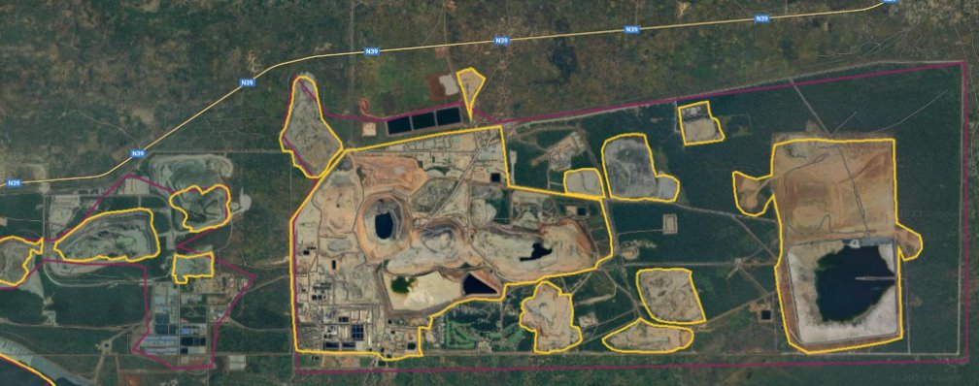
Figure 2: Remote sensing data for the Mutanda copper and cobalt mine

A novel approach was developed by incorporating data on remotely sensed particulate emissions around the locations of these mines. The presence of particulate emissions can be used as an indicator that the remotely sensed mining site is active. Moreover, the product of remotely sensed mine surface area and particulate emissions is used as a proxy for production volume. While there are many factors that may affect the relationship between particulate emissions and production volume (such as geology, efficiency, and mine depth), it is deemed preferable to utilise a proxy for production, rather than assuming that production is taking place. Moreover, the proxy is used as an indicator of relative production for mines with missing data, as it is used to spatially allocate the excess of national production over that reported on aggregate for specific mines. It is also necessary to know which commodities are produced at each mine. While, in principle, this could be done by cross-referencing remote sensing data with geological maps, in this case the application of this approach was limited to mines listed in S&P (but without production data), as S&P provides the list of commodities produced by the mine.

In sum, the following steps were followed for the incorporation of remote sensing data:
- Remote sensing of all mines and associated particulate emissions was conducted.
- Coordinates for mines in the S&P Database were matched with remotely sensed mines.
- The following types of mines were filtered out: those without particulate emissions; those marked as inactive by S&P; and those with existing production data in S&P
- For each commodity and country, the excess national production arising when BGS figures exceeded those of S&P, was allocated among the remaining mines proportionally to the indicator of mine surface area multiplied by particle emissions detected in that surface area.

2.2 Projection of geo-localised mineral production into the future

2.2.1 Availability of projections for mining production was assessed.

While the S&P Database contains data on mineral reserves, project development stages, and planned timelines, these data were missing for a significant percentage of the relevant mines (as shown in Table 2). Moreover, different types of information were missing in different cases. Some projects are expected to open without known production quantities, others lack opening dates, and data on future production of current mines are missing. This necessitated the development of statistical techniques to impute missing observations based on patterns observable in the available information.

2.2.2 Production start year was estimated.

All S&P projects are assigned to one of 18 mine stages to designate their state of development, ranging from grassroots and exploration, all the way through to construction, commissioning, and closure (see Table 3). However, only some non-producing projects have a projected start year. For those without a start year, we assume the mine can open between the lower and upper bounds listed in Table 3 depending on the current mine stage – such that the earlier the mine stage, the longer the anticipated delay until the start year. The ranges were defined based on the authors’ expertise. In reality, the uncertainty on determining mine exact opening time is high. We therefore set all mines to begin production at the lower bound (eg 11 years from now for an exploration-stage mine) with 0 production and then ramp up production linearly to 100% at the upper bound. While this approach has limitations, it allows for production to be spread out across all possible projects.

Table 3: List of lower and upper bounds for expected start years to mine start for different mine stages.
Mine stage | Expected years to mine start date
Mine stage | Lower bound | Upper bound
Grassroots | 14 | 60
Exploration | 11 | 40
Target Outline | 9 | 20
Advanced Exploration | 8 | 16
Prefeasibility/Scoping | 7 | 11
Feasibility Started | 6 | 10
Feasibility | 6 | 10
Feasibility Complete | 5 | 9
Reserves Development | 4 | 8
Construction Planned | 3 | 7
Construction Started | 2 | 6
Preproduction | 2 | 6
Commissioning | 2 | 6
Limited Production | 1 | 5
Operating | 0 | 5
Satellite | 0 | 5
Expansion | 0 | 5
Closed | 0 | 0

2.2.3 Mine closure year was estimated.

For existing mines where S&P does not provide a closing year, there are two possibilities. Either, production projections stop before 2040, in which case the latest value is taken to be the closure year. Otherwise, existing mines start closing in 2030 and are all closed by 2040. Mines opening in the future without a planned closure year are assumed to still be producing in 2040, which is the time horizon for the study. S&P projects that a few mines will open after 2022 and close before 2040.

2.2.4 Future production was estimated from reserves where available.

Once start and closure years are defined, it is necessary to project yearly production tonnages. For some mines, S&P predicts production. In other cases, production is not projected, but there is information on either current production or future reserves. In either case, Taylor’s Law can be used to provide missing projections of production. Taylor’s Law is an empirical observation that there exists a log-log linear relationship between daily metal production and reserves⁸. This relationship is confirmed for all six commodities of interest using S&P data, as shown in Figure 3. For copper, the equation fitted on the S&P Database is consistent with earlier literature^{9–12}. If reserves were not available, resources were transformed into reserves using a linear regression and Taylor’s law was used to transform these calculated reserves into production.

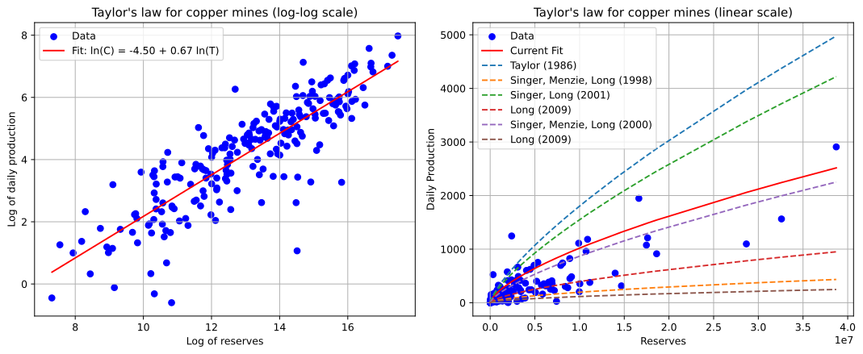
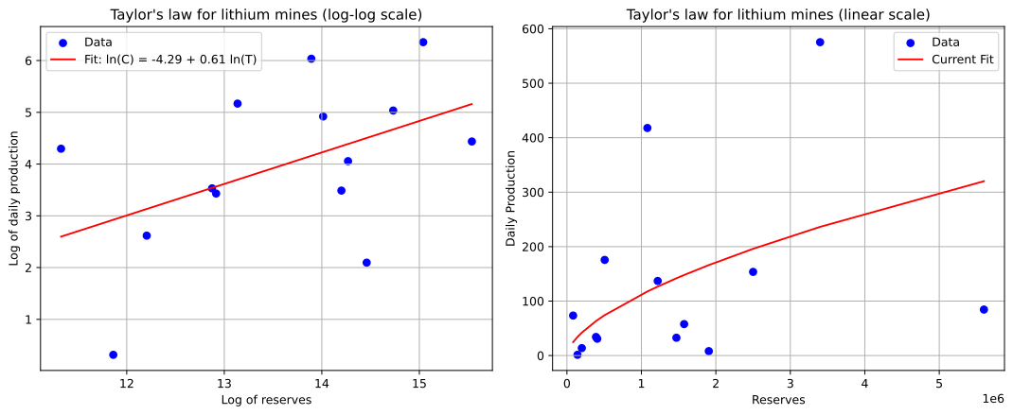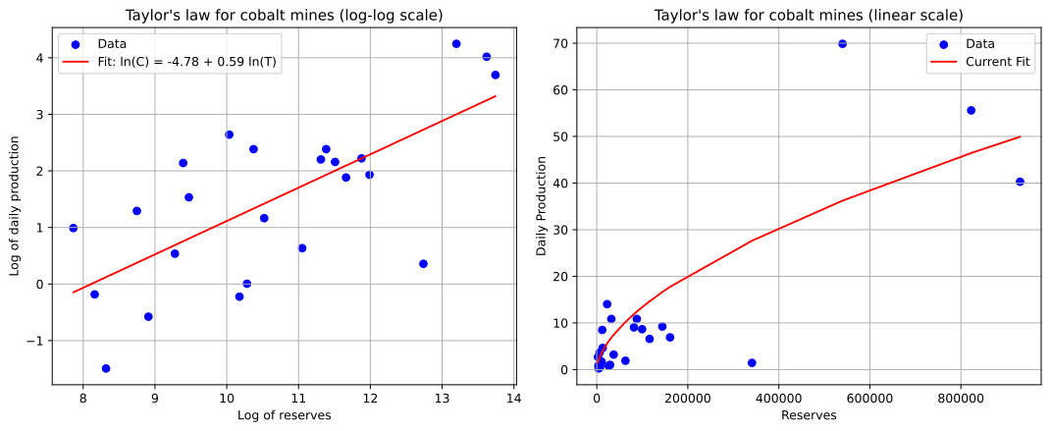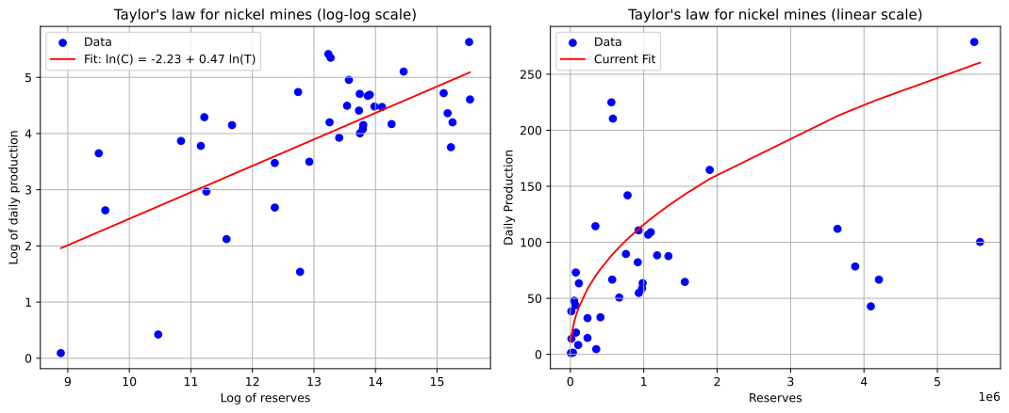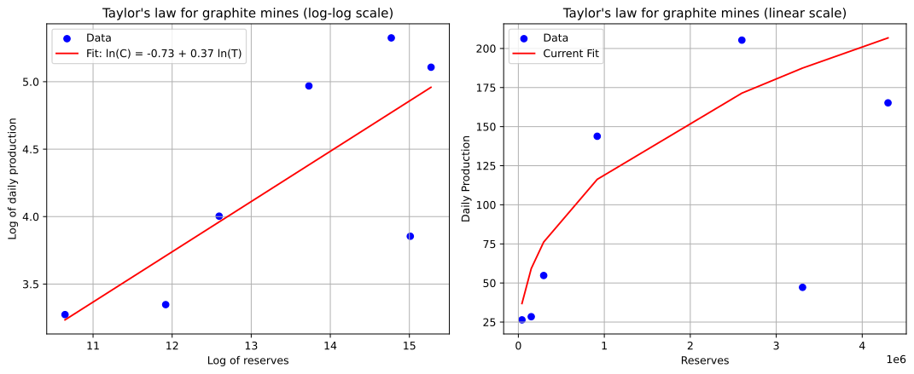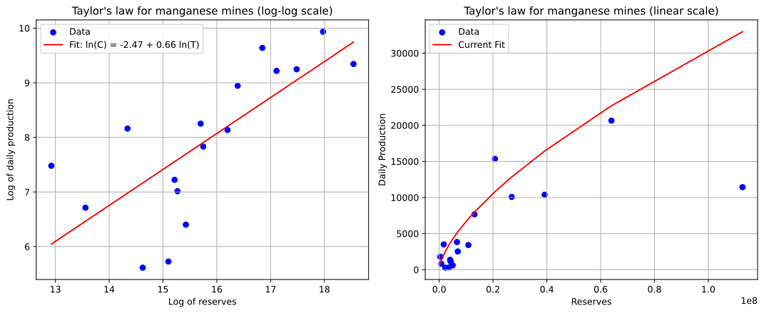
Figure 3: Illustration of Taylor’s law for copper, lithium, cobalt, nickel, graphite, and manganese mines globally

2.2.5 Calibrating to future demand
The primary goal of this report is not to precisely forecast mine-level future production but rather to identify optimal processing locations under various scenarios. Given the considerable uncertainty in future production estimates derived using Taylor’s Law and opening timelines, projected values for mines without initial S&P data were adjusted to ensure the total production—combining S&P-provided production values and those with imputed production based on hypothetical timelines and Taylor’s Law—aligns with demand projections from the International Energy Agency. The Announced Pledges Scenario was adopted as the medium case, the Stated Policies Scenario as the low case, and the Net Zero Emissions by 2050 Scenario as the high case¹³. The adjustment shares applied to align production with demand projections are detailed in Table 4.

Table 4: Correction factors on calculated future production in order to match future demand
 |  | 2030 | 2040
Lithium | Low | 0.04 | 4.22
Lithium | Mid | 0.46 | 6.27
Lithium | High | 2.08 | 8.73
Cobalt | Low | 0.2 | 0.87
Cobalt | Mid | 0.3 | 1.06
Cobalt | High | 0.88 | 1.31
Copper | Low | 0.11 | 0.67
Copper | Mid | 0.18 | 0.76
Copper | High | 0.32 | 0.93
Graphite | Low | 5.1 | 8.14
Graphite | Mid | 5.5 | 9.61
Graphite | High | 7.03 | 11.61
Nickel | Low | 0.46 | 1.52
Nickel | Mid | 0.54 | 1.64
Nickel | High | 0.81 | 1.87
Manganese | Low | 0.37 | 0.82
Manganese | Mid | 0.37 | 0.82
Manganese | High | 0.37 | 0.82

Figure 4 illustrates resulting global production projections for each mineral on this basis, together with regional production projections for Southern Africa, based on the assumption that the region’s market share remains constant and simply grows in line with the global market.

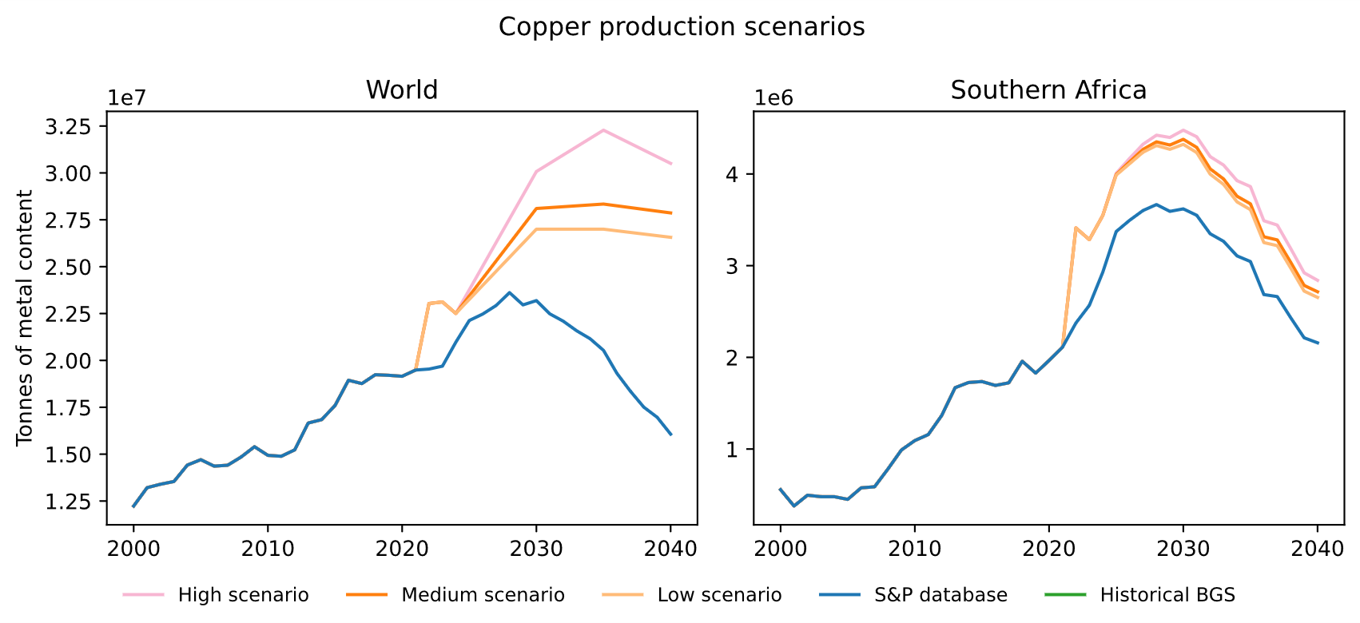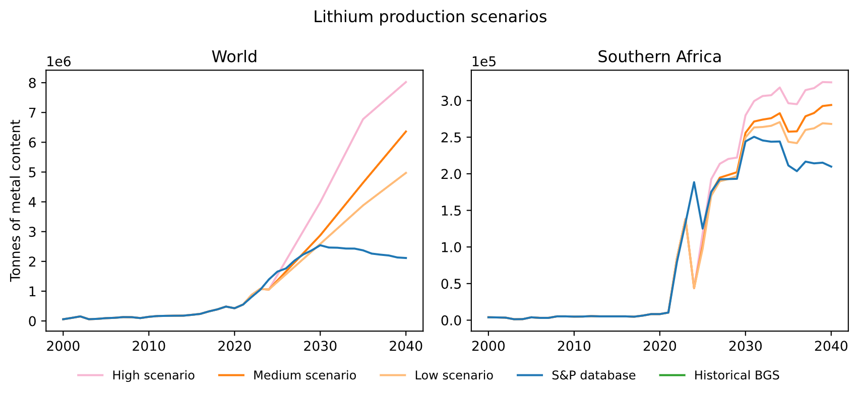
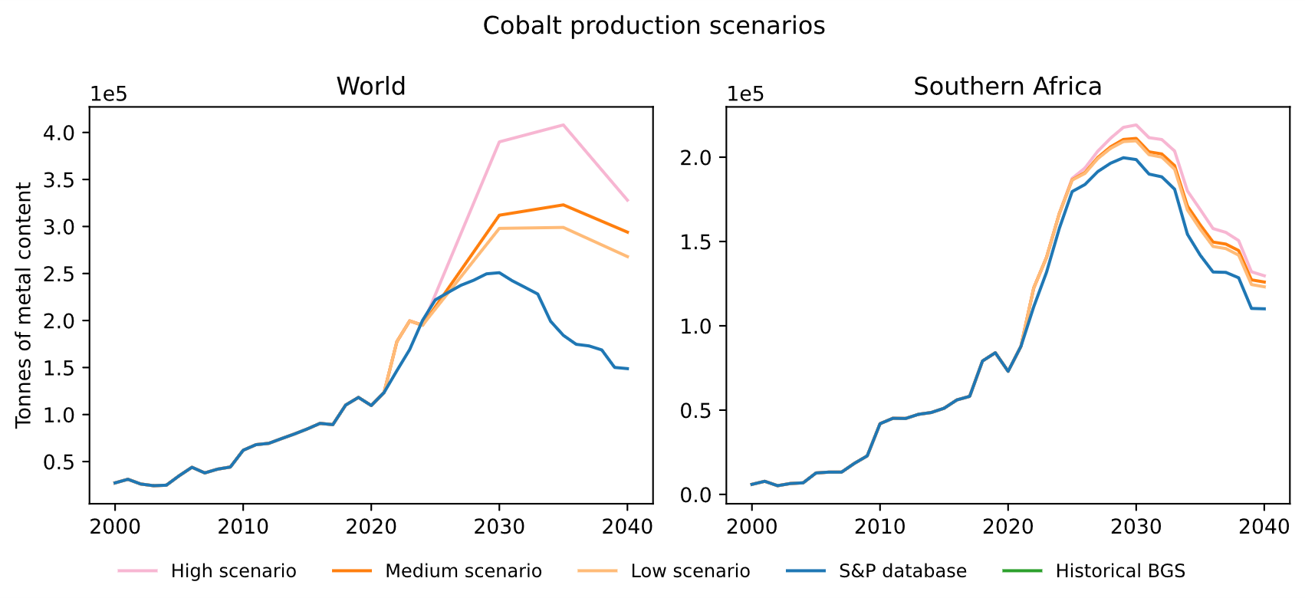
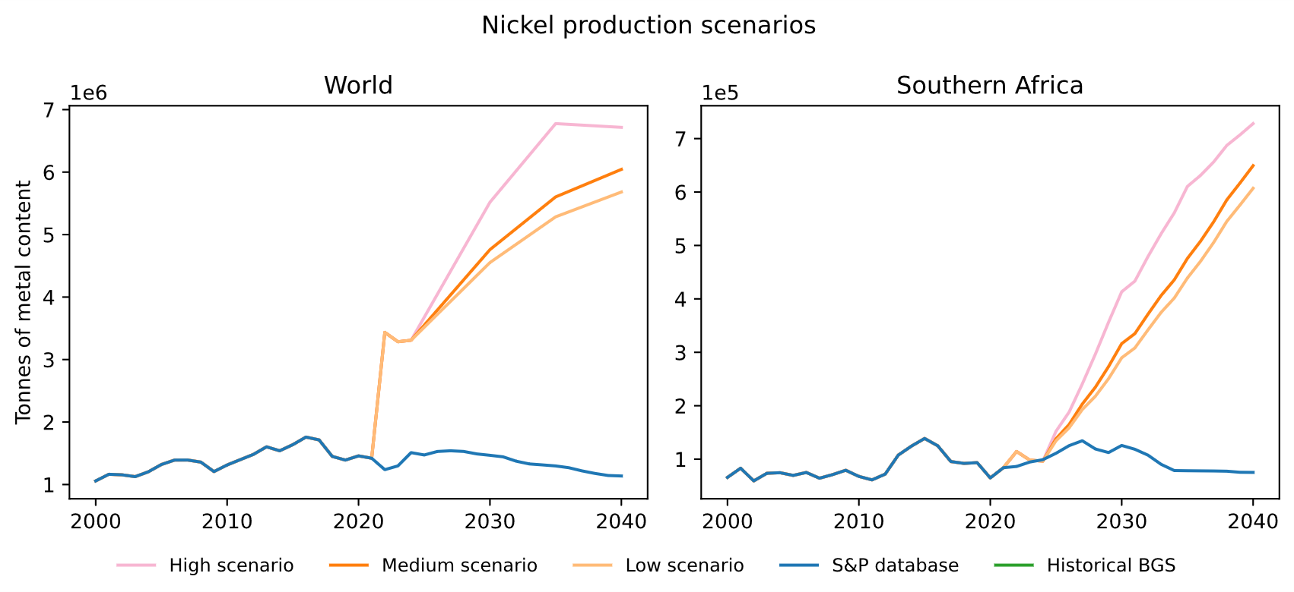
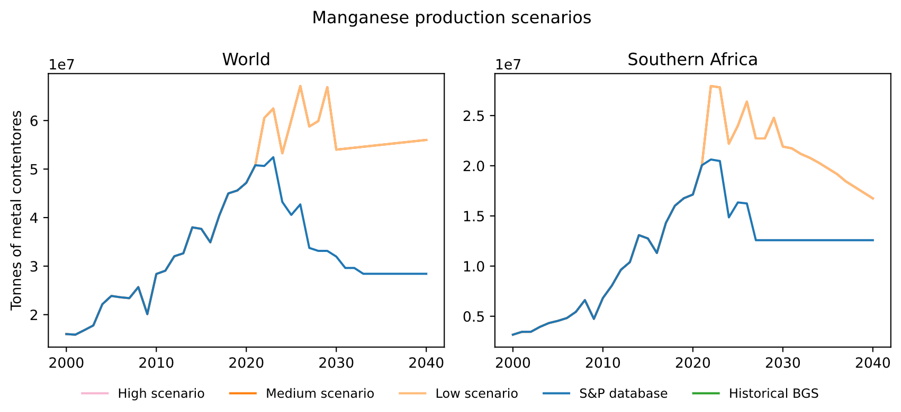
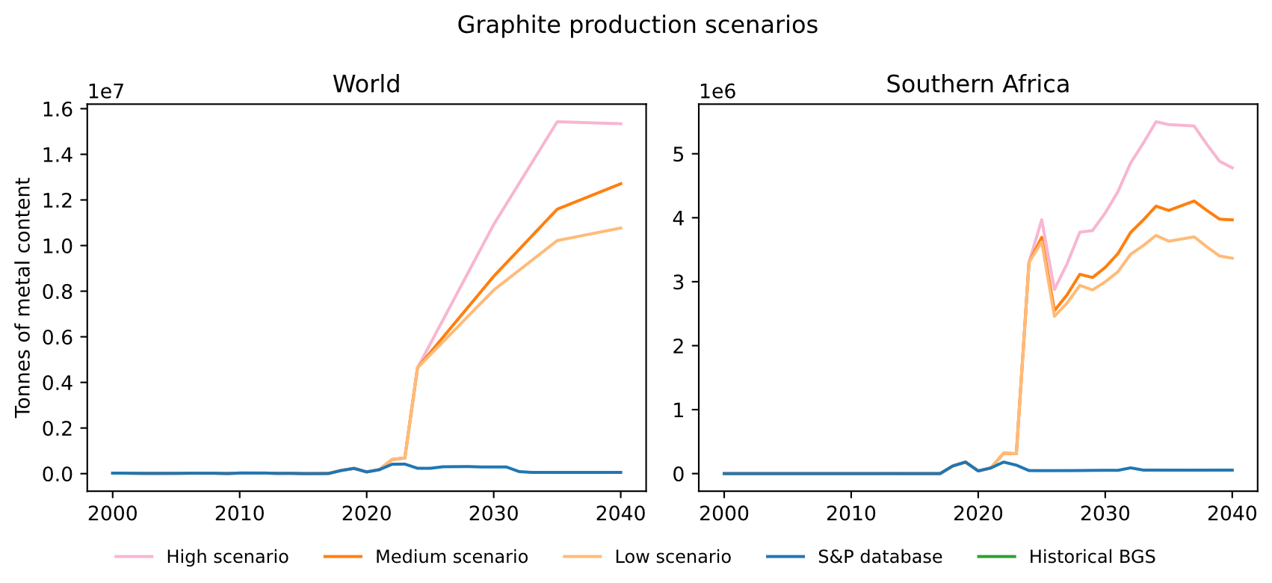
Figure 4: Primary production projections globally and in Southern Africa. Note the y-axis has different ranges depending on the location and unit multipliers are shown in the top left corner of each graph.

Modelling Value Addition Along the Critical Minerals Supply Chain
This Annex documents the detailed methodological steps used to model physical flows, as well as financial costs and revenues along the different stages of critical minerals value chains.

3.1 Physical modelling of critical minerals supply chains

3.1.1 Relevant processing stages along the supply chain were identified.
For each of the six minerals covered, products are identified which are useful for battery precursor manufacturing. The target products for the 2040 scenarios with increasing processing ambition were carefully selected due to the steps required in the battery value chain. Table 5 shows the role of each target stage in battery value chains highlighting that high-density battery applications were prioiritised. Refined minerals such as copper cathodes have a wide range of applications outside of batteries and are a fundamental product for subsequent transformations. In turn, some products are very specific to battery applications such as graphite in spherical purified form which is as such to improve battery functioning.
Table 5: Overview of the role in battery value chains of the two focus stages assumed to be reached in critical minerals processing scenarios in this study.
Mineral | Selected products for refining targets | Role in battery precursor application | Use in battery precursor application
Cobalt (Co) | Cobalt hydroxide (Co(OH)₂) | An intermediate from cobalt ore refining (often a by-product of copper or nickel mining) | Co hydroxide is stable and transportable but needs to be further refined and converted into cobalt sulphate to be used in battery applications
Cobalt (Co) | Cobalt sulphate (CoSO₄) | A critical precursor for making cathode active materials (CAMs) | Co sulphate is combined with nickel and manganese sulphates to form NMC or NCA cathode chemistries. Cobalt helps improve thermal stability, cycle life, and safety of the cathode
Copper (Cu) | Copper cathode | The refined form of copper metal, produced via electrorefining or solvent extraction/electrowinning | It needs to be further transformed into copper sulphate and copper foil to be used in battery applications
Copper (Cu) | Copper sulphate (CuSO₄) | Used to produce copper foil via electroplating. | Copper foil serves as the current collector for the anode in LIBs. It provides the conductive base onto which active anode materials (like graphite) are coated
Graphite (Gr) | Spherical graphite | First step towards producing an anode-relevant graphite product | The spherical form improves packing density, cycle life, and electrical conductivity of the anode active material
Graphite (Gr) | Spherical purified graphite | The second step towards producing an anode-relevant product. The final step involves coating the spherical purified graphite to become the anode-active material (AAM) | The AAM serves as the host material into which lithium ions intercalate during charging
Lithium (Li) | Lithium carbonate (Li₂CO₃) | A primary lithium source for cathode production but mainly for low-density applications | Used in LFP cathodes, some NMC formulations, and for solid-state electrolytes.  Lithium carbonate is often preferred in phosphate-based or lower-Ni chemistries.
Lithium (Li) | Lithium hydroxide (LiOH·H₂O) | A key lithium precursor, but for high-density applications | Used to make high-nickel cathodes (NMC, NCA) because lithium hydroxide reacts more efficiently at lower temperatures during synthesis of these high-energy materials
Manganese (Mn) | Manganese oxide (MnO) | A manganese intermediate, often produced by refining manganese ores | It needs to be further transformed into manganese sulphate to be used in battery applications
Manganese (Mn) | Manganese sulphate (MnSO₄) | Precursor for cathode active material | Used in NMC cathodes and also in LMO cathodes
Nickel (Ni) | Nickel matte | An intermediate product (~70% Ni, plus sulphur and iron) obtained by smelting nickel ores | Processed further through hydrometallurgy to make nickel sulphate
Nickel (Ni) | Nickel sulphate (NiSO₄) | One of the most important precursors for high-density cathodes | Provides the nickel for NMC and NCA cathodes. Nickel increases energy density of the battery

For each of the six minerals covered and the target products useful for battery precursor manufacturing, processing stages are identified which relate to mining and refining up to the target compounds. The stages include mineral extraction, concentration (called beneficiation in our study and other sources), smelting (if applicable), refining, and manufacturing of compounds that are used in the preparation of Cathode Active Materials (CAM) and Anode Active Materials (AAM) for lithium-ion batteries. Table 6 shows the stages considered, the relevant data sources, and assumptions made.
Table 6: Relevant processing stages, data sources and assumptions for each critical mineral supply chain. Source: Authors’ elaboration, based on literature review.
Mineral | Stages considered | Source(s) and assumption(s)
Copper (Cu) | Mining and Beneficiation, Smelting, Electrorefining or Solvent extraction and electrowinning (SX-EW), Cu oxide production, Cu sulphate production | Mining material intensity estimated per country depending on grade and recovery rates from S&P ¹. Wernet et al. (2016) version 3.9.1. Activity names: copper mine operation and beneficiation, sulphide ore, copper oxide production, copper production, cathode, SX-EW process, copper sulphate production, smelting of copper concentrate, sulphide ore, electrorefining of copper, anode.
Cobalt (Co) | Mining and Beneficiation, Smelting and refining, Cathode production, Co hydroxide production to Co sulphate production | Mining material intensity estimated per country depending on ore grades from S&P ¹ and estimated concentrate grade higher in DRC owning to it having the largest mines with the highest ore grades in the region. Wernet et al. (2016) version 3.9.1. Activity names: cobalt production, cobalt sulphate production; cobalt production, copper concentrate, sulfide ore. ¹⁵. ¹⁶ ^{17–19} Activity names: Cobalt, refined (metal); hydro- and pyrometallurgical processes; production mix, at plant; >99% Co, Cobalt, refined (metal); mining, beneficiation, primary extraction, refining, transport; production mix, at plant; 99.8% cobalt, Crude cobalt hydroxide (Co(OH)2); mining, beneficiation, primary extraction, refining, transport; production mix, at plant; 30- 40% cobalt.
Nickel (Ni) | Mining and Beneficiation, Smelting, Electrorefining, Ni class 1 production, Ni sulphate production | Mining material intensity estimated per country depending on grade and recovery rates from S&P ¹. Wernet et al. (2016) version 3.9.1. Activity names: nickel mine operation and beneficiation to nickel concentrate, 16% Ni, nickel mine operation and beneficiation to nickel concentrate, 7% Ni, smelting and refining of nickel concentrate, 16% Ni, nickel sulphate production, processing of nickel-rich materials
Graphite | Mining, Flotation, Spheronisation, Purification, Coating | Mining material intensity estimated per country depending on grade and recovery rates from S&P ¹. Wernet et al. (2016) version 3.9.1. Activity names: graphite production, battery grade, graphite production. Additional information from Engels et al. (2022).
Manganese (Mn) | Mining and Beneficiation, Roasting, Mn sulphate production | Mining material intensity estimated per country depending on grade and recovery rates from S&P ¹. Wernet et al. (2016) version 3.9.1 from which activity names: manganese concentrate production, manganese sulphate production. Farjana et al. (2019), from which activity name: manganese production.
Lithium (Li) | Mining and Beneficiation, Li carbonate production, Li hydroxide production | For concentrate, an average of petalite and lepidolite material intensities are estimated which depend on ore grades form S&P ¹ and recovery ratios from ^{22–24}.  Wernet et al. (2016) version 3.9.1. Activity names: lithium carbonate production, from spodumene, lithium hydroxide production, lithium sulphate production. Yin et al. (2019) which contains information for spodumene and lithium carbonate. Gao et al. (2023) and Wang et al. (2025) for petalite and lepidolite insights. Vieceli et al. (2017) on lithium concentrate. This is based on ore grade and assuming concentrate is lepidolite concentrate (1.95% Li or 4.20% Li₂O) from Vieceli et al. (2017).

3.1.2 Target processing stages for the study were selected.
For each mineral, an intermediate and advanced stage of processing was selected as a basis for the determination of policy targets. The intermediate stage represents a significant advance into refining beyond the production of ores and concentrates, while the advanced stage represents the manufacturing of compounds that are inputs to battery precursor manufacturing.
Figure 5 shows the stages relevant for lithium-ion batteries considered for each of the six minerals. The target compounds for the two 2040 scenarios with increased mineral processing ambition are highlighted shown in green and blue. The stages considered African geology, thereby excluding processes that do not occur in the region. For example, lithium is only extracted from rocks but not from brines. The compounds in the 2040 Precursor Related Product are mineral products known to be used in the battery precursor industry.

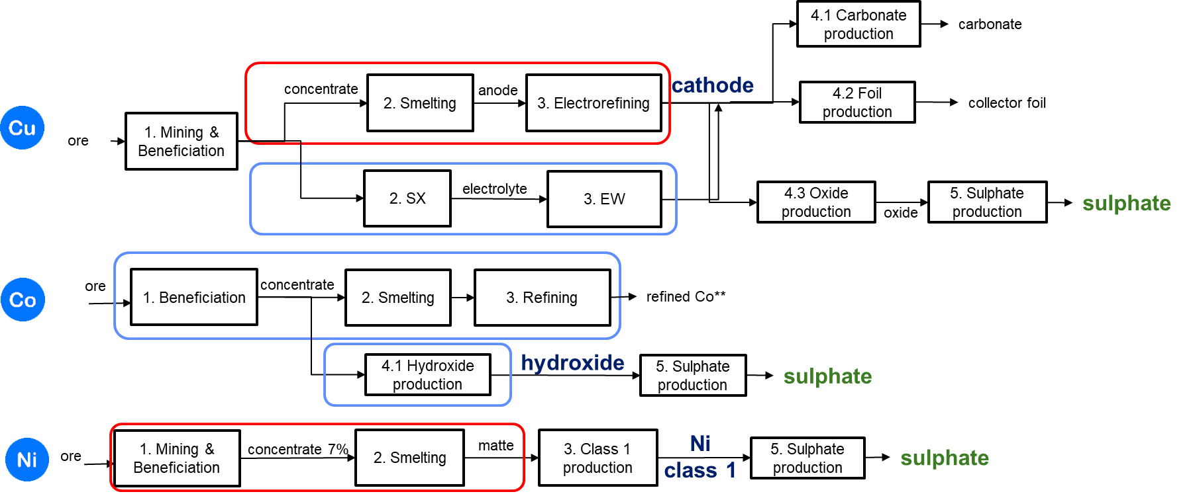
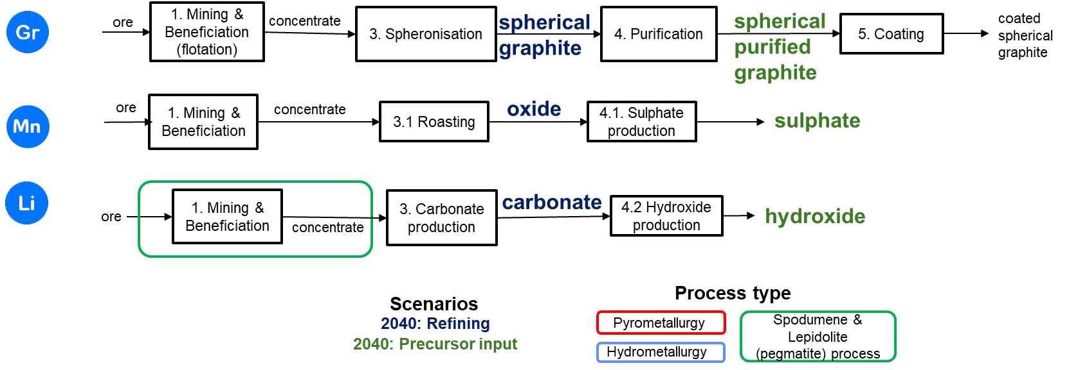
Figure 5: Mineral refining stages considered in the 2040 scenarios (green for precursor related product scenarios) up to manufacturing of inputs for lithium-ion battery cathode or anode active material. Only the stages in blue and green are presented as results for this study. Other known copper and graphite products related to lithium-ion batteries are shown as an illustration of additional manufacturing that could be undertaken. Source: Authors’ elaboration, based on literature review and estimations. Notes: Copper, cobalt and nickel may be found in the same deposit. Thus, the intensities reflect the shares of resources and energy needed for the production share of the relevant mineral insofar as the background data allowed. **Cobalt is produced via a hydro route in Madagascar that ends with refined cobalt (and refined nickel). This route is accounted for in the country and trade data but refined cobalt is not assumed to be processed further into battery-related compounds. SX-EW refers to solvent extraction and electrowinning.

3.1.3 The input intensities for each stage of mineral processing were established.
For supply chain modelling purposes, it is important to understand the input intensity for each mineral at each stage. Four inputs of particular interest are materials, water, fuels and electricity, whose relative intensities are shown in Figure 6. The intensities are all presented relative to the amount of output produced at each relevant stage.
The intensities obtained at the mining level are combined with the ore grades of each mineral and linear relationships are assumed between intensities and ore grades to scale the amounts of material moved, the energy, fuel or water required. If required, the alternative production routes are considered in the intensities per country depending on weighted production per route in 2022.
- Material intensity. Material intensity is of interest because it affects the demand for energy and transport infrastructure. For the most part, as minerals are processed a tonne of ore is transformed into progressively smaller volumes of refined output, affecting the transport capacity required to move material along the value chain²⁹. Figure 6 shows that cobalt, lithium and nickel beneficiation are particularly voluminous in relation to subsequent stages of processing due to the mining stage and the low amounts of metal per ore extracted.

- Water intensity. Water intensity is of interest because much of Southern Africa is affected by water scarcity, which may affect the cost or feasibility of processing operations³⁰. Figure 6 shows that water intensity varies significantly across minerals, with copper cathode (stage 3) having the highest water intensity due to the hydrometallurgical process. Water intensity also varies significantly across processing stages for a given mineral and does not necessarily decrease as minerals progress to higher stages of processing. Not all stages have water intensities reported in the original data sources. This can be due to some stages not requiring water and some not having a value available.
- Energy intensity. Energy intensity is of interest due to the relatively high cost of energy and scarcity of energy infrastructure in Southern Africa, which may affect the competitiveness of processing activities and the extent to which mining companies decide to invest in their own energy infrastructure³¹. Energy intensity can be broken down by energy source, such as electricity, heat, diesel, and gas. Figure 6 shows that lithium carbonate is by far the most energy intensive compound (stage 3). For other minerals, nickel beneficiation (stage 1) and copper cathode production (stage 3) also have high energy intensities. Generally, intermediate or later stages of mineral processing are the ones with the highest intensities.

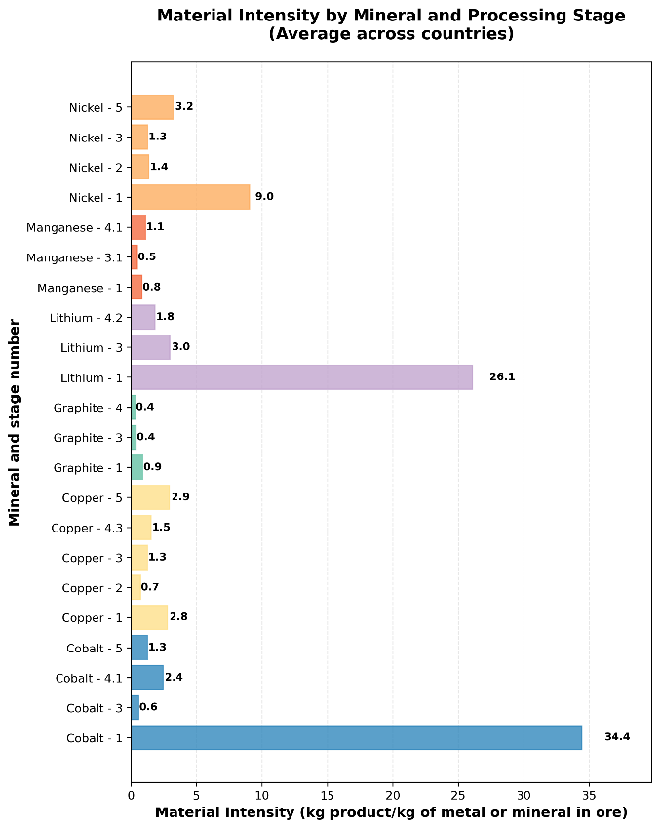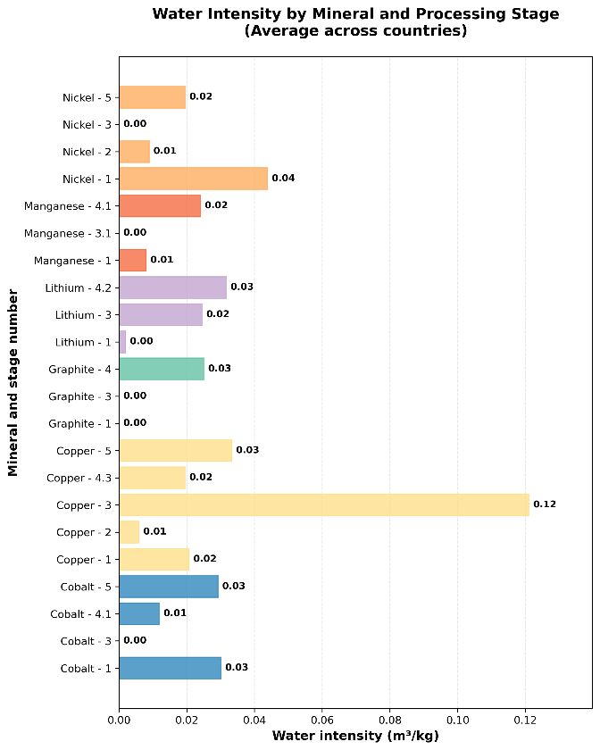
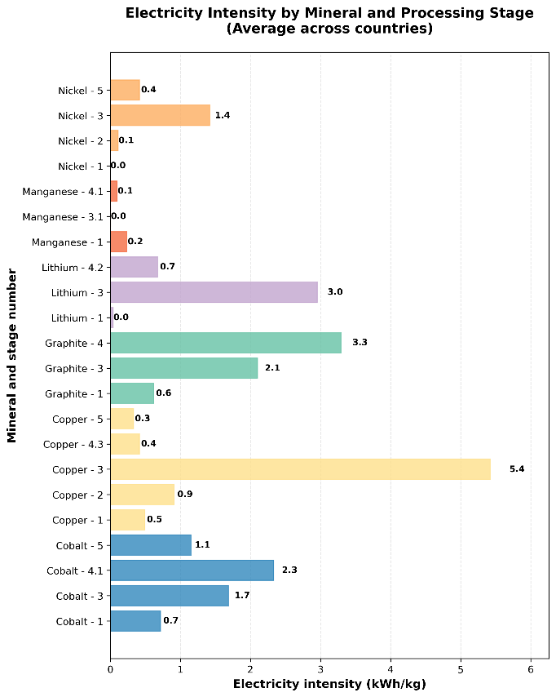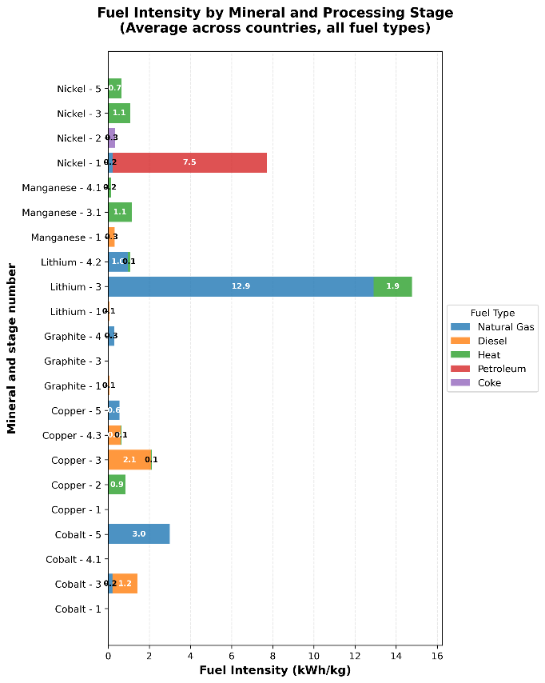
Figure 6: Material, water, electricity and fuel intensities for each relevant processing stage as country average. Source: Authors’ elaboration, based on literature review. Please see sources in Table S4.

3.2 Financial modelling of critical minerals supply chains
The analysis of prices and unit costs is critical for understanding the economics of critical minerals processing and will inform subsequent analysis of competitiveness and value addition. Figure 7 provides an overview of the process that was followed to establish baseline unit costs for intermediate stage and advanced stage processing for each mineral, as well as the methodology used to project these costs forward for the time horizon of the study. The methodology adopted at each stage of the process is described below.

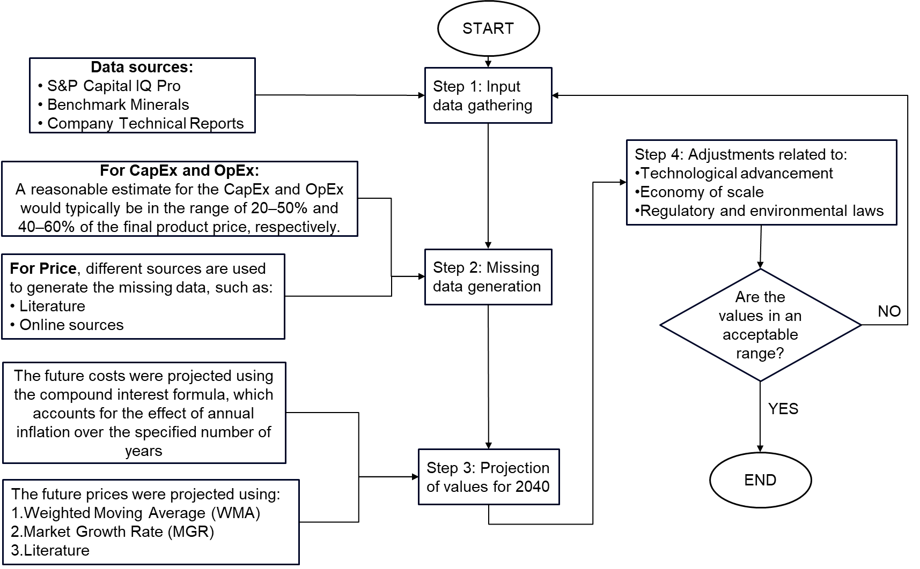
Figure 7: Process overview for establishing baseline unit costs

3.2.1 Baseline unit costs for intermediate stage processing of each mineral were collected.
For beneficiation, baseline data on processing costs were available for most minerals from the S&P Database for 2022¹. In the case of cobalt, copper, and nickel, the S&P Database contained a significant number of observations allowing average beneficiation unit costs to be produced at the project level as shown in Figure 8. Unit costs are broken down between the steps of beneficiation (including mining and milling) and processing, which are those of primary interest. Unit costs include costs related to production, reagents, labour, energy, transport, cash costs, among other. Transport costs for each facility are aggregated in a single number in the database. Our study models transport required between facilities and for trade but not internal transport within a facility. S&P has a category of fuel costs which include fuel used for internal transport which was then preserved in the aggregated costs for the model. With this inclusion and since detailed modelling of transport and electricity is undertaken within this study, other transport and electricity costs available in S&P are excluded from the unit costs used for modelling. Royalties are also identified and excluded, since they present a financial cost rather than an economic one. To preserve known costs, any facility which contained cost data uses it, while any new future mine uses an average value. The average value is obtained combining available country data. Due to relatively small sample sizes, unit costs for mining and processing are averaged across all observations available for Southern Africa. For cobalt these are DRC, Madagascar, South Africa, Zambia, Zimbabwe; for copper, Botswana, DRC, South Africa, Tanzania, Zambia, and Zimbabwe; for graphite, Madagascar; for manganese, Botswana; and for nickel, Madagascar, South Africa, Zambia, Zimbabwe. In the case of lithium, there was one Southern African country (Zimbabwe) and a number of other country values, namely Australia, Brazil, China, Portugal, and the US used to project costs for different stages.

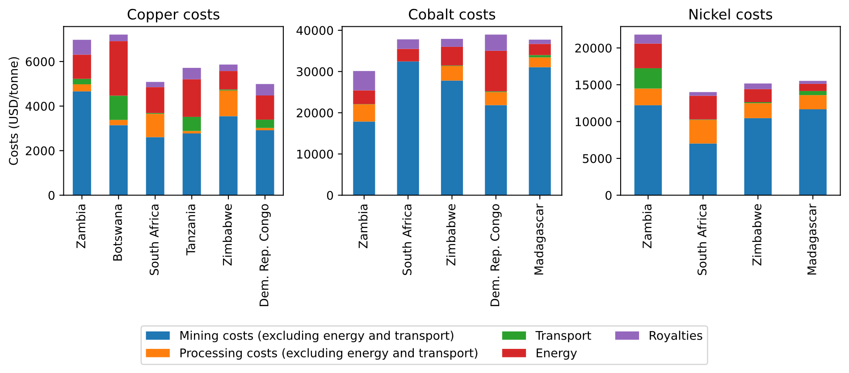
Figure 8: Baseline costs of mining and processing for copper, cobalt, and nickel (US$/t). Source: Authors’ elaboration, based on S&P Database.
The resulting cost curves we were able to derive for cobalt, copper and nickel are shown in Figure 9, while the supply curves comparing country projects are shown in Figure 10.
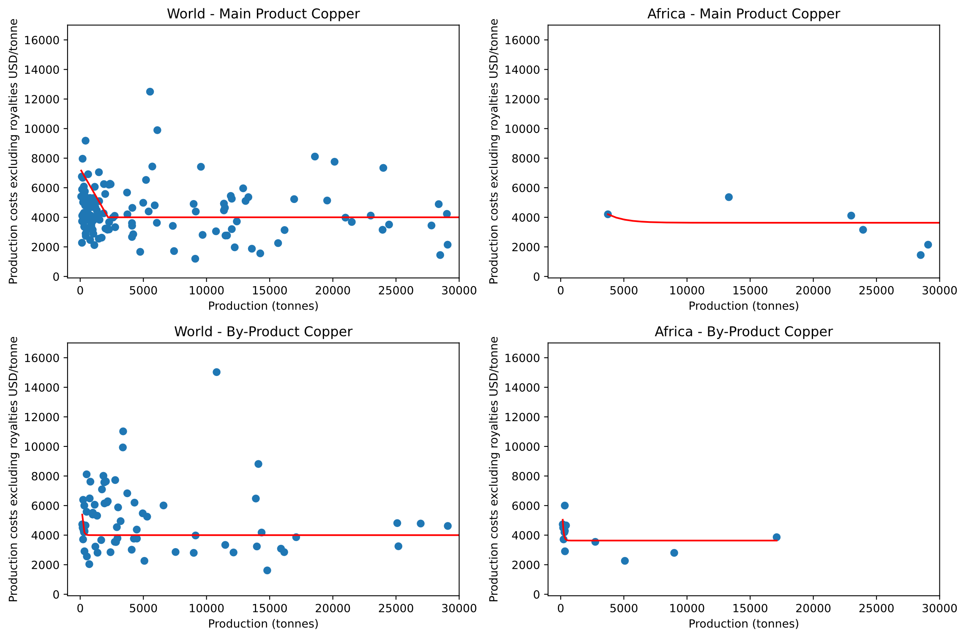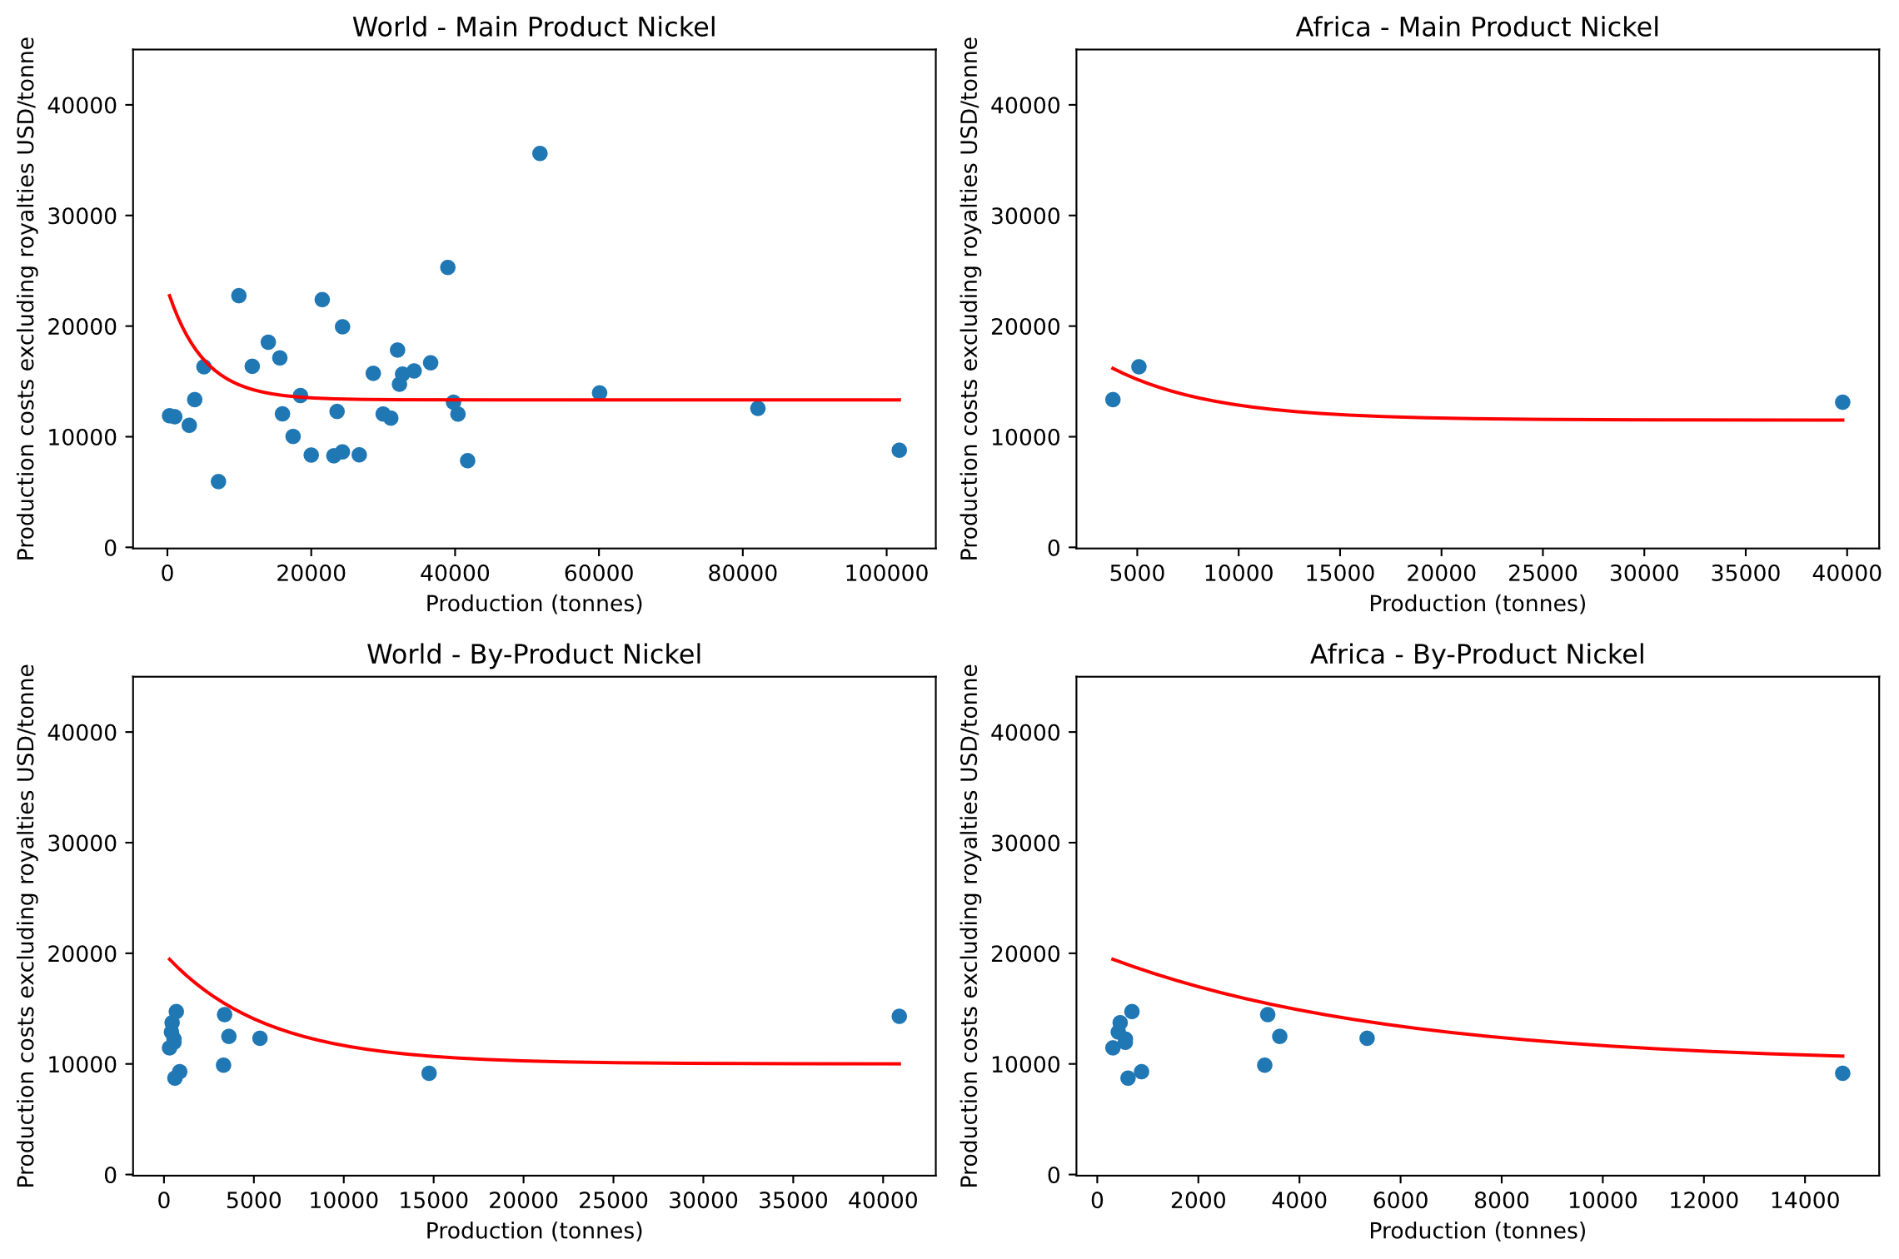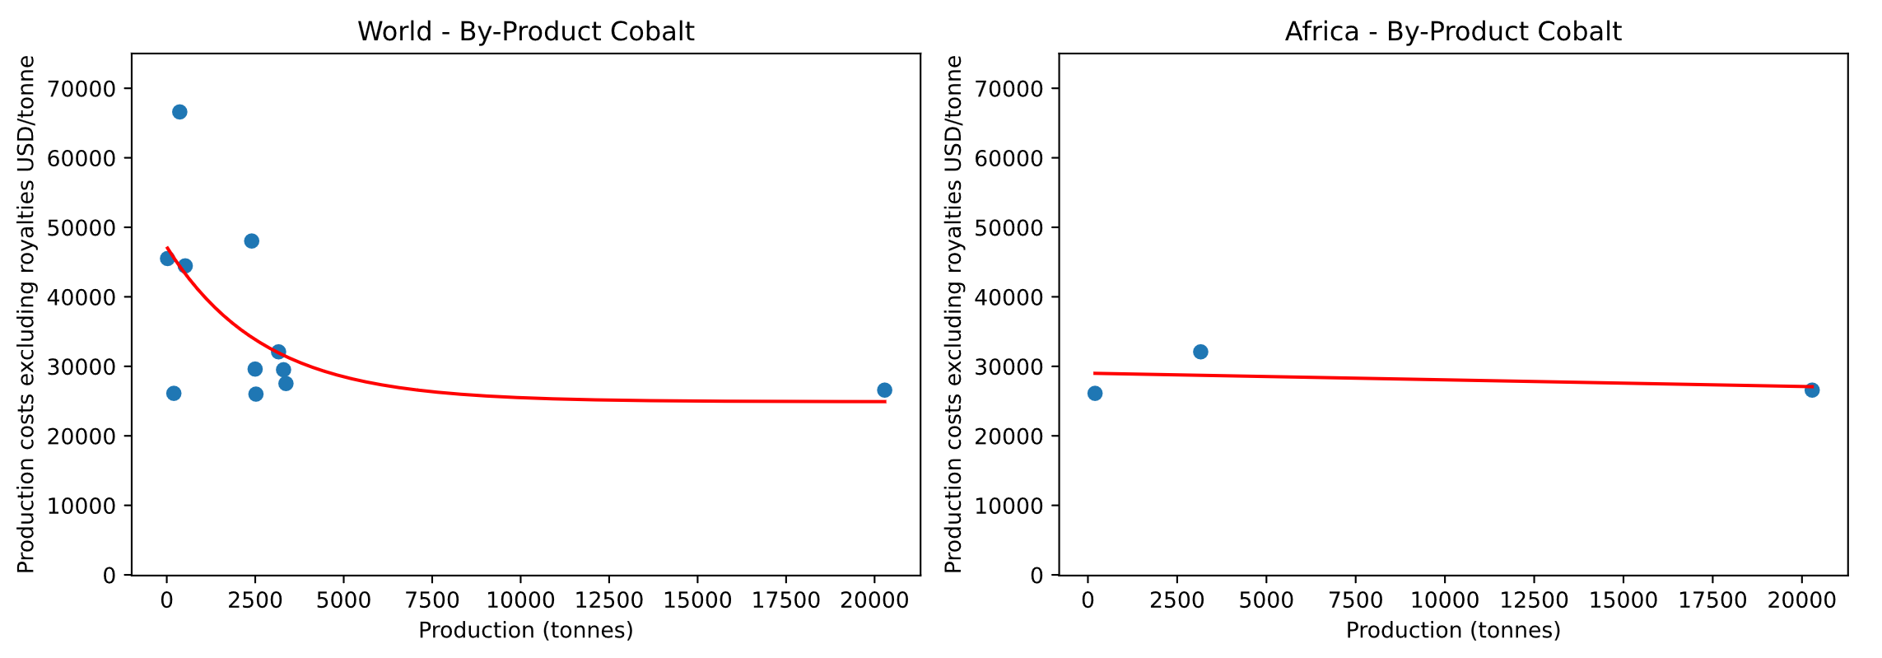
Figure 9: Cost curves of mining and processing for cobalt, copper, and nickel (US$/t) in 2022 including the classification as main or by-product and the relevant geographical group. Note: cobalt is not mined as a main product.

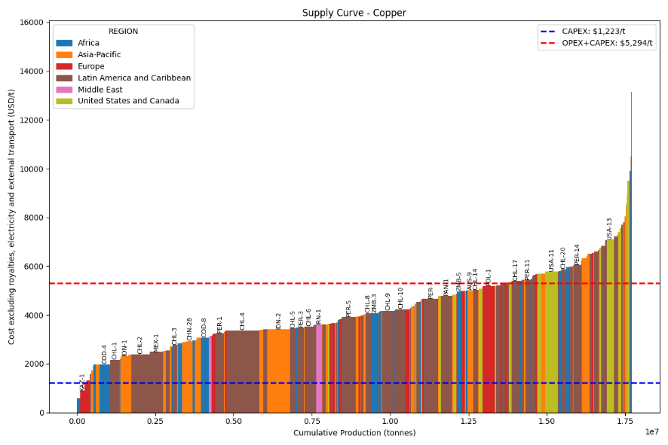
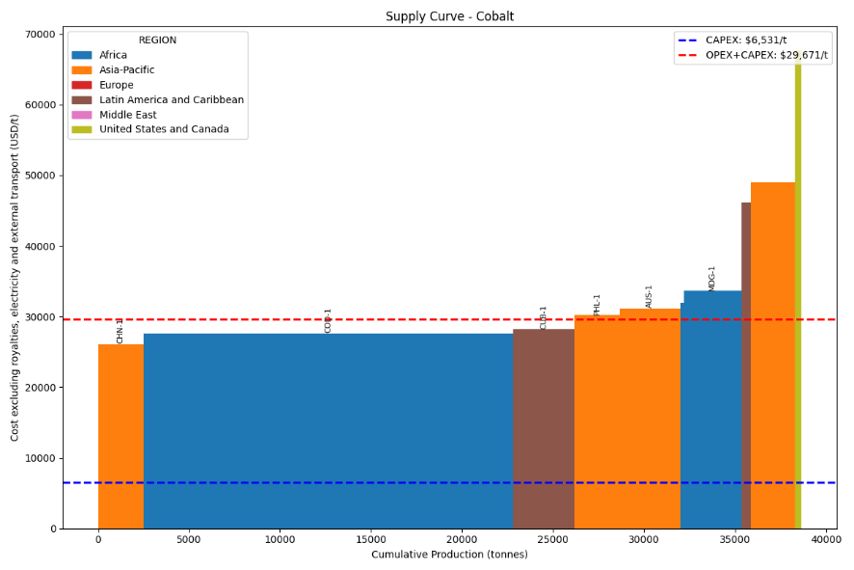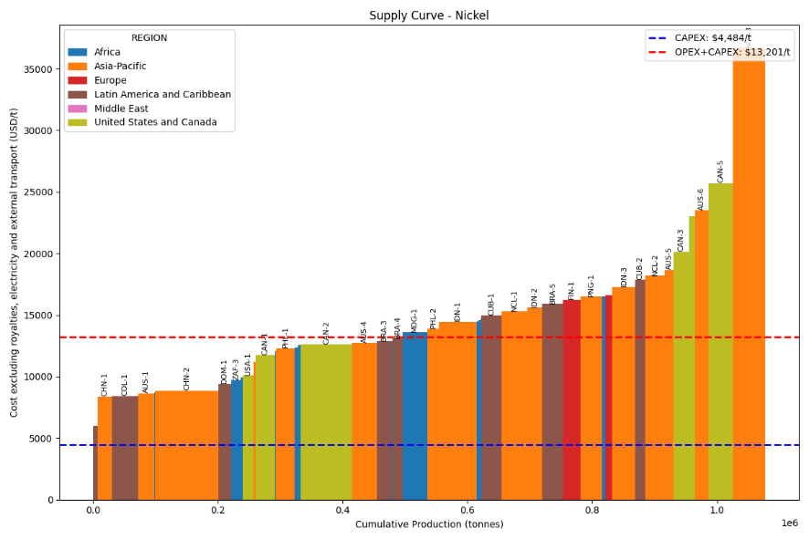
Figure 10: Costs including CAPEX and OPEX of mining and processing for cobalt, copper, and nickel (US$/t) in 2022 per facility with known costs and averages used for the model. Source: Authors’ elaboration, based on S&P database.

In the case of lithium, due to relatively incipient mining operations in Southern Africa, the only data available from the S&P Database were for countries outside of Africa, as shown in Figure 11. Once again, transport, energy and royalties were excluded, and mining and processing costs were averaged across all observations available globally as the only available proxy for Southern Africa. Given the data scarcity in S&P, a different database focused on lithium was used³² to discern cost curves for different processing steps (Figure 12). As before, royalties were excluded to allow for comparisons on a similar basis to be made.
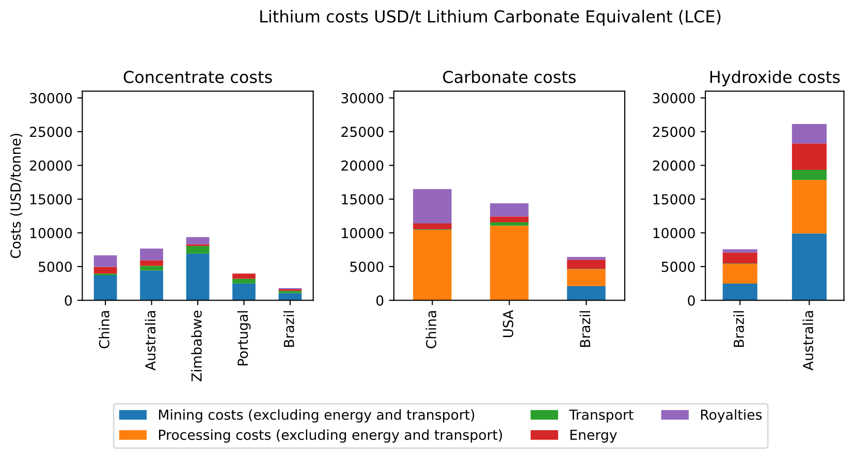
Figure 11: Baseline costs of mining and processing for lithium (US$/t Lithium Carbonate Equivalent). Source: Authors’ elaboration, based on S&P Database.

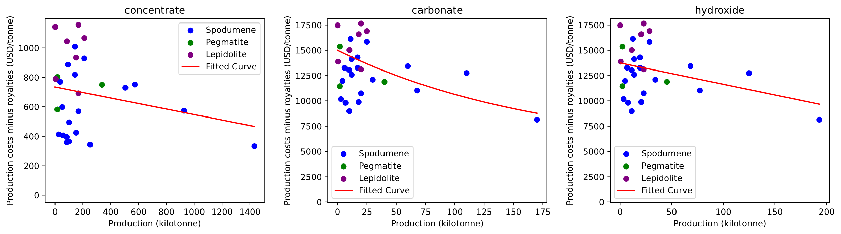
Figure 12: concentrate 6%, LCE and lithium hydroxide respectively). Source: Authors’ elaboration, based on Benchmark Lithium database 32.

In the case of graphite and manganese, no unit cost information was available within the S&P Database, even outside of Southern Africa. As an alternative, an extensive search for company reports revealed just one report with sufficiently detailed information for each mineral. As shown in Figure 13, the unit costs for graphite are based on a Molo report for Madagascar³³, while the unit costs of manganese are based on a Giyani report for Botswana³⁴. As before, transport, energy, and royalties were excluded, and mining and processing costs from each of these reports were taken as the only available proxy for Southern Africa.

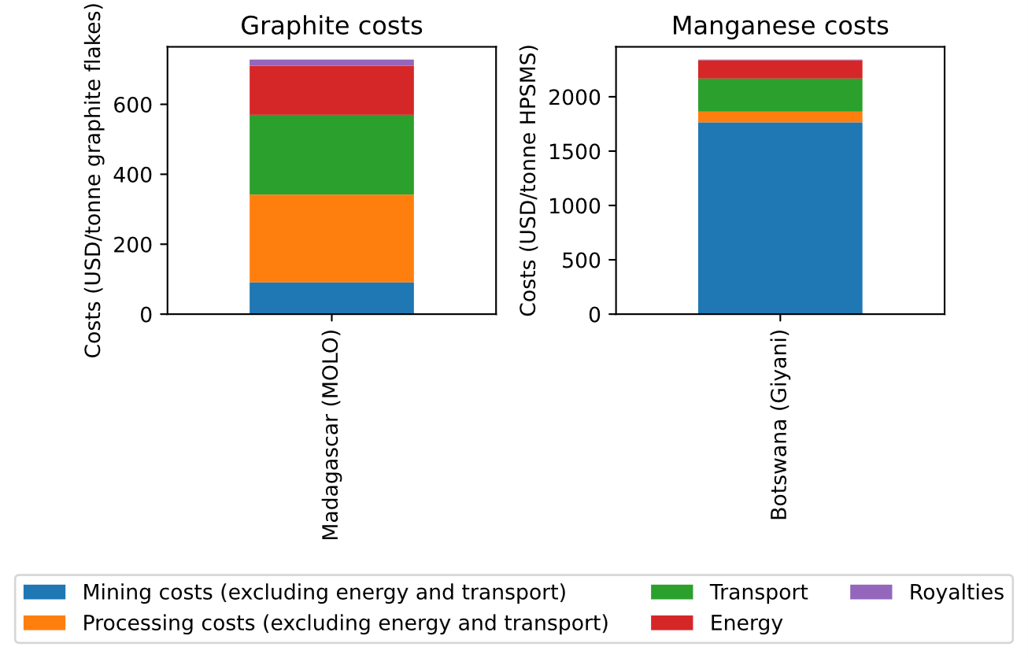
Figure 13: Baseline costs for mining and processing for graphite and manganese. Source: Authors’ elaboration, based on company reports.

3.2.2 Missing baseline unit costs for advanced stages of processing were estimated.
Unfortunately, the S&P Database does not include cost information for battery precursor input manufacturing, and neither did a search of company reports reveal any usable cost data. As a result, unit costs for advanced stage processing are proxied as a percentage of the retail price, based on expert judgment regarding industry norms. Given the technical expertise and capital-intensive nature of industrial operations for specialty inorganic chemicals (such as metal sulphates and oxides), the literature suggests that profit margins equivalent to 20–30% of prices are to be expected, indicating that unit costs of production (comprising raw materials, industrial processing and overheads) would typically amount to 70–80% of prices³⁵.

3.2.3 Unit costs for each stage of processing were projected into the future.
Given that baseline costs were estimated for 2022, these need to be rolled forward into the future up to the study horizon of 2040. Due to limited data, some scenarios were created, estimating ranges for innovation or regulatory frameworks based on the authors’ industry knowledge. Ranges were not used to avoid increasing the complexity of model runs. In rolling costs forward, three factors were considered and are reflected in the equation below.
- General price inflation (i). Based on IMF data³⁶, it was determined that the average annual inflation rate in the US for the period 2012–22 was 2.5%, and this was assumed to continue to 2040.

- Technological progress (t). As with any industry, the critical minerals mining and processing industry can expect to experience innovations that will gradually reduce the cost of industrial operations over time³⁷. Automation, digital analytics, remote operation centres, process optimisation, and sustainable energy integration are all improving efficiency, helping with lower costs. Although estimates vary by commodity, mining location, and regulatory environment, we assumed an average of 1.2% annual reduction for our cost projection³⁷.
- Regulatory changes (r). Given the environmental and social sensitivity of the minerals sector, and growing political pressure to improve governance³⁸, it is expected that the regulatory environment affecting the industry will continue to tighten with associated cost implications³⁹. We assumed this because regulatory burden increases faster than technological advancement in the mining sector. It is assumed that regulatory tightening will lead to a 5% increase in costs per year.
$$C_{n}=C_{2022}{\left(1+\left(i+r-t\right)\right)}^{\left(n-2022\right)}$$
Final cost estimates per mineral and stage of processing for the baseline year of 2022, as well as the 2030 and 2040 Scenarios are summarised in Table 7.
Table 7: Final OPEX estimates per mineral and stage of processing. The OPEX excludes electricity, transport outside the mine and royalty costs.
Unit costs of production (US$/tonne) |  | 2022 | 2040
Commodity | Stage | OPEX
Copper | Stage 1 | 2,929 | 4,537
Copper | Stage 2 | 991 | 1,304
Copper | Stage 3 | 1,141 | 1,502
Copper | Stage 4.3 | 648 | 853
Copper | Stage 5 | 720 | 948
Cobalt | Stage 1 | 20,868 | 32,320
Cobalt | Stage 3 | 2,271 | 3,517
Cobalt | Stage 4.1 | 3,845 | 5,062
Cobalt | Stage 5 | 3,290 | 4,331
Nickel | Stage 1 | 7,147 | 11,069
Nickel | Stage 2 | 785 | 1,216
Nickel | Stage 3 | 1,571 | 2,433
Nickel | Stage 5 | 1,460 | 1,922
Lithium | Stage 1 | 2,265 | 3,508
Lithium | Stage 3 | 4,783 | 6,297
Lithium | Stage 4.2 | 4,352 | 5,729
Manganese | Stage 1 | 306 | 403
Manganese | Stage 3.1 | 988 | 1,301
Manganese | Stage 4.1 | 440 | 579
Graphite | Stage 1 | 255 | 336
Graphite | Stage 3 | 450 | 592
Graphite | Stage 4 | 1,600 | 2,106
Graphite | Stage 5 | 1,600 | 2,106

3.2.3 Prices for different stages of processed mineral were projected.
Projections of future prices of critical minerals at each stage of processing are an important input into the study. These are needed to calculate future export revenues and value addition, as well as to anchor calculations of unit cost for late-stage processing (see Table 7). Baseline data on prices of processed minerals were obtained from the London Metal Exchange⁴⁰ for the base year of 2022, as well as a range of other sources detailed in Table 8. Identifying prices for some stages was challenging since some stages are not tracked by indices since they are hard to standardise or prices are kept private between companies and customers. In such cases, estimations were made as described below.
Table 8: Price sources consulted for this study.
Mineral | Price source | Comments on source
copper concentrate | ⁴¹
copper cathode | ^{1,42} | Prices widely available for cathode. Anode does not have tracked prices so it was assumed the price was equivalent to metal content in the absence of other data (98% of the price of cathode).
copper sulphate | ⁴³ | Price available for sulphate. Price for oxide was not available so it was assumed to be 90% of the price of sulphate.
cobalt concentrate | ⁴⁴ | Averaging country values for Turkey, China, India, Uganda, and Kenya.
refined cobalt | ⁴⁵ | Price only used for Madagascar and Zambia.
cobalt hydroxide | ⁴⁶ | Averaging country values for Angola, DRC, Kenya, Namibia, South Africa, Uganda, Tanzania and Zambia.
cobalt sulphate | ⁴⁷ | Historical Cobalt Sulphate Price from SMM Metal Market
cobalt sulphate | ⁴⁸ | Battery Grade Cobalt Sulphate Price Index, Shanghai Non-ferrous Metals
cobalt sulphate | ⁴⁹ | From report
manganese concentrate | ⁵⁰ | Price for Manganese Ore and Concentrate in Angola - 2022
manganese concentrate | ⁵¹ | Price for Manganese Ore and Concentrate in Kenya - 2021
manganese concentrate | ⁵² | Price for Manganese Ore and Concentrate in South Africa - 2023
manganese concentrate | ⁵³ | Price for Manganese Ore and Concentrate in Germany - 2023
manganese concentrate | ⁵⁴ | Price for Manganese Ore and Concentrate in Brazil - 2023
manganese concentrate | ⁵⁵ | Price for Manganese Ore and Concentrate in Belgium - 2023
manganese oxide | ⁵⁶ | Manganese Oxides Price in the UK - 2023
manganese oxide | ⁵⁷ | Manganese Oxides Price in Angola - 2022
manganese oxide | ⁵⁸ | Manganese Oxides Price in Kenya - 2021
manganese oxide | ⁵⁹ | Manganese Oxides Price in South Africa - 2023
manganese oxide | ⁶⁰ | Manganese Oxides Price in Uganda - 2022
manganese oxide | ⁶¹ | Manganese Oxides Price in Tanzania - 2022
manganese sulphate | ⁶² | SMM Manganese Sulfate Index (Battery Level) price
manganese sulphate | ⁶³ | Manganese Sulfate( Battery Level) price
manganese sulphate | ⁶⁴ | Manganese Historical Prices, Graph – Asian Metal
manganese ore | ⁶⁵ | Manganese Ore - Price - Chart - Historical Data
natural graphite | ⁶⁶ | Graphite Price in Angola - 2022
natural graphite | ⁶⁷ | Graphite Price in Tanzania - 2022
natural graphite | ⁶⁸ | Graphite Price in Kenya - 2022
natural graphite | ⁶⁹
natural graphite | ⁷⁰ | Graphite Price in South Africa - 2023
spherical graphite | ⁷¹ | Spherical Graphite 99.95%min 17μm max EXW China
coated spherical graphite | ⁷²
coated spherical graphite | ⁷³
lithium metal | ⁷⁴ | Battery Grade Lithium Metal, SMM Metal Market
lithium metal | ⁷⁵ | Industrial Grade Lithium Metal, SMM Metal Market
lithium metal | ⁷⁶ | Orangi et al., 2023, (USD/kg)
6% spodumene concentrate | ¹
lithium carbonate | ⁷⁷ | Lithium Carbonate (99.2% Industrial Grade), SMM Metal Market
lithium carbonate | ⁷⁸ | Lithium Carbonate Price in Uganda - 2022
lithium carbonate | ⁷⁹ | Lithium Carbonate Price in Tanzania - 2022
lithium carbonate | ⁸⁰ | Lithium Carbonate Price in South Africa - 2023
lithium carbonate | ¹
lithium hydroxide | ⁸¹ | SMM Lithium Hydroxide Index (Battery Grade), SMM Metal Market
lithium hydroxide | ⁸² | Lithium Hydroxide (56.5% Battery Grade, Fine Powder), SMM Metal Market
lithium hydroxide | ¹

Forecasting future prices is extremely challenging and official published price forecasts typically focus on traded mineral commodities, thereby excluding stages of interest in this study, and provide relatively short time horizons. Due to price volatility, linear extrapolations of historic price trends are likely to be misleading. Instead, two preferable statistical methods are considered and illustrated in Figure 14 and Figure 15 below for the specific case of copper.
- Weighted Moving Average (WMA). Following Ramadhani et al., (2023), the WMA method aims to smooth out market fluctuations and allow for evolving conditions over several years to be reflected in the forecast. It is recommended that the most recent five years of price (P) data be used for the calculation of each moving average, and that a weighting system be adopted so that more recent years are given a higher weight (W) (for example, with W1 = 0.35, W2 = 0.25, W3 = 0.20, W4 = 0.15, W5 = 0.05), as shown in the equation below.
$P_{n}=\sum_{i=1}^{5}{W_{i}}P_{\left(n-i\right)}$
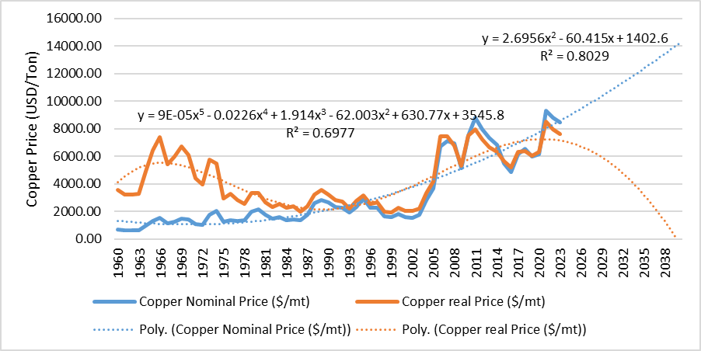
Figure 14: Illustration of Weighted Moving Average (WMA) methodology for forecasting price of copper

- Market Growth Rate (MGR). Following⁸⁴, a Compound Annual Growth Rate (CAGR) is calculated to provide a smoothed annual growth rate that reflects the overall trends in the market over the specified period, as shown in the equation below. The CAGR used for projection purposes is taken from the literature as indicated in Table 9. It is important to note that the CAGR does not account for market volatility, economic cycles, or unforeseen events that could impact material prices, and hence should be complemented by a broader analysis that includes qualitative factors and potential market disruptions.
$$CAGR={\left(\frac{P_{b}}{P_{0}}\right)}^{\frac{1}{b}}-1$$
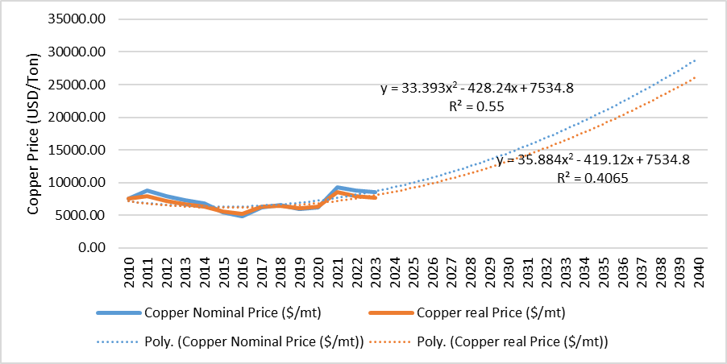
Figure 15: Illustration of Market Growth Rate (MGR) methodology for forecasting price of copper

Table 9: CAGR of prices and literature sources
Mineral | CAGR of prices (%) | Sources
Copper | 6.7 | ⁸⁵
Cobalt | 6.0 | ⁸⁶ ⁸⁵
Nickel | 7.3 | ⁸⁷ ⁸⁵
Lithium | 9.4 | ⁸⁸
Manganese | 5.0 | ⁸⁷
Graphite | 6.4 | ⁸⁹ ⁸⁷

For this study, the final average global projected price for each mineral at each stage of processing is calculated using MGR and is reported in Table 10.

Table 10: Projected average global commodity prices
Commodity Prices (US$/tonne) | Stage | 2022 | 2040
Copper | Stage 1 | 1,575 | 3,714
Copper | Stage 2 | 8,300 | 24,618
Copper | Stage 3 | 8,469 | 25,120
Copper | Stage 4.3 | 2,593 | 5,791
Copper | Stage 5 | 2,881 | 6,434
Cobalt | Stage 1 | 8,078 | 28,656
Cobalt | Stage 2 | 63,755 | 173,026
Cobalt | Stage 3 | 70,839 | 192,252
Cobalt | Stage 4.1 | 20,770 | 63,964
Cobalt | Stage 5 | 13,160 | 40,885
Nickel | Stage 1 | 1,775 | 6,310
Nickel | Stage 2 | 18,425 | 28,536
Nickel | Stage 3 | 15,289 | 54,348
Nickel | Stage 5 | 5,839 | 19,878
Lithium | Stage 1 | 5,752 | 28,939
Lithium | Stage 3 | 39,122 | 164,461
Lithium | Stage 4.2 | 42,278 | 212,671
Manganese | Stage 1 | 321 | 774
Manganese | Stage 3.1 | 1,485 | 3,585
Manganese | Stage 4.1 | 1,100 | 2,656
Graphite | Stage 1 | 937 | 2,863
Graphite | Stage 3 | 3,000 | 9,164
Graphite | Stage 4 | 3,600 | 10,996
Graphite | Stage 5 | 8,000 | 24,437

Modelling Transport Along Critical Minerals Value Chains
This section documents the detailed methodological steps used to model transport of minerals along critical minerals value chains. This is based on progressing from an international trading matrix to a more granular origin–destination matrix, and then to a mapping of specific transport routes based on an optimisation algorithm.

4.1 Developing an international trading matrix
An overview of this process is provided in Figure 16, with each step described in greater detail below.
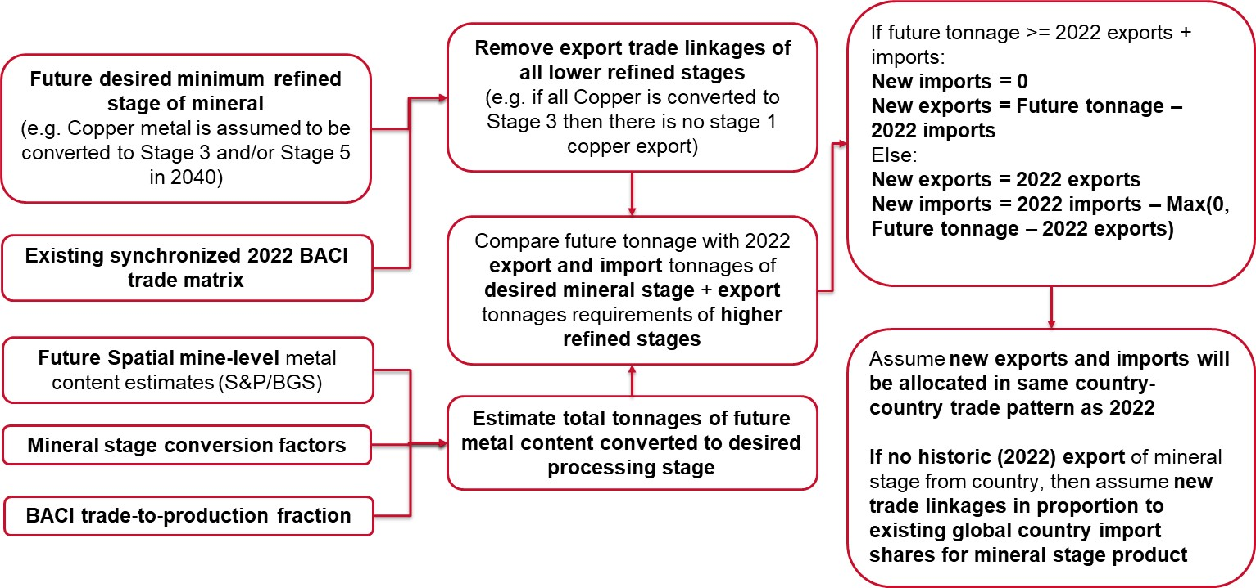
Figure 16: Flowchart for the development of an international trading matrix

4.1.1 Processed minerals of interest were matched against international trade data.
To have an accurate estimation of material flows, ideally mine-level information regarding the tonnage of mineral produced, processed, and shipped to various locations globally would be needed. Unfortunately, such detailed information is not available. However, it is known that mineral production in Africa is predominantly export-oriented ⁹⁰, suggesting that global trade datasets could be used to determine material flows between countries.
The reference global database of international trade at product level is BACI (Base pour l’Analyse du Commerce International)⁹¹, which is derived from the United Nations Commodity Trade Statistics Database⁹². BACI combines UN Comtrade data to give bilateral flows between 200 countries in both tonnes and US dollars for over 5,000 globally aggregated products as per a harmonised system (HS) of 6-digit product codes⁹³. These HS digits include several minerals and commodities of them with some logic. In some cases, the codes are used for unique enough types of compounds, while in other cases, compounds are grouped into a single category.

From BACI, specific product names and codes that best match the different minerals and their stages were mapped and used to extract their full global trade data. The outcome of the matching process is detailed in Table 11, highlighting varying degrees of correspondence between mineral processing stages of interest to this study and BACI codes. The main points of note are as follows.
- Cobalt: Stage 4.1 (hydroxide) is supposed to be mapped directly to its BACI code. However, an analysis if production revealed that DRC reports stage 4.1 in the code 810520. Thus, such code was used for stage 4.1 in most countries except for Zambia and Madagascar where some mines produce cobalt metal (stage 3) in which case, this is the category corresponding to it. There was no BACI code corresponding to Stage 5 processing, which was instead proxied by the broader code 283329: “Sulphates: n.e.c. in item no 2833.2” ⁹⁴.
- Copper: There was a direct one-to-one mapping between the identified mineral processing stages and the BACI commodity codes.
- Graphite: There are two BACI code corresponding to graphite, 250410, “graphite: nature, power or in flakes”, and 250490, “graphite: natural, in other forms, excluding powder or flakes”. Code 250410 was used as a proxy of trading patterns for stages past beneficiation (stage 1).
- Lithium: There was no BACI code for Stage 1 processing, which was proxied by the broader code 253090, “Arsenic sulfides, alunite, pozzolana, earth colours and other mineral substances, n.e.s.” ⁹⁵. This code is known to contain lithium products of interest.
- Manganese: There was no BACI code for Stage 5 processing, which was instead captured under a broader code 283329: “Sulphates: n.e.c. in item no 2833.2” (Matthews, 2020). Generally, there is a low representation of manganese trade compared to mineral production.
- Nickel: There was a direct one-to-one mapping between the identified mineral processing stages and the BACI commodity codes.

Table 11: BACI codes matched to mineral refining stage
 | BACI product description | BACI code | Refining stage
Cu | copper ores and concentrates | 260300 | 1
Cu | copper: unrefined, copper anodes for electrolytic refining | 740200 | 2
Cu | copper: refined, unwrought, cathodes and sections of cathodes | 740311 | 3
Cu | copper oxides and hydroxides | 282550 | 4.3
Cu | sulphates: of copper | 283325 | 5
Co | cobalt ores and concentrates | 260500 | 1
Co | cobalt: mattes and other intermediate products of cobalt metallurgy, unwrought cobalt, powders | 810520 | 2
Co | cobalt: mattes and other intermediate products of cobalt metallurgy, unwrought cobalt, powders | 810520 | 3
Co | cobalt oxides and hydroxides: commercial cobalt oxides | 282200 | 4.1
Co | Sulphates: n.e.c. in item no. 2833.2 | 283329 | 5
Ni | nickel ores and concentrates | 260400 | 1
Ni | nickel: nickel mattes | 750110 | 2
Ni | nickel: powders and flakes | 750400 | 3
Ni | sulphates: of nickel | 283324 | 5
Gr | graphite: natural, in other forms, excluding powder or flakes | 250490 | 1
Gr | graphite: natural, in powder or in flakes | 250410 | 1
Gr | graphite: natural, in powder or in flakes | 250410 | 3
Gr | graphite: natural, in powder or in flakes | 250410 | 4
Mn | manganese ores and concentrates, including ferruginous manganese ores and concentrates with a manganese content of 20% or more, calculated on the dry weight | 260200 | 1
Mn | manganese oxides: excluding manganese dioxide | 282090 | 3.1
Mn | Sulphates: n.e.c. in item no. 2833.2 | 283329 | 4.1
Li | Arsenic sulfides, alunite, pozzuolana, earth colours and other mineral substances, n.e.s. | 253090 | 1
Li | carbonates: lithium carbonate | 283691 | 3
Li | lithium oxide and hydroxide | 282520 | 4.2

4.1.2 International trade data was converted into equivalent metal tonnages.
For the purposes of the transport analysis, it was necessary to understand physical volumes of material flowing along the mineral supply chains. Although the BACI data provided physical tonnages, the aggregation of multiple different stages of processed minerals with widely differing metal contents into single BACI codes made this information difficult to use. For example, copper ores and concentrates are grouped together under a single BACI code, when copper ore typically has a metal concentration of 0.5%, while copper concentrates contain around 30% copper ^{96,97} .
Some of the commodity codes in BACI were generic and only a subset of the type of products within each commodity code could be expected to be used as battery precursors. Adjustments to complete the conversion to estimates of actual country-to-country tonnages that were being transported was done in the BACI trade data as follows.
- The mine-level data (see Section 1) contained estimates of the total reported metal content produced by a country for all uses. This provided an estimate of the total feasible amount of metal that would be processed into other stages.
- Known mineral stage-specific material conversion factors were used, which gave estimates of the amount (kg) of a given stage output produced per one unit weight (1 kg) of metal or mineral (for graphite) in the ore. Figure 17 shows the conversion factors starting from the mining and beneficiation stage all the way to the desired stages related to battery precursor production.
- The material conversion factors were next applied sequentially to the initially corrected BACI trade data, where mass-balance checks were applied to estimate if the total country-level exports at all stages would be possible by converting the remaining metal content at mine level (left after factoring in previous stage exports) and import tonnages of lower stages to the higher stage product using the conversion factors from Figure 17. If for any mineral exports at any stage the BACI estimated exports were lower than the feasible production achieved by adding the converted (to higher stage) volume of remaining metal content production plus the converted (to higher stage) volumes of lower stage imports, no changes were made to the BACI trade data. If the BACI estimated higher stage exports exceeded the feasible production from converting metal content volumes plus converting lower stage imports, then the higher stage exports were reduced to match feasible production values. Lowering a country’s total export estimates would then result in proportional reductions of its existing exports to other trade partner countries and create a new export–import global balance for the particular stage. This would then propagate through the next higher stage of production till the highest stage of product for each mineral was reached.

Figure 17: Mineral stage-specific material conversion factors. Note: Material conversion factors showing the volume (in kilograms) of each stage of mineral product produced for unit kilogram (1 kg) of metal or mineral in ore.
An intermediate result of from the analysis is shown in Table 12, where the estimated country totals of metal (or lithium carbonate) contents utilised in higher stage productions for exports (from BACI data) are compared with the mine-level estimates of total metal productions. Where the values are equal (ie the trade-to-production fraction is 100%) the BACI trade values were proportionally reduced to match mine-level production. For example, in the case of lithium this means that the trade for the generic-looking product code 253090 “Arsenic sulfides, alunite, pozzolana, earth colours and other mineral substances, n.e.s.” (which is known for including lithium products relevant to the study) was reduced to capture only lithium-specific trade. Also, it means all the product mine-level outputs would be utilised for production of the chosen higher stage products for exporting. Where the trade-to-production fraction values are less than 100% it means that there were possibly other uses of the metal that were not captured through the selected products in the trade data or there was unaccounted domestic consumption. For example, only 57% of South Africa’s mine-level cobalt production was accounted for in the production of the chosen higher stage products for export, while the remaining 43% went to other nickel-related products that were being used to non-EV battery manufacturing.
Table 12: Estimated country totals of metal contents for higher stage productions for exports compared with mine-level estimates of total metal productions
Mineral | Exporting country (name) | Metal converted to the chosen commodities and exported (tonnes) | Total mine-level metal production estimates (tonnes) | Trade-to-production-fraction (%)
Cobalt | DRC | 118,077 | 118,077 | 100%
Cobalt | Madagascar | 3,428 | 3,428 | 100%
Cobalt | South Africa | 250 | 250 | 100%
Cobalt | Zambia | 940 | 940 | 100%
Copper | Botswana | 54,849 | 59,225 | 93%
Copper | DRC | 1,797,006 | 2,394,630 | 75%
Copper | Namibia | 3,500 | 3,500 | 100%
Copper | Tanzania | 118,027 | 118,000 | 100%
Copper | South Africa | 59,533 | 59,528 | 100%
Copper | Zambia | 720,848 | 763,550 | 94%
Copper | Zimbabwe | 201 | 12,907 | 2%
Graphite | Madagascar | 116,700 | 116,700 | 100%
Graphite | Mozambique | 165,932 | 165,932 | 100%
Graphite | Tanzania | 9,559 | 38,891 | 25%
Lithium | Namibia | 978 | 978 | 100%
Lithium | Zimbabwe | 2,342 | 2,342 | 100%
Manganese | DRC | 955 | 1,972 | 48%
Manganese | Namibia | 84,616 | 183,441 | 46%
Manganese | South Africa | 10,783,337 | 10,777,205 | 100%
Manganese | Zambia | 89,024 | 89,048 | 100%
Nickel | Madagascar | 19,258 | 39,780 | 48%
Nickel | South Africa | 28,809 | 50,154 | 57%
Nickel | Zambia | 4,059 | 4,059 | 100%
Nickel | Zimbabwe | 615 | 20,676 | 3%

4.1.3 Future patterns of international trade were projected
Since the aim of the study is to simulate an expansion of future production of more highly processed minerals, it was necessary to use information contained in current trading exchanges to proxy for potential future trading patterns for products that are not yet being produced.
Forecasting future trade patterns between countries is a complex process, subject to considerable uncertainties, and none of the existing methodologies in the literature was suitable for this purpose.
- Computable General Equilibrium (CGE) Models. A global model for long-term trade evolution has been proposed using dynamic CGE methods, with exogenous inputs of macroeconomic, demographic, sectoral and transport cost projections⁹⁸. However, the model is at a very aggregated scale of 25 regional clusters (with Africa divided into 2 broad clusters) and 4 sectors (agriculture, services, extractives, and manufacturing), which does not provide adequate resolution for the countries and commodities under consideration.
- Network Complexity-Based Models. Zhang et al. (2023) developed a network complexity-based model to predict trade links between 254 countries for 9 raw critical minerals products used in the lithium-ion battery chain, using UN Comtrade data from 2011 to 2020. However, their model relied on preserving the types of products countries were producing and did not consider countries moving up towards higher stage processing and exporting new products.
- Regression Models. Approaches using regression and material flow analysis to quantify evolution of stocks and demand for critical minerals were also developed ¹⁰⁰; however, they lack the geographic details needed in this case.
Since there were no readily available approaches for estimating the type of future trade matrices needed for this study, a new approach was proposed. Future trade matrices for 2040 were created specifically to reflect changes in global exports and import for the 14 African countries, based on the following steps.
- The future mine-level metal content estimates for 2040 were added up to get the country-level production of total metal content (see Section 2).
- The baseline (2022) BACI trade matrix was used to infer existing and future trade relationships between countries. The baseline trade-to-production fraction (%) values (see Table 12) were assumed to remain constant over time, which meant that whatever future metal contents were produced by a country, they were utilised in the same proportion for the different products that were being tracked in this study. If countries were mining and producing new minerals they did not historically produce, then for these new products the trade-to-production fraction (%) was assumed to be 100%.
- Threshold level values were estimated to determine the lowest required volume of total metal (or mineral for graphite) content that would be needed to move towards higher stage mineral processing production and exports. Based on cost curve analysis, a production threshold was identified for all minerals offering sufficient data points (see Table 13 and recall Section 2).
  - Minimum observable scale of processing activity. This is the smallest size of processing plant observed in the S&P Database, and for individual countries producing below this amount it is assumed that processing is not economically feasible.

Table 13: Minimum observable scale of processing
Mineral | Minimum observable scale of processing (tonnes/year)
Copper (metal content) | 3,737
Nickel (metal content) | 3,800
Cobalt (metal content) | 200
Graphite (mineral content) | 17,227
Manganese (metal content) | 73,000
Lithium (carbonate content) | 6,269
- The study simulates three future trade scenarios by 2040. The Business-As-Usual Scenario assumes that countries maintain existing trade patterns and processing products in 2040. So, the trade grows or contracts according to the total mine level outputs. For countries not previously producing a mineral product (due to lack of mines) new mine level outputs were assumed to be converted to the initial stage products (i.e. Stage 1) and exported globally to countries with existing demands for the product. In the Precursor-Related Product Scenario countries move to progressively higher levels of processing over time. The table below clarifies the target processing stage for each mineral under the 2040 Precursor-Related Product Scenario. Nevertheless, it is not always feasible for countries to be able to process 100% of Stage 1 production to the target stage, either due to resource and energy constraints, or because there are other possible processing directions for the Stage 1 mineral beyond the battery value chain. This is also clarified in Table 14. For example, only 10% of future manganese ores and concentrates would be converted to a Stage 5 (manganese sulphate) product in 2040. The percentage values in Table 12 were arrived at based on the sources and assumptions described.

Table 14: Percentage of mineral production at each stage that is assumed to be processed to the next stage of the battery value chain (proportion used as metal content restriction). This proportion enables modelling shares of products that may be used for non-battery applications.
Mineral | Refining stage | Metal content (or mineral for graphite) share for next stage (%) | Comments and source
Copper | 1 | 100
Copper | 2 | 100
Copper | 3 | 100
Copper | 4.3 | 50
Copper | 5 | 50 | 2040 Precursor related product target ¹⁰¹.
Cobalt | 1 | 100
Cobalt | 2 | 100
Cobalt | 3 | 100 | Only used for Zambia and Madagascar
Cobalt | 4.1 | 100
Cobalt | 5 | 60 | 2040 Precursor related product target. This grows to 0.6 to reflect a higher global demand for batteries and is to be used for the 2040 scenario but the share of the total mineral is reduced from the previous stage in real life ¹⁰².
Nickel | 1 | 100
Nickel | 2 | 100
Nickel | 3 | 100
Nickel | 5 | 25 | 2040 Precursor related product target
Graphite | 1 | 100
Graphite | 3 | 30
Graphite | 4 | 40 | 2040 Precursor related product target ¹⁰².
Manganese | 1 | 100
Manganese | 3.1 | 10
Manganese | 4.1 | 10 | 2040 Precursor related product target ¹⁰².
Lithium | 1 | 100
Lithium | 3 | 100
Lithium | 4.2 | 100 | 2040 Precursor related product target. Lithium is the mineral which has the highest uses in batteries, thus all production is used ¹⁰².

- For the scenario where all mineral processing is constrained to take place within the borders of the country where it is mined, total country-level mineral-specific metal (or mineral for graphite) content volumes were compared with the threshold values set for the minimum observable scale. This was then used to estimate the new total volumes of imports and exports entering and leaving each country.
  - If a country produced metal content above the threshold, then it would consider converting its metal content into higher stages of processed products. Otherwise, its least stage of export would be the Stage 1 (ores and concentrates) product.
  - The global trade for all countries moving towards higher stage production would then start with the least stage of processed product for the future year and all historical exports of products corresponding to stages below that would vanish to zero.
  - If the historic trade data (step 2, above) showed that a country was exporting certain volumes of products at stages above the least stage of processed product then these volumes would remain the same in the future years, if there were sufficient metal or lithium carbonate) content production. This meant that the priority for countries would be to change their productions and exports of the chosen least stage of processed products, while trying to maintain the historic level of exports of further higher stages of refined products.
  - If a country was historically importing products corresponding to the future least stage of processed products, then its first priority would be to replace this with its domestic production. Also, import volumes of lower stage products (stages below the least stage of future production) that would historically go into the production of higher stage export volumes were also assumed to be displaced by domestic production if the future metal content was sufficient. If the future metal production was not sufficient then the lower stage imports were continued but were not allowed to exceed their historic levels. This would simply mean that countries would not try to increase imports if their metal (or mineral for graphite) content production fell in future.
  - All import volumes of future products corresponding to stages higher than the future least stage of processed product were assumed to remain unchanged.
  - The new volumes of the least stage of processed product in the future were estimated from the metal content that was left after estimating the new volumes of higher stage exports and the volumes of domestic production that would displace historic imports of least stage of processed product.
  - Using the material conversion factors (see Figure 17), each country’s metal content volumes were converted to all the new identified stages of products (from the list shown in Table 14) and the corresponding volumes for total exports, imports, and domestic usage, by following the rules outlined in steps 5a–f above.
- For the scenario where minerals are allowed to cross-borders to seek more cost-effective opportunities for minerals processing at minimum observable scale, the initial assumption was that each country would export any volume of minerals at or above the minimum observable scale for next stage processing to allow regional accumulation of metal content. This meant that the default assumption was that each country’s exports would start from the least stage of processed product for the future year. The remaining export, import, and domestic trade volumes for the future will be estimated by following steps 5b–g above.
- The next step was to disaggregate the total volumes of each country’s exports and imports into country-to-country trade. This was done in the following steps:
  - The exports and imports of the 14 African countries of interest were fixed, while it was assumed that the rest of the world would have flexible demand to be able to accommodate increased exports coming from these 14 countries and adjust their own supply if the 14 African countries were not importing product from them in the future.
  - Using the same trading partners as in the baseline (2022) BACI trade data, all exports of products no longer produced in the future, by the 14 countries of interest, were set to zero.
  - Using the same trading partners as in the baseline (2022) BACI trade data, first the import volumes for each product coming into each of the 14 countries of interest from historic partner countries were proportionally changed to match the future total imports of these products into each country.
  - Next the exports out of the 14 countries were adjusted. If a country exported a product in the baseline (2022) BACI trade data, then it was assumed that it would continue to export to the same countries and the trade would change proportionally to match the future total exports of these products out of each country.
  - If a country started producing a new product that it was not exporting in the baseline, then its exports of this product were assumed to be distributed to countries (outside the 14 African countries of interest) globally in the same proportion as the global baseline demand for the product.

4.2 Disaggregating cross-border trade flows to higher resolution origin–destination travel matrix

4.2.1 Origin–destination points were identified.
Following the creation of the country-to-country trade matrices, the trade material flow volumes (in tonnes) were disaggregated to specific locations to create origin–destination matrices. These origin–destination matrices were created with respect to each one of the different trade flow scenarios. For very accurate estimation of transport flows, data would be needed on detailed locations and supply and demand volumes shipped between every mine, processing plant, ports, and other manufacturing facilities globally where the products would be utilised for EV battery production. Having such detailed supply chain information was not possible as it would require mining and manufacturing company data which are often not open source. For the scope of this study, locations were interpreted as proxies for most likely areas for concentration of mining and processing activities and areas for facilitation of the transport logistics of the mineral supply chain globally. The types of locations for origin–destination disaggregation were chosen as follows.
- Mine locations. The starting locations for all minerals were at the mines, which were chosen as origins where lower stage processing was being done before being sent for transport. As mentioned in Section 1, some existing mine locations were accurate as per remote sensing datasets, while future mine locations were inferred from S&P estimates.
- Major city locations. Certain higher stages of processed product (eg copper sulphate) are already being produced in some countries in Africa such as South Africa¹⁰³. Ideally the exact locations of the specific processing plants and their production volumes (or capacities) would help disaggregate the country-level exports for these products to locations. However, such data were not available. An assumption was taken that the existing higher stage processing plants would be located in the vicinity of major cities where labour and energy inputs would be readily accessible. A UN population dataset on major city locations with population more than 300,000 was chosen¹⁰⁴, for identifying locations of existing higher stage processing.
- African gateway ports. Specific ports in Africa were identified as gateway ports for the entry and exit of mineral-specific products. While these were neither origin nor destination locations, they were important for inferring trade routes within Africa as they are connected to important corridors for transport. The list of the gateway ports in Africa identified in this study is provided in Table 15 with the types of minerals being handled at each port. The annual vessel capacities for general and dry bulk cargo vessels arriving at these ports are also reported. These values were taken from¹⁰⁵, which derived values from global shipping datasets.
- Global ports. For countries outside the African continent, ports handling highest volumes of bulk or general cargo were identified as destinations for receiving the exports coming from the 14 Africa countries and as origins from where the 14 African countries would be getting their imports. This simplified approximation was taken because there were no data on the types of mineral products being handled at ports in every country in the world. Also, the aim of the study was to identify approximate gateway points for trade entry and exit to countries outside the 14 African countries of interest, to infer the most feasible maritime routes out of Africa.

Table 15: Gateway ports in Africa
 |  | Minerals processed at port
African gateway port | Country | Cu | Co | Ni | Li | Mn | Gr | Annual vessel capacities (tonnes)
 |  |  |  |  |  |  |  | General cargo | Dry bulk cargo
Lobito | Angola |  |  |  |  |  |  | 686,515 | 607,419
Mombasa | Kenya |  |  |  |  |  |  | 1,848,161 | 13,985,304
Toamasina | Madagascar |  |  |  |  |  |  | 335,929 | 3,638,271
Beira | Mozambique |  |  |  |  |  |  | 1,057,356 | 8,749,086
Maputo | Mozambique |  |  |  |  |  |  | 1,758,199 | 23,477,057
Nacala | Mozambique |  |  |  |  |  |  | 455,498 | 10,249,784
Walvis Bay | Namibia |  |  |  |  |  |  | 2,901,211 | 1,860,172
Luderitz Bay | Namibia |  |  |  |  |  |  | 126,312 | 805,992
Saldanha Bay | South Africa |  |  |  |  |  |  | 804,523 | 66,277,596
Durban | South Africa |  |  |  |  |  |  | 7,121,630 | 39,746,309
East London | South Africa |  |  |  |  |  |  | 71,561 | 358,922
Port Elizabeth | South Africa |  |  |  |  |  |  | 2,226,238 | 40,410,807
Dar Es Salaam | Tanzania |  |  |  |  |  |  | 1,090,358 | 6,142,306

4.2.2 Processing locations were established.
Since little mineral processing is currently taking place in Southern Africa, assumptions had to be made regarding where future processing would take place. This was based on the approach summarised in Table 16. Across the scenarios most of the early-stage processing (eg ores and concentrates, unrefined products) was assumed to be produced at the mining site, which is common in the mining industry given the large volumes of ore extracted¹⁰⁶. The intermediate stages (eg copper and cobalt cathode, spherical graphite, lithium carbonate, manganese oxide, and nickel mattes) were assumed to be processed at the mines or right next to them in the baseline scenario, which currently occurs for large-scale operations such as Glencore’s Mutanda mine in DRC which produces copper and cobalt¹⁰⁷. The assumption is less true for lesser developed mineral processing in the continent such as lithium, graphite, or manganese (for battery applications), yet using the same assumption facilitated calculations and comparisons. In the absence of any data, higher stages were assumed to have processing locations in the vicinity of cities where manufacturing would be located. In the Business-As-Usual Scenario the processing at the mines would scale up if the mine level output increased. In the Precursor-Related Product Scenario the mine level processing would at most match their baseline volumes. Any excess tonnage of metal content (or ores and concentrates) in the future scenarios would be moved out of the mines towards new locations. For the future scenarios the processing of the desired stages of products was assumed to move towards locations of flow concentration as estimated from a flow optimisation model (see Table 16).

Table 16: Summary of assumptions regarding future processing locations
 |  |  |  | Processing locations
 | BACI product description | BACI code | Refining stage | Baseline (2022) | Precursor product 2040
Cu | copper ores and concentrates | 260300 | 1 | Mine | Mine
Cu | copper: unrefined, copper anodes for electrolytic refining | 740200 | 2 | Mine | From flow optimisation
Cu | copper: refined, unwrought, cathodes and sections of cathodes | 740311 | 3 | Mine | From flow optimisation
Cu | copper oxides and hydroxides | 282550 | 4.3 | City | From flow optimisation
Cu | sulphates: of copper | 283325 | 5 | City | From flow optimisation
Co | cobalt ores and concentrates | 260500 | 1 | Mine | Mine
Co | cobalt: mattes and other intermediate products of cobalt metallurgy, unwrought cobalt, powders | 810520 | 2 | Mine | From flow optimisation
Co | cobalt: mattes and other intermediate products of cobalt metallurgy, unwrought cobalt, powders | 810520 | 3 | Mine | From flow optimisation
Co | cobalt oxides and hydroxides: commercial cobalt oxides | 282200 | 4.1 | Mine | From flow optimisation
Co | Sulphates: n.e.c. in item no. 2833.2 | 283329 | 5 | City | From flow optimisation
Ni | nickel ores and concentrates | 260400 | 1 | Mine | Mine
Ni | nickel: nickel mattes | 750110 | 2 | Mine | Mine
Ni | nickel: powders and flakes | 750400 | 3 | Mine | From flow optimisation
Ni | sulphates: of nickel | 283324 | 5 | Mine | From flow optimisation
Gr | graphite: natural, in other forms, excluding powder or flakes | 250490 | 1 | Mine | Mine
Gr | graphite: natural, in powder or in flakes | 250410 | 1 | Mine | Mine
Gr | graphite: natural, in powder or in flakes | 250410 | 3 | Mine | From flow optimisation
Gr | graphite: natural, in powder or in flakes | 250410 | 4 | City | From flow optimisation
Mn | manganese ores and concentrates, including ferruginous manganese ores and concentrates with a manganese content of 20% or more, calculated on the dry weight | 260200 | 1 | Mine | Mine
Mn | manganese oxides: excluding manganese dioxide | 282090 | 3.1 | Mine | From flow optimisation
Mn | Sulphates: n.e.c. in item no. 2833.2 | 283329 | 4.1 | City | From flow optimisation
Li | Arsenic sulfides, alunite, pozzuolana, earth colours and other mineral substances, n.e.s. | 253090 | 1 | Mine | Mine
Li | carbonates: lithium carbonate | 283691 | 3 | Mine | From flow optimisation
Li | lithium oxide and hydroxide | 282520 | 4.2 | City | From flow optimisation

4.2.3 National trade flows were disaggregated across origin–destination points.
The country-level trade values were disaggregated to the location-specific origins and destinations as follows.
- Since the country-level metal (or lithium carbonate) content productions were aggregated from mine-level metal (or lithium carbonate) content values, the trade out of the mines to all destination locations was assumed to be disaggregated in the same proportions.
- The products being manufactured and traded out of the city locations were assumed to be disaggregated in proportion to the populations assigned to these locations.
- Since unique global ports per country were identified as destination locations for products, it was straightforward to assign all trade coming into a country to a given port. It was assumed that all mines (or cities) producing a particular product in the origin country would be shipping to the destination country’s port. For example, if DRC was exporting Stage 1 copper to China, then all mines in DRC were assumed to shipping Stage 1 copper to China. While this is unlikely to be entirely accurate, in the absence of detailed mine-level information, disaggregating the total trade to each mine was a sensible approach that captures the overall trade patterns.
- If there was trade to be assigned from mine-to-city or city-to-city within Africa, then the values from each origin location were disaggregated in proportion to the population weights of each destination location.

4.3 Modelling optimal routing of trade flows across travel infrastructure

4.3.1 A transport flow allocation model was created.
A transport flow allocation model was created to estimate how the volumes (in annual tonnes) of products being produced at different supply locations (origins) would be moved via transport networks to demand locations (destinations), along the mineral supply chain, as illustrated in Figure 18. Broadly, the trade flows routes were divided into two types:
- Trade within Africa. This involved routing flows in the following ways:
  - Between mines to convert unrefined products to lower stage refined products. This was done between mines of separate countries, if the high-level trade matrix indicated that these countries would be trading unrefined product which would be converted into lower stage refined product in the destination country for further usage (see Figure 18).
  - From mines to existing higher processing locations (cities), within a country and between trading countries. Routing was also done between mines and cities within a country for transporting the residual unrefined product for manufacture of other products not being used in the EV battery value chain (based on the assumptions from Table 16).
  - Between cities to send higher stage processed products from one country to another, as indicated by the trade data.
  - From mines and cities towards gateway ports for global exports.
  - Imports from gateway ports towards mines (those producing refined product only) and cities. The imports headed towards mines were assumed to be distributed in proportion to the metal content production of each mine, and the imports headed towards the cities were assumed to be distributed in proportion to the population of each city.
- Trade beyond Africa. This involved sending flows (exports and imports) via a global shipping network between the African gateway ports to one port per country of destination or origin.

Figure 18: Schematic of baseline flow routing
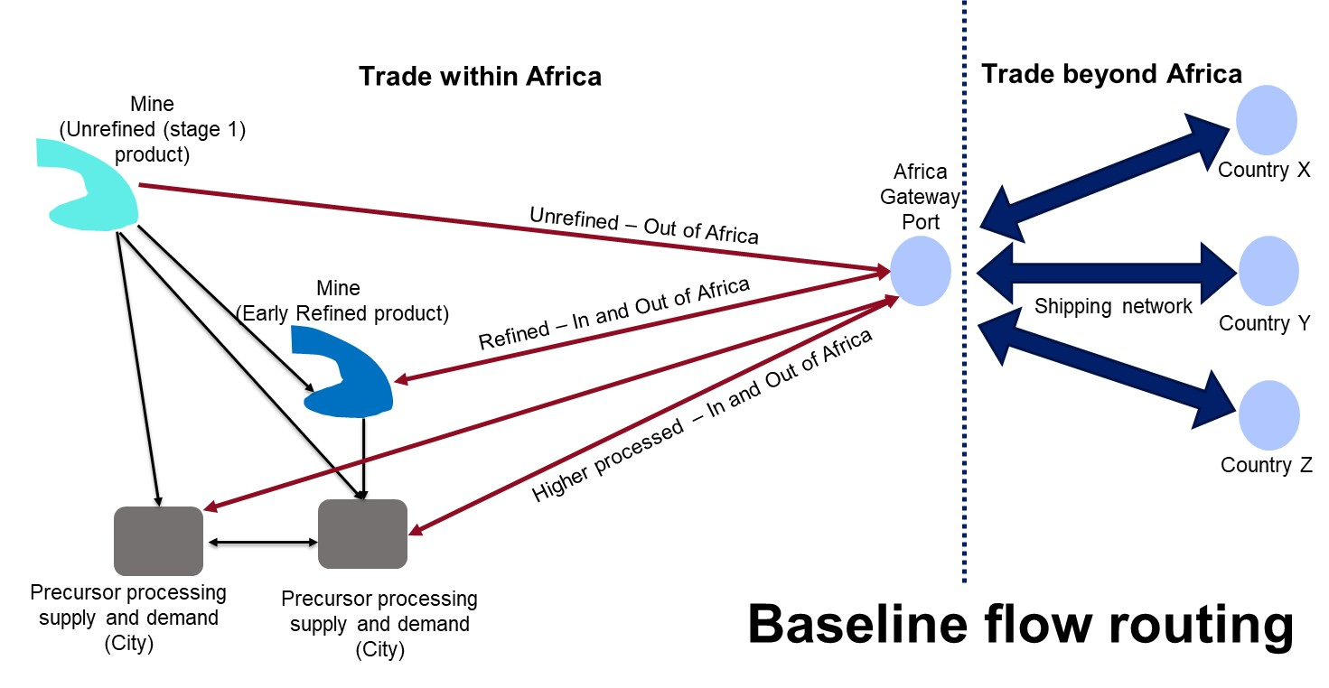

4.3.2 A multi-modal routable transport network was constructed.
To implement the transport routing, first spatial network datasets were collected and joined together to create a multi-modal routable network, based on the sources identified in Table 17.
Table 17: Sources for mapping a multi-modal routable network
Transport Mode | Network elements | Coverage | Source
Maritime | - 3,780 nodes (1,473 Ports)  - 9,538 maritime links  - ~82,000 direct shipping routes | Global | ^{105,108}
Railways | - 51,351 nodes (3,667 Stations)  - 51,489 rail line segments | Africa | ^{109,110}
Roads | - 2,179,766 endpoints of road segments  - 2,305,150 road segments | Africa | ¹⁰⁹

Data for each transport mode was organised as a layer of nodes (eg ports, railway stations, road junctions) and a layer of edges connecting nodes (eg maritime routes, rail lines, road links), which defined the well-known concept of topology of a network graph ^{111–113}.
- Maritime. The maritime network topology information was based on the existing global dataset created by Verschuur et al. (2022), to which some missing ports in Africa were added from a USGS database¹⁰⁸.
- Rail. The railway network topology was created from OpenStreetMap (OSM) data, which did not have connectivity between stations and lines. This connectivity was created via a Python function¹¹⁴, by joining stations to their nearest rail lines. Further modifications were made to add attributes to the lines (eg status of operation) and stations (eg type of usage: container depot, mine, ports, intermodal, etc) to infer major hubs where the railways network would connect with mines, roads, and ports. Some existing rail projects, missing in OSM, were also identified from a recent study¹¹⁰, spatially mapped, and joined to the OSM rail network.
- Roads. The road network topology was created from road links data from OSM. The dataset of all roads in Africa contained several millions of roads, the majority of which were not useful for this study. This was converted to a topological network utilising a Python workflow¹¹⁵. Roads that formed the main corridors in Africa and facilitated long-distance transport from mines to ports and major cities were most important. Hence, roads in OSM classified as motorways, trunk, primary, and secondary were selected as the main network of Africa, along with all the roads that connected mines, cities, and ports to the main network.
The three networks were also spatially connected with each other by connecting mines, cities, and ports to their nearest roads. In the case of railways, the mines, cities, and ports were only connected to a railway station if it was within 2 km of the site. Rail stations that were identified as intermodal locations were connected to their nearest road node. The maps of all three modal networks for Southern Africa are shown in Figure 19.

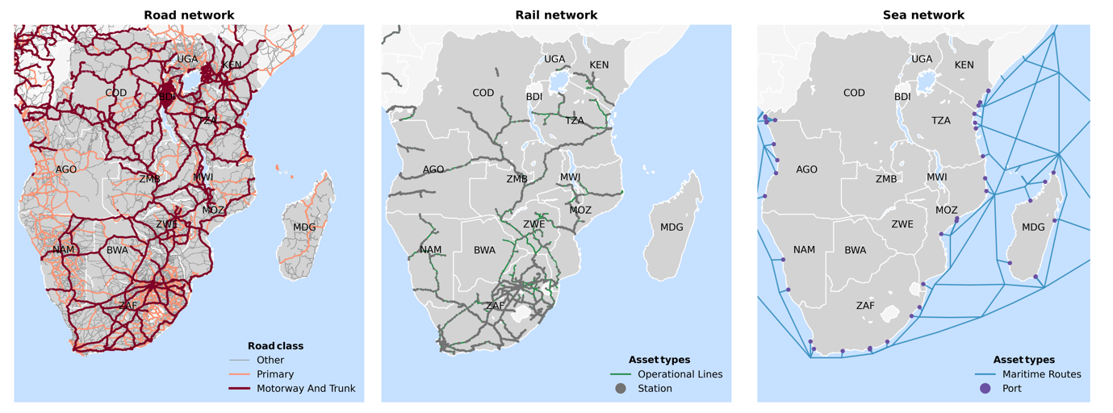
Figure 19: Road, rail, and sea network maps

4.3.3 Network flows were optimised.
The transport flow routing model for quantifying trade flows on the multi-modal transport network involved connected mines, roads, railways, and maritime ports in Africa to a global shipping network. These locations were therefore embedded within the multi-modal transport network that included geolocated railways, roads, and maritime nodes and edges. The resulting full transport network topology was modelling as a graph $G=(N,E)$ with nodes $N=\{1,…,n\}$ and edges $E= \left\{e_{ij}=\left(i,j\right) ∀i,j∈N\right\}$, where the relationship $e_{ij}=\left(i,j\right)$ showed that edge $e_{ij}$ connected from node $i$ towards $j$. Edges were assumed to be directed, that is $e_{ij}≠e_{ji}$, to distinguish between the direction and volumes of export and import trade flows. This meant that the road and rail lines were duplicated to account for flows in both directions.
The multi-commodity origin–destination matrix data, for the set of $K=\{1,…,q\}$ unique mineral products, denoted as $V\left(N,N,K\right)= \left[v_{od}^{k}\right],∀1≤r,s≤n;1≤k≤q$, contained the volume in annual tonnes ($v_{od}^{k}$) to be assigned between mines, processing locations, and ports via the network edges. For assigning the origin–destination matrix onto the network, each edge ($e_{ij}$) was assigned a generalised cost ($c_{ij}$) (in US$/tonne) of freight transport. Commodity-specific flows ($f_{ij}^{k}$) along network edges were estimated by minimising the total cost of transport for each origin–destination matrix flow ($v_{od}^{k}$) along the network edges (Equation (1)), with the total flow assigned to an edge not exceeding its capacity ($μ_{ij}$) (Equation (2)), and all origin–destination matrix flows being assigned onto the network (Equation (3)). Here $1_{ijod}$ denotes an indicator function equal to 1 if the edge $e_{ij}$ was chosen in the route between and origin ($o$) and destination ($d$) pair and was 0 otherwise.
$$\begin{matrix}min & \sum_{j=1}^{j=n}{\sum_{i=1}^{i=n}{1_{ijod}f_{ij}^{k}c_{ij}^{k}}},∀k,o,d \\ s.t. & \sum_{k=1}^{k=q}{f_{ij}^{k}}≤μ_{ij}, ∀i,j \\ & \sum_{j=1}^{j=n}{\sum_{i=1}^{i=n}{\sum_{k=1}^{k=q}{f_{ij}^{k}}}}=\sum_{d=1}^{d=n}{\sum_{o=1}^{o=n}{\sum_{k=1}^{k=q}{v_{od}^{k}}}}\end{matrix}$$ | (1)
 | (2)
 | (3)

The solution of the above flow assignment problem resulted in optimising the flow of the commodities between mines, processing sites, and ports. The generalised cost along a particular network edge is expressed in Equation (4) in terms of factors described below.
$c_{ij}^{k}=a_{ij}(w_{ij}^{k}+t_{ij}^{ })+h_{ij}^{k}+l_{ij}b_{ij}^{k}$ (4)
- Waiting times or dwell times ($w_{ij}^{k}$). Commodity-specific time (in hours) spent by unit tonnage of the cargo from its arrival to departure at a port or land border crossing (road or rail post). In the network flow assignment model, these costs were applied to country-specific ports and border crossings (point locations), and they were given to the edges that connected to these point locations.
- Travel times ($t_{ij}^{ }$). The time (in hours) depending upon the speed to travel through a network edge (road section, rail line, or maritime routes).
- Value of time ($a_{ij}$). A factor applied to indicate the cost of time (in US$/tonne-hour) to the shipping company sending the cargo.
- Handling costs ($h_{ij}^{k}$). Commodity-specific costs in US$/tonnes for loading and unloading cargo at maritime ports and inter-modal transfer points between road and rail links. These costs are applied the multi-modal edges that connect these point locations.
- Edge length ($l_{ij}$). The length of the road, rail, or maritime route in kilometres.
- Tariff rates ($b_{ij}^{k}$). A fixed commodity-specific tariff (in US$/tonne-km) imposed on the road or rail routes based on the weight and distance of cargo being transported.

Values for the parameters of the generalised cost function were obtained from a global database ¹¹⁶. Since the transport flows only captured a small fraction of the actual products being transported along roads, railways, and maritime networks, there was no need to put capacity constraints along most of the edges. Annual capacity values ($μ_{ij}$) were applied to the edges coming in and out of the port nodes to constrain the flows in and out of these ports.

4.3.4 Future processing sites were identified via transport flow optimisation.

The flow allocation in the future scenarios (2040) involved moving towards higher stages of processing and finding locations where such processing could be done, either within a country (constrained by a minimum observable scale) or via regional collaboration (aiming for processing above observable scale), as illustrated in Figure 18. This involved the following steps.
- The origin–destination matrix for a given future scenario was taken, which contained new products being traded out of the 14 African countries, and the flow allocation was done as described in the previous section.
- The flows corresponding to the highest mineral stage of product for each mineral in the future (eg Stage 5 copper in 2050) were tracked along the transport routes from each origin to each destination. This resulted in identifying each road and rail node and edge over which these flows passed and their total volumes (in annual tonnes).
- The nodes with the highest accumulation of flows of the desired mineral stage product and the required metal (or lithium carbonate) content were identified as potential locations for future processing and out of these locations the one which required the least total transport costs, distance and time to reach across all origin–destination routes (passing through it) was chosen as the location of a new processing hub in the future. In other words, this was a network level optimisation problem of maximising flow volumes and minimising transport costs, distance and time.
- The choice of the hub was finally determined by the total volume of the metal content arriving at it, because if it was below the relevant scale thresholds needed for production then the conversion to the higher stage would not happen. Instead, the mineral would be traded for the products corresponding to the unrefined (eg Stage 1) mineral stages.
- Steps 3–4 were repeated multiple times to find successive locations for the origin–destination flows going through different routes that did not involve passing through the chosen processing hubs, till all unique origin–destination flow routes were accounted for.
- In the National Scenario (based on minimum observable scale), the processing hub locations were determined based on only flows originating and remaining within country. While, in the regional scenario (based on processing above the minimum observable scale), all flows across all countries were accumulated at the suitable locations.

Figure 20: Schematic for future flow routing
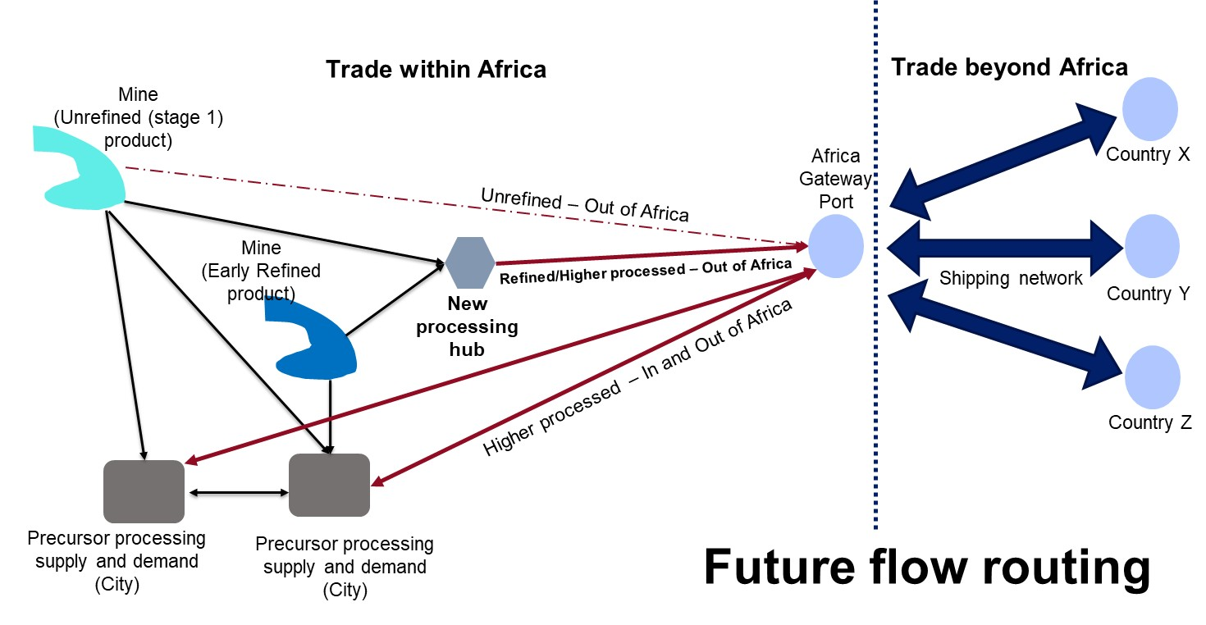

4.3.5 Transport-related carbon emissions were estimated.
Following the allocation of flows on the transport network for each scenario, the carbon emissions in tonnes-CO₂eq were estimated. A Transport Energy and Air pollution Model (TEAM) was used to convert the tonnages of cargo transported along roads and railway lines in tonnes-CO₂eq of carbon emissions¹¹⁷. The aim of the analysis was to produce a generalised estimate of carbon emissions, instead of using more detailed estimates that would require, among other attributes, data on individual cargo vehicle types, their fuel types, and occupancy¹¹⁸. TEAM allowed such a generalised estimate based on the assumption that all cargo along roads and rail networks would be transported using standard class of vehicles.
Along a given network edge, $e_{ij}$, the conversion of tonnage of cargo ($T_{ij}^{m}$) to carbon emissions ($E_{ij}^{m}$) carried along a given mode ($m$) of travel (road or rail) was done by applying the following equation:
$E_{ij}^{m}= {10}^{-5}T_{ij}^{m}l_{ij}\left(\frac{ϵ_{m}d_{m}}{ω_{m}f_{m}}\right)$ (5)
Where $l_{ij}$ is the length of the edge in kilometres, $ϵ_{m}$ is the energy consumption in litres per 100 km (L/100 km) of a standard vehicle type carrying the cargo, $d_{m}$ is the fuel density in kg/L for the standard fuel type of a vehicle, $ω_{m}$ is the standard vehicle weight in tonnes of a fully loaded vehicle, and $f_{m}$ is a load factor signifying the fraction of the vehicle that might be carrying the load.
For the study region, the values for the mode-specific parameters were chosen based on the assumption that the standard vehicle type on the roads was a heavy goods truck that used diesel and was designed as per the EURO 5 (2009–2014) emission standard, whereas for railways a standard diesel locomotive train was assumed¹¹⁹. Parameter values obtained from¹¹⁹ are shown in Table 18.
Table 18: Parameter values for road and rail vehicle types
Mode ($m)$ | Energy consumption ($ϵ_{m}$) – L/100 km | Fuel density ($d_{m}$) – kg/L | Vehicle weight ($ω_{m}$) - tonnes | Load factor ($f_{m})$
Road | 32.19 | 0.83 | 22 | 0.386
Rail | 301.34 | 0.83 | 380 | 0.7

Modelling Energy Needs Along Critical Minerals Value Chains

This section documents the detailed methodological steps used to model energy supply for critical minerals processing. This begins by estimating location-specific energy requirements and goes on to calculate and compare the cost of serving each location through grid versus off-grid technologies.
5.1 Estimation of Energy Requirements per location
5.1.1 Location-specific energy demands were estimated
Modelling the costs of energy provision for critical minerals processing entails estimating location-specific energy demand. This builds on previous steps, which have already identified the nature of the mining and processing activities taking place at each geographic location, as well as the tonnages of minerals involved. Since the energy intensities associated with each stage of mineral processing are already known (see Table 19), an estimate of energy demand can be obtained simply by multiplying energy intensities by mineral tonnages.
Table 19: Overview of average energy intensity of mineral processing at different stages in kWh per kg of output product. The processing stage is simplified to remove decimals. For example, if any stage was called 3.1, it is now referred to as 3.
 | Average electricity intensity (kWh/kg)
Simplified processing stage | Cobalt | Copper | Graphite | Lithium | Manganese | Nickel
1 | 0.72 | 0.49 | 0.62 | 0.04 | 0.23 | 0
2 |  | 0.91 |  |  |  | 0.11
3 | 1.69 | 5.42 | 2.10 | 2.95 | 0.01 | 1.42
4 | 2.33 | 0.42 | 3.29 | 0.68 | 0.10
5 | 1.15 | 0.33 |  |  |  | 0.42

5.1.2 A methodology for estimating costs of meeting energy demand was developed
While mining and processing activities call for a combination of motive and thermal energy, for the purposes of this study the focus will be on estimating electricity demand. The reason is that, for many processes, electricity accounts for the bulk of energy use. Also, it is assumed that with the increasing trend towards industrial electrification, most of the remaining processes would be capable of being substituted by electricity. While this electrification requires a change in equipment and implementation of new methods, the assumption allowed us to test future electrification potential. Thus, where non-electric forms of energy are currently used, the study estimates the equivalent amount of electricity that would be needed to serve the equivalent energy needs.
Estimated energy demands could potentially be met either by on-grid or off-grid electricity. Some mining and processing locations are remotely situated, and it is common practice for mining companies to self-supply energy based on off-grid technologies. Other locations, particularly downstream processing locations, are more likely to be situated closer to urban centres and the power grid. In yet other cases, mining and processing sites may be located relatively close to the grid, making it relevant to consider whether a grid connection would be justified by the energy demand.
To fully represent these choices, the study began by estimating and projecting the cost of grid electricity in each country for the study time horizon to 2050, which is done using the open-source energy system planning tool, OSeMOSYS Global (see further below). These costs are then entered into a modified version of the Open-Source Spatial Electrification Tool – OnSSET (see further below) – which can compare the cost of meeting energy demand at any location through grid or off-grid technologies, determining the optimal solution in each case and estimating the associated cost. To ensure that the needs of the local worker communities are also met, an additional energy demand was incorporated into the calculations at any off-grid site where mining and/or processing takes place. Finally, given increasing concerns around carbon emissions embedded in industrial products, the models also report the associated carbon intensity of the energy provided.
5.2 Calculation of unit costs and emission intensity for grid electricity
5.2.1 The OSeMOSYS Global tool was calibrated for each country
The Open-Source Energy Modelling System (OSeMOSYS) framework provides the basis for the modelling of national grid-based power systems, whereby linear optimisation was used to identify the power sector technologies capable of meeting exogenously defined energy demands on a least-cost basis, subject to specified constraints. The main objective of the model is to determine the lowest net present value (NPV) cost of an energy system to meet given demand(s) for specific energy services¹²⁰. The model permits techno-economic assessment of the least-cost pathways to meet any predetermined energy demand scenario, covering both generation and transmission (but not distribution) costs.
OSeMOSYS Global was applied individually to each country selected for this study, based on pre-existing calibrations of the corresponding national power system¹²¹, with model specification details summarised in Table 20. The work entailed the development of 14 distinct models for each of the 14 countries covered: Angola, Botswana, Burundi, Democratic of Congo, Kenya, Madagascar, Malawi, Mozambique, Namibia, South Africa, Tanzania, Uganda, Zambia, and Zimbabwe.
Table 20: Overview of assumptions underpinning least-cost power system expansion modelling
Time horizon | 2022–2050
Time representation | 48 sub-annual time slices comprising six seasons and eight-day parts.
Techno-economic data | These were primarily sourced from the OSeMOSYS Global Africa-specific dataset¹²¹, with additional sources utilised to fill existing data gaps and increase accuracy where possible.
Residual capacity | Installed capacity of existing power plants and committed powerplant projects were sourced from¹²².
Demand projections | Historic demand projections for all regions provided by the International Energy Agency (IEA) ^{123–135}, with more specific demand growth rates projections sourced from regional integrated resource plans (IRP) (Botswana IRP, 2020; South Africa IRP, 2023; Kenya Least Cost Development Plan, 2024; Malawi IRP, 2024; Mozambique IRP, 2018; Tanzania Power System Master Plan, 2024; Zambia IRP, 2022; Uganda Least Cost Electricity Expansion, 2021 and Namibia IRP, 2022). With the remaining regions utilising OSeMOSYS Global inputs¹²¹ with the exception of Burundi which utilised CCG Starter Data Kits demand projections.
Fuel assumptions | Fuels included were coal, heavy oil, gas, and biomass. Prices were referenced to US$ in 2020 and projected up to 2050 in five-year intervals.
Cost assumptions | Future capital costs and fixed operating costs were extracted from the IEA’s 2050 Stated Policies scenarios for Africa (IEA’s 2022 World Energy Outlook¹²³). Future capital costs were considered on a weighted average basis, with costs associated with renewable energy technologies and Carbon Capture and Storage-equipped power plants based on below assumed learning rates sourced from IEA¹²³.
Discount rate | 10%
Reserve margin | 10%

5.2.2 Scenarios were estimated with and without critical minerals processing demand
Once the models were calibrated, they could be used to determine the impact associated with meeting projected demand for critical minerals processing, in terms of capital cost, levelised costs of energy, and carbon emissions. Each model incorporated a reference demand projection scenario. However, due to the increasing marginal cost of energy, a substantial increase in energy demand attributable to critical minerals processing can be expected to raise systemwide energy costs. For countries where the additional demand associated with critical minerals processing was deemed substantial (defined as in excess of five percent of reference demand by the end years of 2040), an alternative demand scenario was run to capture these higher costs. To avoid double counting, existing industrial demand projection attributable to the mining sector was ‘stripped out’ of the reference demand projection, before the two demand scenarios were compared.
As shown in Figure 2E in the paper, in some cases (notably, Kenya, Uganda, South Africa, Zimbabwe), the incremental demand associated with critical minerals processing is marginal relative to the reference demand scenario and simulations are based on the reference model. However, in other cases (notably, Botswana, Burundi, DRC, Madagascar, Namibia, Tanzania, and Zambia), the incremental demand is substantial, necessitating an alternative modelling scenario where critical minerals processing demand estimated in the preceding step was incorporated into the industrial demand projection. The difference is deemed substantial if critical minerals processing energy needs surpass five percent of projected demand by 2040.

5.2.3 Power grid performance parameters were calculated for each country
National power sector planning models were run using the relevant demand projections for the different scenarios considered in the study. The results of each scenario could be summarised by means of three output parameters.
- Average generation capital expenditure (US$/kW): To determine the average generation capital expenditure, the capital investment for on-grid generating power sector technologies was divided by new capacity additions.
- Average levelised cost of grid energy (US$/kWh): To determine the average levelised cost of electricity, the total discounted system cost of generation and associated high voltage transmission is divided by the total volume of generation across the modelling period.
- Average grid emission factor (gCO₂eq/kwh): To determine the grid emission factor for each country without accounting for electricity imports, the total power system emissions are divided by the total amount of electricity produced. Total power system emissions are obtained by multiplying the emission factor for each power generation technology by the total volume of electricity generated using that technology ¹³⁶.
The table below provides the resulting values for these three indicators across countries for the National Precursor-Related Product 2040 Scenario, given that there was hardly any variation in these parameters across scenarios (Table 21). In addition, the projected generation mix for each country is graphically represented below for the baseline scenario.

Table 21: Summary of power grid performance parameters by country and scenario (National Precursor-Related Product Scenario by 2040)
 | Average generating capex ($/KW) | Levelised Cost of Energy (LCOE) for generation and transmission ($/KWh) | Average power grid carbon emission factor (gCO_{2eq}/kWh)
Angola | 1641.00 | 0.06 | 127.36
Botswana | 694.35 | 0.10 | 213.99
Burundi | 822.03 | 0.16 | 18.13
DRC | 2029.51 | 0.10 | 13.91
Kenya | 2251.64 | 0.04 | 14.41
Madagascar | 1575.54 | 0.07 | 97.66
Malawi | 1540.11 | 0.05 | 14.48
Mozambique | 1205.87 | 0.04 | 80.61
Namibia | 1259.17 | 0.06 | 154.33
South Africa | 624.38 | 0.06 | 598.35
Tanzania | 1263.18 | 0.06 | 68.05
Uganda | 1408.09 | 0.06 | 36.38
Zambia | 1634.07 | 0.04 | 26.97
Zimbabwe | 1519.65 | 0.03 | 40.83

For the countries Kenya, South Africa, Uganda and Zimbabwe, changes in projected energy demands fell below the 5% threshold for both 2040 across national and regional scenarios. It was therefore assumed that the total installed capacity, average generative capital expenditure, average LCOE, and average grid emission factors would remain unchanged relative to the baseline under both cases for those countries.
The figures below highlight the total installed capacity under the baseline scenario for these seven countries (Figure 21). They also highlight the variation in generation technologies across countries. Hydropower remains the dominant source of electricity in Zambia and Uganda. Solar picks up to play a significant system role by 2040 in Zimbabwe, Mozambique, and South Africa. Gas plays a growing role in replacing displaced coal power in South Africa, while Kenya continues to rely heavily on geothermal power.
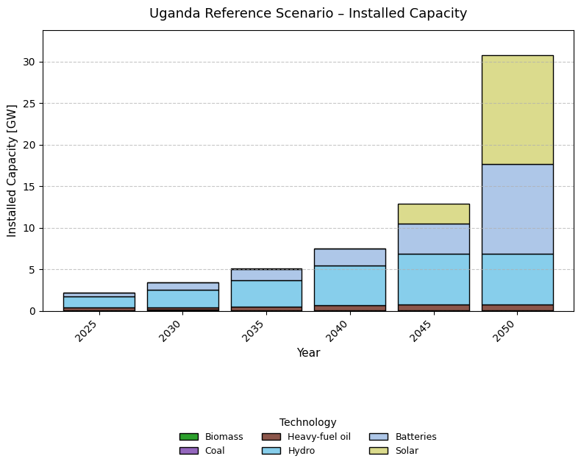
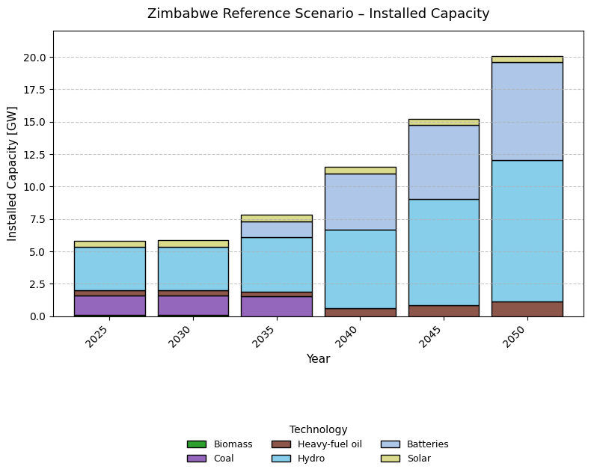
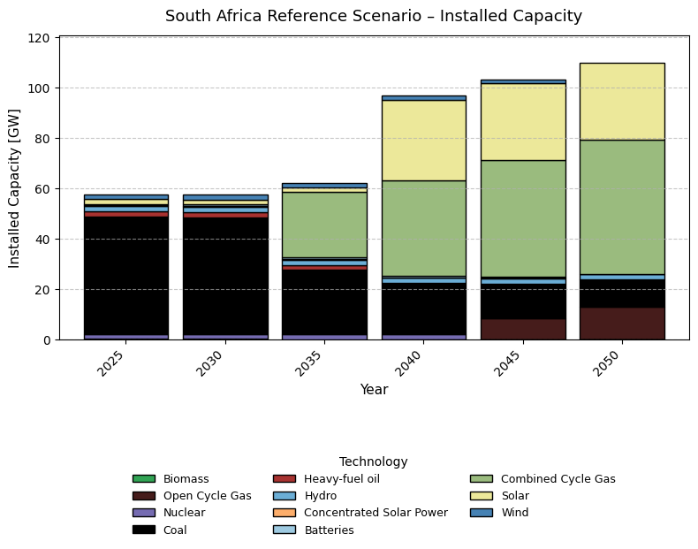
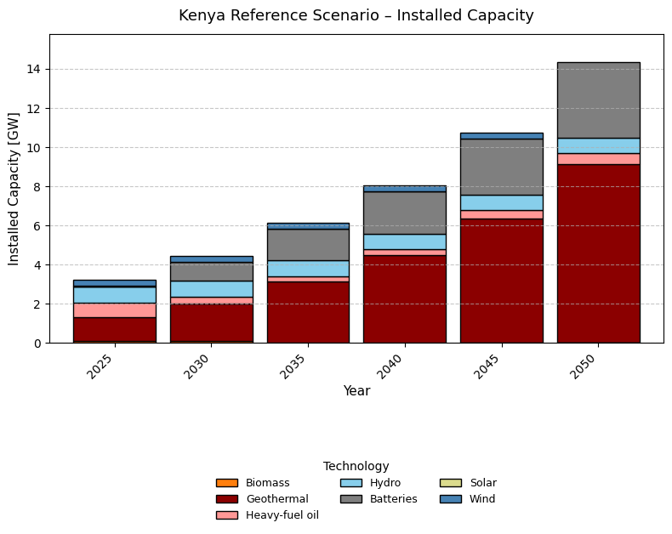

Figure 21: Projected baseline power system expansion capacity for countries where incremental critical minerals processing demand is negligible (<5 percent of total)

For the remaining countries, some significant differences can be observed across system expansion plans under different critical minerals processing scenarios.
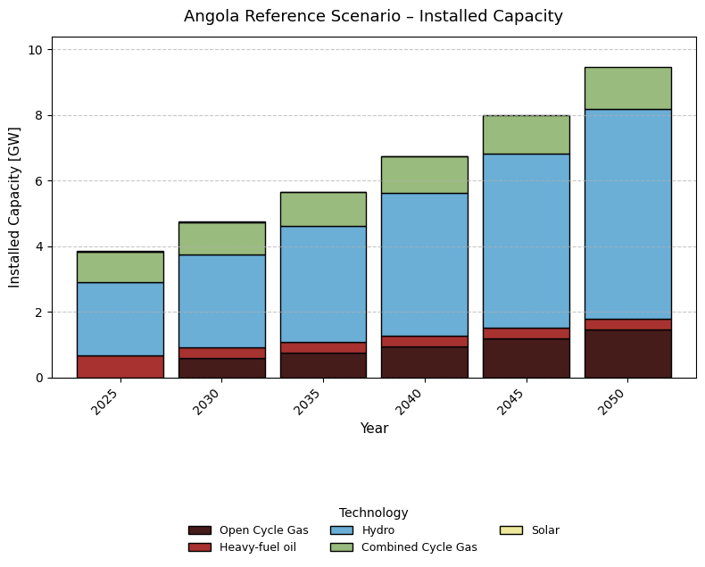
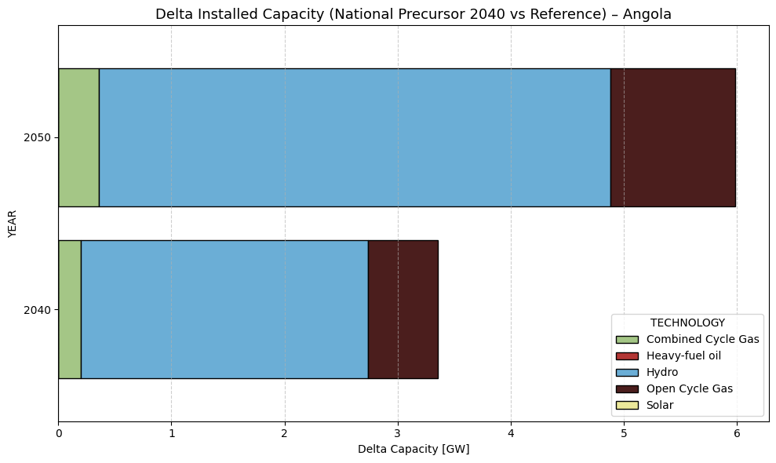
- Angola. Hydropower is the baseload resource for Angola given its substantial resource potential. Gas resources are utilised during later years, bringing some diversification. Under both National and Regional scenarios, at least 2.5GW hydropower capacity is added to the electricity grid in 2040 and 5GW in 2050 to satisfy a 45% increase in electricity demand relative to the baseline (Figure 22).

Figure 22: Projected power system capacity in Angola under different critical minerals processing scenarios
- Botswana. Botswana’s current power system is primarily fossil fuel based on coal. However, over the modelling period solar capacity is planned to be added to the electricity grid to meet growing demand. It appears under the National Precursor 2040 scenario, there is an increase of 2.5GW of solar capacity followed by 750MW of natural gas capacity to accommodate a 16% increase in electricity demand (Figure 23).
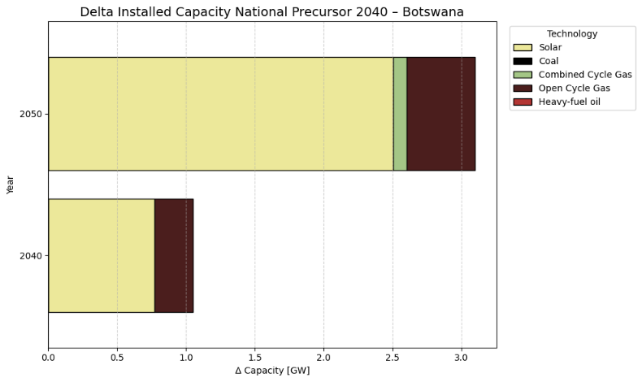
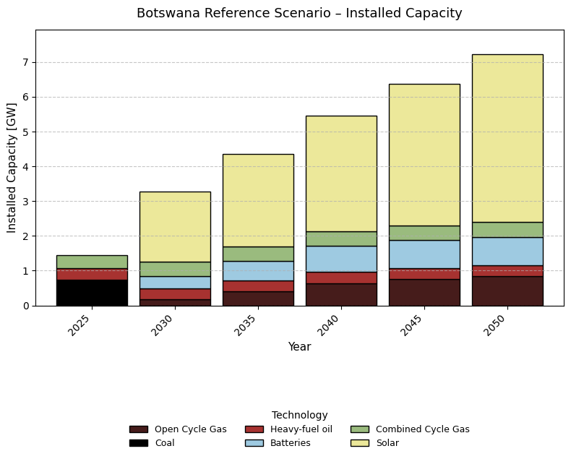

Figure 23: Projected power system capacity in Botswana under different critical minerals processing scenarios

- Burundi. In Burundi, solar appears to grow in dominance over the modelling period for the baseline scenario. To accommodate the 21% increase in national electricity demand and 14% increase regional scenarios, 1GW of solar capacity is added to the electricity grid (Figure 24).
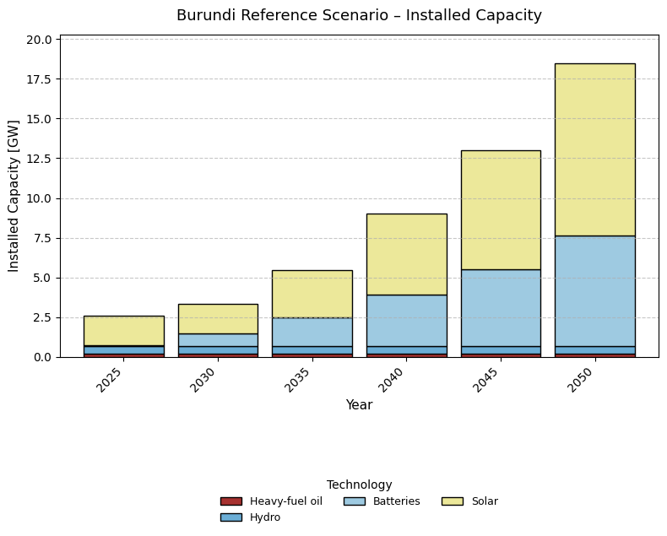
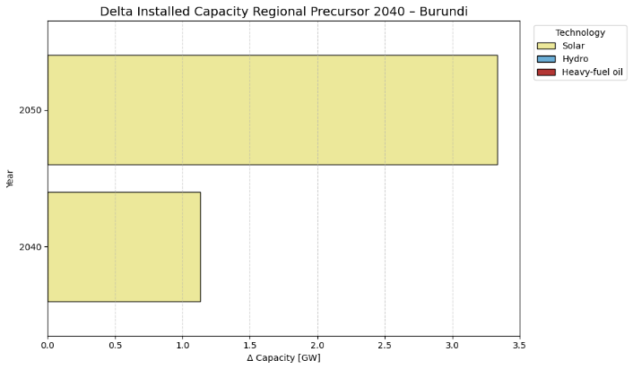
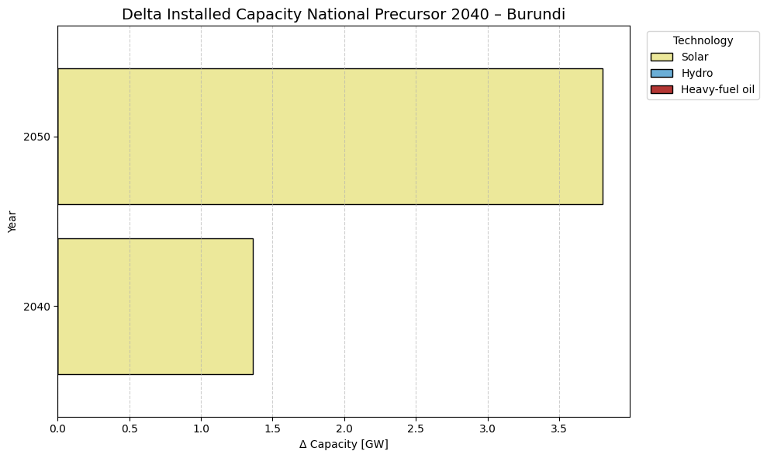

Figure 24: Projected power system capacity in Burundi under different critical minerals processing scenarios

- Democratic of Congo (DRC). Hydropower is the baseload resource for the DRC given its substantial resource potential. Batteries are utilised during later years to accommodate this renewable energy Under both National and Regional scenarios, 15 GW hydropower capacity is added to the electricity grid in 2040 and 30GW in 2050 to satisfy at least 50% increase in electricity demand relative to the baseline (Figure 25).

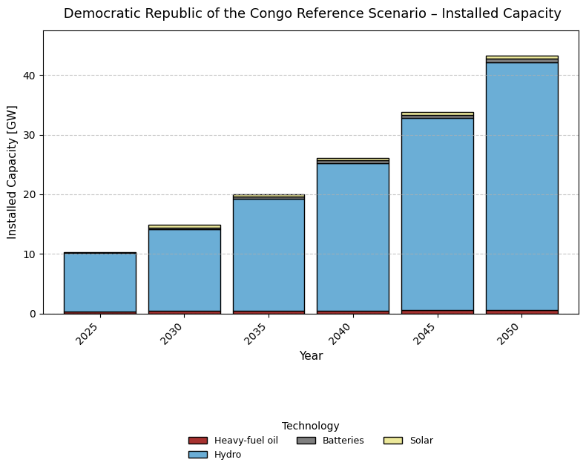
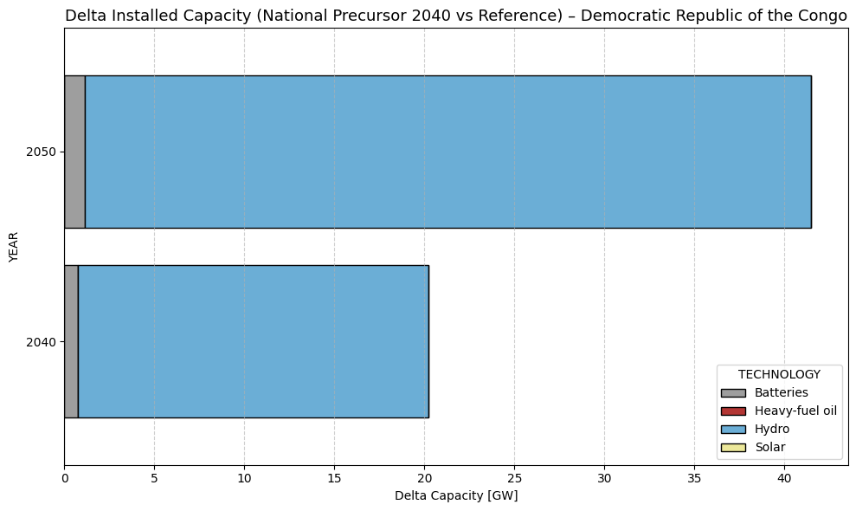

Figure 25: Projected power system capacity in DRC under different critical minerals processing scenarios

- Madagascar. In both the baseline and Regional 2040 Scenarios, hydropower dominates the system from the year 2025 and onwards, accounting for 65% of total installed capacity. To accommodate for the 7% increase in mineral processing demand, hydropower capacity increases by 1.2GW in 2050 (Figure 26).
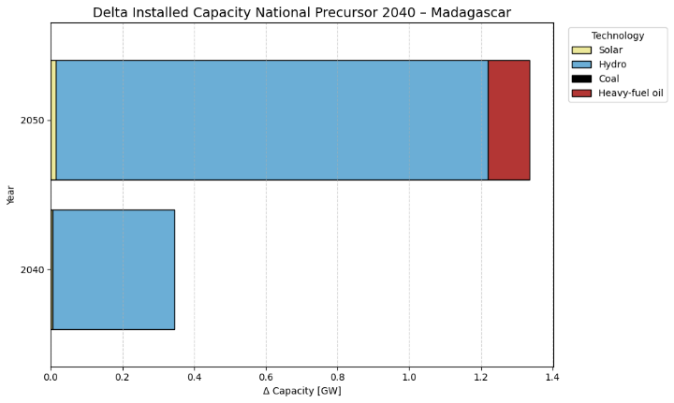
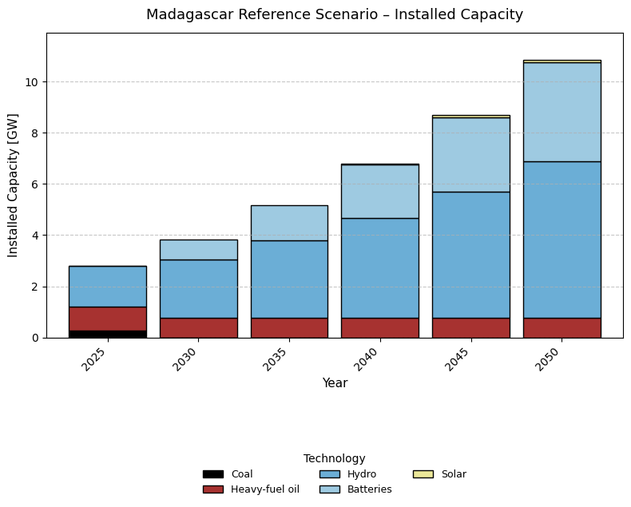
Figure 26: Projected power system capacity in Madagascar under different critical minerals processing scenarios
- Malawi. In Malawi, in the hydropower dominates the system over the modelling period In order to accommodate the 7% and 9% increase in electricity demand in the national scenario, there an increase solar and wind of 2.5GW across the years 2040 and 2050 (Figure 27).
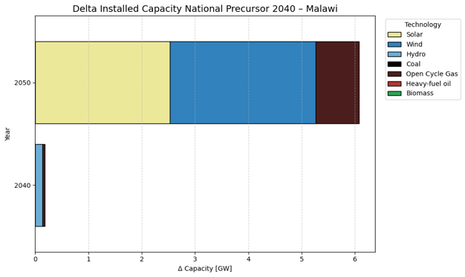
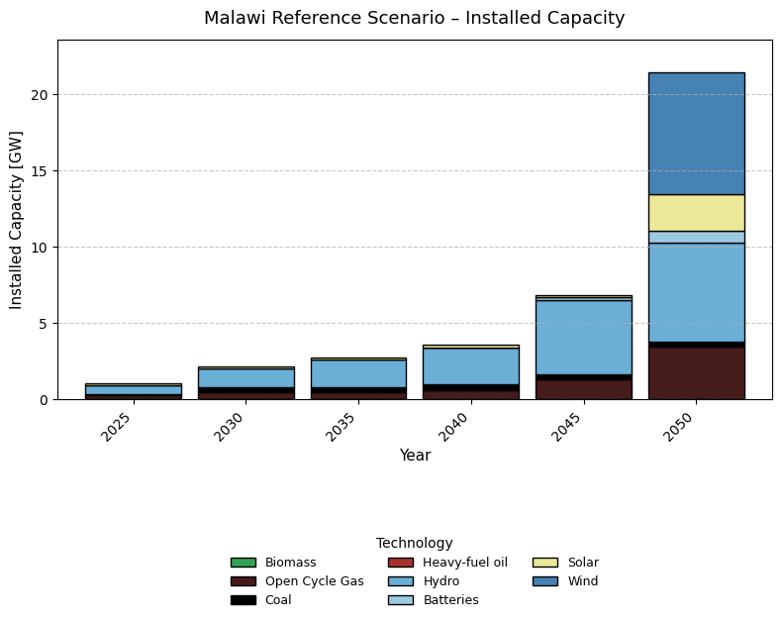

Figure 27: Projected power system capacity in Malawi under different critical minerals processing scenarios

- Mozambique. In Mozambique, hydropower appears to grow in dominance over the modelling period for the baseline scenario. To accommodate the 26% and 47% increase in electricity demand in regional precursor scenarios, 5GW of hydropower capacity alongside 3GW of open cycle gas and 1.5GW of combined cycle natural gas is added to the electricity grid (Figure 28).
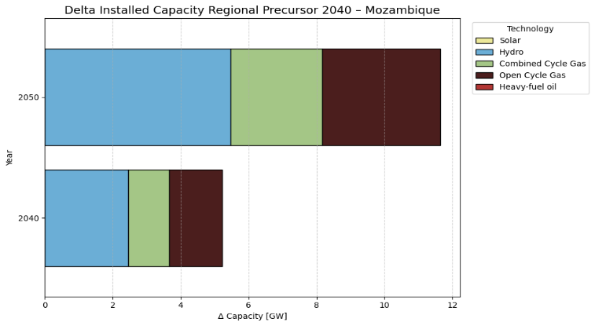
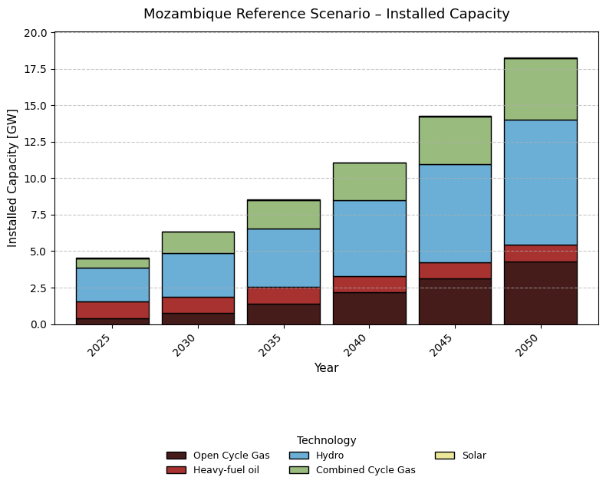
Figure 28: Projected power system capacity in Mozambique under different critical minerals processing scenarios

- Namibia. In Namibia, the base year across both the baseline shows a varied energy mix, with oil, hydropower, and coal resources being reflected. The national scenario shows a reduced reliance on fossil fuel resources and additional energy demand is predominately met with an increase of solar capacity (Figure 29).
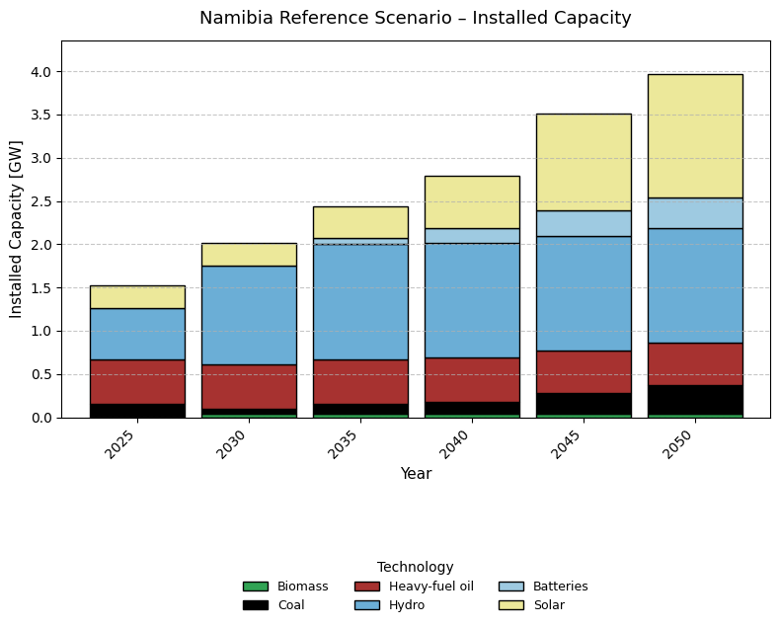
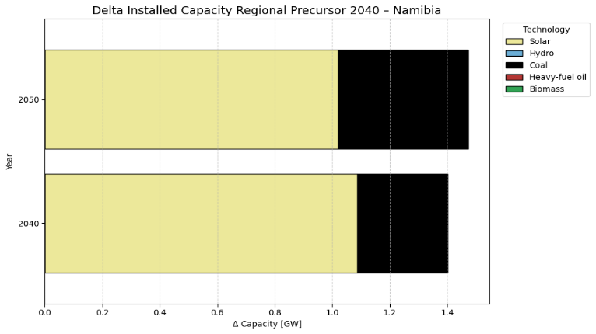
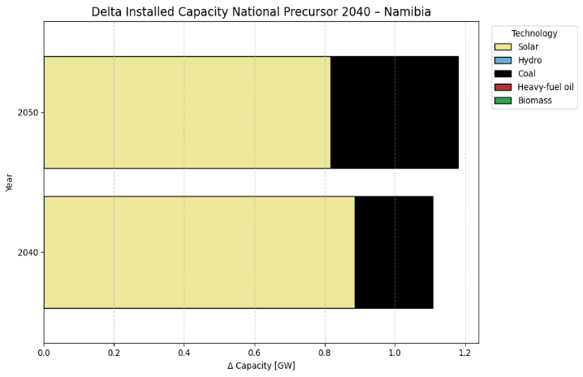
Figure 29: Projected power system capacity in Namibia under different critical minerals processing scenarios

- Tanzania. Baseline projections show solar and hydropower capacity representing a growing share of the energy mix in the later years. Under the national and regional precursor scenarios, Tanzania requires at least 16 and 30 GW of additional capacity between 2040 and 2050, predominantly wind (Figure 30).
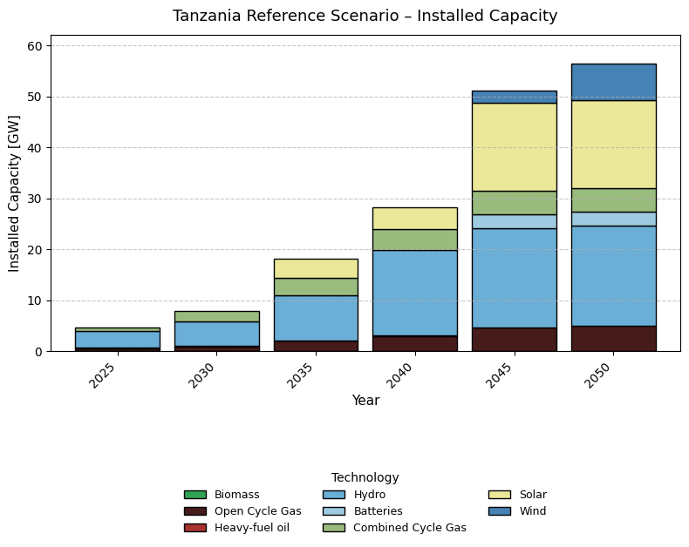
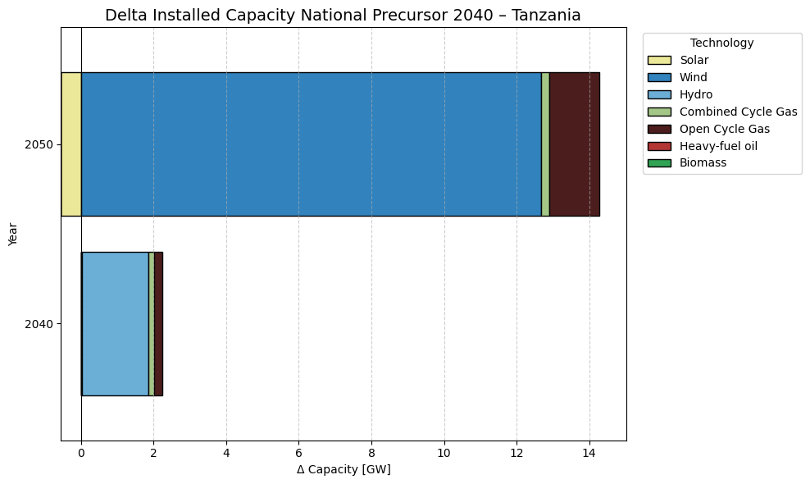
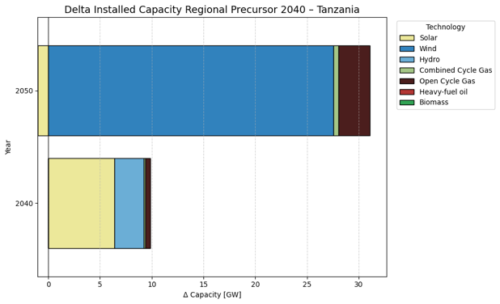

Figure 30: Projected power system capacity in Tanzania under different critical minerals processing scenarios

- Zambia. Zambia’s current power system is primarily renewable based on hydropower. However, to accommodate the increase in electricity across both national and regional scenarios, 3GW hydropower capacity is added to the grid by 2050 (Figure 31).

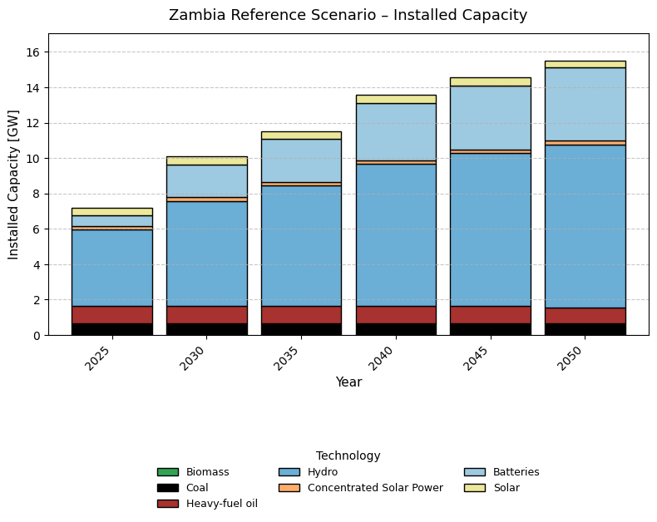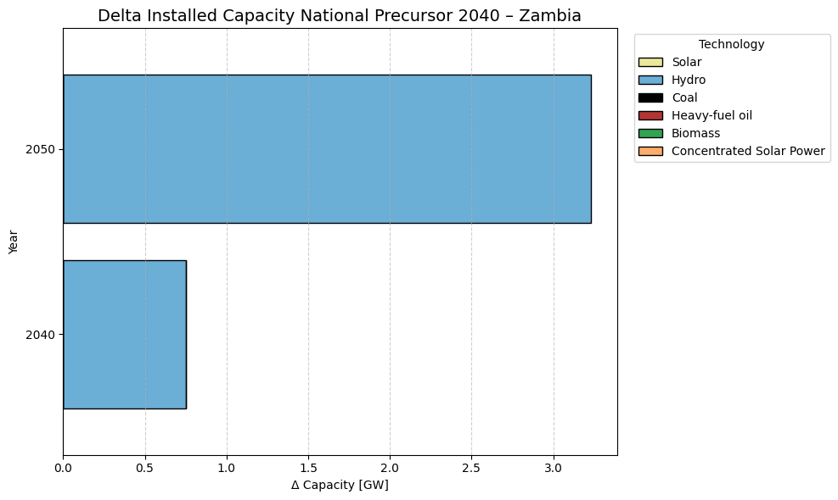
Figure 31: Projected power system capacity in Zambia under different critical minerals processing scenarios

5.3 Determination of least-cost energy solution at each location
5.3.1 OSeMOSYS Global results for grid electricity were soft-linked to OnSSET model
The resulting values from the OSeMOSYS Global analysis were extracted and incorporated into a modified version of OnSSET to provide values for the LCOE of grid electricity at each location. More specifically, the LCOE for the national power grid produced by OSeMOSYS Global was marked up with a location-specific marginal cost of distribution, which was calculated based on the distance between each site and the nearest transmission line.
Geospatial data for national high voltage transmission grids was collected and compiled to yield the grid displayed in Figure 32. Attempts were also made to collect data on the location of sub-stations and medium voltage lines, but these were not sufficiently complete or consistent to permit their use in the analysis. For grid electricity, the generation capital expenditure was estimated by multiplying the peak load at each location by the average generation capital expenditure for the country where the site was located, and then incorporating the location-specific cost of distribution which was assumed to be around $20,000/km. Finally, operating costs for both generation and distribution were assumed to be 2 percent of the original investment per year. Using the above parameters, the algorithm calculated the levelised cost of grid electricity, now adjusted to account for location-specific distribution costs, over the modelling period up to 2040.
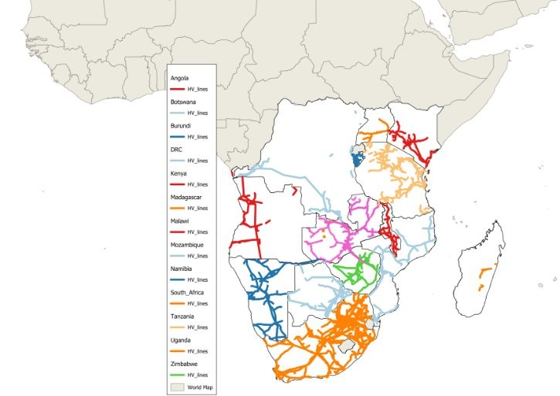
Figure 32: Map of available geospatial data on location of high voltage transmission lines in Southern Africa

5.3.2 OnSSET model was used to estimate the costs of off-grid electricity at each location
OnSSET (Open-Source Spatial Electrification Tool) is a bottom-up medium- to long-term optimisation model, which uses population settlements, together with different geospatial characteristics and socio- and tecno-economic data, to identify the least-cost supply option to reach universal electrification in each location. OnSSET considers both grid-based, mini-grid, and other off-grid technologies, and it identifies which of these can be considered optimal in each specific location.
OnSSET estimates the optimal configuration of solar PV, battery storage, and diesel generation that meets the electricity demand requirements and yields the expected levelised cost of electricity, as well as the estimated capital and operating expenditure that deployment of an off-grid system would require in that location. The sizing of the off-grid systems was based on a subset of the OnSSET code¹³⁷, which has been customised in order to approximate the optimal configuration of mini-grid sites for mineral processing sites at each given location and demand profile. While not a fully-fledged optimisation, the model compares the location-specific requirements with a large set of system configurations within a solution space and evaluates the combination of solar PV, battery, and/or the diesel generator, that best fits the demand profile, energy resource availability, and specific techno-economic requirements defined by the user¹³⁸.
The underlying techno-economic parameters for the off-grid (mini-grid) systems are summarised in Table 22. The algorithm uses geospatial analytics in order to estimate the energy resource availability at each location (solar irradiation) and adjust the cost of diesel based on transportation requirements by estimating travel time to major towns. Figure 33 summarises the relative LCOE of off-grid electricity at all the relevant mining and processing locations.
Table 22: Summary of techno-economic parameters used for OnSSET analysis
PV panel capital cost | 1,200 $/kWp
PV panel life | 25 years
Annual O&M cost of PV panels | 1.5%
Diesel generator capital cost | 325 $/kVA
Annual O&M cost of diesel genset | 10% of CAPEX
Diesel generator life | 10 years
Diesel pump price | 1 $/litre (fuel cost changes per location)
Inverter cost | 230 $/kW
Inverter life | 10 years
Inverter efficiency | 0.92
Battery cost | 593 $/kWh
Charge/Discharge efficiency of battery | 0.92
Maximum depth of discharge of battery | 0.80
Maximum loss of load allowed (% of kWh) | 0.01%
Max diesel capacity share | 50%
Discount rate | 13.8%
Modelling period | 2023–2040 (17 years)

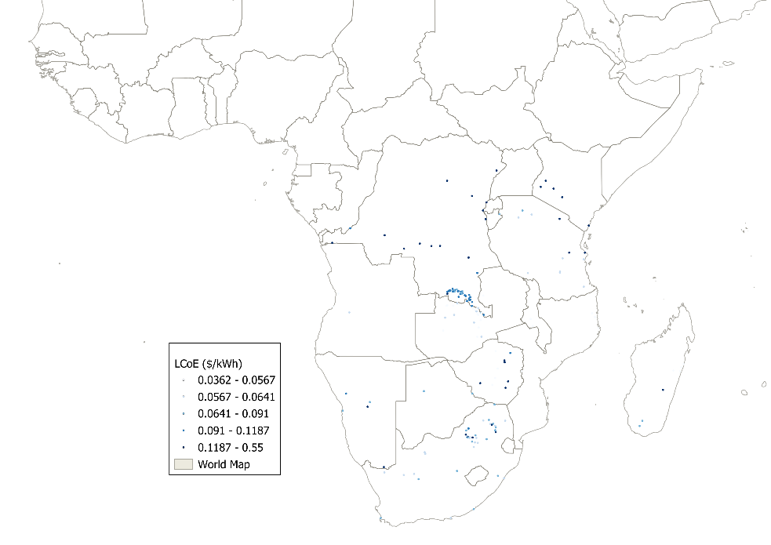
Figure 33: Map of locations where off-grid electricity was selected by OnSSET

5.3.3 OnSSET model was used to determine the optimal energy solution at each location
With cost information for both on-grid and off-grid energy solutions at each location available to OnSSET, it was possible to select the preferred technology for each specific location. All sites located within five kilometres from existing grid infrastructure (in this case a transmission network) were automatically assigned grid as the optimal electrification option, on the basis that grid connection is typically economic for such a short distance. For sites beyond the five-kilometre buffer, the decision between grid and off-grid electrification was based on which option presented the lower estimated investment cost.
Results showed that grid electricity is optimal for most electricity demand (Figure 34), particularly for 2040 scenarios.
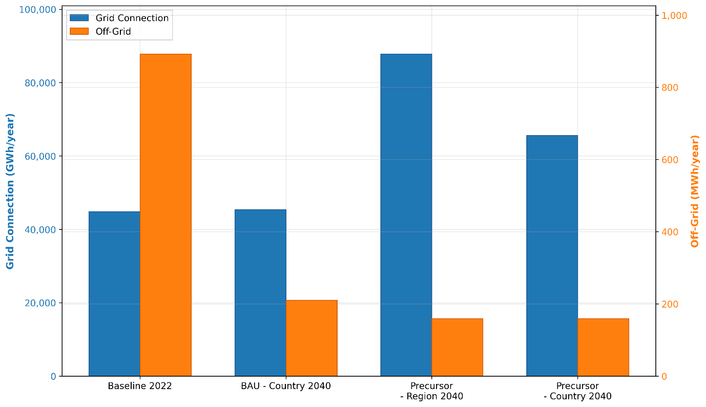
Figure 34: Regional annual energy demand for critical minerals processing met by grid (left axis) versus off-grid (right axis) electricity for the medium production scenarios. Note the axis have different units for ease of comparison. Note: Grid electricity depicted by blue bars reads from the left-hand axis in units of gigawatt-hours per year, while off-grid electricity depicted by orange bars reads from right-hand axis in units of kilowatt-hours per year.

Methodology for Screening out Environmentally Sensitive Areas
This Annex documents the detailed methodological steps used to screen out environmentally sensitive areas from the analysis of mineral processing.

6.1 Relevant indicators for environmentally sensitive areas were identified
Mining and mineral processing activities can cause major environmental damage. Moreover, potential future mining and mineral processing sites identified in this study may overlap with environmentally sensitive areas. It is therefore important for the geospatial simulation exercise to be informed by the presence of such environmental constraints. Since a detailed analysis of site-specific environmental concerns on a sub-continental scale lies beyond the scope of this study, a high-level approach is developed to screen out from consideration potential mining and mineral processing sites that overlap with areas of particular environmental sensitivity.
A review of the relevant environmental indicators and associated literature informed the development of the methodology. Following¹³⁹, the following geospatial data layers are considered to be particularly relevant for this purpose.
- Protected areas¹⁴⁰: Protected areas are updated on a monthly basis. They are useful for identifying biodiversity risks and opportunities within a project boundary. The data used was updated up to July 2024.

- Last of the wild¹⁴¹: The last remaining 'wild' areas on the Earth's land surface are identified based on cumulative human pressure on the environment in 2009. The human pressure is measured using eight variables: built-up environments, population density, electric power infrastructure, crop lands, pasture lands, roads, railways, and navigable waterways.

- Key biodiversity areas¹⁴²: Defined as places that are critical for the survival of unique plants and animals, and the ecological communities they comprise. The dataset is the result of a partnership between 13 global conservation organisations. The data used were updated up to June 2024.

- Water stress areas¹⁴³: Defined as locations affected by significant water supply risk. In these data, average water stress at hydrological sub-basins were estimated for the period 2015–2045 based on a SSP3/RCP 7.0 scenario of climate and socioeconomic conditions that derive from CMIP6 climate models. The chosen sub-basins, used for constraining the 2030 and 2040 mining and refining sites, were selected based on the following classifications:
- Arid and low water use: A sub-basin was considered arid if the annual availability of water within it was below 0.03 m/year, and a sub-basin with annual gross total withdraw less than 0.012 m/year was considered as low water use.
- High water stress: A sub-basin where the ratio of total water demand (domestic, industrial, irrigation, and livestock consumptive and non-consumptive uses) to available renewable surface water and ground water supplies was between 40–80%.
- Extremely high water stress: A sub-basin where the ratio of total water demand (domestic, industrial, irrigation, and livestock consumptive and non-consumptive uses) to available renewable surface water and ground water supplies exceeded 80%.

6.2 Indicators of environmental sensitivity were used to filter out potential production locations
On this basis a single screening layer was created that combined all these different environmental constraints, and this was applied to filter out any mining sites that fell within these affected areas and limit the optimisation for processing sites to find locations outside of these areas.

7. Additional results

7.1 Additional production implications
Processing locations for the relevant scenarios (Figure 35) show the expansion of processing sites going form South Africa, the Copperbelt and Madagascar being the main countries with processing activity in BAU to an expansion in processing in the Precursor scenario dependant on mining activity and the aggregated flows that allow for processing sites to be simulated. In particular, the regional scenario shows the processing hubs near coastal countries.
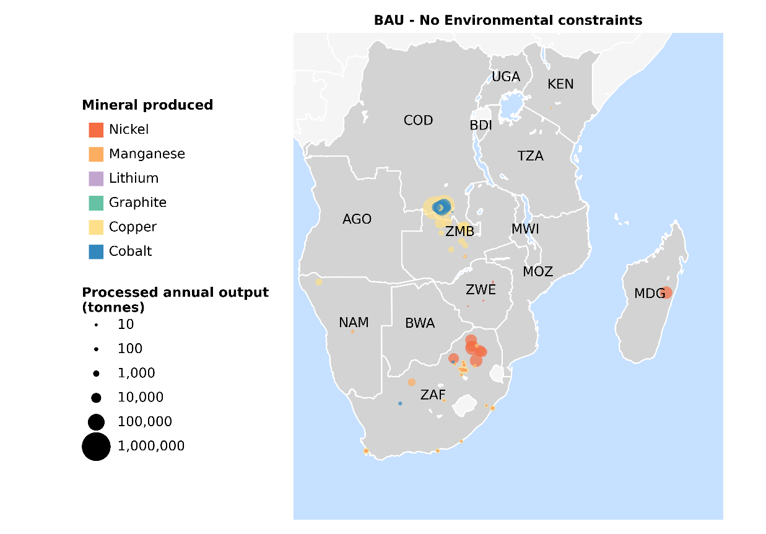
National Regional
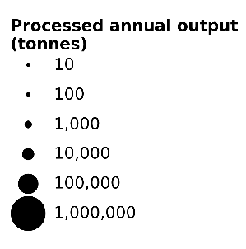
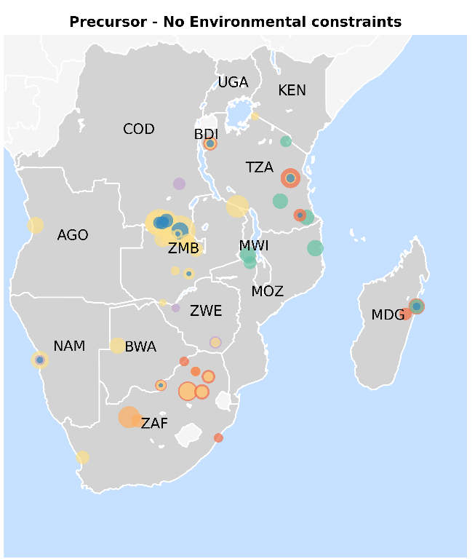
Figure 35: Map illustrating shift in processing locations under BAU (top) and National and Regional Unconstrained medium Precursor Scenarios for 2040 (bottom.)

7.2 Additional economic implications

Net export revenues expressed as a share of GDP for all countries under both national and regional processing policies are calculated to show the relative contribution of the minerals sector to economies (Figure 36). Under national and regional policies, two countries (Burundi and DRC under regional policies, Namibia under national unconstrained) achieve mineral export revenues of up to 32% (Burundi), 27% (DRC), and 21% (Namibia) of GDP in Precursor-related Product scenarios, compared to up to 19% (Burundi) and 17% (DRC and Namibia) under national policies. The uncertainty heatmaps reveal that demand variability introduces ranges of up to 10 pp across countries: DRC and Angola show relatively stable projections (<0.5 pp), while Burundi and Namibia exhibit the highest demand sensitivity (9–10 pp). These figures allow for the identification of countries with the highest economic stakes.
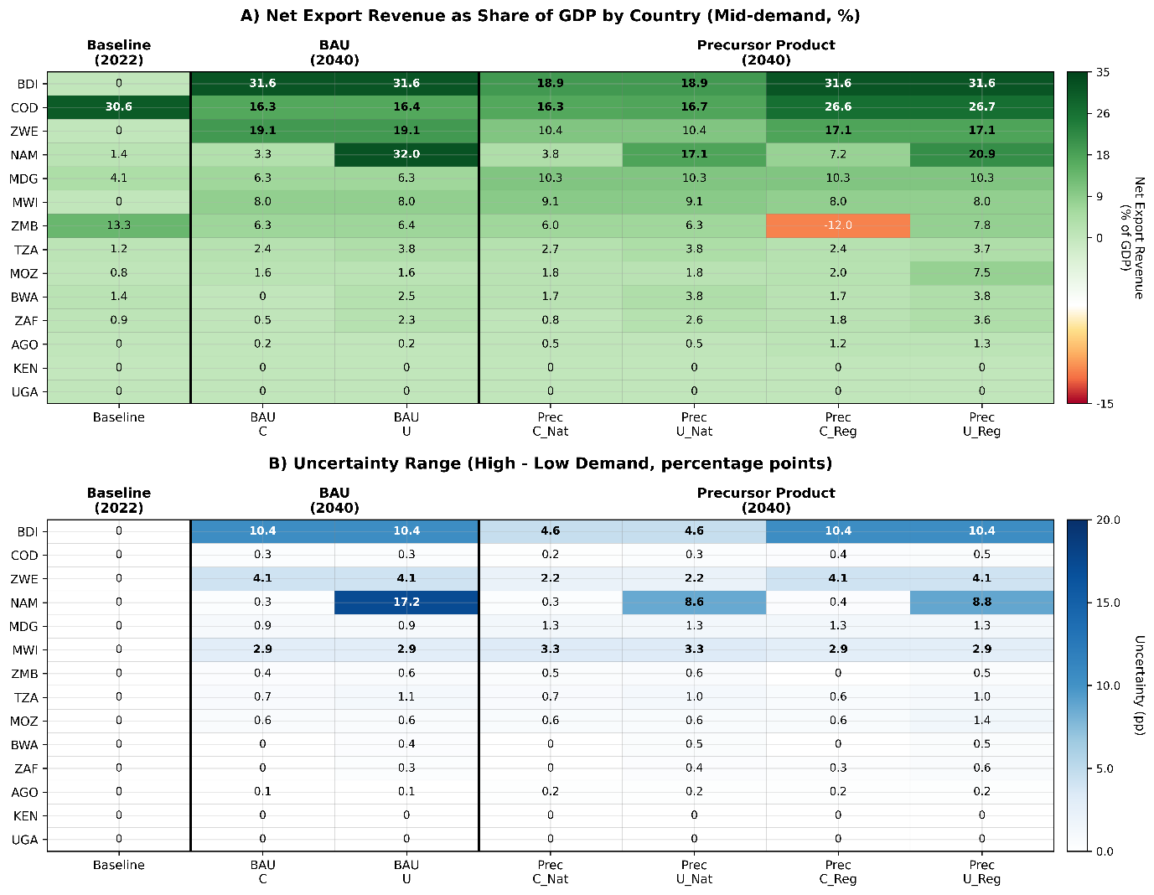
Figure 36 Net export revenue as share of GDP by country. Percentages in top panel and difference between percentages in bottom panel as uncertainty range. Each panel includes two heatmaps: absolute GDP share values (mid-demand scenario) and uncertainty ranges (high-low demand difference).
The competitiveness of each scenario and country considering cumulative unit processing costs (production, transport and energy) (Figure 37) show costs rising with processing ambition. Unit costs increase three to four times from BAU to Precursor scenarios reflecting the energy and capital intensity of advanced refining stages.
A core group of countries is consistently cost-competitive. Zambia ranks as the lowest-cost copper processor across all scenarios ($5.9k/t in BAU, $18.2k/t in the Precursor Regional scenario), reflecting proximity to ore bodies and established smelting infrastructure. Namibia leads in cobalt competitiveness in both Precursor scenarios ($48.7–48.9k/t, rank 1), and South Africa is the clear leader in manganese ($1.2–4.0k/t, rank 1) and emerges as lowest-cost lithium processor under regional cooperation. Tanzania and Mozambique are consistently competitive in nickel and graphite.
Regional cooperation reshapes processing geography. Under national policies, 10–11 countries appear as active processors across at least one mineral. Mozambique emerges as a multi-mineral hub under regional unconstrained cooperation, ranking first in both nickel and graphite, and second in cobalt which contrasts against its limited role under national scenarios. Environmental constraints have limited effect on relative rankings but reduce the number of active processing countries, reinforcing the advantage of already-established processing locations.
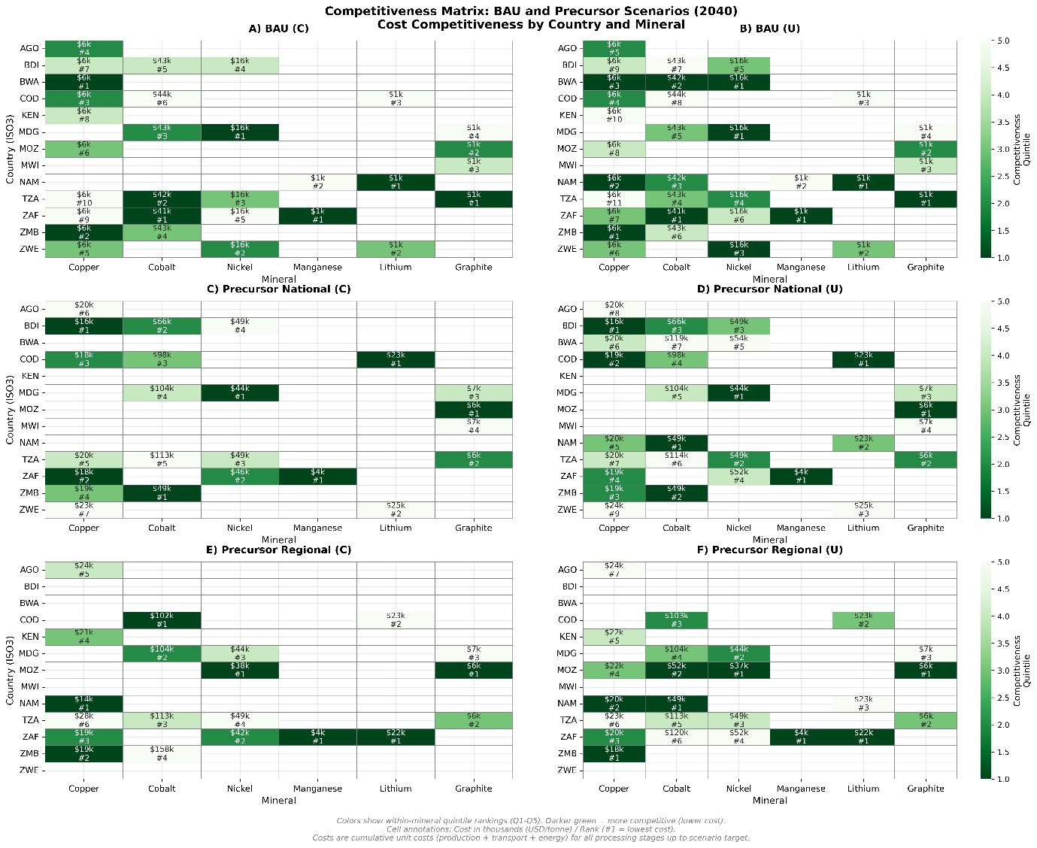
Figure 37 Competitiveness matrices of 2040 scenarios. Colours show quintile rankings from 1-5. Darker green means more competitive, i.e., lower cost. The costs in each cell are in USD/tonne. The ranking refers to cost, where #1 is lowest cost. The unit costs are cumulative including energy, production and transport.

References

1. S&P Global. S&P Capital IQ Pro. S&P Global https://www.spglobal.com/marketintelligence/en/solutions/sp-capital-iq-pro (2024).
2. Berman, N., Couttenier, M., Rohner, D. & Thoenig, M. This Mine is Mine! How Minerals Fuel Conflicts in Africa. Am. Econ. Rev. 107, 1564–1610 (2017).
3. British Geological Survey. World mineral statistics. https://www.bgs.ac.uk/mineralsuk/statistics/world-mineral-statistics/ (2025).
4. Jasansky, S., Lieber, M., Giljum, S. & Maus, V. An open database on global coal and metal mine production. Sci. Data 10, 52 (2023).
5. Maus, V. et al. A global-scale data set of mining areas. Sci. Data 7, 289 (2020).
6. Tang, L. & Werner, T. T. Global mining footprint mapped from high-resolution satellite imagery. Commun. Earth Environ. 4, 1–12 (2023).
7. Maus, V. & Werner, T. T. Impacts for half of the world’s mining areas are undocumented. Nature 625, 26–29 (2024).
8. Taylor, H. K. Rates of working of mines-a simple rule of thumb. Trans. - Inst. Min. Metall. Sect. A 95, A203–A204 (1986).
9. Long, K. R. A Test and Re-Estimation of Taylor’s Empirical Capacity–Reserve Relationship. Nat. Resour. Res. 18, 57–63 (2009).
10. Long, K. R. & Singer, D. A. A Simplified Economic Filter for Open-Pit Mining and Heap-Leach Recovery of Copper in the United States. https://pubs.usgs.gov/of/2001/0218/pdf/of01-218.pdf (2001).
11. Singer, D., Menzie, W. D. & Long, K. R. A Simplified Economic Filter for Open-Pit Gold-Silver Mining in the United States. https://pubs.usgs.gov/of/1998/0207/ (1998).
12. Singer, D. A., Menzie, W. D. & Long, K. R. A Simplified Economic Filter for Underground Mining of Massive Sulfide Deposits. Open-File Report https://pubs.usgs.gov/publication/ofr00349 (2000) doi:10.3133/ofr00349.
13. IEA. Global Critical Minerals Outlook 2025. https://www.iea.org/reports/global-critical-minerals-outlook-2025 (2025).
14. Wernet, G. et al. The ecoinvent database version 3 (part I): overview and methodology. Int. J. Life Cycle Assess. 21, 1218–1230 (2016).
15. Nuss, P. & Eckelman, M. J. Life cycle assessment of metals: A scientific synthesis. PLoS ONE 9, (2014).
16. Dai, Q., Kelly, J. C. & Elgowainy, A. Cobalt Life Cycle Analysis Update for the GREET Model. https://greet.anl.gov/files/update_cobalt (2018).
17. Cobalt Institute. Process data set overview page - Cobalt Institute LCA Data Data set: Cobalt, refined (metal). https://lca-data.cobaltinstitute.org/showProcess.xhtml?uuid=071d5149-b91b-4f4d-b245-ad620f51e795&version=00.00.000&stock=default (2012).
18. Cobalt Institute. Process Data set: Crude cobalt hydroxide (Co(OH)2); mining, beneficiation, primary extraction, refining, transport; production mix, at plant; 30- 40% cobalt (en) - Cobalt Institute LCA Data. https://lca-data.cobaltinstitute.org/datasetdetail/process.xhtml?uuid=121e9553-953f-4e7d-9bb8-46b34a1531a3&version=00.00.001&stock=default (2019).
19. Cobalt Institute. Process data set overview page - Cobalt Institute LCA Data Cobalt, refined (metal); mining, beneficiation, primary extraction, refining, transport; production mix, at plant; 99.8% cobalt. https://lca-data.cobaltinstitute.org/showProcess.xhtml?uuid=935f46f9-1bd3-4412-84b8-09416221a0e3&version=00.00.001&stock=default (2019).
20. Engels, P. et al. Life cycle assessment of natural graphite production for lithium-ion battery anodes based on industrial primary data. J. Clean. Prod. 336, 130474 (2022).
21. Farjana, S. H., Huda, N., Mahmud, M. A. P. & Lang, C. A global life cycle assessment of manganese mining processes based on EcoInvent database. Sci. Total Environ. 688, 1102–1111 (2019).
22. Lepidico Ltd. Karibib Mineral Resource Expanded. https://cdn.lepidico.com/production/LPD_210312_Karibib_Mineral_Resource_Expanded_5f229723d6.pdf#:~:text=concentrate%20containing%201.25,lithium%20muscovite (2021).
23. O’Keefe, M. AVZ MINERALS LIMITED Developing a World Class Lithium Deposit with Near-Term Production. https://static1.squarespace.com/static/5934d2ae6b8f5beeb5ba23f3/t/622a9e7547c61c69c318265f/1646960251512/20220217+-+Cantor+Initial+Coverage.pdf#:~:text=using%20conventional%20blasting%2C%20truck%20and,Flowsheet%20Source%3A%20AVZ%20Minerals%20Ltd (2022).
24. Prospect Resources. Lycopodium Completes Direct OFS for Arcadia Project. https://prospectresources.com.au/wp-content/uploads/2022/07/61068491.pdf#:~:text=Recovery%20Spodumene%20,27.0 (2021).
25. Yin, R., Hu, S. & Yang, Y. Life cycle inventories of the commonly used materials for lithium-ion batteries in China. J. Clean. Prod. 227, 960–971 (2019).
26. Gao, T., Fan, N., Chen, W. & Dai, T. Lithium extraction from hard rock lithium ores (spodumene, lepidolite, zinnwaldite, petalite): Technology, resources, environment and cost. China Geol. 6, 137–153 (2023).
27. Wang, H., Zhou, C., Liu, X., Yu, M. & Peng, P. Life Cycle Environmental Impact and Carbon Footprint Analysis of Lithium Extraction from Lepidolite. Preprint at https://doi.org/10.2139/ssrn.5134159 (2025).
28. Vieceli, N. et al. Effects of mechanical activation on lithium extraction from a lepidolite ore concentrate. Miner. Eng. 102, 1–14 (2017).
29. Das, J., Kleiman, A., Rehman, A. U., Verma, R. & Young, M. H. The Cobalt Supply Chain and Environmental Life Cycle Impacts of Lithium-Ion Battery Energy Storage Systems. Sustainability 16, 1910 (2024).
30. Matchaya, G., Nhamo, L., Nhlengethwa, S. & Nhemachena, C. An Overview of Water Markets in Southern Africa: An Option for Water Management in Times of Scarcity. Water 11, 1006 (2019).
31. Botha, Z. The Mining Industry and the Energy Crisis - What is the role we are playing? J. South. Afr. Inst. Min. Metall. 122, v–vi (2022).
32. Benchmark Minerals Intelligence. Lithium Total Cost Model Q3 2024. (2024).
33. de Bruin, J. K. MOLO FEASIBILITY STUDY. https://www.nextsourcematerials.com/wp-content/uploads/2022/07/NEX3001_Other-Reports_Molo-Feasibility-Study-Technical-Report.pdf (2017).
34. Giyani Metals Corp. K.Hill Battery-Grade Manganese Project Feasibility Study Effective Date: 14 Th November 2022 National Instrument 43-101 Technical Report. https://giyanimetals.com/downloads/Technical-Reports/Giyani%20Metals%20NI43-101%20FS%20-%202022-12-08.pdf (2022).
35. Christophers, B. Fossilised Capital: Price and Profit in the Energy Transition. New Polit. Econ. 27, 146–159 (2022).
36. IMF. World Economic Outlook, October 2024: Policy Pivot, Rising Threats. https://elibrary.imf.org/openurl?genre=book&isbn=9798400281150&cid=551244-com-dsp-crossref (2024) doi:10.5089/9798400281150.081.
37. Daly, A., Humphreys, D., Raffo, J. D. & Valacchi, G. Global Challenges for Innovation in the Mining Industries. in Global Challenges for Innovation in Mining Industries (eds Daly, A., Humphreys, D., Raffo, J. & Valacchi, G.) 1–24 (Cambridge University Press, 2022). doi:10.1017/9781108904209.002.
38. Andersen, M. & Noailly, J. Environmental Regulations in the Mining Sector and Their Effect on Technological Innovation. in Global Challenges for Innovation in Mining Industries (eds Daly, A., Humphreys, D., Valacchi, G. & Raffo, J.) 142–171 (Cambridge University Press, Cambridge, 2022). doi:10.1017/9781108904209.007.
39. Dechezleprêtre, A. & Sato, M. The Impacts of Environmental Regulations on Competitiveness | Review of Environmental Economics and Policy: Vol 11, No 2. 11, (2017).
40. The London Metal Exchange. Reports and data | London Metal Exchange. Lme https://www.lme.com/Market-data/Reports-and-data (2025).
41. Trade Metal. Copper Ore Concentrate South Africa. https://trade-metal.com/copper-ore-concentrate-p69475.html (2025).
42. Index Mundi. Copper, grade A cathode - Monthly Price - Commodity Prices - Price Charts, Data, and News - IndexMundi. https://www.indexmundi.com/commodities/?commodity=copper&months=60 (2025).
43. Chemanalyst. Global Chemical and Petrochemicals, Specialty Chemicals, Elastomer and Rubber, Fertilizer and Feedstock - Latest Chemical Prices, News and Market Analysis | ChemAnalyst. https://www.chemanalyst.com/ (2025).
44. Index box. Price for Cobalt Ores and Concentrates in India - 2025 - Charts and Tables. https://www.indexbox.io/search/price-for-cobalt-ores-and-concentrates-india/ (2025).
45. Trade metal. Selling cobalt concentrate, purity 30 % Turkey 7000 USD id:85867. https://trade-metal.com/selling-cobalt-concentrate-purity-30-p85867.html (2025).
46. Index box. Price for Cobalt Oxides and Hydroxides in Angola - 2025. https://www.indexbox.io/search/price-for-cobalt-oxides-and-hydroxides-angola/ (2025).
47. SMM. Cobalt Sulphate price today | Historical Cobalt Sulphate Price Charts | SMM Metal Market. https://www.metal.com/Chemical-Compound/201102250381 (2025).
48. SMM. [SMM Notice] SMM Battery Grade Cobalt Sulphate Price Index Officially Online! | SMM. https://news.metal.com/newscontent/102045694/%5bSMM-Notice%5d-SMM-Battery-Grade-Cobalt-Sulphate-Price-Index-Officially-Online (2025).
49. Cobalt Institute. Cobalt Market Report 2022. https://www.cobaltinstitute.org/wp-content/uploads/2023/05/Cobalt-Market-Report-2022_final-1.pdf (2022).
50. Index box. Price for Manganese Ore and Concentrate in Angola - 2025 - Charts and Tables - IndexBox. https://www.indexbox.io/search/price-for-manganese-ore-and-concentrate-angola/ (2022).
51. Index box. Kenya’s Manganese Ores and Concentrates Market Report 2025 - Prices, Size, Forecast, and Companies. https://www.indexbox.io/store/kenya-manganese-ores-and-concentrates-market-analysis-forecast-size-trends-and-insights/ (2021).
52. Index box. Price for Manganese Ore and Concentrate in South Africa - 2025 - Charts and Tables - IndexBox. https://www.indexbox.io/search/price-for-manganese-ore-and-concentrate-south-africa/ (2023).
53. Index box. Price for Manganese Ore and Concentrate in Germany - 2025 - Charts and Tables - IndexBox. https://www.indexbox.io/search/price-for-manganese-ore-and-concentrate-germany/ (2023).
54. Index box. Price for Manganese Ore and Concentrate in Brazil - 2025 - Charts and Tables - IndexBox. https://www.indexbox.io/search/price-for-manganese-ore-and-concentrate-brazil/ (2023).
55. Index box. Price for Manganese Ore and Concentrate in Belgium - 2025 - Charts and Tables - IndexBox. https://www.indexbox.io/search/price-for-manganese-ore-and-concentrate-belgium/ (2023).
56. Index box. Manganese Oxides Price in the UK - 2025 - Charts and Tables - IndexBox. https://www.indexbox.io/search/manganese-oxides-price-the-uk/ (2023).
57. Index box. Oxides and Hydroxides Price in Angola - 2025 - Charts and Tables - IndexBox. https://www.indexbox.io/search/oxides-and-hydroxides-price-angola/ (2022).
58. Index box. Manganese Oxides Price in Kenya - 2025 - Charts and Tables - IndexBox. https://www.indexbox.io/search/manganese-oxides-price-kenya/ (2021).
59. Index box. Manganese Dioxide Price in South Africa - 2025 - Charts and Tables - IndexBox. https://www.indexbox.io/search/manganese-dioxide-price-south-africa/ (2023).
60. Index box. Manganese Oxides Price in Uganda - 2025 - Charts and Tables - IndexBox. https://www.indexbox.io/search/manganese-oxides-price-uganda/ (2022).
61. Index box. Manganese Oxides Price in Tanzania - 2025 - Charts and Tables - IndexBox. https://www.indexbox.io/search/manganese-oxides-price-tanzania/ (2022).
62. SMM. SMM Battery-Grade Manganese Sulphate Index price today | Historical price charts of SMM Battery-Grade Manganese Sulphate Index - Shanghai Metal Market. https://www.metal.com/en/prices/202208300001 (2025).
63. SMM. Battery-Grade Manganese Sulphate (Ex-Factory Price) price today | Historical price charts of Battery-Grade Manganese Sulphate (Ex-Factory Price) - Shanghai Metal Market. https://www.metal.com/en/prices/201805300001 (2025).
64. Asian Metal. Manganese Historical Prices, Graph – Asian Metal. https://www.asianmetal.com/Manganese-Price-Index/ (2025).
65. Trading economics. Manganese Ore - Price - Chart - Historical Data - News. https://tradingeconomics.com/commodity/manganese (2025).
66. Index box. Graphite Price in Angola - 2025 - Charts and Tables - IndexBox. https://www.indexbox.io/search/graphite-price-angola/ (2022).
67. Index box. Graphite Price in Tanzania - 2025 - Charts and Tables - IndexBox. https://www.indexbox.io/search/graphite-price-tanzania/ (2022).
68. Index box. Graphite Price in Kenya - 2025 - Charts and Tables - IndexBox. https://www.indexbox.io/search/graphite-price-kenya/ (2022).
69. Mike. Natural graphite price index. businessanalytiq https://businessanalytiq.com/procurementanalytics/index/graphite-price-index/ (2021).
70. Index box. Graphite Price in South Africa - 2025 - Charts and Tables - IndexBox. https://www.indexbox.io/search/graphite-price-south-africa/ (2023).
71. Spherical Graphite Historical Prices, Graph – Asian Metal. https://www.asianmetal.com/Spherical-Graphite-Price/ (2025).
72. Hayes, T. Graphite for batteries. (2016).
73. Westwater resources. Graphite Market. Westwater Resources https://westwaterresources.net/minerals-portfolio/graphite-market/ (2024).
74. SMM. Battery-Grade Lithium Metal (Weekly) price today | Historical Battery-Grade Lithium Metal (Weekly) Price Charts | SMM Metal Market. https://www.metal.com/Lithium/202304250002 (2024).
75. SMM. Industrial-Grade Lithium Metal (Weekly) price today | Historical Industrial-Grade Lithium Metal (Weekly) Price Charts | SMM Metal Market. https://www.metal.com/Lithium/202304250001 (2025).
76. Orangi, S. et al. Trajectories for Lithium-Ion Battery Cost Production: Can Metal Prices Hamper the Deployment of Lithium-Ion Batteries? Batter. Supercaps 6, e202300346 (2023).
77. SMM. Industrial-Grade Lithium Carbonate price today | Historical Industrial-Grade Lithium Carbonate Price Charts | SMM Metal Market. https://www.metal.com/Lithium/201905160001 (2025).
78. Index box. Lithium Carbonate Price in Uganda - 2025 - Charts and Tables - IndexBox. https://www.indexbox.io/search/lithium-carbonate-price-uganda/ (2022).
79. Index box. Lithium Carbonate Price in Tanzania - 2025 - Charts and Tables - IndexBox. https://www.indexbox.io/search/lithium-carbonate-price-tanzania/ (2022).
80. Index box. Lithium Carbonate Price in South Africa - 2025 - Charts and Tables - IndexBox. https://www.indexbox.io/search/lithium-carbonate-price-south-africa/ (2023).
81. SMM. SMM Battery-Grade Lithium Hydroxide Index price today | Historical SMM Battery-Grade Lithium Hydroxide Index Price Charts | SMM Metal Market. https://www.metal.com/Lithium/202212140004 (2025).
82. SMM. Battery-Grade Lithium Hydroxide (Micro Powder) price today | Historical price charts of Battery-Grade Lithium Hydroxide (Micro Powder) - Shanghai Metal Market. https://www.metal.com/en/prices/202106020003 (2025).
83. Ramadhani, S., Eltivia, N. & Riwajanti, N. I. Stock Price Forecasting with the Weight Moving Average Method in Technology Sector Companies on the Indonesia Stock Exchange (IDX). J. Appl. Bus. Tax. Econ. Res. 3, 1–13 (2023).
84. Sadorsky, P. Wind energy for sustainable development: Driving factors and future outlook. J. Clean. Prod. 289, 125779 (2021).
85. Nguyen, R. T., Eggert, R. G., Severson, M. H. & Anderson, C. G. Global Electrification of Vehicles and Intertwined Material Supply Chains of Cobalt, Copper and Nickel. Resour. Conserv. Recycl. 167, 105198 (2021).
86. Fu, X. et al. Perspectives on Cobalt Supply through 2030 in the Face of Changing Demand. Environ. Sci. Technol. 54, 2985–2993 (2020).
87. Ciacci, L. et al. Material system analysis: Characterization of flows, stocks, and performance indicators of manganese, nickel, and natural graphite in the EU, 2012–2016. J. Ind. Ecol. 26, 1247–1260 (2022).
88. Miatto, A., Reck, B. K., West, J. & Graedel, T. E. The rise and fall of American lithium. Resour. Conserv. Recycl. 162, 105034 (2020).
89. Ramji, A. Releasing the Pressure: Graphite Value Chains and Implications for Supply Diversification. https://doi.org/10.7922/G2GQ6W38 (2024) doi:10.7922/G2GQ6W38.
90. Boafo, J., Obodai, J., Stemn, E. & Nkrumah, P. N. The race for critical minerals in Africa: A blessing or another resource curse? Resour. Policy 93, 105046 (2024).
91. Gaulier, G. & Zignago, S. BACI: International Trade Database at the Product-Level (the 1994-2007 Version). SSRN Electron. J. https://doi.org/10.2139/ssrn.1994500 (2010) doi:10.2139/ssrn.1994500.
92. United Nations. UN Comtrade. https://comtradeplus.un.org/ (2024).
93. WCO. World Customs Organization - Harmonized System. https://www.wcoomd.org/en/topics/nomenclature/overview/what-is-the-harmonized-system.aspx (2024).
94. Matthews, D. Global Value Chains: Cobalt in Lithium-ion Batteries for Electric Vehicles. https://www.usitc.gov/publications/332/working_papers/id_wp_cobalt_final_052120-compliant.pdf (2020).
95. UNCTAD. Technical note on critical minerals: Supply chains, trade flows and value addition. https://unctad.org/system/files/official-document/ditcmisc2023d1_en_0.pdf (2023).
96. Northey, S., Mohr, S., Mudd, G. M., Weng, Z. & Giurco, D. Modelling future copper ore grade decline based on a detailed assessment of copper resources and mining. Resour. Conserv. Recycl. 83, 190–201 (2014).
97. Schlesinger, M. E., King, M. J., Sole, K. C. & Davenport, W. G. Chapter 22 - Costs of Copper Production. in Extractive Metallurgy of Copper (Fifth Edition) (eds Schlesinger, M. E., King, M. J., Sole, K. C. & Davenport, W. G.) 427–439 (Elsevier, Oxford, 2011). doi:10.1016/B978-0-08-096789-9.10022-8.
98. Bekkers, E., Corong, E., Métivier, J. & Orlov, D. How will global trade patterns evolve in the long run? World Econ. 47, 3578–3617 (2024).
99. Zhang, Y., Dong, Z., Liu, S., Yang, Q. & Jia, Y. Prediction of the Potential Trade Relationship of Lithium-Ion Battery’s Main Element Raw Material Minerals Combined with the Local Characteristics of the Trade Network. Int. J. Energy Res. 2023, 2280027 (2023).
100. Schipper, B. W. et al. Estimating global copper demand until 2100 with regression and stock dynamics. Resour. Conserv. Recycl. 132, 28–36 (2018).
101. USGS. Mineral Commodity Summaries: Copper. https://pubs.usgs.gov/periodicals/mcs2023/mcs2023-copper.pdf (2023).
102. IRENA. Critical Materials: Batteries for Electric Vehicles. https://www.irena.org/-/media/Files/IRENA/Agency/Publication/2024/Sep/IRENA_Critical_materials_Batteries_for_EVs_2024.pdf (2024).
103. WITS. Sulphates of copper exports by country 2018. World Integrated Trade Solutions https://wits.worldbank.org/trade/comtrade/en/country/ALL/year/2018/tradeflow/Exports/partner/WLD/product/283325 (2024).
104. UNDESA. World Urbanization Prospects The 2018 Revision. https://population.un.org/wup/publications/Files/WUP2018-Report.pdf (2019).
105. Verschuur, J., Koks, E. E. & Hall, J. W. Ports’ criticality in international trade and global supply-chains. Nat. Commun. 13, 4351 (2022).
106. Haldar, S. K. Chapter 12 - Mineral Processing. in Mineral Exploration (ed. Haldar, S. K.) 223–250 (Elsevier, Boston, 2013). doi:10.1016/B978-0-12-416005-7.00012-X.
107. Glencore. Cobalt. https://www.glencore.com/what-we-do/metals-and-minerals/cobalt (2025).
108. Neustaedter, E. R., Kemna, R. F., Padilla, A. J. & Otarod, D. Geospatial PDF Map of the Compilation of GIS Data for the Mineral Industries and Related Infrastructure of Africa. Open-File Report https://pubs.usgs.gov/publication/ofr20241041 (2024) doi:10.3133/ofr20241041.
109. Open Street Map. Open Street Map. OpenStreetMap https://www.openstreetmap.org/ (2024).
110. Thorn, J. P. R., Bignoli, D. J., Mwangi, B. & Marchant, R. A. The African Development Corridors Database: a new tool to assess the impacts of infrastructure investments. Sci. Data 9, 679 (2022).
111. Barabási, A.-L. Network Science. https://eravilaipnada.wordpress.com/wp-content/uploads/2016/01/barabasi-2012.pdf (2012).
112. Barnes, J. A. & Harary, F. Graph theory in network analysis. Soc. Netw. 5, 235–244 (1983).
113. Martinetz, T. & Schulten, K. Topology representing networks. Neural Netw. 7, 507–522 (1994).
114. Russell, T., Majid, A., Thomas, F., Koks, E. & Montant, J. tomalrussell/snkit: v1.9.0. Zenodo https://doi.org/10.5281/zenodo.3379650 (2023).
115. Thomas, F., Russell, T., Lestang, T. & maxrob27. nismod/open-gira: v0.3.0. Zenodo https://doi.org/10.5281/zenodo.13760165 (2024).
116. Verschuur, J., Vittis, Y., Obersteiner, M. & Hall, J. Cost drivers of international grains and oilseeds trade. Preprint at https://doi.org/10.21203/rs.3.rs-3289367/v1 (2023).
117. Brand, C., Tran, M. & Anable, J. The UK transport carbon model: An integrated life cycle approach to explore low carbon futures. Energy Policy 41, 107–124 (2012).
118. Anable, J., Brand, C., Tran, M. & Eyre, N. Modelling transport energy demand: A socio-technical approach. 41, 125–138 (2019).
119. Brand, C., Anable, J., Philips, I. & Morton, C. Transport Energy Air Pollution Model (TEAM): Methodology Guide. https://ukerc.rl.ac.uk/UCAT/PUBLICATIONS/UKERC_WP_TEAM_Guide.pdf (2019).
120. Howells, M. et al. OSeMOSYS: The Open Source Energy Modeling System. An introduction to its ethos, structure and development. Energy Policy 39, 5850–5870 (2011).
121. Barnes, T., Shivakumar, A., Brinkerink, M. & Niet, T. OSeMOSYS Global, an open-source, open data global electricity system model generator. Sci. Data 9, 623 (2022).
122. Global Energy Monitor. Global Energy Monitor: Home. Global Energy Monitor https://globalenergymonitor.org/ (2024).
123. IEA. World Energy Outlook 2022. https://www.iea.org/reports/world-energy-outlook-2022 (2022).
124. IEA. Angola - Countries & Regions. IEA https://www.iea.org/countries/angola/electricity (2023).
125. IEA. Botswana - Countries & Regions. IEA https://www.iea.org/countries/botswana/electricity (2023).
126. IEA. Democratic Republic of the Congo - Countries & Regions. IEA https://www.iea.org/countries/democratic-republic-of-the-congo/electricity (2023).
127. IEA. Kenya - Countries & Regions. IEA https://www.iea.org/countries/kenya/electricity (2023).
128. IEA. Madagascar - Countries & Regions. IEA https://www.iea.org/countries/madagascar/electricity (2023).
129. IEA. Mozambique - Countries & Regions. IEA https://www.iea.org/countries/mozambique/electricity (2023).
130. IEA. Namibia - Countries & Regions. IEA https://www.iea.org/countries/namibia/electricity (2023).
131. IEA. South Africa - Countries & Regions. IEA https://www.iea.org/countries/south-africa/electricity (2023).
132. IEA. Tanzania - Countries & Regions. IEA https://www.iea.org/countries/tanzania/electricity (2023).
133. IEA. Zambia - Countries & Regions. IEA https://www.iea.org/countries/zambia/electricity (2023).
134. IEA. Zimbabwe - Countries & Regions. IEA https://www.iea.org/countries/zimbabwe/electricity (2023).
135. IEA. Uganda - Countries & Regions. IEA https://www.iea.org/countries/uganda/electricity (2023).
136. United States Environmental Protection Agency. Emission Factors. https://www.epa.gov/sites/default/files/2021-04/documents/emission-factors_apr2021.pdf (2021).
137. Stewart, B., Korkovelos, A., Sahlberg, A. & Khavari, B. Global Electrification Platform: Open Source Spatial Electrification Tool (OnSSET). (2023).
138. Khavari, B. & Sahlberg, A. Geo-spatial electricity demand assessment & hybrid off-grid solutions to support electrification efforts using OnSSET: the case study of Tanzania. (Stockholm, 2017).
139. Lèbre, É. et al. The social and environmental complexities of extracting energy transition metals. Nat. Commun. 11, 4823 (2020).
140. UNEP-WCMC & IUCN. Protected Planet: The World Database on Protected Areas (WDPA)[On-line]. https://doi.org/10.34892/6fwd-af11 (2024).
141. NASA- SEDAC. Last of the Wild Project, Version 3 (LWP-3): 2009 Human Footprint, 2018 Release. SEDAC https://doi.org/10.7927/H46T0JQ4 (2018).
142. KBA. Key Biodiversity Areas Data. https://app.powerbi.com/view?r=eyJrIjoiYTY5Mzk5ZjctYmU1Mi00OTA4LTlkNjktNWZiYTljYmY0NDUwIiwidCI6IjMxNTUyMGY1LTJhYmUtNGRhZi1hMjY4LTk5NTU5ODgzYTY4NSIsImMiOjh9 (2024).
143. Kuzma, S., Saccoccia, L. & Chertock, M. 25 Countries, Housing One-Quarter of the Population, Face Extremely High Water Stress. https://www.wri.org/insights/highest-water-stressed-countries (2023).

