Appendix A. Goodness of Fit: Multi-horizon SSS Forecast with the Hybrid and MAformer.
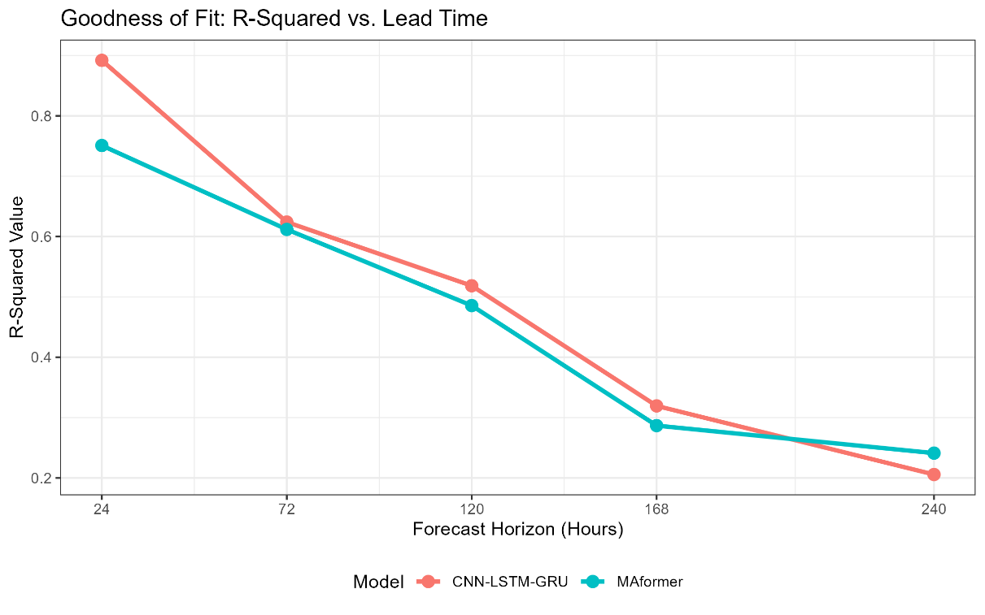

Appendix B. Horizon Decay: Multi-horizon SSS Forecast with the Hybrid and MAformer.
