Supplementary Material

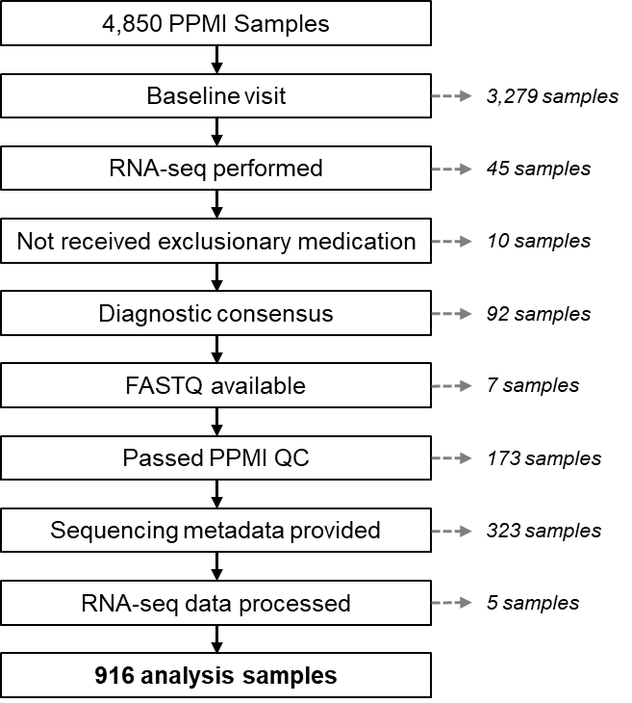

Supplementary Figure 1. PPMI analysis sample selection. The number of samples excluded at each step is shown on the right-hand side.

Supplementary Figure 2. RNA expression variation. (a) First two RNA expression principal components. (b) Associations between five RNA expression principal components and technical sequencing metrics. Blank tiles had an FDR-adjusted P > 0.05. (c) Selection of explanatory PC1 models using technical metrics that maximises the Bayesian information criterion (BIC). (d) Individual RNA expression variation attributable to select biological and technical covariates.

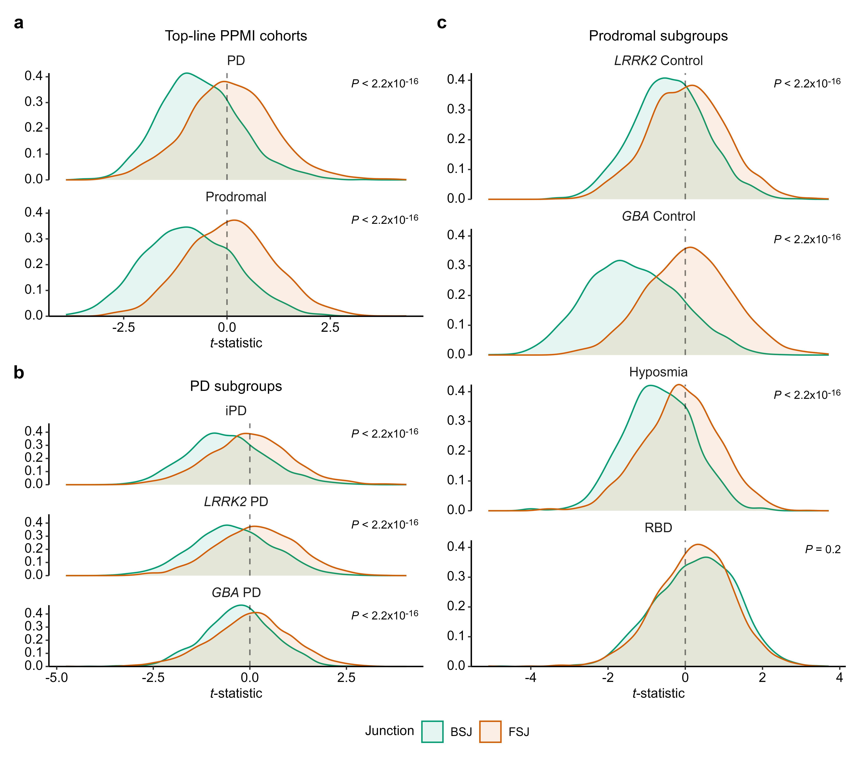
Supplementary Figure 3. Distribution of splice junction moderated t-statistics. Moderated t-statistics comparing circRNA (BSJ) and linear RNA (FSJ) expression levels to Controls (n = 162) across (a) top-line PPMI cohorts (PD n = 490, Prodromal n = 264), (b) PD subgroups (iPD n = 324, LRRK2 PD n = 125, GBA PD n = 36), (c) Prodromal subgroups (LRRK2 control n = 136, GBA Control n = 76, Hyposmia n = 18, RBD n = 24). Significance assessed using permutation testing. Reported P-values are uncorrected as only one test was performed per comparison.

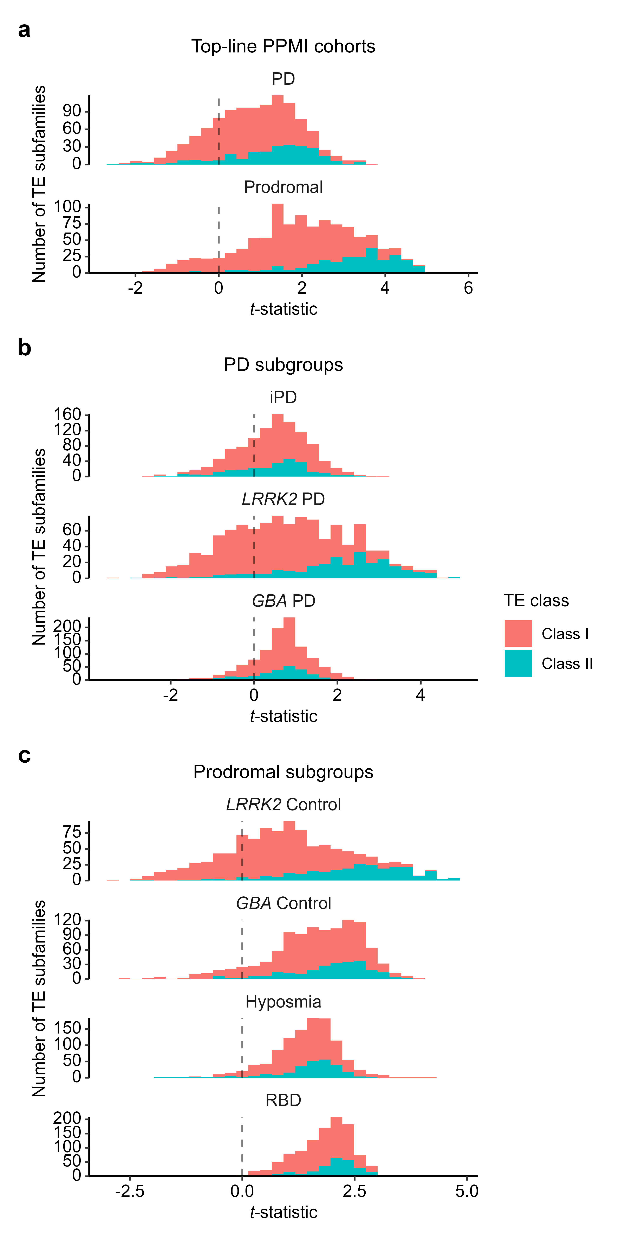
Supplementary Figure 4. Blood transposable element t-statistic distributions. Moderated t-statistics comparing Class I and II transposable element subfamily expression to Controls (n = 162) across (a) top-line PPMI cohorts (PD n = 490, Prodromal n = 264), (b) PD subgroups (iPD n = 324, LRRK2 PD n = 125, GBA PD n = 36), (c) Prodromal subgroups (LRRK2 control n = 136, GBA Control n = 76, Hyposmia n = 18, RBD n = 24).

