Supplemental material
Table S1: individual tumour volumes and group mean ± SD values of (cm³) for the EGFRvIII, WT, and sham groups.
EGFRvIII tumour (n=8) cm³ | WT tumour (n=3) cm³ | Sham (n=2) cm³
0.032 | 0.004 | -
0.036 | 0.007 | -
0.019 | 0.005
0.023
0.015
0.044
0.034
0.047
0.031 ± 0.011 | 0.005 ± 0.001 | -

Table S2: mean ± SD of kinetic parameters estimated using the irreversible two-tissue compartment model (2-TCM) and the Patlak model in EGFRvIII tumour, blocking, wild-type (WT) tumour, and sham groups.
2-TCM-irrev
 | K_{i} (mL/cm³/min) | SE% K_{i} | K₁ (mL/cm³/min) | SE% K₁
EGFRvIII tumour | 1.6E-05±1.1E-05 | 8.9E+01±1.5E+0.2 | 6.2E-05±2.9E-05 | 6.9E+00±6.9E-01
Blocking | 6.2E-06±2.1E-06 | 1.6E+01±3.9E+00 | 5.3E-04±7.0E-04 | 4.6E+01±3.8E+01
WT tumour | 4.9E-07±6.9E-07 | 9.9E+101±1.4E+102 | 2.8E-06±1.0E-06 | 1.0E+02±1.8E+00
Sham | 2.8E-104±0 | 1.0E+104±0 | 1.8E-06±0 | 2.6E+06±0
 | k₂ (min⁻¹) | SE% k₂ | k₃ (min⁻¹) | SE% k₃
EGFRvIII tumour | 6.1E-04±3.3E-04 | 2.5E+01±8.4E+00 | 2.2E-04±1.6E-04 | 1.2E+02±1.7E+02
Blocking | 6.0E-02±8.0E-02 | 5.5E+01±3.5E+01 | 5.8E-04±3.9E-04 | 3.3E+01±1.3E+00
WT tumour | 3.7E-04±3.3E-04 | 6.7E+02±4.7E+02 | 1.2E-04±1.6E-04 | 1.0E+102±1.4+102
Sham | 9.9E-06±0 | 3.5E+08±0 | 1.5E-103±0 | 1.0E+104±0
Patlak
 | K_{i} (mL/cm³/min) | SE% K_{i} | Intercept (mL/cm³) | SE% Intercept
EGFRvIII tumour | 2.4E-05±9.4E-06 | 8.4E+00±1.1E+00 | 2.6E-02±1.1E+02 | 3.0E+01±6.1E+00
Blocking | 6.4E-06±2.2E-06 | 1.2E+01±2.8E+00 | 1.4E-02±6.5E-03 | 2.1E+01±3.5E+00
WT tumour | 1.4E-06±3.3E-07 | 1.6E+01±5.9E+00 | 2.4E-03±9.8E-04 | 4.4E+01±3.5E+01
Sham | 1.7E-06±2.6E-07 | 3.7E+05±2.0E+04 | 1.6E-03±1.5E-04 | 1.5E+05±2.6E+04

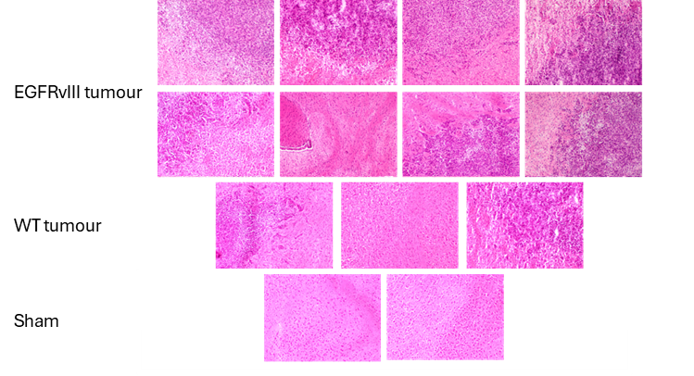
Figure S1: hematoxylin and eosin–stained brain sections from all animals in the EGFRvIII tumour, wild-type (WT) tumour, blocking tumour, and sham groups. All images were acquired using brightfield microscopy at 10× magnification.
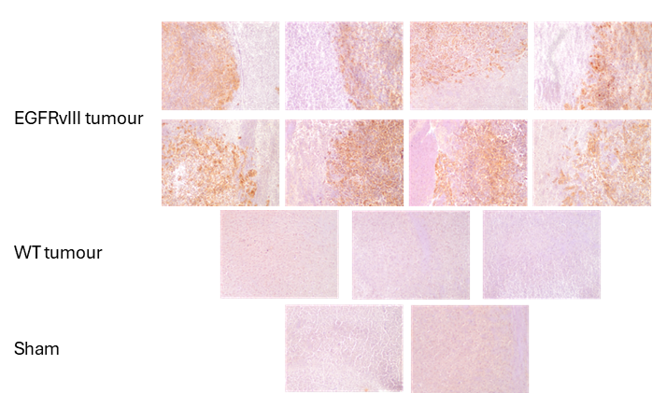
Figure S2: immunohistochemical detection of EGFRvIII expression in all animals from the EGFRvIII tumour, wild-type (WT) tumour, blocking tumour, and sham groups. All images were acquired using brightfield microscopy at 10× magnification.

