Supplementary
Supplementary figure 1
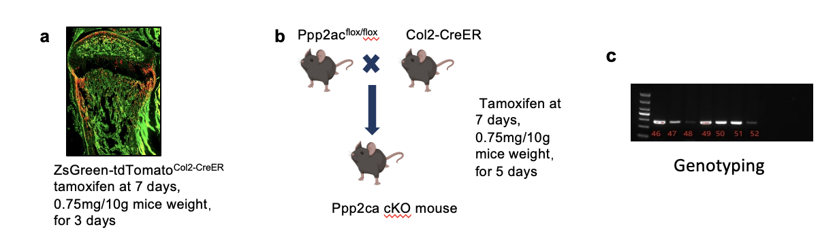
Fig. S1 Generation of chondrocyte-specific Ppp2ca knockout mice. (a) Lineage tracing of Col2-expressing cells in joint tissues, demonstrating chondrocyte-specific localization. (b) Breeding scheme for generating conditional Ppp2ca knockout (KO) (Col2CreER;Ppp2ca^{f/f}) mice. (c) Genotyping confirming successful Ppp2ca chondrocyte-specific KO animals.

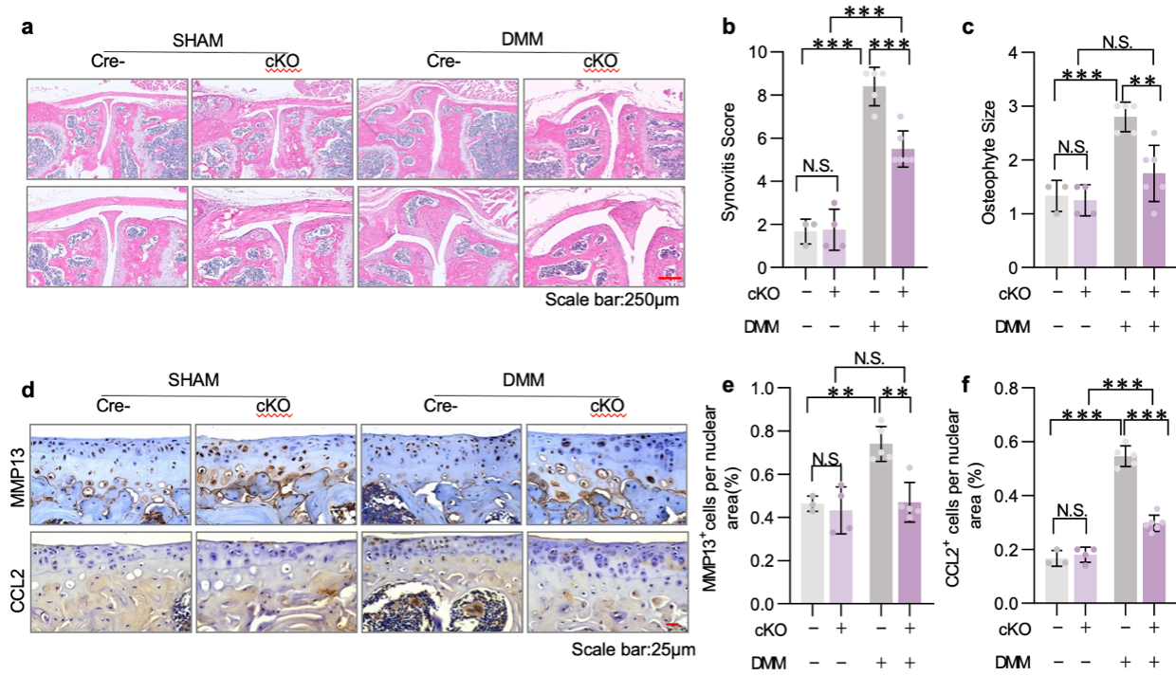
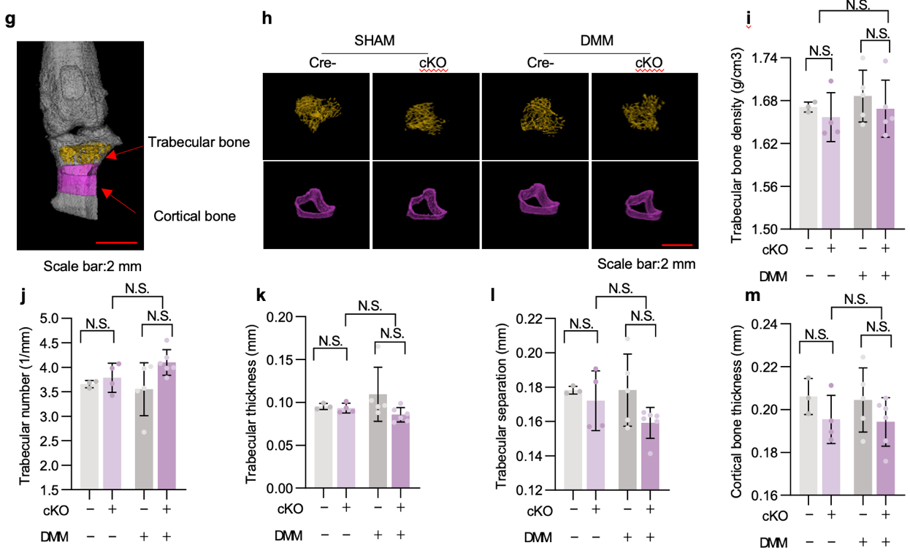
Fig. S2 Micro-CT imaging and histopathological analysis Ppp2ca cKO mice with DMM surgery. (a) Representative H&E-stained joint sections (scale bar: 250 μm) and quantitative analysis of (b) synovitis scores and (c) osteophyte size in Sham or DMM-operated control (Cre-) and Ppp2ca cKO mice (n≥3). (d-f) Immunohistochemical evaluation showing (d) representative sections (scale bar: 25 μm) with quantification of (e) MMP13⁺ and (f) CCL2⁺ chondrocytes (n≥3). (g) Micro-CT reconstructions of trabecular and cortical bone architecture (scale bar: 2 mm) with corresponding quantification of (h) trabecular bone mineral density (BMD), (i) trabecular number (Tb.N), (j) trabecular thickness (Tb.Th), (k) trabecular separation (Tb.Sp), and (l) cortical thickness (Ct.Th) (n≥3). Data represent mean ± SD. Statistical analysis was performed by two-way ANOVA followed by the Tukey post-hoc test ; *P < 0.05, **P < 0.01, ***P < 0.001 were considered as statistically significant, N.S., not significant.
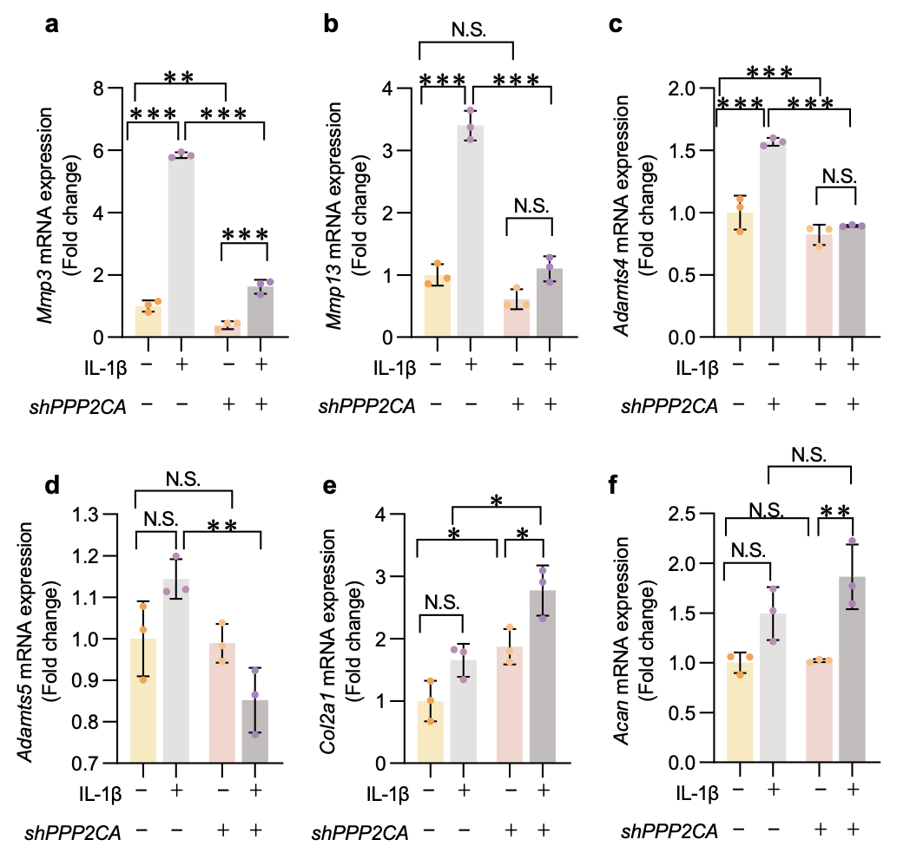
Fig. S3 PPP2CA knockdown modulates extracellular matrix gene expression in ATDC5 chondrocytes. Quantitative PCR analysis of (a) Mmp3, (b) Mmp13, (c) Adamts4, (d) Adamts5, (e) Col2a1, and (f) AcanmRNA levels in ATDC5 cells following PPP2CA knockdown (n=3). Data represent mean ± SD. Statistical analysis was performed by two-way ANOVA followed by the Tukey post-hoc test ; *P < 0.05, **P < 0.01, ***P < 0.001 were considered as statistically significant, N.S., not significant.

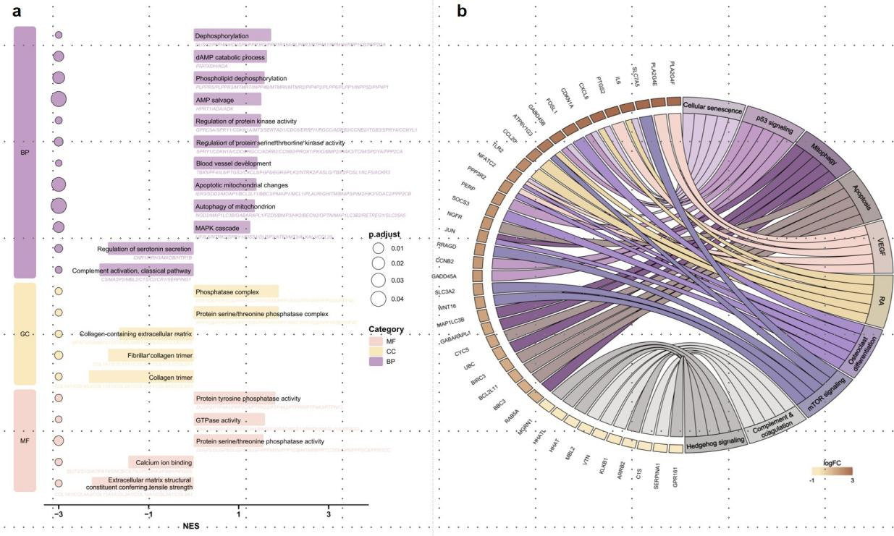
Fig. S4 Functional annotation analyses of PPP2CA. (a) Gene ontology (GO) analysis of top cellular functions in OA cartilage with high versus low PPP2CA expression (E-MTAB-4304 v.s. GSE114007). (b) Top enriched pathways and associated genes in high-PPP2CA expressing OA cartilage (KEGG).

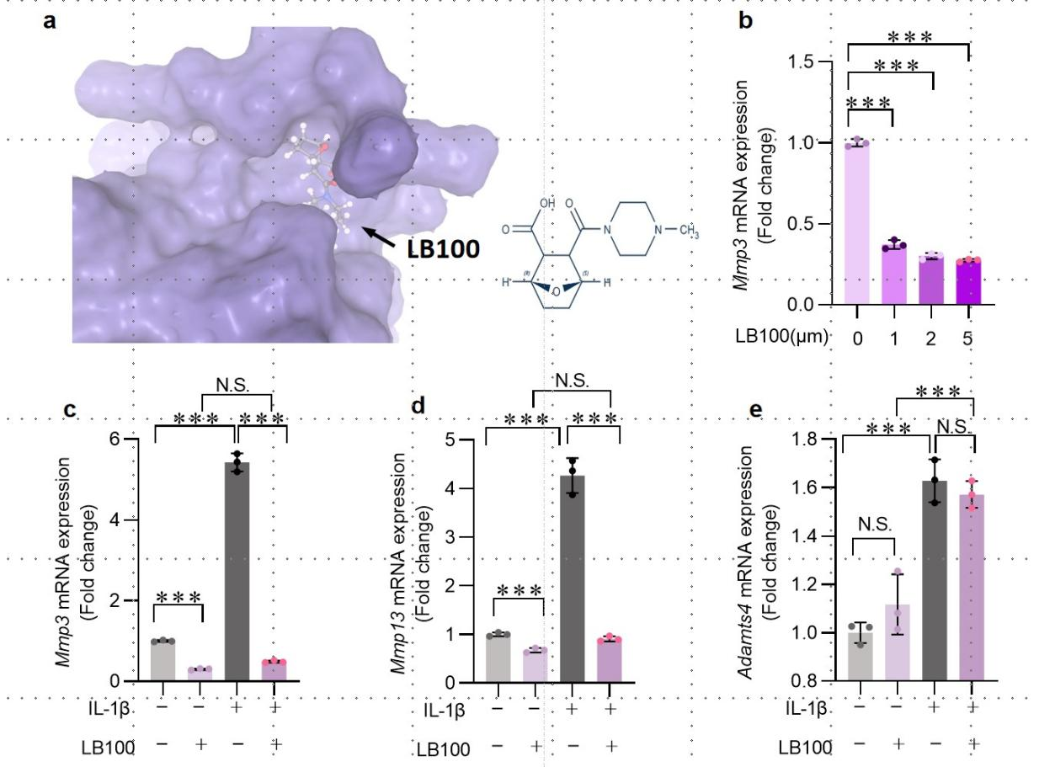
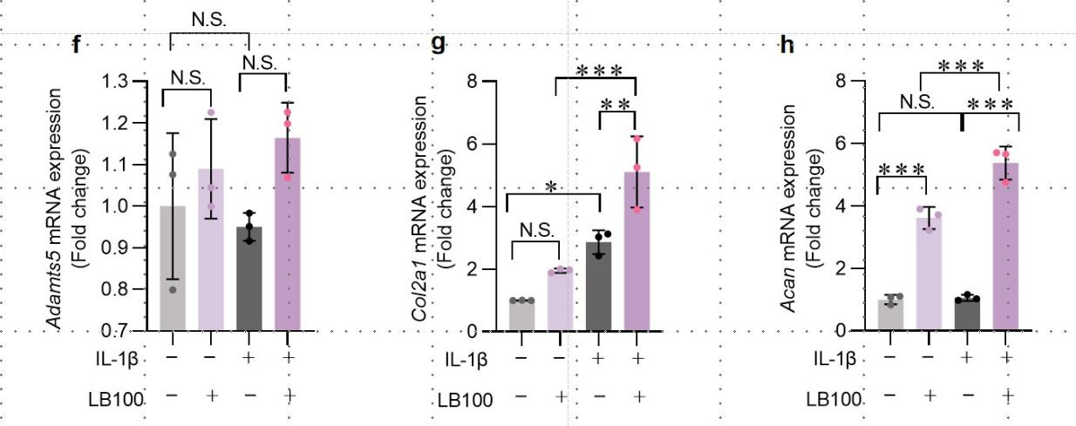
Fig. S5 LB-100 modulates ECM gene expression in ATDC5. (a) The SWISS-Dock model estimates high binding affinity between LB-100 and PPP2CA (AC score: -23.235179). (b) Dose-response analysis of Mmp3 expression in ATDC5 cells treated with increasing concentrations of LB-100 (0-5 μM). (c-h) qPCR analysis of extracellular matrix-related genes in IL-1β-stimulated ATDC5 cells with or without LB-100 treatment (2 μM): (c) Mmp3, (d) Mmp13, (e) Adamts4, (f) Adamts5, (g) Col2a1, and (h) Acan (n=3). Data represent mean ± SD. Statistical analysis was performed by two-way ANOVA followed by the Tukey post-hoc test ; *P < 0.05, **P < 0.01, ***P < 0.001 were considered as statistically significant; N.S., not significant.

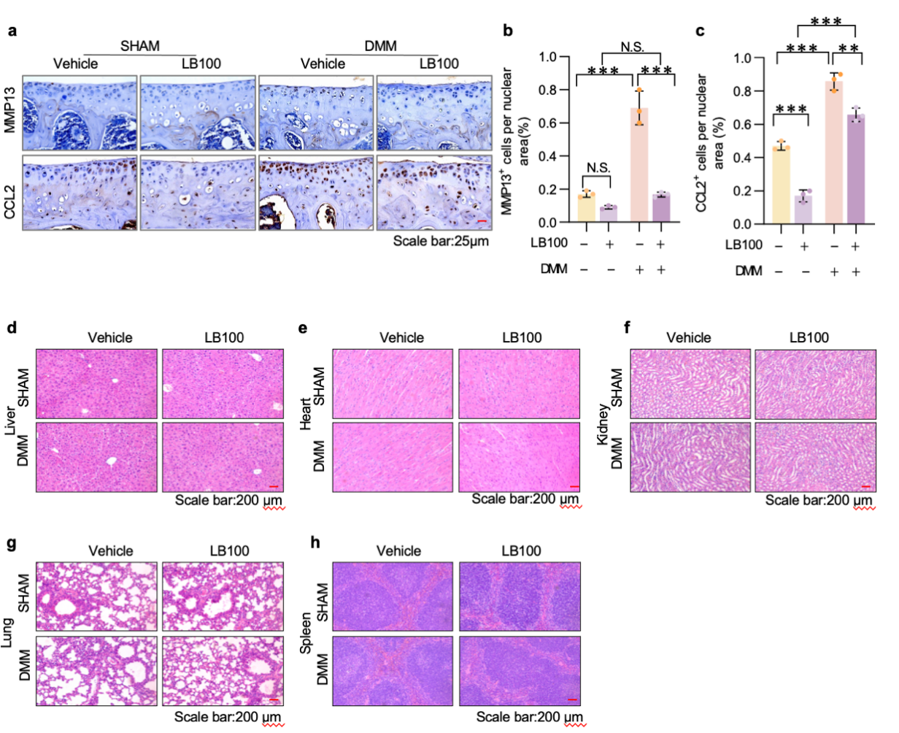
Fig. S6 Safety evaluation of YC-LB-100 treatment in OA mice. (a) Representative immunohistochemical images (scale bar: 25 μm) and quantitative analysis of (b) MMP13⁺ and (c) CCL2⁺ cells in articular cartilage of wild-type (WT) and DMM-operated mice treated with vehicle or YC-LB-100 (n≥3). (d-h) Hematoxylin and eosin (H&E)-stained sections of (d) liver, (e) heart, (f) kidney, (g) lung, and (h) spleen from treated mice, demonstrating no pathological alterations. Data represent mean ± SD. Statistical analysis was performed by two-way ANOVA followed by the Tukey post-hoc test ; *P < 0.05, **P < 0.01, ***P < 0.001 were considered as statistically significant; N.S., not significant. (i) In vivo fluorescence imaging tracking NCG-NPs following oral administration.

