Supporting information
In Situ Synthesis of Mn-Doped CoP@Ni₂P Nanoneedles as a High-Performance Bifunctional Electrocatalyst for Efficient Water Splitting
Yu Dong¹, Xuan Zhao¹, Zhijie Wang¹, Ende Wang², Yusheng Qiu¹, Naikun Sun¹ *, Yongli Tong¹ *

Supplementary Figures and Tables

Figure S1 Local XRD magnified diffraction pattern

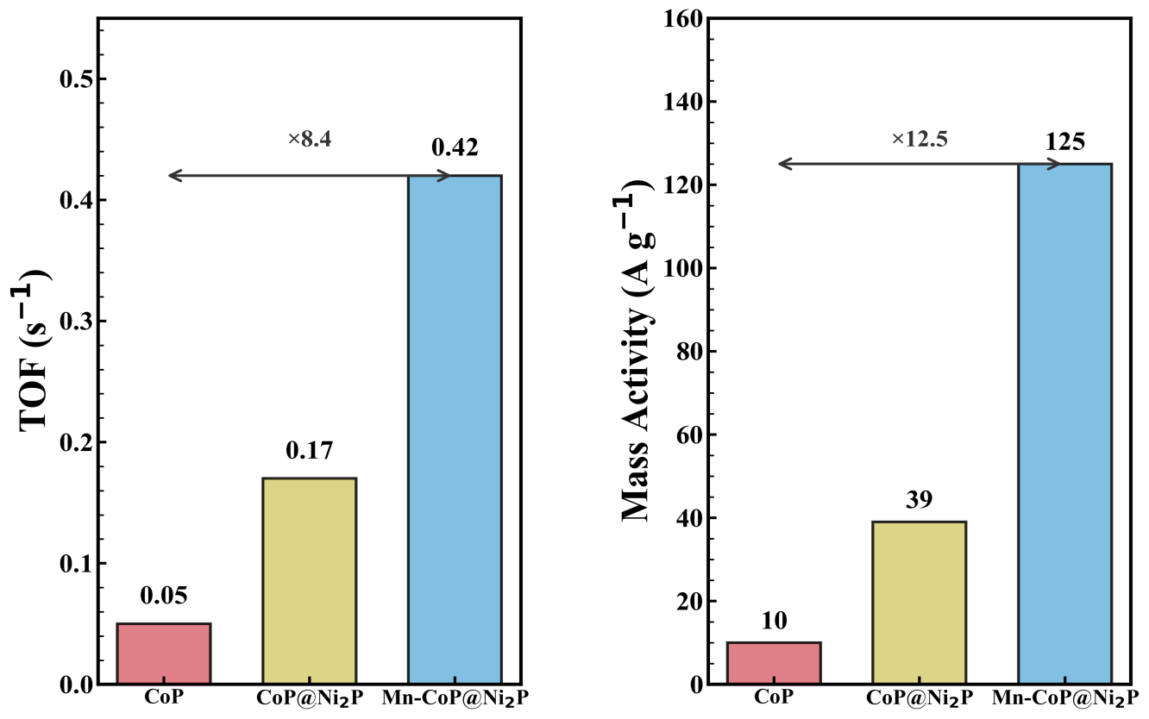
(b)
(a)
Figure S2. （a) TOF comparison of CoP, CoP@Ni₂P and Mn-CoP@Ni₂P. (b) Mass activity comparison.

(d)
(c)
(b)
(a)

Figure S3. LSV curves of Mn-CoP@Ni₂P for (a) HER and (b) OER measured in KOH solutions (pH ≈ 13.0, 14.0, 14.5, and ~15.0)；(c) HER and (d) OER measured in H₂SO₄ solutions (pH ≈ 0.7, 0.5, 0.3, and 0.1).

(a)
(b)

Figure S4. Comparison of polarization curves and corresponding Tafel plots obtained from LSV and steady-state potentiostatic measurements for Mn-CoP@Ni₂P/NF of HER.

(a)
(b)
Figure S5. Comparison of polarization curves and corresponding Tafel plots obtained from LSV and steady-state potentiostatic measurements for Mn-CoP@Ni₂P/NF of
OER.

Table S1. Comparison of HER performance in 1 M KOH (pH = 14) for the Mn-CoP@Ni₂P with other similar electrocatalysts.
Catalyst | Electrolyte | η (mV) @ 10 mA cm⁻² | Tafel slope (mV dec⁻¹) | Reference
CoMoP@C | 1 M KOH | 81 | 55.53 | 46
CoP_{x}/N-rGO | 1 M KOH | 104 | 65 | 47
NiP₂ | 1 M KOH | 102 | 65 | 48
Cu_{0.3}Co_{2.7}P/Nitrogen doped carbon | 1 M KOH | 220 | 122 | 49
CoP@CoOOH/CP | 1 M KOH | 81.7 | 50.7 | 50
Ni₂P/Fe₂P | 1 M KOH | 121 | 67 | 51
Ni–P/Ni₂P/CC-2 | 1 M KOH | 95 | 80.4 | 52
CoP@NiCo LDH-100 | 1 M KOH | 62 | 74.03 | 53
Mn-CoP@Ni₂P | 1 M KOH | 61.7 | 40 | This work

Table S2. Comparison of OER performance in 1 M KOH (pH = 14) for the Mn-CoP@Ni₂P with other similar electrocatalysts.
Catalyst | Electrolyte | η (mV) @ 10 mA cm⁻² | Tafel slope (mV dec⁻¹) | Reference
Co₂P/CoP@NPGC-1 | 1 M KOH | 340 | 116 | 54
Ni-NCN/CoFe-LDH | 1 M KOH | 280 | 42.83 | 55
n-Co₂P | 1 M KOH | 370 | 134 | 56
NiCo@NC-900 | 1 M KOH | 390 | 143.7 | 57
Co-NiP@NC | 1 M KOH | 280 | 52 | 58
CoFeP@C | 1 M KOH | 262 | 44.8 | 59
Ni₁-Co₁-P | 1 M KOH | 292 | 74 | 60
Ni-Co-P/GDY | 1 M KOH | 290 | 72.7 | 61
Mn-CoP@Ni₂P | 1 M KOH | 122 | 64.09 | This work

