 | A1 | A2 | A3 | A4 | A5 | A6 | A7 | A8 | A9 | A10 | A11 | A12 | D1 | D2 | D3 | D4 | D5 | D6 | D7 | D8 | D9 | D10
A1 | 0.000 | 0.100 | 0.061 | 0.100 | 0.052 | 0.058 | 0.091 | 0.093 | 0.069 | 0.019 | 0.033 | 0.040 | 0.034 | 0.109 | 0.009 | 0.000 | 0.066 | 0.000 | 0.082 | 0.000 | -0.068 | 0.000
A2 | 0.064 | 0.000 | 0.000 | 0.000 | 0.043 | 0.000 | 0.079 | 0.084 | 0.078 | 0.000 | 0.015 | 0.019 | 0.000 | 0.000 | 0.000 | 0.000 | 0.027 | 0.068 | 0.046 | 0.000 | 0.000 | 0.118
A3 | 0.022 | 0.019 | 0.000 | -0.032 | 0.000 | 0.000 | 0.000 | 0.034 | 0.016 | 0.000 | 0.001 | -0.009 | -0.128 | 0.008 | 0.000 | 0.000 | 0.000 | 0.000 | 0.000 | -0.067 | 0.000 | -0.122
A4 | 0.087 | 0.050 | 0.000 | 0.000 | 0.032 | 0.024 | 0.009 | 0.000 | 0.009 | 0.000 | 0.034 | 0.000 | 0.034 | 0.033 | 0.012 | 0.000 | 0.000 | 0.075 | 0.023 | 0.015 | 0.000 | 0.079
A5 | 0.018 | 0.020 | -0.002 | 0.046 | 0.000 | 0.015 | 0.032 | 0.023 | 0.000 | 0.003 | 0.000 | 0.000 | 0.023 | 0.002 | 0.042 | 0.040 | 0.000 | 0.086 | 0.037 | 0.024 | 0.000 | 0.000
A6 | 0.047 | 0.004 | 0.000 | 0.047 | 0.053 | 0.000 | 0.019 | 0.000 | 0.046 | 0.012 | 0.058 | 0.027 | 0.130 | 0.094 | 0.000 | 0.000 | 0.062 | 0.100 | 0.027 | 0.000 | 0.025 | 0.091
A7 | 0.038 | 0.077 | 0.025 | 0.063 | 0.065 | 0.015 | 0.000 | 0.098 | 0.048 | 0.011 | 0.013 | 0.029 | 0.000 | 0.000 | 0.000 | 0.000 | 0.000 | 0.204 | 0.106 | 0.063 | 0.007 | 0.062
A8 | 0.089 | 0.112 | 0.054 | 0.022 | 0.055 | 0.038 | 0.136 | 0.000 | 0.074 | 0.054 | 0.000 | 0.052 | 0.000 | 0.000 | 0.000 | 0.000 | -0.047 | 0.000 | 0.000 | 0.000 | 0.000 | 0.000
A9 | 0.030 | 0.058 | 0.010 | 0.043 | 0.034 | 0.025 | 0.061 | 0.110 | 0.000 | 0.049 | 0.012 | 0.054 | 0.000 | 0.059 | 0.000 | 0.097 | 0.000 | 0.049 | 0.087 | 0.000 | 0.000 | 0.000
A10 | 0.000 | 0.000 | 0.007 | 0.007 | 0.000 | -0.010 | 0.000 | 0.000 | 0.000 | 0.000 | 0.000 | 0.002 | 0.020 | 0.034 | 0.000 | 0.031 | 0.074 | 0.025 | 0.061 | 0.000 | 0.000 | 0.000
A11 | 0.000 | 0.021 | 0.016 | 0.013 | 0.000 | 0.034 | 0.014 | 0.034 | 0.000 | 0.005 | 0.000 | 0.043 | 0.088 | 0.059 | 0.038 | 0.093 | 0.093 | 0.000 | 0.000 | 0.080 | 0.000 | 0.064
A12 | 0.005 | 0.016 | 0.007 | 0.000 | 0.001 | 0.017 | 0.048 | 0.020 | 0.052 | 0.028 | 0.041 | 0.000 | 0.119 | 0.057 | 0.056 | 0.003 | 0.119 | 0.044 | 0.122 | 0.092 | 0.121 | 0.062
D1 | 0.003 | 0.008 | 0.002 | 0.005 | 0.002 | 0.000 | 0.006 | 0.000 | 0.000 | 0.002 | 0.000 | 0.006 | 0.000 | 0.065 | 0.107 | 0.031 | 0.051 | 0.042 | 0.050 | 0.023 | 0.001 | 0.052
D2 | 0.002 | 0.002 | 0.000 | 0.003 | 0.007 | 0.001 | 0.001 | 0.000 | 0.000 | 0.000 | 0.001 | 0.000 | 0.048 | 0.000 | 0.022 | 0.050 | 0.046 | 0.051 | 0.066 | 0.023 | 0.000 | 0.060
D3 | 0.000 | 0.000 | 0.000 | 0.000 | 0.000 | 0.005 | 0.000 | 0.001 | 0.000 | 0.000 | 0.000 | 0.000 | 0.042 | 0.008 | 0.000 | 0.044 | 0.032 | 0.035 | 0.015 | 0.018 | 0.006 | 0.034
D4 | 0.000 | 0.000 | 0.000 | 0.000 | 0.001 | 0.000 | 0.000 | -0.002 | 0.000 | -0.007 | 0.003 | 0.003 | 0.026 | 0.052 | 0.035 | 0.000 | 0.056 | 0.042 | 0.043 | 0.005 | -0.016 | 0.004
D5 | 0.001 | 0.002 | 0.001 | 0.006 | 0.003 | 0.004 | 0.016 | 0.008 | 0.000 | 0.000 | 0.004 | 0.009 | 0.042 | 0.009 | 0.033 | 0.000 | 0.000 | 0.063 | 0.000 | 0.024 | 0.000 | 0.000
D6 | 0.006 | 0.005 | 0.000 | 0.005 | 0.018 | 0.001 | 0.020 | 0.010 | 0.009 | 0.007 | 0.003 | 0.012 | 0.092 | 0.030 | 0.033 | 0.031 | 0.085 | 0.000 | 0.060 | 0.025 | 0.025 | 0.020
D7 | 0.007 | 0.005 | 0.000 | 0.006 | 0.007 | 0.004 | 0.006 | 0.000 | 0.000 | 0.006 | 0.002 | 0.000 | 0.038 | 0.078 | 0.042 | 0.041 | 0.012 | 0.032 | 0.000 | 0.000 | 0.061 | 0.056
D8 | 0.000 | 0.000 | 0.003 | 0.001 | 0.006 | 0.001 | 0.007 | 0.003 | 0.000 | 0.001 | 0.005 | 0.002 | 0.047 | 0.031 | 0.049 | 0.016 | 0.027 | 0.036 | 0.022 | 0.000 | 0.000 | 0.016
D9 | 0.000 | 0.008 | 0.000 | 0.005 | 0.003 | 0.001 | 0.006 | 0.001 | 0.000 | 0.001 | 0.000 | 0.003 | 0.030 | 0.014 | 0.000 | 0.000 | 0.016 | 0.023 | 0.015 | 0.000 | 0.000 | 0.088
D10 | 0.000 | 0.000 | 0.002 | 0.000 | 0.006 | 0.002 | 0.005 | 0.006 | 0.004 | 0.000 | 0.004 | 0.002 | 0.083 | 0.046 | 0.099 | 0.018 | 0.071 | 0.046 | 0.039 | 0.034 | 0.070 | 0.000
Table s1. Longitudinal network correlation matrix between activities of daily living (ADL) and CESD-10 items in Chinese older adults

Table s2. Cross-Lagged Association Coefficients (β values) for the all-Specific ADL-Depression Network
 | nodeOut | nodeIn | value
1 | A7: Housework | D6: Effortfulness | 0.204053071999719
2 | A8: Cooking | A7: Housework | 0.136321621583782
3 | A6: Controlling elimination | D1: Depressiveness | 0.129688646064176
4 | A12: Money management | D7: Inertia | 0.122167647539922
5 | A12: Money management | D9: Hopelessness | 0.121392920619545
6 | A12: Money management | D5: Cognitive trouble | 0.118963430498279
7 | A12: Money management | D1: Depressiveness | 0.118953299556345
8 | A2: Bathing | D10: Unhappiness | 0.118281287074691
9 | A8: Cooking | A2: Bathing | 0.111613618944547
10 | A9: Shopping | A8: Cooking | 0.110270801614892
11 | A1: Dressing | D2: Loneliness | 0.108623054657786
12 | D1: Depressiveness | D3: Botheredness | 0.107134659867384
13 | A7: Housework | D7: Inertia | 0.106222930911064
14 | A1: Dressing | A4: Getting up | 0.100297601459376
15 | A6: Controlling elimination | D6: Effortfulness | 0.100047742515641
16 | A1: Dressing | A2: Bathing | 0.0997939924478307
17 | D10: Unhappiness | D3: Botheredness | 0.0990216182630635
18 | A7: Housework | A8: Cooking | 0.0981513737872629
19 | A9: Shopping | D4: Fearfulness | 0.0973225757153541
20 | A6: Controlling elimination | D2: Loneliness | 0.0941579167411861
21 | A11: Medication | D5: Cognitive trouble | 0.0932485352355095
22 | A11: Medication | D4: Fearfulness | 0.0930299619347159
23 | A1: Dressing | A8: Cooking | 0.0927821366895221
24 | D6: Effortfulness | D1: Depressiveness | 0.092462499127182
25 | A12: Money management | D8: Restlessness | 0.0924464048654948
26 | A1: Dressing | A7: Housework | 0.0912789443477927
27 | A6: Controlling elimination | D10: Unhappiness | 0.0907852490495755
28 | A8: Cooking | A1: Dressing | 0.0885579900998977
29 | D9: Hopelessness | D10: Unhappiness | 0.0882454595649823
30 | A11: Medication | D1: Depressiveness | 0.0875851709010569
31 | A9: Shopping | D7: Inertia | 0.0872667618711793
32 | A4: Getting up | A1: Dressing | 0.0866246729198824
33 | A5: Toileting | D6: Effortfulness | 0.0855698202795396
34 | D6: Effortfulness | D5: Cognitive trouble | 0.0850096230275044
35 | A2: Bathing | A8: Cooking | 0.0839762155017966
36 | D10: Unhappiness | D1: Depressiveness | 0.0829094794352228
37 | A1: Dressing | D7: Inertia | 0.081638503100278
38 | A11: Medication | D8: Restlessness | 0.0795269743875588
39 | A2: Bathing | A7: Housework | 0.0790852289983476
40 | A4: Getting up | D10: Unhappiness | 0.0789003251808533
41 | A2: Bathing | A9: Shopping | 0.0783395936896107
42 | D7: Inertia | D2: Loneliness | 0.07818847660318
43 | A7: Housework | A2: Bathing | 0.0769084009633753
44 | A4: Getting up | D6: Effortfulness | 0.0753744856364169
45 | A8: Cooking | A9: Shopping | 0.0742671768819579
46 | A10: Phone use | D5: Cognitive trouble | 0.0736052388691315
47 | D10: Unhappiness | D5: Cognitive trouble | 0.0713145166265354
48 | D10: Unhappiness | D9: Hopelessness | 0.0701795603251903
49 | A1: Dressing | A9: Shopping | 0.0693540125099811
50 | A2: Bathing | D6: Effortfulness | 0.0682867099955402

Table s3. Unstandardized In-Expected Influence and Out-Expected Influence for All Nodes in the Cross-Lagged Panel Network (Total Sample)
 | in-EI | out-EI
A1: Dressing | 0.417160575957613 | 0.947380032873572
A2: Bathing | 0.506714142526191 | 0.641650515571573
A3: Eating | 0.186113387644252 | -0.259067786
A4: Getting up | 0.340714144284498 | 0.514612196116938
A5: Toiletin | 0.38833171780541 | 0.407576113198383
A6: Controlling elimination | 0.236652398141332 | 0.841437471886433
A7: Housework | 0.55728680593496 | 0.924444277286802
A8: Cooking | 0.522286033813583 | 0.639208669576474
A9: Shopping | 0.405892156719961 | 0.778927477047313
A10: Phone use | 0.190971633386076 | 0.251372401859306
A11: Medication | 0.228680271420954 | 0.694581285350256
A12: Money management | 0.294254966334412 | 1.03352631090823
D1: depressiveness | 0.766350106286463 | 0.45531670277127
D2: loneliness | 0.788129547667399 | 0.383959436690351
D3: botheredness | 0.579444665885317 | 0.239614951769339
D4: fearfulness | 0.494442168772395 | 0.244066144671341
D5: cognitive trouble | 0.791118731464979 | 0.226395885364602
D6: effortfulness | 1.02323408157569 | 0.499393548546362
D7: inertia | 0.90175906493308 | 0.404265544026448
D8: restlessness | 0.35861984776575 | 0.275294342557031
D9: hopelessness | 0.231829117294152 | 0.213860981935789
D10: unhappiness | 0.684980532783813 | 0.537149594046986

Table s4. Longitudinal network correlation matrix between activities of daily living (ADL) and CESD-10 items in Chinese female older adults
 | A1 | A2 | A3 | A4 | A5 | A6 | A7 | A8 | A9 | A10 | A11 | A12 | D1 | D2 | D3 | D4 | D5 | D6 | D7 | D8 | D9 | D10
A1 | 0.000 | 0.066 | 0.050 | 0.121 | 0.043 | 0.044 | 0.108 | 0.131 | 0.058 | 0.036 | 0.079 | 0.040 | 0.000 | 0.040 | 0.000 | 0.000 | 0.000 | 0.000 | 0.039 | 0.013 | -0.050 | 0.090
A2 | 0.042 | 0.000 | 0.000 | 0.000 | 0.005 | 0.028 | 0.042 | 0.060 | 0.087 | 0.020 | 0.001 | 0.014 | 0.000 | 0.022 | 0.000 | 0.000 | 0.000 | 0.078 | 0.011 | 0.021 | 0.000 | 0.012
A3 | 0.095 | 0.127 | 0.000 | 0.000 | 0.000 | 0.000 | 0.000 | 0.025 | 0.050 | 0.000 | 0.056 | 0.015 | -0.104 | 0.051 | 0.000 | 0.000 | 0.000 | 0.000 | 0.000 | 0.000 | 0.000 | -0.099
A4 | 0.091 | 0.033 | 0.000 | 0.000 | 0.043 | 0.000 | 0.025 | 0.000 | 0.000 | 0.000 | 0.016 | 0.000 | 0.052 | 0.109 | 0.034 | 0.063 | 0.026 | 0.086 | 0.151 | 0.026 | 0.000 | 0.110
A5 | 0.027 | 0.021 | -0.001 | 0.023 | 0.000 | 0.000 | 0.002 | 0.013 | 0.004 | 0.000 | 0.005 | 0.003 | 0.000 | 0.000 | 0.020 | 0.051 | 0.000 | 0.079 | 0.022 | 0.000 | 0.032 | 0.001
A6 | 0.042 | 0.024 | 0.000 | 0.093 | 0.113 | 0.000 | 0.027 | 0.000 | 0.055 | 0.000 | 0.072 | 0.027 | 0.155 | 0.005 | 0.000 | 0.000 | 0.078 | 0.090 | 0.057 | 0.000 | 0.000 | 0.057
A7 | 0.000 | 0.041 | 0.002 | 0.056 | 0.044 | 0.023 | 0.000 | 0.050 | 0.011 | 0.000 | 0.007 | 0.023 | 0.000 | 0.000 | 0.000 | 0.001 | 0.000 | 0.107 | 0.005 | 0.091 | 0.000 | 0.007
A8 | 0.104 | 0.143 | 0.078 | 0.043 | 0.088 | 0.051 | 0.182 | 0.000 | 0.102 | 0.059 | 0.009 | 0.077 | -0.041 | 0.000 | -0.069 | 0.000 | 0.000 | 0.041 | 0.000 | 0.000 | 0.000 | 0.000
A9 | 0.012 | 0.063 | 0.019 | 0.013 | 0.009 | 0.027 | 0.034 | 0.106 | 0.000 | 0.042 | 0.012 | 0.046 | 0.000 | 0.034 | 0.000 | 0.119 | 0.000 | 0.026 | 0.185 | 0.000 | 0.000 | 0.056
A10 | 0.035 | 0.032 | 0.000 | 0.021 | 0.000 | 0.000 | 0.001 | 0.001 | 0.000 | 0.000 | 0.000 | 0.000 | 0.007 | 0.068 | 0.000 | 0.073 | 0.000 | 0.035 | 0.140 | 0.015 | 0.000 | 0.000
A11 | 0.000 | 0.000 | 0.005 | 0.000 | 0.000 | 0.008 | 0.000 | 0.001 | 0.000 | 0.000 | 0.000 | 0.049 | 0.053 | 0.000 | 0.000 | 0.000 | 0.030 | 0.000 | 0.000 | 0.033 | 0.000 | 0.047
A12 | 0.000 | 0.000 | 0.000 | 0.000 | 0.000 | 0.000 | 0.035 | 0.005 | 0.040 | 0.025 | 0.028 | 0.000 | 0.060 | 0.000 | 0.060 | 0.015 | 0.150 | 0.010 | 0.093 | 0.060 | 0.013 | -0.003
D1 | 0.006 | 0.001 | 0.000 | 0.000 | 0.000 | 0.000 | 0.003 | 0.000 | 0.000 | 0.009 | 0.000 | 0.007 | 0.000 | 0.067 | 0.106 | 0.042 | 0.043 | 0.036 | 0.062 | 0.021 | 0.000 | 0.041
D2 | 0.003 | 0.007 | 0.000 | 0.004 | 0.007 | 0.006 | 0.000 | 0.000 | 0.000 | 0.000 | 0.000 | -0.002 | 0.072 | 0.000 | 0.006 | 0.059 | 0.023 | 0.050 | 0.085 | 0.020 | 0.000 | 0.046
D3 | 0.002 | 0.000 | 0.001 | 0.001 | 0.000 | 0.003 | 0.000 | 0.005 | 0.000 | 0.000 | 0.000 | 0.000 | 0.011 | 0.000 | 0.000 | 0.020 | 0.017 | 0.000 | 0.021 | 0.000 | 0.002 | 0.046
D4 | 0.003 | 0.001 | 0.000 | 0.005 | 0.006 | 0.000 | 0.009 | 0.000 | 0.000 | 0.000 | 0.005 | 0.009 | 0.040 | 0.060 | 0.030 | 0.000 | 0.059 | 0.048 | 0.050 | 0.006 | 0.000 | 0.021
D5 | 0.000 | 0.005 | 0.000 | 0.009 | 0.001 | 0.007 | 0.019 | 0.003 | 0.000 | 0.001 | 0.006 | 0.009 | 0.037 | 0.000 | 0.016 | 0.002 | 0.000 | 0.065 | 0.000 | 0.000 | 0.000 | -0.021
D6 | 0.003 | 0.004 | 0.001 | 0.005 | 0.024 | 0.000 | 0.028 | 0.013 | 0.012 | 0.003 | 0.006 | 0.011 | 0.087 | 0.015 | 0.081 | 0.016 | 0.091 | 0.000 | 0.047 | 0.038 | 0.022 | 0.047
D7 | 0.000 | 0.000 | 0.000 | 0.005 | 0.000 | 0.000 | 0.000 | 0.000 | 0.000 | 0.000 | 0.002 | -0.001 | 0.016 | 0.069 | 0.048 | 0.051 | 0.017 | 0.043 | 0.000 | 0.000 | 0.024 | 0.028
D8 | 0.002 | 0.001 | 0.001 | 0.004 | 0.005 | 0.000 | 0.012 | 0.007 | 0.000 | 0.000 | 0.006 | 0.003 | 0.033 | 0.020 | 0.068 | 0.032 | 0.042 | 0.041 | 0.017 | 0.000 | 0.000 | 0.013
D9 | 0.000 | 0.008 | 0.000 | 0.003 | 0.000 | 0.000 | 0.004 | 0.004 | 0.000 | 0.002 | 0.003 | 0.008 | 0.044 | 0.031 | 0.010 | 0.000 | 0.034 | 0.038 | 0.020 | 0.006 | 0.000 | 0.094
D10 | 0.000 | 0.000 | 0.000 | 0.000 | 0.000 | 0.000 | 0.001 | 0.000 | 0.004 | 0.000 | 0.002 | 0.000 | 0.083 | 0.052 | 0.102 | 0.038 | 0.054 | 0.035 | 0.034 | 0.017 | 0.083 | 0.000
Table s5. Longitudinal network correlation matrix between activities of daily living (ADL) and CESD-10 items in Chinese male older adults
 | A1 | A2 | A3 | A4 | A5 | A6 | A7 | A8 | A9 | A10 | A11 | A12 | D1 | D2 | D3 | D4 | D5 | D6 | D7 | D8 | D9 | D10
A1 | 0.000 | 0.082 | 0.011 | 0.056 | 0.044 | 0.025 | 0.023 | 0.003 | 0.086 | 0.000 | 0.000 | 0.067 | 0.138 | 0.132 | 0.089 | 0.000 | 0.000 | 0.000 | 0.018 | 0.000 | -0.020 | 0.000
A2 | 0.087 | 0.000 | 0.000 | 0.016 | 0.062 | 0.000 | 0.147 | 0.116 | 0.020 | 0.000 | 0.026 | 0.000 | 0.000 | 0.000 | 0.000 | 0.000 | 0.072 | 0.087 | 0.105 | 0.000 | 0.005 | 0.245
A3 | -0.030 | 0.000 | 0.000 | 0.000 | 0.000 | -0.013 | 0.028 | 0.019 | 0.019 | 0.000 | 0.000 | -0.059 | -0.130 | 0.000 | 0.000 | 0.000 | 0.000 | 0.000 | 0.000 | 0.000 | 0.000 | -0.061
A4 | 0.068 | 0.058 | 0.022 | 0.000 | 0.032 | 0.074 | 0.023 | 0.019 | 0.047 | 0.008 | 0.028 | 0.029 | 0.010 | 0.000 | 0.000 | 0.000 | 0.000 | 0.099 | 0.000 | 0.000 | 0.000 | 0.031
A5 | 0.000 | 0.000 | 0.011 | 0.059 | 0.000 | 0.069 | 0.046 | 0.034 | 0.006 | 0.019 | 0.000 | 0.000 | 0.054 | 0.013 | 0.073 | 0.000 | 0.000 | 0.006 | 0.080 | 0.000 | -0.076 | 0.000
A6 | 0.046 | 0.007 | 0.021 | 0.004 | 0.021 | 0.000 | 0.000 | 0.000 | 0.000 | 0.000 | 0.038 | 0.038 | 0.094 | 0.004 | 0.000 | 0.000 | 0.016 | 0.160 | 0.000 | 0.000 | 0.000 | 0.076
A7 | 0.065 | 0.110 | 0.041 | 0.011 | 0.090 | 0.028 | 0.000 | 0.171 | 0.075 | 0.014 | 0.006 | 0.027 | 0.000 | 0.015 | 0.000 | 0.000 | 0.038 | 0.324 | 0.216 | 0.000 | 0.123 | 0.000
A8 | 0.107 | 0.083 | 0.024 | 0.033 | 0.011 | 0.000 | 0.079 | 0.000 | 0.050 | 0.027 | 0.000 | 0.017 | 0.058 | 0.082 | 0.000 | 0.000 | 0.000 | 0.033 | 0.000 | 0.000 | 0.013 | 0.020
A9 | 0.035 | 0.044 | 0.020 | 0.063 | 0.055 | 0.085 | 0.103 | 0.112 | 0.000 | 0.021 | 0.021 | 0.104 | 0.000 | 0.000 | 0.000 | 0.062 | 0.091 | 0.000 | 0.016 | 0.174 | 0.000 | 0.000
A10 | -0.039 | -0.011 | 0.013 | 0.000 | 0.000 | -0.043 | 0.000 | -0.019 | 0.000 | 0.000 | 0.026 | 0.009 | 0.072 | 0.010 | 0.000 | 0.000 | 0.148 | 0.037 | 0.040 | 0.000 | 0.000 | -0.084
A11 | 0.000 | 0.062 | 0.059 | 0.019 | 0.000 | 0.034 | 0.011 | 0.111 | 0.000 | 0.000 | 0.000 | 0.015 | 0.023 | 0.174 | 0.071 | 0.007 | 0.000 | 0.000 | 0.000 | 0.000 | 0.099 | 0.135
A12 | 0.051 | 0.075 | 0.022 | 0.031 | 0.015 | 0.040 | 0.060 | 0.021 | 0.062 | 0.016 | 0.045 | 0.000 | 0.141 | 0.142 | 0.071 | 0.000 | 0.000 | 0.085 | 0.052 | 0.027 | 0.194 | 0.193
D1 | 0.000 | 0.010 | 0.002 | 0.008 | 0.002 | 0.008 | 0.000 | 0.003 | 0.000 | 0.000 | 0.000 | 0.002 | 0.000 | 0.048 | 0.076 | 0.012 | 0.047 | 0.012 | 0.000 | 0.000 | 0.000 | 0.059
D2 | 0.000 | 0.000 | 0.000 | 0.000 | 0.004 | 0.000 | 0.008 | 0.006 | 0.000 | 0.000 | 0.005 | 0.016 | 0.021 | 0.000 | 0.060 | 0.036 | 0.057 | 0.028 | 0.026 | 0.011 | 0.000 | 0.062
D3 | 0.000 | 0.000 | 0.000 | 0.000 | 0.007 | 0.004 | 0.000 | 0.000 | 0.000 | 0.000 | 0.000 | 0.002 | 0.081 | 0.037 | 0.000 | 0.026 | 0.020 | 0.060 | 0.026 | 0.017 | 0.007 | 0.019
D4 | 0.000 | -0.008 | -0.003 | 0.000 | 0.000 | 0.000 | 0.000 | -0.008 | -0.006 | 0.000 | 0.000 | 0.000 | 0.017 | 0.018 | 0.023 | 0.000 | 0.018 | 0.025 | 0.063 | 0.000 | -0.004 | 0.000
D5 | 0.000 | 0.000 | 0.006 | 0.000 | 0.007 | 0.001 | 0.008 | 0.008 | 0.002 | 0.000 | 0.005 | 0.006 | 0.055 | 0.030 | 0.078 | 0.011 | 0.000 | 0.096 | 0.000 | 0.056 | 0.000 | 0.012
D6 | 0.011 | 0.001 | 0.000 | 0.000 | 0.003 | 0.000 | 0.008 | 0.001 | 0.006 | 0.000 | 0.000 | 0.011 | 0.132 | 0.048 | 0.022 | 0.050 | 0.084 | 0.000 | 0.109 | 0.043 | 0.022 | 0.020
D7 | 0.013 | 0.019 | 0.000 | 0.004 | 0.013 | 0.005 | 0.021 | 0.002 | 0.000 | 0.000 | 0.000 | -0.006 | 0.063 | 0.082 | 0.018 | 0.044 | 0.007 | 0.017 | 0.000 | 0.000 | 0.053 | 0.062
D8 | 0.000 | 0.000 | 0.003 | 0.000 | 0.005 | 0.000 | 0.000 | 0.000 | 0.000 | 0.000 | 0.001 | 0.000 | 0.048 | 0.037 | 0.019 | 0.007 | 0.021 | 0.028 | 0.023 | 0.000 | 0.000 | 0.015
D9 | 0.000 | 0.005 | 0.000 | 0.003 | 0.010 | 0.002 | 0.001 | 0.000 | 0.000 | 0.000 | 0.000 | 0.004 | 0.021 | 0.007 | 0.000 | 0.000 | 0.000 | 0.022 | 0.011 | 0.000 | 0.000 | 0.075
D10 | 0.004 | 0.003 | 0.005 | 0.000 | 0.003 | 0.004 | 0.005 | 0.011 | 0.000 | 0.000 | 0.000 | 0.004 | 0.068 | 0.026 | 0.075 | 0.004 | 0.068 | 0.042 | 0.030 | 0.042 | 0.063 | 0.000
Table s6. Cross-Lagged Association Coefficients (β values) for the Female-Specific ADL-Depression Network
 | nodeOut | nodeIn | value
1 | A9: Shopping | D7: Inertia | 0.185000752471383
2 | A8: Cooking | A7: Housework | 0.181562078031146
3 | A6: Controlling elimination | D1: Depressiveness | 0.155124764934125
4 | A4: Getting up | D7: Inertia | 0.151458281305369
5 | A12: Money management | D5: Cognitive trouble | 0.15009836631007
6 | A8: Cooking | A2: Bathing | 0.142841769386808
7 | A10: Phone use | D7: Inertia | 0.140129172736094
8 | A1: Dressing | A8: Cooking | 0.130917795599985
9 | A3: Eating | A2: Bathing | 0.127240881840579
10 | A1: Dressing | A4: Getting up | 0.121356037068777
11 | A9: Shopping | D4: Fearfulness | 0.118866671108661
12 | A6: Controlling elimination | A5: Toileting | 0.112603682360081
13 | A4: Getting up | D10: Unhappiness | 0.109778833852199
14 | A4: Getting up | D2: Loneliness | 0.10861502234771
15 | A1: Dressing | A7: Housework | 0.107555794897148
16 | A7: Housework | D6: Effortfulness | 0.106745246852654
17 | D1: Depressiveness | D3: Botheredness | 0.106227768066238
18 | A9: Shopping | A8: Cooking | 0.105572011464607
19 | A8: Cooking | A1: Dressing | 0.104307492765027
20 | D10: Unhappiness | D3: Botheredness | 0.102257345123638
21 | A8: Cooking | A9: Shopping | 0.101602024938865
22 | A3: Eating | A1: Dressing | 0.0952235668715564
23 | D9: Hopelessness | D10: Unhappiness | 0.0944476384888144
24 | A12: Money management | D7: Inertia | 0.0934913153071161
25 | A6: Controlling elimination | A4: Getting up | 0.0933207462360839
26 | A4: Getting up | A1: Dressing | 0.0913420905512601
27 | D6: Effortfulness | D5: Cognitive trouble | 0.0908365917753297
28 | A7: Housework | D8: Restlessness | 0.090777649059958
29 | A6: Controlling elimination | D6: Effortfulness | 0.0901780391269188
30 | A1: Dressing | D10: Unhappiness | 0.0895011301965321
31 | A8: Cooking | A5: Toileting | 0.0876586964836767
32 | D6: Effortfulness | D1: Depressiveness | 0.0874366607610151
33 | A2: Bathing | A9: Shopping | 0.0869372434689128
34 | A4: Getting up | D6: Effortfulness | 0.085968663317441
35 | D2: Loneliness | D7: Inertia | 0.0853117558802134
36 | D10: Unhappiness | D9: Hopelessness | 0.0832905038337014
37 | D10: Unhappiness | D1: Depressiveness | 0.0832394300754128
38 | D6: Effortfulness | D3: Botheredness | 0.0805544922077186
39 | A1: Dressing | A11: Medication | 0.0790831100453986
40 | A5: Toileting | D6: Effortfulness | 0.0785767713929745
Table s7. Cross-Lagged Association Coefficients (β values) for the male-Specific ADL-Depression Network
 | nodeOut | nodeIn | value
1 | A7: Housework | D6: Effortfulness | 0.324477185916156
2 | A2: Bathing | D10: Unhappiness | 0.244959228731319
3 | A7: Housework | D7: Inertia | 0.21590313686262
4 | A12: Money management | D9: Hopelessness | 0.194124403580064
5 | A12: Money management | D10: Unhappiness | 0.192840515967664
6 | A9: Shopping | D8: Restlessness | 0.174333408224227
7 | A11: Medication | D2: Loneliness | 0.174262251343934
8 | A7: Housework | A8: Cooking | 0.170567566129116
9 | A6: Controlling elimination | D6: Effortfulness | 0.159661777836663
10 | A10: Phone use | D5: Cognitive trouble | 0.147874768984843
11 | A2: Bathing | A7: Housework | 0.14749706231007
12 | A12: Money management | D2: Loneliness | 0.141728144705092
13 | A12: Money management | D1: Depressiveness | 0.141258899975764
14 | A1: Dressing | D1: Depressiveness | 0.137563600786122
15 | A11: Medication | D10: Unhappiness | 0.134741092084473
16 | D6: Effortfulness | D1: Depressiveness | 0.131728927872711
17 | A1: Dressing | D2: Loneliness | 0.131600473056117
18 | A7: Housework | D9: Hopelessness | 0.122954332518356
19 | A2: Bathing | A8: Cooking | 0.116247525099451
20 | A9: Shopping | A8: Cooking | 0.1116005919634
21 | A11: Medication | A8: Cooking | 0.110971193682134
22 | A7: Housework | A2: Bathing | 0.110292143231401
23 | D6: Effortfulness | D7: Inertia | 0.108621423386935
24 | A8: Cooking | A1: Dressing | 0.106891595510733
25 | A2: Bathing | D7: Inertia | 0.104894968466054
26 | A9: Shopping | A12: Money management | 0.104407406801276
27 | A9: Shopping | A7: Housework | 0.102630510308283
28 | A11: Medication | D9: Hopelessness | 0.0992853960775519
29 | A4: Getting up | D6: Effortfulness | 0.0988502994002058
30 | D5: Cognitive trouble | D6: Effortfulness | 0.0955309586911479
31 | A6: Controlling elimination | D1: Depressiveness | 0.0944402103398316
32 | A9: Shopping | D5: Cognitive trouble | 0.0908797557284418
33 | A7: Housework | A5: Toileting | 0.0895107977224962
34 | A1: Dressing | D3: Botheredness | 0.0893518641950365
35 | A2: Bathing | A1: Dressing | 0.0874427935197571
36 | A2: Bathing | D6: Effortfulness | 0.0866006716081544
37 | A1: Dressing | A9: Shopping | 0.0855585174712073
38 | A9: Shopping | A6: Controlling elimination | 0.084690854883999
39 | A12: Money management | D6: Effortfulness | 0.0845126351967489
40 | D6: Effortfulness | D5: Cognitive trouble | 0.0844163690654091
Table s8. Unstandardized In-EI and Out-EI for All Nodes (Female Subsample)
 | Out-EI | In-EI
A1: Dressing | 0.905726830218107 | 0.468182372139251
A2: Bathing | 0.443377691636905 | 0.578503578490519
A3: Eating | 0.21681647596139 | 0.156143055151203
A4: Getting up | 0.865014663473774 | 0.408173611059702
A5: Toiletin | 0.302532020356138 | 0.388063340269945
A6: Controlling elimination | 0.893431576950424 | 0.19760570304697
A7: Housework | 0.467472071131554 | 0.531490979303265
A8: Cooking | 0.864997171119205 | 0.423102280296886
A9: Shopping | 0.803115079065085 | 0.421460586417468
A10: Phone use | 0.427225630888526 | 0.195671164457241
A11: Medication | 0.225664361923415 | 0.316115729153649
A12: Money management | 0.591927217092362 | 0.338249041489531
D1: depressiveness | 0.443783288012919 | 0.604425801714464
D2: loneliness | 0.386312322264268 | 0.642872990652707
D3: botheredness | 0.130009744412512 | 0.512894720187777
D4: fearfulness | 0.353104015013866 | 0.583812799403345
D5: cognitive trouble | 0.161536555818149 | 0.663617220243381
D6: effortfulness | 0.552148690202452 | 0.90712338492856
D7: inertia | 0.304085805456734 | 1.04030376666597
D8: restlessness | 0.309750749087456 | 0.365331763819946
D9: hopelessness | 0.309583904235735 | 0.127330762646876
D10: unhappiness | 0.507199877756628 | 0.594341090538947

Table s9. Unstandardized In-EI and Out-EI for All Nodes (Male Subsample)
 | Out-EI | In-EI
A1: Dressing | 0.753180462155119 | 0.41903655555328
A2: Bathing | 0.988427088804421 | 0.540068048570464
A3: Eating | -0.226780107 | 0.257178908429809
A4: Getting up | 0.548028881669315 | 0.305463593456282
A5: Toiletin | 0.391690759138974 | 0.384048737973317
A6: Controlling elimination | 0.523964705549814 | 0.322063049361501
A7: Housework | 1.35242221401454 | 0.571217611983794
A8: Cooking | 0.635112393523652 | 0.608935663877543
A9: Shopping | 1.00624779465349 | 0.36379336996491
A10: Phone use | 0.15877600789232 | 0.103570853108664
A11: Medication | 0.821582521078592 | 0.201411957568036
A12: Money management | 1.34059647196113 | 0.286024689372577
D1: depressiveness | 0.288780023019535 | 0.964475912996949
D2: loneliness | 0.340182450768907 | 0.905299465096029
D3: botheredness | 0.3056519416738 | 0.675112032770145
D4: fearfulness | 0.133468868185217 | 0.258325560039321
D5: cognitive trouble | 0.382954529360889 | 0.685841280900578
D6: effortfulness | 0.569974742488396 | 1.1584578570069
D7: inertia | 0.417514434259489 | 0.814135238080207
D8: restlessness | 0.206326291049224 | 0.371152408862664
D9: hopelessness | 0.159787012086947 | 0.47881462931758
D10: unhappiness | 0.455735268786759 | 0.879197330599301

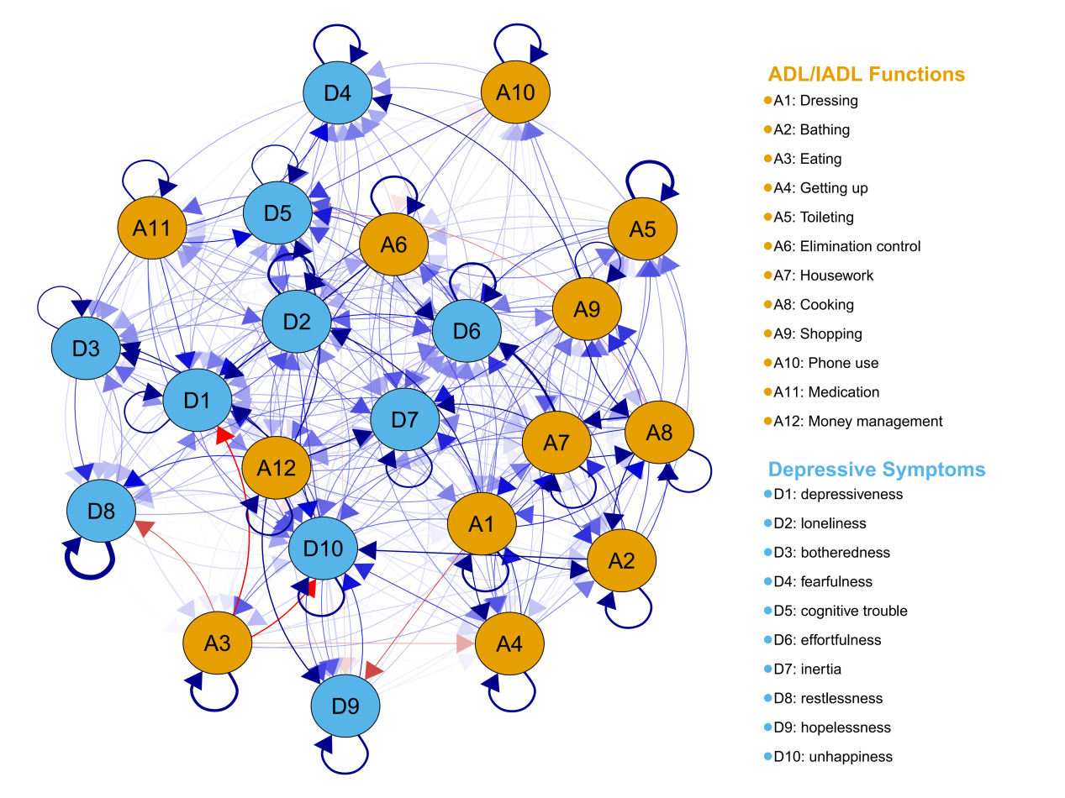
Figure s1. Cross-lagged panel network including autoregressive paths for all variables in the total sample (N=5850).
Note: The relationship between symptoms is indicated by the arrow’s color (blue = positive, red = negative), and the strength of the relationship is indicated by the arrow’s thickness (thicker = stronger). This figure displays the complete model, with solid arrows representing cross-lagged effects and circular arrows (or arrows pointing back to the same node) representing autoregressive effects (i.e., a variable’s prediction of itself over time).

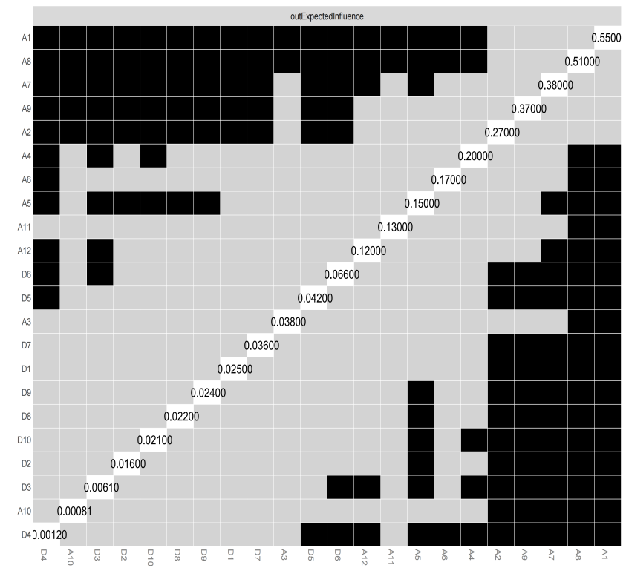
Figure s2. In-expected-influence difference tests for ADL and CESD-10 network in Chinese older adults with black boxes indicating edges that significantly differ from each other (p < .05) and gray boxes indicating no differences.

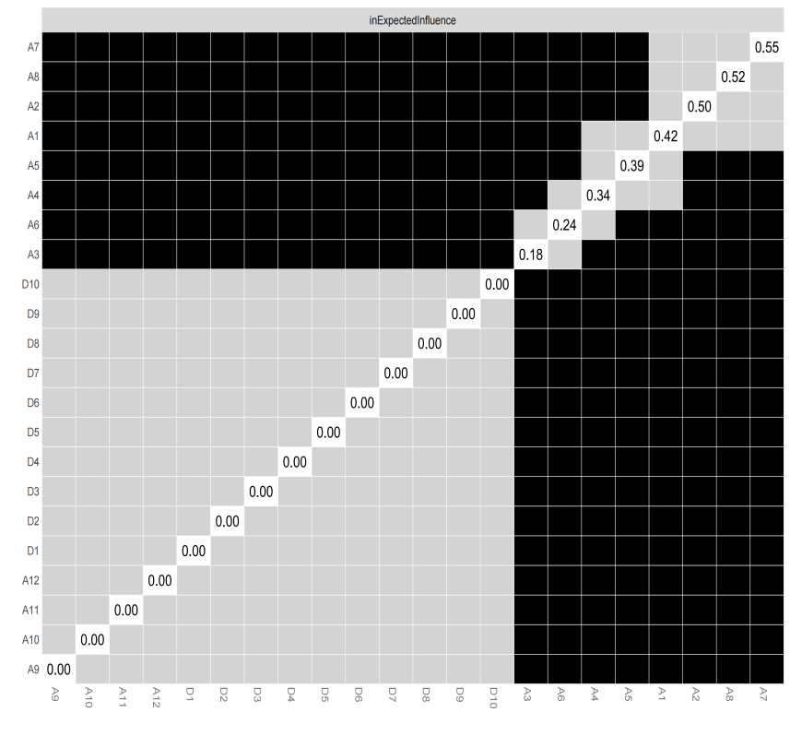
Figure s3. Out-expected-influence difference tests for ADL and CESD-10 network in Chinese older adults with black boxes indicating edges that significantly differ from each other (p < .05) and gray boxes indicating no differences.

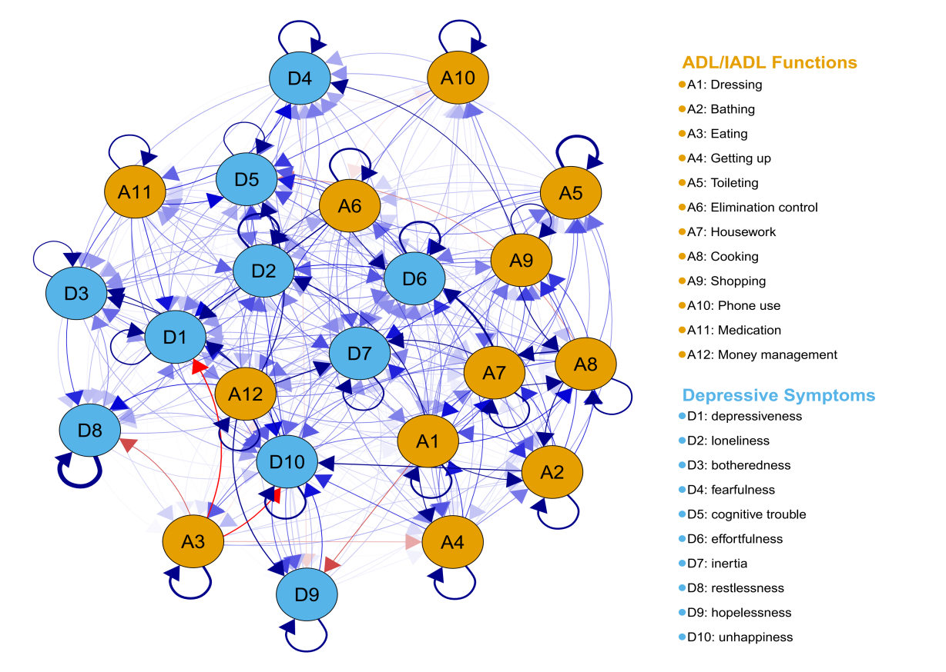
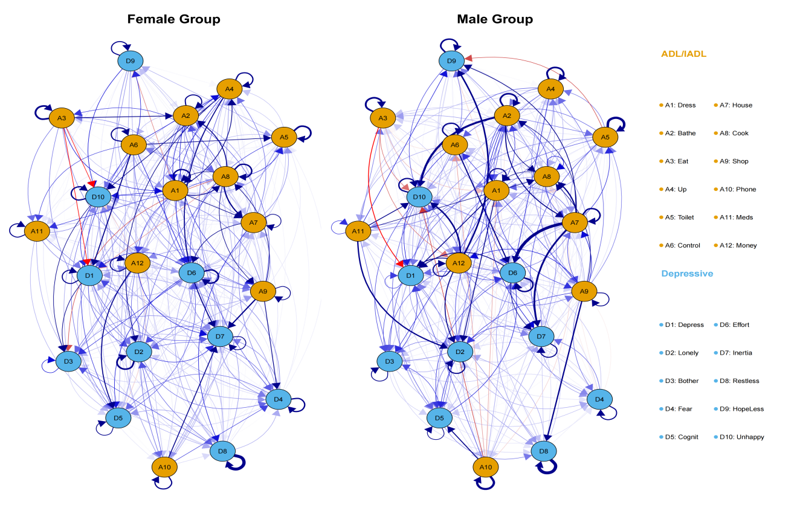

Figure s4. Cross-lagged panel networks including autoregressive paths for all variables in the female (left) and male (right) subsamples.
Note: The relationship between symptoms is indicated by the arrow’s color (blue = positive, red = negative), and the strength of the relationship is indicated by the arrow’s thickness (thicker = stronger). This figure displays the complete model, with solid arrows representing cross-lagged effects and circular arrows (or arrows pointing back to the same node) representing autoregressive effects (i.e., a variable’s prediction of itself over time).

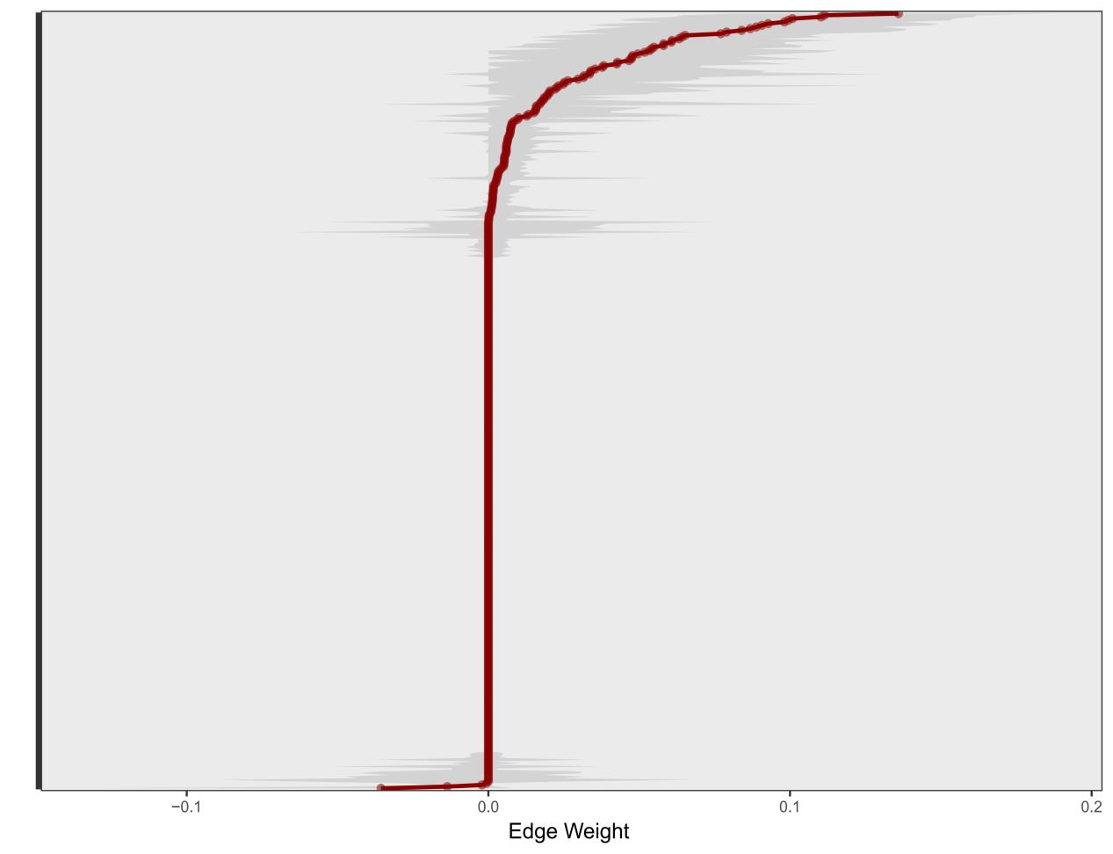
Figure s6. Accuracy of edge weights in the ADL-depression cross-lagged panel network for the total sample of Chinese older adults (N=5850). The plot shows the sample interrelations (i.e., edge weights; red dots), the means of the bootstrapped interrelations (i.e., edge weights; black dots), and the gray area represents the 95% Confidence Intervals of edge weights.

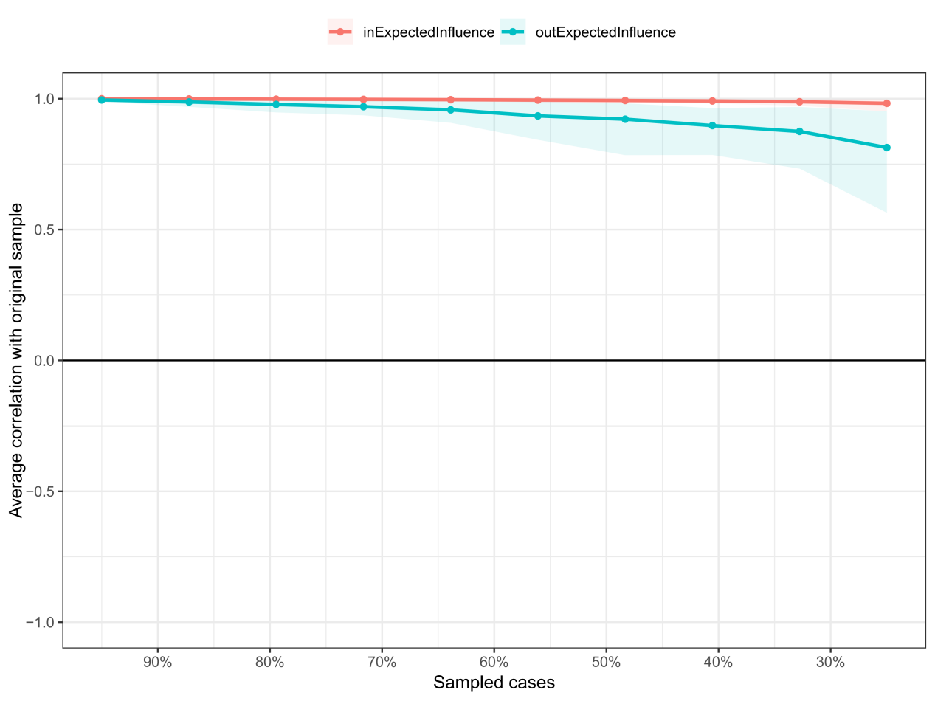
Figure s7. Stability of centrality measures for ADL and CESD-10 network in Chinese older adults. Lines indicate the means and areas indicate the range from the 2.5th quantile to the 97.5th quantile.

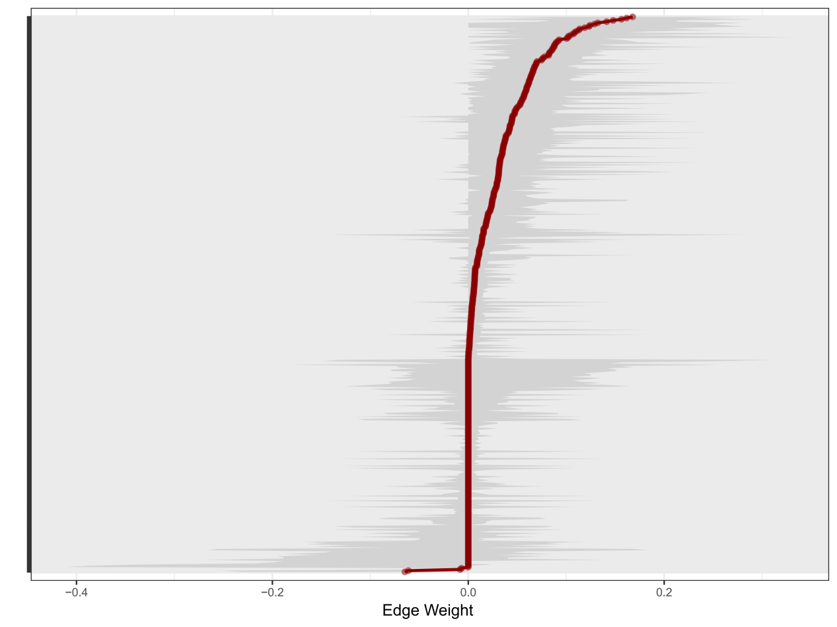
Figure s8. Accuracy of edge weights in the ADL-depression cross-lagged panel network for the female subsample of Chinese older adults (N=3038). The plot shows the sample interrelations (i.e., edge weights; red dots), the means of the bootstrapped interrelations (i.e., edge weights; black dots), and the gray area represents the 95% Confidence Intervals of edge weights.

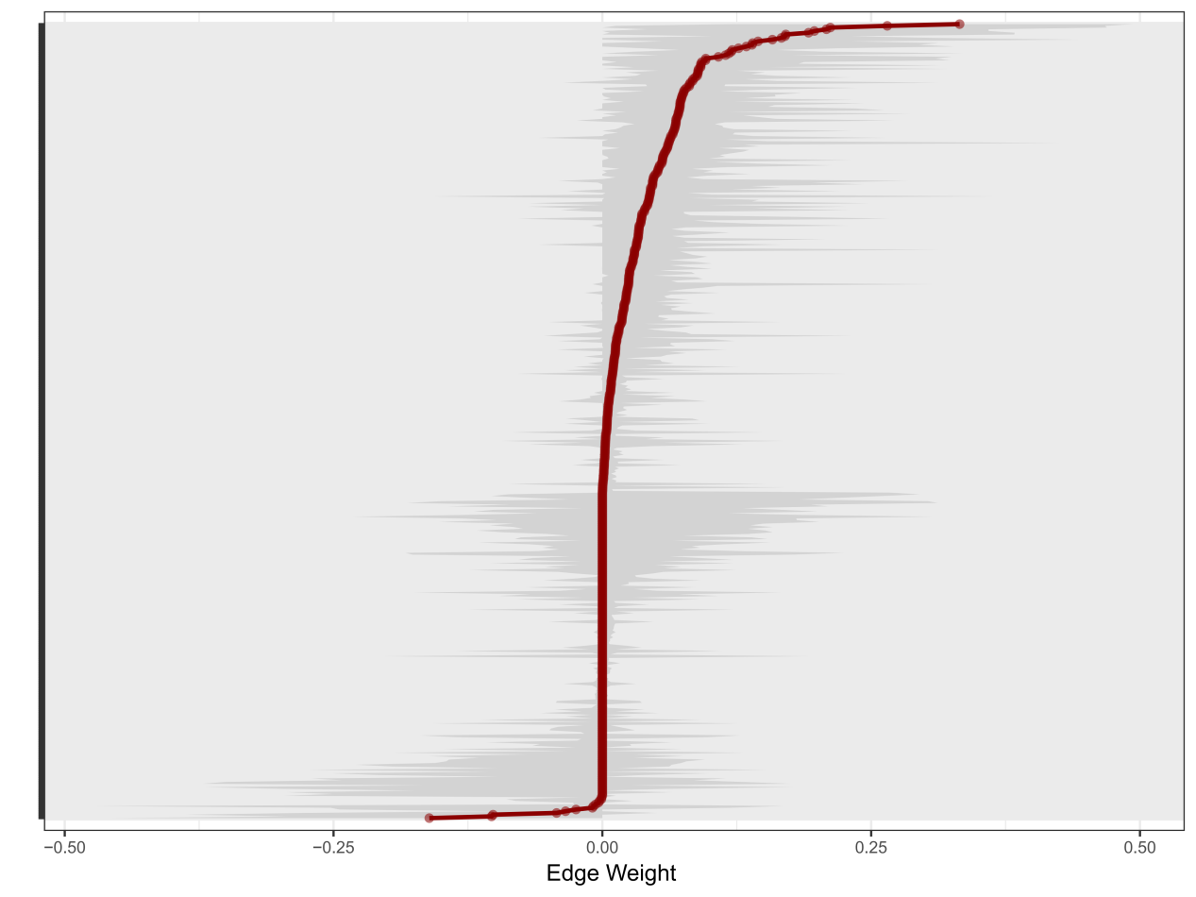
Figure s9. Accuracy of edge weights in the ADL-depression cross-lagged panel network for the male subsample of Chinese older adults (N=2812). The plot shows the sample interrelations (i.e., edge weights; red dots), the means of the bootstrapped interrelations (i.e., edge weights; black dots), and the gray area represents the 95% Confidence Intervals of edge weights.

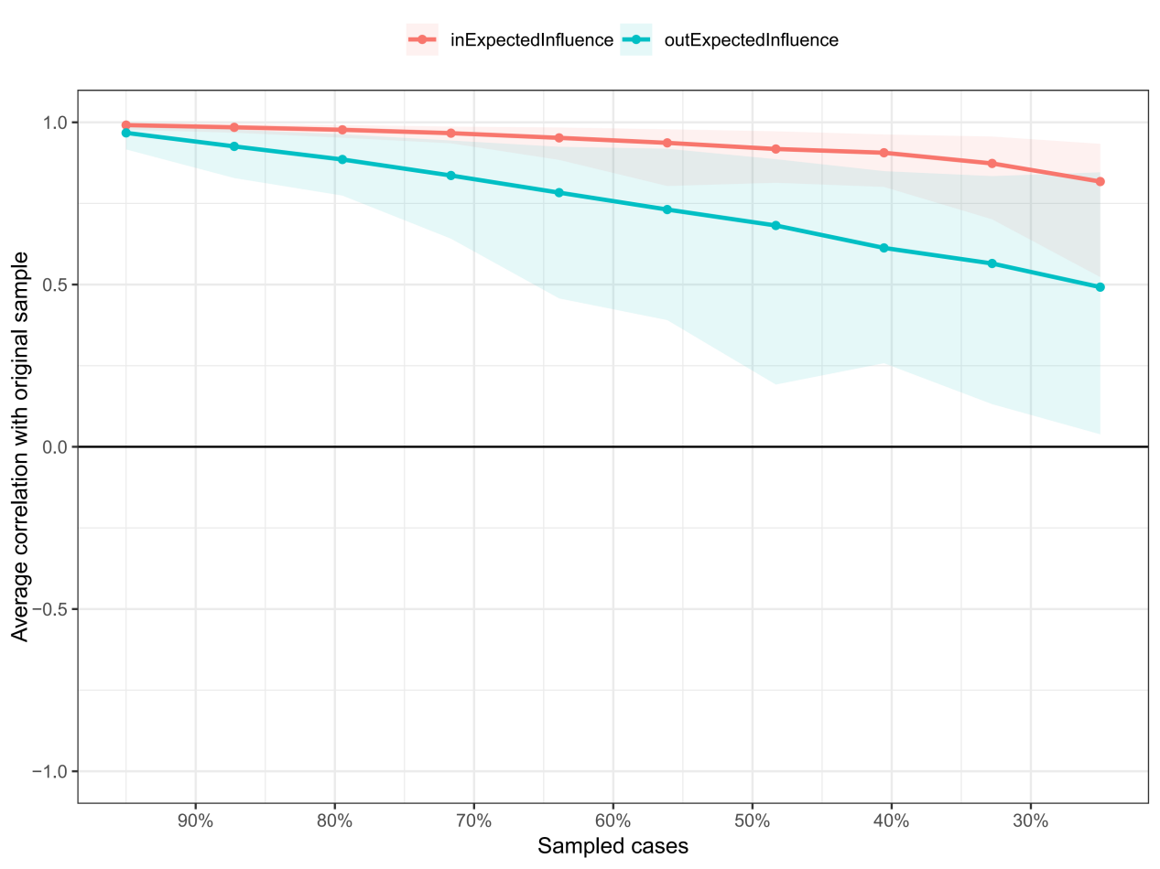
Figure s10. Stability of centrality measures for ADL and CESD-10 network in Chinese female older adults.. Lines indicate the means and areas indicate the range from the 2.5th quantile to the 97.5th quantile.

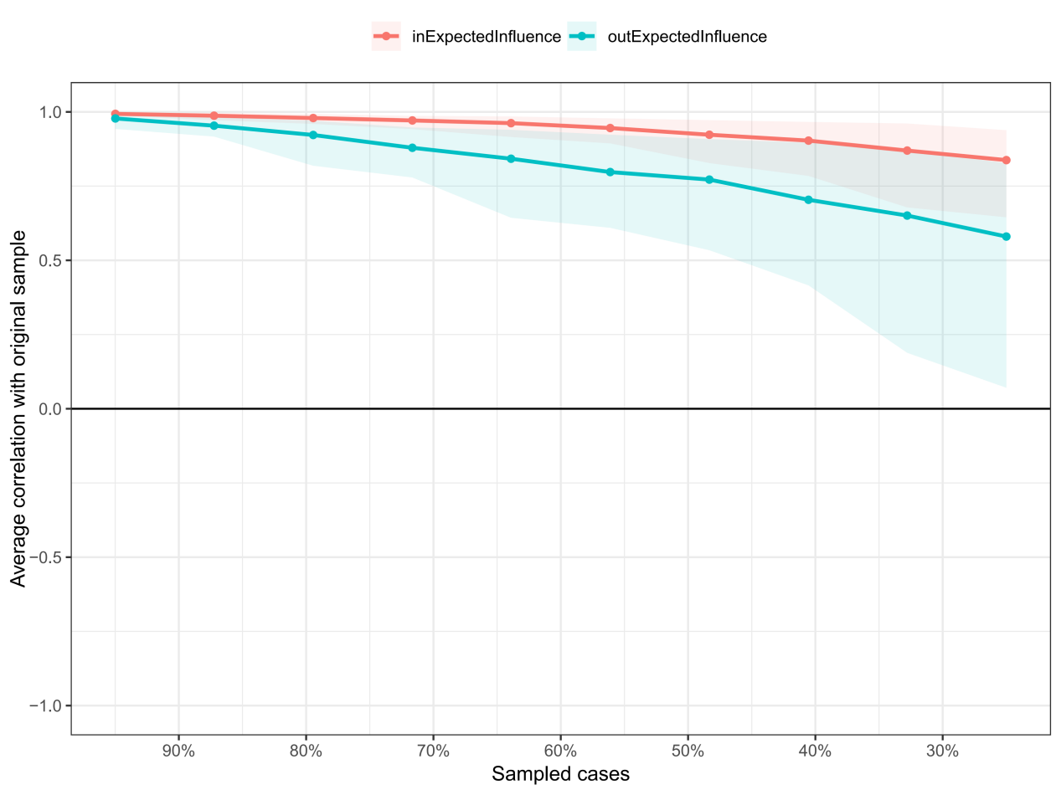
Figure s11. Stability of centrality measures for ADL and CESD-10 network in Chinese male older adults.. Lines indicate the means and areas indicate the range from the 2.5th quantile to the 97.5th quantile.

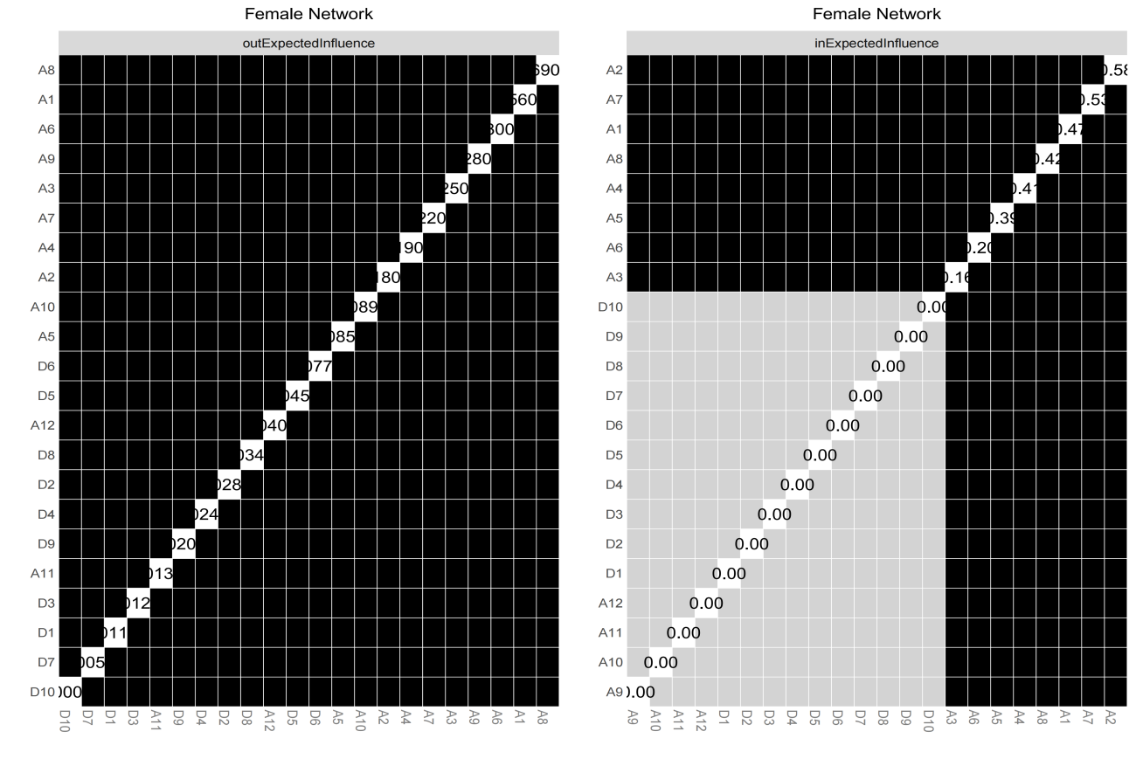

Figure s12.Out-expected-influence difference tests for ADL and CESD-10 network in Chinese female older adults with black boxes indicating edges that significantly differ from each other (p < .05) and gray boxes indicating no differences.
Figure s13.In-expected-influence difference tests for ADL and CESD-10 network in Chinese female older adults with black boxes indicating edges that significantly differ from each other (p < .05) and gray boxes indicating no differences.

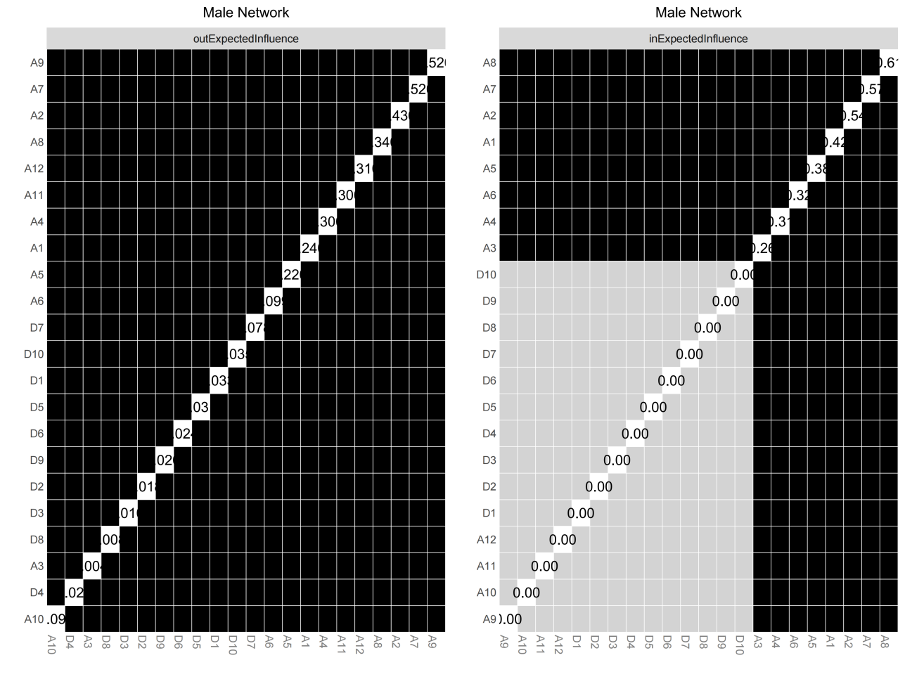
Figure s14.Out-expected-influence difference tests for ADL and CESD-10 network in Chinese male older adults with black boxes indicating edges that significantly differ from each other (p < .05) and gray boxes indicating no differences.

Figure s15.In-expected-influence difference tests for ADL and CESD-10 network in Chinese male older adults with black boxes indicating edges that significantly differ from each other (p < .05) and gray boxes indicating no differences.

