Controlling Ce³⁺ 5d states dynamics in zinc-based metal halide scintillator via hot exciton manipulation

Hang Yin†*, Bingxi Song†, Xin Zhou, Qinhua Wei, Yufeng Tong, Xuhui Feng, Peiqing Cai, Ruichen Wang, Fan Yang, Yuntao Wu, Andrej Hovan, Jakub Dostál, Miroslav Kloz, Junsheng Chen*, Laishun Qin*

[a] Hang Yin, Bingxi Song, Xin Zhou, Qinhua Wei, Laishun Qin
College of Materials and Chemistry, China Jiliang University, Hangzhou 310018, China
E-mail: yinhang@cjlu.edu.cn E-mail: qinlaishun@cjlu.edu.cn
[b] Hang Yin
Chemical Physics and NanoLund, Lund University, Lund 22100, Sweden
[c] Yufeng Tong, Yuntao Wu
Artificial Crystals Research Center, Shanghai Institute of Ceramics, Chinese Academy of Sciences, Shanghai 201899, China
[d] Xuhui Feng, Peiqing Cai
College of Optical and Electronic Technology, China Jiliang University, Hangzhou 310018, China
[e] Ruichen Wang, Fan Yang
School of Physics, Nankai University, Tianjin 300071, China
[f] Junsheng Chen
Nano-Science Center & Department of Chemistry, University of Copenhagen, Copenhagen 2100, Denmark
E-mail: junsheng.chen@chem.ku.dk
[g] Andrej Hovan, Jakub Dostál, Miroslav Kloz
Extreme Light Infrastructure ERIC, ELI Beamlines Facility, Dolní Břežany 252 41, Czech Republic

Corresponding Author
*yinhang@cjlu.edu.cn
*junsheng.chen@chem.ku.dk
*qinlaishun@cjlu.edu.cn
†These authors contributed equally to this work.

S1. Experimental Methods
Exciton binding energy: The exciton binding energy (E_{b}) was determined by fitting the temperature-dependent photoluminescence (PL) intensity using a thermal quenching model. The model is described by an Arrhenius-type expression:
(Equation S1)
Where I(T) is PL intensity at temperature T, I₀ is the PL intensity at 0 K, and k_{B} is the Boltzmann constant. Fitting the experimental data yields the E_{b} values of 0.380 eV and 0.325 eV for the Ce³⁺ and STE emissions, respectively.
Carrier-phonon coupling: The charge carriers in metal halides can couple to both optical and the acoustic phonons, which can be described by the following equation:
(Equation S2)
Where Γ₀ represents the temperature-independent inhomogeneous broadening, γ_{ac} and γ_{LO} are the acoustic and longitudinal optical (LO) phonon coupling strengths, respectively, and Γ_{imp} term describes the inhomogeneous broadening from ionic impurities, which is negligible in this study.
Herein, N_{LO}(T) represents the average number of LO phonons populated at temperature T, which determines the strength of carrier–phonon interactions. It follows the Bose–Einstein distribution:
(Equation S3)
where k_{B} is the Boltzmann constant, E_{LO} is the energy of the LO phonons.
Energy transfer efficiency: The energy transfer efficiency (η) from Ce³⁺ to Cu⁺ was determined by comparing the decay times of Ce³⁺ emission with and without Cu⁺, according to the following expression:
(Equation S4)
where τ_{Ce} is the amplitude-weighted average decay time of Ce³⁺ emission for Cs₂ZnCl₄:6%Ce³⁺, and τ_{Ce−Cu} is the corresponding decay time of Ce³⁺ emission for Cs₂ZnCl₄:6%Ce³⁺–x%Cu⁺ (x%=2%–10%). The corresponding decay time are summarized in Tables S1 and S2
S2. Figures
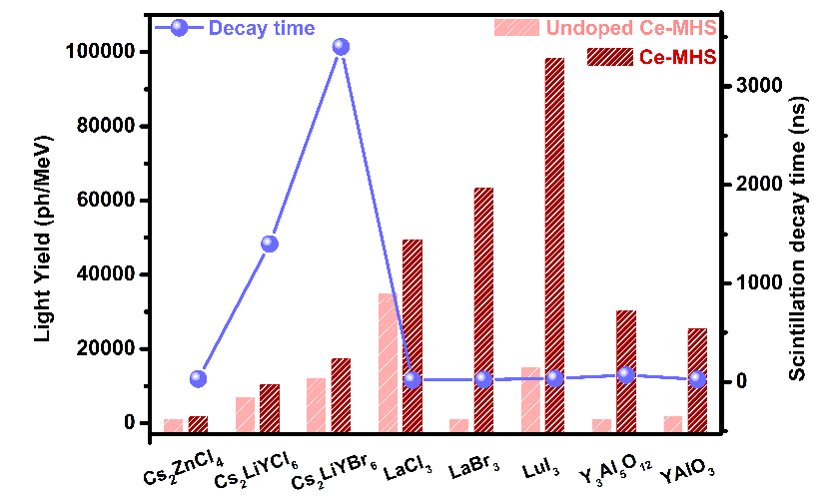
Figure S1 The scintillation decay time and light yield for Ce³⁺-doped metal halides.

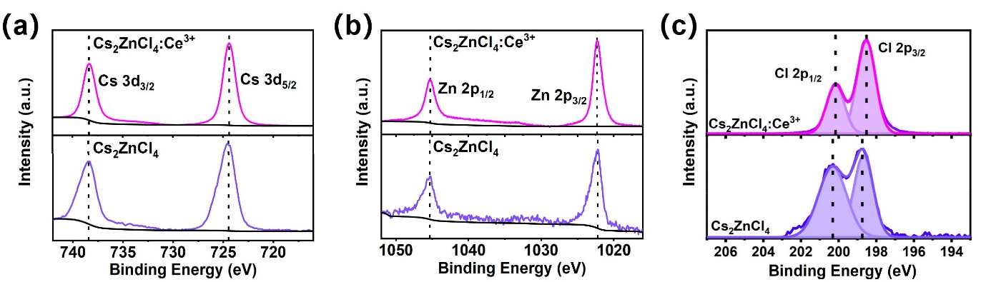
Figure S2 High-resolution XPS spectra of Cs 3d, Zn 2p, and Cl 2p for Cs₂ZnCl₄ and Cs₂ZnCl₄:Ce³⁺ single crystals.

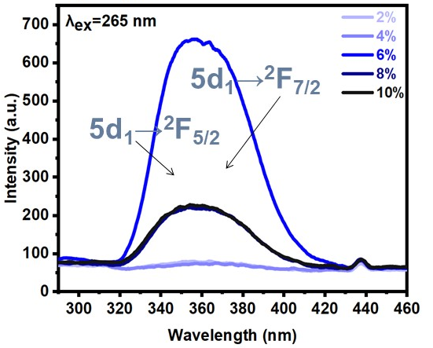
Figure S3 The PL spectra excited at 265 nm for Cs₂ZnCl₄:x%Ce³⁺ (x% = 2%–10%).
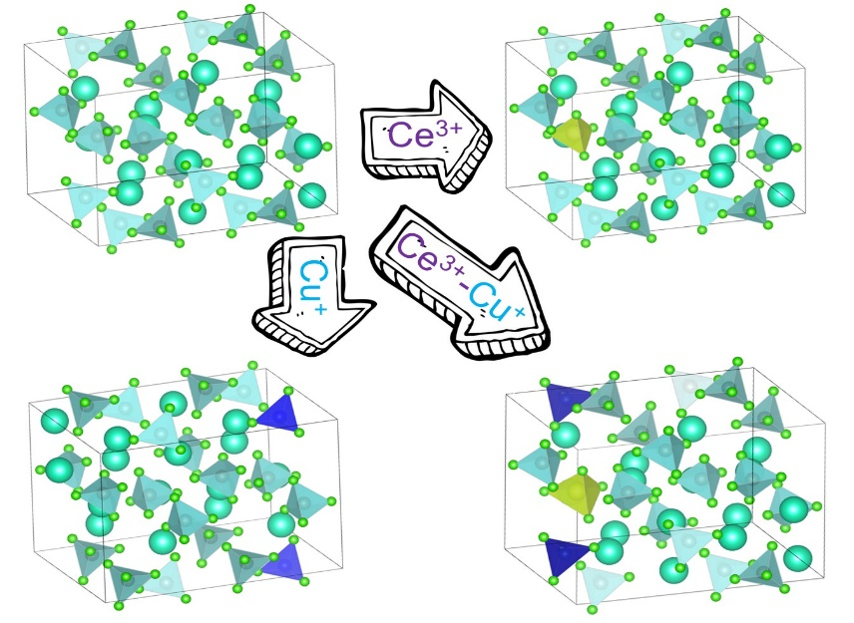
Figure S4 The lattice structure of doped/co-doped Cs₂ZnCl₄ single crystals.

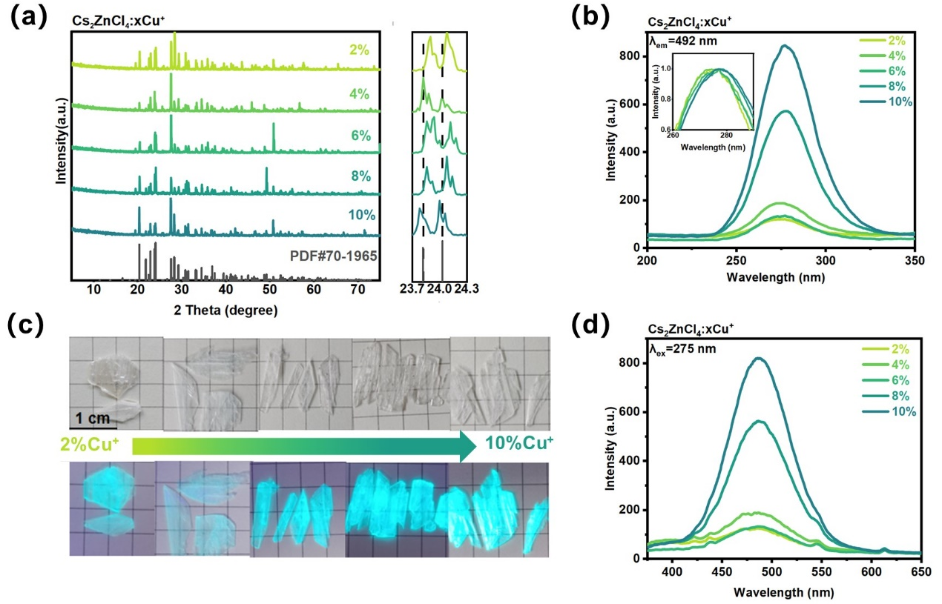
Figure S5 (a) XRD patterns of different crystal segments for Cs₂ZnCl₄:x%Cu⁺ (x% = 2%–10%). (b) The PLE spectra probed at 492 nm. (c) Photographs of hydrothermally synthesized Cs₂ZnCl₄:x%Cu⁺ under daylight and UV excitation. (d) The PL spectra excited at 275 nm.
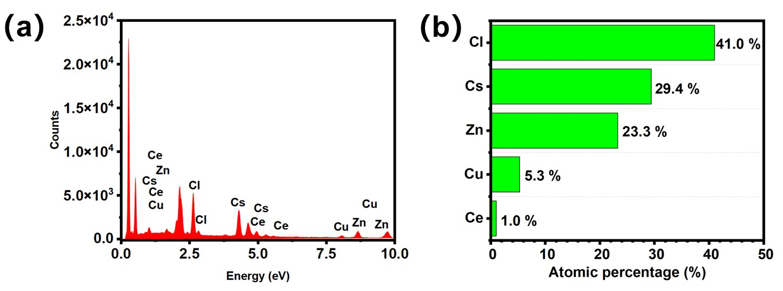
Figure S6 SEM-EDS measurement and element distribution of Cs, Zn, Cl, Ce, and Cu for Cs₂ZnCl₄:6%Ce³⁺-6%Cu⁺ single crystals.

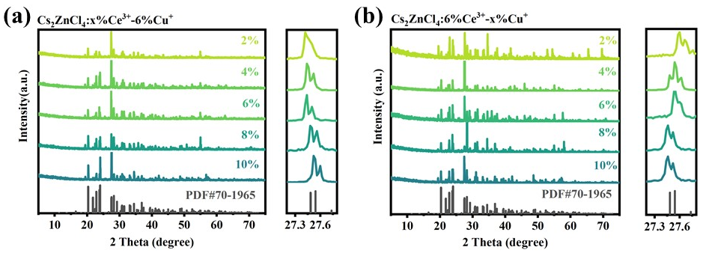
Figure S7 XRD patterns of different crystal segments for two branches of samples, i.e. Cs₂ZnCl₄:6%Ce³⁺–x%Cu⁺ (x% = 2%–10%) and Cs₂ZnCl₄:x%Ce³⁺–6%Cu⁺ (x% = 2%–10%).

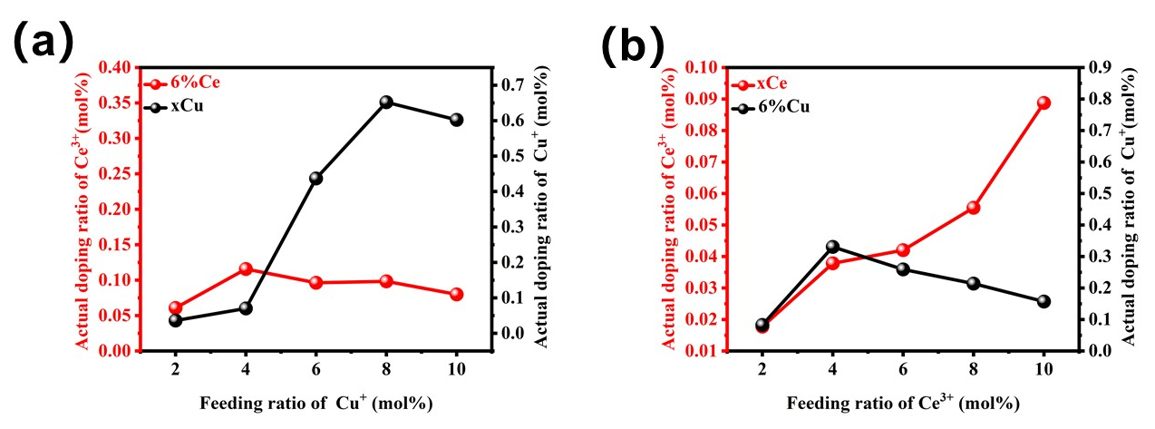
Figure S8 The actual incorporation ratio of Ce³⁺ and Cu⁺ for Cs₂ZnCl₄:6%Ce³⁺–x%Cu⁺ (x% = 2%–10%) and Cs₂ZnCl₄:x%Ce³⁺–6%Cu (x% = 2%–10%) measured by ICP-MS.
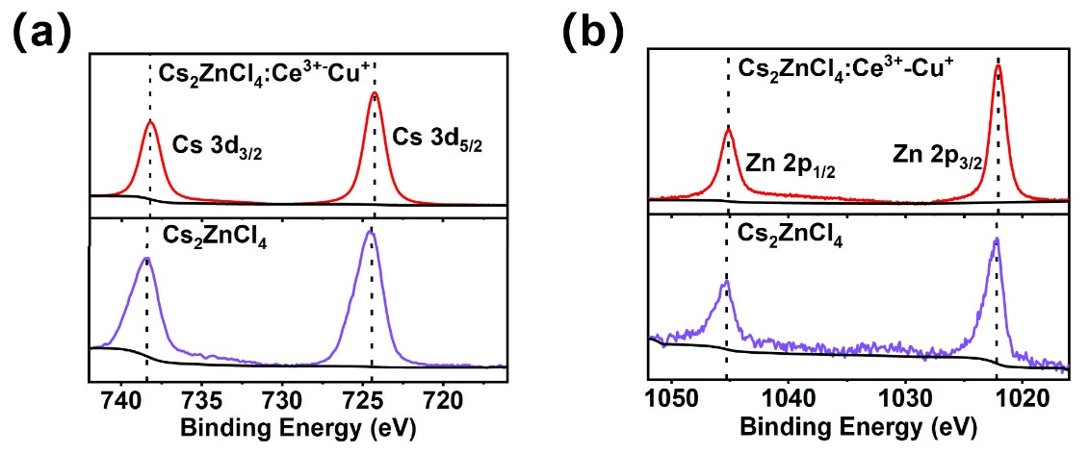
Figure S9 High-resolution XPS spectra of Cs 3d and Zn 2p for Cs₂ZnCl₄ and Cs₂ZnCl₄:6%Ce³⁺-6%Cu⁺ single crystals.

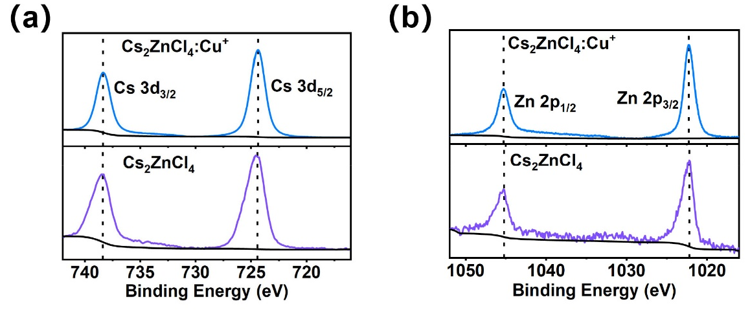
Figure S10 High-resolution XPS spectra of Cs 3d and Zn 2p for Cs₂ZnCl₄ and Cs₂ZnCl₄:6%Cu⁺ single crystals.

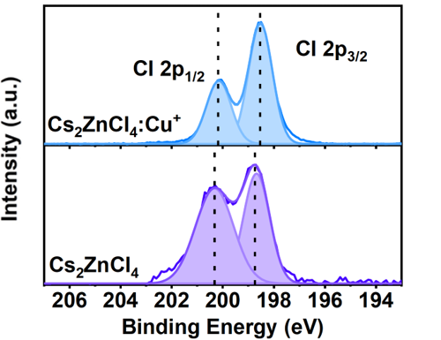
Figure S11 High-resolution XPS spectra of Cl 2p for Cs₂ZnCl₄ and Cs₂ZnCl₄:6%Cu⁺ single crystals.
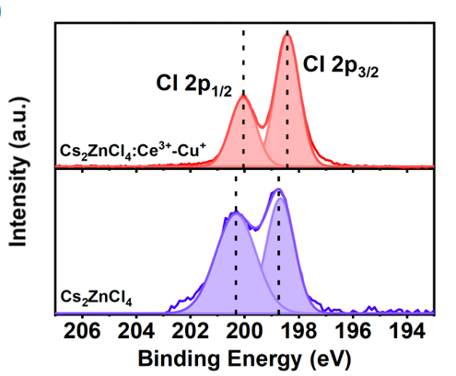
Figure S12 High-resolution XPS spectra of Cl 2p for Cs₂ZnCl₄ and Cs₂ZnCl₄:6%Ce³⁺-6%Cu⁺ single crystals.

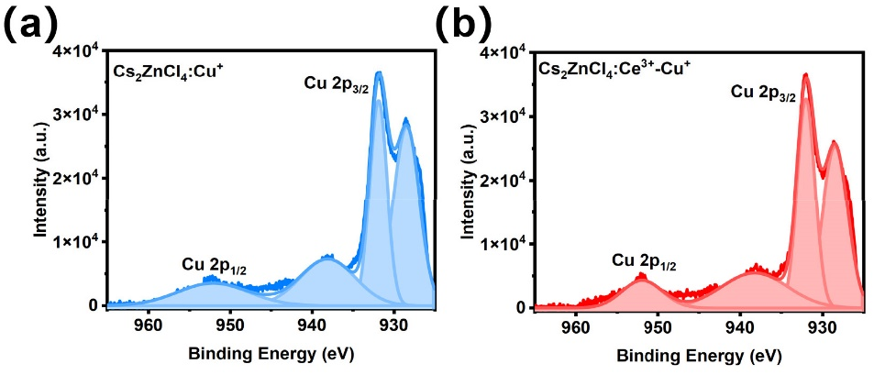
Figure S13 High-resolution XPS spectra of Cu 2p for Cs₂ZnCl₄:6%Cu⁺ and Cs₂ZnCl₄:6%Ce³⁺-6%Cu⁺ single crystals.

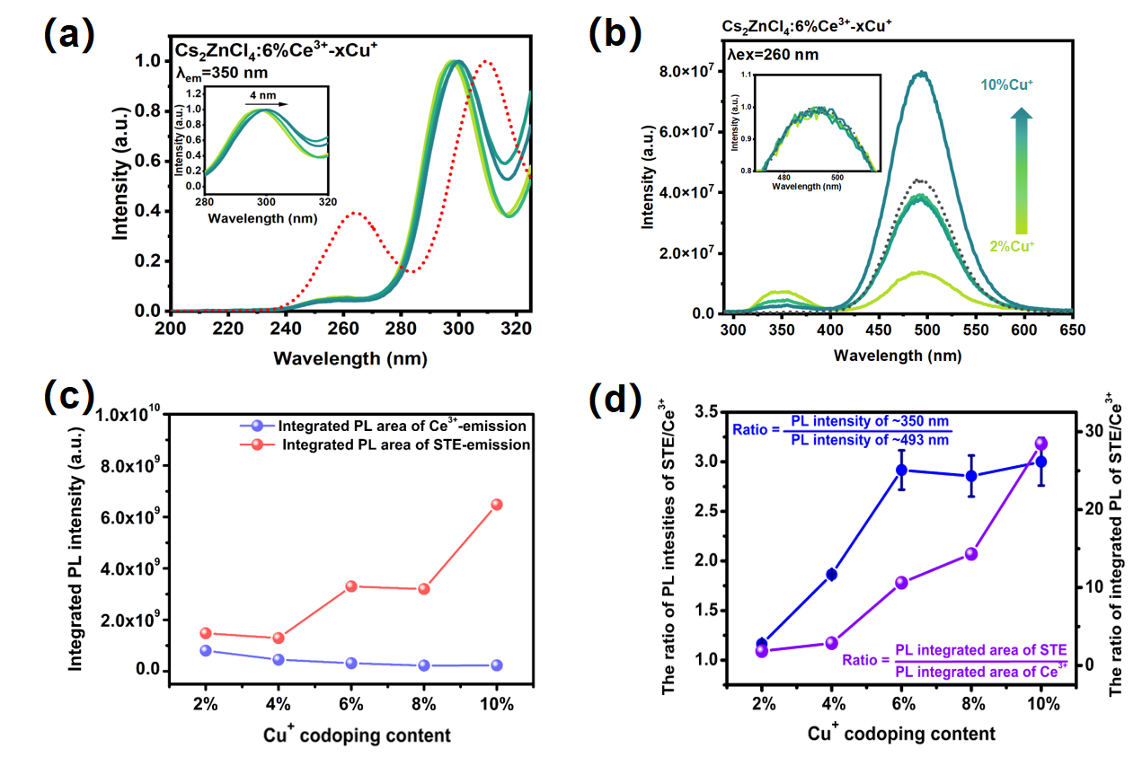
Figure S14 The PL spectra (λ_{ex} = 260 nm) of Cs₂ZnCl₄:6%Ce³⁺–6%Cu⁺ single crystals.
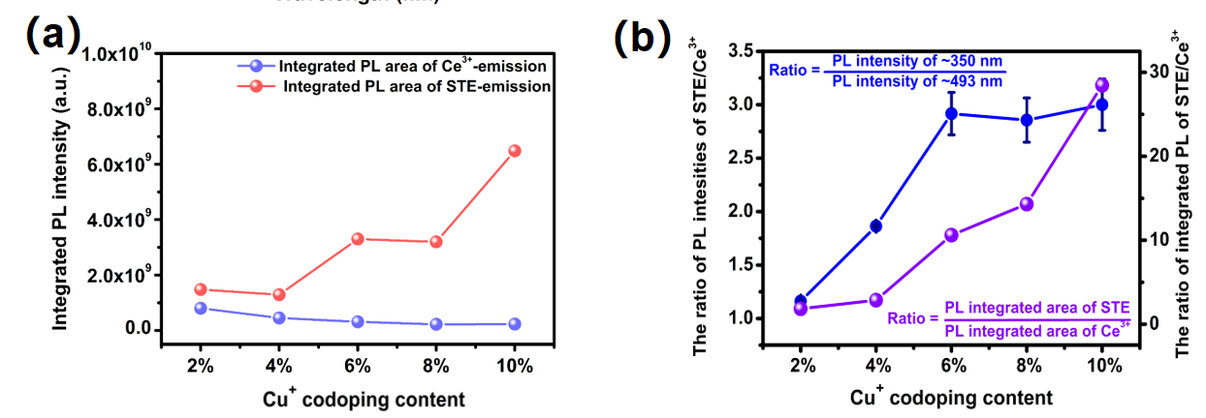
Figure S15 The integrated PL intensities and their relative ratio of STE/Ce³⁺ emission for Cs₂ZnCl₄:6%Ce³⁺–x%Cu⁺ (x%=2%–10%).

Figure S16 The PLE spectra probed at 350 nm for Cs₂ZnCl₄:6%Ce³⁺–x%Cu⁺ (x%=2%–10%). The red curve represents the PLE spectrum probed at 350 nm for Cs₂ZnCl₄:6%Ce³⁺.

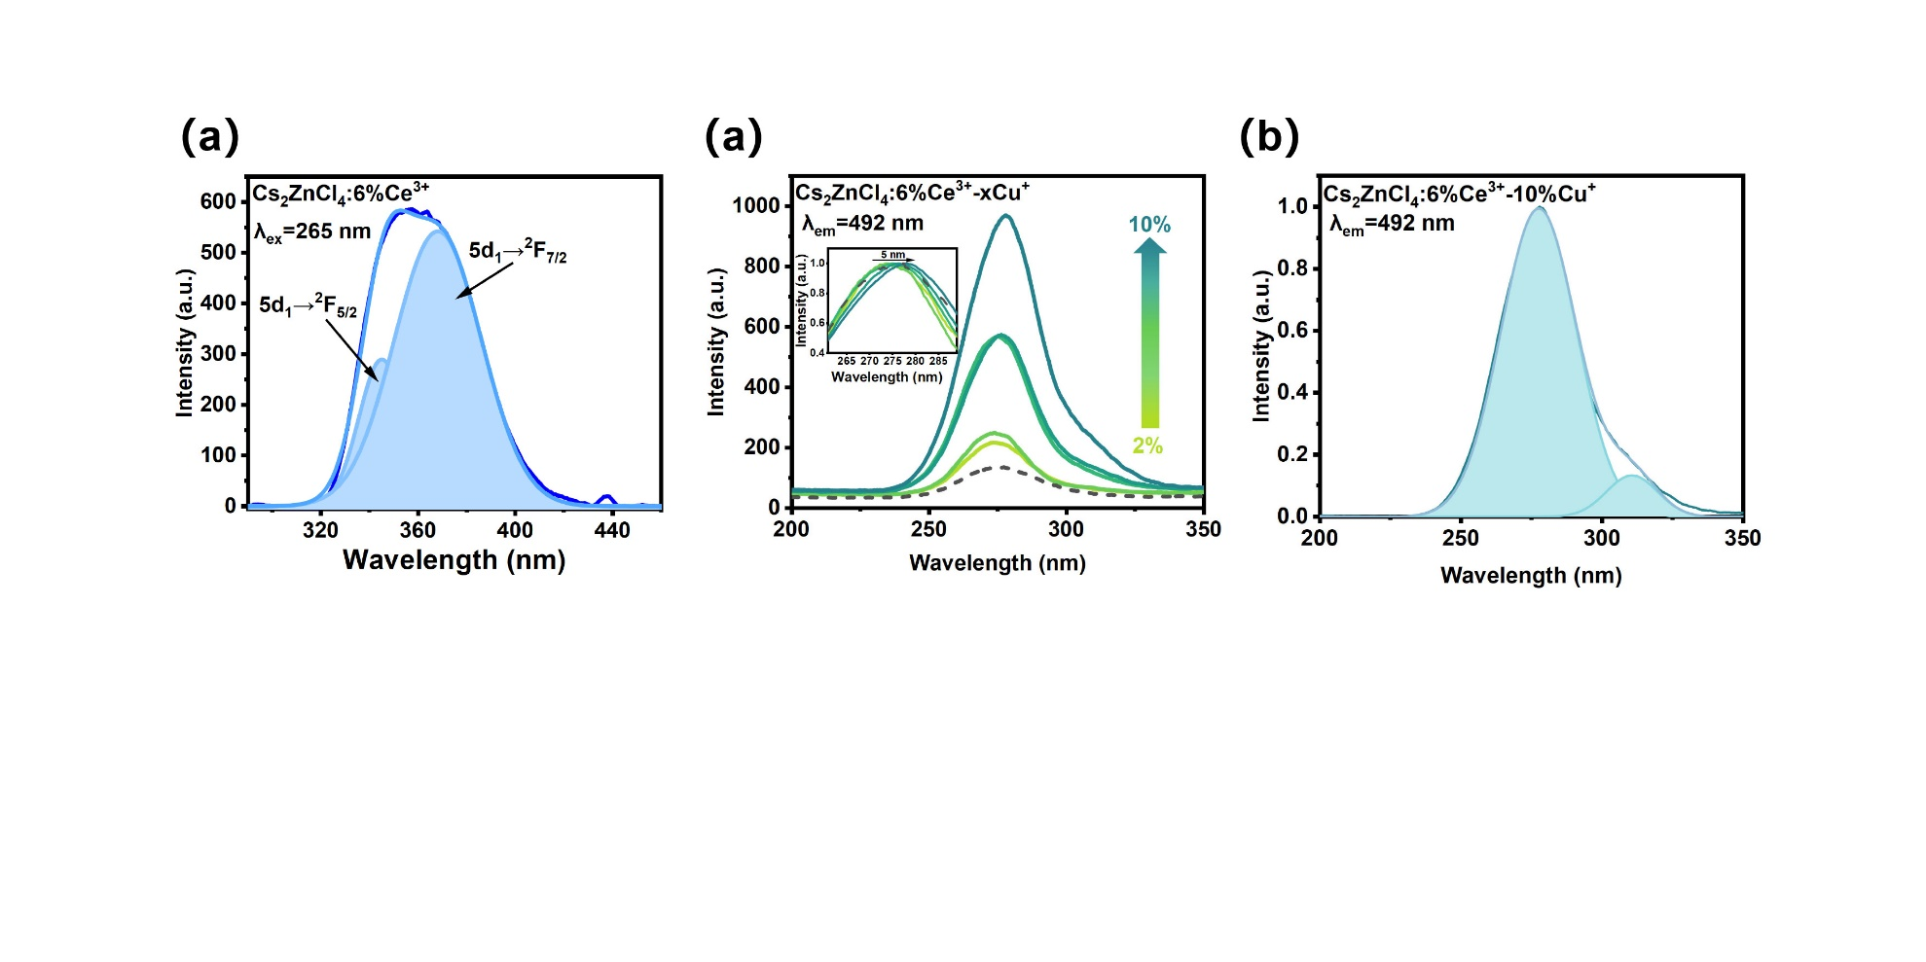
Figure S17 (a) The PL spectra probed at 492 nm for Cs₂ZnCl₄:6%Ce³⁺–x%Cu⁺ (x%=2%–10%). (b) The peak deconvolution of PL spectrum for Cs₂ZnCl₄:6%Ce³⁺–10%Cu⁺.

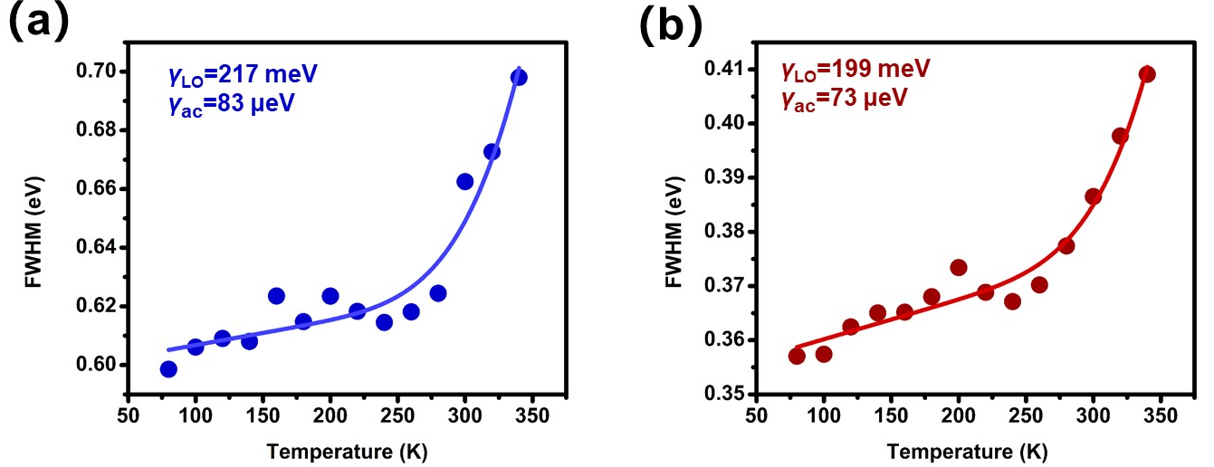
Figure S18 (a) The fitted LO phonon (γ_{LO}) and acoustic phonon coupling (γ_{ac}) for of the Ce³⁺ emission, and (b) that of STE emission in Cs₂ZnCl₄:6%Ce³⁺–6%Cu⁺.

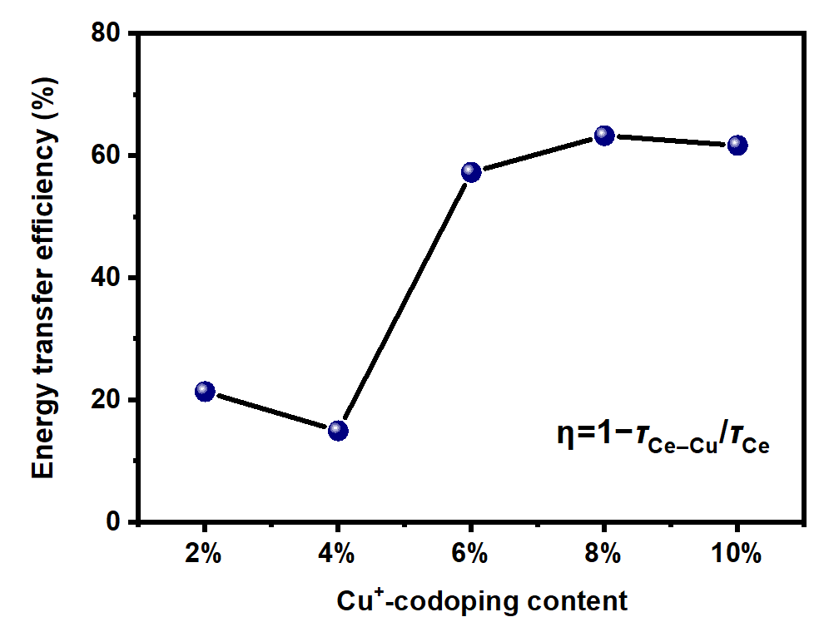
Figure S19 The calculated energy transfer efficiencies for a series of Cs₂ZnCl₄:6%Ce³⁺–x%Cu⁺ (x%=2%–10%).

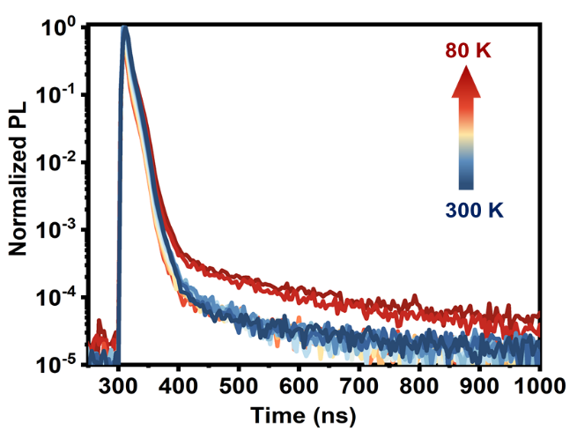
Figure S20 The PL decay curves monitored at 340 nm under 280 nm excitation for Cs₂ZnCl₄:6%Ce³⁺–x%Cu⁺ (x = 0–10%)

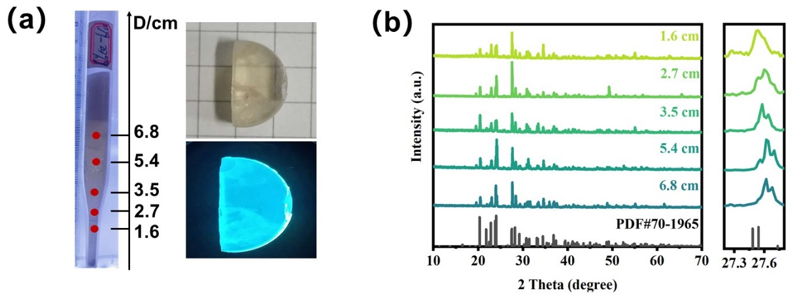
Figure S21 (a) The photograph of transparent inch-scale Cs₂ZnCl₄:6%Ce³⁺–6%Cu⁺ crystal with red-marked segment. (b) XRD patterns collected from different segments along the crystal growth direction.
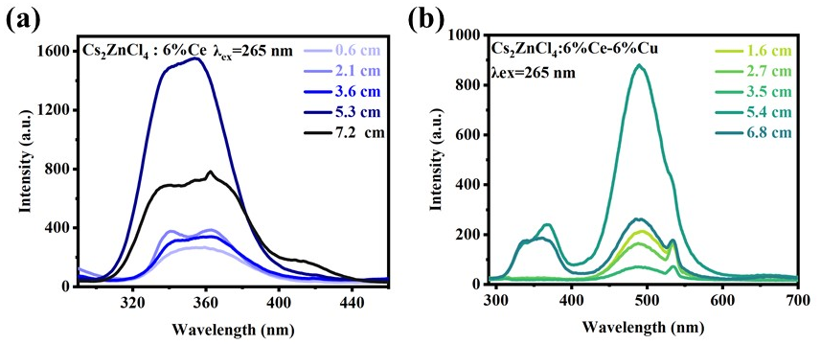
Figure S22 The PL spectra collected from different segments along the crystal growth direction for (a) Cs₂ZnCl₄:6%Ce³⁺ and (b) Cs₂ZnCl₄:6%Ce³⁺–6%Cu⁺.

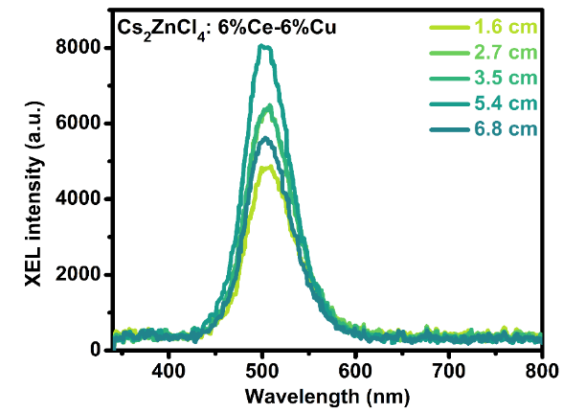
Figure S23 The RL spectra collected from different segments along the crystal growth direction for Cs₂ZnCl₄:6%Ce³⁺–6%Cu⁺.

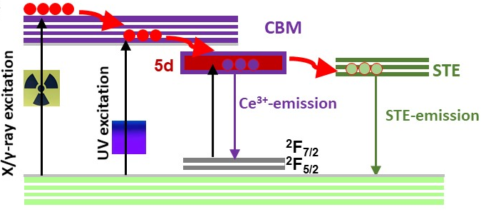
Figure S24 Schematic scintillation dynamics model for Ce³⁺–Cu⁺ co-doped Cs₂ZnCl₄ single crystal.
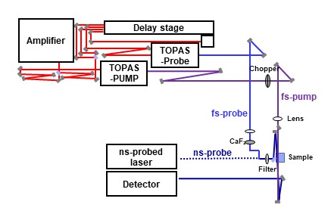
Figure S25 The home-build fs–μs transient absorption measurements.

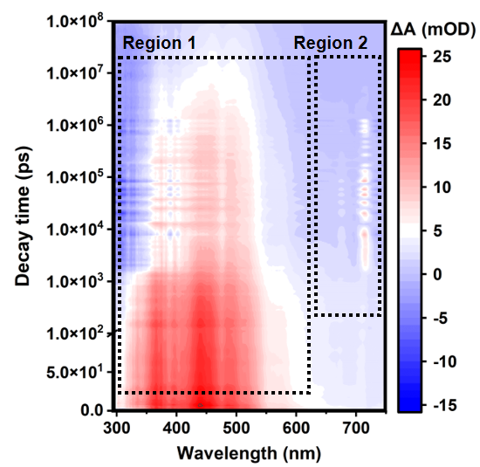
Figure S26 The pseudo color fs–μs TA plot for Cs₂ZnCl₄:6%Ce³⁺–6%Cu⁺.

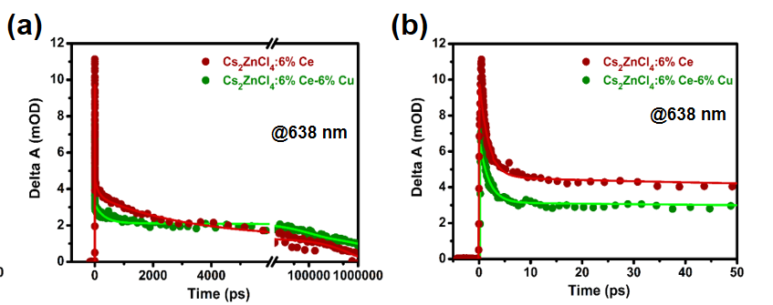
Figure S27 (a) The μs‐scale TA decay and (b) ps-scale TA decay probed at 638 nm.

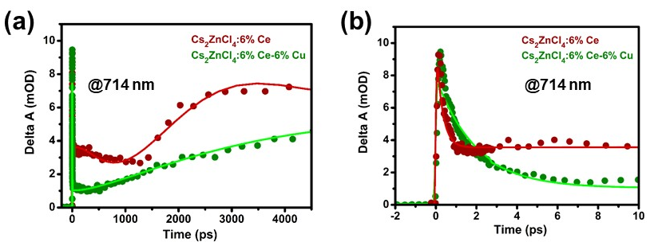
Figure S28 (a) The ns‐scale TA decay and (b) ps-scale TA decay probed at 714 nm.

S3. Tables
Table S1 The PL decay time monitored at 340 nm under 280 nm excitation for Cs₂ZnCl₄:6%Ce³⁺–x%Cu⁺ (x%=0%–10%).
Cs₂ZnCl₄:6%Ce³⁺–x%Cu⁺ | x=0% | x=2% | x=4% | x=6% | x=8% | x=10%
τ₁ (ns) | 6.4 | 4.9 | 6.8 | 2.1 | 1.3 | 1.1
Rel% | 45% | 30% | 62% | 70% | 71% | 69%
τ₂ (ns) | 20.4 | 13.5 | 20.0 | 14.9 | 14.4 | 14.7
Rel% | 54% | 70% | 38% | 30% | 29% | 31%
τ_{average} (ns) | 13.9 | 10.9 | 11.8 | 5.9 | 5.2 | 5.3

Table S2 The PL decay time monitored at 500 nm under 280 nm excitation for Cs₂ZnCl₄:6%Ce³⁺–x%Cu⁺ (x%=2%–10%).
Cs₂ZnCl₄:6%Ce³⁺–x%Cu⁺ | x=2% | x=4% | x=6% | x=8% | x=10%
τ (μs) | 36.3 | 37.2 | 37.0 | 36.2 | 36.7
Rel% | 99% | 99% | 99% | 99% | 99%

Table S3 The crystal-field–splitting (ΔE_{CFS}) and corresponding energy separations (ΔE_{sep}) of adjacent Ce³⁺ 5d sublevels for Cs₂ZnCl₄:6%Ce³⁺.
TA Peaks | Region I (nm) | Region II (nm) | ΔE_{CFS} (eV) | ΔE_{sep} (eV)
Peak V | 367 | 825 | 0.24 | 0.04
Peak IV | 395 | 804 | 0.33 | 0.05
Peak III | 439 | 777 | 0.27 | 0.06
Peak II | 486 | 750 | 0.14 | 0.08
Peak I | 515 | 714 | -- | --

Table S4 The crystal-field–splitting (ΔE_{CFS}) and corresponding energy separations (ΔE_{sep}) of adjacent Ce³⁺ 5d sublevels for Cs₂ZnCl₄:6%Ce³⁺–6%Cu⁺.
TA Peaks | Region I (nm) | Region II (nm) | ΔE_{CFS} (eV) | ΔE_{sep} (eV)
Peak V | 338 | 825 | 0.53 | 0.04
Peak IV | 395 | 802 | 0.32 | 0.06
Peak III | 439 | 771 | 0.14 | 0.05
Peak II | 462 | 748 | 0.35 | 0.08
Peak I | 530 | 714 | -- | --

